NETWORKWALKS CYBERSECURITY INTERNSHIP
WEEK 2 PENETRATION TESTING REPORT
Footprinting, GHDB Analysis & Network Scanning

Prepared by | Antoinette Thompson
Program | NetworkWalks Cybersecurity Internship
Batch | B082
Week | 2
Modules completed | W2-PM1, W2-PM2, W2-PM5
Assessment period | August 2026

CONFIDENTIAL TRAINING EVIDENCE – REDACTED FOR SAFE SHARING
IP addresses, MAC addresses, exposed third-party camera URLs, contact details and other sensitive values have been blurred or redacted in the evidence images included in this report. Original evidence should be retained privately for authorized assessment purposes.

1. Authorization, Scope and Liability Disclaimer
This report documents practical cybersecurity exercises completed as part of the NetworkWalks Cybersecurity Internship, Batch B082. The activities described were performed for educational and assessment purposes within the scope provided by the internship modules.
The report is intended to document reconnaissance, footprinting and authorized network-discovery techniques. The presence of a discovered technology, indexed resource, host or service is not by itself treated as proof of exploitable vulnerability. Risk statements in this report are analytical interpretations of the observed results.
Sensitive information has been deliberately blurred or redacted from screenshots intended for sharing. This includes public IP addresses discovered during reconnaissance, private local-network addressing, MAC addresses, live third-party camera URLs, and contact/token information.

2. Executive Summary
During Week 2 of the NetworkWalks Cybersecurity Internship, I completed three practical modules covering footprinting and reconnaissance with multiple Kali Linux tools (PM1), Google Hacking Database (GHDB) based footprinting (PM2), and network scanning with Zenmap/Nmap (PM5). The combined exercises provided practical experience with passive reconnaissance, web and DNS enumeration, search-engine-assisted information discovery, and authorized local-network host discovery.
PM1 produced a multi-source profile of the assigned web domain. WHOIS exposed registration and nameserver information; WhatWeb identified web-server, CMS and supporting technologies; Nslookup confirmed DNS resolution; cURL exposed HTTP response information; Wafw00f identified a ModSecurity web application firewall; and DNSRecon enumerated SOA, NS, MX, A, TXT and SRV records. The consistency between the WhatWeb and DNS results provided useful corroboration of the observed web endpoint.
PM2 demonstrated the security implications of search-engine indexing. The exercise produced more than the required ten findings for each task: eleven camera-related results were recorded for Task 1 and eleven mathematics-PDF directory/listing results were recorded for Task 2. No usernames or passwords were recorded in the completed table. The exercise illustrated how public indexing can expose interfaces and document repositories without requiring direct exploitation.
PM5 identified eleven live hosts on the authorized local network, including the assessment workstation, and documented corresponding IP and MAC information. The topology evidence showed the discovered hosts around the scanning workstation. For safe sharing, individual local addresses and MAC values are not reproduced in this report.

3. Objectives
- Practice reconnaissance and footprinting against the assigned training target using multiple Kali Linux tools.
- Identify information that can be learned from WHOIS, web technology fingerprinting, DNS, HTTP headers, WAF detection and DNS enumeration.
- Use GHDB-style search operators to understand how search engines can expose publicly indexed resources.
- Perform authorized network discovery with Zenmap/Nmap and identify live hosts within a local subnet.
- Interpret technical observations from a security perspective without automatically classifying every observation as a confirmed vulnerability.
- Document evidence, findings, risks, limitations and recommendations in a professional penetration-testing report.

4. Scope and Methodology
The assessment followed the sequence represented by the three completed modules: reconnaissance, public-information discovery, and authorized network discovery.
Phase | Module | Primary approach | Evidence produced
1 | W2-PM1 | Kali reconnaissance and enumeration | Six command results and screenshots
2 | W2-PM2 | GHDB/search-engine footprinting | Camera-interface and mathematics-PDF findings
3 | W2-PM5 | Zenmap/Nmap host discovery | Live-host count, IP/MAC results and topology

For PM1, each tool was run against the assigned NetworkWalks domain. For PM2, the exercise used search-engine queries/dorks supplied by the module to locate publicly indexed resources. For PM5, the scan was performed against the local authorized network used for the lab.
The screenshots in this report are sanitized copies of the submitted evidence. Redaction was applied after the practical work was completed, so the technical observations in the narrative remain based on the original results.

5. Tools and Technologies Used
Tool / Technology | Purpose in the exercise
WHOIS | Domain registration, registrar, nameserver and status information
WhatWeb | Web-technology and server fingerprinting
Nslookup | DNS name-to-address resolution
cURL | HTTP response-header inspection
Wafw00f | Web application firewall fingerprinting
DNSRecon | DNS record enumeration
Google / GHDB search operators | Discovery of publicly indexed resources
Zenmap / Nmap | Authorized local-network host discovery and visualization
Windows IP configuration tools | Identification of the local network context for PM5

6. W2-PM1 – Footprinting & Reconnaissance with Multiple Kali Tools
PM1 used six reconnaissance tools to build a layered profile of the assigned domain. The value of using multiple tools is that each produces a different view of the target, while overlapping observations can be used to corroborate results.

6.1 Task 1 – WHOIS Enumeration
Command used: whois networkwalks.com
The WHOIS output identified GoDaddy.com, LLC as the registrar and showed a domain creation date of November 6, 2019 and a registry expiration date of November 6, 2027. The output also identified HostGator nameserver infrastructure and indicated that DNSSEC was unsigned. The raw result also contained registrar contact information and registry identifiers, which have been blurred in the evidence image.
Security interpretation:
- Registration and nameserver information can help an assessor understand the domain's administrative and hosting relationships.
- Domain lifecycle dates can provide context for infrastructure age and ownership history.
- Nameserver information can help connect a domain to its hosting/DNS provider.
- The output itself is reconnaissance information; it does not demonstrate a compromise.
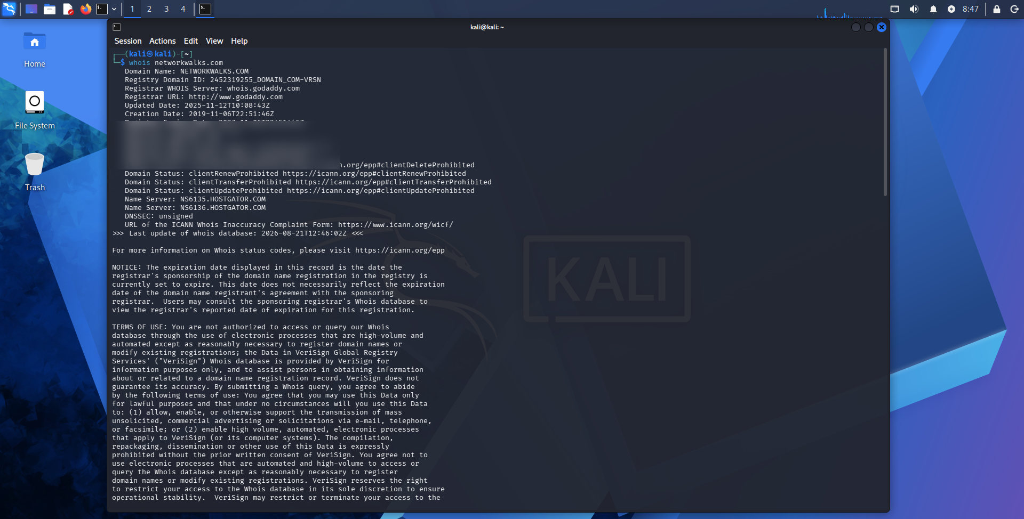
Figure 1. Sanitized WHOIS evidence; registrar contact details have been blurred.

6.2 Task 2 – WhatWeb Web-Technology Fingerprinting
Command used: whatweb networkwalks.com
WhatWeb identified Apache as the HTTP server and identified WordPress 7.1, WordPress Download Manager 3.3.58, jQuery 3.7.1, Bootstrap 7.1, Google Tag Manager, HTML5, Open Graph Protocol and other web characteristics. The result also exposed an organizational email address and the target's IP address; those values are blurred in the sanitized evidence.
Security interpretation: technology fingerprinting can reduce uncertainty for an attacker by revealing the software stack. Version information can then be compared against public vulnerability information during a later assessment phase. However, the WhatWeb result alone does not prove that any identified component is vulnerable.
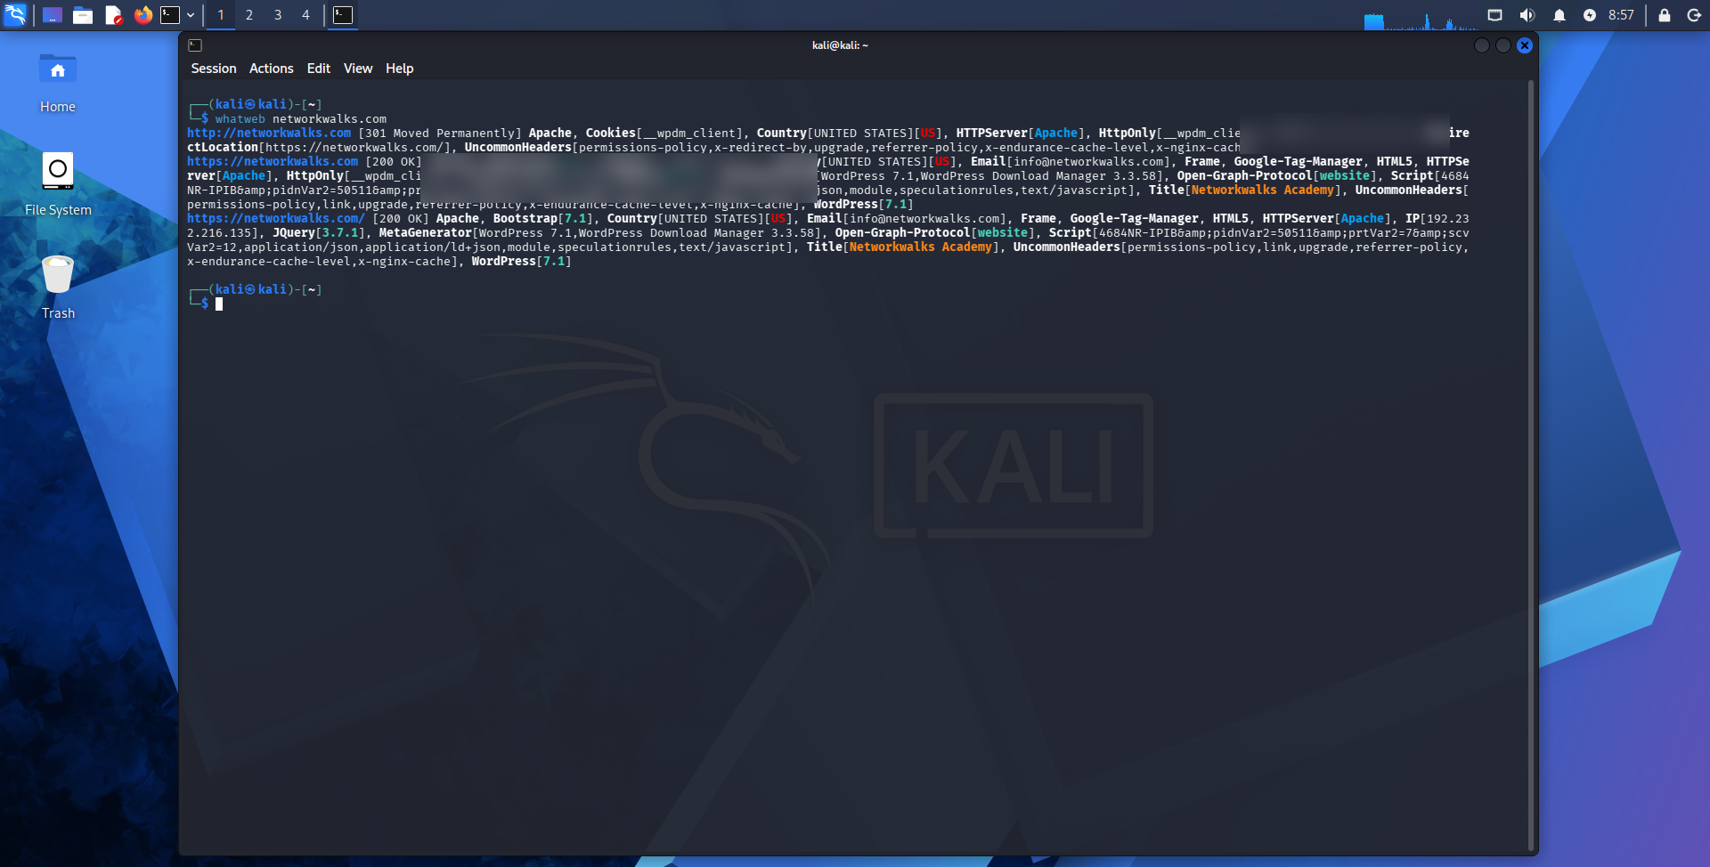
Figure 2. Sanitized WhatWeb evidence; IP and contact information have been blurred.

6.3 Task 3 – DNS Resolution with Nslookup
Command used: nslookup networkwalks.com
Nslookup returned a non-authoritative answer for the domain using a public DNS resolver. The result resolved the domain to a single observed IPv4 address. The resolver address and resolved target address are blurred in the evidence image.
Security interpretation: DNS resolution provides a direct link between a domain name and an observed network endpoint. This is a foundational reconnaissance step because subsequent HTTP, service or infrastructure analysis can be directed at the resolved endpoint.
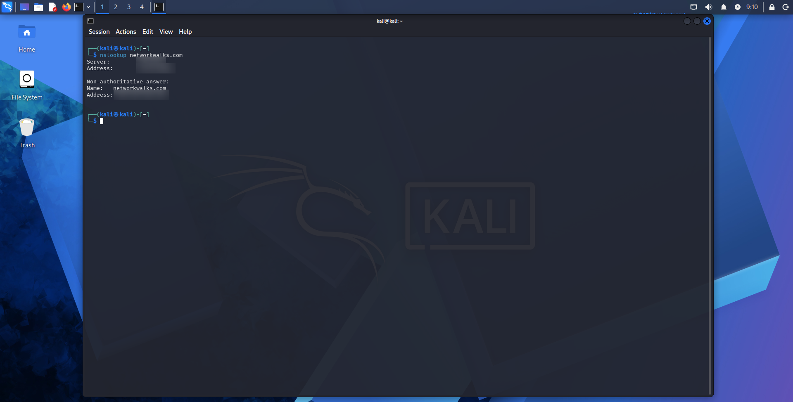
Figure 3. Sanitized Nslookup evidence; resolver and target IP addresses have been blurred.

6.4 Task 4 – HTTP Header Inspection with cURL
Command used: curl -I https://networkwalks.com
The server returned HTTP/2 200. The response exposed several headers and metadata elements, including Apache server information, WordPress-related API links, a WordPress download-manager cookie, referrer-policy and cache-related headers, content type, and the response date. The cookie value has been blurred in the evidence.
Security interpretation: HTTP response headers can reveal implementation details and application behavior before any deeper testing is performed. The discoverable WordPress API links are useful for mapping the application's exposed surface. The presence of a security-related header does not by itself establish that the site is securely configured in every respect.
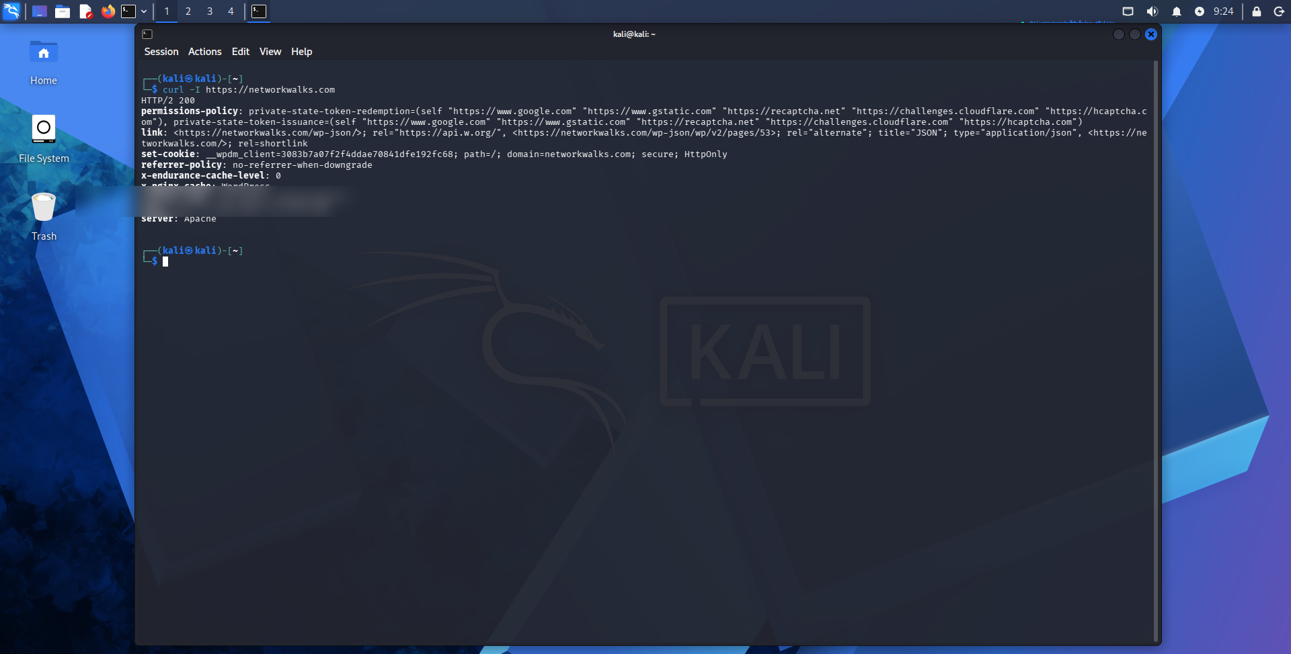
Figure 4. Sanitized cURL header evidence; session-cookie information has been blurred.

6.5 Task 5 – WAF Detection with Wafw00f
Command used: wafw00f networkwalks.com
Wafw00f v2.4.2 reported that the target site is behind a ModSecurity (SpiderLabs) web application firewall and completed the identification using two requests.
Security interpretation: a WAF is a defensive control that can filter or block malicious web requests. Knowing that a WAF is present provides useful information about the target's defensive architecture, while the identification of the product does not mean the WAF has been bypassed or defeated.
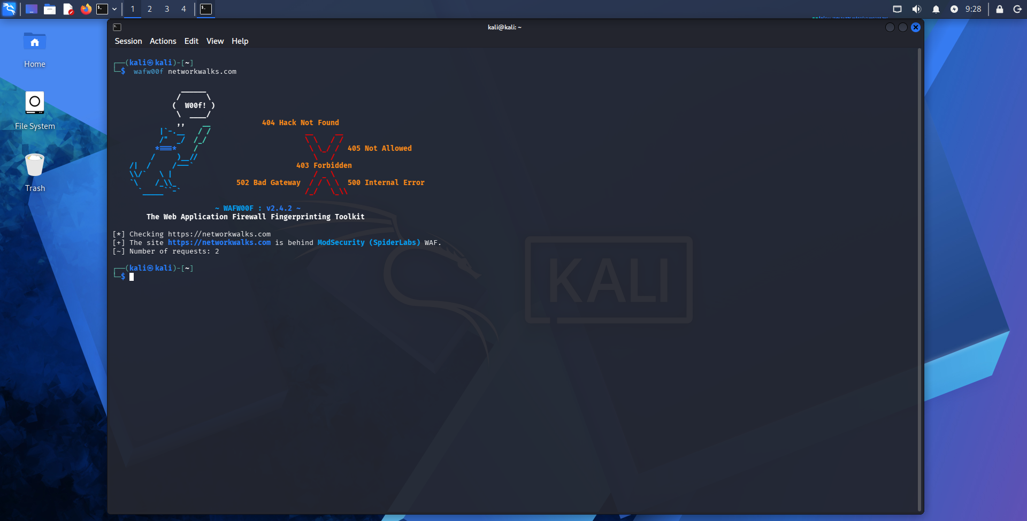
Figure 5. Wafw00f evidence showing the detected ModSecurity (SpiderLabs) WAF.

6.6 Task 6 – DNS Enumeration with DNSRecon
Command used: dnsrecon -d networkwalks.com
DNSRecon performed general enumeration and reported an unsuccessful DNSSEC query. It identified SOA, NS, MX, A, TXT and SRV information and reported eight records. The output included nameserver information, mail infrastructure, an SPF TXT record, a Google site-verification TXT record, and several autodiscover-related SRV records. All IP addresses and the verification token have been blurred in the sanitized evidence.
Security interpretation: DNS enumeration can reveal relationships among web hosting, DNS hosting, email infrastructure and service-discovery mechanisms. This information can help an assessor map the external attack surface. It should therefore be reviewed for unnecessary or outdated records.
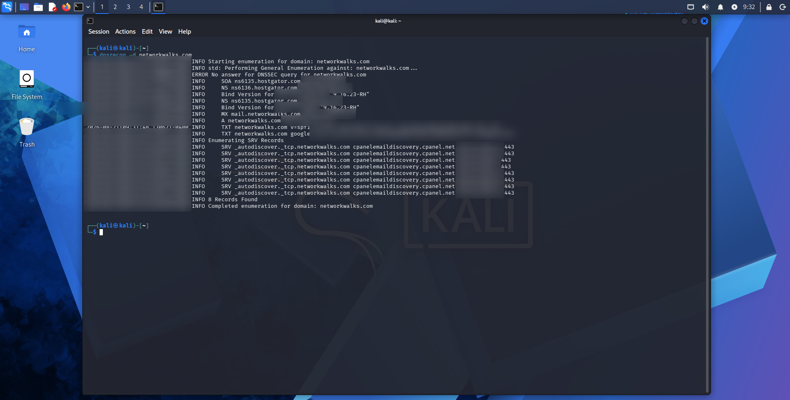
Figure 6. Sanitized DNSRecon evidence; IP addresses and verification-token information have been blurred.

6.7 PM1 Summary
Tool | Key observation | Security significance
WHOIS | Registrar, registration dates and nameserver information identified | Supports domain/infrastructure profiling
WhatWeb | Apache, WordPress and supporting components fingerprinted | Reveals technology stack for further assessment
Nslookup | Domain resolved to an observed IPv4 endpoint | Links domain name to network endpoint
cURL | HTTP/2 response and implementation headers exposed | Provides web-server/application metadata
Wafw00f | ModSecurity (SpiderLabs) identified | Reveals a defensive technology layer
DNSRecon | SOA, NS, MX, A, TXT and SRV data enumerated | Provides broader DNS/infrastructure mapping

7. W2-PM2 – Footprinting with the Google Hacking Database (GHDB)
PM2 demonstrated how search engines can be used as a reconnaissance source. Rather than attacking a service directly, GHDB-style operators can reveal resources that have already been indexed by search engines. The completed worksheet contained eleven entries for each task, exceeding the required ten.
Because the results included live third-party camera interfaces, the exact URLs are intentionally not reproduced in this report. The submitted worksheet can retain the original assessment evidence for authorized review, while this report uses redacted descriptions.

7.1 Task 1 – Publicly Indexed Camera Interfaces
Eleven camera-related findings were recorded. The search patterns included operators targeting common webcam software and interface filenames, including webcamXP, Yawcam, NetCamX, guest-image pages, multi-camera pages, and MOBOTIX-related interfaces. No usernames or passwords were recorded in the completed table.
Security interpretation:
- Search-engine indexing can unintentionally expose camera interfaces to anyone who knows the appropriate search terms.
- A publicly indexed interface should be reviewed to determine whether public access is intentional and whether authentication is appropriately enforced.
- The discovery of an interface is not equivalent to proof that the underlying device is compromised.
- Organizations should review externally indexed administrative or monitoring interfaces and request removal from search indexes where appropriate.
Result category | Examples observed | Public-report treatment
Webcam software pages | webcamXP, Yawcam, NetCamX | Exact URLs redacted
Camera image/interface pages | guest-image and multi-camera pages | Exact URLs redacted
Network camera platforms | MOBOTIX-related interface | Exact URL redacted
Credentials | No username/password recorded | No credentials reproduced

7.2 Task 2 – Mathematics PDF Directory Listings
Eleven directory/listing locations were recorded containing mathematics-related PDF resources. The same GHDB-style directory-index query pattern was used across the findings. The completed worksheet did not record usernames or passwords.
Security interpretation:
- Directory indexing can make file collections easier to discover than intended by the content owner.
- The security impact depends on whether the files are intended to be public and whether the directory reveals additional sensitive material.
- Organizations should disable directory listing where it is unnecessary and should review search-engine indexing of file repositories.
- Public documents should still be reviewed for metadata, internal information and unintended disclosure.

7.3 PM2 Summary
Task | Completed results | Main lesson | Risk consideration
Task 1 | 11 camera-related findings | Search engines can expose internet-accessible camera interfaces | Potentially high if access is unintended or unauthenticated
Task 2 | 11 mathematics-PDF listings | Directory indexing can expose document collections | Low–Medium depending on content and intended exposure

8. W2-PM5 – Network Scanning with Zenmap
PM5 moved the assessment from external/passive reconnaissance into authorized local network discovery. The exercise used Zenmap/Nmap to identify live hosts on the local subnet and to produce a visual topology.

8.1 Live-Host Discovery
The completed PM5 results reported eleven live hosts, including the assessment workstation. The worksheet also recorded the IP address and MAC address associated with each discovered host. These values are intentionally omitted from the public-facing version of this report.
Security interpretation: asset discovery is a fundamental defensive activity. A network owner should know which devices are active, what they are intended to do, and whether they are authorized. Unknown or unmanaged devices can increase attack surface and complicate incident response.

8.2 Network Topology
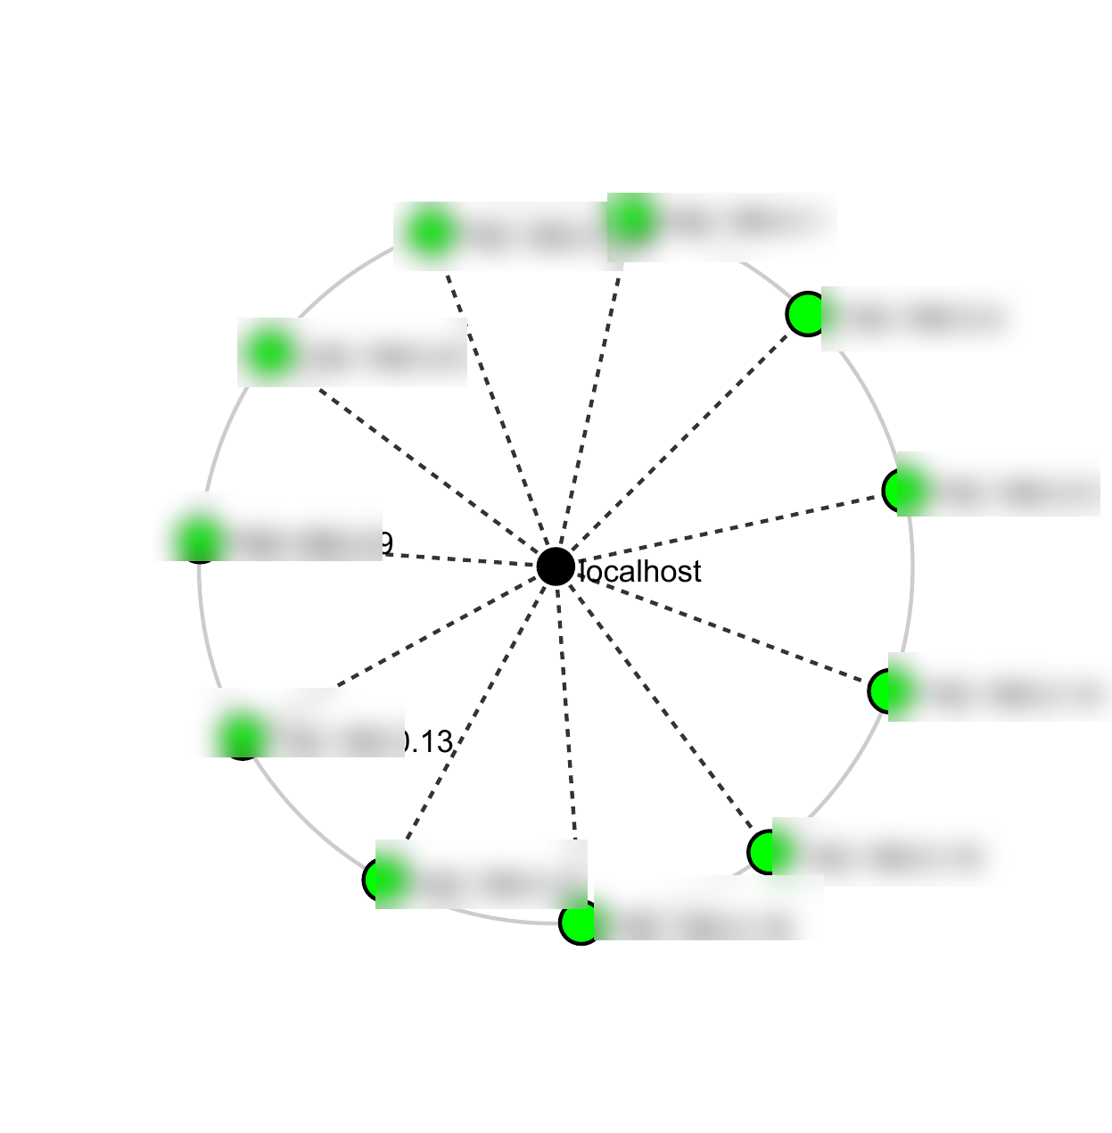
Figure 7. Sanitized Zenmap topology. Host IP labels have been blurred while the overall discovery structure remains visible.
The topology visualization shows the discovered hosts arranged around the scanning workstation. The sanitized version preserves the relationship and host count while removing local addressing information.

8.3 PM5 Summary
Metric | Observed result
Live hosts | 11, including the assessment workstation
IP address mapping | Recorded in original evidence; redacted here
MAC address mapping | Recorded in original evidence; redacted here
Topology | Generated successfully from the Zenmap discovery results

9. Consolidated Findings
ID | Finding | Evidence source | Indicative risk*
F-01 | External technology stack can be fingerprinted | PM1 – WhatWeb | Low–Medium
F-02 | DNS and hosting relationships are discoverable | PM1 – Nslookup/DNSRecon/WHOIS | Medium
F-03 | HTTP response metadata exposes implementation details | PM1 – cURL | Low
F-04 | WAF technology can be identified | PM1 – Wafw00f | Low
F-05 | Search engines can surface camera interfaces | PM2 – GHDB Task 1 | High if unintended
F-06 | Search engines can surface directory-indexed documents | PM2 – GHDB Task 2 | Low–Medium
F-07 | Multiple live devices were discoverable on the authorized LAN | PM5 – Zenmap | Informational–Medium

*Risk levels are analytical judgments based on the nature of the observation, not proof that a target is exploitable. The highest-risk PM2 observation depends on whether the camera interfaces were intentionally public and whether authentication/access controls were present.

10. Risk Analysis
The most important lesson from the combined modules is that risk can accumulate through information exposure. A single public record may appear harmless, but several observations can be combined to form a more useful map of a target's technologies, infrastructure and externally visible services.

Reconnaissance aggregation
WHOIS, DNS, HTTP and technology-fingerprinting results complement one another. An assessor can use the information to understand how a domain is hosted and what technologies support it.

Public indexing
GHDB results demonstrate that organizations may expose resources through search-engine indexing even when those resources are not deliberately advertised. The appropriate response is to review exposure and access controls rather than assume every indexed resource is vulnerable.

Network visibility
The Zenmap results demonstrate the importance of knowing the devices present on an internal network. Host discovery is a basic step for asset management and can reveal devices that should be investigated.

11. Recommendations
- Maintain an accurate inventory of externally exposed domains, subdomains, services and internal network assets.
- Review WHOIS/DNS records periodically and remove or correct outdated records where appropriate.
- Minimize unnecessary disclosure of software versions and implementation details in public-facing responses.
- Keep WordPress, plugins, themes and supporting libraries patched and monitor them for known vulnerabilities.
- Review HTTP headers and cookies to ensure they follow secure configuration practices.
- Maintain the WAF and periodically validate that it is correctly configured and monitored; detection of a WAF should not be treated as a substitute for secure application design.
- Review search-engine indexing for cameras, administrative interfaces and file repositories.
- Require authentication for any camera or management interface that is not explicitly intended for public access.
- Disable directory listing where it is unnecessary and review public repositories for unintended files or metadata.
- Perform periodic internal network discovery so that unknown or unauthorized devices can be investigated.
- Separate public-facing systems from internal assets using appropriate network segmentation and access controls.
- Retain detailed raw evidence privately while using redacted screenshots in public portfolios or repositories.

12. Lessons Learned
Week 2 reinforced that penetration testing begins with understanding the environment before attempting to exploit anything. I learned that different reconnaissance tools reveal different layers of information and that the most useful conclusions often come from combining results.
- WHOIS and DNS information provide an initial view of domain ownership and infrastructure relationships.
- WhatWeb can quickly identify the technologies supporting a website, which can guide later research.
- cURL is useful for inspecting HTTP responses and identifying metadata that is not necessarily obvious from the web page itself.
- Wafw00f demonstrates how defensive technologies can also be fingerprinted during reconnaissance.
- DNSRecon can reveal service relationships that are not immediately visible from a simple DNS lookup.
- GHDB demonstrates the power and risk of search-engine indexing: information does not need to be hidden behind an exploit to become discoverable.
- Zenmap provides a practical way to visualize network discovery and understand which devices are active on an authorized subnet.
- Sensitive evidence should be handled deliberately. Public documentation should demonstrate the work without unnecessarily exposing addresses, credentials, tokens or third-party systems.

13. Limitations
- The report documents reconnaissance and discovery activities; it does not claim successful exploitation of the observed systems.
- The PM2 camera findings are summarized rather than reproduced as live URLs to avoid redistributing access paths to third-party systems.
- The PM5 local IP and MAC mappings are omitted from this public-facing report because they identify the assessment network.
- Sanitized screenshots are used in this report. Original unredacted evidence should be retained separately for authorized instructor review.
- Risk ratings are based on the observed evidence and the educational scope of the exercises; additional testing would be required to validate exploitability.

14. Conclusion
Week 2 provided a practical progression through three important areas of cybersecurity assessment. PM1 showed how multiple reconnaissance tools can be combined to build a technical profile of a domain. PM2 demonstrated that search engines can expose interfaces and document repositories through indexing. PM5 then applied network-discovery techniques to an authorized local environment and produced a visual view of active hosts.
The exercises reinforced that effective security assessment is not limited to finding an obvious vulnerability. Understanding what information is publicly visible, what technologies are deployed, what services are discoverable, and which devices are active is essential to reducing attack surface. The next step for an organization would be to validate which exposures are intentional, remove unnecessary information, strengthen access controls, maintain current software, and continuously monitor the environment.

15. Evidence Index
Evidence | Description | Sanitized in report
E-01 | PM1 Task 1 – WHOIS terminal output | Yes
E-02 | PM1 Task 2 – WhatWeb terminal output | Yes
E-03 | PM1 Task 3 – Nslookup terminal output | Yes
E-04 | PM1 Task 4 – cURL HTTP headers | Yes
E-05 | PM1 Task 5 – Wafw00f output | Yes
E-06 | PM1 Task 6 – DNSRecon output | Yes
E-07 | PM2 Task 1 – GHDB camera findings table | Live URLs redacted
E-08 | PM2 Task 2 – GHDB mathematics-PDF findings table | URLs redacted
E-09 | PM5 – Live-host results | IP/MAC values redacted
E-10 | PM5 – Zenmap topology | IP labels blurred

16. Source Documents Used
- NetworkWalks Internship Program Guidelines – Week 2 v2.
- W2-PM1 – Footprinting with Multiple Tools.
- W2-PM2 – Footprinting with GHDB.
- W2-PM5 – Network Scanning with Zenmap.
- W2-PM-FINAL – Sample Report v2.
- Student evidence files and screenshots generated during the Week 2 exercises.

