NETWORKWALKS CYBERSECURITY INTERNSHIP
Batch B082
WEEK 3 PROJECT REPORT
Password Auditing & Password Cracking
Completed Modules
W3-PM1 – Password Cracking with JTR
W3-PM2 – Password Cracking with NetworkWalks Tools
Prepared by
Antoinette Thompson
NetworkWalks Cybersecurity Internship – Batch B082
August 2026

1. Executive Summary
This report documents my Week 3 practical cybersecurity work for the NetworkWalks Cybersecurity Internship, Batch B082. The project focused on password auditing and password recovery using two approaches: John the Ripper (JTR) with Johnny, and the NetworkWalks Hash Calculator with the NetworkWalks Password Cracker.
The exercises used the password-protected training PDF supplied for the internship. The practical workflow demonstrated how a protected PDF can be assessed by extracting its password-verification data, preparing that data for an auditing tool, performing a controlled dictionary-based password search, and then verifying the recovered password against the original protected document.
OVERALL RESULT – SUCCESSFUL
Both W3-PM1 and W3-PM2 were completed successfully. The training password was recovered and the recovered value was used to unlock the supplied protected PDF.

This report intentionally includes the original evidence screenshots supplied by the learner. Because these originals contain password/hash information, this document should be treated as a training/submission artifact and should not be published publicly without first applying proper irreversible redaction.

2. Project Scope and Objectives
The Week 3 assignment consisted of two practical modules covering password-cracking concepts and tools. PM1 focused on John the Ripper and Johnny. PM2 focused on NetworkWalks' browser-based Hash Calculator and Password Cracker.

Objectives
- Understand the relationship between a password-protected PDF and its password-verification data.
- Extract the information required for controlled password auditing.
- Use John the Ripper to perform password recovery against the supplied training file.
- Use Johnny to interact with the JTR workflow through a graphical interface.
- Use the NetworkWalks Hash Calculator to identify a protected PDF and extract a crackable hash.
- Use the NetworkWalks Password Cracker to perform a dictionary attack against the extracted PDF hash.
- Verify the recovered password by opening the protected PDF.
- Analyze the security implications of weak and predictable passwords.
- Document the process and evidence responsibly.

3. Lab Environment and Tools
Component | Role in the project | Observed outcome
Kali Linux | Cybersecurity testing environment | Used for the local JTR/Johnny workflow
John the Ripper | Password-auditing/cracking tool | Used to process the PDF password-verification data
Johnny | GUI front end for JTR | Displayed the PDF hash/password-auditing entry
Online PDF Hash Extractor | Extracted PDF password-verification data for PM1 | Produced a PDF-compatible hash format
NetworkWalks Hash Calculator | Extracted a crackable hash from the protected PDF | Identified the PDF as encrypted and produced a hash
NetworkWalks Password Cracker | Dictionary-based password attack | Recovered the training password
Protected training PDF | Authorized target supplied for the internship | Successfully unlocked after recovery

4. W3-PM1 – Password Cracking with JTR
PM1 demonstrated the conventional local password-auditing workflow. The first stage was to obtain the password-verification data from the protected PDF. The resulting value was then loaded into the JTR workflow so that candidate passwords could be tested against it.

4.1 Hash Extraction
The first PM1 screenshot shows an online PDF hash-extraction page after the supplied PDF was processed. The tool reports that it converts PDF password information into a format usable by password-auditing tools such as John the Ripper. The output begins with the PDF-specific '$pdf$' structure, confirming that the extraction produced a PDF password-verification value rather than ordinary plaintext.
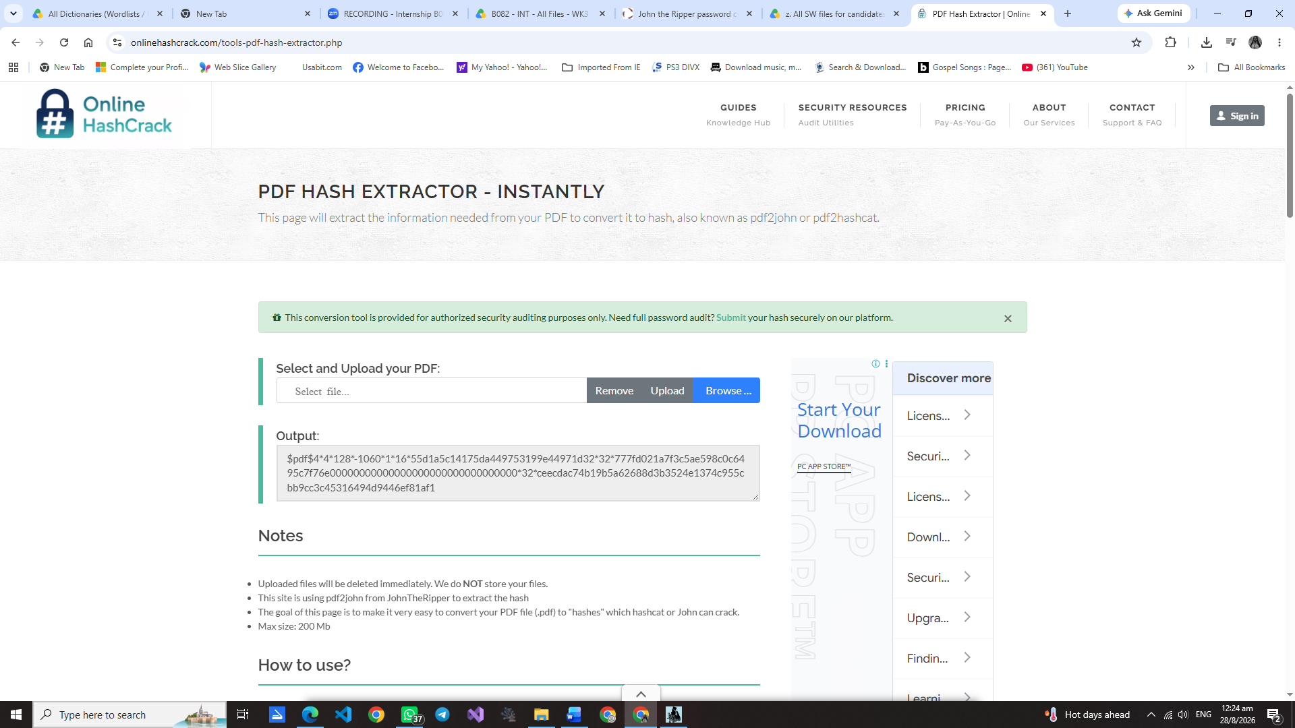
Figure 1. PM1 – PDF hash extraction output. Original evidence screenshot; contains sensitive hash material.

Analysis of Finding
- The protected PDF was successfully processed by the extractor.
- The output uses a PDF-specific hash representation intended for password-auditing tools.
- The extracted value contains cryptographic/password-verification material and should therefore be protected.
- The key security lesson is that a protected file may still be subject to offline password auditing if the attacker obtains the relevant verification data.

4.2 JTR / Johnny Processing
The second PM1 screenshot shows Johnny with a single PDF entry loaded into the password auditing interface. The screenshot provides evidence that the extracted PDF data was successfully prepared and recognized as a PDF-formatted target.
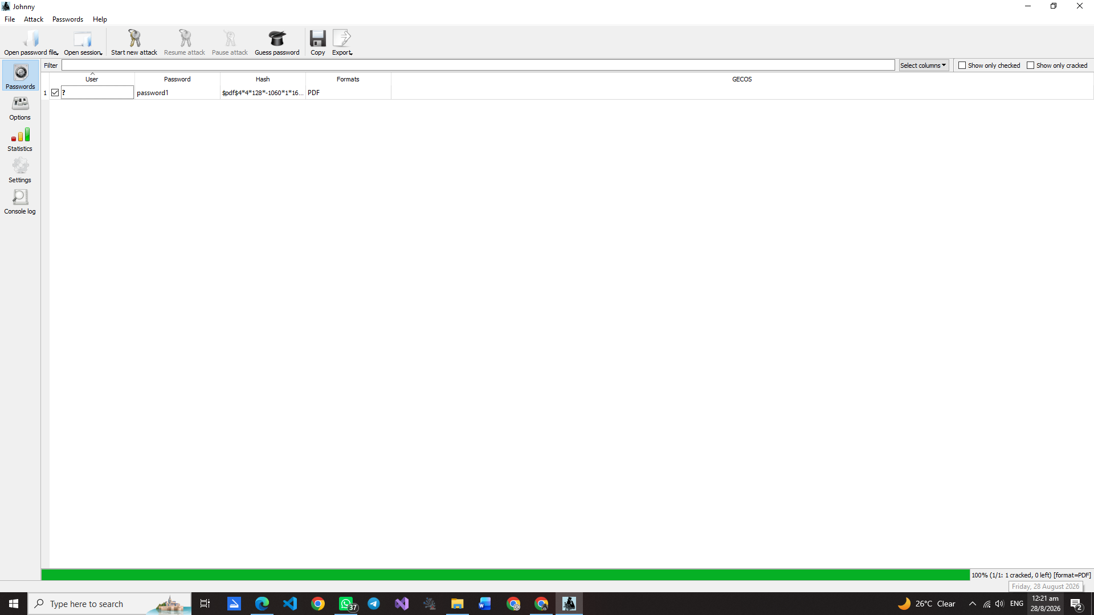
Figure 2. PM1 – Johnny showing the prepared PDF password-auditing entry. Original evidence screenshot.

Analysis of Finding
- Johnny recognized the supplied data as a PDF target, demonstrating compatibility between the extracted format and the JTR workflow.
- The presence of a single target entry corresponds to the single protected training PDF used in the exercise.
- This stage illustrates the difference between extracting a password-verification value and actually testing password candidates against it.

4.3 Password Verification
The third PM1 screenshot shows the protected PDF requesting a password. This is the verification stage of the exercise: the recovered value must be tested against the original file rather than being accepted solely because a cracking tool reports a match.
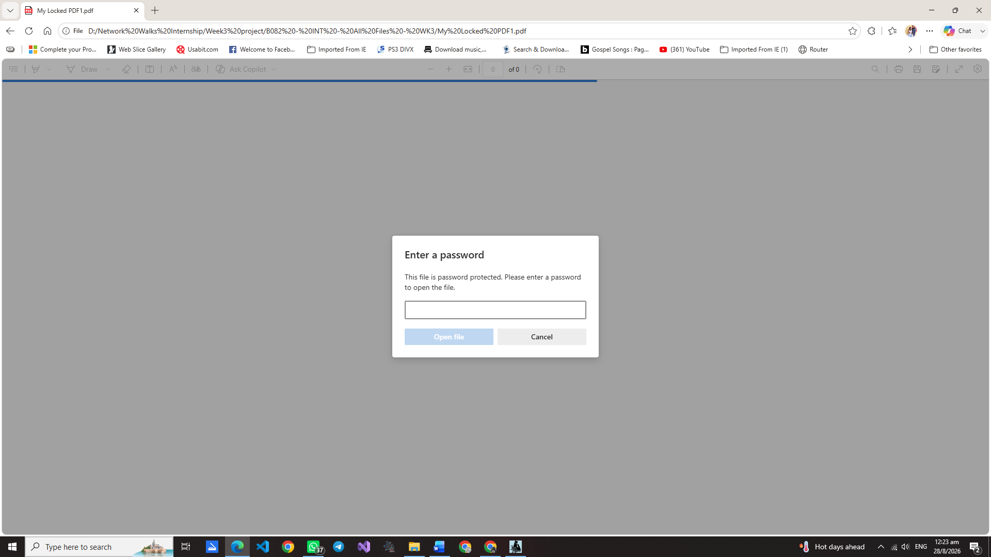
Figure 3. PM1 – Protected PDF password prompt used for final verification.

4.4 PM1 Completion Evidence
The final PM1 screenshot records successful completion of the NetworkWalks training exercise and capture of the required flag.

Figure 4. PM1 – NetworkWalks training completion/flag evidence.

PM1 CONCLUSION
The PM1 workflow was completed from extraction through JTR/Johnny processing and training verification. The exercise demonstrated how password-verification data can be prepared for offline password auditing.

5. W3-PM2 – Password Cracking with NetworkWalks Tools
PM2 presented the same fundamental password-auditing concept through NetworkWalks' own browser-based tools. The supplied lab explains a three-step workflow: extract the $pdf$ hash, paste it into the Password Cracker, run the attack, and then open the PDF using the recovered password.

5.1 Lab Instructions and Scope
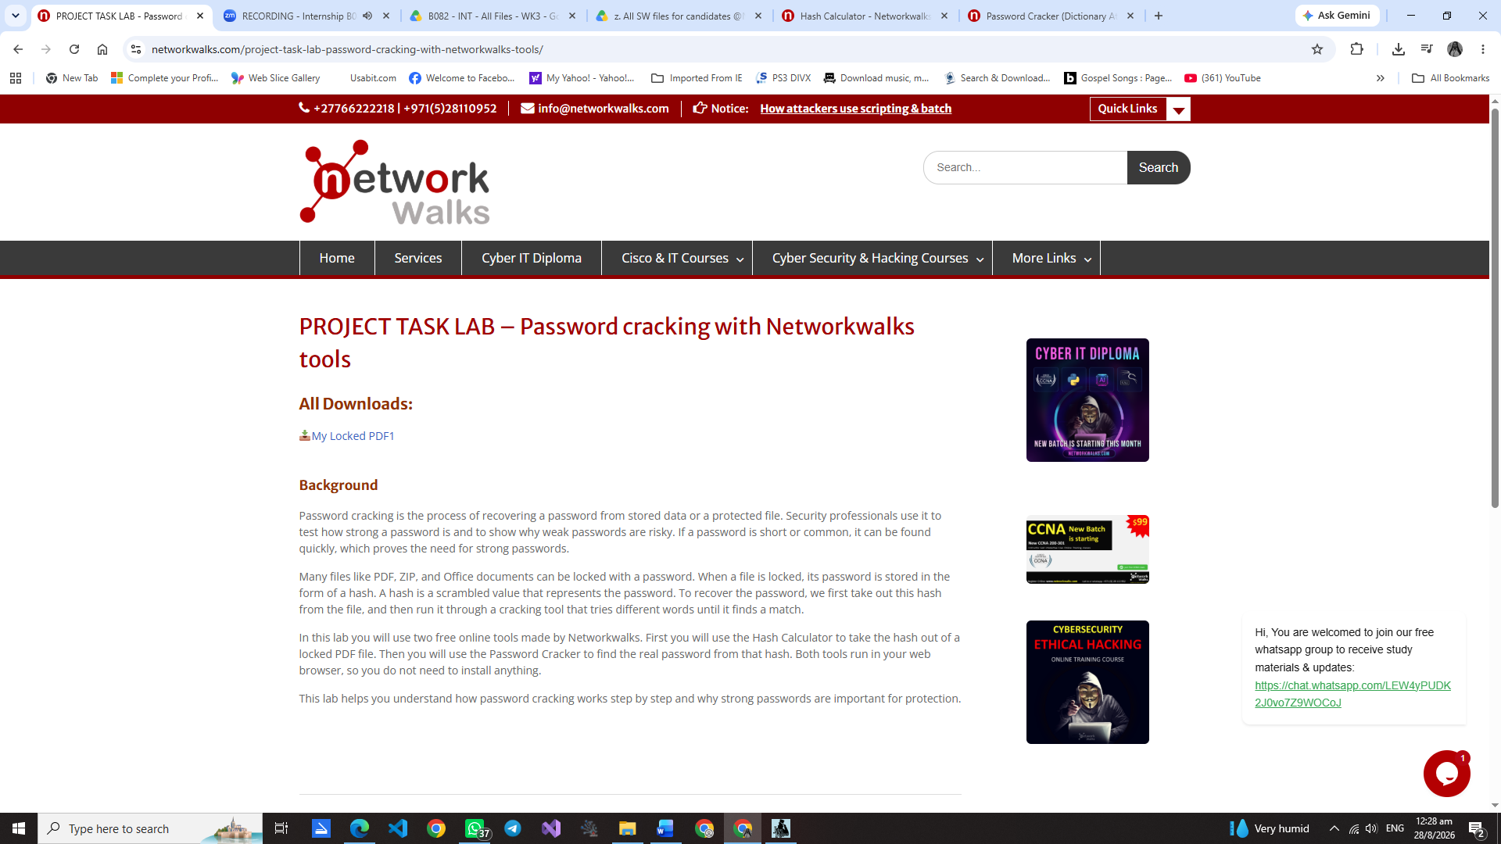
Figure 5. PM2 – NetworkWalks lab instructions describing the password-cracking workflow.

The lab background explains that password cracking is used by security professionals to test password strength and demonstrate the risks of weak passwords. It also explains the general workflow of extracting a hash from a protected file and testing candidate passwords until a matching value is found.

5.2 Hash Calculator – Initial State
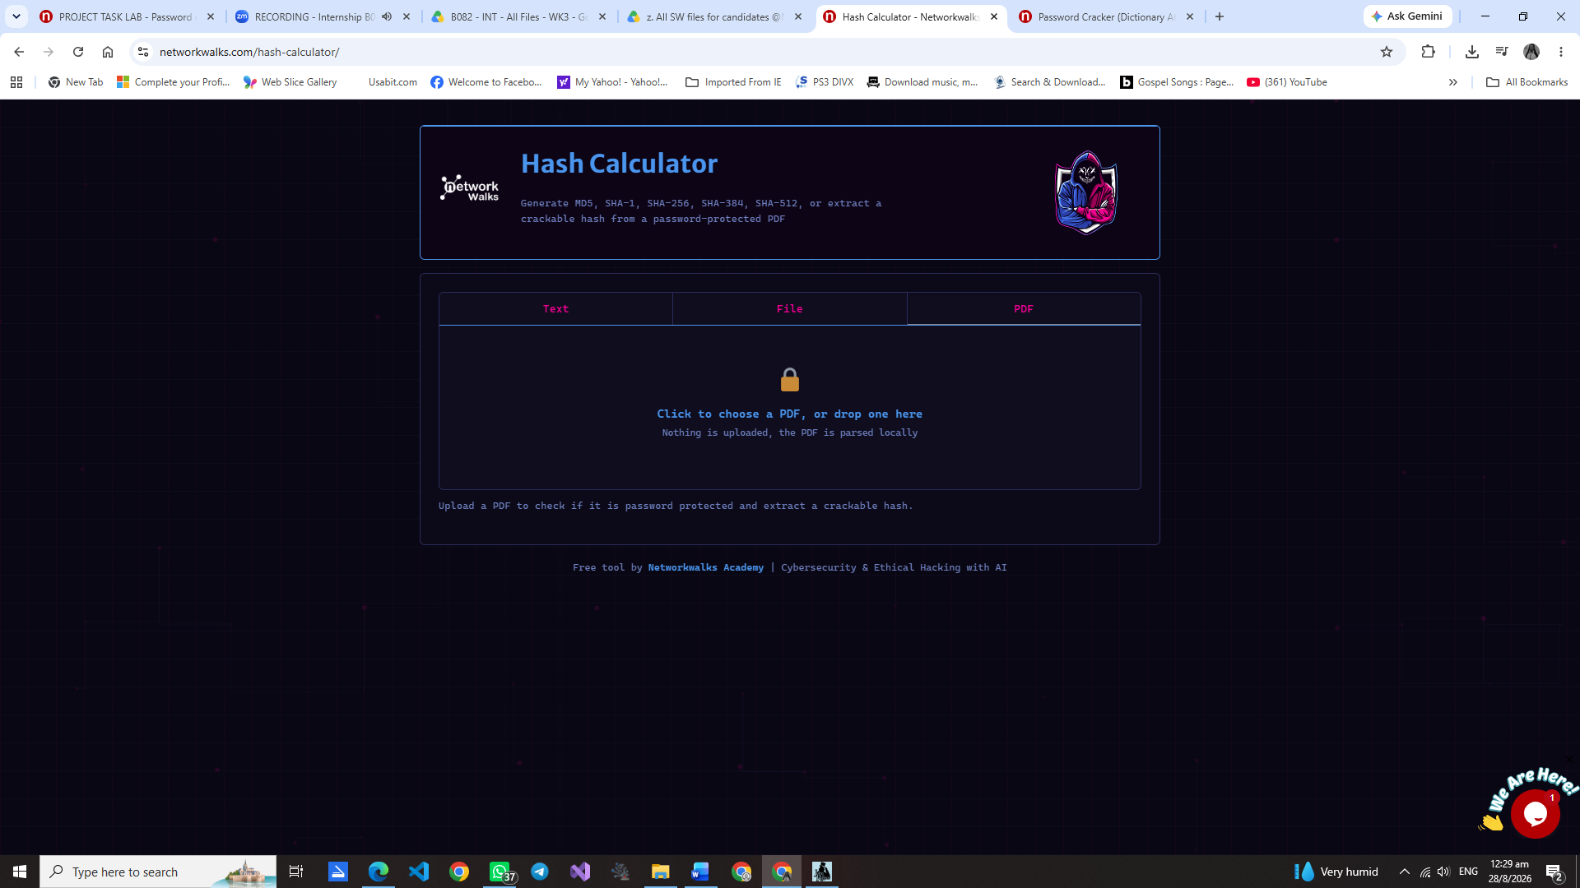
Figure 6. PM2 – NetworkWalks Hash Calculator before the PDF is processed.

The initial state shows the Hash Calculator with the PDF input area ready to accept a file. The interface states that the PDF can be parsed locally, establishing the intended workflow for the exercise.

5.3 Hash Extraction
After the training PDF was uploaded, the Hash Calculator identified it as encrypted and reported that a crackable hash had been extracted in a pdf2john/hashcat-compatible format. The interface also displayed the PDF revision/version information and key length.
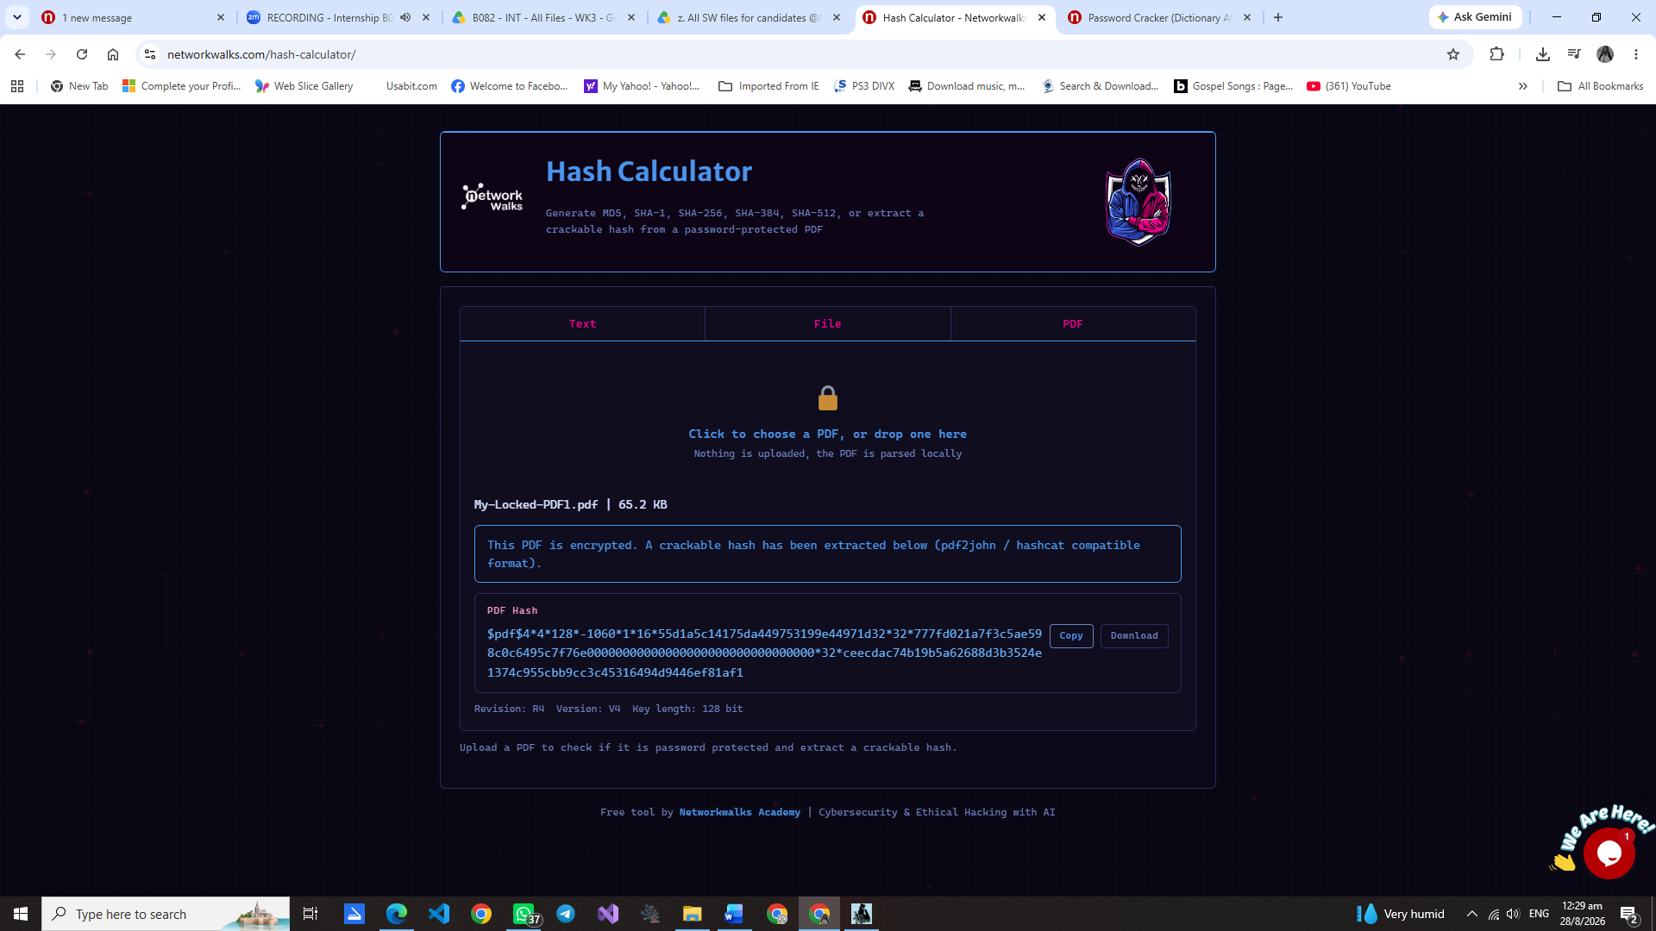
Figure 7. PM2 – Hash Calculator identifying the PDF as encrypted and producing a crackable hash. Original evidence screenshot.

Analysis of Finding
- The tool confirmed that the PDF was encrypted/password-protected.
- A crackable password-verification value was successfully extracted.
- The extracted value was compatible with the same general password-auditing concept demonstrated in PM1.
- The presence of a crackable hash does not mean the password is immediately known; candidate passwords still need to be tested.
- The extracted hash is sensitive evidence because possession of it can facilitate offline password auditing.

5.4 Password Cracker – Attack Configuration
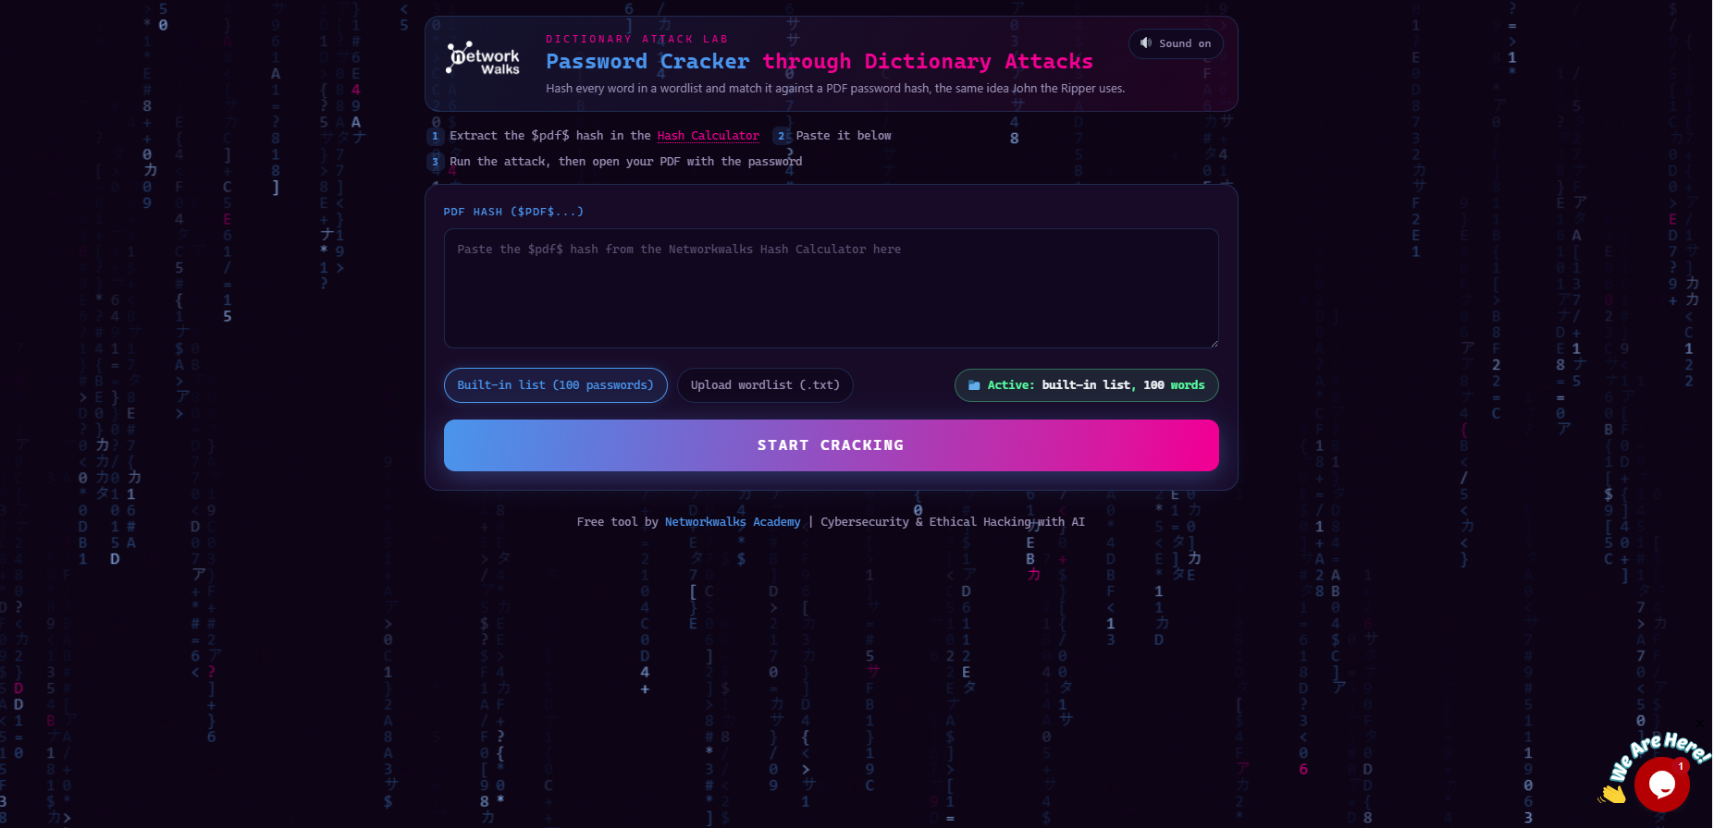
Figure 8. PM2 – NetworkWalks Password Cracker configured for a dictionary attack.

The Password Cracker interface describes a dictionary attack in which candidate words are hashed and compared with the supplied PDF password hash. The screenshot shows the built-in password list selected and the attack ready to begin.

5.5 Password Recovery Result
The recovery screenshot provides the strongest quantitative evidence in PM2. The tool shows 91 of 100 candidates tried, a displayed rate of approximately 9 passwords per second, and a successful password match. The recovered training password is visibly displayed in the original evidence and is intentionally discussed here without reproducing it in the report narrative.
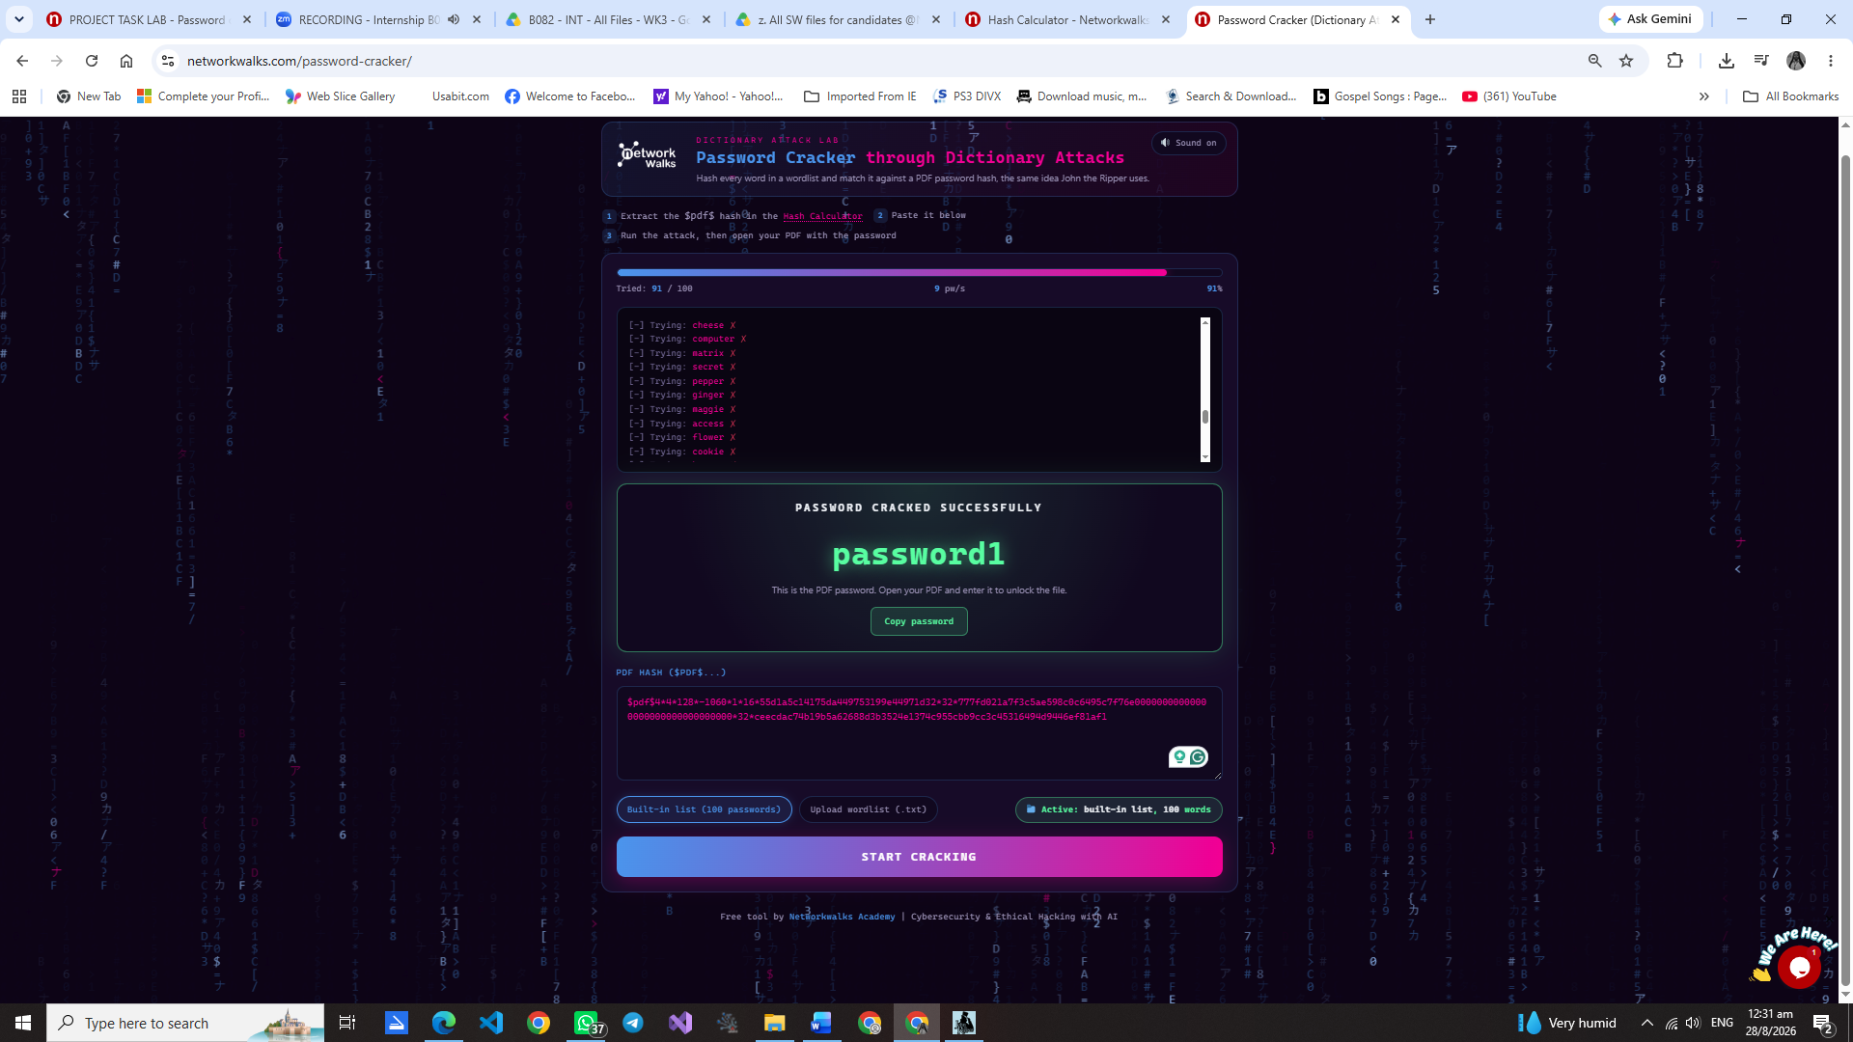
Figure 9. PM2 – Successful dictionary attack. Original evidence screenshot; contains the recovered training password and hash.

Detailed Analysis of the Result
- The attack used a finite built-in dictionary rather than an unrestricted brute-force search.
- The password was found before the entire 100-word candidate list had been exhausted, demonstrating that the credential appeared within the selected dictionary.
- The displayed progress of 91/100 means the tool had tested 91 candidate entries at the time represented by the screenshot; the successful match was displayed in the same result screen.
- The displayed rate of about 9 passwords per second demonstrates that a small dictionary can be tested rapidly in a controlled environment.
- Most importantly, the successful recovery shows that the training password was predictable enough to be present in a common-word/password candidate list.
- A real attacker who obtained equivalent password-verification data could potentially perform similar offline testing without needing repeated attempts against the original PDF interface.

5.6 Password Verification Against the PDF
The next screenshot shows the protected PDF password prompt with the recovered training password entered. This is important because it validates the cracking result against the original artifact.
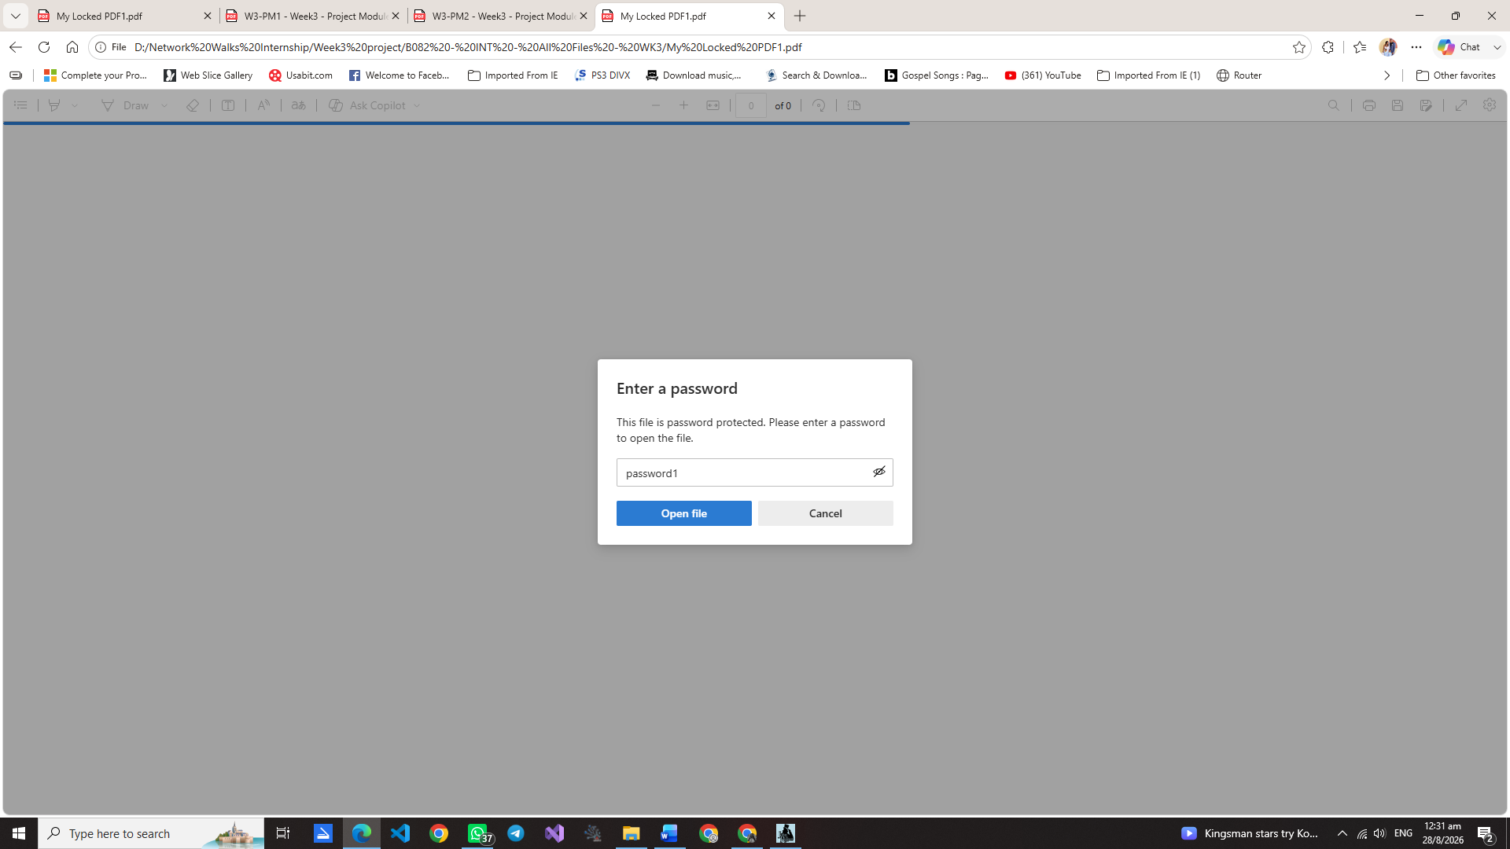
Figure 10. PM2 – Recovered password entered into the protected PDF for verification.

5.7 PM2 Completion Evidence

Figure 11. PM2 – NetworkWalks training completion/flag evidence.

PM2 CONCLUSION
The Hash Calculator successfully extracted the PDF password-verification data, the Password Cracker successfully identified a matching password from its dictionary, and the recovered value was used to verify access to the protected PDF.

6. Comparative Analysis: PM1 vs PM2
Stage | PM1 – JTR/Johnny | PM2 – NetworkWalks Tools
Target preparation | PDF password-verification data extracted for JTR | PDF processed directly by Hash Calculator
Hash format | PDF-specific $pdf$ representation | PDF-specific $pdf$ representation
Auditing interface | John the Ripper / Johnny | NetworkWalks Password Cracker
Attack model | JTR password-auditing workflow | Dictionary-based candidate matching
Verification | Protected PDF used as final check | Protected PDF used as final check
Primary learning | Hands-on familiarity with a widely used password-auditing workflow | Understanding the same concept through a simplified web-based workflow
The two modules reinforce the same security principle from different perspectives. PM1 provided exposure to an established password-auditing toolchain, while PM2 made the underlying process more visually explicit: extract the verification data, supply candidate passwords, identify a match, and verify the result.

7. Findings and Security Analysis

Finding 1 – Offline password auditing is possible
Once password-verification data is extracted from a protected file, candidate passwords can be tested offline. This reduces reliance on interacting directly with the protected application or document.

Finding 2 – Predictable passwords are vulnerable to dictionary attacks
The training password was recovered using the built-in dictionary, demonstrating that common or predictable passwords can be identified without needing an exhaustive search.

Finding 3 – Password strength matters independently of file protection
A file can be correctly configured as password-protected while still being weakly protected if the chosen password is easy to guess.

Finding 4 – Verification is essential
A password-cracking result should be validated against the original protected artifact. PM2 explicitly demonstrated this by entering the recovered value into the PDF password prompt.

Finding 5 – Hashes are sensitive security evidence
The extracted PDF hash is not a plaintext password, but it can enable offline password auditing. It should therefore be treated as sensitive and not published unnecessarily.

Finding 6 – Small candidate lists can be effective against weak passwords
The PM2 result demonstrates that a limited dictionary can succeed quickly when a target password is common enough to appear in that list.

8. Risk Assessment
Risk Area | Assessment | Reasoning
Weak / predictable password | High | The training password was found using a dictionary attack.
Exposure of password-verification data | High | Obtaining the hash enables offline candidate testing.
Unauthorized password auditing | High | The same tools can be misused if authorization and scope are ignored.
Insufficient verification | Medium | Tool output should always be validated against the original protected resource.
Public disclosure of credentials/hashes | High | Publishing them can enable unnecessary reuse or offline analysis.
These ratings are contextual to the training scenario and are not a formal enterprise risk assessment. They indicate the relative security significance demonstrated by the exercise.

9. Security Recommendations
- Use long, unique passwords or passphrases rather than short, common, or predictable credentials.
- Avoid passwords based on common words, obvious sequences, personal information, or previously exposed credentials.
- Use a reputable password manager to generate and store unique credentials.
- Where supported, use multi-factor authentication as an additional layer of protection.
- Protect password-verification data and treat hashes as sensitive security material.
- Limit access to protected documents and apply appropriate file permissions and access controls.
- Conduct authorized password audits periodically to identify weak credentials before attackers do.
- Keep cybersecurity testing within a defined scope and obtain explicit authorization before assessing systems or files.
- Do not publish recovered passwords, hashes, tokens, or other sensitive evidence in public GitHub repositories or social-media posts.
- When creating portfolio evidence, use irreversible redaction and verify that the original value cannot be recovered by copying, selecting, zooming, or viewing image layers.

10. Ethical, Legal and Privacy Considerations
The work documented in this report was performed as part of an authorized NetworkWalks cybersecurity internship exercise using the supplied training materials. The tools and techniques demonstrated are dual-use technologies: they are valuable for defensive security testing but can also be misused.
Accordingly, password recovery should only be performed against files, systems, accounts, or other targets that the tester owns or has explicit permission to assess. The scope of the exercise should be respected, and recovered credentials should be handled as confidential security information.

11. What I Learned
- How PDF password protection can be represented as a crackable verification value.
- How to move from protected-file analysis to password auditing.
- How John the Ripper and Johnny can be used to perform controlled password recovery.
- How browser-based tools can demonstrate the same underlying password-auditing concepts.
- How dictionary attacks work by testing candidate words against a password-verification value.
- Why predictable passwords can be recovered quickly with relatively small candidate lists.
- Why successful password recovery should be verified against the original protected file.
- Why hashes and recovered passwords must be handled carefully when documenting cybersecurity work.
- How cybersecurity skills must be applied within authorization, scope, and ethical boundaries.

12. Limitations of the Exercise
- The assessment used a single training PDF and therefore does not represent the security of all PDF encryption configurations.
- The PM2 password search used a finite built-in dictionary; a password that is not in that dictionary could require another authorized approach.
- The observed cracking speed is specific to the training tool and environment shown in the evidence.
- The exercise demonstrates password recovery, not exploitation of an operating system, network service, or real-world user account.
- No conclusion should be drawn that every password-protected PDF can be cracked using the same method or in the same amount of time.

13. Evidence Register
Evidence ID | Evidence | Purpose | Status
PM1-01 | PDF hash extraction screenshot | Demonstrates extraction of PDF password-verification data | Original evidence included
PM1-02 | Johnny password-file screenshot | Demonstrates preparation/recognition of PDF data by Johnny | Original evidence included
PM1-03 | PDF password prompt | Demonstrates protected-file verification stage | Original evidence included
PM1-04 | PM1 lab flag | Demonstrates completion | Original evidence included
PM2-01 | NetworkWalks lab page | Documents task background and workflow | Original evidence included
PM2-02 | Hash Calculator initial state | Documents tool setup | Original evidence included
PM2-03 | Hash Calculator extracted hash | Demonstrates successful PDF hash extraction | Original evidence included
PM2-04 | Password Cracker configuration | Documents dictionary-attack setup | Original evidence included
PM2-05 | Password recovery result | Demonstrates successful dictionary attack | Original evidence included
PM2-06 | PDF password prompt with recovered value | Verifies the recovered credential | Original evidence included
PM2-07 | PM2 lab flag | Demonstrates completion | Original evidence included

14. Conclusion
Week 3 successfully demonstrated the practical process of password auditing and password recovery in a controlled cybersecurity training environment. PM1 established the workflow using John the Ripper and Johnny, while PM2 demonstrated the same underlying concept using NetworkWalks' Hash Calculator and Password Cracker.
The central security finding was that password protection alone is not sufficient when the password itself is predictable. The successful dictionary recovery demonstrated how quickly a weak credential can be identified once password-verification data is available for offline testing. The exercise also reinforced that a professional security assessment requires more than obtaining a result: the result must be verified, documented, protected, and interpreted within the authorized scope.
PROJECT TAKEAWAY
Learn → Extract → Audit → Verify → Analyze → Protect

15. Author Information
Field | Information
Name | Antoinette Thompson
Program | NetworkWalks Cybersecurity Internship
Batch | B082
Week | 03
Project | Password Auditing & Password Cracking
Modules Completed | W3-PM1 and W3-PM2

16. Disclaimer
TRAINING / AUTHORIZED USE
This report documents cybersecurity techniques performed in an authorized NetworkWalks training environment for educational purposes. The techniques described are dual-use and must only be applied to files, systems, accounts, or targets for which explicit authorization has been granted. The original screenshots embedded in this report contain sensitive training information and should be treated as confidential submission evidence. Before any public release, all passwords, hashes, tokens, URLs, and other sensitive values should be irreversibly redacted and the resulting files independently checked for residual information.

17. Supplementary Evidence – Additional Protected PDFs
Additional screenshots were supplied showing the same password-auditing workflow applied to two further protected PDF training files. These screenshots are included here as supplementary evidence rather than as replacements for the primary PM1 and PM2 evidence.

17.1 Additional PDF – Hash Extraction and Verification
The first group of supplementary screenshots shows a second protected PDF being processed through the NetworkWalks Hash Calculator. The calculator identifies the file as encrypted and produces a PDF-compatible password-verification value. A separate screenshot shows the protected PDF password prompt, demonstrating that the file remains password protected until the correct credential is supplied.
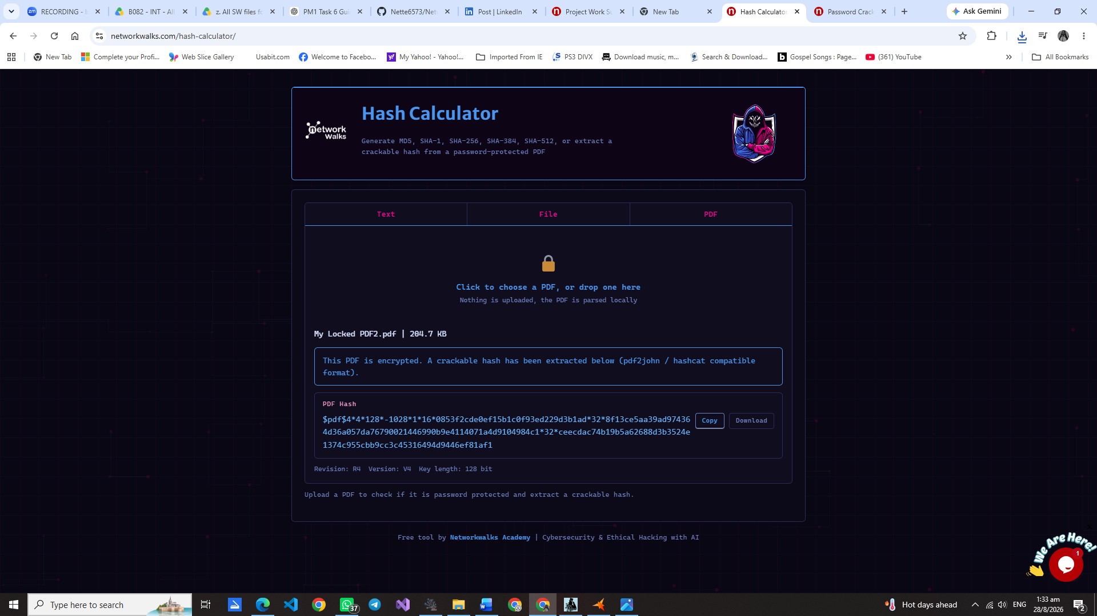
Figure 12. Additional PDF evidence – NetworkWalks Hash Calculator output.
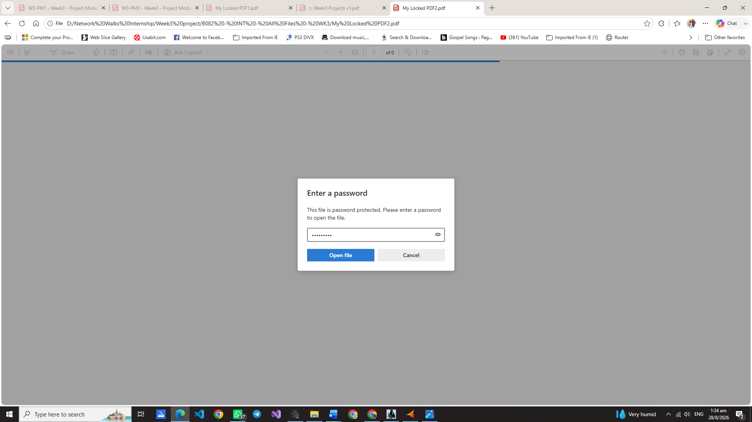
Figure 13. Additional PDF evidence – password prompt for the additional protected PDF.
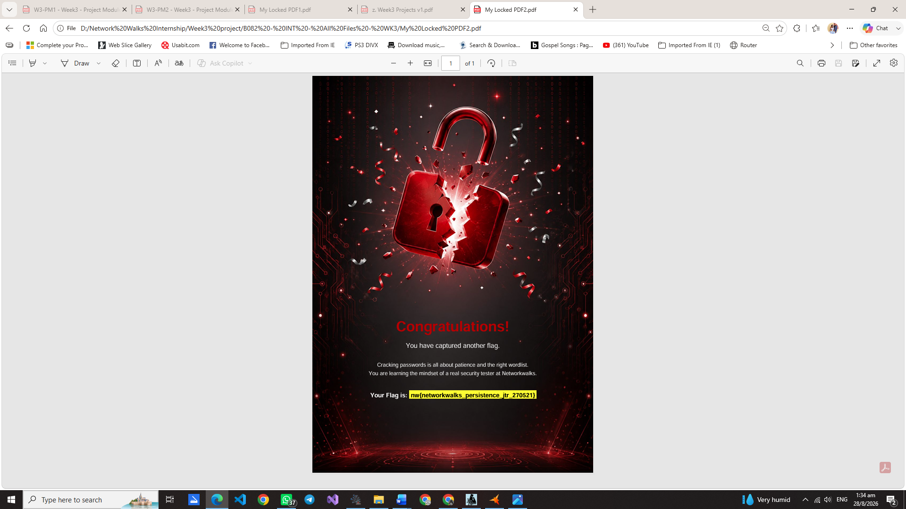
Figure 14. Additional PDF evidence – successful NetworkWalks completion/flag evidence.

17.2 Additional PDF – Hash Extraction, JTR/Johnny and Verification
The second group shows another protected PDF being processed through the Hash Calculator. The resulting PDF hash was then recognized in Johnny as a PDF-format password-auditing target. The final screenshot records successful completion of the corresponding training exercise.
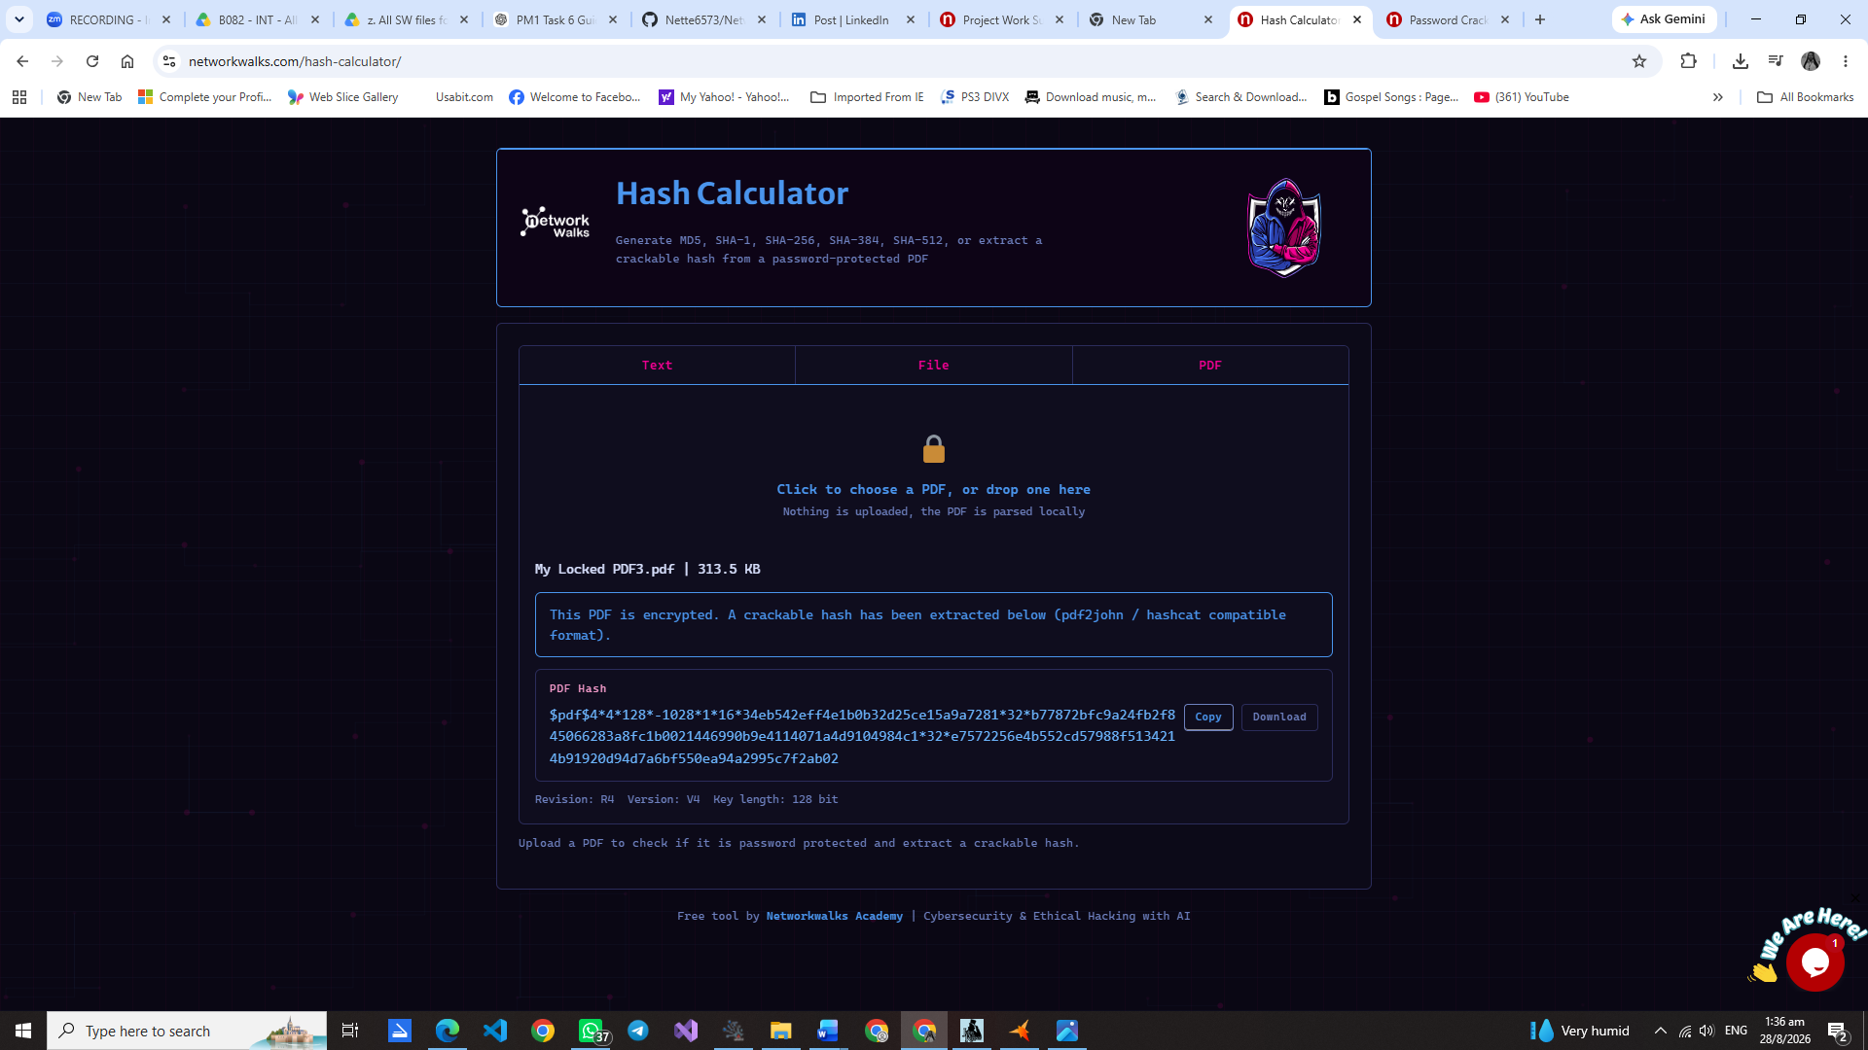
Figure 15. Additional PDF evidence – second PDF Hash Calculator output.
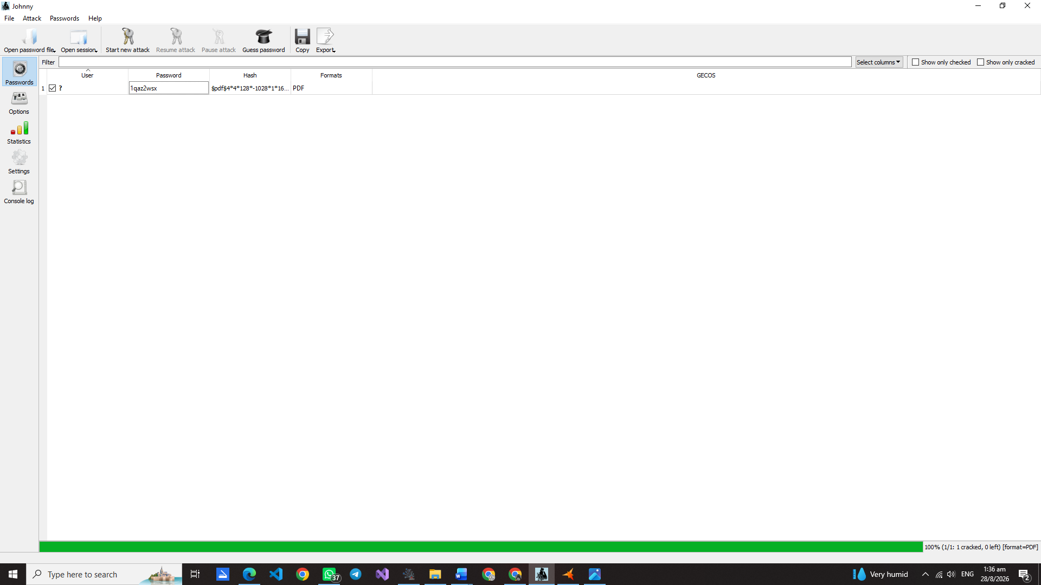
Figure 16. Additional PDF evidence – Johnny recognizing the extracted PDF password-auditing data.

Figure 17. Additional PDF evidence – successful completion/flag evidence.

17.3 Supplementary Evidence Analysis
- The additional screenshots demonstrate repeatability: the same general workflow can be applied to more than one protected training PDF.
- The Hash Calculator identifies the protected state of each PDF and produces password-verification data suitable for further auditing.
- The Johnny screenshot demonstrates that the extracted data can be recognized by a local JTR-based workflow as a PDF target.
- The completion screens provide evidence that the additional exercises were successfully completed in the NetworkWalks training environment.
- These additional exercises strengthen the practical lesson that password auditing is a repeatable process rather than a one-off result tied to a single document.

17.4 Evidence Handling Note
The supplementary images are the original screenshots supplied for this report. They may contain sensitive password, hash, or training-flag information. They are therefore appropriate for a private internship evidence package but should not automatically be treated as public portfolio material.

