Support Ticketing System
Module: Web & Cloud Applications (IT Management Y3)
Assignment: Project 1 — Client–Server Application

Student: [Student Name]
Student ID: [Student ID]
Date: 18/10/2026
──────────────────────────────
Table of Contents
1. Introduction 3
2. The Ticketing System — What It Is, How It Operates 3
The two areas 3
Ticket lifecycle 4
How a ticket moves through the system 4
3. Storyboard of the Application 5
4. Tables Used 6
Agents 6
User 6
Tickets 6
5. Per-Function Description with Client/Server Code 8
5.1 User Registration 8
5.2 User Login / Logout 12
5.3 Open a Ticket 14
5.4 My Tickets (Check Ticket Status) 16
5.5 Close a Ticket 18
5.6 Support Agent Login 19
5.7 Search Open Tickets 20
5.8 Resolve a Ticket 22
5.9 Elevate a Ticket 24
6. UX Decisions 26
7. Assumptions 27

1. Introduction
This project is a Support (Helpdesk) Ticketing System built as a
client–server web application. It uses PHP for server-side processing, MySQL for data storage, and HTML/CSS/JavaScript for the client side.
The system lets users report problems as tickets and track them through to resolution, and lets support agents find, resolve, and escalate those tickets. It is deployed locally with Docker Compose (Apache + PHP, MySQL, phpMyAdmin).
All of the application code lives in a single folder (html/) with one file per page, kept deliberately simple so that every page is easy to read and maintain.

2. The Ticketing System — What It Is, How It Operates
A helpdesk ticketing system records requests for help as tickets and tracks each one until it is finished.

The two areas
Area | Actors | What they do
User area | Registered users | Register, log in, open a ticket, view their tickets, close a resolved ticket
Support area | Support agents | Log in, search open tickets, resolve tickets, elevate tickets to a higher support level

Ticket lifecycle
A ticket has one of three statuses:
Open --> Resolved --> Closed
- Open — the ticket needs action from an agent. Every new ticket starts Open by default.
- Resolved — an agent has provided a solution and recorded resolution notes.
- Closed — the user has closed the ticket after seeing the resolution.
If an agent cannot resolve a ticket, the ticket may be elevated to an agent with a higher support level; its status remains Open.

How a ticket moves through the system
- A user registers and logs in.
- The user opens a ticket (subject + description). It is stored as Open.
- An agent finds the ticket (browse or search), investigates, and either:
  - resolves it (status becomes Resolved, resolution notes saved), or
  - elevates it to a higher-level agent (status stays Open).
- The user sees the resolution in My Tickets and can close the ticket.
- The ticket is now Closed and no further action is needed.

3. Storyboard of the Application
┌─────────────────────┐
│ Home (index) │
└─────────┬───────────┘
┌────────────────┼────────────────┐
▼ ▼ ▼
┌───────────────┐ ┌───────────────┐ ┌───────────────┐
│ User Register │ │ User Login │ │ Agent Login │
└───────┬───────┘ └───────┬───────┘ └───────┬───────┘
│ │ │
▼ ▼ ▼
(goes to Login) ┌───────────────┐ ┌─────────────────┐
│ Dashboard │ │ Agent Dashboard │
│ ("My Tickets")│ │ (open tickets) │
└───────┬───────┘ └───────┬─────────┘
│ │
┌────────────────┼──────┐ ┌───────┼────────┐
▼ ▼ ▼ ▼ ▼
┌───────────────┐ ┌────────────┐ ┌────────────────┐ ┌────────────┐
│ Open a Ticket │ │ Ticket view│ │ Agent ticket │ │ Logout │
└───────────────┘ │ (details) │ │ (resolve / │ └────────────┘
└────────────┘ │ elevate) │
└────────────────┘
Screenshot of the running home page:
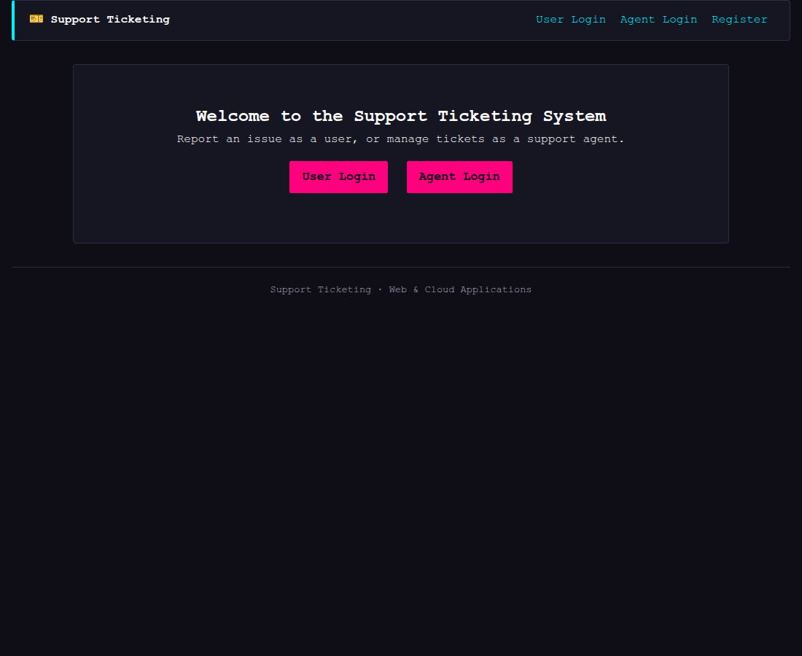

4. Tables Used
The database Ticketing contains three tables: agents, users, tickets.
Screenshot: phpMyAdmin structure tab showing the three tables.

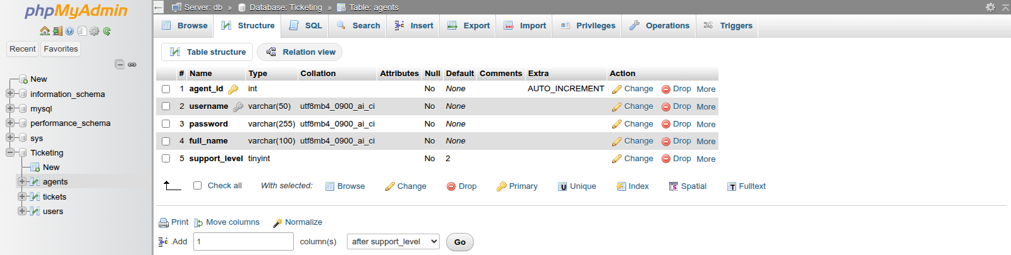
Agents

User

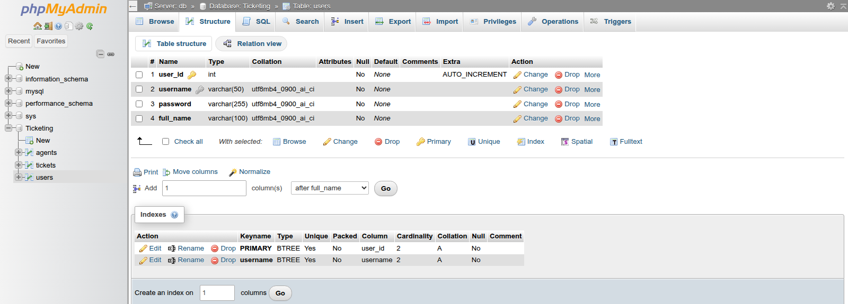
Tickets
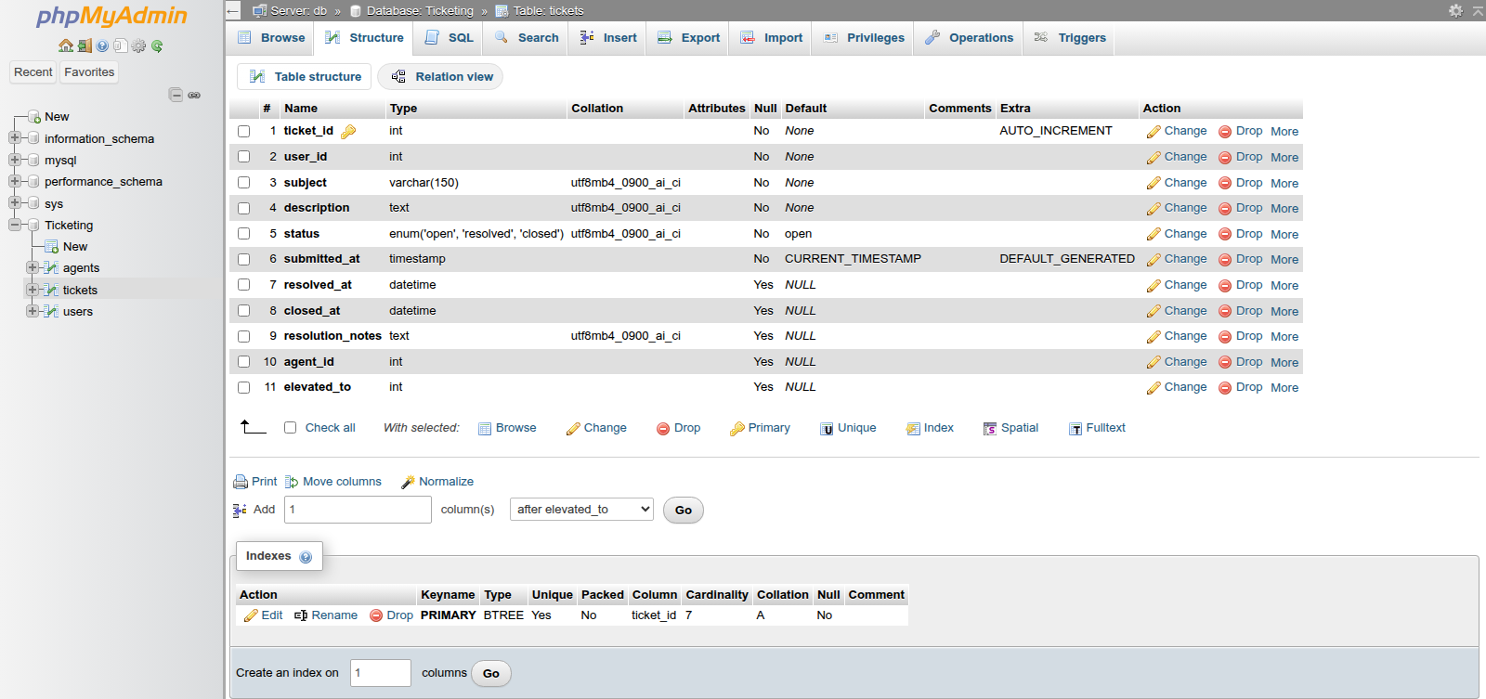
They are created by setup.php using the SQL below.
CREATE TABLE IF NOT EXISTS agents (
agent_id INT AUTO_INCREMENT PRIMARY KEY,
username VARCHAR(50) NOT NULL UNIQUE,
password VARCHAR(255) NOT NULL,
full_name VARCHAR(100) NOT NULL,
support_level TINYINT NOT NULL DEFAULT 2
);
CREATE TABLE IF NOT EXISTS users (
user_id INT AUTO_INCREMENT PRIMARY KEY,
username VARCHAR(50) NOT NULL UNIQUE,
password VARCHAR(255) NOT NULL,
full_name VARCHAR(100) NOT NULL
);
CREATE TABLE IF NOT EXISTS tickets (
ticket_id INT AUTO_INCREMENT PRIMARY KEY,
user_id INT NOT NULL,
subject VARCHAR(150) NOT NULL,
description TEXT NOT NULL,
status ENUM("open","resolved","closed") NOT NULL DEFAULT "open",
submitted_at TIMESTAMP NOT NULL DEFAULT CURRENT_TIMESTAMP,
resolved_at DATETIME,
closed_at DATETIME,
resolution_notes TEXT,
agent_id INT,
elevated_to INT
);
setup.php also adds sample data (two agents, two users, three tickets) the first time it runs, and is safe to re-run.
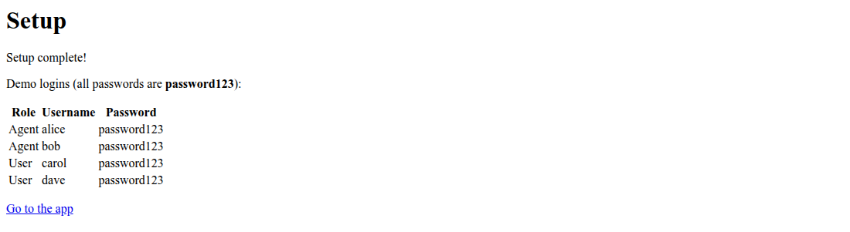

5. Per-Function Description with Client/Server Codes
This section uses the following notation:
- Client side — the HTML/JavaScript the browser sends. Each page is a plain form, and a single shared file (js/validate.js) is loaded on every page to check that all required fields are filled in before the form submits. This is a UX convenience only — every page also validates again on the server.

- Server side — the PHP that processes the request. Most pages share a common header (header.php) which draws the navigation bar and flash messages, so only each page's own logic is shown below.

5.1 User Registration
Description: A new user provides a full name, username, and password. The server rejects empty fields and duplicate usernames before inserting the new user, then sends them to the login page with a success message.
Screenshot: the registration page
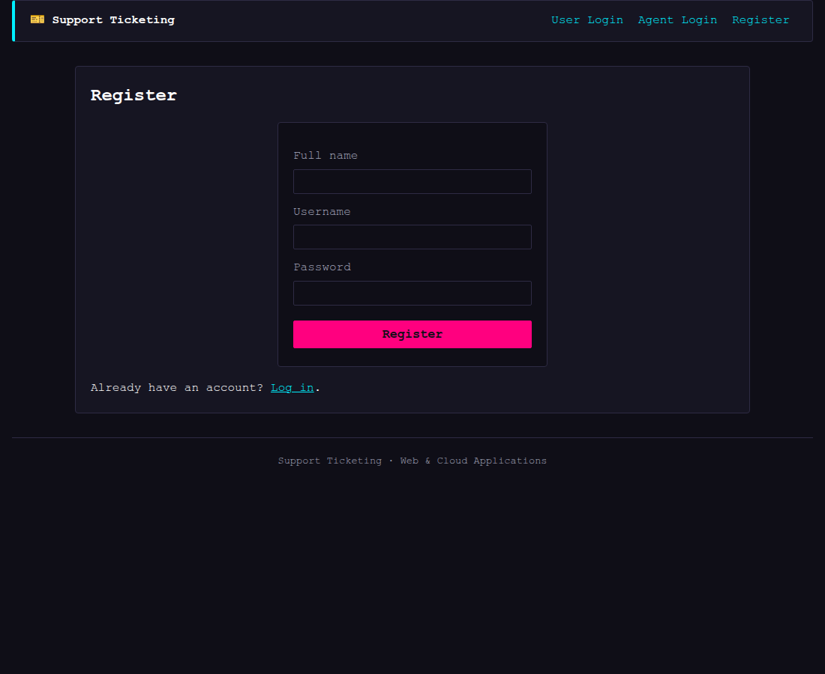
Client side (register.php):
<form method="post">
<p>
<label for="full_name">Full name</label><br>
<input type="text" id="full_name" name="full_name" required>
</p>
<p>
<label for="username">Username</label><br>
<input type="text" id="username" name="username" required>
</p>
<p>
<label for="password">Password</label><br>
<input type="password" id="password" name="password" required>
</p>
<p><button type="submit">Register</button></p>
</form>
Server side (register.php, key part):
if ($_SERVER['REQUEST_METHOD'] === 'POST') { // was the form submitted?
// Get the values the user typed.
$full_name = trim($_POST['full_name'] ?? '');
$username = trim($_POST['username'] ?? '');
$password = $_POST['password'] ?? '';
if ($full_name === '' || $username === '' || $password === '') {
$error = 'All fields are required.';
} else {
// Check if this username is already in the database.
$check = $pdo->prepare('SELECT user_id FROM users WHERE username = ?');
$check->execute([$username]);
$existing = $check->fetch();
if ($existing) {
$error = 'That username is already taken.';
} else {
// Save the new user.
$add = $pdo->prepare('INSERT INTO users (username, password, full_name) VALUES (?, ?, ?)');
$add->execute([$username, $password, $full_name]);
flash('Account created! You can now log in.');
header('Location: login.php');
exit;
}
}
}
Client-side validation (shared by every form): a single JavaScript file, js/validate.js, is loaded on every page (in footer.php). It turns off the browser's own required popup and instead checks each required field when the form is submitted, showing a friendly message and focusing the first empty field. The key part:
document.querySelectorAll('form').forEach(function (form) {
form.noValidate = true; // use our message, not the browser's popup
form.addEventListener('submit', function (event) {
var missing = [];
// Find every required field left blank.
form.querySelectorAll('[required]').forEach(function (field) {
if (field.value.trim() === '') missing.push(field);
});
if (missing.length === 0) return; // all filled in: submit
event.preventDefault(); // stop the submit
// Show one message listing what is missing, then focus the first.
var msg = form.querySelector('.js-message');
if (!msg) {
msg = document.createElement('p');
msg.className = 'js-message';
form.prepend(msg);
}
msg.textContent = 'Please fill in: ' + missing.map(function (f) {
var label = form.querySelector('label[for="' + f.id + '"]');
return label ? label.textContent.trim() : f.name;
}).join(', ') + '.';
missing[0].focus();
});
});

This is a UX convenience only — the PHP on the server always re-checks the data before saving, so validation is enforced in both places.
Screenshot: the registration page with an empty form attempted — the JavaScript message is shown and the submit is blocked.

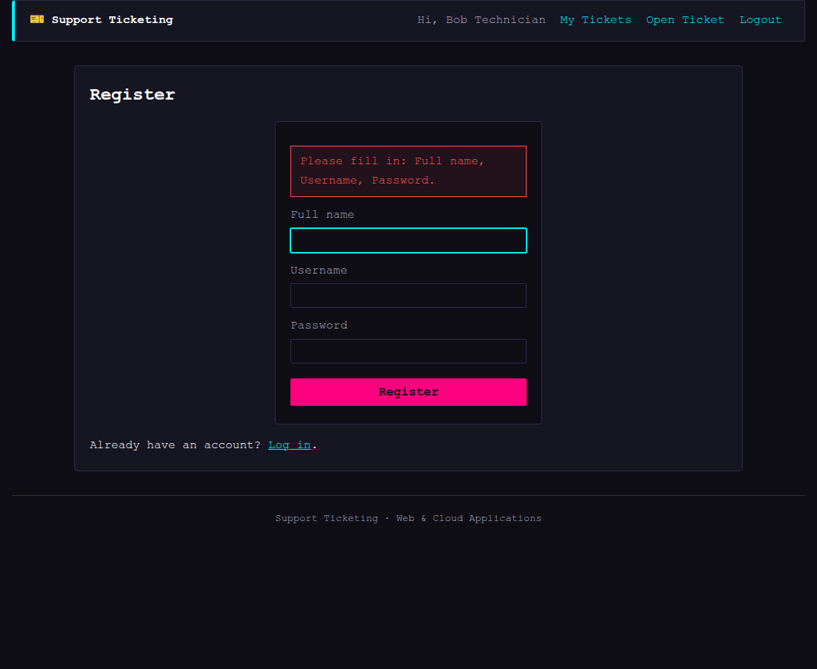

5.2 User Login / Logout
Description: A user enters username and password. The server looks the user up and, if the password matches, starts a session and redirects to the dashboard. Logout clears the session for both user and agent roles.
Screenshot: the user login page

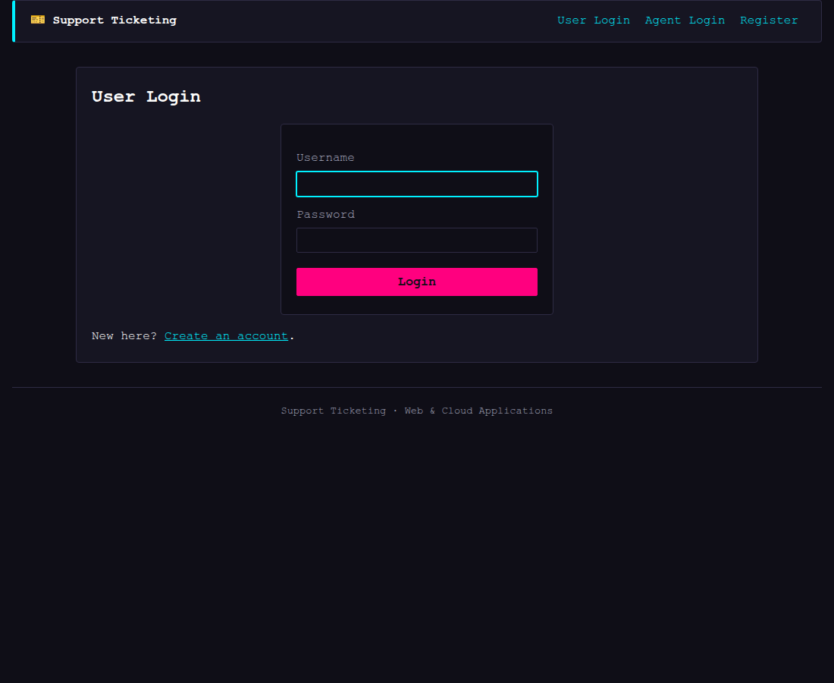

Client side (login.php):
<form method="post">
<p>
<label for="username">Username</label><br>
<input type="text" id="username" name="username" required autofocus>
</p>
<p>
<label for="password">Password</label><br>
<input type="password" id="password" name="password" required>
</p>
<p><button type="submit">Login</button></p>
</form>
Server side (login.php, key part):
$search = $pdo->prepare('SELECT * FROM users WHERE username = ?');
$search->execute([$username]);
$user = $search->fetch();
// Check the password matches.
if ($user && $user['password'] === $password) {
// Remember who is logged in. $_SESSION carries over to
// the next page because of session_start().
$_SESSION['user_id'] = $user['user_id'];
$_SESSION['full_name'] = $user['full_name'];
// Redirect BEFORE printing anything.
header('Location: dashboard.php');
exit;
} else {
$error = 'Invalid username or password.';
}
Server side (logout.php):
session_start();
require_once 'db.php'; // gives us flash()
$_SESSION = []; // wipe the session (forget logins)
flash('You have been logged out.'); // tell them on the home page
header('Location: index.php');
exit;

5.3 Open a Ticket
Description: A logged-in user submits a subject and description. The server inserts the ticket with status open (the default) and sends the user to the new ticket's page.
Screenshot: the open-a-ticket page

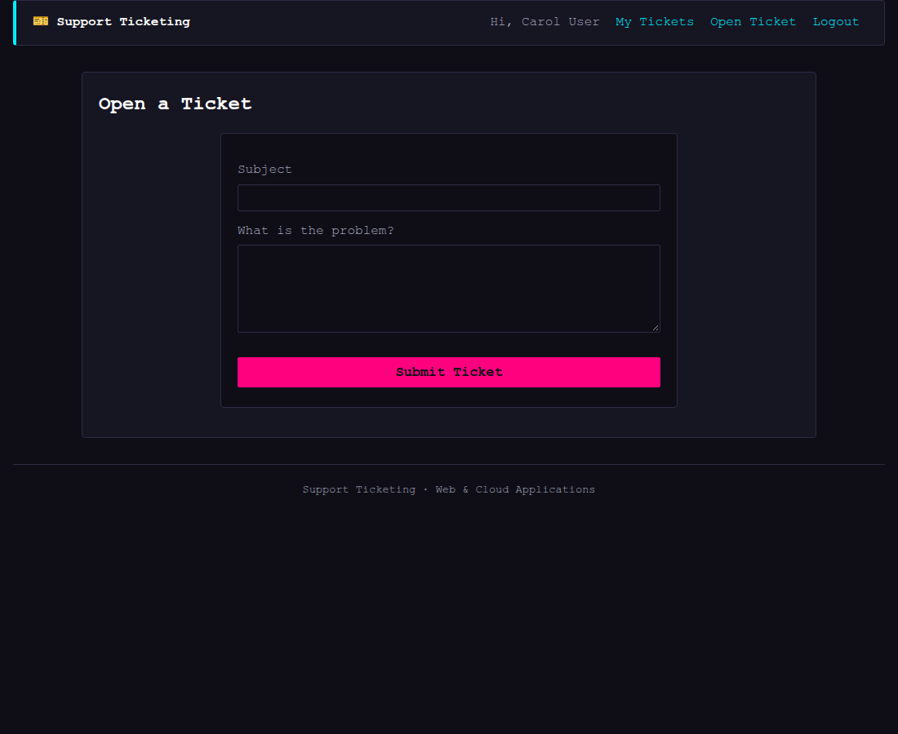

Client side (new-ticket.php):
<form method="post">
<p>
<label for="subject">Subject</label><br>
<input type="text" id="subject" name="subject" maxlength="150" required>
</p>
<p>
<label for="description">What is the problem?</label><br>
<textarea id="description" name="description" rows="6" required></textarea>
</p>
<p><button type="submit">Submit Ticket</button></p>
</form>
Server side (new-ticket.php, key part):
// Insert the ticket. status is always 'open' for a new ticket.
$add = $pdo->prepare(
'INSERT INTO tickets (user_id, subject, description, status)
VALUES (?, ?, ?, "open")'
);
$add->execute([$_SESSION['user_id'], $subject, $description]);
// lastInsertId gives us the ID MySQL just created for this ticket.
$new_id = $pdo->lastInsertId();
flash('Ticket #' . $new_id . ' opened — it is now waiting for an agent.');
header('Location: ticket.php?id=' . $new_id);
exit;

5.4 My Tickets (Check Ticket Status)
Description: Shows the logged-in user their own tickets with current status (open / resolved / closed), newest first. Each row links to the ticket detail page.
Screenshot: the My Tickets dashboard

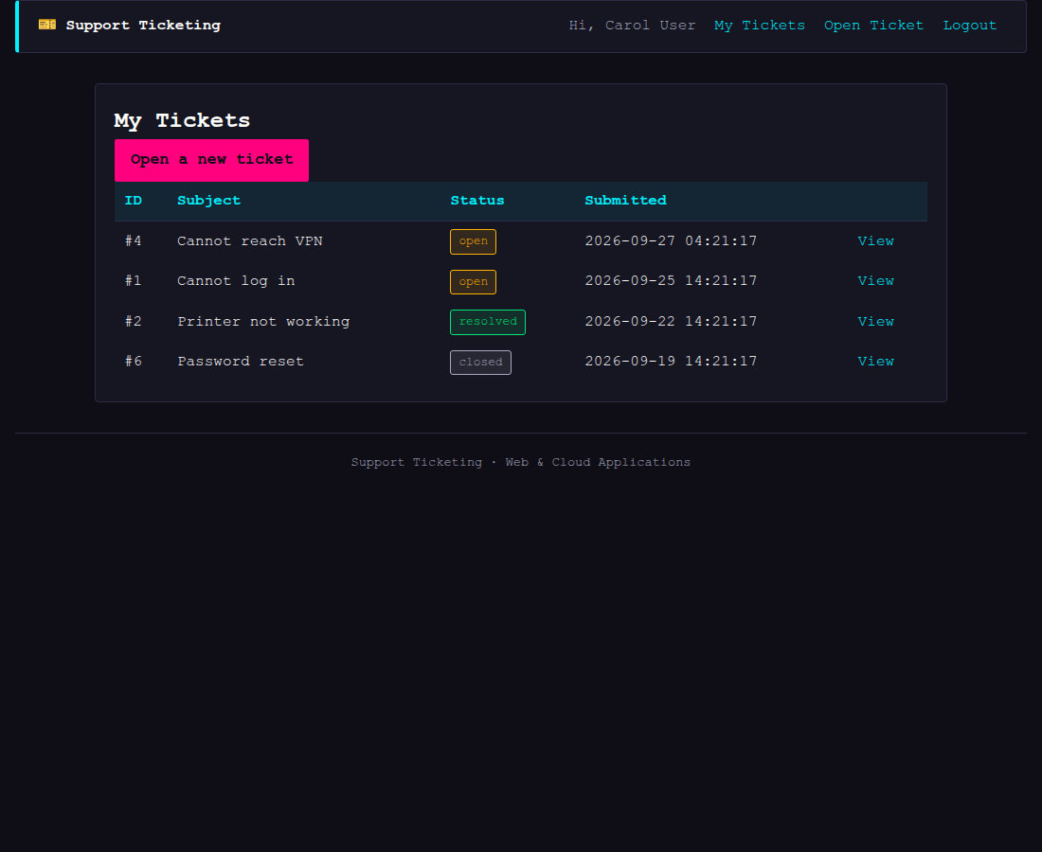

Server side (dashboard.php, key part):
// Get only this user's tickets, newest first.
$tickets = $pdo->query(
'SELECT * FROM tickets
WHERE user_id = ' . $_SESSION['user_id'] . '
ORDER BY submitted_at DESC'
)->fetchAll();
Client side: a table rendered server-side, with each row showing the ticket ID, subject, status, submission date, and a link to the detail page.

5.5 Close a Ticket
Description: A user can close a ticket only when it is Resolved. The server checks ownership (the ticket query includes user_id = ?) and status before updating it to closed.
Screenshot: ticket detail showing the Close button (visible once an agent has resolved the ticket)
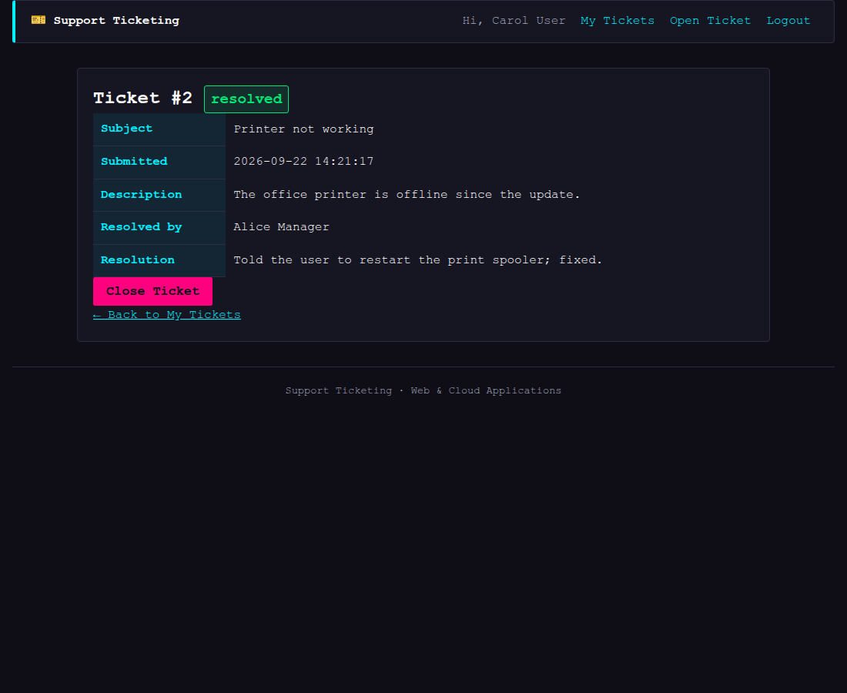
Client side (ticket.php):
<?php if ($ticket['status'] == 'resolved'): ?>
<!-- Close button — only shown when the ticket is Resolved -->
<form method="post" onsubmit="return confirm('Close this ticket?');">
<button type="submit">Close Ticket</button>
</form>
<?php endif; ?>
Server side (ticket.php, key part):
if ($_SERVER['REQUEST_METHOD'] === 'POST') {
if ($ticket['status'] === 'resolved') {
$pdo->query(
"UPDATE tickets SET status = 'closed', closed_at = NOW()
WHERE ticket_id = " . $ticket_id
);
flash('Ticket #' . $ticket_id . ' closed.');
header('Location: ticket.php?id=' . $ticket_id);
exit;
} else {
$close_error = 'A ticket can only be closed after an agent has resolved it.';
}
}
The ticket used by this page was fetched with:
$search = $pdo->prepare('SELECT * FROM tickets WHERE ticket_id = ? AND user_id = ?');
$search->execute([$ticket_id, $_SESSION['user_id']]);
$ticket = $search->fetch();
so a user can only ever see and close their own tickets.

5.6 Support Agent Login
Description: Mirrors the user login but checks the agents table. The agent's support level is stored in the session because it controls whether the agent may elevate tickets.
Screenshot: the agent login page
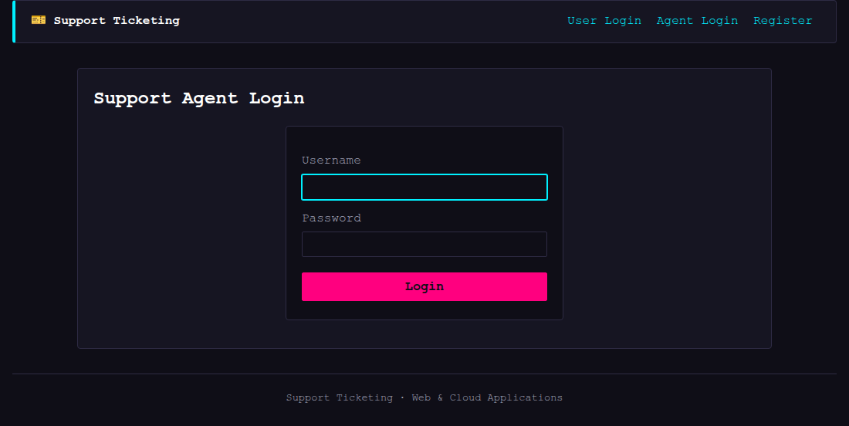
Server side (agent-login.php, key part):
$search = $pdo->prepare('SELECT * FROM agents WHERE username = ?');
$search->execute([$username]);
$agent = $search->fetch();
if ($agent && $agent['password'] === $password) {
$_SESSION['agent_id'] = $agent['agent_id'];
$_SESSION['full_name'] = $agent['full_name'];
$_SESSION['support_level'] = $agent['support_level']; // 1 = senior, 2 = junior
header('Location: agent-dashboard.php');
exit;
} else {
$error = 'Invalid username or password.';
}

5.7 Search Open Tickets
Description: The support dashboard lists all open tickets by default. The agent can filter them by typing a word in the subject; the search uses a LIKE query so typing "printer" finds "Printer not working". A
History view (?view=all) drops the status filter so agents can also browse resolved and closed tickets, each shown with a status badge.
Screenshot: the agent dashboard, and the same page filtered by a search ("printer")
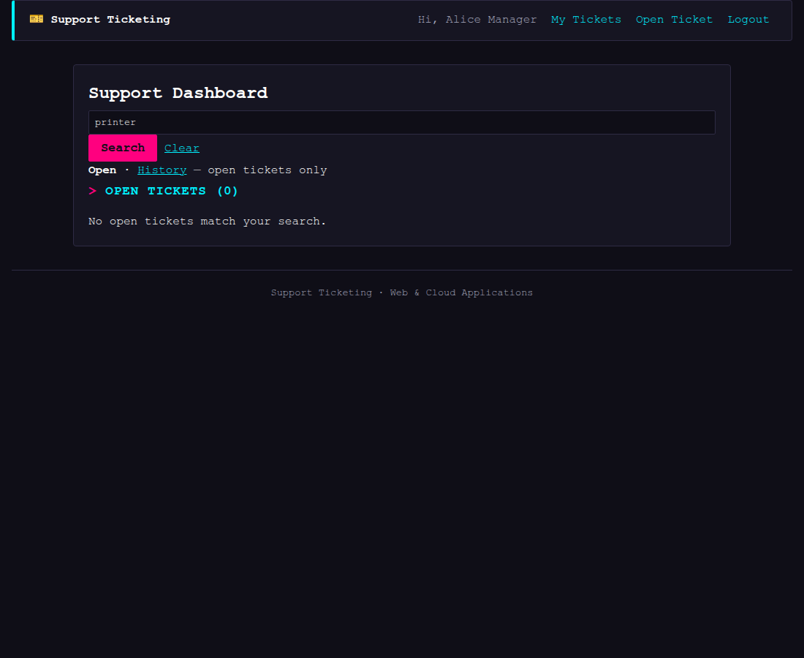
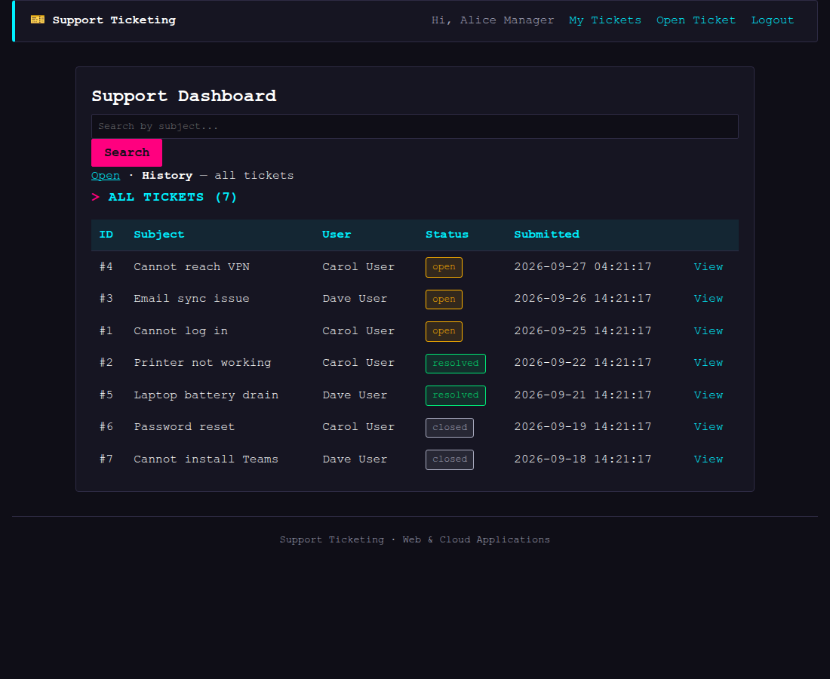

Client side (agent-dashboard.php):
<!-- Search form: sends ?q=... to this same page (method=get) -->
<form method="get">
<input type="text" name="q" value="<?= htmlspecialchars($search) ?>" placeholder="Search by subject...">
<button type="submit">Search</button>
<?php if ($search !== ''): ?><a href="agent-dashboard.php">Clear</a><?php endif; ?>
</form>
Server side (agent-dashboard.php, key part):
$search = trim($_GET['q'] ?? '');
// Build the query. If there is a search term we add a WHERE part
// that looks for it in the subject. LIKE '%...%' means "contains".
$sql = 'SELECT t.*, u.full_name AS user_full_name
FROM tickets t
JOIN users u ON u.user_id = t.user_id
WHERE t.status = "open"';
if ($search !== '') {
// Escape % and _ (LIKE wildcards) so they are treated as normal text.
$safe = str_replace(['%', '_'], ['\\%', '\\_'], $search);
$sql .= ' AND t.subject LIKE "%' . $safe . '%"';
}
$sql .= ' ORDER BY t.submitted_at DESC';
$tickets = $pdo->query($sql)->fetchAll();

5.8 Resolve a Ticket
Description: An agent opens an open ticket and enters resolution notes. The server sets the status to resolved, records the resolution time and the resolving agent. The resolving agent's name is stored on the ticket (via agent_id) and shown to the user and to other agents on the ticket detail page.
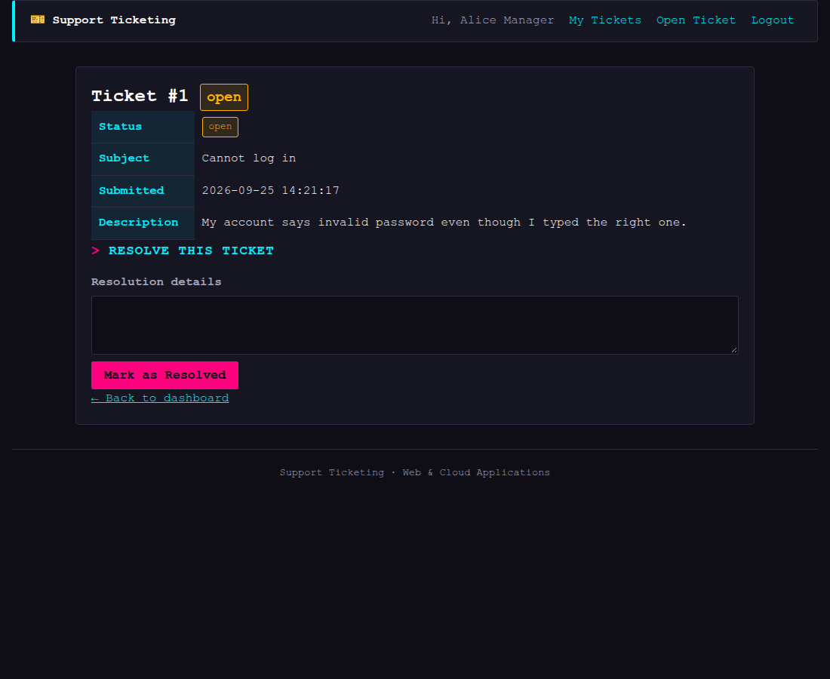
Screenshot: an open ticket with the resolve form
Screenshot: A ticket once resolved — details include which agent resolved it.
Client side (agent-ticket.php):
<?php if ($ticket['status'] === 'open'): ?>
<h2>Resolve this ticket</h2>
<form method="post">
<input type="hidden" name="action" value="resolve">
<p>
<label for="resolution_notes">Resolution details</label><br>
<textarea id="resolution_notes" name="resolution_notes" rows="4" required></textarea>
</p>
<p><button type="submit">Mark as Resolved</button></p>
</form>
<?php endif; ?>
Server side (agent-ticket.php, key part):
if ($action === 'resolve') {
$notes = trim($_POST['resolution_notes'] ?? '');
if ($notes === '') {
$error = 'Please write the resolution details.';
} else {
$update = $pdo->prepare(
"UPDATE tickets
SET status = 'resolved',
resolved_at = NOW(),
resolution_notes = ?,
agent_id = ?
WHERE ticket_id = ?"
);
$update->execute([$notes, $_SESSION['agent_id'], $ticket_id]);
flash('Ticket #' . $ticket_id . ' resolved.');
header('Location: agent-ticket.php?id=' . $ticket_id);
exit;
}
}

5.9 Elevate a Ticket
Description: If an agent cannot resolve an open ticket, the ticket can be elevated to an agent with a higher support level. In this system a junior agent (level 2) can elevate an open ticket to a senior agent (level 1). The ticket's status stays Open, but it is reassigned to the senior agent and the hand-off is recorded in elevated_to.
Screenshot: the same open ticket, viewed by a junior agent (Bob, level 2) who also sees the Elevate form

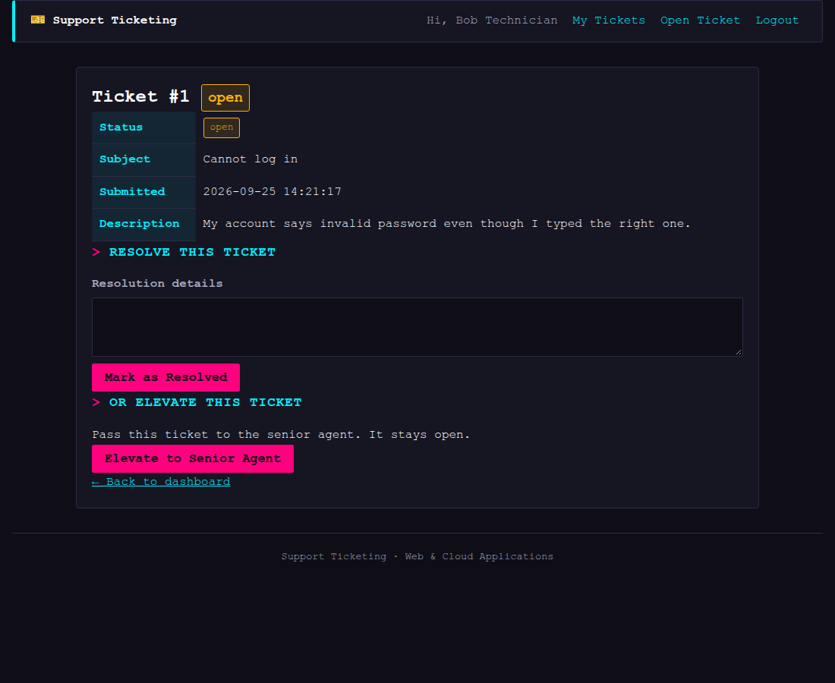

Client side (agent-ticket.php) — the Elevate form is only shown to a
junior agent (level 2):
<?php if ((int) $_SESSION['support_level'] === 2): ?>
<!-- The Elevate form is only shown to junior agents (level 2) -->
<h2>Or elevate this ticket</h2>
<p>Pass this ticket to the senior agent. It stays open.</p>
<form method="post">
<input type="hidden" name="action" value="elevate">
<p><button type="submit">Elevate to Senior Agent</button></p>
</form>
<?php endif; ?>
Server side (agent-ticket.php, key part):
if ($action === 'elevate') {
if ((int) $_SESSION['support_level'] !== 2) {
$error = 'Only a junior agent (level 2) can elevate a ticket.';
} else {
// Find the level-1 senior agent.
$senior = $pdo->query('SELECT agent_id FROM agents WHERE support_level = 1 LIMIT 1')->fetch();
if (!$senior) {
$error = 'No senior agent found to elevate to.';
} else {
$senior_id = $senior['agent_id'];
// Re-assign the ticket to the senior agent and record
// the elevation. status stays 'open'.
$pdo->prepare(
'UPDATE tickets
SET agent_id = ?, elevated_to = ?
WHERE ticket_id = ? AND status = "open"'
)->execute([$senior_id, $senior_id, $ticket_id]);
flash('Ticket #' . $ticket_id . ' elevated to the senior agent.');
header('Location: agent-ticket.php?id=' . $ticket_id);
exit;
}
}
}

6. UX Decisions
- Two clear entry points (User vs Agent) from the home page, so the correct role can start immediately.
- Terminal-style visual theme — a dark, monospace look with cyan links/headings and high-contrast magenta buttons, chosen to match a terminal aesthetic and keep the status tables easy to scan on a dark background.
- Consistent layout — a shared header/navigation on every page; the user is always one click from My Tickets or a new ticket.
- Clear status text — each ticket shows its current status (open / resolved / closed) in the list and on the detail page, so there is no guessing where a ticket is in the life cycle.
- Guided forms — every form uses HTML required attributes so the browser prompts for missing fields, and the server re-checks as well.
- Search without friction — agents can search on the dashboard itself rather than navigating to a separate search page.
- Progress feedback — a flash message confirms every important action (account created, ticket opened, resolved, elevated, closed, logout) so the user knows it succeeded.
- Confirmation on close — closing is irreversible, so the browser asks for confirmation before submitting.

7. Assumptions
- Passwords are stored in plaintext for the purposes of this project in order to keep the code simple and readable. In a production system they would be hashed with password_hash().
- The system is for educational use and runs locally via Docker Compose; no HTTPS or production hardening is included.
- Support levels: level 1 is the highest (senior) and level 2 is the lowest (junior). Elevation is kept simple: a junior agent elevates only to the senior agent (level 1).
- A user may only close their own ticket, and only after it is Resolved (enforced by the WHERE ticket_id = ? AND user_id = ? query).
- Elevated tickets are not automatically re-assigned to a queue; the target agent's ID is recorded in elevated_to.
- Sample data is seeded by setup.php for demonstration; the same script is safe to re-run.

