SDN On-The-Go (OTG)
Paper Category - Tool

Test Bed Components
The standalone testbed is designed to be easy for one person to carry and setup in a few minutes. The components are mounted on a 2’x3’ main board. The two component boards, the switch board and the host board attach to the main board with a simple bar/catch. The monitor slips into a bracket and the Kangaroo+ slips in to its fan cooled mount.

Almost all of the cabling can remain hooked up when the unit is disassembled and stored. The switch and host board fold together and fit in a small hard sided case without unhooking the majority of the cabling. The controller, monitor, routers, keyboard, mouse, power supplies and spare cabling fit in two small bags.

The many power supplies remain connected to three, 120V power strips so the unit is powered by a single 120V cable and the power cabling can be left connected while disassembled.

For a complete component list and more installation details, please see the SDN-OTG github project.[19]

Zodiac FX Switch Board

The switch board consists of the four Zodiac switches, a five port hub and a five port router. The four Zodiac switches are arranged in two rows of two pointing in the same direction. This seemed to give the best wiring arrangement for the different network topologies. The hub and router are mounted to the right of the switches. The hub acts as an accumulator for the SDN network. The router acts as an accumulator and provides a separate VPN for the four RaspberryPi3 hosts. We use this VPN as the public network access point. The wiring can be removed without affecting the capabilities of the test bed.

In the default configuration, each Pi3 host is connected to its own switch, providing 5V power via USB to micro-USB on the switch. The Zodiac FX provides serial connectivity through this USB port for changing the switch configuration. This way each host powers a switch and is responsible for configuring the switch via the serial USB connection. Using the on-board monitor, keyboard and mouse you can change the configuration on each switch. Or, if the isolated VPN is hooked up you can RDP into each host to change configuration.

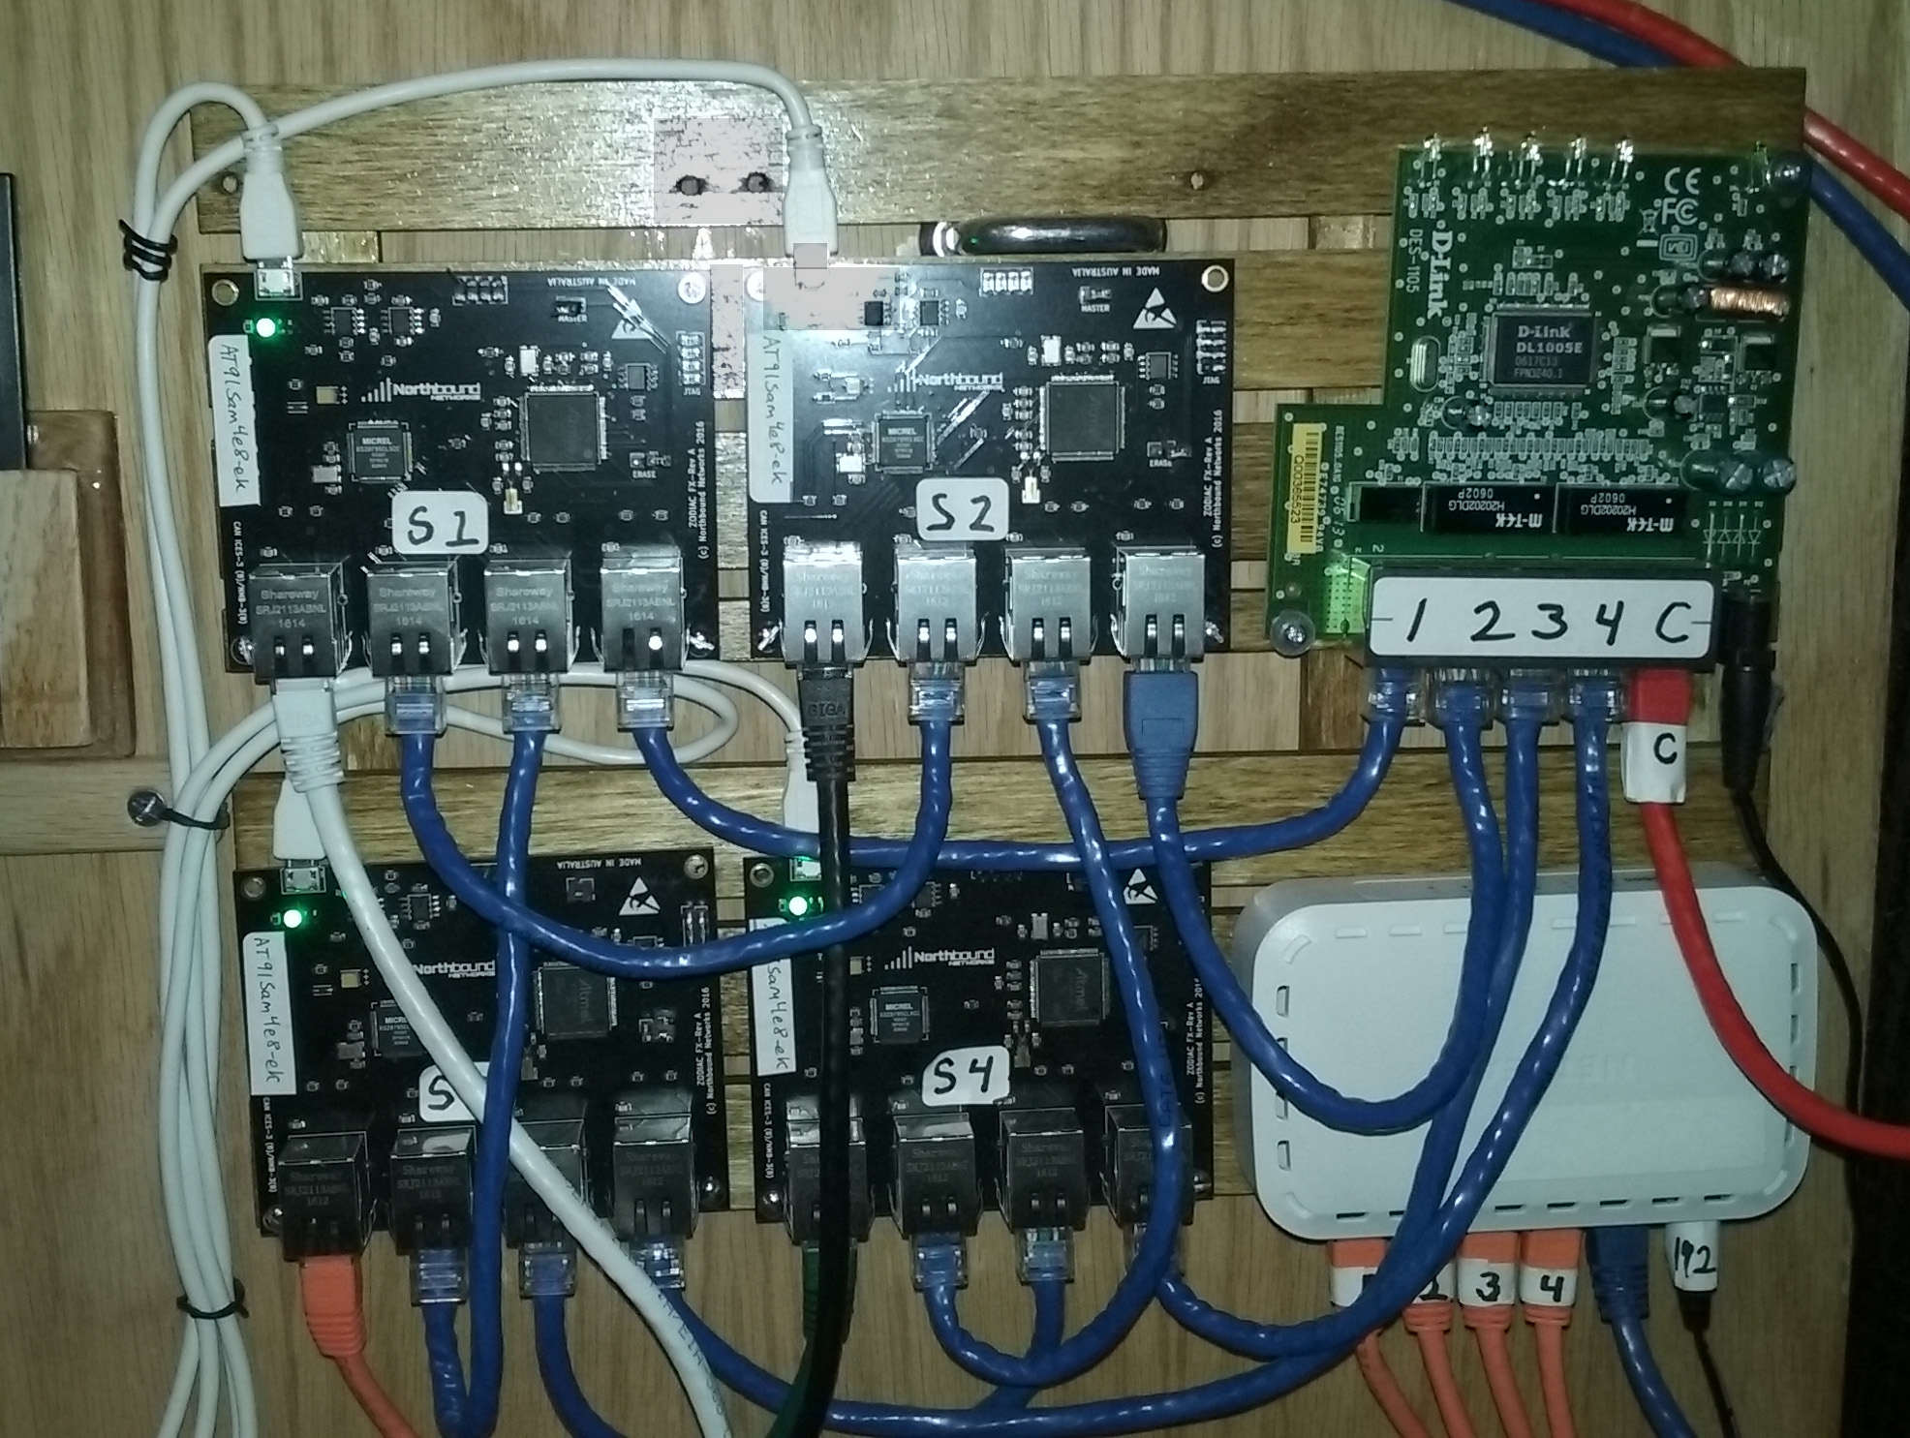
Fig. 5. OTG Zodiac FX switch board

Host Board

With the four RaspberryPi3 hosts, a variety of pseudo real world network traffic can be generated at any given time over the configured network. The default configuration connects each host to port 1 on each switch. Host1 Eth1 connects to Switch1-Port1, Host2 Eth1 connects to Switch2 Port1, etc.
(h1-1 -> s1-1, h2 -> s2-1, h3 -> s3-1, h4 -> s4-1)

Each host is connected to an USB Keyboard / Mouse switch, (lower right hand corner of the picture) to provide switching between the Logitech MK240 2.4 GHz Wireless Keyboard and mouse. Each host video HDMI output is connected to an IOGear IR switch (upper right) which drives the 10” LED Monitor.

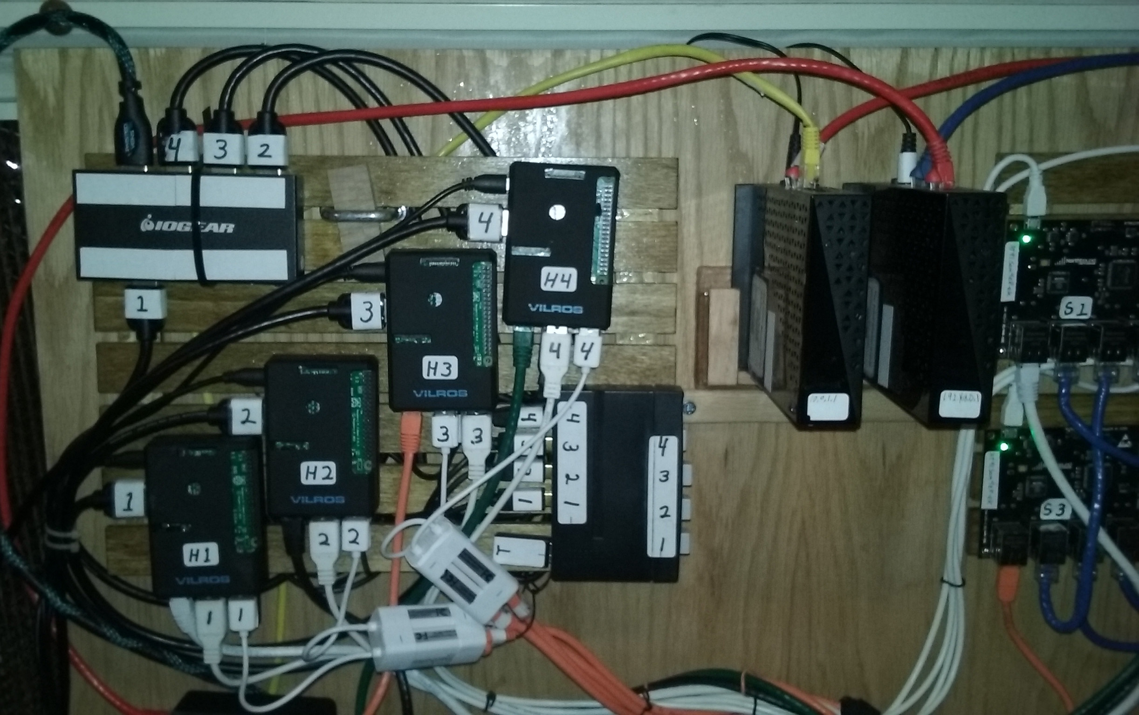
Fig. 6. OTG host board

Kangaroo+ Controller

The Kangaroo+ is mounted to the main board on the left of the monitor, inside the very well constructed box that it came in. The Kangaroo does generate heat, so we installed a small 5V blower fan in the box with ducting to inject air into the side cooling vents of the Kangaroo. The box lid pulls off to expose the top of the Kangaroo while the system is being used.

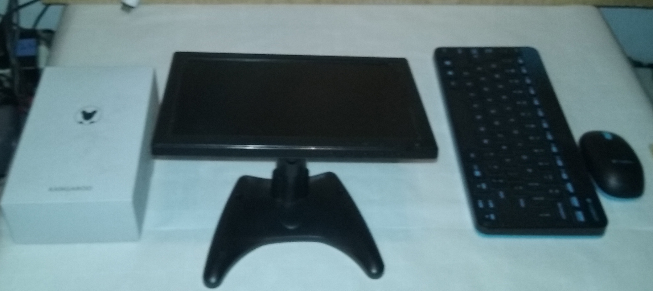
Fig. 7. OTG Kangaroo+ SDN Controller

Routers
Two routers with wifi form the subnets for the test bed. These routers can be configured with the wired subnets, wireless subnets and Bluetooth on the Kangaroo. Four hosts, four switches and three routers on three independent transmission spectrums can create many significant and challenging topologies.

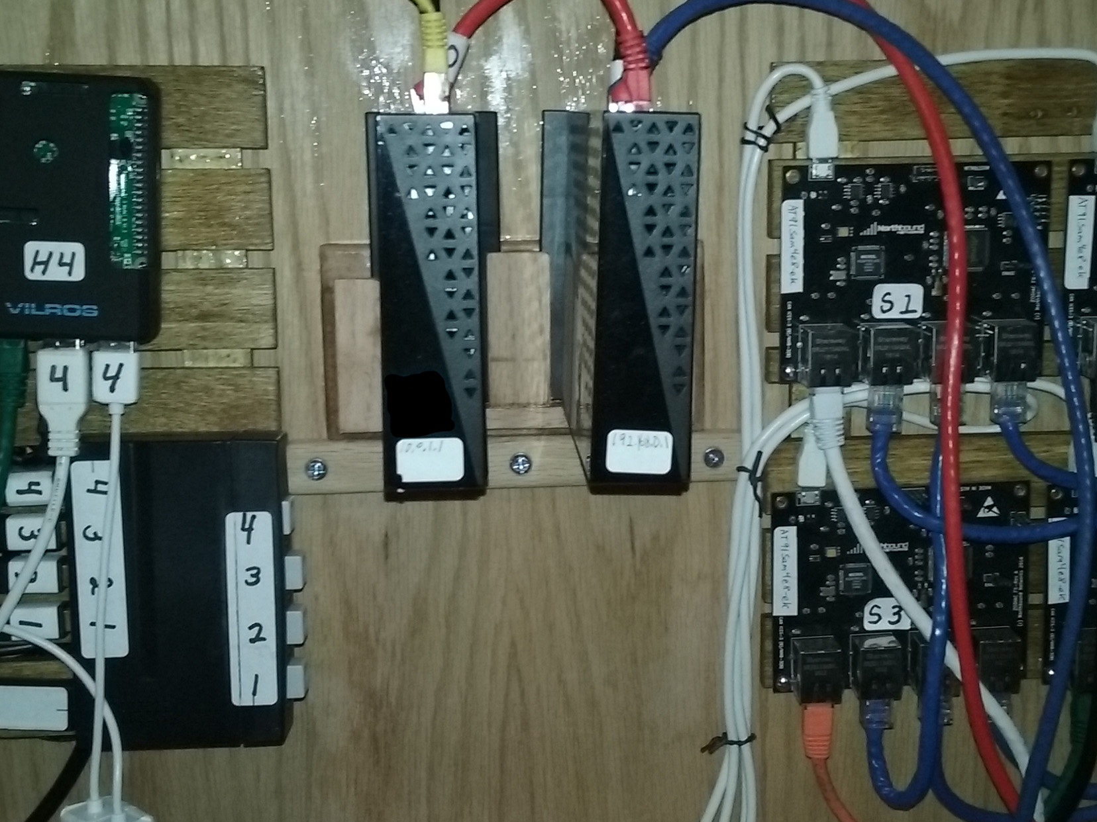
Fig. 8. Routers with wifi

Main Board

The main board can to be used in a horizontal position like on a table top or actually used as a table top. It can also be hung vertically or stood on edge. It is a ¼” thick by 2’x3’ piece of furniture grade hardwood plywood. All of the test bed components mount to the main board with the exception of the keyboard and mouse. They remain free to move about.

The two routers slide in to their brackets in between the switch board and the host board. The host keyboard and mouse switch is the manual four switch box below the routers. The HDMI switch for the host’s display is an IR remote controlled device also mounted on the host board.
The Kangaroo+ can be removed from its fan cooled mount. Like the four hosts, the Controller can be used with the on-board keyboard/mouse/monitor or you can RDP from an external network, if the test bed is connected to that network. Laptops and other devices can also be plugged directly into the main board public network.

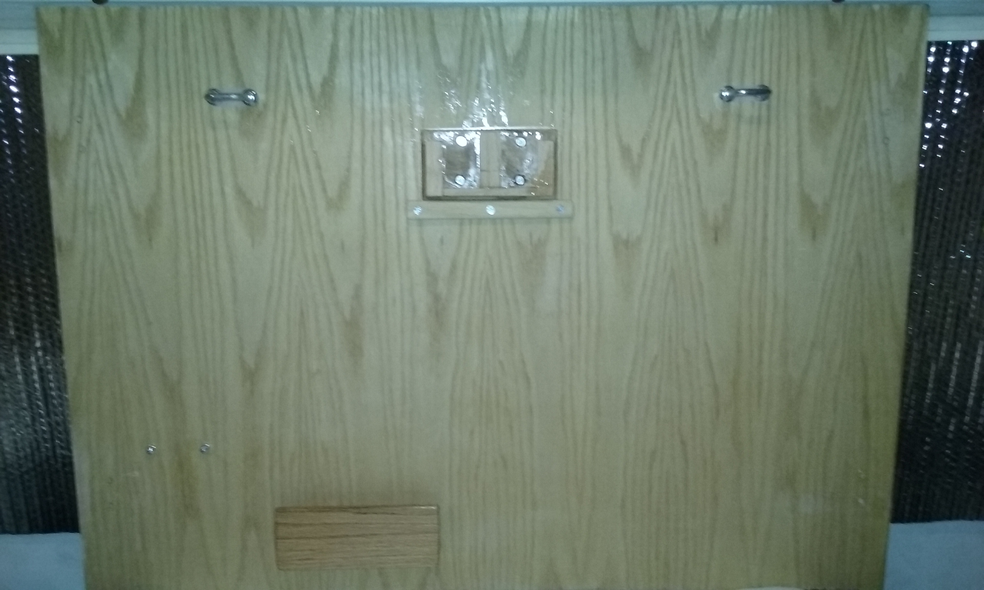
Fig. 9. Front side main board

The back side of the main board is equipped with wooden feet to support the board and allow clearance for the hardwood reinforcement brackets that stiffen the switch brackets, main support bracket, monitor bracket, controller mount and the two sub boards mounts. The hardwood reinforcement brackets are bolted to the main board and front bracket.

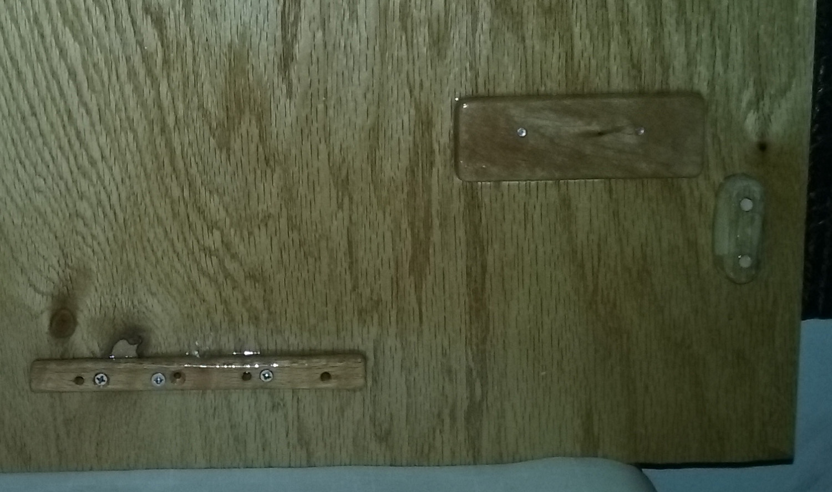
Fig. 10 Wooden foot to give reinforcement brackets clearance

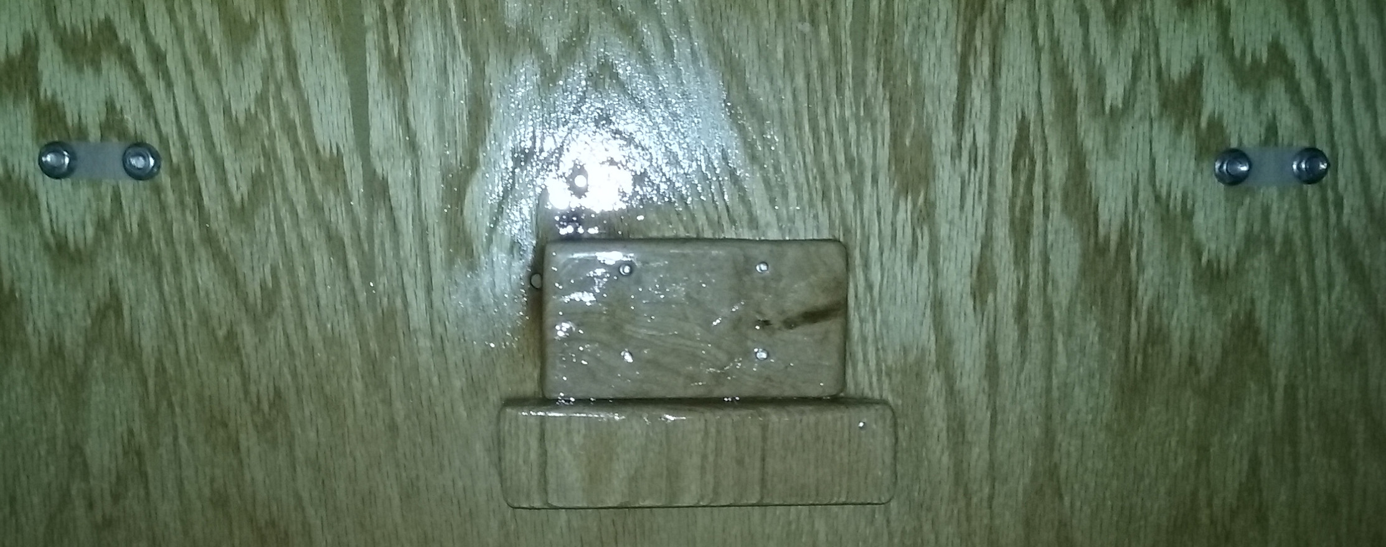
Fig. 11 Router and main support bracket reinforcement plates

