SDN On-The-Go (OTG)
Paper Category - Tool

Configuration examples

All of the topologies described in the Switch Plane section are supported by the SDN test bed. These configurations, linear, star, tree etc. can be extended using the three routers on the main board. Two of the three routers have a wireless radio making hybrid, wireless network configurations possible. There are also spare Ethernet ports on the routers for extending the configuration. Additional networked devices can be connected in a custom network topology for testing embedded performance. The Controller, Kangaroo+ computer is capable of Bluetooth. That could also be thrown in the mix.

Here are a few example topologies:

Topology 1
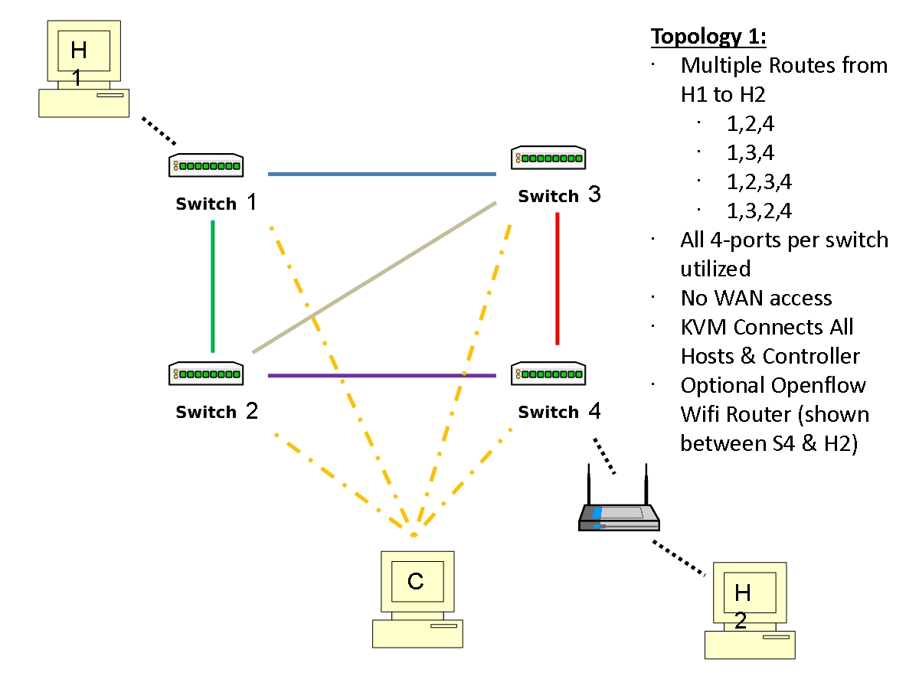
Fig. 2. Four switch two host hybrid

Topology 2
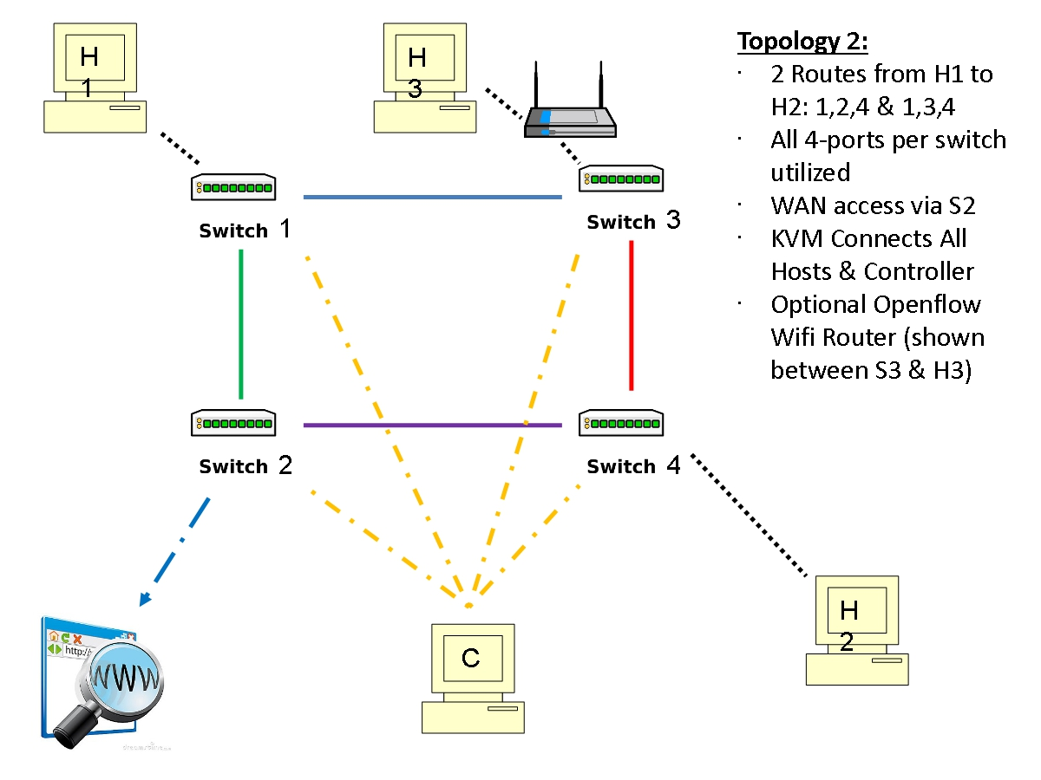
Fig. 3. Four switch four host hybrid subnet

Topology 3
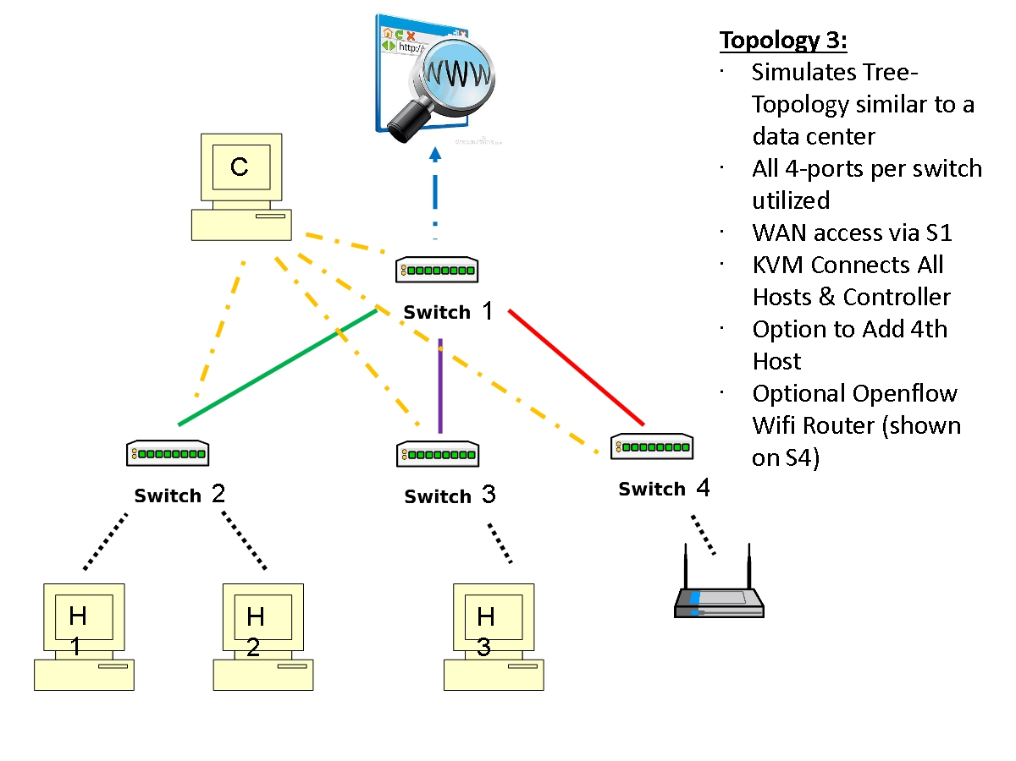
Fig. 4. Four switch four host hybrid fattree subnet

OTG Default Configuration

LAN1 - SDN Network consisting of four ZodiacFX switches connected in a partial mesh configuration. Each switch Port 1 is connected to the primary ethernet port on each RaspberryPi3.

LAN2 - Port 4 of each Zodiac FX switch is a dedicated port for the control plane. These ports are connected to a DLink DL1005E hub which is connected to a NetGear WNR2000v5 router, 10.0.1.0/24. The controller computer is connected through its primary eth0 to this Netgear router, completing the control plane.

LAN3 - The test bed is complete with an HDMI switch that drives a 7” monitor along with a keyboard / mouse switch for one common keyboard and mouse. LAN3 is the separate LAN for Remote Desktop Protocol (RDP) of each host. This is accomplished using USB-ethernet converters connected to a NetGear WNR5000v5 switch. External devices are connected through this switch.

