SDN On-The-Go (OTG)
Paper Category - Tool

Introduction

Software Defined Networking is not a new proposal, but more of an extension and amalgamation of earlier proposals like programmable networks and control-plane separation projects.[11] These projects have gained considerable momentum with the development of SDN. SDN appears to have been adopted by academia and industry as the next programmable network.[1]

With the rise in popularity of SDN networks, researchers and early adopters have an increasing need for adequate SDN testing facilities.[2] The network infrastructure industry is responding with embedded support for SDN in their network hardware but the response is slow and includes the inevitable implementation differences and proprietary bias.[3] Industry-built SDN hardware costs thousands of dollars per switch, which for many researchers is cost prohibitive to building a physical test bed with embedded SDN support. This expense may be affordable in larger research centers or in community networks like PlanetLab[4] or GENI[5], but for many researchers these facilities can be expensive to join, subject to community schedules and complex to implement jobs and verify results.[6]

Detailed and accurate experiments over SDN require a network test environment.[2] Researchers who do not have access to a research center with SDN enabled hardware or find community SDN networks untenable are limited to software network simulation tools such as Mininet[7], NS3 or EstiNet.[8] [9]

As a software based simulation, Mininet uses linux process-based virtualization on a single OS kernel to run many hosts and switches. Communication and functionality are also provided by the same OS. Using network namespaces, Mininet can isolate these processes and assign separate network interfaces, routing and ARP tables to virtual devices such as hosts or switches. These virtual network devices are limited by the CPU and memory resources of the single OS kernel. While scaling the system or adding skew values can lessen the impact of these limitations, there will always be processing overhead and resource limitations that restrict simulation accuracy. Mininet also has a weak concept of virtual time as a part of real time so event timing can vary depending on system load. Mininet uses OpenVSwitch switches running on the same OS as the virtual hosts so all of the hosts and switches will have similar round-trip time(RTT) between each other and the controller. Also, buffering by the OS compounds the timing issues between devices leaving it very difficult to accurately simulate real-world timing metrics. Due to these interdependencies and the unpredictable behavior of the OS, accurate, real-world network behavior is very difficult to simulate.[10]

Simulation goes a long way in testing and proving new and innovative research in SDN, but research also depends heavily on accurate metrics. Simulation can also provide an understanding of temporal relationships in network behavior but arguably do not adequately emulate real-world behavior. Simulation also tends to become a hidden mess of virtual devices each effected by the other in ways that are unpredictable, difficult to troubleshoot and not representative of a real-world network.[9][11]

As an alternative to a room full of expensive network hardware or software simulation, we purpose built a portable, standalone, four host, four switch, isolated network test bed with a dedicated SDN controller. Based on the Zodiac FX SDN network development platform switches, RaspberryPi3 hosts and Kangaroo+ controller this test bed is highly configurable and capable of supporting wide variety of pseudo real-world experiments running any of the SDN controllers including OpenDaylight. It fits in a small suitcase, weighs less than twenty pounds and is a complete, standalone SDN test bed.

Our solution was to build a low cost, portable, standalone SDN test bed. This test bed, called SDN On-The-Go (OTG) supports pseudo real-world SDN experiments. Northbound Networks has developed a SDN enabled switch, called the Zodiac FX,[12] at an affordable cost for researchers and enthusiasts. Our topology consists of four Zodiac FX SDN switches that are configurable between four RaspberryPi3 compute nodes. The control plane consists of a single Kangaroo+ computer that will run any available SDN Controller including the resource intensive OpenDaylight. Three routers and a hub provide subnet isolation between the switched network, control plane and a public subnet for outside RDP connection to the Pi3 and Kangaroo+ computers or other devices.

But why stop there? This test bed needed to be self contained, as it can be used as a portable teaching device, moved from classroom to classroom or taken home for private work. It also needed to be very easy to set up and use, hence it needed to be a standalone network. As a teaching device, it needed to have a monitor, keyboard and mouse to locally control the four PI3s and Kangaroo+ computers. The four Zodiac FX switches and four Pi3s are mounted on small boards that mount to a larger, vertical display board. The smaller boards can be easily removed from the main board and folded up to fit into a small, hard-sided case without disconnecting any cables. The peripheral devices and power supplies fit in two small bags. The complete test bed weighs about twenty pounds, costs about a thousand bucks and can be setup as a fully functional SDN test bed in a couple minutes.

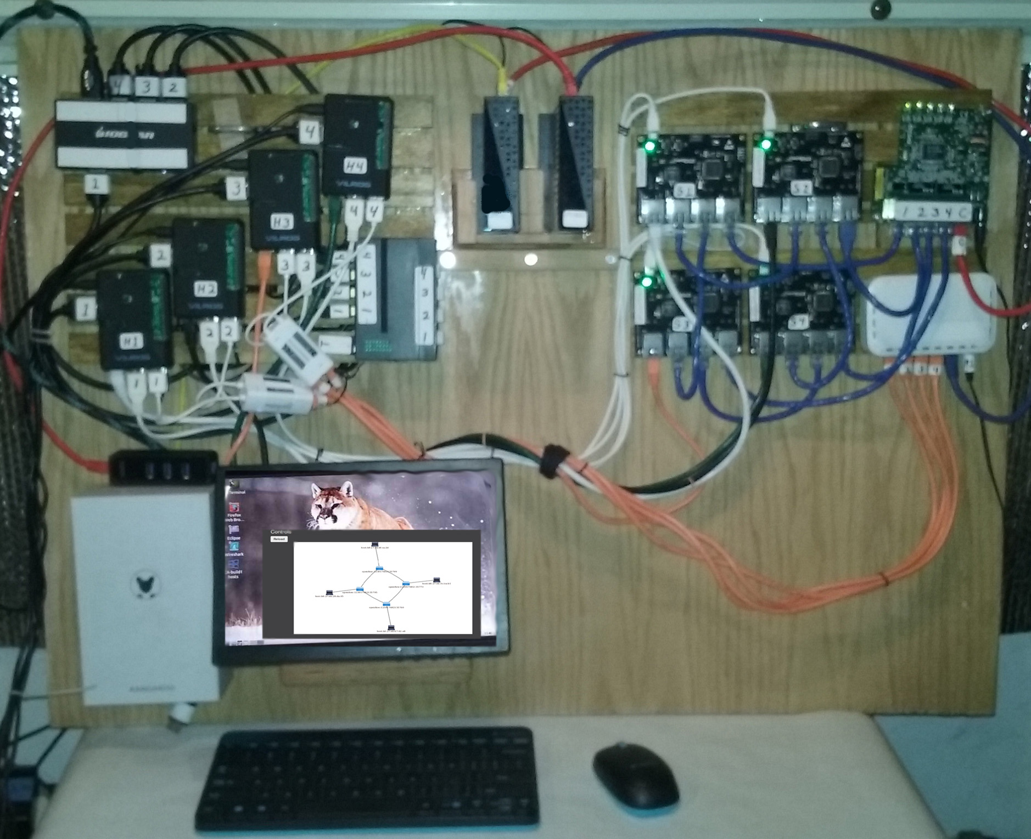
Fig. 1. SDN On-The-Go - a low cost, portable, standalone SDN test bed

