# Portable SDN Network Test Environment for Confidence Assessment

Detailed experiments over SDN require a network test environment. Researchers who do not have access to commercially available SDN enabled hardware are limited to software network simulation, primarily Mininet. Mininet uses linux process-based virtualization on a single OS kernel to run many hosts and switches. Communication and functionality are provided by the single OS. Using network namespaces, Mininet can isolate these processes and assign separate network interfaces, routing and ARP tables to virtual devices such as hosts or switches. These virtual network devices are limited by the CPU speed and physical memory of the single OS kernel. While scaling the system to meet the needs of simulation can lessen the impact of these limitations, there will always be processing overhead and resource limitations that restrict simulation.

Mininet also has a weak concept of virtual time as a part of real time so event timing can vary depending on system load. Mininet uses OpenVSwitch switches running on the same OS so all of the hosts and switches will have similar round-trip time(RTT) between each other and the controller. In addition, buffering by the OS compounds the timing issues leaving it extremely difficult to accurately emulate system performance metrics.

Our research in Confidence Analysis depends heavily on accurate performance metrics. As an alternative to a room full of very expensive network hardware, we have purpose built a portable, four host, four switch, isolated dual band network with a dedicated SDN controller. It fits in a small suitcase, weighs less than ten pounds and is a complete SDN test bed. Our test results in this paper are gathered from this test bed using real network traffic on purpose built SDN switches.

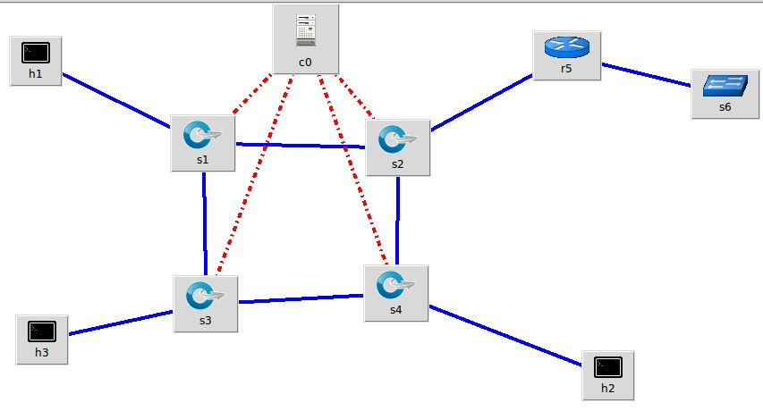

## Test Bed Configuration

### Four switches in a partial mesh configuration:

Zodiac FX – Rev A from Northbound Networks, 10/100Mbs switch based on the Atmel ARM® Cortex®-M4 microcontroller (MCU) at 120 MHz, ATSAM4E8C, 512KB Flash, supporting 2.0 A/B compatible CAN interface, IEEE Std 1588-compatible 10/100Mbps Ethernet MAC, FS USB, HS SDCard / SDIO / MMC interfaces, USARTs, SPIs and multiple TWIs.

### Four Host Computers:

RasberryPi3 Model B v1.2 - 1.2GHz 64-bit quad-core ARMv8 CPU, 1GB RAM, 802.11n Wireless LAN, Bluetooth 4.1, 4 USB ports, 40 GPIO pins, Full HDMI VideoCore IV 3D graphics core, Camera interface (CSI), Display interface (DSI), Micro SD card slot, 3.5mm audio jack.

Each Pi3 Host is connected to its own switch, (h1 > s1, h2 > s2, etc) via the powered USB port. Serial connectivity is provided through this USB port for configuring each switch settings.

Each Pi3 is connected to a with USB Keyboard / Mouse switch, to provide for a Logitech MK240 2.4 GHz Wireless Keyboard and mouse.

Each Pi3 is connected to an IOGear HDMI switch which drives a 10” LED Monitor.

### SDN Controller / Development computer:

Kangaroo Plus by InFocus, Model MD2B, 1.44 GHz 64-bit quad-core Atom x5 Z8300, 4 GB RAM, 32 GB SSD, 802.11 A/C, Ethernet. The primary Ethernet port, eth0 is connected to the NetGear WNDR2000v5 LAN2. A secondary Ethernet port via USB conversion is connected to external LAN3 for remote access.

### Three LANs:

LAN1 – SDN Network consisting of four ZodiacFX switches connected in a partial mesh configuration. Each switch Port 1 is connected to the primary ethernet port eth0 on each RaspberryPi3.

LAN2 - Port 4 of each switch is a dedicated port for the control plane. These ports are connected to a DLink DL1005E hub which is connected to a NetGear WNR2000v5 switch, 10.0.1.0/24. The controller computer is connected through its primary eth0 to this Netgear switch, completing the control plane.

LAN3 – The test bed is complete with an HDMI switch that drives a 7” monitor along with a keyboard / mouse switch for one common keyboard and mouse. LAN3 is the separate LAN for Remote Desktop Protocol (RDP) of each host. This is accomplished using USB-ethernet converters connected to a NetGear WNR5000v5 switch. External devices are connected through this switch.