**Project Name:** **Network Shares**

**Team names:** Philip Boadu Asare

Pascal Amoudzi Tamekloe

Ransford Nii Ahene Nunoo

**Team Photo:**

|  |
| --- |
|  |

**Photos of us working on the project:**

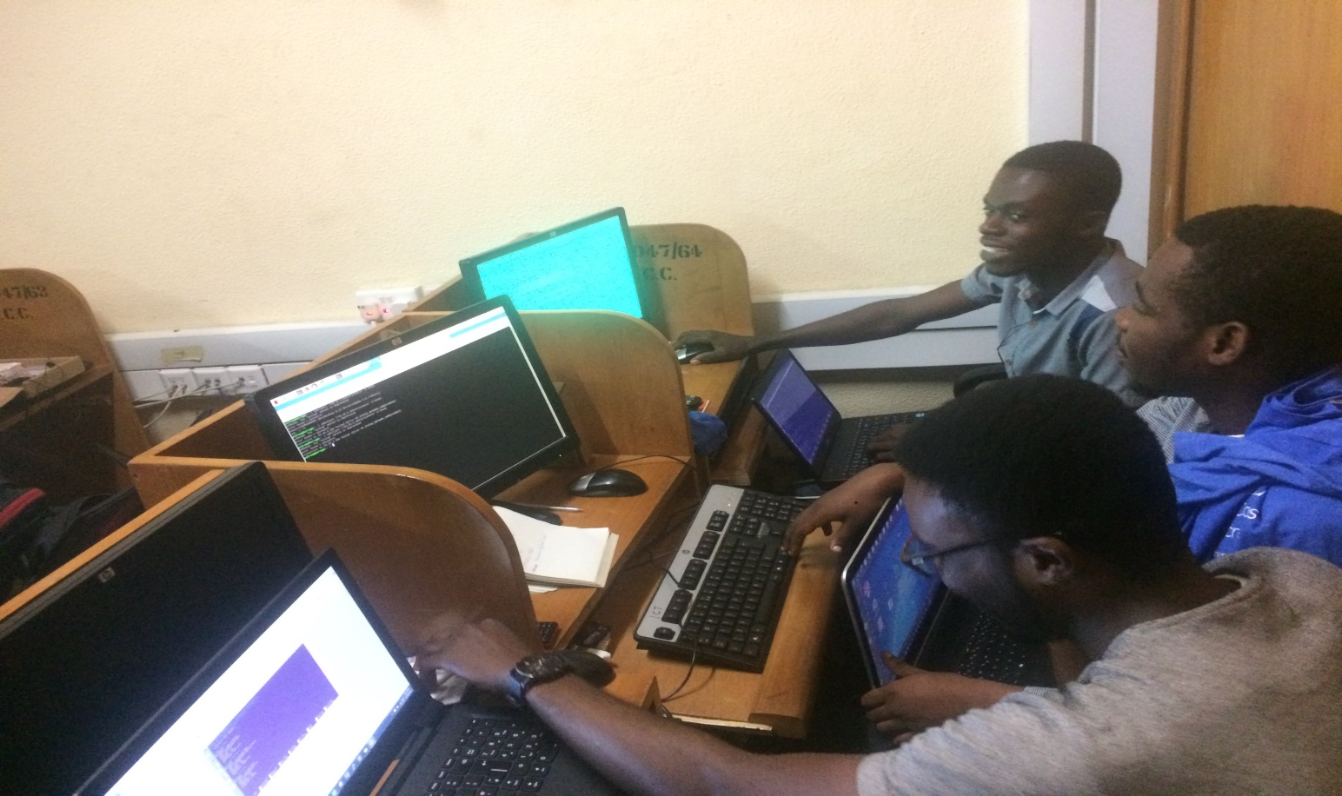

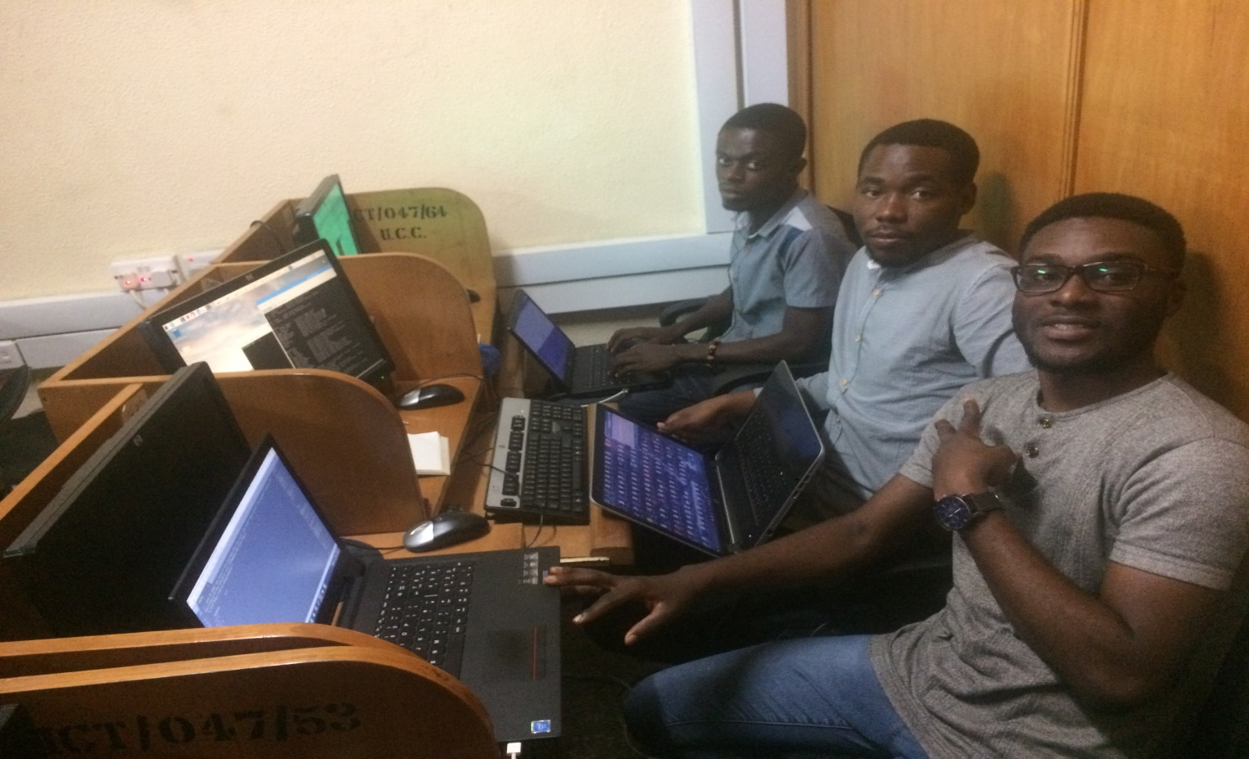

**Sample codes:**

**HTML Code for UI**

|  |
| --- |
|  |

**Samba configuration file (smb.conf)**

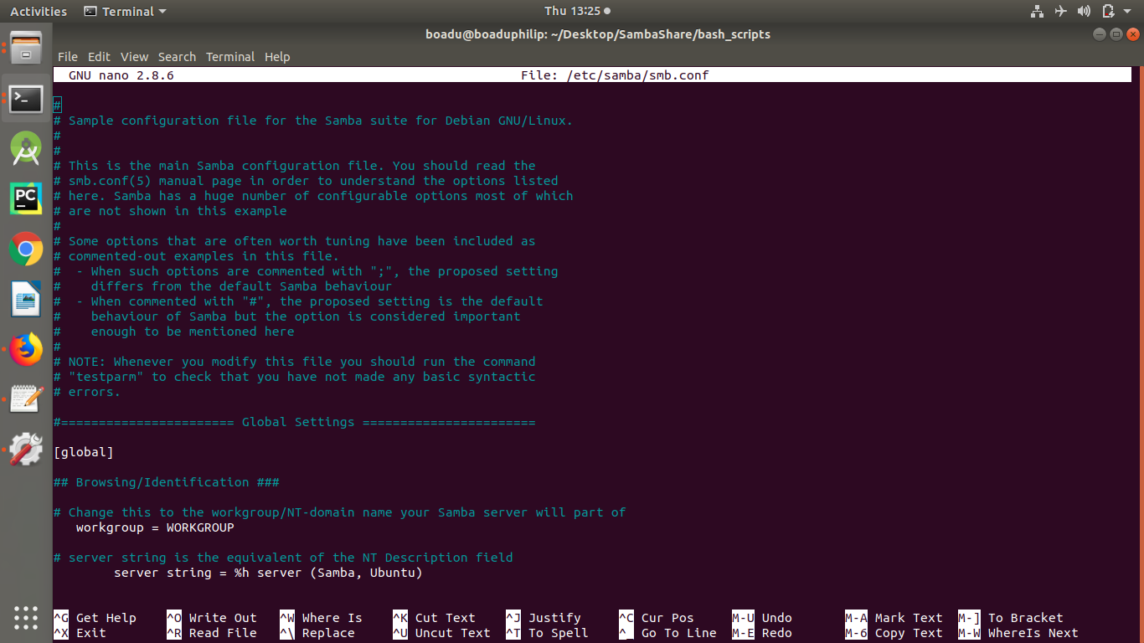

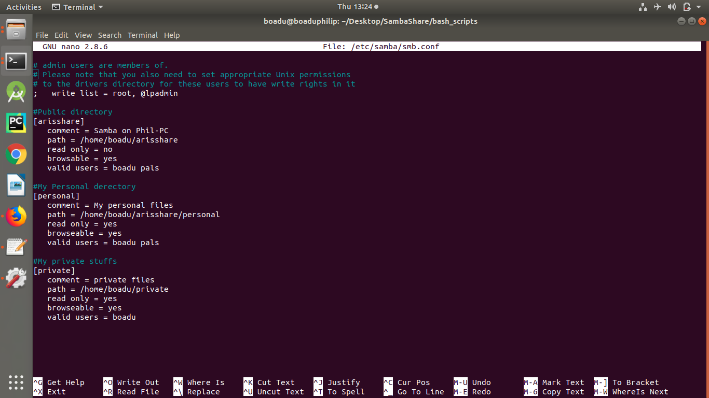

**Screenshot of working interface**

