Names:

Malotsha Talifhani – UI/UX DESIGNER

Sizwe Ndzinisa - BACKEND DEVELOPER

Ponani Chamango - FRONTEND DEVELOPER

Tebogo Ramagoshi – TESTER

Student numbers:

(same order as the names)

St10359475

St10279809

St10057836

St10396455

Course: Diploma of Information Technology in Software Development

Module: Project Management (IPMA6212)

Date: 04 October 2024

**Question 1: Project Identification and Planning**

1.1

The regular delays in emergency response times in South Africa's township and urban areas made this project necessary. There are many instances where locals find themselves in dire circumstances—accidents, robberies, medical crises, etc.—and find it difficult to get in touch with emergency services because of communication gaps or delayed access. The goal of the solution is to give customers a quick, one-touch SOS button that shares their position with pre-defined emergency contacts and instantly connects them to emergency services. (Waugh, 2006)

**Issue Resolved:**

- The emergency services' tardy reaction in dire circumstances.

- Inaccurate location information when calling for help.

Some people cannot call for help in an emergency because they are panicking or are not connected to the network.

**Q1.2: Technological Trend to Be Implemented**

**Technological Trend: Flutter-based cross-platform mobile development.**

**Advantages of the Project:**

Decreased Development Time: Flutter makes it possible to create iOS and Android apps from a single codebase, which speeds up development and enables us to complete the project inside the allotted 10-month period.

Cost Efficiency: By creating a single app for both platforms, we can stay well within our R1,500,000 budget because less resources are needed.

Enhanced User Experience: Uniform functionality and design on both the iOS and Android platforms.

**Three Possible Hazards:**

1. Restricted Utilisation of Native Features: App performance may be limited by cross-platform frameworks' inability to provide all native device functionalities.

2. Performance Issues: In comparison to completely native apps, the app can have some slight lag or performance issues.

3. Dependency on Framework Stability: The third-party framework (Flutter) that is used determines the app's stability and updates.

**Advantages for Users:**

- Same User Experience: Regardless of whether they use iOS or Android, users will get the same experience.

Excellent Availability: Because of its small size, the software will be able to function in places with poor network coverage, which is important in emergency scenarios.

Simple to Access: During situations, customers can rapidly engage the SOS button thanks to the design's simplicity and intuitiveness.

(Hazzard, 2021)

**Q1.3: Deliverables of the Project Charter**

1. Mobile Application Prototype: A complete working prototype that exemplifies the main features of the application.

2. Emergency Services Integration: Direct access via integration with emergency contact databases.

3. Location Sharing Feature: Ability to share GPS location in real time.

4. Cross-Platform Deployment: The application has been successfully deployed on the iOS and Android platforms.

The user documentation includes a video instruction and an extensive user manual. ((PMI), 2021)

Project Management Institute (PMI), 2021. *A Guide to the Project Management Body of Knowledge (PMBOK Guide)*. 7th ed. Newtown Square, PA: Project Management Institute.

**Question 2:**

Work Breakdown Structure

Level 0: Emergency SOS App Project

Level 1:

1. Design

- UI/UX Design

- Wireframe Creation

- Prototype Testing

2. Development

- Backend Development

- Frontend Development

- API Integration

3. Testing

- Unit Testing

- Integration Testing

- User Acceptance Testing

4. Deployment

- App Store Deployment (iOS)

- Google Play Store Deployment (Android)

- Post-Deployment Monitoring

Level 2 Sub-Tasks (for "Development - Backend Development"):

- Setting up a database

- Developing API endpoints

- Implementing security protocols

Team Assignments:

- UI/UX Design: St10359475-Malotsha Talifhani

- Backend Development: St10279809-Sizwe Ndzinisa

- Frontend Development: St10057836-Ponani Chamango

- Testing: St10396455_Tebogo Ramagoshi

Budget Breakdown:

- Design: R300,000

- Development: R700,000

- Testing: R300,000

- Deployment: R200,000 ((PMI), 2021)

**Question 3:**

Q3.1: Project Management Software

Using MS Project:

|  |  |  |  |  |  |  |
| --- | --- | --- | --- | --- | --- | --- |
| Task Name | Duration | Start | Finish | Predecessors | Resource Names | Cost |
| 1. UI/UX Design | 60 days | Fri 24/10/04 | Thu 24/12/26 |  | Malotsha Talifhani | R100 000,00 |
| 1.1 Conduct research about system | 30 days | Fri 24/12/27 | Thu 25/02/06 | 1 |  | R50 000,00 |
| 1.2 Design Wireframe and Models of system | 20 days | Fri 25/02/07 | Thu 25/03/06 | 2 |  | R20 000,00 |
| 1.3 Test Prototype | 10 days | Fri 25/03/07 | Thu 25/03/20 | 3 |  | R10 000,00 |
| 2.Development | 40 days | Mon 24/12/30 | Fri 25/02/21 |  | Sizwe ndzinisa | R250 000,00 |
| 2.1 Backend Development | 30 days | Mon 25/02/24 | Fri 25/04/04 | 5 |  | R250 000,00 |
| 2.1.1 Set up database | 15 days | Mon 25/04/07 | Fri 25/04/25 | 6 |  | R125 000,00 |
| 2.1.2 Develop API endpoints | 7 days | Mon 25/04/28 | Tue 25/05/06 | 7 |  | R62 500,00 |
| 2.1.3 Implement security protocols | 8 days | Wed 25/05/07 | Fri 25/05/16 | 7,8 |  | R62 500,00 |
| 2.2 Frontend Development | 10 days | Mon 25/05/19 | Fri 25/05/30 | 7,8,9 | Ponani chamango | R50 000,00 |
| 2.2.1 API Intergration | 10 days | Mon 25/06/02 | Fri 25/06/13 | 10 |  | R50 000,00 |
| 3. Testing | 15 days | Tue 25/02/18 | Mon 25/03/10 |  | Tebogo Ramagoshi | R100 000,00 |
| 3.1 Unit test application | 8 days | Mon 25/06/16 | Wed 25/06/25 | 11 |  | R65 000,00 |
| 3.2 Test intergration of app | 5 days | Thu 25/06/26 | Wed 25/07/02 | 13 |  | R25 000,00 |
| 3.3 Test user acceptance | 2 days | Thu 25/07/03 | Fri 25/07/04 | 14 |  | R10 000,00 |
| 4. Deployment | 30 days | Mon 25/03/10 | Fri 25/04/18 |  |  | R0,00 |
| 4.1 Deploy to Android and iOS stores | 7 days | Mon 25/07/07 | Tue 25/07/15 | 15 |  | R0,00 |
| 4.2 Monitor issues after deployment | 21 days | Wed 25/07/16 | Wed 25/08/13 | 17 |  | R0,00 |

Milestones:

1. Completion of UI/UX Design

2. Completion of Development Phase

3. Successful Deployment on App Stores

Q3.2: GitHub Issues Log

GitHub Repository Link: https://github.com/NetworkersEd/ProjectApp

**Question 4:**

Q4.1: Network Diagram

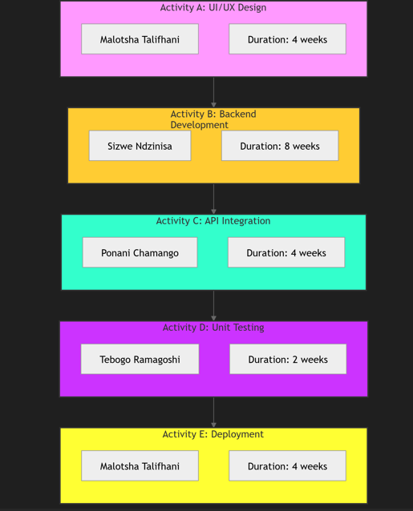

- Activities and Times (in weeks):

- Activity A: UI/UX Design (4 weeks)

- Activity B: Backend Development (8 weeks)

- Activity C: API Integration (4 weeks)

- Activity D: Unit Testing (2 weeks)

- Activity E: Deployment (4 weeks)

Critical Path: A → B → C → D → E ((PMI), 2021)

(Meredith, 2020)

Project Management Institute (PMI), 2021. *A Guide to the Project Management Body of Knowledge (PMBOK Guide)*. 7th ed. Newtown Square, PA: Project Management Institute.

**Q4.2: Justification for Project Completion**

The critical route activities will take a total of 22 weeks, or around 5.5 months, according to the network diagram. As a result, the project can be finished considerably ahead of the 10-month target, giving time for unanticipated events or more testing.

**Question 5:**

5.1

Q5.2: Five-Mark Self-Reflection

As a tester in the team, my role involved addressing various concerns, complaints, queries, and conflicts effectively. I was responsible for thoroughly testing features, identifying and reporting issues, and ensuring the quality of the final product. When concerns or complaints were raised, you approached them with a problem-solving mindset, providing detailed feedback and collaborating closely with developers to find solutions. Proactive communication helped clarify queries from other team members and resolved conflicts that arose due to differing expectations. My contribution helped maintain transparency, foster collaboration, and ensure the team stayed on track toward the project's goals. (Daft, 2018)

**REFERENCES:**

South African Local Government Association (SALGA), 2017. *Emergency Response Times in Townships*. Available at: https://www.salga.org.za/research/EM-response-times [Accessed 3 October 2024].

Waugh, W.L. and Streib, G., 2006. Emergency Management: Principles and Practice for Local Government. 2nd ed. Washington, D.C.: ICMA Press. [Accessed 3 October 2024].

Project Management Institute (PMI), 2021. *A Guide to the Project Management Body of Knowledge (PMBOK Guide)*. 7th ed. Newtown Square, PA: Project Management Institute. [Accessed 3 October 2024].

Lock, D., 2020. *Project Management*. 11th ed. London: Routledge. [Accessed 3 October 2024].

Rouse, M., 2023. *Flutter Overview*. TechTarget. Available at: https://www.techtarget.com/searchmobilecomputing/definition/Flutter-cross-platform [Accessed 3 October 2024].

Daft, R.L., 2018. *The Leadership Experience*. 7th ed. Boston: Cengage Learning. [Accessed 3 October 2024].

Meredith, J.R. and Shafer, S.M., 2020. *Operations Management for MBAs*. 7th ed. Hoboken: Wiley. [Accessed 3 October 2024].