UI Specification
Contents
1. Introduction 4
2. Purpose 4
3. Scope 4
4. UI Design Principles 4
5. Navigation Model 9
5.1 Unauthenticated Navigation 9
5.2 Navigation Header Unauthenticated Screens 9
5.3 Authenticated Navigation 9
5.5 Navigation Behavior 10
5.6 Related Requirements 10
5.7 Header Specification 11
5.7.1 Unauthenticated Header 11
5.7.2 Authenticated Header 11
5.7.3 Header States 12
5.7.4 Related Requirements 12
6. Screen Specifications 13
6.1 UIS-Log-01 Login 13
6.2 UIS-CA-01 Create Account 15
6.3 UIS-RP-01 Reset Password Modal Confirmation 18
6.4 UIS-RP-02 Reset Password 20
6.5 UIS-RP-03 Reset Password Success 23
6.6 UIS-PROF-01 Profile 25
6.7 UIS-PROF-02 Personal Information 27
6.8 UIS-DASH-01 Dashboard 32
6.9 UIS-EP-01 Exercise Program List 35
6.10 UIS-PROG-01 Workout Detail 38
6.11 UIS-LW-01 Log Workout 41
6.12 UIS-HELP-01 Help 45
6.13 UIS-NOTE-01 Notification List 48
6.14 UIS-NOTE-PREF-01 Notification Preference 52
6.15 UIS-RPT-01 Reports 54
6.16 UIS-RPT-02 Power BI Embedded Report Viewer 56
6.17 UIS-WT-01 Weight Tracking 59
6.18 UIS‑ERR‑01 — Error Banner (Global Component) 64
6.19 UIS‑ERR‑02 Global Error Page 66
6.20 UIS‑ERR‑03 Field Validation Error (Global Component) 69
6.21.1 UIS-Login-MFA-01 72
6.22.1 UIS-PROF-MFA-01 MFA Enrollment 74
7.1.1 Focus Order 77
7.1.2 Focus Indicators 78
7.1.3 Keyboard Activation 78
7.2 Screen Reader Support 78
7.2.1 Labels and Roles 78
7.2.2 Announcements 78
7.2.3 Hidden Content 78
7.3 Focus Management 79
7.3.1 Initial Focus 79
7.3.2 Focus Return 79
7.3.3 Focus Trap 79
7.4 ARIA Live Regions 79
7.4.1 Error Messages 79
7.4.2 Notifications 79
7.4.3 Loading States 79
7.5 Reduced Motion 79
7.5.1 Motion Preferences 79
7.5.2 Required Motion 80
7.6 Text Scaling 80
7.6.1 Dynamic Type 80
7.6.2 Minimum Tap Targets 80
7.7 Color and Contrast 80
7.7.1 Contrast Ratios 80
7.7.2 Color Independence 80
7.8 Accessible Error Handling 80
7.8.1 Inline Errors 80
7.8.2 Non‑Blocking Errors 80
7.9 Related Requirements 80
8. Loading & Skeleton States 81
8.1 When Loading States Are Used 81
8.2 Skeleton Loader Usage 81
8.3 Loading Indicators (Non‑Skeleton) 82
8.4 Screen‑Level Loading 82
8.5 List Loading Behavior 82
8.6 Graph Loading Behavior 83
8.7 Insight Loading Behavior 83
8.8 Error Transition from Loading 83
8.9 Accessibility Requirements 83
8.10 Related Requirements 84
9. Error & Empty States 84
9.1 Error States 84
9.1.1 When Error States Appear 84
9.1.2 Error Banner (Global Pattern) 84
9.1.3 Inline Form Errors 85
9.1.4 Screen‑Level Errors 85
9.1.5 Notification‑Specific Errors 86
9.2 Empty States 86
9.2.1 When Empty States Appear 86
9.2.2 Empty State Pattern (Global) 87
9.2.3 Module‑Specific Empty States 87
9.3 Loading → Error → Empty Transitions 88
9.3.1 Loading → Error 88
9.3.2 Loading → Empty 88
9.3.3 Error → Retry → Loading 88
9.4 Accessibility Requirements 88
9.5 Related Requirements 88
10. References 88
11. Revision History 89
12. Approval 89
13. Glossary of Terms 89
14. Appendix B: Document Cross Reference 89

1. Introduction
This UI Specification defines the visual layout, interaction patterns, and user interface behaviors for the NeuByte Fitness Application. It serves as a reference for designers, developers, and testers to ensure consistent implementation of the application’s screens and navigation model.

2. Purpose
The purpose of this document is to describe the structure and behavior of each user‑facing screen, including layout, components, navigation, and interaction rules. This ensures that the implemented UI aligns with business requirements, functional specifications, and accessibility expectations

3. Scope
This document covers all user interface elements for authenticated and unauthenticated screens, including navigation, forms, lists, charts, and feedback mechanisms. It does not define backend logic, API contracts, or low‑level technical implementation details

4. UI Design Principles
Responsive rules
The User Interface will respond to input in a reasonable time (under a few seconds)
Platform guidelines
These principles ensure the NeuByte Fitness App behaves consistently with modern mobile platform standards, providing users with predictable, intuitive interactions regardless of device.
1. Follow Native Navigation Conventions
The app adheres to platform‑standard navigation patterns to reduce cognitive load and ensure familiarity.
- Primary navigation uses a hamburger menu consistent with Android/iOS mobile norms.
- Back navigation uses the OS‑native gesture or back button.
- Screen transitions follow platform‑appropriate motion (slide-in, fade, etc.).

2. Respect System-Level UI Components
The app uses native controls where possible to ensure accessibility, performance, and user trust.
- Native pickers for date, time, and numeric inputs.

- Native keyboard types (numeric for weight, email keyboard for login).
- Native modal sheets for confirmations and destructive actions.
3. Optimize for Mobile-First Interaction
The UI is designed for thumb‑reachable zones and small-screen ergonomics.
- Primary actions placed in lower-third of the screen.
- Tap targets meet minimum 44–48 pixel. guidelines.
- Layouts adapt to portrait-first usage, with responsive behavior for foldables.
4. Honor System Accessibility Settings
The app respects OS-level accessibility preferences to ensure inclusive use.
- Dynamic Type scaling for text.
- High-contrast mode support.
- Reduced motion settings for animations.
- Voice Over/Talk Back compatibility for all interactive elements.
- Keyboard navigation
- Focus management
- ARIA roles
- Live regions
- Reduced motion
- Text scaling
- Contrast
5. Support Platform Security Expectations
The app aligns with mobile security norms to protect user data.
- Use secure OS-level authentication (biometrics, passcode).
- Prevents screenshots on sensitive screens (optional for portfolio).
- Follows platform guidelines for secure storage of tokens and credentials.
6. Leverage Platform Feedback Patterns
The app uses platform-native feedback mechanisms to communicate state.
- Haptic feedback for key actions (save, delete, complete).
- Toast/snack bar notifications for non-blocking messages.
- System vibration patterns for errors or invalid inputs.
7. Component Library
Button
- Purpose: triggers primary action
- States: default, disabled, loading
- Behavior: validates form, shows spinner, blocks double‑submit
- Accessibility: focus ring, ARIA label if icon‑only
- Structure: label + optional icon
Input(s)
Purpose
A reusable form control for user input.
Variants
- Text
- Password
- Number
- Date
- Dropdown
- Radio Group
- Checkbox
States
- Default
- Focus
- Error
- Disabled
- Read‑only
- Loading (if applicable)
Behavior
- Validates on blur or submit
- Shows inline error messages
- Supports keyboard navigation
- Supports screen reader labels
- Supports required/optional indicators

Accessibility
Label must be programmatically associated
- Error must be announced via ARIA live region
- Input must expose correct role
- Focus ring must be visible
Structure
- Label
- Input control
- Helper text (optional)
- Error message (optional)
Error Banner
Role: Alert
Trigger: validation failure or system error
Placement: above form or section
Behavior:
- appears instantly
- traps focus on appearance
- dismissible or not (defined per module)
- announced via screen reader
States:
- error
- warning
- success (if reused)
Content:
- icon (decorative or semantic)
- message text
- optional action link
Cards
- Purpose: container for grouped content
- States: default, focus, selected, loading

- Behavior: clickable, expandable, keyboard‑navigable
- Accessibility: role= “group” or “button”
Skeleton loaders
A skeleton loader appears when:
- Data is being fetched
  - The fetch is expected to take > 200ms
- The user is waiting for content that has a known structure
Appearance:
- Card → rectangular block
- A list row → horizontal bar
- An avatar → circle
- A graph → grey box
- A table → repeated rows
Skeleton loaders persist until:
- the data is returned
- or a timeout threshold is reached (usually 5–10 seconds)
or an error state replaces them
Skeleton loaders must be:
- screen‑reader silent
- non‑focusable
- not announced as content
- not announced as loading indicators
- paired with an ARIA live region for actual loading messages
8. Ensure Performance and Responsiveness
The app meets platform expectations for smooth, fluid interaction.
- 60fps target for animations and transitions.
- Lazy-loading for workout history lists.
- Local caching for offline-first behavior where appropriate.
NeuByte color palette
- Typography
In Order to Match closely Eras Family, the Web page will use Manrope
- Iconography
Font Awesome collection for Hamburger menu and Arrows used to indicate expansion and close.6. Navigation Model
The NeuByte Fitness App uses a mobile‑first navigation structure based on a persistent header and a collapsible hamburger menu. Navigation behavior differs between unauthenticated and authenticated states.

5. Navigation Model
The NeuByte Fitness App uses a mobile‑first navigation structure based on a persistent header and a collapsible hamburger menu. Navigation behavior differs between unauthenticated and authenticated states.

5.1 Unauthenticated Navigation
Unauthenticated screens include:
- Login
- Create Account
- Reset Password
These screens display only the NeuByte logo in the header.
They do not display:
- Notification icon
- Hamburger menu
- User profile access
Navigation is limited to links within the screen (e.g., “Create Account,” “Reset Password”).
Related Requirements
BR-MENU-01, BR-MENU-02, BR-MENU-03, BR-MENU-04, BR-MENU-06

5.2 Navigation Header Unauthenticated Screens
- Display NeuByte Logo only.
- No Notification Icon.
- No Hamburger Menu.

5.3 Authenticated Navigation
After successful login, all screens display a persistent header containing:
- NeuByte Logo (left)
- Notification Icon (right)
- Hamburger Menu Icon (right)
The Notification Icon provides direct access to the Notification List (UIS‑10).
The Hamburger Menu provides access to all primary modules.
5.4 Hamburger Menu Structure
The hamburger menu contains the following items:
- Dashboard
- Exercise Programs
- Log Workout
- Weight Tracking
- Reports
- Profile
- Notifications
- Help
- Logout
- Reset Password
Notifications are not included in the menu because they are accessed exclusively through the Notification Icon in the header.
5.4.1 Wire Frame Reference
UIS-MENU-01
5.4.2 User Interface Design
5.4.1 User Interface Design
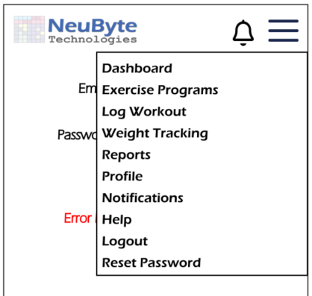
5.4.1.1 Menu UI

5.5 Navigation Behavior
- Selecting a menu item closes the menu and loads the selected screen.
- The menu overlays the current screen and traps focus until closed.
- The Notification Icon displays an unread count badge when applicable.
- The Notification List opens as a full screen and returns to the previous screen when closed.
- Back navigation uses the platform‑native back gesture or button.

5.6 Related Requirements
BR‑MENU‑01, BR‑MENU‑02, BR‑MENU‑03, BR‑MENU‑04, BR‑MENU‑06, BR‑NOTE‑02

5.7 Header Specification
The NeuByte Fitness App uses a persistent header to provide consistent navigation and access to global actions. Header behavior differs between unauthenticated and authenticated states.

5.7.1 Unauthenticated Header
Displayed on:
- UIS‑01 Login
- UIS‑02 Create Account
- UIS‑03 Reset Password
Contents
- NeuByte Logo (left‑aligned)
Behavior
- No Notification Icon
- No Hamburger Menu
- No user‑specific actions
- Navigation occurs only through links within the screen (e.g., “Create Account,” “Reset Password”)
- Header remains static and non‑interactive
Accessibility
- Logo is decorative and does not receive focus
- No interactive elements are present

5.7.2 Authenticated Header
Displayed on all screens after successful login.
Contents
- NeuByte Logo (left‑aligned)
- Notification Icon (right‑aligned)
- Hamburger Menu Icon (right‑aligned, positioned after the Notification Icon)
Behavior
- The header is persistent across all authenticated screens
- The Notification Icon displays an unread count badge when applicable
- Activating the Notification Icon opens the Notification List (UIS‑10)
- Activating the Hamburger Menu opens the primary navigation menu
- The header does not scroll with content (remains fixed at the top)
- Tapping the logo returns the user to the Dashboard (UIS‑04)

Focus & Keyboard Behavior
- Notification Icon is keyboard‑focusable
- Hamburger Menu Icon is keyboard‑focusable
- When the menu is open, focus is trapped inside the menu until closed
- When the Notification List is open, focus moves to the first notification
Accessibility
- Notification Icon includes an ARIA label announcing unread count (e.g., “Notifications, 3 unread”)
- Hamburger Menu Icon includes an ARIA label (“Menu”)
- Header elements follow logical tab order
- Screen readers announce header landmarks

5.7.3 Header States
Default State
- Logo visible
- Notification Icon visible (authenticated only)
- Hamburger Menu visible (authenticated only)
Unread Notifications
- Notification Icon displays a numeric badge
- Badge updates immediately when notifications are read or created
Error State
If notification retrieval fails:
- Notification Icon remains visible
- Badge is suppressed
- A non‑blocking toast message appears (“Unable to load notifications”)

5.7.4 Related Requirements
- BR‑MENU‑01, BR‑MENU‑02, BR‑MENU‑03, BR‑MENU‑04
- BR‑NOTE‑02 (Unread count behavior)
- BR‑A11Y‑xx (Accessibility requirements)
- FS‑NOTE‑04, FS‑NOTE‑05, FS‑NOTE‑11

6. Screen Specifications
Users must have valid credentials to access the system.
All data entries are subject to validation rules.
The system will be accessible via standard web browsers, including mobile devices.

6.1 UIS-Log-01 Login
6.1.1 Purpose
Allows the user to authenticate for the use of the application. Link to Create a new Account if the user needs one.
6.1.2 Screen Layout
6.1.2.1 Layout Structure
Header
- NeuByte Logo centered or left-aligned
- No Notification Icon
- No Hamburger Menu
- No navigation elements
- Static, non-interactive
Body
A vertically stacked login form centered on the screen.
Elements:
- Email Label + Text Input
- Password Label + Password Input
- Forgot Password? link (opens UIS-RP-01)
- Create Account link (opens UIS-CA-01)
- Login Button (primary action)
- Inline Error Label (appears only on authentication failure)
Footer
- App version
- Privacy / Terms links
- Copyright
6.1.2.3 Component Definitions
Email Input
- Label: “Email”
- Text input with email keyboard
- Required
- Validates on blur and submit
Password Input
- Label: “Password”
- Password-masked input

- Required
- Validates on submit
Forgot Password Link
- Opens UIS-RP-01 Reset Password Modal Confirmation
- Inline text link
Create Account Link
- Opens UIS-CA-01 Create Account
Login Button
- Primary action
- Disabled until both fields contain input
- Shows loading state during authentication
Error Label
- Appears only when authentication fails
- Uses global error banner pattern (UIS-ERR-01)
6.1.2.4 Interaction Rules & Behaviors
- Pressing Login triggers authentication
- On success → navigate to Dashboard (UIS-DASH-01)
- On failure → show inline error
- “Forgot Password?” → opens UIS-RP-01 modal
- “Create Account” → navigates to UIS-CA-01
- Keyboard “Enter” submits the form
6.1.2.5 Accessibility Requirements
- Email and Password labels programmatically associated with inputs
- Error message announced via ARIA live region
- Login button reachable via keyboard
- Minimum tap targets (44–48px)
- Screen reader announces: “Login screen” on load
6.1.2.6 Related Requirements
BR-Login-01, BR-Login-02, BR-Login-03, BR-Login-06, BR-Login-07, BR-Login-13
6.1.3 Wire Frame Reference
UIS-Login-01

6.1.35 User Interface Design
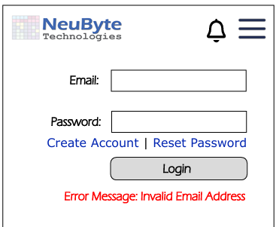
6.1.3.1 Login UI



6.2 UIS-CA-01 Create Account
6.2.1 Purpose
Allow the user to create a new account for the use of the application.
6.2.4 Screen Layout
6.2.4.1 Layout Structure
Header
- NeuByte Logo centered or left-aligned
- No Notification Icon
- No Hamburger Menu
- No navigation elements
- Static, non-interactive
- Matches unauthenticated header rules
Body
A vertically stacked account creation form centered on the screen.
Elements:
- Full Name + Text Input
- Email Label + Text Input
- Password Label + Password Input
- Password Requirements Text (1–2 lines)
- Confirm Password Label + Password Input
- Create Account Button (primary action)
- Inline Error Label (appears only when validation fails)
- Link back to Login (optional, depending on your navigation pattern)
Footer
- App Version
- Privacy / Terms links
- Copyright
6.2.4.3 Component Definitions
Email Input
- Label: “Email”
- Text input with email keyboard
- Required
- Validates on blur and submit
- Inline error for invalid format or duplicate email
Password Input
- Label: “Password”
- Password-masked input
- Required
- Shows password requirements text below
Password Requirements Text
- Example: “Minimum 8 characters, 1 uppercase, 1 number”
- Non-interactive
- Secondary text style
Confirm Password Input
- Label: “Confirm Password”
- Password-masked input
- Required
- Must match Password field
Create Account Button
- Primary action
- Disabled until all fields contain valid input
- Shows loading state during account creation
Inline Error Label
- Appears only when validation fails
- Uses global error banner pattern (UIS-ERR-01)
Login Link
- Text link: “Already have an account? Login”
- Navigates to UIS-01 Login
6.2.4.4 Interaction Rules & Behaviors
- Pressing Create Account triggers account creation
- On success → navigate to Login (UIS-01) or auto-login (depending on your BRs)
- On failure → show inline error
- Password mismatch → inline error under Confirm Password
- Email already used → inline error under Email
- Keyboard “Enter” submits the form
6.2.4.5 Accessibility Requirements
- Labels programmatically associated with inputs
- Password requirements announced via screen reader
- Inline errors announced via ARIA live region
- Create Account button reachable via keyboard
- Minimum tap targets (44–48px)
- Screen reader announces: “Create Account screen” on load
6.2.2 Related Requirements
BR-Create-01 through BR-Create-13
6.2.3 Wire Frame Reference
UIS-CA-01
6.2.4 User Interface Design

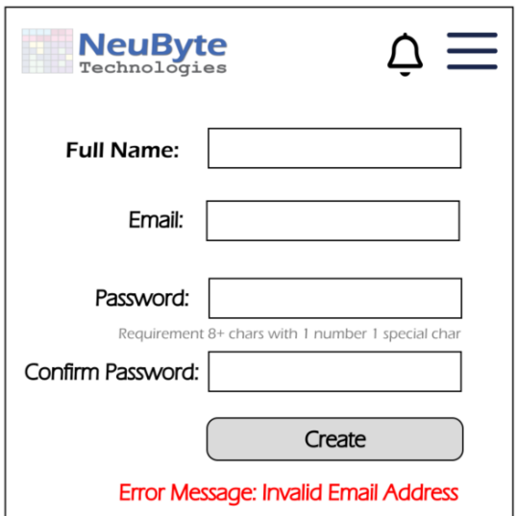
6.2.4.1 Create Account UI

6.3 UIS-RP-01 Reset Password Modal Confirmation
6.3.1. Purpose
This modal provides a lightweight confirmation step when the user selects “Forgot Password?” from the Login screen. It prevents accidental navigation, provides brief context, and transitions the user into the Reset Password form (UIS‑RP‑02).
This is intentionally a modal dialog, not a full screen, to keep the flow simple and aligned with portfolio scope.
6.3.2. Modal Layout
- Modal Container
- Centered on screen
- Approx. 150–250px tall
- Rounded corners
- Background overlay dims Login screen (non‑interactive)
- Content
- Title: “Reset Password?”
- Description: “You’ll create a new password on the next step.”
- Buttons:
- Continue (primary)
- Cancel (secondary / link‑style)
6.3.3. Component Definitions
- Modal Container
- Fixed width (e.g., 320–360px)
- Vertical stack layout

- Dismissible only via Cancel button (no tap‑outside dismissal for security)
- Title Text
- Bold, centered
- Short, action‑oriented
- Description Text
- Secondary text
- Centered
- Max 2 lines
- Primary Button: Continue
- Navigates to UIS‑RP‑02 — Reset Password Form
- Secondary Button: Cancel
- Closes modal
- Returns user to Login screen unchanged
6.3.4. Interaction Rules & Behaviors
- Trigger
- User taps “Forgot Password?” on Login screen → modal opens
- Continue
- Modal closes
- Navigate to UIS‑RP‑02
- Cancel
- Modal closes
- User remains on Login screen
- Background Behavior
- Login screen is visually dimmed
- All background elements disabled
- Keyboard / Accessibility
- ESC closes modal (equivalent to Cancel)
- Focus is trapped inside modal until dismissed
6.3.5. Error States
(Modal has no API calls; errors occur only in UIS‑RP‑02.) There are no error states required.
6.3.6. Accessibility Requirements
- Modal must receive initial focus when opened
- Focus trapping until modal is dismissed
- ARIA role:
- Title announced via screen reader
- Buttons must be keyboard‑navigable
- Background content marked inert
6.3.7. Analytics & Logging
- Modal opened (Forgot Password clicked)
- Continue clicked
- Cancel clicked
6.3.7. Related Requirements
BR-RP-01, BR-RP-02, BR-RP-03
6.3.8 Wire Frame Reference:
UIS-RP-02
6.3.9 User Interface Design
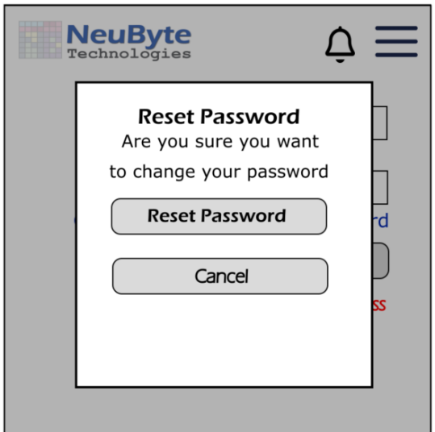
6.3.9.1 Confirm Reset Password

6.4 UIS-RP-02 Reset Password
6.4.1 Purpose
Allow the user to reset existing account password.
6.4.4 Screen Layout
6.4.4.1 Layout Structure
Header
- NeuByte Logo centered or left-aligned
- No Notification Icon
- No Hamburger Menu
- Matches unauthenticated header rules
- Static, non-interactive
Body
A vertically stacked reset password form centered on the screen.
Elements:
- Email Label + Static Email Display (Non-editable; shows the user’s account email)
- Password Label + Password Input
- Password Requirements Text (1–2 lines)
- Confirm Password Label + Password Input
- Reset Password Button (primary action)
- Inline Error Label (appears only when validation fails)
Footer
- App Version
- Privacy / Terms links
- Copyright
6.4.4.3 Component Definitions
Email Display
- Label: “Email”
- Non-editable text field
- Shows the email passed into the reset flow
- Ensures users know which account is being updated
New Password Input
- Label: “New Password”
- Password-masked input
- Required
- Shows password requirements text below
Password Requirements Text
- Example: “Minimum 8 characters, 1 uppercase, 1 number”
- Non-interactive
- Secondary text style
Confirm Password Input
- Label: “Confirm Password”
- Password-masked input
- Required
- Must match New Password
Reset Password Button
- Primary action
- Disabled until all fields contain valid input

- Shows loading state during reset process
Inline Error Label
- Appears only when validation fails
- Uses global error banner pattern (UIS-ERR-01)
6.4.4.4 Interaction Rules & Behaviors
- Pressing Reset Password triggers password update
- On success → navigate to UIS-RP-03 Reset Password Success
- On failure → show inline error
- Password mismatch → inline error under Confirm Password
- Keyboard “Enter” submits the form
- Back navigation returns to Login (optional depending on your flow)
6.4.4.5 Accessibility Requirements
- Labels programmatically associated with inputs
- Password requirements announced via screen reader
- Inline errors announced via ARIA live region
- Reset Password button reachable via keyboard
- Minimum tap targets (44–48px)
- Screen reader announces: “Reset Password screen” on load
6.4.2 Related Requirements
BR-RP-04 through BR-RP-22
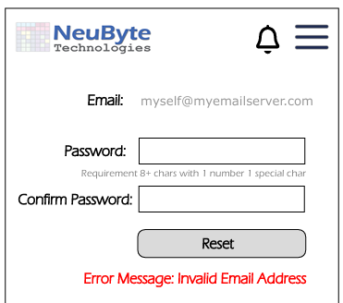
6.4.3 Wire Frame Reference
UIS-RP-01
6.4.3 User Interface Design
6.4.3.1 Reset Password

6.5 UIS-RP-03 Reset Password Success
6.5.1. Purpose
This screen confirms that the user’s password has been successfully reset and provides a clear, single action to return to the Login screen. It completes the Reset Password flow and ensures the user understands the reset was successful.
6.5.2. Screen Layout
- Header
- None (optional) — success screens often omit headers for simplicity
- Success Icon
- Checkmark inside a circle
- Green or brand‑accent color
- Title
- “Password Reset Successfully”
- Description
- “You can now sign in with your new password.”
- Primary Action Button
- Return to Login
- App version
- Privacy / Terms links
6.5.3. Component Definitions
- Success Icon
- Vector or SVG
- 48–64px
- Centered
- Title Text
- Bold
- Centered
- Short and affirmative
- Description Text
- Secondary text
- Centered
- Max 2 lines
- Primary Button: Return to Login
- Navigates to Login screen
- Clears any temporary reset state
6.5.4. Interaction Rules & Behaviors
- On Load
- Display success message
- No API calls required
- Return to Login
- Navigate to Login screen
- User must authenticate with new password
- Back Navigation
- Disabled (user should not return to reset form)
- Timeout (Optional)
- Auto‑redirect after 5–10 seconds
- Only if desired; not required for portfolio
6.5.5. Error States
(None — this screen only displays static success content.)
6.5.6. Accessibility Requirements
- Success icon must have descriptive alt text
- Title announced via screen reader
- Button must be keyboard‑navigable
- Focus placed on the title or success icon on load
6.5.7. Analytics & Logging
- Password reset success event
- Return to Login button clicked
- Auto‑redirect triggered (if implemented)
6.5.8 Wire Frame Reference
6.5.9 User Interface Design
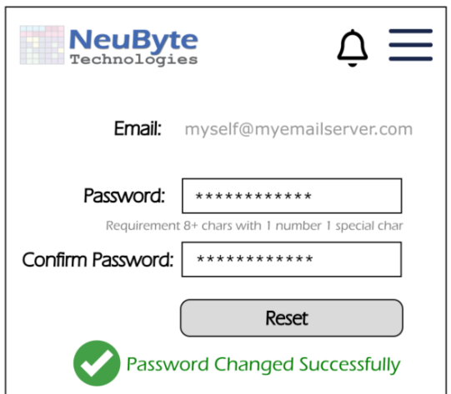
6.5.9.1 Reset Password Success

6.6 UIS-PROF-01 Profile
6.6.1. Purpose
This screen displays the user’s core profile information and provides entry points to profile‑related configuration screens (e.g., personal details, notification preferences, password change, MFA settings). It acts as the central hub for all user‑managed account settings.
6.6.2. Screen Layout
- Header
  - Title: “Profile”
- Profile Summary Block
  - User avatar (static)
  - Full name
  - Email address (primary identifier)
- Profile Sections (List Items)
- Personal Information
  - Subtext: “Name, contact details”
  - Navigates to UIS‑PROF‑02
  - Notification Preferences
  - Subtext: “Email and in‑app notifications”
  - Navigates to UIS‑NOTE‑PREF‑01
- Security Settings
  - Subtext: “Password, MFA”
  - Navigates to UIS‑SEC‑01
  - Logout
  - Standalone action row
- Footer
  - App version
  - “Privacy Policy” link
  - “Terms of Use” link
  - Copyright
6.6.3 Component Definitions
- Avatar Component
- Circular placeholder or initials
- Optional: tap to change photo (future enhancement)
- Profile Summary Text
- Name: bold, primary text
- Email: secondary text
- Verification badge: small icon + “Verified”
- List Item Component
- Label
- Subtext (optional)
- Chevron icon indicating navigation
- Touch target: full row
- Logout Button
- Styled as a destructive or standalone action
- Confirmation dialog on tap
6.6.4 Interaction Rules & Behaviors
- Initial Load
- Fetch user profile data
- Render name, email, verification status
- Navigation
- Tapping a list item routes to the corresponding UIS screen
- Back button returns to previous screen
- Logout Behavior
- Confirmation dialog:
- “Are you sure you want to log out?”
- On confirm → clear session + redirect to Login
- Error Handling
- If profile data fails to load → show inline error + retry option
6.6.5 Error States
- Unable to load Profile
  - API Failure on initial fetch
- Unable to log out
  - Logout API failure
6.6.6 Accessibility Requirements
- All list items must be keyboard‑navigable
- Avatar must have descriptive alt text
- Error messages announced via ARIA live region
- Minimum contrast for all text and icons
6.6.7 Analytics & Logging
- Profile screen viewed
- Navigation events (per section)
- Logout attempts (success/failure)
- Profile load failures
6.6.8 Wire Frame Reference
6.6.9 User Interface Design
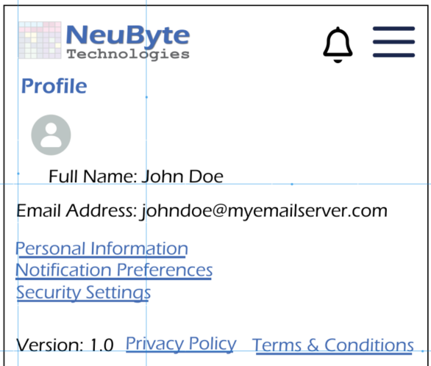
6.6.9.1 Profile

6.7 UIS-PROF-02 Personal Information
6.7.1 Purpose
This screen allows the user to view and update their personal profile information, including name and contact details. It also provides a direct link to the Reset Password flow. This screen is accessed from the Profile hub (UIS‑PROF‑01).
6.7.4 Screen Layout
6.7.4.1 Layout Structure
Header
- Title: “Personal Information”
- Back navigation to UIS-PROF-01 Profile
- Standard authenticated header containing:
  - NeuByte Logo (left)
  - Notification Icon (right)
  - Hamburger Menu (right)
- Header remains fixed at the top
Body
A vertically stacked form allowing the user to view and update their personal information.
Elements:
- Full Name Label + Text Input
- Phone Number Label + Text Input (U.S. format only)
- Phone Type Dropdown (Mobile, Home, Work)
- Reset Password Link (opens UIS-RP-01 modal)
- Save Button (primary)
- Cancel Button (secondary)
- Inline Error Label (appears only when validation fails)
Footer
- App Version
- Privacy Policy / Terms links
- Copyright
6.7.4.3 Component Definitions
Full Name Input
- Required
- Pre-populated with user’s current name
- Validates on blur and submit
Phone Number Input
- Optional
- U.S. format only: ###-###-####
- Numeric keyboard
- Inline error if format is invalid
Phone Type Dropdown
- Required only if Phone Number is provided
- Options: Mobile, Home, Work
Reset Password Link
- Opens UIS-RP-01 Reset Password Modal Confirmation
- Uses same flow as unauthenticated reset
Save Button
- Primary action
- Enabled only when changes are detected
- Shows loading state during save
Cancel Button
- Secondary action
- Returns to UIS-PROF-01 without saving
Inline Error Label
- Appears only when validation fails
- Uses global error banner pattern (UIS-ERR-01)
6.7.4.4 Interaction Rules & Behaviors
Initial Load
- Fetch user profile data
- Populate Full Name, Phone Number, Phone Type
Save Behavior
- Validate fields
- Submit updated profile
- On success → show toast (“Profile updated”) and return to UIS-PROF-01
- On failure → show inline error
Cancel Behavior
- Discard changes
- Navigate back to UIS-PROF-01
Reset Password Link
- Opens UIS-RP-01 modal
- User proceeds through UIS-RP-02 and UIS-RP-03
6.7.4.5 Accessibility Requirements
- All form fields keyboard-navigable
- Labels programmatically associated with inputs
- Inline errors announced via ARIA live region
- Reset Password link must have descriptive ARIA label
- Minimum tap targets (44–48px)
6.7.2 Related Requirements
BR-PROF-01, BR-PROF-02, BR-PROF-03, BR-PROF-04, BR-PROF-05
BR-RP-01 (Reset Password entry point)
6.7.3 Wire Frame Reference
UIS‑PROF‑02
6.7.4 User Interface Design
6.7.4.1 Personal Information UI
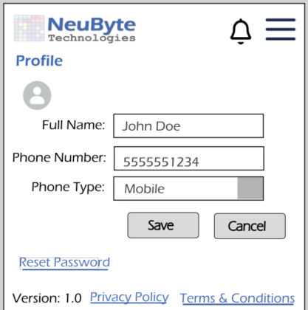
Header
- Title: “Personal Information”
- Back navigation to Profile (UIS‑PROF‑01)
- Standard authenticated header with NeuByte Logo, Notification Icon, and Hamburger Menu
Form Fields
- Full Name
- Text input
- Pre‑populated with user’s current name
- Editable
- Phone Number
- Text input
- U.S. format only (###‑###‑####)
- Numeric keyboard
- Optional field
- Phone Type
- Dropdown: Mobile, Home, Work
- Required only if Phone Number is provided

Account Actions
- Reset Password (link)
- Opens UIS‑RP‑01 (Reset Password Modal Confirmation)
- Uses the same flow as unauthenticated reset
Buttons
- Save (primary)
- Enabled only when changes are detected
- Cancel (secondary)
- Returns to UIS‑PROF‑01 without saving
6.7.5 Interaction Rules & Behaviors
Initial Load
- Fetch user profile data
- Populate Full Name, Phone Number, and Phone Type
- Reset Password link always available
- Save Behavior
- Validate fields
- Submit updated profile data
- Show success toast (“Profile updated”)
- Return to UIS‑PROF‑01
Cancel Behavior
- Discard changes
- Navigate back to UIS‑PROF‑01
- Reset Password Link
- Opens UIS‑RP‑01 modal
- User proceeds through UIS‑RP‑02 and UIS‑RP‑03
Validation Rules
- Full Name: required
- Phone Number: optional, but must match U.S. format if provided
- Phone Type: required only if Phone Number is provided
6.7.6 Error States
- Unable to load the profile
- Inline error + Retry button
- Unable to save changes
- Inline error message
- Save button remains enabled
- Invalid phone number format
- Inline field error
6.7.7 Accessibility Requirements
- All form fields must be keyboard‑navigable
- Labels programmatically associated with inputs
- Inline errors announced via ARIA live region
- Reset Password link must have descriptive ARIA label
- Minimum tap targets for all interactive elements
6.7.8 Analytics & Logging
- Personal Information screen viewed
- Profile update attempted (success/failure)
- Reset Password link clicked

6.8 UIS-DASH-01 Dashboard
6.8.1 Purpose
Provide the user with a clean, lightweight, high-signal overview of their fitness program, today’s workout, recent activity, and key progress indicators. The dashboard is intentionally minimal and mobile-friendly, avoiding heavy analytics or graphs.
6.8.2 Screen Overview
The dashboard includes:
- User identity and last login
- Current or next workout (based on workout log)
- Today’s workout summary
- Weight trend indicator (arrow + color)
- Recent activity (3–5 items)
- Program Progress Summary
- Notifications
- Optional: Last Synced indicator
No charts, no cards, no complex visuals.
6.8.3 Layout Structure
Header
- Title: Dashboard
- Last Login: “Last login: MM/DD/YYYY HH:MM”
- Email: “johndoe@myemailserver.com”
6.8.4 Current / Next Workout Logic
Rule
- If today’s scheduled workout has NOT been logged → show Current Workout
- If today’s scheduled workout HAS been logged → show Next Workout
Display
Current Workout
Week 4, Day 1 — Upper Body Strength
Start Workout
Next Workout
Week 4, Day 2 — Lower Body Strength
If program is complete
Next Workout
Program Complete This section is intentionally minimal — no icons, no cards.
6.8.5. Today’s Workout Summary
Displayed only when the workout is “Current.”
Fields:
- Number of exercises
- Estimated duration
- Optional: Equipment needed (text only)
- Start Workout button
Example:
Today’s Workout
8 exercises • ~42 minutes
Start Workout
6.8.6. Weight Trend Indicator
Display
- Up arrow (green) → positive trend – This should depend on weight goal versus current weight some may want to gain others lose weight.
- Down arrow (red) → negative trend
- Flat arrow (gray) → stable trend
Tooltip
“Based on last 7 days. View Weight Trend Report for detailed graph.”
This keeps the dashboard lightweight and pushes analytics to Reports.
6.8.7 Recent Activity
A list of the last 3–5 logged workouts.
Fields
- Date
- Program + Week/Day
- Completion status
- Tap → opens View/Edit Activity screen
Example
Recent Activity
04/28 — Week 3 Day 4 — Completed
04/27 — Week 3 Day 3 — Completed
04/25 — Week 3 Day 2 — Completed
No icons, no thumbnails, no cards.
8. Program Progress Summary
A simple text-based summary:
Program Progress
Week 4 of 8 • 42% Complete
Still text-only, no progress bars unless you explicitly want them.
6.8.2 Related Requirements
BR-DASH-01, BR-DASH-02, BR-DASH-03, BR-DASH-04, BR-DASH-05, BR-DASH-06, BR-DASH-07, BR-DASH-08, BR-DASH-09, BR-DASH-10, BR-DASH-11, BR-DASH-12, BR-DASH-13, BR-DASH-14, BR-DASH-15, BR-DASH-16, BR-DASH-17, BR-DASH-18, BR-DASH-19, BR-DASH-20, BR-DASH-21, BR-DASH-22, BR-DASH-23
6.8.3 Wire Frame Reference
UIS-DASH-01
6.8.4 User Interface Design
6.8.4.1 Dashboard
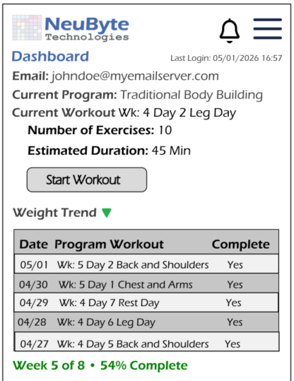

6.9 UIS-EP-01 Exercise Program List
6.9.1 Purpose
The Exercise list shows a variety of exercise programs the user can choose from to select in support of their fitness journey.
6.9.4 Screen Layout
6.9.4.1 Layout Structure
Header
- Standard authenticated header containing:
  - NeuByte Logo (left)
  - Notification Icon (right)
  - Hamburger Menu (right)
- Header remains fixed at the top
- Back navigation uses platform-native gesture or OS back button

Body
A vertically scrolling list of available exercise programs the user can browse and select.
Elements:
- Page Title: “Exercise Programs”
- Program List (scrollable)
  - Program Name
  - Duration (e.g., “8 Weeks”)
  - Difficulty (Beginner / Intermediate / Advanced)
  - Short Description (1–2 lines)
  - Chevron or row-tap navigation to Program Detail (UIS-PROG-01)
- Optional Filters (future enhancement)
  - Difficulty
  - Duration
  - Category
Footer
- App Version
- Privacy Policy / Terms links
- Copyright
6.9.4.3 Component Definitions
Program List Item
Each program row contains:
- Program Name (bold)
- Duration (text)
- Difficulty (text)
- Short Description (1–2 lines)
- Chevron or row-tap navigation to UIS-PROG-01
Behavior:
- Entire row is tappable
- Opens Program Detail screen
- Uses standard list item component
List Behavior
- Scrollable vertical list
- Lazy-loading if list is long
- Skeleton loaders appear while fetching data
Empty State
If no programs are available:
No exercise programs available.
Please check back later.
Uses global empty state pattern.
Error State
If program list fails to load:
- Show UIS-ERR-01 error banner
- Provide “Retry” action
6.9.4.4 Interaction Rules & Behaviors
Initial Load
- Fetch list of available programs
- Display skeleton loaders until data is returned
Selecting a Program
- Tap on a program row → navigate to UIS-PROG-01 Workout Detail
Back Navigation
- Uses OS-native back gesture or button
- Returns to Dashboard or previous screen
6.9.4.5 Accessibility Requirements
- All list items must be keyboard-navigable
- Program Name announced as primary label
- Duration and Difficulty announced as secondary text
- Chevron icon marked decorative
- Inline errors announced via ARIA live region
- Minimum tap targets (44–48px)
6.9.2 Related Requirements
BR-EP-01, BR-EP-02, BR-EP-03, BR-EP-04, BR-EP-05, BR-EP-06, BR-EP-07, BR-EP-08, BR-EP-09, BR-EP-10
6.9.3 Wire Frame Reference
UIS-DASH-01

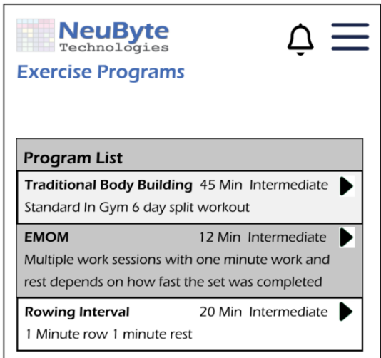
6.9.4 User Interface Design
6.9.4.1 Exercise Program List

6.10 UIS-PROG-01 Workout Detail
6.10.1 Purpose
Show a Selected Exercise Program Detail so the user can understand what is being asked for in the program.
6.10.4 Screen Layout — Workout Detail
6.10.4.1 Layout Structure
Header
- Standard authenticated header containing:
  - NeuByte Logo (left)
  - Notification Icon (right)
  - Hamburger Menu (right)
- Header remains fixed at the top
- Back navigation uses OS-native gesture or back button
Body
Displays the full details of a selected workout from an exercise program.
Elements:
- Workout Title (e.g., “Week 4, Day 1 — Upper Body Strength”)
- Workout Description (1–3 lines)
- Estimated Duration (e.g., “~42 minutes”)
- Equipment Needed (optional text list)
- Exercise List (scrollable)
  - Exercise Name
  - Sets × Reps or Duration
- Start Workout Button (primary action)
Footer
- App Version
- Policy / Terms links
- Copyright
6.10.4.3 Component Definitions
Workout Title
- Bold, primary text
- Includes program context (Week/Day)
Workout Description
- Short summary of workout goals
- Optional but recommended
Duration
- Text only
- Example: “~42 minutes”
Equipment Needed
- Optional
- Text list (no icons, no images)
Exercise List
Each row includes:
- Exercise Name (bold)
- Prescription (Sets × Reps or Duration)
- Entire row is non-interactive (view-only)
Start Workout Button
- Primary action
- Navigates to UIS-LW-01 Log Workout
- Enabled at all times
Empty State
If workout has no exercises:
No exercises found for this workout.
Uses global empty state pattern.
Error State
If workout details fail to load:
- Show UIS-ERR-01 error banner
- Provide “Retry” action
6.10.4.4 Interaction Rules & Behaviors
Initial Load
- Fetch workout detail data
- Display skeleton loaders until data is returned
Start Workout
- Navigates to UIS-LW-01 Log Workout
- Passes workout ID and exercise list
Back Navigation
- Uses OS-native back gesture or button
- Returns to Exercise Program List (UIS-EP-01)
6.10.4.5 Accessibility Requirements
- All list items keyboard-navigable
- Exercise Name announced as primary label
- Sets × Reps announced as secondary text
- Inline errors announced via ARIA live region
- Minimum tap targets (44–48px)
- Screen reader announces: “Workout Detail screen” on load
6.10.2 Related Requirements
BR-PROG-01, BR-PROG-02, BR-PROG-03, BR-PROG-04, BR-PROG-05, BR-PROG-06, BR-PROG-07
6.10.3 Wire Frame Reference
UIS-WP-01

6.10.4 User Interface Design
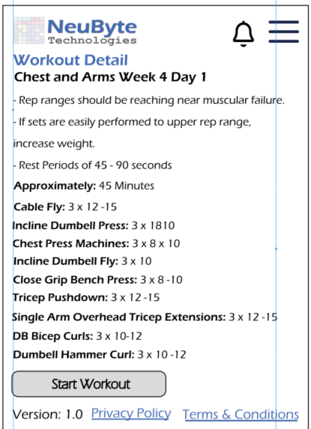
6.10.4.1 Workout Detail

6.11 UIS-LW-01 Log Workout
6.11.1 Purpose
Allow the user to record the details of their completed workout for the current day, including sets, reps, weight, duration, distance, and rest periods as applicable. This enables accurate tracking of workout performance and progress over time.
6.11.4 Screen Layout — Log Workout
6.11.4.1 Layout Structure
Header
- Standard authenticated header containing:
  - NeuByte Logo (left)
  - Notification Icon (right)
  - Hamburger Menu (right)
- Header remains fixed at the top
- Back navigation uses OS-native gesture or back button
- Title is not required (Workout Detail already provides context)
Body
A vertically scrolling form that allows the user to log sets, reps, weight, duration, or other metrics for each exercise in the selected workout.

Elements:
- Workout Title (Week/Day + Name)
- Exercise List (scrollable) Each exercise includes:
  - Exercise Name
  - Set Rows (1 row per set)
    - Reps input
    - Weight input (optional)
    - Duration input (if applicable)
    - RPE input (optional)
  - “Add Set” button (if user wants additional sets)
- Workout Notes (optional text area)
- Save Workout Button (primary action)
- Cancel Button (secondary action)
- Inline Error Label (appears only when validation fails)
Footer
- App Version
- Privacy Policy / Terms links
- Copyright
6.11.4.3 Component Definitions
Workout Title
- Bold, primary text
- Includes program context (Week/Day)
Exercise Section
Each exercise block contains:
- Exercise Name (bold)
- Set Rows
  - Reps input (numeric)
  - Weight input (numeric, optional)
  - Duration input (if exercise is time-based)
  - RPE input (optional)
- Add Set Button
  - Adds a new set row
  - Uses standard button component
Workout Notes
- Optional text area
- Multi-line input
Save Workout Button
- Primary action
- Validates all inputs
- Saves workout log
- Returns user to Dashboard or Workout History
Cancel Button
- Secondary action
- Discards changes
- Returns to previous screen
Inline Error Label
- Appears only when validation fails
- Uses global error banner pattern (UIS-ERR-01)
6.11.4.4 Interaction Rules & Behaviors
Initial Load
- Fetch workout structure (exercises + default sets)
- Pre-populate set rows based on program definition
- Display skeleton loaders until data is returned
Logging Sets
- User enters reps, weight, duration, or RPE
- Validation occurs on blur and on submit
- Add Set adds a new row at the bottom
Save Behavior
- Validate all fields
- Submit workout log
- On success →
  - Show toast (“Workout logged”)
  - Navigate to Dashboard or Recent Activity
Cancel Behavior
- Discard changes
- Navigate back to Workout Detail (UIS-PROG-01)
Error Handling
- Inline errors for invalid numeric inputs
- Global error banner for save failures
6.11.4.5 Accessibility Requirements
- All form fields keyboard-navigable
- Labels programmatically associated with inputs
- Inline errors announced via ARIA live region
- Add Set button must have descriptive ARIA label
- Minimum tap targets (44–48px)
- Screen reader announces: “Log Workout screen” on load
6.11.2 Related Requirements
BR-LW-01 through BR-LW-15 BR-DASH-xx (Recent Activity integration) FS-LW-xx (Workout logging functional rules)
6.11.3 Wire Frame Reference
UIS-WP-01
6.11.4 User Interface Design
6.11.4.1 Log Workout
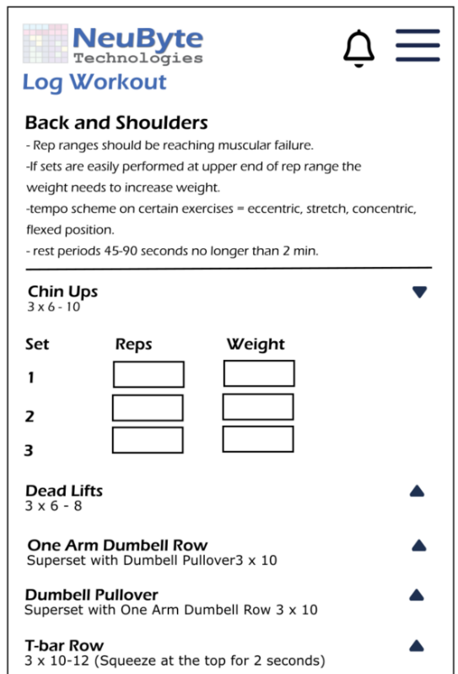

6.12 UIS-HELP-01 Help
6.12.1 Purpose
The main application page to provide help to the user.
6.12.4 Screen Layout — Help
6.12.4.1 Layout Structure
Header
- Standard authenticated header containing:
  - NeuByte Logo (left)
  - Notification Icon (right)
  - Hamburger Menu (right)
- Header remains fixed at the top
- Back navigation uses OS-native gesture or back button
Body
Vertically scrolling helps screen provide access to support resources.
Elements:
- Page Title: “Help”
- Support Options Section
  - “Contact Support” (email link)
  - “FAQ”
- Static Help Content
  - Short description of how to get help
  - Support email address
  - Expected response time (optional)
- FAQ List (Expandable Items)
  - Question (tap to expand)
  - Answer (1–3 lines)

Footer
- App version
- Privacy Policy / Terms Links
- Copyright
6.12.4.3 Component Definitions
Support Options
- Contact Support
  - Opens default email client
  - Pre-populates “To” field with support email
- FAQ
  - Scrolls to FAQ section or opens UIS-HELP-FAQ (if separate)
- Policies
  - Opens Privacy Policy and Terms of Use
FAQ Items
Each FAQ row includes:
- Question (bold)
- Chevron or “>” indicator
- Expandable Answer (1–3 lines)
Behavior:
- Tap to expand/collapse
- Only one FAQ open at a time (optional)
Policies
- Text links
- Opens external or internal policy pages
Error State
If FAQ or policy content fails to load (if dynamic):
- Show UIS-ERR-01 error banner
- Provide “Retry” action
6.12.4.4 Interaction Rules & Behaviors
Initial Load
- Display static help content immediately
- Load FAQ items (static or dynamic depending on implementation)
Contact Support
- Opens email client
- Pre-fills support address
- Subject line optional: “NeuByte Fitness Support Request”
FAQ Interaction
- Tap question → expand answer
- Tap again → collapse
- Screen scrolls to expanded content
Policies
- Opens Privacy Policy or Terms of Use
- Back navigation returns to Help
6.12.4.5 Accessibility Requirements
- All list items keyboard-navigable
- FAQ expand/collapse announced via ARIA live region
- Email link must have descriptive ARIA label
- Minimum tap targets (44–48px)
- Screen reader announces: “Help screen” on load
6.12.2 Related Requirements
BR-HELP-01, BR-HELP-02, BR-HELP-03, BR-HELP-04, BR-HELP-05, BR-HELP-06, BR-HELP-07, BR-HELP-08, BR-HELP-09, BR-HELP-10, BR-HELP-11, BR-HELP-12, BR-HELP-13, BR-HELP-14, BR-HELP-15, BR-HELP-16, BR-HELP-17
6.12.3 Wire Frame Reference
UIS-HELP-01
6.12.4 User Interface Design
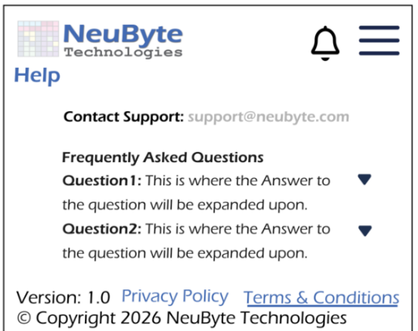
6.12.4.1 Help

6.13 UIS-NOTE-01 Notification List
6.13.1 Purpose
Show a central List of application Notifications for a user.
6.13.4 Screen Layout — Notification List
6.13.4.1 Layout Structure
Header
- Standard authenticated header containing:
  - NeuByte Logo (left)
  - Notification Icon (right, with unread badge if applicable)**
  - Hamburger Menu (right)
- Header remains fixed at the top
- Back navigation uses OS-native gesture or back button
- Opening this screen clears unread count (per BR-NOTE-02)
Body
A vertically scrolling list of user notifications.
Elements:
- Page Title: “Notifications”
- Notification List (scrollable) Each notification includes:
  - Title (bold)
  - Timestamp (e.g., “2 hours ago”)
  - Short message (1–2 lines)
  - Unread indicator (dot or bold text)
- Optional Filters (future enhancement)
  - All
  - Unread
  - System
  - Program Updates
- Empty State (if no notifications)
- Error State (if notifications fail to load)
Footer
- App Version
- Privacy Policy / Terms links
- Copyright
6.13.4.3 Component Definitions
Notification List Item
Each row contains:
- Unread Indicator
  - Dot or bold title
  - Removed once user views the list
- Title
  - Short, bold summary
- Message
  - 1–2 lines of detail
- Timestamp
  - Relative time (e.g., “2 hours ago”)
  - Or absolute date if older
Behavior:
- Entire row is tappable
- Opens Notification Detail (if implemented) or simply marks as read
- Uses standard list item component
List Behavior
- Scrollable vertical list
- Lazy-loading if list is long
- Skeleton loaders appear while fetching data
Empty State
If no notifications exist:
Code
No notifications yet.
You’ll see updates about your workouts and progress here.
Uses global empty state pattern.
Error State
If notifications fail to load:
- Show UIS-ERR-01 error banner
- Provide “Retry” action
6.13.4.4 Interaction Rules & Behaviors
Initial Load
- Fetch notifications
- Display skeleton loaders until data is returned
- Clear unread count when screen is opened
Selecting a Notification
- Tap row →
  - If Notification Detail exists → navigate
  - If not → mark as read only
- Unread indicator removed immediately
Back Navigation
- Uses OS-native back gesture or button
- Returns to previous screen
Error Handling
- Inline error banner for load failures
- Retry reloads the list
6.13.4.5 Accessibility Requirements
- All list items keyboard-navigable
- Unread indicator announced via ARIA label (“Unread notification”)
- Timestamp announced as secondary text
- Inline errors announced via ARIA live region
- Minimum tap targets (44–48px)
- Screen reader announces: “Notification List screen” on load
6.13.2 Related Requirements
BR-NOTE-01, BR-NOTE-02, BR-NOTE-03, BR-NOTE-04, BR-NOTE-05 FS-NOTE-04, FS-NOTE-05, FS-NOTE-11 BR-MENU-xx (header behavior)
6.13.3 Wire Frame Reference
UIS-NOTE-01

6.13.4 User Interface Design
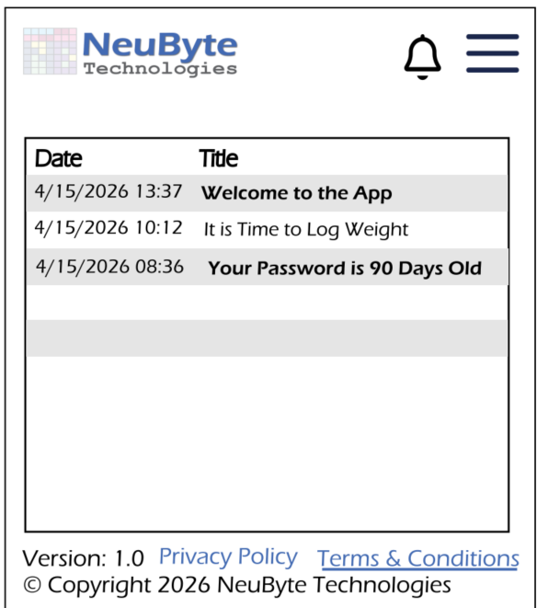
6.13.4.1 Notification List

6.14 UIS-NOTE-PREF-01 Notification Preference
6.14.1 Purpose
This screen allows the user to configure which system notifications they want to receive and through which delivery channels (Email and In‑App). SMS is intentionally excluded from the portfolio scope due to cost and infrastructure requirements.
6.14.2 Screen Layout
- Header
- Title: “Notification Preferences”
- Back navigation to Profile or Settings
- Intro Text
- “Choose how you want to receive notifications.”
- Notification Category List
Each category is displayed as a card or row with:
- Category name
- Channel toggles:
- Email
- In‑App
- State reflects user’s saved preferences
- Save Button
- Primary action
- Disabled until a change is detected
- Footer
- “Learn more about notifications” link
6.14.3 Component Definitions
- Category Row
- Label: Notification category (e.g., “Account Alerts”, “Program Updates”)
- Channel Toggles:
- Email (on/off)
- In‑App (on/off)
- Toggles reflect current stored preferences
- Save Button
- Enabled only when unsaved changes exist
- On click → submit updated preferences
6.14.4 Interaction Rules & Behaviors
- Initial Load
- Fetch user’s current notification preferences
- Render categories dynamically based on BR list
- Toggle Behavior
- Changing any toggle marks screen as “dirty”
- Save button becomes active
- Save Action
- Submit updated preferences
- On success → confirmation toast: “Preferences saved.”
- On failure → inline error
- Channel Availability Rules
- Email toggle disabled if user’s email is unverified
- In‑App is always available
6.14.5 Error States
- Unable to Load Preferences
  - API failure on initial fetch
- Unable to save changes
  - API failure on save
- Email Unavailable
  - User has no valid email
6.14.6. Accessibility Requirements
- All toggles must be keyboard‑navigable
- ARIA labels for each toggle: “Email notifications for [Category]”
- Error messages announced via ARIA live region
- Minimum contrast for toggle states
6.14.7 Analytics & Logging
- Screen viewed event
- Toggle changes (per category, per channel)
- Save success/failure
- Email‑unverified state detection
6.14.8 Analytics & Logging
UIS-NOTE-PREF-01
6.14.9 Related Requirements
BR-NOTE-17, BR-NOTE-18, BR-NOTE-20, BR-NOTE-21, BR-NOTE-22, BR-NOTE-23, BR-NOTE-29
6.14.10 Wire Frame Reference
NOTE-PREF-01
6.14.11 User Interface Design
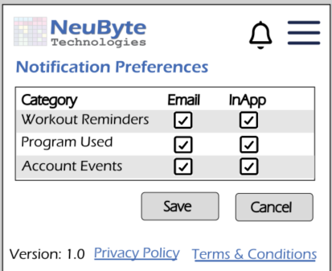
6.14.11.1 Notification Preference

6.15 UIS-RPT-01 Reports
6.15.1 Purpose
Display the list of available reports in a clean, enterprise-style table/grid, allowing the user to browse, understand, and select a report to view. This screen replaces the earlier “card list” concept and aligns with the portfolio’s established table-based list patterns.
6.15.2 Screen Overview
As a design decision to keep things minimal there is no need to have an Actions column.
As such, the design will use a simple, minimal, table-driven layout with:
- Page title: Reports
- Optional description text (one line)
- A table/grid with alternating row background colors
  - Row 1: white
  - Row 2: “#F7F7F7”
  - Repeat pattern

- No icons, no thumbnails, no card UI
- Each report name is a text link that navigates to UIS-RPT-02 (Report Viewer)
3. Layout Structure
Header
- Title: Reports
Table Columns
- Report Name — clickable text link
- Updated — date (MM/DD/YYYY)
- Alternating background colors
- Hover state: light highlight (“#EFEFEF”)
- Hover text: The Report Description
- Click on Report Name → navigates to UIS-RPT-02
4. Interaction Rules
Sorting
- Default sort: Report Name (A–Z)
- Users may click column headers to sort:
  - Report Name
  - Updated
5. Empty State
If no reports are available:
Message: “No reports are currently available.”
No buttons, no icons, no illustrations.
6. Error State
If the report list fails to load:
Banner (UIS-ERR-01): “Unable to load reports. Please try again.”
7. Navigation
- Clicking a report name → UIS-RPT-02 (Report Viewer)
- Back navigation handled by browser or app shell
6.15.2 Related Requirements
BR-RPT-01, BR-RPT-02, BR-RPT-03, BR-RPT-04, BR-RPT-05, BR-RPT-06, BR-RPT-07, BR-RPT-08, BR-RPT-09, BR-RPT-10, BR-RPT-11, BR-RPT-12, BR-RPT-13, BR-RPT-14, BR-RPT-15, BR‑RPT‑16, BR‑RPT‑17, BR‑RPT‑18, BR‑RPT‑19, BR‑RPT‑20, BR‑RPT‑21, BR‑RPT‑22, BR‑RPT‑23, BR‑RPT‑24, BR‑RPT‑25, BR‑RPT‑26, BR‑RPT‑27, BR‑RPT‑28
6.15.3 Wire Frame Reference
UIS-RPT-01
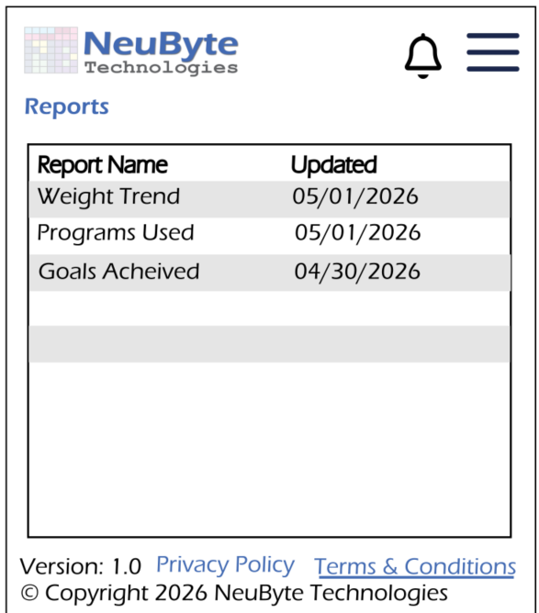
6.15.4 User Interface Design
6.15.4.1 Report List

6.16 UIS-RPT-02 Power BI Embedded Report Viewer
6.16.1. Purpose
This screen displays a selected Power BI report inside the application using the Power BI Embedded Viewer. It provides navigation, loading states, and error handling while delegating all report interactions (filtering, exporting, drill‑down, refresh) to Power BI itself.
This screen is required because the viewer container is part of your UI, even though the report content is not.
6.16.2. Screen Layout
- Header
- Title: dynamic, based on selected report name
- Back navigation: “Back to Reports List”
- Loading State
- Spinner or progress indicator
- Text: “Loading report…”
- Embedded Viewer Container
- Full‑width, scrollable container
- Hosts the Power BI iframe
- No custom controls inside the container
- Error State (Conditional)
- Inline error message
- Retry button
6.16.3. Component Definitions
- Header Title
- Displays the report name passed from UIS‑RPT‑01
- Truncated if long
- Back Button
- Returns to UIS‑RPT‑01 (Report List)
- Viewer Container
- Fixed region on the screen
- Embeds Power BI via iframe or JavaScript SDK
- No styling of internal Power BI UI
- Loading Indicator
- Visible until Power BI signals “loaded”
- Error Message Block
- Shown if embed token fails, report ID invalid, or network error
- “Unable to load report. Please try again.”
6.16.4. Interaction Rules & Behaviors
- On Navigation to Screen
- App receives
- App requests embed token from backend
- App initializes Power BI Embedded Viewer
- Loading Behavior
- Show loading indicator until Power BI viewer fires “loaded” event
- Error Handling
- If token request fails → show error block
- If Power BI viewer fails to load → show error block
- Retry button re‑attempts initialization
- Back Navigation
- Always returns to UIS‑RPT‑01
- Does not preserve Power BI state (Power BI handles its own state)
- User Interactions Inside Report
- Filtering
- Drill‑down
- Export
- Refresh
- Page navigation
- Bookmarking
- Slicers
All handled by Power BI. Not part of app UI Spec.
6.16.5. Error States
- Unable to load report
  - Token request Failure
- Report Not Found
  - Invalid Report ID
- Viewer Initialization Failed
  - Power BI Embedded Error
- Network Error
  - Connectivity issue
6.16.6. Accessibility Requirements
- Back button must be keyboard‑navigable
- Loading indicator must have ARIA role
- Error messages announced via ARIA live region
- Viewer container labeled as “Embedded Power BI Report”
6.16.7. Analytics & Logging
- Report viewer opened
- Report load success
- Report load failure
- Retry attempts
- Time‑to‑load metrics
6.16.8. Related Requirements
BR‑RPT‑03, BR‑RPT‑04, BR‑RPT‑05, BR‑RPT‑06, BR‑RPT‑07
6.16.9 Wire Frame Reference
UIS-RPT-02
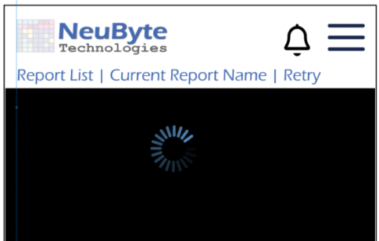
6.16.9 User Interface Design
6.16.9.1 User Profile

6.17 UIS-WT-01 Weight Tracking
6.17.1 Purpose
Allow the user to enroll in MFA for the first time or manage an existing MFA configuration. This includes viewing current MFA status, enrolling in MFA, and reenrolling (regenerating the TOTP secret).
6.17.4 Screen Layout — Weight Tracking
6.17.4.1 Layout Structure
Header
- Standard authenticated header:
  - NeuByte Logo (left)
  - Notification Icon (right)
  - Hamburger Menu (right)
- Fixed at top
- Back navigation uses OS-native gesture or back button
Body
A vertically scrolling screen that supports:
- Logging new weight
- Viewing current weight
- Viewing trend
- Viewing recent entries
- Inline editing of entries
- Deleting entries via modal
Sections:
- Current Weight Display
  - Latest logged weight
  - Timestamp (“Last logged: Today at 7:42 AM”)
- Log New Weight
  - Weight input (numeric)
  - Date picker (defaults to today)
  - Save Weight button
- Trend Indicator
  - Arrow (↑ ↓ →)
  - Color-coded (green/red/gray)
  - Text summary (“Down 1.8 lbs this week”)
- Recent Entries List Each entry row includes:
  - Date
  - Weight
  - Change from previous entry
  - Edit button (inline)
  - Delete button (opens modal)
- Inline Edit Mode When user taps “Edit”:
  - Weight input
  - Date input
  - Save / Cancel buttons
  - Row expands inline
Footer
- App Version
- Privacy Policy / Terms links
- Copyright
6.17.4.3 Component Definitions
Current Weight Display
- Shows the most recent logged weight
- Includes timestamp
- Non-editable
Weight Entry Section
- Weight Input
  - Numeric keyboard
  - Required
  - Supports decimals
- Date Picker
  - Defaults to today
  - Allows back-dating
- Save Weight Button
  - Primary action
  - Disabled until valid input is provided
- Delete Button
  - Appears when row is clicked
  - Disappears if current date is selected
Trend Indicator
- Arrow + color
  - Green ↑ = trending up
  - Red ↓ = trending down
  - Gray → = stable
- Based on last entry
- Text summary included
Recent Entries List
Each row includes:
- Date
- Weight
- Difference
- Indicator Arrow + color
  - Green ↑ = trending up
  - Red ↓ = trending down
  - Gray → = stable

- Entire row is tappable
- Populates the form with the Weight Entry
Empty State
If no weight entries exist:
No weight entries yet.
Log your first weight to begin tracking progress.
Error State
If weight data fails to load:
- Show UIS-ERR-01 error banner
- Provide “Retry” action
6.17.4.4 Interaction Rules & Behaviors
Initial Load
- Fetch weight history
- Display skeleton loaders until data is returned
Saving Weight
- Validate numeric input
- Save entry
- Update:
  - Current Weight
  - Trend Indicator
  - Recent Entries
- Show toast (“Weight saved”)
Editing/Deleting Weight
- Tap entry → open UIS-WT-05 or UIS-WT-06
- After edit/delete → refresh list and trend
Back Navigation
- Uses OS-native back gesture or button
- Returns to previous screen
6.17.4.5 Accessibility Requirements
- All form fields keyboard-navigable
- Labels programmatically associated with inputs
- Trend indicator includes ARIA label describing direction
- Inline errors announced via ARIA live region
- Minimum tap targets (44–48px)
- Screen reader announces: “Weight Tracking screen” on load
6.17.5 Component Definitions
Current Weight Display
- Shows most recent weight
- Includes timestamp
- Non-editable
Log New Weight Section
- Weight Input
  - Numeric keyboard
  - Required
- Date Picker
  - Defaults to today
  - Allows back-dating
- Save Weight Button
  - Primary action
  - Disabled until valid input
Trend Indicator
- Arrow + color
- Summary text
- Based on last 7 days or last N entries
Recent Entries List
Each row includes:
- Date
- Weight
- Change from previous entry
- Edit button
- Delete button
Inline Edit Mode
When user taps Edit:
Row expands to:
Weight: [182.4 ]Date:[04/30/2026 ▼][Save][Cancel]
- Save updates entry
- Cancel collapses row
Delete Confirmation Modal (Modular Component)
Trigger
User taps Delete on an entry.
Modal Layout
Delete Weight Entry?
This action cannot be
undone. [Delete] [Cancel]
Behavior
- Delete removes entry
- Trend + list refresh
- Cancel closes modal
6.17.2 Related Requirements
BR-WT-01 through BR-WT-26 BR-DASH-xx (Dashboard trend integration) FS-WT-xx (Weight Tracking functional rules)
6.17.3 Wire Frame Reference
UIS-WT-01
6.17.3 User Interface Design
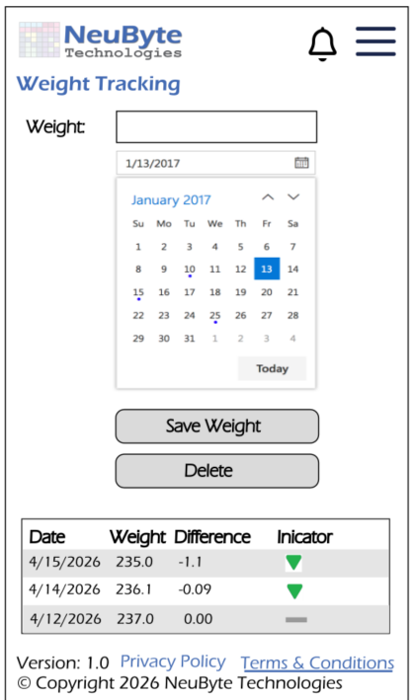
6.17.3.1 Weight Tracking

6.18 UIS‑ERR‑01 — Error Banner (Global Component)
6.18.1. Purpose
The Error Banner provides a standardized, page‑level mechanism for communicating non‑field‑level errors to the user. It ensures consistent placement, behavior, and accessibility across all screens that surface operational, API, or system‑level failures.
6.18.2. Component Description
The Error Banner is a global UI component rendered at the top of the primary content area on any screen that needs to display one or more errors.
Key characteristics:
- High‑visibility container for page‑level errors
- Supports single or multiple error messages
- May include optional action controls (e.g., Retry)

- Non‑modal; does not block interaction unless specified by the calling screen
- Consistent styling and behavior across all modules
6.18.3. Placement Rules
- Appears directly below the page header or screen title area
- Always occupies full width of the content column (not full browser width unless the layout is full‑bleed)
- Pushes page content downward; never overlays content
- Only one Error Banner may be visible at a time per screen
6.18.4. Trigger Conditions
The Error Banner is displayed when:
- A page‑level API call fails
- Required data cannot be loaded
- A long‑running operation time out
- The user attempts an action that fails due to server or client error (, BR‑ERR‑12)
- The system detects offline mode, and the page cannot complete its operation
- The user lacks permission for the requested action
Field‑level validation errors do not use this component
6.18.5. Behavior
6.18.5.1 Display Behavior
- Banner animates into view (standard fade/slide defined globally)
- Remains visible until:
- User dismisses it (if dismissible), or
- The triggering condition is resolved (e.g., successful retry)
6.18.5.2 Dismissal
- Dismiss button is optional
- If dismissible, the banner collapses and removes its content from the DOM
- If non‑dismissible, the banner remains until the page state changes
6.18.5.3 Multiple Errors
- If multiple errors occur simultaneously, they are displayed as a stacked list inside the banner
- Order is chronological (most recent first)
- The banner itself does not scroll; the page scrolls normally
6.18.6. States
6.18.6.1 Error (Default)
Used for operational failures, API errors, and system issues.
- Red accent
- Error icon
- Optional Retry button
6.18.7. Accessibility Specification
The NeuByte Fitness App adheres to WCAG 2.1 AA accessibility standards and supports inclusive use across all devices. Accessibility behaviors apply globally across all screens, components, and interactive elements.
This section defines required behaviors for keyboard navigation, screen reader support, focus management, ARIA usage, and reduced‑motion compliance.
6.18.8 Related Requirements
BR-A11Y-06, BR‑ERR‑01, BR‑ERR‑03, BR‑ERR‑05, BR‑ERR‑07, BR‑ERR‑10, BR‑ERR‑12
6.18.9 Responsive Behavior
- Mobile: Banner spans full width of viewport; content stacks vertically
- Tablet/Desktop: Icon, text, and actions align horizontally when space allows
- Long messages wrap; no horizontal scrolling
6.18.10 Usage Rules
• Do not redefine this component in any page‑specific UI Spec
• Pages must reference it as: Uses Global Component: UIS‑ERR‑01 Error Banner
• Do not use for field‑level validation
• Do not use for catastrophic system failures (use UIS‑ERR‑02 Global Error Page)
• Do not use multiple banners on a single screen
6.18. 11. Wireframe Reference
UIS-ERR-BNR-01

6.19 UIS‑ERR‑02 Global Error Page
6.19.1 Purpose
The Global Error Page provides a full‑screen fallback experience when the application encounters a critical, unrecoverable error that prevents normal operation.
It ensures a consistent, branded, accessible response to catastrophic failures such as server outages, unhandled exceptions, or system‑wide downtime.
This page replaces the current screen entirely and is not embedded within any module.

6.19.2 Scope
The Global Error Page is used only when:
- The application cannot render the requested screen
- A fatal server error occurs (HTTP 500/503)
- A client‑side exception prevents the UI from loading
- The system is in maintenance mode
- The application cannot initialize required global services (auth, config, routing, etc.)
It is not used for:
- Page‑level API failures (handled by UIS‑ERR‑01)
- Field‑level validation errors (handled by UIS‑ERR‑03)
- Permission/authorization failures (403/401 screens defined elsewhere)

6.19.3 Page Description
The Global Error Page is a standalone screen with the following elements:
- Application logo or brand identifier
- Large, high‑visibility error title
- Human‑readable error message
- Optional error reference code (for support/debugging)
- Primary action (e.g., “Return to Home”)
- Secondary action (e.g., “Retry”, “Contact Support”)
- Optional diagnostic details (collapsed by default)
The layout is centered vertically and horizontally for maximum clarity.

6.19.4 Trigger Conditions
The system navigates to UIS‑ERR‑02 when:
- Unhandled Exception
- A client‑side error is thrown and not caught by the application’s error boundary.
- Server Failure (500/503)
- The backend returns a fatal error that prevents the page from loading.
- Application Initialization Failure
- Required global configuration or authentication cannot be loaded.
- Maintenance Mode
- The backend indicates the system is temporarily unavailable.
- Routing Failure
The application cannot resolve the requested route and no fallback exists.
6.19.5 Behavior
6.19.5.1 Display Behavior
- Page replaces all previous content
- No partial UI from the previous screen remains
- Page loads instantly without animation (to avoid compounding failure states)
6.19.5.2 Navigation Behavior
- “Return to Home” always navigates to the application’s root route
- If the user is unauthenticated, the system may redirect to Login instead
6.19.5.4 Error Reference Code
If provided by backend:
- Displayed as a short alphanumeric code
- Helps support teams correlate logs
- Optional “Copy” icon may be included
6.19.5 States
6.19.5.1 System Error (Default)
Used for 500/503 and unhandled exceptions.
- Red accent
- Error icon
- “Something went wrong” title
6.19.6.2 Maintenance Mode
Used when backend indicates scheduled downtime.
- Neutral/blue accent
- Wrench or maintenance icon
- “We’ll be back soon” title
6.19.6.3 Offline Mode (Escalated)
If the application cannot initialize due to offline state.
- Yellow accent
- Offline icon
- “You’re offline” title
6.19.7 Accessibility Requirements
- Must meet WCAG 2.1 AA
- All interactive elements must be keyboard accessible
- Page must include or for the error message
- Color contrast must meet the minimum 4.5:1
- Focus must move to the page title on load
- Screen readers must announce the error state immediately
6.19.8 Responsive Behavior
- Mobile: Content stacks vertically, centered
- Tablet/Desktop: Content centered with balanced whitespace
- Long messages wrap; no horizontal scrolling
- Technical details section collapses into a single accordion element
6.19.9 Usage Rules
- This page is global and must not be redefined per module
- No module‑specific UI components appear on this page
- Do not include navigation menus, sidebars, or footers
- Do not use it for recoverable errors
- Do not use for validation or permission errors
- Must be reachable from any module when a fatal error occurs

6.19.10 Wireframe Reference
UIS-ERR‑GLBL-01.png

6.19.11 Related Requirements
BR-ERR-03, BR-ERR-08, BR-ERR-10, BR-ERR-12
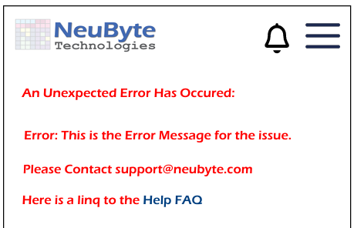
6.19.11 User Interface
6.19.11 Global Error

6.20 UIS‑ERR‑03 Field Validation Error (Global Component)
6.20.1 Purpose
The Field Validation Error component provides a standardized, inline mechanism for displaying validation errors associated with individual input fields.
It ensures consistent styling, placement, and behavior across all forms and modules.
This component is used only for field‑level validation failures, not page‑level or system‑level errors.
6.20.2 Component Description
The Field Validation Error is a small, inline message associated with a specific input field.
It communicates that the user’s input does not meet one or more validation rules.
Key characteristics:
- Appears adjacent to the field it refers to
- Uses consistent styling and iconography
- Does not interrupt page flow
- Supports multiple validation rules per field
- Works with both client‑side and server‑side validation
6.20.3 Placement Rules
- Appears directly below the input field (default)
- If the design system requires, may appear above the field (rare)
- Must be visually and semantically tied to the field
- Field containers must expand vertically to accommodate the message
- Only one message is shown at a time per field (see Multiple Errors section)
6.20.4 Trigger Conditions
The component is displayed when:
- The required field is empty
- Input fails format validation (email, phone, date, etc.)
- Input fails numeric constraints (min/max, positive integer, etc.)
- Input fails business rules (e.g., password complexity)
- Backend returns a field‑specific error (e.g., “Email already exists”)
Field‑level errors are not displayed in UIS‑ERR‑01.
6.20.5. Behavior
6.20.5.1 Display Behavior
- Appears immediately after validation failure
- Disappears when the field becomes valid
- Does not animate unless defined globally
- Does not shift focus
6.20.5.2 Interaction Behavior
- User may continue typing while the message is visible
- Message updates dynamically as validation rules pass/fail
- If backend returns a field error, message persists until corrected
6.20.5.3 Multiple Errors
If multiple validation rules fail:
- Only the highest‑priority message is shown
- Priority is defined globally (e.g., required → format → business rule)
- Additional errors may be shown sequentially as the user corrects earlier ones
6.20.5.4 Field Highlighting
The component may trigger optional field‑level styling:
- Red border
- Red underline
- Error icon inside the field
These styles are defined globally and not per screen.
6.20.6. States
6.20.6.1 Error (Default)
Used for invalid input.
- Red accent
- Error icon (optional)
- Short, actionable message
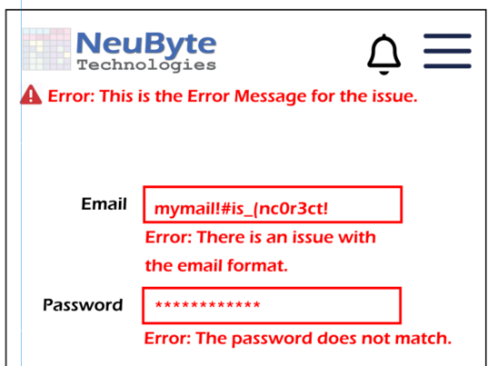
Only Error is required for Error Handling.
6.20.8 Accessibility Requirements
- Must meet WCAG 2.1 AA
- Must use to associate the message with the field
- Must not steal focus
- Must be announced by screen readers when it appears
- Color contrast must meet the minimum 4.5:1
- Icons must include accessible labels or be hidden from assistive tech
6.20.9 Responsive Behavior
- Message wraps naturally under the field
- No horizontal scrolling
- On mobile, message may occupy full width of the form column
- Field highlighting must remain visible on all breakpoints
6.20.10 Usage Rules
- Do not redefine this component per screen
- All form fields must use UIS‑ERR‑03 for validation failures
- Do not use UIS‑ERR‑01 for field‑level issues

- Do not display multiple messages simultaneously for the same field
- Do not use for system or backend fatal errors
6.20.11 Related Requirements
BR-ERR-05, BR-ERR-07, BR-ERR-09, BR-ERR-11
6.20.11 Wireframe Reference
ERROR‑INLN-01
6.20.12 User Interface Design
6.20.12.1 Inline Error

6.21.1 UIS-Login-MFA-01
6.21.1. Purpose
The MFA Verification Screen collects the user’s second authentication factor after successful primary login. It supports TOTP (Authenticator App) and Email OTP, depending on the user’s configured preference.
6.21.2. Screen Layout (Structural)
- Header Area
- Product logo
- Page title: “Multi‑Factor Authentication”
- Instruction Block
- Dynamic text based on MFA method:
- TOTP: “Enter the 6‑digit code from your authenticator app.”
- Email OTP: “Enter the 6‑digit code sent to your email.”
- OTP Input Area
- Six single‑character input boxes OR one numeric text field with masking
- Autofocus on first box
- Auto‑advance on input
- Backspace moves to previous box
- Actions
- Verify (primary button)
- Resend Code (secondary link; Email OTP only)
- Use a different method (optional future enhancement; hidden if only one method exists)
- Footer
- “Having trouble?” link (routes to MFA help page)
6.21.3. Component Definitions
- OTP Input Field
- Type: with
- Max length: 6
- Reject non‑numeric characters
- Verify Button
- Enabled only when 6 digits are present
- Triggers MFA verification API
- Disabled for 30 seconds after click
6.21.4. Interaction Rules & Behaviors
- Successful Verification
- On valid code → redirect to Dashboard
- Initialize session token
- Log MFA success event
- Invalid Code
- Show inline error: “Invalid code. Try again.”
- Shake animation (optional)
- Clear input fields
- Expired Code
- Show inline error: “This code has expired. Request a new one.”
- Rate Limiting
- After X failed attempts → show error:
- “Too many attempts. Please wait 60 seconds before trying again.”
- Resend the Email OTP
- Throttle: 30 seconds
- Logs resend event
6.21.5 Error States (UI‑Level)
- Invalid Code
  - Wrong 6 Digit Code
- Code Expired
  - Server returns expiration
- Too Many Attempts
  - Rate Limit
- Delivery Failure
  - Email service unavailable
6.21.6 Accessibility Requirements
- OTP boxes must be screen‑reader friendly
- Provide a single input alternative for assistive tech
- Announce errors via ARIA live region
- Ensure sufficient contrast for focus states
6.21.7 Analytics & Logging
- MFA verification success/failure
- OTP resend events
- Rate‑limit triggers
- Time‑to‑complete MFA step
6.21.11 Related Requirements
BR-LOGIN-MFA-01, BR-LOGIN-MFA-02, BR-LOGIN-MFA-03, BR-LOGIN-MFA-04,
BR-LOGIN-MFA-05, BR-LOGIN-MFA-06, BR-LOGIN-MFA-07
6.21.12 Wire Frame Reference
UIS-Login-MFA-01
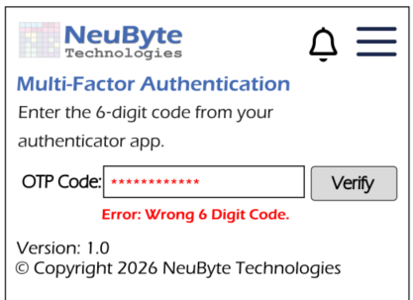
6.21.12 User Interface
6.21.12.1 Login MFA

6.22.1 UIS-PROF-MFA-01 MFA Enrollment
6.22.1. Purpose
Allows the user to set up or re-enroll Multi-Factor Authentication (MFA) using a TOTP-based authenticator app. This screen is accessed from Profile → Manage MFA.
This screen is not part of the Login flow.
6.22.2. 2. Screen Layout (Text Description)
The screen displays an instruction block at the top, followed by a mock QR code centered on the page. Below the QR code is a single 6-digit numeric input field labeled “Verification Code.” At the bottom of the form are two buttons: Verify (primary) and Cancel (secondary). In re-enrollment mode, the Verify button is replaced with Save Changes, and a Delete MFA button appears below the form. The global footer displays the version and copyright.
4. Components
4.1 Instruction Block
Not Enrolled: “To secure your account, set up Multi-Factor Authentication (MFA). Scan the QR code with your authenticator app, then enter the 6-digit verification code to complete enrollment.”
Enrolled (Re-Enrollment): “Your account is already protected with MFA. To update your MFA device, scan the new QR code and enter the 6-digit verification code.”
4.2 QR Code (Mock Image)
- Mock QR code image (may link to GitHub repo for portfolio purposes)
- Represents TOTP provisioning
- No real secret generated
4.3 Verification Code Input
- Single numeric text box
- Accepts exactly 6 digits
- Masked input
- No auto-submit
- Verify button disabled until 6 digits entered
4.4 Buttons
- Verify (primary; enabled only when 6 digits entered)
- Cancel (secondary; always enabled)
- Save Changes (re-enrollment only)
5. Interaction Rules

- Verify remains disabled until 6 digits entered
- When 6 digits are entered, Verify becomes enabled
- No auto-submit
- Cancel returns to Profile without saving
- Successful verification returns to Profile with success toast
- Delete MFA opens confirmation modal and removes MFA enrollment
6. Error States
- Invalid Code: “The verification code is incorrect. Please try again.”
- Expired Code: “The verification code has expired. Enter the latest code from your authenticator app.”
- Empty Code: Verify remains disabled
7. Navigation
- Cancel → Profile
- No breadcrumbs
- No links
- No Send Code / Resend Code (TOTP-only system)
8. Footer
- App Version
- Copyright
9. Navigation
- Back navigation: Cancel button only
- No breadcrumbs
- No links
- No Send Code / Resend Code (TOTP-only system)

10. Accessibility
- All controls are keyboard navigable.
- Screen reader labels:
  - “Verification Code, 6-digit input”
  - “Verify button”
  - “Cancel button”
  - “QR Code for MFA enrollment (mock image)”
6.22.11 Related Requirements
BR-LOGIN-MFA-01, BR-LOGIN-MFA-02, BR-LOGIN-MFA-03, BR-LOGIN-MFA-04,
BR-LOGIN-MFA-05, BR-LOGIN-MFA-06, BR-LOGIN-MFA-07
6.22.12 Wire Frame Reference
UIS-Login-MFA-01
6.22.12 User Interface
6.22.12.1 MFA
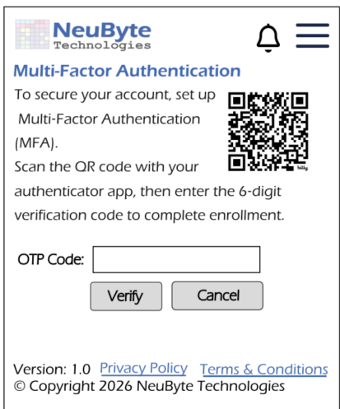

7.1.1 Focus Order
- All interactive elements must be reachable using the Tab key.
- Focus order must follow a logical, top‑to‑bottom, left‑to‑right sequence.
- Hidden or disabled elements must not receive focus.

7.1.2 Focus Indicators
- All focusable elements must display a visible focus ring.
- Focus indicators must meet contrast requirements.

7.1.3 Keyboard Activation
- Buttons, links, and interactive cards must be activated on Enter and Space.
- Dropdowns must open with Enter or Space and navigate with arrow keys.
- Radio groups must support arrow‑key navigation.

7.2 Screen Reader Support

7.2.1 Labels and Roles
All interactive elements must expose correct semantic roles, including:
- (button)
- (link)
- (list) / (list item)
- (dialog)
- (img)
- (checkbox)
- (radiogroup) / (radio)
- (textbox)
Each element must include:
- A programmatically associated label
- A descriptive accessible name

7.2.2 Announcements
Screen readers must announce:
- Page titles
- Section headings
- Error messages
- Success confirmations
- Notification unread counts
- Expanded/collapsed states

7.2.3 Hidden Content
- Skeleton loaders must be screen‑reader silent.
- Decorative icons must use (aria-hidden = “ true”)

7.3 Focus Management

7.3.1 Initial Focus
- On page load, focus moves to the first meaningful element (not the logo).
- On modal/dialog open, focus moves to the modal container.

7.3.2 Focus Return
- When closing a modal, drawer, or expanded notification, focus returns to the triggering element.

7.3.3 Focus Trap
Focus must be trapped inside:
- Hamburger menu
- Notification List (when opened as a full screen)
- Expanded notification view
- Any modal dialog
Focus trap rules:
- Tab cycles within the container
- Shift + Tab cycles backward
- Escape closes the container (where applicable)

7.4 ARIA Live Regions

7.4.1 Error Messages
- Inline form errors must use (aria-live=” assertive”) .
- Error banners must be announced immediately when displayed.

7.4.2 Notifications
- New notifications must be announced using (aria-live=” polite”).
- Unread count changes must be announced when the Notification Icon receives focus.

7.4.3 Loading States
- Skeleton loaders must not announce anything.
- Loading messages (if used) must use (aria-live=” polite”).

7.5 Reduced Motion

7.5.1 Motion Preferences
The app must respect system‑level “Reduce Motion” settings:
- Disable non‑essential animations
- Replace animated transitions with instant transitions
- Remove parallax or sliding effects

7.5.2 Required Motion
Essential motion (e.g., focus movement, menu open/close) must remain minimal and non‑distracting.

7.6 Text Scaling

7.6.1 Dynamic Type
- All text must be scaled with system font size settings.
- Layouts must not break at 200% text size.

7.6.2 Minimum Tap Targets
• All interactive elements must meet 44–48 px minimum touch area.

7.7 Color and Contrast

7.7.1 Contrast Ratios
- Text must meet 4.5:1 contrast ratio.
- Icons and focus indicators must meet 3:1.

7.7.2 Color Independence
- Color must not be the only means of conveying meaning (e.g., unread notifications must include a text or structural indicator).

7.8 Accessible Error Handling

7.8.1 Inline Errors
- Displayed directly beneath the input
- Announced via live region
- Must include actionable guidance

7.8.2 Non‑Blocking Errors
- Error banners appear at the top of the screen
- Must not trap focus
- Must be dismissible

7.9 Related Requirements
- BR‑A11Y‑01 → BR‑A11Y‑12
- FS‑A11Y
- FS‑NOTE‑11
- WCAG 2.1 AA

8. Loading & Skeleton States
The NeuByte Fitness App uses loading indicators and skeleton loaders to maintain perceived performance and provide a stable layout while data is being retrieved. Loading behaviors apply globally across all screens and components.
Loading states must never block navigation unless explicitly required (e.g., form submission). Skeleton loaders are used for content placeholders and must remain visually consistent across modules.

8.1 When Loading States Are Used
Loading states appear when:
- Data retrieval exceeds approximately 200ms
- A screen requires server‑side data before rendering
- A list, graph, or insight component is waiting for data
- A user action triggers a server‑side update (e.g., marking notifications read)
Loading states must not appear for instantaneous operations.

8.2 Skeleton Loader Usage
Skeleton loaders are used for:
- Dashboard insights
- Trend graphs
- Notification List

- Program List
- Weight entries
- Any card‑based or list‑based content
Skeleton loaders replace only the content area, not the entire screen.
Skeleton Loader Rules
- Must match the shape of the content they represent
- Must not shift layout when replaced by real content
- Must not receive focus
- Must be screen‑reader silent
- Must disappear immediately when data is available

8.3 Loading Indicators (Non‑Skeleton)
Used for actions such as:
- Form submissions
- Save operations
- Delete operations
- Mark‑all‑as‑read
- Login / Create Account / Reset Password
Indicator Rules
- Replace button label with spinner
- Button enters a disabled state
- Screen readers announce “Loading”
- Spinner must have accessible text equivalent

8.4 Screen‑Level Loading
Some screens require a full‑screen loading state when:
- Authentication is being validated
- Initial Dashboard data is loading
- Reports are loading Power BI embed tokens
- Program Detail is loading multi‑day content
Screen‑Level Loading Rules
- Display centered spinner
- Do not display partial UI
- Do not allow interaction
- Must include accessible text: “Loading content”

8.5 List Loading Behavior
Lists (notifications, programs, weight entries) use:
- Skeleton rows for initial load
- Infinite scroll or pagination loading indicators
List Loading Rules
- Skeleton rows appear for initial load
- Additional items load with a bottom spinner

- Errors must show an inline error banner
- No “jumping” or layout shifts

8.6 Graph Loading Behavior
Trend graphs use:
- Graph‑shaped skeleton block
- No axes, labels, or tooltips during loading
Graph Loading Rules
- Skeleton must match graph dimensions
- Tooltip interactions disabled
- Screen readers must receive a text announcement: “Loading trend data”

8.7 Insight Loading Behavior
Insight components use:
- Text line skeletons
- Placeholder trend indicators
Insight Loading Rules
- Skeleton must match insight layout
- No trend arrows shown during loading
- Screen readers must not announce skeletons

8.8 Error Transition from Loading
If loading fails:
- Skeleton loaders disappear
- Error banners appear
- User may retry the operation
- Screen readers announce the error
Skeleton loaders must never remain visible after an error.

8.9 Accessibility Requirements
Skeleton Loaders
- Must be
- Must not expose roles or labels
- Must not be focusable

Loading Indicators
- Must include accessible text (e.g., )
- Must be announced via
Screen‑Level Loading
- Must announce “Loading content”
- Must trap focus if the screen is blocked

8.10 Related Requirements
- BR‑PERF‑01 → BR‑PERF‑08
- FS‑NOTE‑12
- FS‑DASH, FS‑WT, FS‑EP (list and graph loading)
- WCAG 2.1 AA

9. Error & Empty States
The NeuByte Fitness App provides consistent, accessible handling of errors and empty states across all screens. Error states communicate when an operation fails or data cannot be retrieved. Empty states communicate that the system is functioning correctly, but no data is available.
Error and empty states must be visually distinct, non‑blocking, and accessible to all users.

9.1 Error States

9.1.1 When Error States Appear
Error states appear when:
- A server request fails
- Data cannot be retrieved
- A form submission fails validation
- A user action (delete, save, mark‑as‑read) fails
- A graph or list cannot load data
- A network or timeout error occurs
Errors must never be silent or hidden.

9.1.2 Error Banner (Global Pattern)
Used for non‑blocking errors that occur during:
- Data retrieval
- Notification operations
- Dashboard loading

- Program List loading
- Weight entry retrieval
Structure:
- Error icon
- Error message text
- Optional “Retry” action
Behavior:
- Appears at the top of the content area
- Does not block interaction
- Disappears when the user retries or navigates away
Accessibility:
- Must use
- Must be keyboard‑focusable if dismissible

9.1.3 Inline Form Errors
Used for:
- Login
- Create Account
- Reset Password
- Log Workout
- Weight Tracking
Behavior:
- Displayed directly beneath the input
- Must include actionable guidance
- Must persist until corrected
Accessibility:
- Announced via ARIA live region
- Associated with the input using

9.1.4 Screen‑Level Errors
Used when:
- A screen cannot load any required data
- A critical failure prevents rendering

Behavior:
- Replace content area with error message
- Provide a “Retry” button
- Do not show partial UI
Accessibility:
- Announced immediately
- Retry button must be focusable

9.1.5 Notification‑Specific Errors
Aligned with FS‑NOTE‑12.
Examples:
- Retrieval failure → show error banner
- Mark‑as‑read failure → revert UI state
- Delete failure → show inline error
Accessibility:
- All errors must be announced
- Focus must remain stable

9.2 Empty States

9.2.1 When Empty States Appear
Empty states appear when:
- The system is functioning correctly
- No data exists for the requested view
Examples:
- No notifications
- No weight entries
- No workout history
- No selected program
- Insufficient data for trends
Empty states must not be treated as errors.

9.2.2 Empty State Pattern (Global)
Structure:
- Icon or illustration (optional)
- Title text
- Supporting text
- Optional action button (e.g., “Add Weight Entry”)
Behavior:
- Replaces the content area
- Does not block navigation
- Encourages user action when appropriate
Accessibility:
- Must be fully readable by screen readers
- Must not trap focus
- Must not use color alone to convey meaning

9.2.3 Module‑Specific Empty States
Dashboard
- No recent activity → “No recent activity logged.”
- No weight trend → “Not enough data to calculate weight trend.”
- No consistency trend → “Consistency trend will appear once you begin logging workouts.”
Exercise Program List
No programs available → “No exercise programs found.”
Program Detail
No exercises for selected day → “No exercises defined for this day.”
Log Workout
No sets defined → “No sets available for this exercise.”
Weight Tracking
No weight entries → “Add your first weight entry to begin tracking.”
Notification List
No notifications → “You have no notifications yet.”

9.3 Loading → Error → Empty Transitions

9.3.1 Loading → Error
If loading fails:
- Skeleton loaders disappear
- Error banners appear
- User may retry

9.3.2 Loading → Empty
If loading succeeds but no data exists:
- Skeleton loaders disappear
- Empty state appears

9.3.3 Error → Retry → Loading
Retrying an operation:
- Removes error banner
- Shows loading indicator
- Attempts retrieval again

9.4 Accessibility Requirements
- All errors must be announced via ARIA live regions
- Empty states must include descriptive text
- Error banners must be reachable via keyboard
- Focus must not jump unexpectedly
- Skeleton loaders must remain silent

9.5 Related Requirements
- BR‑ERR‑01 → BR‑ERR‑12
- BR‑NOTE‑10
- FS‑NOTE‑12
- FS‑PERF
- WCAG 2.1 AA

10. References
Include any relevant documents, standards, or external resources referenced in the development of this User Specification document.

11. Revision History
Version | Date | Description | Author
1.0 | 04/10/2026 | Initial draft | Gordon Neuls
1.1 | 04/23/2026 | Updates after BR / FS updates | Gordon Neuls
1.2 | 04/29/2026 | Fixing Error Handling | Gordon Neuls
1.3 | 05/04/2026 | Fix Missing Sections, Missing Images | Gordon Neuls

12. Approval
Date | Role | Author
04/11/2026 | Business System Analyst | Gordon Neuls
04/11/2026 | Principle Software Engineer | Gordon Neuls

13. Glossary of Terms
..\Glossary\glossary.md

14. Appendix B: Document Cross Reference
See the RTM: ..\RTM\NeuByteFitnessAppRequirementTracabilityMatrix.xlsx

