E-LEARNING ON CLOUD USING ADVANCED ENCRYPTION STANDARD
*Note: Sub-titles are not captured in Xplore and should not be used

line 1: 1st Given Name Surname
line 2: dept. name of organization
(of Affiliation)
line 3: name of organization
(of Affiliation)
line 4: City, Country
line 5: email address or ORCID
line 1: 4th Given Name Surname
line 2: dept. name of organization
(of Affiliation)
line 3: name of organization
(of Affiliation)
line 4: City, Country
line 5: email address or ORCID
line 1: 2nd Given Name Surname
line 2: dept. name of organization
(of Affiliation)
line 3: name of organization
(of Affiliation)
line 4: City, Country
line 5: email address or ORCID
line 1: 5th Given Name Surname
line 2: dept. name of organization
(of Affiliation)
line 3: name of organization
(of Affiliation)
line 4: City, Country
line 5: email address or ORCID
line 1: 3rd Given Name Surname
line 2: dept. name of organization
(of Affiliation)
line 3: name of organization
(of Affiliation)
line 4: City, Country
line 5: email address or ORCID
line 1: 6th Given Name Surname
line 2: dept. name of organization
(of Affiliation)
line 3: name of organization
(of Affiliation)
line 4: City, Country
line 5: email address or ORCID

Abstract—Various benefits of Information Technology have created different tools that help learning at any place and anytime. As the technology is changing, education system also needs to be changed for faster, comfortable and easy learning. Information Technology has been involved in learning process which is known as e- learning. Nowadays it is also called as modern learning. Various devices need to use this technology efficiently and its importance. Various devices need the driver and a communication device which may be difficult to use and costly.
Various computer features and services has been revolutionized by cloud computing where various resources are offered as a service over the internet. The basic three services provided by cloud are Software as a service (SaaS), Platform as a service (PaaS), Infrastructure as a service (IaaS). Application model of Hybrid Cloud has various advantages such as elastic computing resources, safety, privacy and cost effectiveness.
Keywords—E-learning, Modern learning, SaaS, Hybrid cloud, Advanced encryption standard, KNN classification, ECC algorithm.

Introduction
Information technology has made it possible to work and study from distance. Learning in user comfortable spaces other than Traditional classrooms is widely accepted. E-leaning is the future of education. It can provide courses and various opportunities to students which may not be available in other forms of education.
The term Cloud refers to a Network or Internet. In other words, we can say that Cloud is something, which is present at remote location. Cloud can provide services over public and private networks, i.e., WAN, LAN or VPN. Now a day’s E-learning is becoming popular in the educational field. E-learning adapts the use of computers and networks to improve the quality of education. The motive of E-learning is to allow the student to learn independently at any place at any time. Education is usually perceived as the method whereby we have students in a classroom receiving lessons from a Teacher but with the help of IT through the internet, learning can now be achieved without necessarily having a teacher right in front of a student. E-learning is one of the tools that emerged from IT & has been integrated into many university educational programs, shifting from the traditional way of education to electronic environment in which a student can access & make use of information anywhere and at any convenient time.
The modern advances in Information and Communication technologies enable us to work and study from a distance. It is widely perceived that learning can happen outside the classroom. It also seems impossible to find institutions in higher education that don’t offer opportunities for remote online learning. In order to evaluate the skills, knowledge, or attitudes of students, education material is required to the student. Different types of study material will upload by teachers depends on the student requirement, for example, the Video or text document or image will help to Learners measure their own. E-learning provides infrastructure based on modern methodologies and tools.

LITERATURE SURVEY

Mohsen Maraoui, et al [1] tries a new and innovative solution for media services that can be accessed from smart devices cloud-based intelligent service environment with a fully integrated system.
Indexation has been used. It can be utilized under circumstances where the availability of resources is limited Post problems related to searching are tedious, costly in resources and time.
Miri Barak et al [2] set to recognize self-regulation skills necessary for online education and to illustrate cognitive move of on-campus and online students. The study integrated two groups of undergraduate students who studied the same course. They are used Self-regulated learning (SRL), diverse learning. Students pointed out that learning from a distance gives them flexibility With respect to time. The study was conducted in one higher education institution with a relatively small number of participant’s eighty-four science and engineering students
Haibo Yi et al [3] has used basic services of cloud like SaaS providing various software like learning system, examination system, PaaS providing on platform software like MySQL, Cfree, oracle, IaaS for providing different kinds of services in this learning model on open stack cloud computing systems using Microsoft ASP.net and SQL .1.Efficient model 2.On demand computer resources sharing. Integrating these services is difficult.
Seppo J. Sirkemaa et al [4] has described that E-learning makes it possible to study regardless of time and space. It may also provide new groups of student’s opportunities that are not available with other forms of education. They are using Traditional storage algorithm. 1. Helps in meeting new 2.People exchanging ideas between individual students and student groups . e-learning has failed to satisfy the needs of a mobile user.
Abiodun Kilanko et al [5] depicts that Cloud providers have platform for users to design and run application located in the cloud. E-learning provides a web based forum for students. Computing power and storage are also being provides on the cloud. These provisions available on the cloud makes it most suitable for e-learning purpose.

Qasim Alajmi et al [6] understand the effectiveness of the traditional and cloud-based e-learning model. E-learning model is the best learning model for individuals learning from home and for education providers as well. Internet has made it easy to for learners and educators to share information interactively, which is vital in enhancing education
Dr. Birajkumar V. Patel [7] explains that there are many search engines available on the web. All are providing solutions in the form of list of URLs, text,images, videos, etc. The new model allow user to get domain specific and decision making information based on past transactions stored. Designing new model incorporates optimizing business strategies for future survival of business

Proposed system
As lot of institutes commonly prefer using Google Drive, these days to upload data or studying material. We can store all our files such as videos, photos, Google Docs, PDFs and etc. It can be managed by either an individual or joint venture, both parties can manage the drive efficiently.
But along with advantages comes disadvantages as well. Using Google Drive, Hackers or the attackers can hack or remove your important data or they install virus into your system and your files are gone. Another disadvantage can be the uploading and downloading speed when millions of users are uploading and downloading together, the speed will be slow down.
In the proposed system we our proposing an E-learning web-based system using cloud, which is specifically targeted towards engineering students and teachers, who can upload the studying material of respected course which can be of any form such as text files, videos, audios and students can access it from any location. Also we our providing test assessments for students who want to get thorough with their subjects. The main motive of our E-learning system is to provide efficient access and upload of materials as well keep the data secure from unauthorized users.

System Architecture:

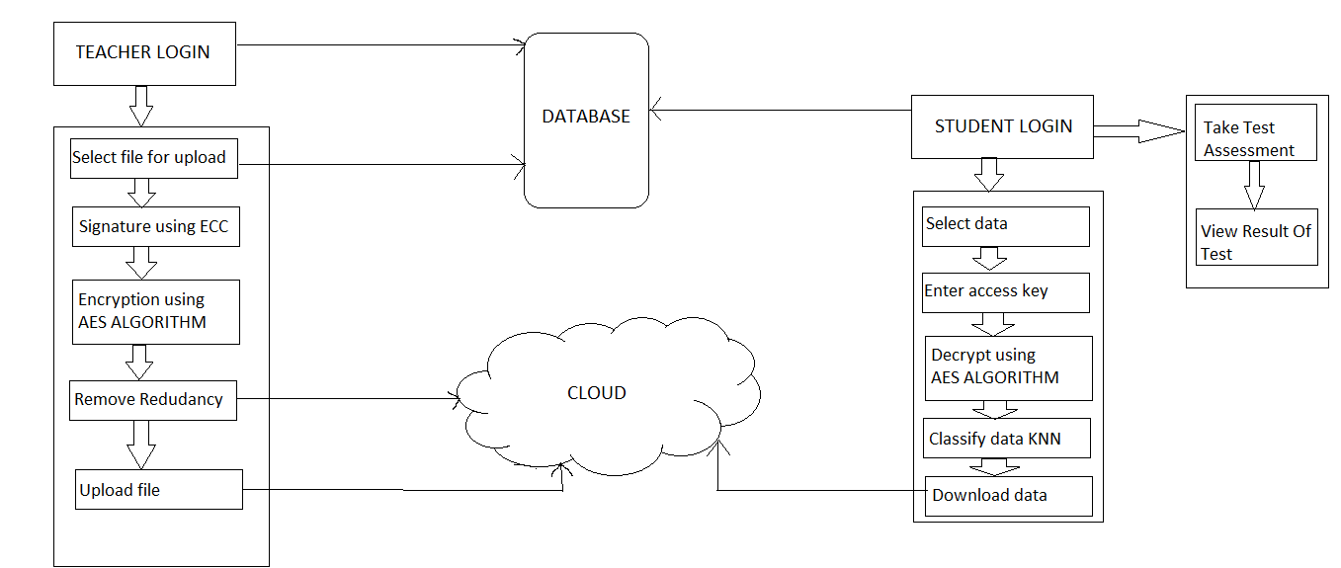
Figure1: System Architecture of Proposed design.
AS shown in figure1, the system consists of two entities who are going to interact with system first is the teacher and second is the student. Each teacher and student will have to first register to the system. Once registration is done the teacher as well as the student can login into the system by providing valid credentials. The teacher can upload the chosen material, every material which is to be uploaded on the cloud will be assigned a unique key so as to avoid redundant material on cloud, this unique key will be generated by using the Elliptic Curve Cryptography (ECC) Algorithm. The next step will be securing the data i.e. encrypting the data which is done by using Advanced Encryption Standard (AES) Algorithm, then the data is further uploaded on the cloud. Simultaneously, the student can login into the system once registered successfully. Student can either access the uploaded data or might the take test assessment. Student can select their respective branch and the can choose the data or material they want to access. If the student wants to download the material, firstly he/she has to enter the unique key which has been sent to their respective mails. Upon entering the valid key they can download the material. The data is decrypted using the same algorithm which is used for encryption. We are also implementing the classification algorithm K-Nearest Neighbor (KNN), for department wise classification of data as well as classifying the test results taken by the student.

UML Design:

Class Diagram:
Class diagram gives the static view of an application. A class diagram describes the type of objects and their relationships involved in the system.
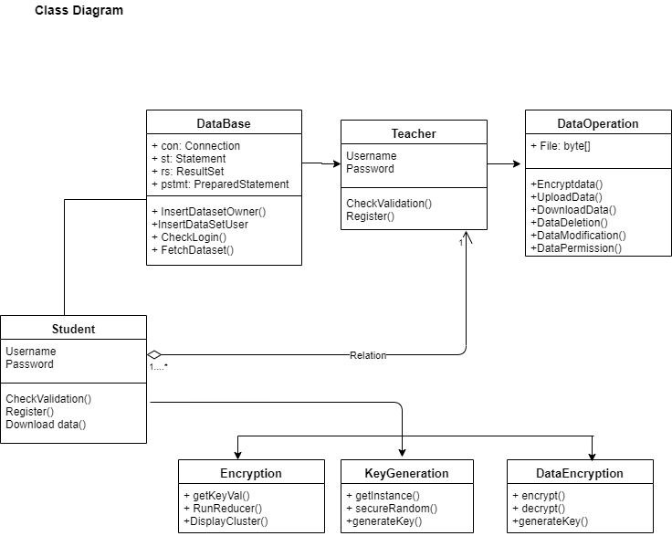
Figure2: Class Diagram

Use case Diagram:
A use case diagram is dynamic or behavior diagram in UML. Use case diagram model the functionality of a system using actors and use cases.
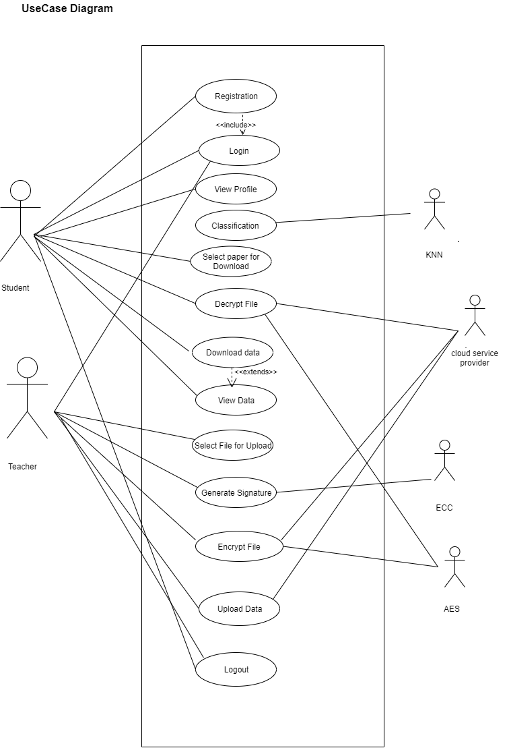

Implementation design

As we know in today’s traditional learning system there are various infrastructure challenges that the student faced while searching their study material online by referring various websites. our team had to find practical solutions in order to solve these infrastructural challenges. This is why we propose a design for a technology e-learning environment the
we find useful for the student.
In recommended system we make a use of amazon S3 cloud for storage purpose along with SQL database which stores Student and instructor personal information (Name, Course, Login id, password) etc. The e-learning cloud is unique cloud technology that allows for all the software and hardware components for developing the e-learning environment in a futuristic manner. By utilizing the cloud characteristics of virtualization, the educational materials can be made available to students, teachers and researchers.
The basic e-learning is new to education, utilizing IT resources. On the other hand, cloud-based e-learning provides a unique opportunity to students, faculty and researcher in any academic environment because of the benefits provided by the cloud infrastructure.
Infrastructural design is mainly divided into two subset of design one is front-end and other one is back-end design.
1] Front-end design features:
Front-end of the infrastructure is represented by two gateways – Teacher and Student. Each portal will serve to pre-defined group of people for their corresponding tasks and needs. The main goal of Teacher portal is to upload required study material on cloud. Some of the features include review of tests and course work, scores of assignments and also functionality to lock/unlock courses. Another important feature will be that teachers can monitor the steps that the students performed while there were working on a particular assignment. For example, which commands they entered to install and configure MySQL and Apache server. In the classic e- learning model, teachers assign teaching tasks, conduct regular lectures, or train students’ skills. The students attend the online autonomous learning act and cooperative learning sessions, or accomplish teachers’ assignments. But in this proposed architecture teachers also answer students’ questions and offer essential teaching to major and difficult points.
Before accessing the system, it must essential for both student and teacher to provide their login details to system and all the information will be synchronized with a database in the Back-end. We use HTML, CSS, and JavaScript to design Front-end of the system.
2] Back-End Design features:
Back-End Design mainly contains cloud and MYSQL database for storing the data. The database will rely on the open source MySQL. We make use it to store information about Student’s ID, first and last name, the current semester, courses which the student has assigned in their curriculum, also the score points from his exercises and grade for the corresponding course where as cloud stores study material for the students uploaded by teachers or instructor. The most common and widely adopted cloud computing services are Infrastructure as a Service (IaaS), Platform as a Service (PaaS), and Software as a Service (SaaS) out of these our team takes advantage of Software as a

3] Service (SaaS) in the system.

Software as a Service (SaaS):
Software as a service (SaaS) is a software distribution model in which a third- party provider hosts applications and makes them available to customers over the Internet. SaaS is closely related to the application service provider on demand computing software delivery models.

4] Control flow of the system Architecture:

1.Student Module:
1)Student login: Students details like name, address, course, username, password.
->Information is stored in MYSQL database.

2)Select file: he/she select the required file for view/download.
->Enter Access Key: For verification and Security purpose (without access
Key one should not allow to download the file)
->File Decryption using Advanced Encryption Standards (AES).

3)View/download file from cloud.
4)Logout
In this proposed system we classify the study material based on the student departments. So it is necessary to classify the data, KNN that is K Nearest Neighbor does this.

2.Teacher module
1) Teacher login: Teacher details like name, address, department, username, password.
->Information is stored in MYSQL database.

2)upload file on cloud.
->Digital Signature Using Elliptical Curve Cryptography (ECC).
->File Encryption Using Advanced Encryption Standards (AES).
3)Logout.

5] Expected Benefit from The Architecture:

The intended advantages derived from the proposed architecture are as follows:

- Powerful computing and storage capacity: Cloud based E-learning architecture locates the computing and data in a large number of distributed computers, the sea of clouds in the tens of thousands of computers to provide powerful computing power and huge data storage space, puts the “cloud” as a service available to students via the Internet.

- High availability: Through the integration of mass storage and high-performance computing power, this system can provide a higher quality of service

- The major advantage of the proposal is that it aims at providing easy access to costly software running on high performance processors to rural students at institutions which lack considerable facilities.

- Visualization: Visualization is the most important characteristics of this type of architecture. team affords different simple and component charts (Graph, line chart, pie chart) for data visualization which helps student to digest there result analysis graph, understanding huge data in easily and well-organized manner. Simply to say it take less time to understand and summarize the data.

System Is also beneficial for the teachers, they can interact with students, prepare online courses and also examine students. On this spot we will assure that our system is dominant to overcome various learning issues and the algorithm used in this system is one of the factors which build that.

Result analysis

As discussed earlier in this paper what infrastructural challenges that the student faced while searching their data material online by introducing this design for e-learning environment, we would like to show that we are aware of and loyal to respond to the challenges. with the use of free and open source software, we are aiming at reducing the total cost of ownership of the whole E-learning environment system. Definitely for hosting the environment on-premise, hardware and support is required. The proposed environment incorporates various modern technologies and provides a foundation for the future development of the skills of the students in various areas: from System and Network Administration to Development and Operations.
Improved student retention and self-directed learning this challenge is becoming very significant in our country and by introducing this system to higher education we aim at attracting new students who are interested in developing their skills and expanding knowledge on their own way. This system is also valuable for appealing rural student to enhance their knowledge, to contribute their own ability to build a nation.
In addition to that we would like to provide the opportunity for the university lecturers and students to have a close touch with modern technologies and a chance to gain new knowledge for their development. For developing countries that are trying to contribute to the global economy, this e-learning system represents the perfect opportunity to give everyone a chance to learn and to adapt. There might be some obstacles that these developing nations are not yet ready to overcome, but progress is being made at the moment.
we also contribute our efforts towards quality education that helps to produce quality students that they act as powerful weapon to develop our nation.

Conclusion

We have tried in our system to provide new and innovative solution for media services that can be accessed from smart devices cloud based intelligent service environment with a fully integrated system, which will access files from the cloud and use it for their wellbeing. We have proposed the problem statement, the main moto of our system. We have proposed the system architecture of our system. A survey of previous systems has also been done through literature survey. Software development cycle has been depicted. The UML diagrams such data flow, class, use case, sequence has been drawn.

E. References

[1] Strahil A. Sokolov, Asen P.Zahariev, Stefan M. Vlaev , “Technology E-learning Evironment for Hybrid Cloud”, International Symposium for Design and Technology in Electronic Packaging, vol. 3, pp. 38-42, 2017.
[2] Haibo Yi, Zhe Nie,“Implementation of Learning Management System Based on Cloud Computing”, International Conference on Information Science and Control Engineering, vol. 2, pp. 478-481, 2017.
[3] Qasim Alajmi, Ali Sadiq “E-Learning Models: The Effectiveness of the Cloud Based E-Learning Model over the Traditional Elearning Model”4(3), pp. 311-316, 2017.
[4], Abiodun Kilanko, Falade Adesola and Isaac Odun-Ayo Member, “Elearning on Cloud-An Analysis”,International MultiConference of Engineers and Computer Scientists vol. 49, pp. 399-404, 2019.
[5] M. A. H. Masud and X. Huang, "An e-learning system architecture based on cloud computing," system, vol. 10, 2017.
[6] Q. Alajmi and A. Sadiq, "in the preceding of Information Technology, Electronics and Mobile Communication Conference (IEMCON) IEEE 7th Annual,pp.1-5, 2016.
[7] C. Lee, Handbook of Research on Cloud-Based STEM Education for Improved Learning Outcomes. IGI Global, 2016.

