Data Flow of the Model:

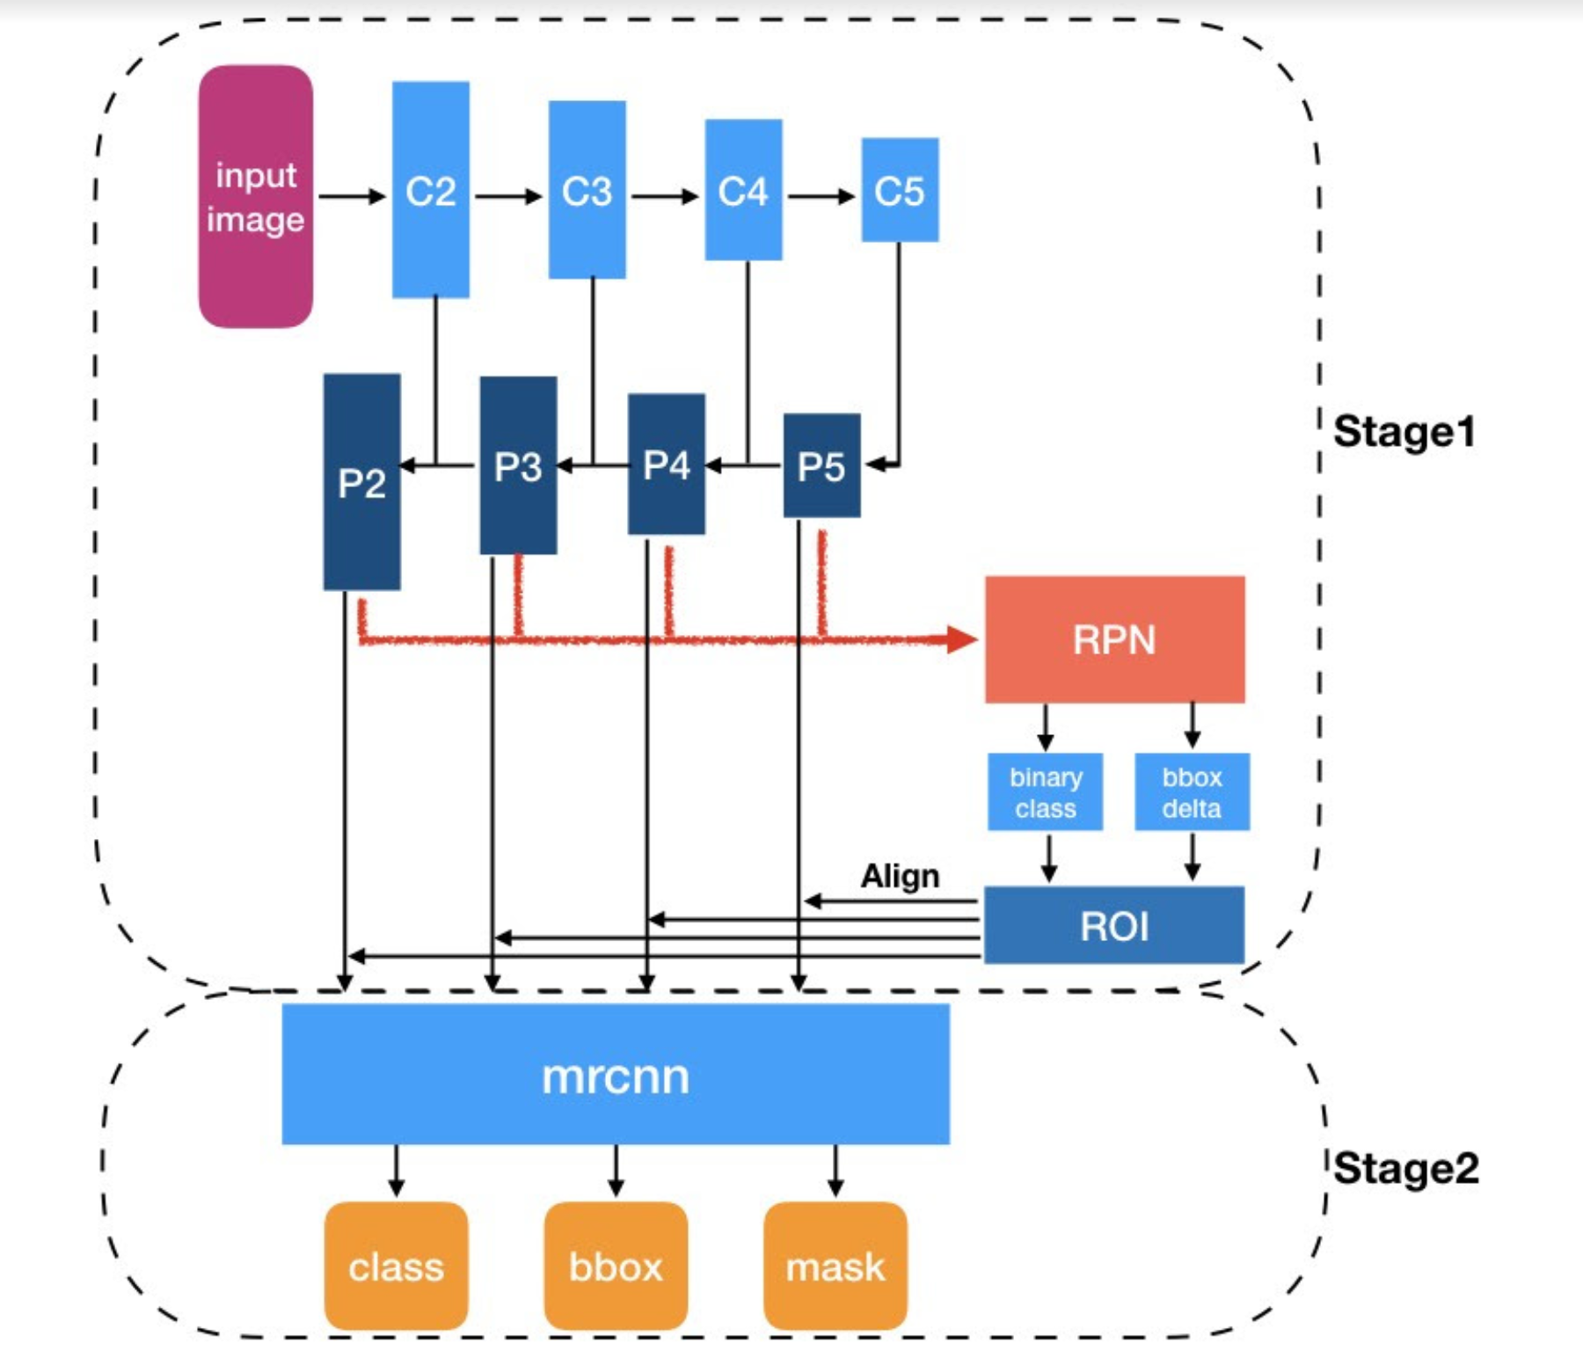

**Timeline:**

I will be devoting about 60% of the time on actually extending the matterport MRCNN model to 3D images and 40% of the time to testing the model for efficiency.

I will be deliberately leaving some days “blank” as a backup if the previous work is still pending.

**Legend:** Importance and time devoted



I have converted the actual schedule of deliverables in a tabulated format and divided the work day-wise. The gist is still exactly same as specified in schedule of deliverables as per the proposal.

(Please scroll down for the table)

|  |  |  |  |  |  |
| --- | --- | --- | --- | --- | --- |
| **Time Frame** | **Start Date** | **End Date** | **Task** | **Legend** | **Status** |
|  | 15th April | 5th May |  |  |  |
|  | 15th April | 18th April | * Fork and Clone the official HahRD repository and matterport repository using *git clone*. * Make sure latest tensorflow and keras versions are installed into the local machine. * Make sure that both python 2.7.x and 3.7.x are there. * Local Machine should be properly set up for deep learning and CV tasks. * Make sure everything in the [file](https://github.com/matterport/Mask_RCNN/blob/master/requirements.txt) is there on the local system. |  |  |
|  | 19th April | 20th April | Run the 2D model by following [installation instruction](https://github.com/matterport/Mask_RCNN/) from the repository. (I already did this.) |  | Will do it when I get access to GPU. (Training) |
|  | 21st April | 22nd April | These are spare days. They should be used to complete pending work if any. Also, prepare a brief plan on what to do next and it should mainly correspond to Pre-GSoC only. |  |  |
|  | 23rd April | 29th April | Convert the [model.py](https://github.com/matterport/Mask_RCNN/blob/master/mrcnn/model.py) file completely for 3D images (everything from Data Generator to actual training). I think 6 days are enough for this. Make sure that the file is compiling *without any inputs*.  I have already done 50% work in assignment and also more by myself. |  |  |
|  | 30th April | 1st May | These are spare days. I will use these days to study flow of data as per model.py file and write the same in a diary. This will help us in debugging model in future. |  |  |
|  | 2nd May | 5th May | Convert all the other files in [this](https://github.com/matterport/Mask_RCNN/tree/master/mrcnn) to 3D and just make sure they compile. Also, try to test *2D slicing* in models.py to test the data flow. |  | Only need to experiment 2D slicing. |
|  | 6th May | 26th May |  |  |  |
|  | 6th May | 8th May | Study how to run the model on a custom dataset. See the [samples](https://github.com/matterport/Mask_RCNN/tree/master/samples). Once we get hold of 3D dataset like HGCAL images, we need to create our own *dataset.py* as in samples pertaining to 3 dimensions. |  |  |
|  | 9th May | 12th May | These are spare days. Make sure, everything before this day is completed if any work is still left pending. |  |  |
|  | 13th May | 16th May | Successfully create custom *dataset.py* and make sure it compiles *independently*. If any work is still pending, complete it. |  |  |
|  | 17th May | 26th May | Create outline of a debugging strategy for the next phase. Make sure that *2D slicing* in the modules inside model.py is mastered correctly. Complete previous pending work if any. Write blog posts and create report until date and the advanced planning for the next phase. |  |  |
| Phase 1 | 27th May | 23rd June |  |  |  |
|  | 27th May | 31st May | These are spare days. Please make sure that the previous pending work is completed, especially the independent module conversion of Pre-GSoC phase. Plan debugging procedure. |  |  |
|  | 1st June | 5th June | Make sure, dataset.py file is done and dataset (3D, HGCAL for instance) is ready to be loaded. |  |  |
|  | 6th June | 8th June | Make sure that every python file in repository is successfully converted. |  |  |
|  | 9th June | 23rd June | Apply debugging strategy to the *model.py* file. This time, debug with the inputs. For instance, in starting we can also test on random 4D matrix. Using 2D slicing and debugging strategy, *at minimum* work and compile 80% of modules in *model.py* file. Also, on test images, make sure each module is giving sensible output. Plan the outline for the next phase. |  |  |
| Phase 2 | 28th June | 21st July |  |  |  |
|  | 28th June | 2nd July | Please make sure that the previous pending work is all but done. |  |  |
|  | 3rd July | 14th July | Using the debugging and validation strategy convert all the modules of *model.py* file, this time using input images and make sure sensible outputs are given. |  |  |
|  | 15th July | 21st July | Train the 3D modified model from scratch using a simple dataset (preferably, 3D HGCAL images). We will use ***python3 dataset.py train --dataset=/path/to/dataset –model***to train from scratch. This will give us weights. Now if possible, we can use 1-2 more simple datasets to train using weights of previous model and try our best to accomplish *IoU metric* of at least 0.6 training and 0.5 validation. Also, plan the outline for the next phase. |  |  |
| Phase 3 | 26th July | 19th August |  |  |  |
|  | 26th July | 2nd August | Please make sure that previous pending work is all but done and everything is ready for training, validation and testing. |  |  |
|  | 3rd August | 12th August | Try to push the IoU metric of the training set and validation set to at least 0.75-0.85 of simple datasets. |  |  |
|  | 13th August | 19th August | Try to push the training and validation IoU of the complex datasets to at least 0.6. Work on creating the *final report* for submission. |  |  |
| Optional Phase |  |  | Segmentation of 3D images, build 3D visualization tools, change the FPN and RPN algorithm using the physics knowledge (the detector) and add a regression module (to evaluate the energy for instance). |  |  |

----------------------------THE END-----------------------------------------------------------------