Chapter 1 – Sorting Algorithm (Task A)

1.1 Overview
This CPT204 Coursework 3 project is an Urban Infrastructure Inspection System, designed to rapidly identify critical inspection targets within large-scale infrastructure networks and compute efficient inspection routes, which focuses on practicing Object-Oriented Programming (OOP), utilizing advanced data structures, and enhancing comprehensive skills in problem-solving, team cooperation, and EDI principles.
The main body of the system consists of two parts: Task A and Task B. This section presents the specific details of Task A: critically evaluate the performance of different sorting algorithms for the candidate-location selection process in this system.

1.2 Algorithm Implementations
Bubble Sort iterates through adjacent pairs and swaps them if they are out of order, repeating until no swap occurs in a full pass. An early-termination flag (swapped) is used: if a complete pass produces no swaps, the array is already sorted and the algorithm exits immediately. This optimisation makes Bubble Sort particularly sensitive to — and fast on — nearly sorted input.
Quick Sort uses a two-pointer partitioning scheme with the first element as pivot. The left pointer advances to find an element larger than the pivot, the right pointer retreats to find one smaller, and the two are swapped. After partitioning, the pivot is placed at its correct position and the algorithm recurses on both sub-arrays. Choosing the first element as pivot is efficient for random data but degrades to O(n²) when the array is already sorted (or nearly sorted) in the target order, because every partition is heavily imbalanced.
Merge Sort divides the array in half recursively until sub-arrays have one element, then merges adjacent pairs into sorted order using temporary arrays. Its divide-and-conquer structure guarantees O(n log n) regardless of input order, at the cost of O(n) auxiliary memory for the temporary arrays.
The complexities of these three algorithms are shown in the table below:
Algorithm | Time Complexity (average) | Time Complexity (worst) | Space Complexity
Bubble Sort | O(n²) | O(n²) | O(1)
Quick Sort | O(n log n) | O(n²) | O(log n)
Merge Sort | O(n log n) | O(n log n) | O(n)

1.3 Dataset Characteristics
Before analysing the timing results it is important to understand the properties of each dataset. The DataAnalyzer utility class performs a full structural analysis of each CSV file.
Property | Dataset A | Dataset B | Dataset C
Total locations | 1,000 | 1,000 | 1,000
Score range | 9,001 – 10,000 | 9,001 – 10,000 | 4,951 – 5,000
Mean score | 9,500.50 | 9,500.50 | 4,970.99
Unique scores | 1,000 | 1,000 | 41
Score groups with ties | 0 | 0 | 41 (100% of data)
Inversion density (first 200) | 0.1% | 49.2% | 5.6%
Initial order | Nearly sorted descending (98.3%) | Random / Unsorted (~49% desc.) | Perfectly sorted descending (100%)

Dataset A is already 98.3% in the target descending order with only 17 adjacent violations and no duplicate scores. It can be thought of as an almost-finished sort.
Dataset B has 49.1% descending sortedness and 49.2% inversion density in the first 200 elements — statistically indistinguishable from a uniformly random permutation. Scores are all unique and span the same range as Dataset A.
Dataset C is already in perfect descending score order (0 violations), but every one of its 1,000 locations shares one of only 41 distinct scores. This means tie-breaking by location ID is required within every score group, and the within-group order may not be sorted ascending, requiring additional work even though the score ordering is already correct.

1.4 Timing Results and Top-10 Selection
Each algorithm was run 3 times per dataset using System.nanoTime() and the average was recorded. Results are shown below.
Dataset | Bubble Sort | Quick Sort | Merge Sort | Top 10 Selected Locations
Dataset A | 420,533 ns (0.421 ms) | 7,709,766 ns (7.710 ms) | 787,366 ns (0.787 ms) | L0001, L0002, L0003, L0004, L0005, L0006, L0007, L0008, L0009, L0010
Dataset B | 13,076,033 ns (13.076 ms) | 1,871,233 ns (1.871 ms) | 1,848,166 ns (1.848 ms) | L0101, L0102, L0103, L0104, L0105, L0106, L0107, L0108, L0109, L0110
Dataset C | 1,798,766 ns (1.799 ms) | 3,637,733 ns (3.638 ms) | 298,233 ns (0.298 ms) | L0201, L0202, L0203, L0204, L0205, L0206, L0207, L0208, L0209, L0210
The top 10 locations from Dataset C all share a priority score of 5,000 — the maximum in that dataset. Because all ties are resolved by ascending location ID, the program correctly selects L0201 through L0210 as the first ten IDs at that score level.

1.5 Analysis and Discussion

1.5.1 How does the initial order of input data affect each algorithm?
The initial order has a profound and algorithm-specific effect on performance.
Bubble Sort's early-termination optimisation makes it highly sensitive to initial order. Dataset A is 98.3% sorted in the target order, so the flag fires after very few passes — the algorithm finishes in just 420,533 ns, making it the fastest on that dataset. Dataset B is random, so no early termination occurs and every pair may need swapping, pushing the time up to 13.1 ms (a 31× slowdown). Dataset C is perfectly sorted by score but has many tied scores whose IDs must be reordered within groups; those within-group inversions prevent full early termination and produce a 1.8 ms runtime.
Quick Sort's first-element pivot strategy is directly exposed by Dataset A: already almost fully sorted in descending order, the first element is almost always the largest remaining value, driving nearly all others into the right partition and pushing the algorithm toward O(n²) behaviour — observed as 7.7 ms, by far its worst result. Dataset B is random, giving the pivot a statistically average split and producing a near-optimal 1.87 ms. Dataset C also triggers partial degradation (3.64 ms) because the sorted score order front-loads larger values, and the heavy tie density further disrupts balanced partitioning.
Merge Sort is the least sensitive to initial order. The three runtimes — 0.787 ms, 1.848 ms, and 0.298 ms — reflect only differences in merge-step work volume (more comparisons on random data, fewer on ordered data) but never approach the worst-case degradation seen in the other two algorithms.

1.5.2 Which algorithm performs best on each dataset?
The results follow directly from the dataset–algorithm interactions analysed in §1.5.1. On Dataset A, Bubble Sort (420,533 ns) wins: early termination fires almost immediately on 98.3%-sorted data, making the O(n log n) algorithms' constant overhead dominant. On Dataset B, Merge Sort (1,848,166 ns) and Quick Sort (1,871,233 ns) are essentially tied — both operate near their O(n log n) average case on random input — while Bubble Sort is 7× slower due to quadratic behaviour. On Dataset C, Merge Sort (298,233 ns) wins decisively: its stable merge step handles each score group's internal ID-ordering efficiently, whereas Quick Sort degrades on equal-valued sequences and Bubble Sort cannot fully exploit early exit.

1.5.3 If only one sorting algorithm could be used in the final system, which would you choose?
The best single choice would be Merge Sort, and the justification depends on the evaluation criterion:
- Best average runtime: Quick Sort has a slightly lower average across the three datasets but its worst case (7.71 ms on Dataset A) is nearly 4× its best case, introducing unpredictable latency.
- Most stable behaviour: Merge Sort, as argued above.
- Simplest implementation: Bubble Sort is trivially simple but quadratic — unsuitable for production use with large datasets.
Merge Sort strikes the best balance: its O(n log n) guarantee eliminates worst-case surprises regardless of how future data arrives, its stability correctly handles tie-breaking (equal-score locations are kept in their original order before location-ID ordering is applied), and its performance is already competitive or best on two of the three datasets. For an infrastructure inspection system where reliability and predictability matter, algorithmic stability outweighs the slight average-case speed advantage Quick Sort offers on random data.

1.5.4 If the number of candidate locations became significantly larger, which algorithm would be most suitable?
With significantly more locations, Merge Sort or Quick Sort with an improved pivot strategy would be appropriate; Bubble Sort must be ruled out entirely. At 10,000 locations, Bubble Sort's O(n²) would take roughly 100× longer than at 1,000 — extrapolating from Dataset B, this reaches around 1.3 seconds per sort, which is unacceptable in an interactive system.
Between the two O(n log n) options, Quick Sort with randomised or median-of-three pivot selection would be preferable for very large datasets due to its in-place nature (O(log n) stack space) and superior cache locality. The current first-element pivot strategy would need to be replaced to avoid worst-case degradation on sorted inputs. If stability is required (as it is here, to preserve tie-breaking determinism), Merge Sort remains the safer choice despite its O(n) auxiliary space cost.

1.5.5 If both runtime efficiency and memory usage are considered, how would your algorithm choice be affected?
Factoring in memory narrows the choice to Quick Sort (with improved pivot selection). Merge Sort allocates O(n) auxiliary arrays during the merge phase — at 1,000 locations this is negligible, but at millions of locations these temporary arrays can put significant pressure on the heap, potentially triggering garbage collection pauses in Java. Quick Sort is in-place, using only O(log n) stack space for recursion frames. However, the trade-off is stability: Quick Sort as implemented is not stable, so tie-breaking by location ID would rely solely on the compareTo comparison rather than insertion order. Since compareTo already encodes the location ID as a secondary key, correctness is maintained, but the developer must ensure this is always the case when the algorithm is modified or reused. In a memory-constrained environment, an in-place O(n log n) Quick Sort with randomised pivot is therefore the preferred solution.

1.6 Most Suitable Algorithm for the Inspection System
The analyses in §§1.5.3–1.5.5 converge on a single recommendation: Merge Sort is the most suitable algorithm for this system. Its O(n log n) worst-case guarantee avoids the unpredictable swings seen in Quick Sort — 1.87 ms on random data versus 7.71 ms on nearly-sorted data, a 4× range — and the 31× variation of Bubble Sort. As the inspection database grows, Merge Sort's n log n scaling keeps sorting time bounded and predictable, unlike Bubble Sort's O(n²) ceiling and Quick Sort's susceptibility to sorted inputs without a pivot improvement. Its O(n) auxiliary memory is negligible at realistic city-database sizes (under 8 KB at 1,000 locations) and is a worthwhile cost for the stability guarantee it provides: equal-score locations retain their ascending-ID order through the merge step, making tie-breaking correctness independent of comparator completeness. Only if memory were severely constrained at very large scale would Quick Sort with a randomised pivot become preferable; within the realistic scope of this system, Merge Sort is the clear choice.

Chapter 2 – Graph Algorithm (Task B)

2.1 Overview
After Task A yields 30 inspection targets — the top 10 highest-priority locations from each of the three candidate datasets — Task B uses those targets as the starting point, destination, and waypoints for four shortest-path queries on the city’s infrastructure network. The network is described in paths.csv as an undirected weighted graph: each row specifies two location IDs and the positive integer distance between them. The graph contains approximately 1,000 nodes and just over 2,000 undirected edges. Critically, the 30 Task A targets are important nodes within this full graph, not the only nodes in it — shortest paths may pass through any location in the network, regardless of whether it appears in the candidate lists.

2.2 Graph Construction
The construction process unfolds in two stages, implemented in separate classes to keep domain logic and I/O cleanly separated.
In the first stage, GraphLoader.load() reads each row of paths.csv and calls graph.addEdge(from, to, weight) on a Graph object. Because the network is undirected, addEdge inserts two directed Edge objects — one in each direction — into a HashMap<String, List<Edge>> adjacency list. After this step every location is a key in the map and every connection is reachable from both endpoints.
The second stage converts the string-keyed adjacency list into an integer-indexed representation via GraphIndex.fromGraph(graph). All location IDs are sorted lexicographically, mapped to consecutive integers from 0 to n−1, and stored in two parallel arrays: neighborIds[i][] and neighborWeights[i][]. This conversion happens once at startup and is shared by all subsequent queries. The benefit is that the inner loop of the shortest-path algorithm works entirely with primitive int array accesses rather than HashMap lookups and object comparisons — a significant constant-factor improvement on a graph this size. The Graph class itself retains the string-keyed representation for readability and debugging; GraphIndex provides the performance-critical view needed by OptimizedDijkstraAlgorithm.
One OptimizedDijkstraAlgorithm instance is created after GraphIndex is built. Its internal arrays (distForward, distBackward, parentForward, parentBackward) are allocated once and reused across all seven segment queries via resetSearchState(), avoiding repeated heap allocation.

2.3 Algorithm: Bidirectional Dijkstra
The algorithm used is Bidirectional Dijkstra, implemented in OptimizedDijkstraAlgorithm. Unidirectional Dijkstra’s algorithm maintains a priority queue of candidate nodes sorted by tentative distance, expanding the closest node at each step until the destination is settled. Bidirectional Dijkstra runs two simultaneous Dijkstra frontiers: one forward from the source and one backward from the destination. At each step, the side with the smaller current heap-top distance is expanded. When the two frontiers meet at a node — meaning that node has been reached from both sides — the algorithm records the total path cost through that meeting point as a candidate for the shortest path. The main loop terminates as soon as the sum of the two frontiers’ smallest pending distances meets or exceeds the best meeting-point cost found so far, since no better path can then be discovered.
This termination condition is implemented as (long) forwardBest + (long) backwardBest >= bestDistance, where the long cast prevents integer overflow when both distances are large. A lazy deletion strategy is used with the priority queues: because a node may be inserted multiple times as its tentative distance is improved, stale entries are discarded by comparing the popped distance to the current known distance before processing. Path reconstruction traces the forward parent array from the meeting point back to the source (then reverses), and the backward parent array forward from the meeting point to the destination, joining the two halves into a single complete path.
Waypoint-constrained queries (Cases 3 and 4) are handled by decomposing each case into a sequence of point-to-point segments. For Case 3, the route L0001 → L0105 → L0101 is split into two calls: findShortestPath(L0001, L0105) and findShortestPath(L0105, L0101). The path segments are concatenated — dropping the duplicate node at each join — and the total cost is the sum of segment costs. This decomposition is managed by TaskBRunner.solveCase() using the PathCase inner class, which encodes the ordered list of route points for each case. Two JVM warm-up runs are executed before each timed measurement to reduce cold-start bias from the JIT compiler.
Why Bidirectional Dijkstra is appropriate. The infrastructure graph has positive integer edge weights, which is the fundamental requirement for Dijkstra correctness — a settled node’s distance is final because no negative edge can later produce a shorter path through an unsettled node. All four query cases are source-to-sink shortest-path queries (or decompose cleanly into them), which is precisely the query shape bidirectional Dijkstra is designed for. The graph contains no node coordinates, so a heuristic-guided approach such as A* is not directly applicable without an additional data source. At the scale of approximately 1,000 nodes and 2,000 edges, the O(m log n) per-query cost is measured in tenths of a millisecond (see §2.4), making the algorithm well-matched to the problem in both correctness and performance.
Complexity. Let n be the number of locations (nodes) and m be the number of undirected edges. The cost of each phase of the workflow is summarised below.
Phase | Time complexity | Space complexity | Notes
Graph construction | O(m) | O(n + m) | One-time startup cost, regardless of how many queries follow
Single findShortestPath call | O(m log n) | O(n) | Each edge relaxed a constant number of times; each relaxation costs O(log n) for a priority-queue insertion
Case with k segments | O(k·m log n) | O(n) | The algorithm object — and its distance/parent arrays — is shared across all segments

The O(m log n) per-query bound arises because each edge is relaxed a constant number of times in the worst case, and each relaxation may insert one entry into a priority queue of size O(n), costing O(log n) per insertion. The O(n) per-query space covers the four distance/parent arrays and the two priority queues, all allocated once in the constructor and reused — so a multi-segment case adds time linearly in k but does not multiply the space cost.

2.4 Required Output: Cases 1–4
The program defines four query cases from the Task A targets. The named nodes are: a1 = L0001 (1st of Dataset A), a10 = L0010 (10th of Dataset A), b1 = L0101 (1st of Dataset B), b5 = L0105 (5th of Dataset B), c1 = L0201 (1st of Dataset C), and c5 = L0205 (5th of Dataset C).
Case | Start | Destination | Waypoints (in order) | Path segments | Total cost | Search time
1 | L0001 | L0001 | — | L0001 (trivial) | 0 | 0.001 ms
2 | L0001 | L0010 | — | L0001 → … → L0010 | 27 | 0.141 ms
3 | L0001 | L0101 | L0105 | L0001→L0105 (cost 22) → L0101 (cost 17) | 39 | 0.133 ms
4 | L0001 | L0201 | L0105, then L0205 | L0001→L0105 (22) → L0205 (18) → L0201 (8) | 48 | 0.169 ms

Case 1 is the self-to-self query: the algorithm detects that start and destination share the same node ID and returns a zero-cost single-node path immediately, without entering the main search loop. Case 2 is a direct point-to-point query over the full graph. Cases 3 and 4 are waypoint-constrained queries: each is decomposed into two or three consecutive segment queries, whose paths are concatenated and costs summed. The total search time across all seven segments is 0.443 ms. Full path sequences are produced by the program at runtime and are included in the Appendix.

2.5 Analysis and Discussion

2.5.1 Algorithm suitability for this weighted graph
paths.csv’s positive integer weights satisfy Dijkstra’s fundamental correctness requirement: once a node is settled — removed from the priority queue at its confirmed minimum distance — no future relaxation can improve it, since no negative-weight edge can produce a shorter path through an unsettled node. This property is essential for the bidirectional termination condition to remain valid: it holds precisely because tentative distances in both frontiers are non-decreasing. The broader case for choosing Bidirectional Dijkstra — Task B’s source-sink query structure and the absence of spatial coordinates ruling out A* — was established in §2.3; the sub-millisecond timings in §2.4 confirm the algorithm is well-matched to the problem’s scale.

2.5.2 Implementation and complexity
Three design choices within OptimizedDijkstraAlgorithm reduce constant-factor overhead. First, the four distance and parent arrays (distForward, distBackward, parentForward, parentBackward) are allocated once in the constructor and reset between queries with Arrays.fill, avoiding repeated allocation for each of the seven segment calls. Second, the integer-indexed GraphIndex replaces string-keyed hash-map lookups with direct array accesses in the inner relaxation loop. Third, lazy deletion — skipping priority-queue entries whose recorded distance no longer matches the current known distance — avoids the cost of a decrease-key operation while still maintaining correctness.
The bidirectional pruning condition reduces the nodes actually expanded in practice — confirmed by the sub-millisecond timings in §2.4 — but does not improve the O(m log n) asymptotic bound established in §2.3; its benefit is purely in the constant factor. The three design choices above — reused arrays, integer indexing, and lazy deletion — likewise leave asymptotic complexity unchanged while visibly shrinking the constant, which is why each of the seven segment queries completes in well under half a millisecond despite the non-trivial graph size.

2.5.3 Local optimality versus global optimality
Each call to findShortestPath(from, to) returns the globally shortest path between those two nodes on the full graph — this is guaranteed by the correctness of Dijkstra’s algorithm on non-negative weights. For Cases 3 and 4, which impose a fixed waypoint order, the sum of the individually optimal segment costs is also the globally optimal cost for that constrained route. This holds because any feasible path that visits the required waypoints in the specified order can be decomposed at those waypoints into the same segments; minimising each segment independently therefore minimises the total. Case 3’s cost of 39 (22 + 17) and Case 4’s cost of 48 (22 + 18 + 8) are thus both the shortest-segment sums and the globally minimum costs for their respective fixed-order route constraints.
What the program does not address is the broader inspection planning problem: finding the optimal order in which to visit the 30 Task A targets, or minimising total travel over all of them. That is a combinatorial problem — related to the Travelling Salesman Problem — whose complexity grows exponentially with the number of targets and cannot be solved by repeated Dijkstra calls. Task B is scoped only to the four prescribed routes with fixed endpoints and fixed waypoint orders; within that scope, every output is optimal.

2.5.4 Alternative algorithms under different conditions
The table below summarises the complexity of Bidirectional Dijkstra against the main alternatives discussed in this section, where n and m denote the number of nodes and edges respectively.
Algorithm | Preprocessing | Per-query time | Per-query space | Required input | Correct on paths.csv?
Bidirectional Dijkstra (this work) | O(m) | O(m log n) | O(n) | Non-negative weights only | Yes
BFS / Bidirectional BFS | O(m) | O(n + m) | O(n) | Edge list only; ignores weights | No (assumes all weights equal)
A* search | O(m) | O(m log n) worst case; | O(n) | Admissible heuristic | Would be, but coordinates are not present
Contraction Hierarchies / Hub Labelling | Minutes; rebuilt on graph change | Microseconds | O(n) plus large auxiliary index | Non-negative weights; static graph | Yes, but overkill at this scale

If the graph were unweighted. When all edges have the same cost — or when only edge-count matters — Breadth-First Search (BFS) is the natural replacement. BFS expands nodes layer by layer from the source, and the first time a node is reached gives a shortest path in terms of hop count. Its time complexity is O(n + m) with no logarithmic factor, since it uses a plain queue rather than a priority queue. A bidirectional BFS applies the same two-frontier idea as bidirectional Dijkstra but meets by hop count rather than weight sum, again improving practical performance on point-to-point queries. Neither BFS variant would be correct on paths.csv because equal hop count does not imply equal total distance — a two-hop path with weights 100 and 100 costs far more than a three-hop path with weights 5, 10, and 5.
If the graph became much larger. With hundreds of thousands or millions of nodes, O(m log n) per query becomes too slow for interactive use if many queries are needed. Two families of approaches are relevant. The first is A search, which augments Dijkstra with a heuristic function h(v) that estimates the remaining distance from node v to the destination. If the graph had node coordinates, the Euclidean straight-line distance provides an admissible heuristic, and A would typically expand far fewer nodes than Dijkstra. Without coordinates, constructing an effective heuristic requires preprocessing, which leads to the second family. Contraction Hierarchies and Hub Labelling are preprocessing-based methods that build auxiliary data structures enabling queries to be answered in microseconds on graphs with millions of nodes. The trade-off is substantial upfront cost and complexity: preprocessing can take minutes, and the structures must be rebuilt whenever the graph changes. At the scale of this coursework — approximately 1,000 nodes, seven total segment queries — neither A* nor preprocessing-based methods are justified. Bidirectional Dijkstra provides correct, sub-millisecond results with no preprocessing, making it the appropriate choice for the current problem scale and data format.

Chapter 3 – Design of the Overall Application (Task C)

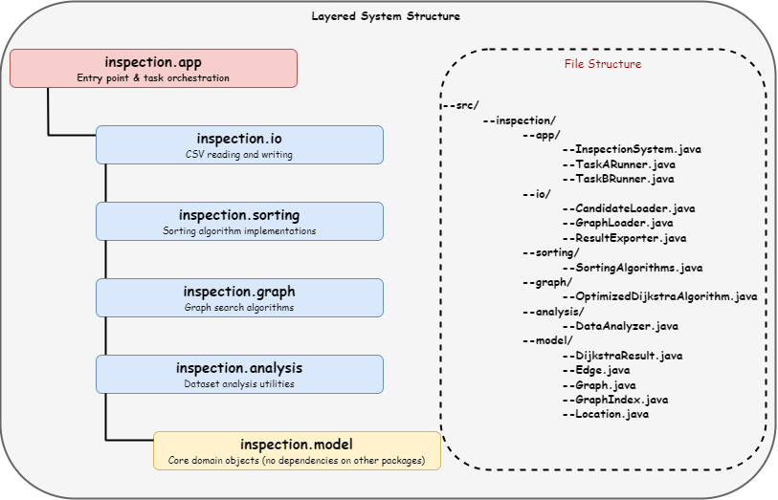
3.1 Overall Application Design
Figure. 1: An overview of the layered system structure and the file structure

The Urban Infrastructure Inspection System is organised as a layered package hierarchy under the root namespace inspection. Each layer has a single, clearly bounded responsibility and depends only on layers below it, creating a directed dependency graph with no cycles.
At runtime, InspectionSystem.main() acts as the single entry point and orchestrates two sequential phases. In Phase 1, TaskARunner.run() loads the three candidate datasets from CSV files via CandidateLoader, times all three sorting algorithms on each dataset, extracts the top 10 locations per dataset, and returns a Location[3][10] array directly to the caller. In Phase 2, TaskBRunner.run(Location[][]) receives that array as a method argument — no intermediate file is re-read — builds the infrastructure graph from paths.csv via GraphLoader, converts it to an integer-indexed representation via GraphIndex, and executes the four prescribed shortest-path cases using OptimizedDijkstraAlgorithm. Both phases write output files to the output/ directory as audit artifacts, but those files are not part of the runtime pipeline.
This two-phase handoff design makes the system a single coherent application rather than two independent programs. The Location[][] array that flows from Phase 1 to Phase 2 carries live Java objects; the downstream code requires no file parsing and no type conversion.

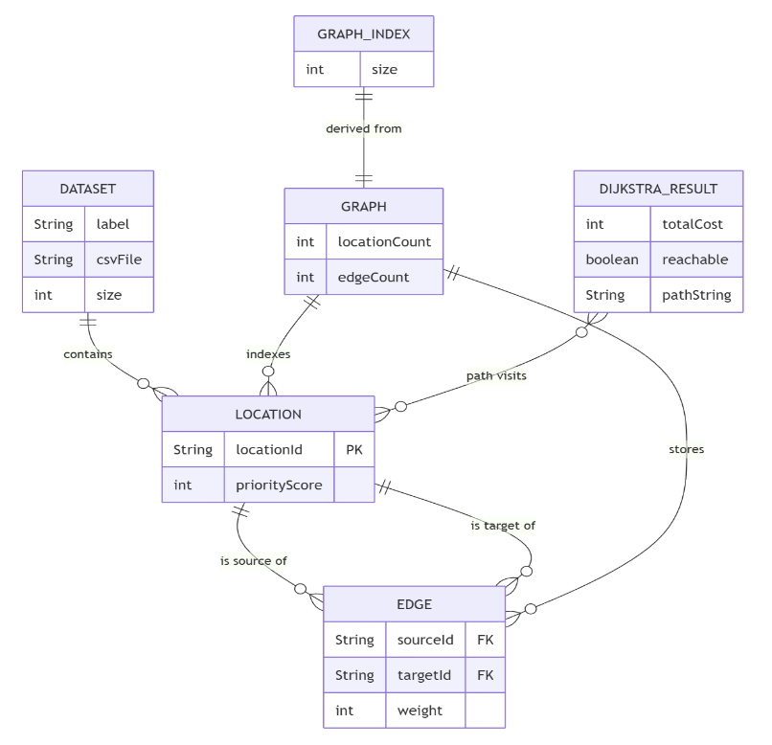
3.2 Data Structures
Figure. 2: An overview of the data structure of the system

Three distinct data structures are used across the system, each chosen to match the access pattern of the component that uses it.
`Location[]` arrays hold candidate datasets. Arrays are chosen over List<Location> because: (1) the dataset size is fixed after loading — CandidateLoader uses a two-pass strategy to allocate an exactly-sized array, avoiding wasted capacity; (2) all three sorting algorithms swap elements in-place via index arithmetic, which requires constant-time random access. A fresh copy is made before each sort using System.arraycopy so the original order is preserved for subsequent runs.
`HashMap<String, List<Edge>>` is the adjacency list used by Graph. Each key is a location ID string; the corresponding value is a List<Edge> holding the outgoing edges from that node. This structure supports the graph-building phase well: HashMap.putIfAbsent and List.add are amortised O(1), and the full graph is built in O(m) time by iterating once through the edge rows of paths.csv. Undirected edges are represented as two directed Edge objects — one in each direction — inserted in the same addEdge call.
`int[][]` parallel arrays are the performance-critical data structure used inside GraphIndex and OptimizedDijkstraAlgorithm. GraphIndex.fromGraph() assigns each location ID a consecutive integer index and stores the graph as two parallel arrays: neighborIds[i][] holds the integer indices of the neighbours of node i, and neighborWeights[i][] holds the corresponding edge weights. The inner relaxation loop of the shortest-path algorithm accesses these arrays with direct index arithmetic, replacing the HashMap.get and string comparison operations that would be required if the string-keyed Graph were queried directly. Four additional flat int[] arrays — distForward, distBackward, parentForward, parentBackward — store current tentative distances and parent pointers for both Dijkstra frontiers. These are allocated once in the constructor and reset with Arrays.fill between calls, avoiding repeated heap allocation across the seven segment queries.
The three data structures serve complementary roles: Location[] enables in-place sorting; HashMap<String, List<Edge>> enables readable, flexible graph construction; and int[][] enables cache-friendly, low-overhead graph traversal.
The entity-relationship diagram below formalises how the core data entities relate to one another. LOCATION and EDGE are the two fundamental domain entities; GRAPH and GRAPH_INDEX are structural containers built from them; and DIJKSTRA_RESULT is the query-output entity produced by the search algorithm.

3.3 Classes and Functions
The system comprises fourteen classes across six packages. The table below summarises each class's responsibility.
Class | Package | Responsibility
Location | model | Domain object for one candidate location
Edge | model | Immutable directed weighted edge
Graph | model | String-keyed adjacency list
GraphIndex | model | Integer-indexed array view of a Graph
DijkstraResult | model | Immutable shortest-path query result
SortingAlgorithms | sorting | Bubble, Quick, and Merge Sort on Location[]
OptimizedDijkstraAlgorithm | graph | Bidirectional Dijkstra with buffer reuse
CandidateLoader | io | Two-pass CSV loading into Location[]
GraphLoader | io | Builds Graph from edge-list CSV
ResultExporter | io | Writes all output CSV files
DataAnalyzer | analysis | Computes structural properties of a dataset
TaskARunner | app | Coordinates the Phase 1 sorting workflow
TaskBRunner | app | Coordinates the Phase 2 routing workflow
InspectionSystem | app | Single main() entry point

SortingAlgorithms and both loader classes (CandidateLoader, GraphLoader) are non-instantiable utility classes with private constructors, signalling that they contain only static methods and should not be used as objects. DijkstraResult and Edge are immutable value objects: their fields are final and no setters are provided; DijkstraResult.getPath() additionally returns a defensive copy of the internal list to prevent external mutation.
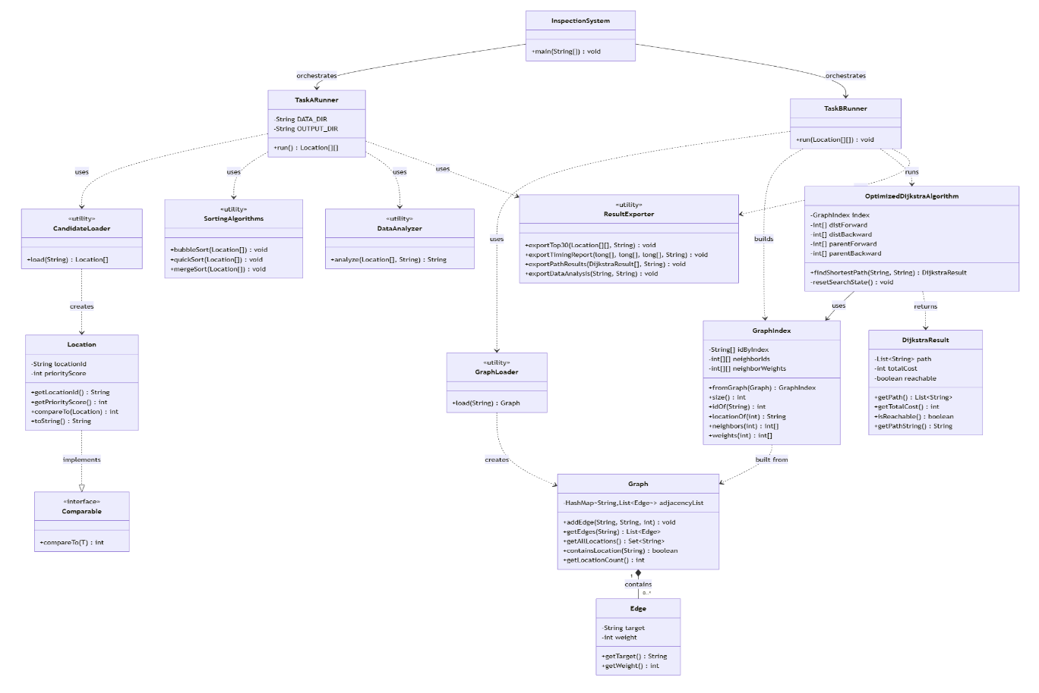
The class diagram below captures the full structure of the system. Solid lines with filled diamonds denote composition; dashed arrows with open arrowheads denote dependency (one class creates or calls another); and the dashed line with a hollow triangle denotes interface realisation.

3.4 Object-Oriented Design
The system applies four core OOP principles consistently across its class design.
Encapsulation is enforced in every domain object. Location's locationId and priorityScore fields are private final; they are exposed only through read-only getters. Graph's adjacency list map is never exposed directly — callers use addEdge, getEdges, and getAllLocations, and the last of these returns an unmodifiable set view via Collections.unmodifiableSet. Edge stores its target and weight as private final fields with no mutation methods. This encapsulation means the internal representation of each class can be changed without affecting the classes that depend on it.
Abstraction is applied at the I/O layer. The CandidateLoader.load(filePath) and GraphLoader.load(filePath) methods hide all file-reading logic, line splitting, header skipping, two-pass counting — behind a single static method call. Callers (TaskARunner and TaskBRunner) interact with these loaders through a one-line call and receive fully constructed Java objects; they are unaware of the CSV format or parsing details.
The `Comparable<Location>` interface formalises the ranking contract for candidate locations. By implementing compareTo(Location other), Location declares that it has a natural ordering. All three sorting algorithms in SortingAlgorithms call arr[i].compareTo(arr[j]) and sort in the order defined by this single method: descending priority score as the primary key, ascending location ID as the tie-breaker. This design means the ranking rule is defined once in Location and is automatically respected by any algorithm that uses compareTo, including Java's own Collections.sort or Arrays.sort if they were used elsewhere in the system.
Single Responsibility Principle is the most pervasive design decision in the codebase. The original code mixed I/O into domain classes: Graph had a readFromCSV method, and DataAnalyzer duplicated the same CSV-reading logic found in TaskA. The refactored design assigns each class one job: Graph models the graph topology, GraphLoader handles file reading, ResultExporter handles file writing, and DataAnalyzer performs statistical analysis. The TaskARunner and TaskBRunner classes exist solely to sequence their respective workflows; InspectionSystem exists solely to chain the two runners together. This strict role separation means each class is testable in isolation and modifications to one concern — say, changing the output format — do not require changes to unrelated classes.

Chapter 4 – Project Reflection (Task D)

4.1 AI-Assisted Planning and Collaboration
While fulfilling the course’s requirement for independent core design, we used AI tools (ChatGPT, Claude) in limited, deliberate ways:
- Generating the initial file structure and task list to ground our GitHub collaboration.
- Interpreting unfamiliar error messages before we decided on fixes.
- Clarifying design trade-offs (e.g., exposing a raw adjacency list versus an unmodifiable view).
- Grammar-checking the final report.

We chose GitHub as the collaboration platform (https://github.com/NeurEv0/25-26_CPT204-138). Since both members already committed code there, the commit history, diffs, and branches naturally tracked contributions. Descriptive messages like “Refactor DataAnalyzer to use CandidateLoader instead of its own readCSV” served as a lightweight task log without a separate board. Real-time design discussions and handoffs happened over WeChat.

4.2 Equality, Diversity, and Inclusion
Equality, diversity, and inclusion (EDI) in software design means that a system should work fairly and accessibly for all potential users, not just those who happen to resemble the developer. For this project, EDI considerations are relevant both in how the system presents its outputs and in how the underlying data might affect different groups of users if the system were deployed in practice.
All output is currently console text or CSV files. This is functional but inaccessible: screen-reader users need structured output, and non-English speakers may not understand location IDs or status messages. A concrete improvement would be adding a text-to-speech layer so visually impaired operators can receive rankings and route results audibly.
A subtler problem lies in the prioritisation scores. The system blindly ranks locations using predetermined scores without questioning whether the scoring methodology favours certain regions or communities. If the model systematically undervalues infrastructure in low-income areas, the audit will reinforce that inequality. Future versions should disclose data sources and scoring methods in output reports, enabling stakeholders to scrutinise the prioritisation process.
Individually these improvements are not technically difficult, but coordinating them is challenging. Text-to-speech introduces audio-hardware dependencies and Java library requirements. Multilingual output must stay machine-readable for downstream processing. Data bias can only be addressed with domain experts and community input—something a software team cannot resolve alone. Recognising these challenges is itself an essential step toward responsible development.

4.3 Life-long Learning and Future Improvement

The core lesson was the gap between theoretical complexity and actual behaviour. Quick Sort seemed competitive, but on Dataset A it took 7.71 ms while Bubble Sort finished in 0.42 ms. This showed that constant factors, pivot strategy, and input shape matter in ways asymptotic notation alone cannot capture—real measurement is irreplaceable. Refactoring in Task C provided a second insight. Originally, Task A and Task B were independent programs with duplicated logic and I/O mixed into domain classes. Restructuring into a layered inspection.* package made the code easier to reason about and modify. Separating GraphLoader from Graph made the Single Responsibility Principle concrete: a change to the CSV format would touch only one class, not scattered domain logic. The most useful next step would replace the console-and-CSV interface with a web API, allowing other systems (mobile field-worker apps, city dashboards) to call the inspection logic. This would demand robust error handling and input validation, as the current code assumes well-formed CSV. A longer-term improvement is incremental graph updates: instead of reloading the entire network when roads are added, dynamic updates would make the system suitable for real-time operational use rather than just batch processing.

Chapter 5 – Program Code

src\inspection\analysis\DataAnalyzer.java
package inspection.analysis;

import inspection.io.CandidateLoader;
import inspection.io.ResultExporter;
import inspection.model.Location;

/**
* Analyses the structural characteristics of a candidate-location dataset.
*
* <p>Can be used in two ways:
* <ol>
* <li><b>Standalone</b> — run {@link #main(String[])} to analyse all three
* datasets and export a report to {@code output/data_analysis_report.txt}.</li>
* <li><b>Integrated</b> — call {@link #analyze(Location[], String)} from
* {@link inspection.app.TaskARunner} to embed per-dataset analysis in the
* sorting workflow output.</li>
* </ol>
*/
public class DataAnalyzer {

private static final String DATA_DIR = "Group Project Datasets";
private static final String OUTPUT_DIR = "output";
private static final String[] DATASETS =
{"candidates_A.csv", "candidates_B.csv", "candidates_C.csv"};

/** Standalone entry point: analyses all three datasets and exports a report. */
public static void main(String[] args) {
StringBuilder report = new StringBuilder();
report.append("==============================================\n");
report.append(" Data Characteristics Analysis\n");
report.append("==============================================\n\n");

for (int d = 0; d < DATASETS.length; d++) {
String filePath = DATA_DIR + "/" + DATASETS[d];
Location[] data = CandidateLoader.load(filePath);
String datasetName = "Dataset " + (char) ('A' + d) + ": " + DATASETS[d];
report.append("──────────────────────────────────────────────\n");
report.append(" ").append(datasetName).append("\n");
report.append("──────────────────────────────────────────────\n");
report.append(analyze(data, datasetName));
report.append("\n");
}

System.out.print(report);
ResultExporter.exportDataAnalysis(report.toString(),
OUTPUT_DIR + "/data_analysis_report.txt");
}

/**
* Analyses {@code data} and returns a formatted multi-line report string.
*
* @param data pre-loaded array in original file order
* @param datasetName label used in the report header
* @return formatted analysis text (does not include the section header)
*/
public static String analyze(Location[] data, String datasetName) {
StringBuilder sb = new StringBuilder();
int n = data.length;

// ---- Basic Statistics ----
int minScore = Integer.MAX_VALUE, maxScore = Integer.MIN_VALUE;
long sum = 0;
int minId = Integer.MAX_VALUE, maxId = Integer.MIN_VALUE;

for (Location loc : data) {
int score = loc.getPriorityScore();
if (score < minScore) minScore = score;
if (score > maxScore) maxScore = score;
sum += score;
int id = extractIdNumber(loc.getLocationId());
if (id < minId) minId = id;
if (id > maxId) maxId = id;
}

double mean = (double) sum / n;
sb.append(" Basic Statistics:\n");
sb.append(" Total locations : ").append(n).append("\n");
sb.append(" Score range : ").append(minScore).append(" ~ ").append(maxScore).append("\n");
sb.append(" Mean score : ").append(String.format("%.2f", mean)).append("\n");
sb.append(" Location ID range: L").append(String.format("%04d", minId))
.append(" ~ L").append(String.format("%04d", maxId)).append("\n");

// ---- Score Distribution ----
int[] scoreFreq = new int[maxScore - minScore + 1];
for (Location loc : data) {
scoreFreq[loc.getPriorityScore() - minScore]++;
}
int uniqueScores = 0, maxFreq = 0, maxFreqScore = 0;
for (int i = 0; i < scoreFreq.length; i++) {
if (scoreFreq[i] > 0) uniqueScores++;
if (scoreFreq[i] > maxFreq) {
maxFreq = scoreFreq[i];
maxFreqScore = i + minScore;
}
}
sb.append(" Unique scores : ").append(uniqueScores).append("\n");
sb.append(" Most frequent : score ").append(maxFreqScore)
.append(" appears ").append(maxFreq).append(" times\n");

// ---- Initial Order Analysis ----
int descViolations = 0, ascViolations = 0;
for (int i = 0; i < n - 1; i++) {
int curr = data[i].getPriorityScore();
int next = data[i + 1].getPriorityScore();
if (curr < next) descViolations++;
if (curr > next) ascViolations++;
}
double descSortedness = (1.0 - (double) descViolations / (n - 1)) * 100;
double ascSortedness = (1.0 - (double) ascViolations / (n - 1)) * 100;

sb.append("\n Initial Order Analysis:\n");
sb.append(" Descending order : ").append(String.format("%.1f%%", descSortedness))
.append(" sorted (").append(descViolations).append(" violations)\n");
sb.append(" Ascending order : ").append(String.format("%.1f%%", ascSortedness))
.append(" sorted (").append(ascViolations).append(" violations)\n");

int sampleSize = Math.min(n, 200);
long inversions = countInversionsSample(data, sampleSize);
long maxPossible = (long) sampleSize * (sampleSize - 1) / 2;
double inversionDensity = (double) inversions / maxPossible * 100;
sb.append(" Inversions (first ").append(sampleSize).append("): ").append(inversions)
.append(" (").append(String.format("%.1f%%", inversionDensity)).append(" of max)\n");

String orderType;
if (descSortedness > 95) orderType = "NEARLY SORTED DESCENDING";
else if (descSortedness > 70) orderType = "PARTIALLY SORTED DESCENDING";
else if (inversionDensity > 40) orderType = "RANDOM / UNSORTED";
else orderType = "PARTIALLY SORTED";
sb.append(" Classification : ").append(orderType).append("\n");

// ---- Tie Analysis ----
int totalTies = 0, tieGroups = 0;
for (int freq : scoreFreq) {
if (freq > 1) { totalTies += freq; tieGroups++; }
}
sb.append("\n Tie Analysis:\n");
sb.append(" Score groups with ties : ").append(tieGroups).append("\n");
sb.append(" Locations sharing a score: ").append(totalTies)
.append(" (").append(String.format("%.1f%%", (double) totalTies / n * 100)).append(")\n");

return sb.toString();
}

/** Counts inversions in a sample using O(n²) brute force. */
private static long countInversionsSample(Location[] data, int sampleSize) {
long inversions = 0;
for (int i = 0; i < sampleSize; i++) {
for (int j = i + 1; j < sampleSize; j++) {
if (data[i].compareTo(data[j]) > 0) inversions++;
}
}
return inversions;
}

private static int extractIdNumber(String locationId) {
return Integer.parseInt(locationId.substring(1));
}
}

src\inspection\app\InspectionSystem.java
package inspection.app;

import inspection.model.Location;

/**
* Entry point for the Urban Infrastructure Inspection System.
*/
public class InspectionSystem {

public static void main(String[] args) {
printBanner();

// ── Phase 1: Sorting & Candidate Selection ────────────────────────────
TaskARunner taskA = new TaskARunner();
Location[][] topTargets = taskA.run();

// ── Phase 2: Graph Construction & Route Planning ──────────────────────
TaskBRunner taskB = new TaskBRunner();
taskB.run(topTargets);

System.out.println("==============================================");
System.out.println(" Inspection system workflow complete.");
System.out.println(" Output files written to: output/");
System.out.println("==============================================");
}

private static void printBanner() {
System.out.println("==============================================");
System.out.println(" Urban Infrastructure Inspection System");
System.out.println(" CPT204 Group Project – AY2526");
System.out.println("==============================================");
System.out.println();
System.out.println(" Phase 1 : Candidate Selection (Task A)");
System.out.println(" Phase 2 : Route Planning (Task B)");
System.out.println();
}
}

src\inspection\app\TaskARunner.java
package inspection.app;

import inspection.analysis.DataAnalyzer;
import inspection.io.CandidateLoader;
import inspection.io.ResultExporter;
import inspection.model.Location;
import inspection.sorting.SortingAlgorithms;

/**
* Executes the Task A workflow: loads the three candidate datasets, sorts each
* one with Bubble Sort, Quick Sort, and Merge Sort, measures average runtimes,
* and extracts the top 10 highest-priority locations per dataset.
*/
public class TaskARunner {

private static final String DATA_DIR = "Group Project Datasets";
private static final String OUTPUT_DIR = "output";
private static final String[] DATASET_FILES = {
"candidates_A.csv", "candidates_B.csv", "candidates_C.csv"
};
private static final int RUNS = 3; // timing runs per algorithm per dataset

/**
* Runs the full Task A workflow.
*/
public Location[][] run() {
System.out.println("==============================================");
System.out.println(" Task A – Sorting Algorithm Evaluation");
System.out.println("==============================================\n");

long[] bubbleTimes = new long[3];
long[] quickTimes = new long[3];
long[] mergeTimes = new long[3];
Location[][] top10s = new Location[3][10];

for (int d = 0; d < DATASET_FILES.length; d++) {
String filePath = DATA_DIR + "/" + DATASET_FILES[d];
String datasetLabel = "Dataset " + (char) ('A' + d);

// Load original data once; copies are made before each sort
Location[] originalData = CandidateLoader.load(filePath);
System.out.printf("[%s] Loaded %d locations from %s%n",
datasetLabel, originalData.length, DATASET_FILES[d]);

// Optional: embed dataset characteristics analysis
System.out.println(DataAnalyzer.analyze(originalData, datasetLabel));

// Time each algorithm (3 runs, report average)
bubbleTimes[d] = timeSort(originalData, "Bubble");
quickTimes[d] = timeSort(originalData, "Quick");
mergeTimes[d] = timeSort(originalData, "Merge");

System.out.printf(" %-12s Bubble: %-18s Quick: %-18s Merge: %s%n",
datasetLabel,
formatTime(bubbleTimes[d]),
formatTime(quickTimes[d]),
formatTime(mergeTimes[d]));

// Extract top 10 using Quick Sort on a fresh copy
Location[] sorted = copyArray(originalData);
SortingAlgorithms.quickSort(sorted);
System.arraycopy(sorted, 0, top10s[d], 0, 10);

System.out.println(" Top 10 selected locations:");
for (int i = 0; i < 10; i++) {
System.out.printf(" %2d. %s (score: %d)%n",
i + 1,
top10s[d][i].getLocationId(),
top10s[d][i].getPriorityScore());
}
System.out.println();
}

// Export timing and selection results as audit files
ResultExporter.exportTop30(top10s, OUTPUT_DIR + "/taskA_top30_targets.csv");
ResultExporter.exportTimingReport(bubbleTimes, quickTimes, mergeTimes,
OUTPUT_DIR + "/taskA_timing_report.csv");

System.out.println();
return top10s;
}

// -------------------------------------------------------------------------
// Private helpers
// -------------------------------------------------------------------------

private long timeSort(Location[] original, String algorithm) {
long total = 0;
for (int run = 0; run < RUNS; run++) {
Location[] copy = copyArray(original);
long start = System.nanoTime();
switch (algorithm) {
case "Bubble": SortingAlgorithms.bubbleSort(copy); break;
case "Quick": SortingAlgorithms.quickSort(copy); break;
case "Merge": SortingAlgorithms.mergeSort(copy); break;
}
total += System.nanoTime() - start;

// Verify sort correctness on the last run
if (run == RUNS - 1) {
verifySorted(copy, algorithm);
}
}
return total / RUNS;
}

/** Asserts that {@code arr} is fully sorted; prints a warning otherwise. */
private void verifySorted(Location[] arr, String algorithm) {
for (int i = 0; i < arr.length - 1; i++) {
if (arr[i].compareTo(arr[i + 1]) > 0) {
System.err.printf(" WARNING: %s sort produced an incorrect result!%n", algorithm);
return;
}
}
}

private Location[] copyArray(Location[] src) {
Location[] dest = new Location[src.length];
System.arraycopy(src, 0, dest, 0, src.length);
return dest;
}

private String formatTime(long nanos) {
if (nanos < 1_000_000L) {
return String.format("%,d ns", nanos);
} else if (nanos < 1_000_000_000L) {
return String.format("%.3f ms", nanos / 1_000_000.0);
} else {
return String.format("%.3f s", nanos / 1_000_000_000.0);
}
}
}

src\inspection\graph\OptimizedDijkstraAlgorithm.java
package inspection.graph;

import inspection.model.DijkstraResult;
import inspection.model.GraphIndex;

import java.util.ArrayList;
import java.util.Arrays;
import java.util.List;
import java.util.PriorityQueue;

/**
* Bidirectional Dijkstra's algorithm for shortest-path queries on the infrastructure graph.
*/
public class OptimizedDijkstraAlgorithm {

private static final int INF = Integer.MAX_VALUE / 4;

private final GraphIndex index;
private final int[] distForward;
private final int[] distBackward;
private final int[] parentForward;
private final int[] parentBackward;
private final PriorityQueue<HeapNode> forwardQueue;
private final PriorityQueue<HeapNode> backwardQueue;

public OptimizedDijkstraAlgorithm(GraphIndex index) {
int n = index.size();
this.index = index;
this.distForward = new int[n];
this.distBackward = new int[n];
this.parentForward = new int[n];
this.parentBackward = new int[n];
this.forwardQueue = new PriorityQueue<HeapNode>();
this.backwardQueue = new PriorityQueue<HeapNode>();
}

/**
* Finds the shortest path from {@code start} to {@code destination}.
*
* @param start location ID of the source node
* @param destination location ID of the target node
* @return a {@link DijkstraResult} containing the path and total cost,
* or an unreachable result if no path exists
*/
public DijkstraResult findShortestPath(String start, String destination) {
int startId = index.idOf(start);
int destId = index.idOf(destination);

if (startId < 0 || destId < 0) {
return new DijkstraResult(new ArrayList<String>(), INF, false);
}

// Trivial case: source == destination (e.g., Case 1 in Task B)
if (startId == destId) {
List<String> path = new ArrayList<String>();
path.add(start);
return new DijkstraResult(path, 0, true);
}

resetSearchState();

distForward[startId] = 0;
distBackward[destId] = 0;
parentForward[startId] = startId;
parentBackward[destId] = destId;
forwardQueue.add(new HeapNode(startId, 0));
backwardQueue.add(new HeapNode(destId, 0));

int bestDistance = INF;
int meetingPoint = -1;

while (!forwardQueue.isEmpty() && !backwardQueue.isEmpty()) {
int forwardBest = forwardQueue.peek().distance;
int backwardBest = backwardQueue.peek().distance;
// Termination criterion: if the sum of the two frontier heads
// already exceeds the best known path, no improvement is possible.
if ((long) forwardBest + (long) backwardBest >= bestDistance) {
break;
}

if (forwardBest <= backwardBest) {
MeetingUpdate update = expandFrontier(
forwardQueue, distForward, distBackward, parentForward, true);
if (update.meetingPoint >= 0 && update.totalDistance < bestDistance) {
bestDistance = update.totalDistance;
meetingPoint = update.meetingPoint;
}
} else {
MeetingUpdate update = expandFrontier(
backwardQueue, distBackward, distForward, parentBackward, false);
if (update.meetingPoint >= 0 && update.totalDistance < bestDistance) {
bestDistance = update.totalDistance;
meetingPoint = update.meetingPoint;
}
}
}

if (meetingPoint < 0) {
return new DijkstraResult(new ArrayList<String>(), INF, false);
}

List<String> path = buildPath(startId, destId, meetingPoint);
return new DijkstraResult(path, bestDistance, true);
}

private void resetSearchState() {
Arrays.fill(distForward, INF);
Arrays.fill(distBackward, INF);
Arrays.fill(parentForward, -1);
Arrays.fill(parentBackward, -1);
forwardQueue.clear();
backwardQueue.clear();
}

private MeetingUpdate expandFrontier(PriorityQueue<HeapNode> queue,
int[] ownDistances,
int[] oppositeDistances,
int[] previous,
boolean isForward) {
HeapNode current;
do {
if (queue.isEmpty()) return MeetingUpdate.none();
current = queue.poll();
} while (current.distance > ownDistances[current.nodeId]); // skip stale entries

int meetingPoint = -1;
int bestTotal = INF;

// Check if the opposite frontier has already reached this node
int oppositeAtCurrent = oppositeDistances[current.nodeId];
if (oppositeAtCurrent < INF) {
long total = (long) current.distance + (long) oppositeAtCurrent;
if (total < bestTotal) {
bestTotal = (int) total;
meetingPoint = current.nodeId;
}
}

int[] neighbors = index.neighbors(current.nodeId);
int[] weights = index.weights(current.nodeId);
for (int i = 0; i < neighbors.length; i++) {
int neighborId = neighbors[i];
int newDistance = current.distance + weights[i];
if (newDistance >= ownDistances[neighborId]) continue;

ownDistances[neighborId] = newDistance;
previous[neighborId] = current.nodeId;
queue.add(new HeapNode(neighborId, newDistance));

int oppositeAtNeighbor = oppositeDistances[neighborId];
if (oppositeAtNeighbor < INF) {
long total = (long) newDistance + (long) oppositeAtNeighbor;
if (total < bestTotal) {
bestTotal = (int) total;
meetingPoint = neighborId;
}
}
}

return new MeetingUpdate(meetingPoint, bestTotal);
}

private List<String> buildPath(int startId, int destId, int meetingPoint) {
List<String> path = new ArrayList<String>();

// Trace forward parent chain from meetingPoint back to start
int current = meetingPoint;
while (current != startId) {
path.add(index.locationOf(current));
current = parentForward[current];
if (current < 0) return new ArrayList<String>();
}
path.add(index.locationOf(startId));
reverseInPlace(path);

// Trace backward parent chain from meetingPoint forward to dest
current = meetingPoint;
int next = parentBackward[current];
while (next != destId) {
if (next < 0) return new ArrayList<String>();
path.add(index.locationOf(next));
current = next;
next = parentBackward[current];
}
path.add(index.locationOf(destId));

return path;
}

private static void reverseInPlace(List<String> list) {
for (int i = 0, j = list.size() - 1; i < j; i++, j--) {
String tmp = list.get(i);
list.set(i, list.get(j));
list.set(j, tmp);
}
}

// -------------------------------------------------------------------------
// Private helper value types
// -------------------------------------------------------------------------

private static final class HeapNode implements Comparable<HeapNode> {
private final int nodeId;
private final int distance;

private HeapNode(int nodeId, int distance) {
this.nodeId = nodeId;
this.distance = distance;
}

@Override
public int compareTo(HeapNode other) {
int cmp = Integer.compare(this.distance, other.distance);
return cmp != 0 ? cmp : Integer.compare(this.nodeId, other.nodeId);
}
}

private static final class MeetingUpdate {
private final int meetingPoint;
private final int totalDistance;

private MeetingUpdate(int meetingPoint, int totalDistance) {
this.meetingPoint = meetingPoint;
this.totalDistance = totalDistance;
}

private static MeetingUpdate none() {
return new MeetingUpdate(-1, INF);
}
}
}

src\inspection\io\CandidateLoader.java
package inspection.io;

import inspection.model.Location;

import java.io.BufferedReader;
import java.io.FileReader;
import java.io.IOException;

/**
* Loads a candidate-location CSV file into a {@link Location} array.
*/
public class CandidateLoader {

private CandidateLoader() {
// Utility class — not instantiable.
}

public static Location[] load(String filePath) {
int count = countDataLines(filePath);
Location[] locations = new Location[count];

try (BufferedReader br = new BufferedReader(new FileReader(filePath))) {
br.readLine(); // skip header
String line;
int idx = 0;
while ((line = br.readLine()) != null) {
if (line.trim().isEmpty()) continue;
String[] parts = line.split(",");
String locId = parts[0].trim();
int score = Integer.parseInt(parts[1].trim());
locations[idx++] = new Location(locId, score);
}
} catch (IOException e) {
System.err.println("[CandidateLoader] Error reading: " + filePath);
e.printStackTrace();
}

return locations;
}

/** Two-pass helper: counts non-empty data rows (excluding header). */
private static int countDataLines(String filePath) {
int count = 0;
try (BufferedReader br = new BufferedReader(new FileReader(filePath))) {
br.readLine(); // skip header
String line;
while ((line = br.readLine()) != null) {
if (!line.trim().isEmpty()) count++;
}
} catch (IOException e) {
System.err.println("[CandidateLoader] Error counting lines: " + filePath);
e.printStackTrace();
}
return count;
}
}

src\inspection\io\GraphLoader.java
package inspection.io;

import inspection.model.Graph;

import java.io.BufferedReader;
import java.io.FileReader;
import java.io.IOException;

/**
* Loads a weighted-edge CSV file into a {@link Graph}.
*/
public class GraphLoader {

private GraphLoader() {
// Utility class — not instantiable.
}

public static Graph load(String filePath) {
Graph graph = new Graph();

try (BufferedReader br = new BufferedReader(new FileReader(filePath))) {
br.readLine(); // skip header
String line;
while ((line = br.readLine()) != null) {
if (line.trim().isEmpty()) continue;
String[] parts = line.split(",");
if (parts.length < 3) continue;
String from = parts[0].trim();
String to = parts[1].trim();
int weight = Integer.parseInt(parts[2].trim());
graph.addEdge(from, to, weight);
}
} catch (IOException e) {
System.err.println("[GraphLoader] Error reading: " + filePath);
e.printStackTrace();
}

return graph;
}
}

src\inspection\io\ResultExporter.java
package inspection.io;

import inspection.model.Location;

import java.io.File;
import java.io.FileWriter;
import java.io.IOException;
import java.io.PrintWriter;
import java.util.List;

/**
* Consolidates all file-export operations for the inspection system.
*/
public class ResultExporter {

private ResultExporter() {
// Utility class — not instantiable.
}

public static void exportTop30(Location[][] top10s, String filePath) {
ensureParentDirs(filePath);
String[] labels = {"A", "B", "C"};
try (PrintWriter pw = new PrintWriter(new FileWriter(filePath))) {
pw.println("rank,dataset,location_id,priority_score");
for (int d = 0; d < top10s.length; d++) {
for (int i = 0; i < top10s[d].length; i++) {
Location loc = top10s[d][i];
pw.println((i + 1) + "," + labels[d] + ","
+ loc.getLocationId() + "," + loc.getPriorityScore());
}
}
System.out.println("[Export] Top-30 targets -> " + filePath);
} catch (IOException e) {
System.err.println("[ResultExporter] Error writing top-30: " + e.getMessage());
}
}

public static void exportTimingReport(long[] bubbleTimes,
long[] quickTimes,
long[] mergeTimes,
String filePath) {
ensureParentDirs(filePath);
String[] labels = {"A", "B", "C"};
try (PrintWriter pw = new PrintWriter(new FileWriter(filePath))) {
pw.println("dataset,bubble_sort_ns,quick_sort_ns,merge_sort_ns");
for (int d = 0; d < 3; d++) {
pw.println(labels[d] + "," + bubbleTimes[d] + ","
+ quickTimes[d] + "," + mergeTimes[d]);
}
System.out.println("[Export] Timing report -> " + filePath);
} catch (IOException e) {
System.err.println("[ResultExporter] Error writing timing report: " + e.getMessage());
}
}

public static void exportPathResults(List<String> reportLines,
String algorithmName,
String filePath) {
ensureParentDirs(filePath);
try (PrintWriter pw = new PrintWriter(new FileWriter(filePath))) {
pw.println("Task B - Shortest Path Results");
pw.println("Algorithm: " + algorithmName);
pw.println("==============================================");
for (String line : reportLines) {
pw.println(line);
}
System.out.println("[Export] Path results -> " + filePath);
} catch (IOException e) {
System.err.println("[ResultExporter] Error writing path results: " + e.getMessage());
}
}

public static void exportDataAnalysis(String content, String filePath) {
ensureParentDirs(filePath);
try (PrintWriter pw = new PrintWriter(new FileWriter(filePath))) {
pw.print(content);
System.out.println("[Export] Data analysis -> " + filePath);
} catch (IOException e) {
System.err.println("[ResultExporter] Error writing data analysis: " + e.getMessage());
}
}

private static void ensureParentDirs(String filePath) {
File parent = new File(filePath).getParentFile();
if (parent != null) parent.mkdirs();
}
}

src\inspection\model\DijkstraResult.java
package inspection.model;

import java.util.ArrayList;
import java.util.List;

/**
* Immutable result of a single shortest-path query.
*/
public class DijkstraResult {

private final List<String> path;
private final int totalCost;
private final boolean reachable;

public DijkstraResult(List<String> path, int totalCost, boolean reachable) {
this.path = path;
this.totalCost = totalCost;
this.reachable = reachable;
}

/** Returns a defensive copy of the path node list. */
public List<String> getPath() {
return new ArrayList<String>(path);
}

public int getTotalCost() {
return totalCost;
}

public boolean isReachable() {
return reachable;
}

/** Formats the path as {@code "L0001 -> L0002 -> ..."} for reporting. */
public String getPathString() {
if (!reachable || path.isEmpty()) {
return "No path found";
}
StringBuilder sb = new StringBuilder();
for (int i = 0; i < path.size(); i++) {
sb.append(path.get(i));
if (i < path.size() - 1) {
sb.append(" -> ");
}
}
return sb.toString();
}
}

src\inspection\model\Edge.java
package inspection.model;

/**
* An immutable, weighted directed edge in the infrastructure graph.
*/
public class Edge {

private final String target;
private final int weight;

public Edge(String target, int weight) {
this.target = target;
this.weight = weight;
}

public String getTarget() {
return target;
}

public int getWeight() {
return weight;
}

@Override
public String toString() {
return "-> " + target + " (w=" + weight + ")";
}
}

src\inspection\model\Graph.java
package inspection.model;

import java.util.ArrayList;
import java.util.Collections;
import java.util.HashMap;
import java.util.List;
import java.util.Map;
import java.util.Set;

/**
* Weighted undirected graph representing the urban infrastructure network.
*/
public class Graph {

private final Map<String, List<Edge>> adjacencyList;

public Graph() {
adjacencyList = new HashMap<String, List<Edge>>();
}

/**
* Adds an undirected weighted edge between {@code from} and {@code to}.
* Both endpoints are registered as nodes even if they have no other edges.
*/
public void addEdge(String from, String to, int weight) {
adjacencyList.putIfAbsent(from, new ArrayList<Edge>());
adjacencyList.putIfAbsent(to, new ArrayList<Edge>());
adjacencyList.get(from).add(new Edge(to, weight));
adjacencyList.get(to).add(new Edge(from, weight));
}

/**
* Returns the outgoing edges for {@code locationId}, or an empty list if
* the location is not present in the graph.
*/
public List<Edge> getEdges(String locationId) {
List<Edge> edges = adjacencyList.get(locationId);
return edges == null ? new ArrayList<Edge>() : edges;
}

public boolean containsLocation(String locationId) {
return adjacencyList.containsKey(locationId);
}

public int getLocationCount() {
return adjacencyList.size();
}

/** Returns an unmodifiable view of all location IDs in this graph. */
public Set<String> getAllLocations() {
return Collections.unmodifiableSet(adjacencyList.keySet());
}
}

src\inspection\model\GraphIndex.java
package inspection.model;

import java.util.ArrayList;
import java.util.HashMap;
import java.util.List;
import java.util.Map;

/**
* Integer-indexed, array-backed view of a {@link Graph}.
*
* <p>Nodes are sorted lexicographically during construction so that the index
* assignment is deterministic across runs.
*/
public final class GraphIndex {

private final String[] idByIndex;
private final Map<String, Integer> indexById;
private final int[][] neighborIds;
private final int[][] neighborWeights;

private GraphIndex(String[] idByIndex,
Map<String, Integer> indexById,
int[][] neighborIds,
int[][] neighborWeights) {
this.idByIndex = idByIndex;
this.indexById = indexById;
this.neighborIds = neighborIds;
this.neighborWeights = neighborWeights;
}

/** Builds a {@code GraphIndex} from a fully constructed {@link Graph}. */
public static GraphIndex fromGraph(Graph graph) {
List<String> ids = new ArrayList<String>(graph.getAllLocations());
ids.sort(String::compareTo);

int n = ids.size();
String[] idByIndex = ids.toArray(new String[0]);
Map<String, Integer> indexById = new HashMap<String, Integer>(n * 2);
for (int i = 0; i < n; i++) {
indexById.put(idByIndex[i], i);
}

int[][] neighborIds = new int[n][];
int[][] neighborWeights = new int[n][];
for (int i = 0; i < n; i++) {
List<Edge> edges = graph.getEdges(idByIndex[i]);
int m = edges.size();
int[] nIds = new int[m];
int[] nWeights = new int[m];
for (int j = 0; j < m; j++) {
Edge edge = edges.get(j);
nIds[j] = indexById.get(edge.getTarget());
nWeights[j] = edge.getWeight();
}
neighborIds[i] = nIds;
neighborWeights[i] = nWeights;
}

return new GraphIndex(idByIndex, indexById, neighborIds, neighborWeights);
}

public int size() {
return idByIndex.length;
}

/** Returns the integer index for {@code locationId}, or {@code -1} if not found. */
public int idOf(String locationId) {
Integer id = indexById.get(locationId);
return id == null ? -1 : id;
}

public String locationOf(int id) {
return idByIndex[id];
}

public int[] neighbors(int id) {
return neighborIds[id];
}

public int[] weights(int id) {
return neighborWeights[id];
}
}

src\inspection\model\Location.java
package inspection.model;

/**
* Represents one candidate location from the inspection dataset.
*/
public class Location implements Comparable<Location> {

private final String locationId;
private final int priorityScore;

public Location(String locationId, int priorityScore) {
this.locationId = locationId;
this.priorityScore = priorityScore;
}

public String getLocationId() {
return locationId;
}

public int getPriorityScore() {
return priorityScore;
}

/**
* Compares two locations using the Task A ranking rule:
* descending by priority score, then ascending by location ID.
*/
@Override
public int compareTo(Location other) {
if (this.priorityScore != other.priorityScore) {
return Integer.compare(other.priorityScore, this.priorityScore); // descending
}
return this.locationId.compareTo(other.locationId); // ascending tie-break
}

@Override
public String toString() {
return locationId + " (score=" + priorityScore + ")";
}
}

src\inspection\sorting\SortingAlgorithms.java
package inspection.sorting;

import inspection.model.Location;

/**
* Provides three sorting algorithms — Bubble Sort, Quick Sort, and Merge Sort —
* all operating on {@link Location} arrays using the natural ordering defined
* by {@link Location#compareTo} (descending priority score, ascending ID tie-break).
*/
public class SortingAlgorithms {

private SortingAlgorithms() {
// Utility class — not instantiable.
}

// -------------------------------------------------------------------------
// Bubble Sort
// -------------------------------------------------------------------------

public static void bubbleSort(Location[] arr) {
int n = arr.length;
for (int i = 0; i < n - 1; i++) {
boolean swapped = false;
for (int j = 0; j < n - 1 - i; j++) {
if (arr[j].compareTo(arr[j + 1]) > 0) {
Location temp = arr[j];
arr[j] = arr[j + 1];
arr[j + 1] = temp;
swapped = true;
}
}
if (!swapped) break; // early termination
}
}

// -------------------------------------------------------------------------
// Quick Sort
// -------------------------------------------------------------------------

public static void quickSort(Location[] arr) {
quickSort(arr, 0, arr.length - 1);
}

private static void quickSort(Location[] arr, int low, int high) {
if (low < high) {
int pivotIndex = partition(arr, low, high);
quickSort(arr, low, pivotIndex - 1);
quickSort(arr, pivotIndex + 1, high);
}
}

private static int partition(Location[] arr, int low, int high) {
Location pivot = arr[low];
int left = low + 1;
int right = high;

while (right > left) {
while (left <= right && arr[left].compareTo(pivot) <= 0) left++;
while (left <= right && arr[right].compareTo(pivot) > 0) right--;
if (right > left) {
Location temp = arr[left];
arr[left] = arr[right];
arr[right] = temp;
}
}

while (right > low && arr[right].compareTo(pivot) >= 0) right--;

if (pivot.compareTo(arr[right]) > 0) {
arr[low] = arr[right];
arr[right] = pivot;
return right;
}
return low;
}

// -------------------------------------------------------------------------
// Merge Sort
// -------------------------------------------------------------------------

public static void mergeSort(Location[] arr) {
mergeSort(arr, 0, arr.length - 1);
}

private static void mergeSort(Location[] arr, int left, int right) {
if (left < right) {
int mid = (left + right) / 2;
mergeSort(arr, left, mid);
mergeSort(arr, mid + 1, right);
merge(arr, left, mid, right);
}
}

private static void merge(Location[] arr, int left, int mid, int right) {
int n1 = mid - left + 1;
int n2 = right - mid;

Location[] leftArr = new Location[n1];
Location[] rightArr = new Location[n2];
System.arraycopy(arr, left, leftArr, 0, n1);
System.arraycopy(arr, mid + 1, rightArr, 0, n2);

int i = 0, j = 0, k = left;
while (i < n1 && j < n2) {
if (leftArr[i].compareTo(rightArr[j]) <= 0) {
arr[k++] = leftArr[i++];
} else {
arr[k++] = rightArr[j++];
}
}
while (i < n1) arr[k++] = leftArr[i++];
while (j < n2) arr[k++] = rightArr[j++];
}
}

Chapter 6 – Appendix

6.1 Dataset Analyze output for each dataset

Dataset A
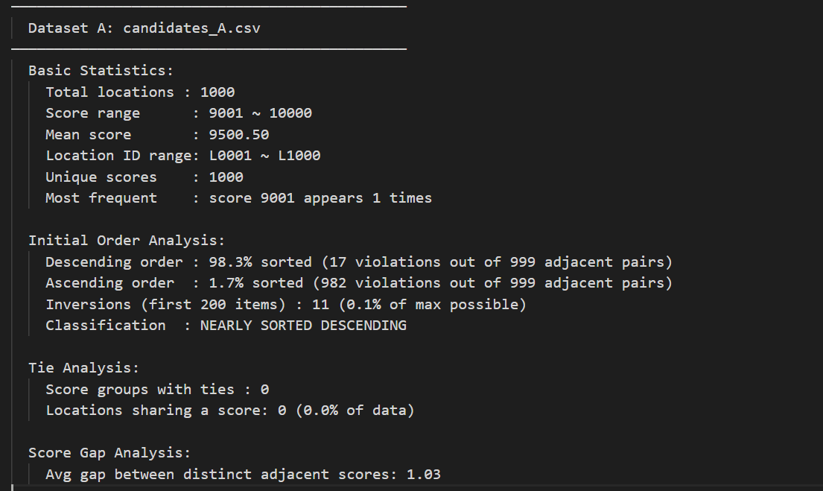

Dataset B
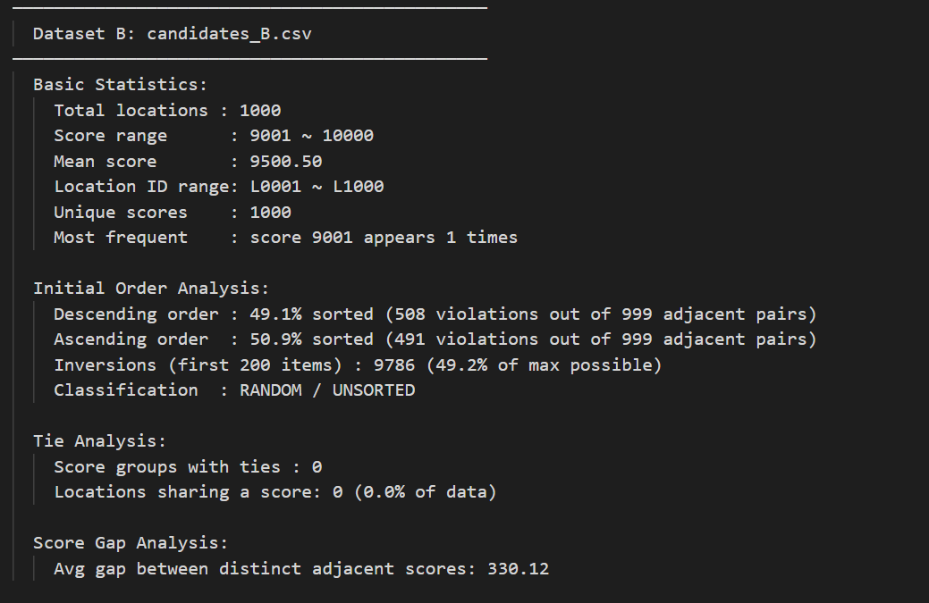

Dataset C
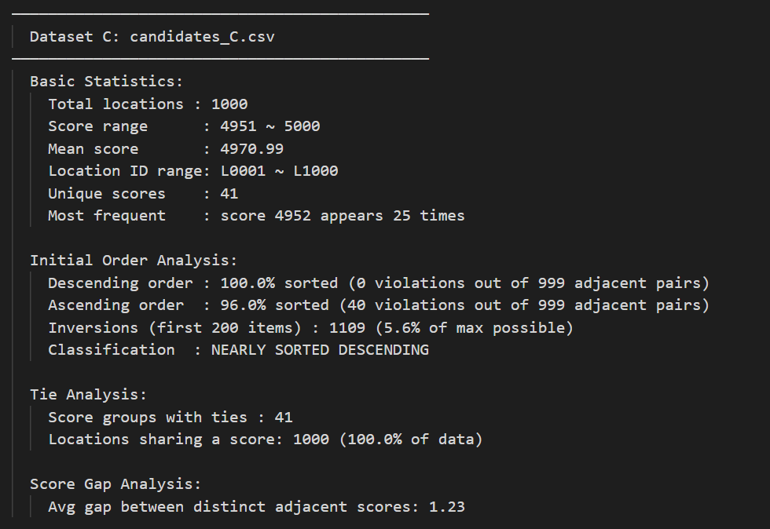

6.2 Task A timing report
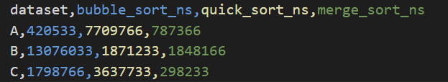

6.3 Task B shortest paths

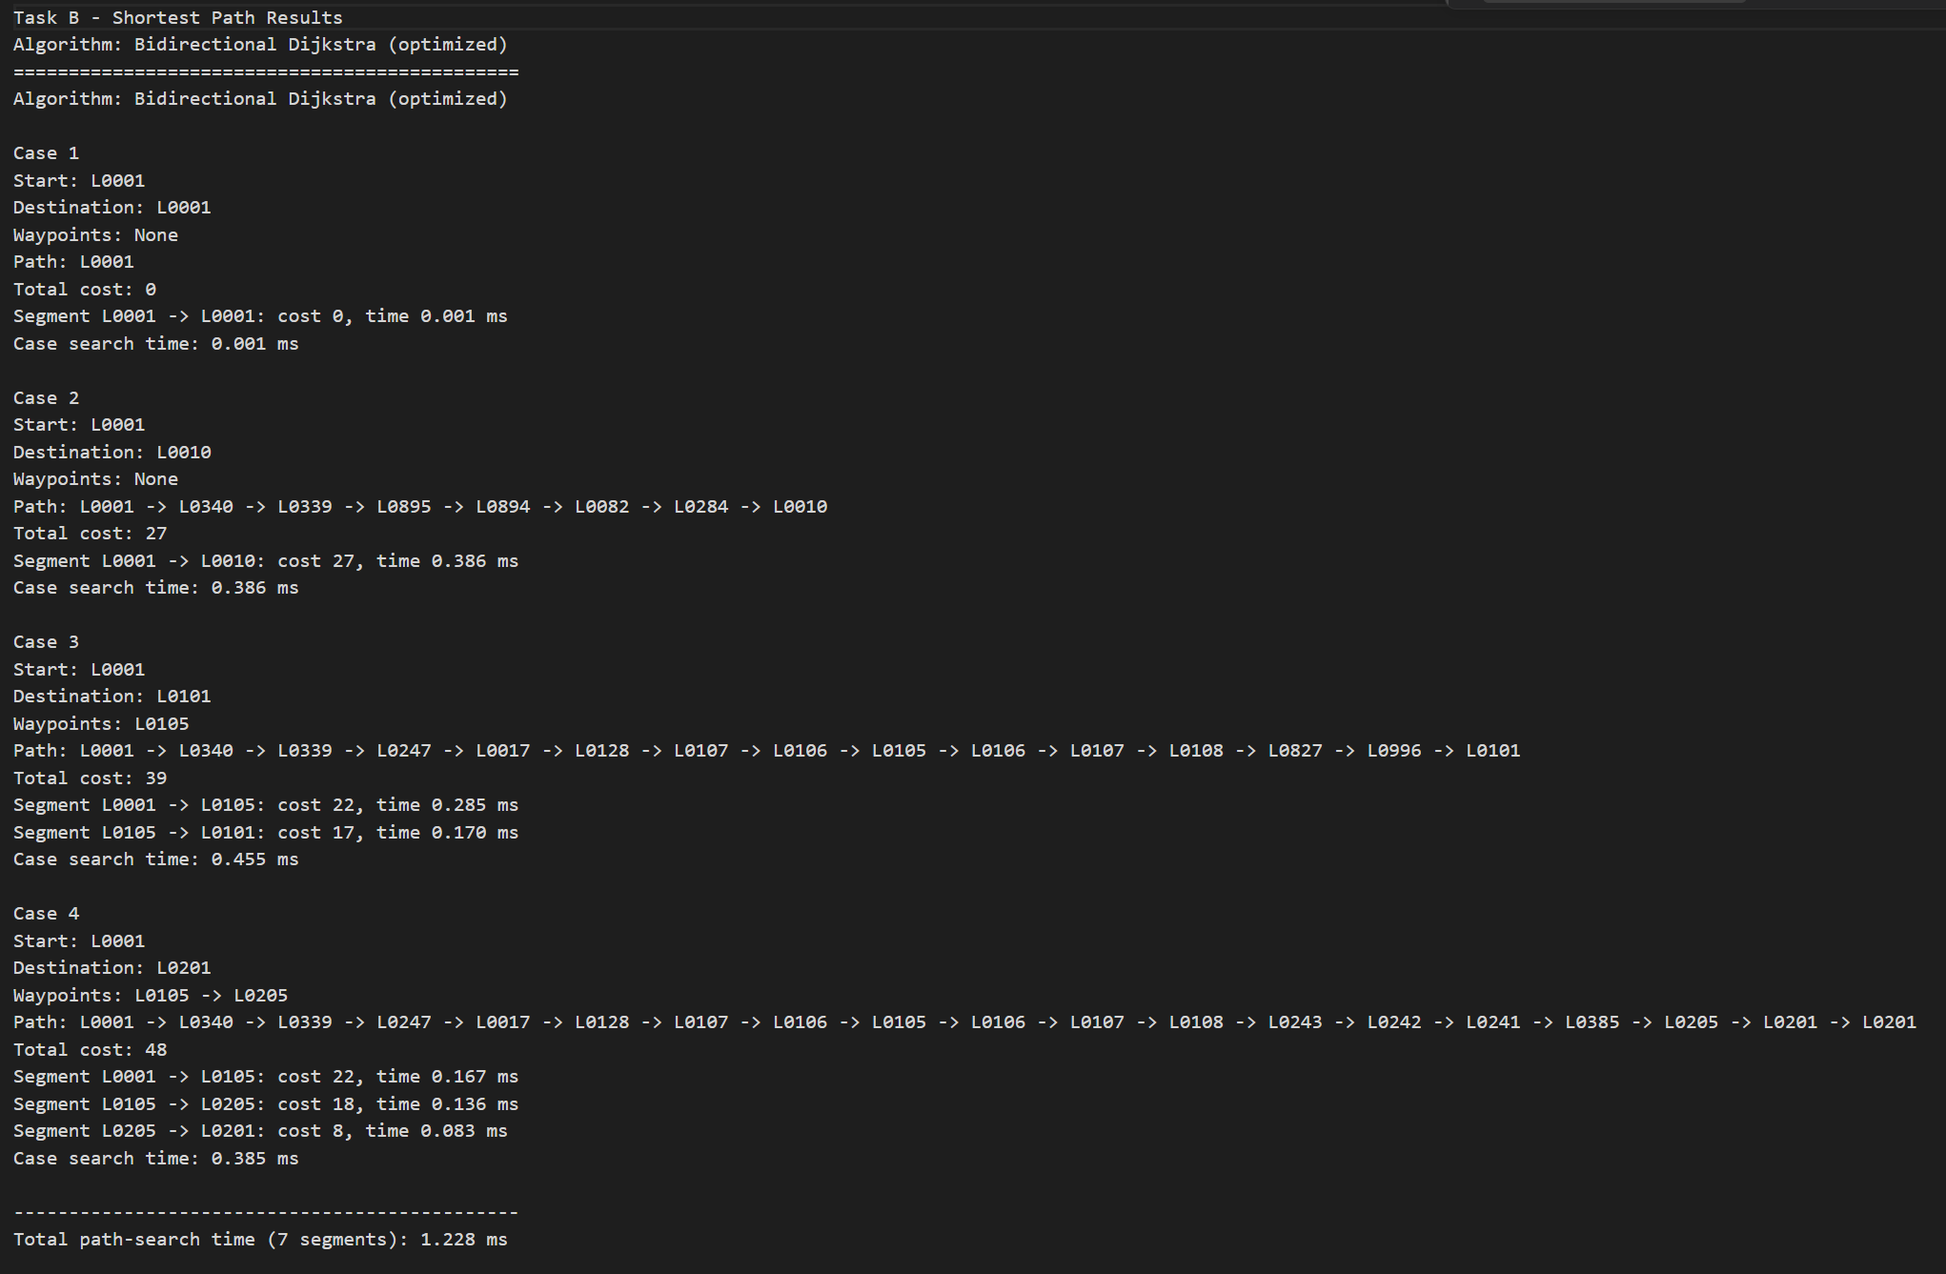
6.4 Task A detailed output
Dataset A — Top 10:
Rank | Location ID | Priority Score
1 | L0001 | 10,000
2 | L0002 | 9,999
3 | L0003 | 9,998
4 | L0004 | 9,997
5 | L0005 | 9,996
6 | L0006 | 9,995
7 | L0007 | 9,994
8 | L0008 | 9,993
9 | L0009 | 9,992
10 | L0010 | 9,991

Dataset B — Top 10:
Rank | Location ID | Priority Score
1 | L0101 | 10,000
2 | L0102 | 9,999
3 | L0103 | 9,998
4 | L0104 | 9,997
5 | L0105 | 9,996
6 | L0106 | 9,995
7 | L0107 | 9,994
8 | L0108 | 9,993
9 | L0109 | 9,992
10 | L0110 | 9,991

Dataset C — Top 10:
Rank | Location ID | Priority Score
1 | L0201 | 5,000
2 | L0202 | 5,000
3 | L0203 | 5,000
4 | L0204 | 5,000
5 | L0205 | 5,000
6 | L0206 | 5,000
7 | L0207 | 5,000
8 | L0208 | 5,000
9 | L0209 | 5,000
10 | L0210 | 5,000

Chapter 7 – Contribution Form
Student ID | Contribution
2362457 | 50%
2362404 | 50%

