Problem definition (physics + discretization)
Category | Setting / Value
Problem type | 2D plane-strain Neo-Hookean elasticity (square domain)
Domain | ([0, L] \times [0, L]), with (L = 1.0)
Mesh type | Structured quadrilateral mesh (2D square)
Mesh resolution | (N = 42) (42 × 42 grid; used by create_2D_square_mesh(L, N))
FE element | 4-node quad, Neo-Hookean (NeoHookeMechanicalLoss2DQuad)
Gauss integration | num_gp = 2 (2×2 Gauss points per element)
Material model | Neo-Hookean, isotropic
Young’s modulus | (E = 1.0)
Poisson’s ratio | (\nu = 0.3)
BC type | Dirichlet on left/right boundaries for (U_x, U_y)
BC – left edge | (U_x = 0.0), (U_y = 0.0)
BC – right edge | (U_x = 0.1), (U_y = 0.1)
Control type | FourierControl (spatially varying stiffness field (K(x,y)))
Fourier x-frequencies | ([2, 4, 6])
Fourier y-frequencies | ([2, 4, 6])
Fourier z-frequencies | ([0]) (effectively 2D)
Fourier amplitude scale | beta = 20
K field range | min = 1e-1, max = 1.0 (clamp of heterogeneity field)
Samples in dictionary | 200 Fourier coefficient vectors (when generated via create_random_fourier_samples)

PI-FNO model & training hyperparameters (parametric/otf/transfer)
Category | Setting / Value
Operator model | FourierNeuralOperator2D
FNO modes (x) | modes1 = 6
FNO modes (y) | modes2 = 6
Channel width | width = 8
Network depth | depth = 4 residual blocks
Last projection channels | channels_last_proj = 32
Output channels | out_channels = 2 (displacement (u_x, u_y))
Output scaling | output_scale = 0.1
Total number of params | ≈ 37,538 (printed in log)
FOL wrapper | PhysicsInformedFourierParametricOperatorLearning
Loss | Physics-informed Neo-Hookean FE residual (NeoHookeMechanicalLoss2DQuad)
Optimizer | Optax Adam, learning rate 1e-3
LR scheduler (unused here) | linear_schedule(1e-4 → 1e-5, transition_steps = 5000)
Max epochs | num_epochs = 5000
Convergence settings | relative_error = 1e-100, absolute_error = 1e-100 (effectively “epoch-based”)
Train batch size (param.) | batch_size = 5
Train indices | 0–179 → 180 samples
Test indices | 181–199 → 19 samples (sample 180 reserved for OTF)
Training plots | total_loss, residual_rms_batch_mean (physics residual RMS)
Train checkpoint | Least-loss checkpoint every 100 epochs → .../flax_train_state
Final state save | flax_final_state in the parametric output folder

OTF fine-tuning & FE solver hyperparameters (slide 3: “OTF from param”)
OTF PI-FNO (starting from parametric weights)

Category | Setting / Value
Initial weights | Restored from parametric run: ./nn_output_mechanical_2D_neohooke_pi_fno_param/flax_train_state
OTF sample ID | otf_id = 180
Train set (OTF) | Only coefficient vector of sample 180 (shape (1 \times n_\text{coeffs}))
Test set (OTF) | Same as train: sample 180
parametric_learning flag | False (enables true on-the-fly mode)
Eval cases | eval_cases = [180]
Batch size (OTF) | batch_size = 1
Max epochs (OTF) | num_epochs = 5000
Convergence settings | Same: relative_error = 1e-100, absolute_error = 1e-100
Plots during OTF | total_loss, residual_rms_batch_mean saved in nn_output_mechanical_2D_neohooke_pi_fno_otf_from_param
Checkpoint directory (OTF) | ./nn_output_mechanical_2D_neohooke_pi_fno_otf_from_param/flax_train_state
OTF- SLIDE 1
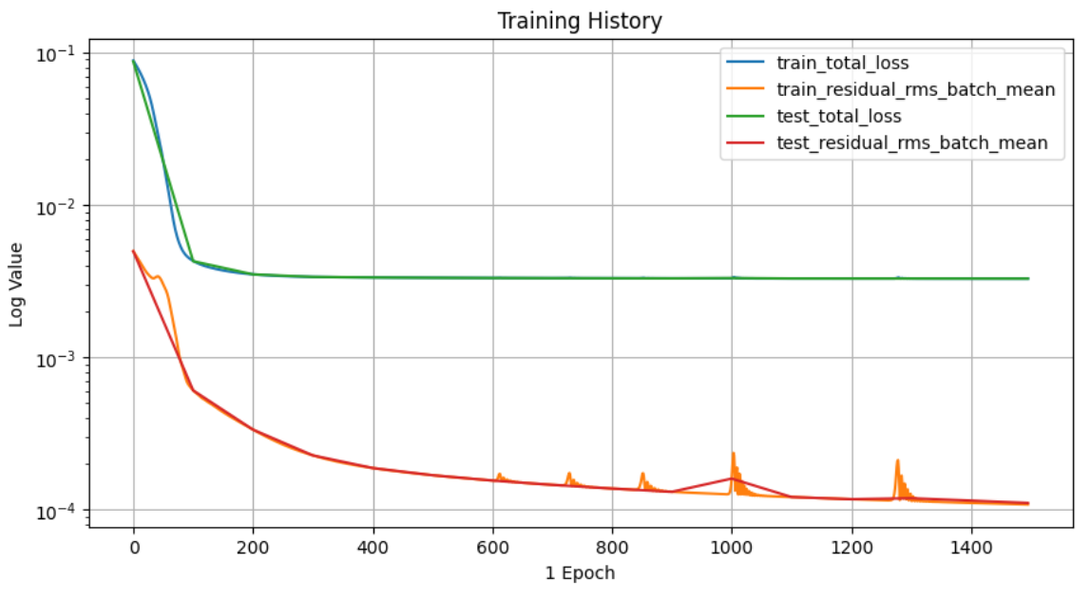
10 mins for training -2000 epochs
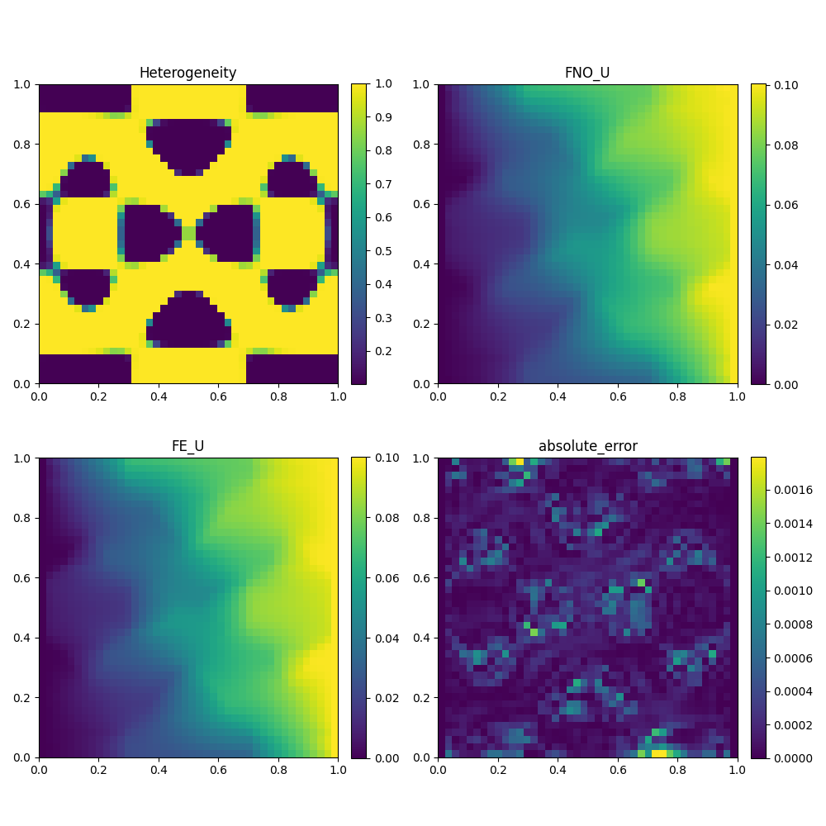

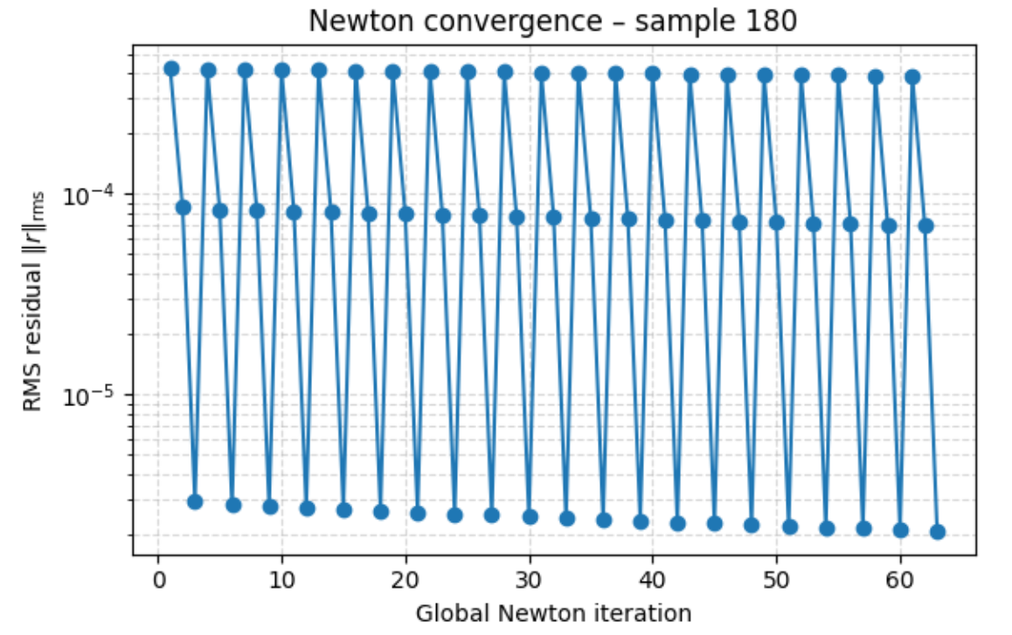

PARAMETRIC- SLIDE 2
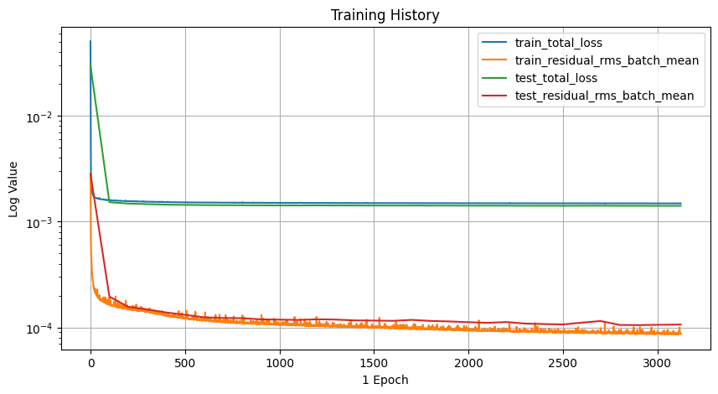
30 mins for training – Auto Stopped between 3000-3500 epochs
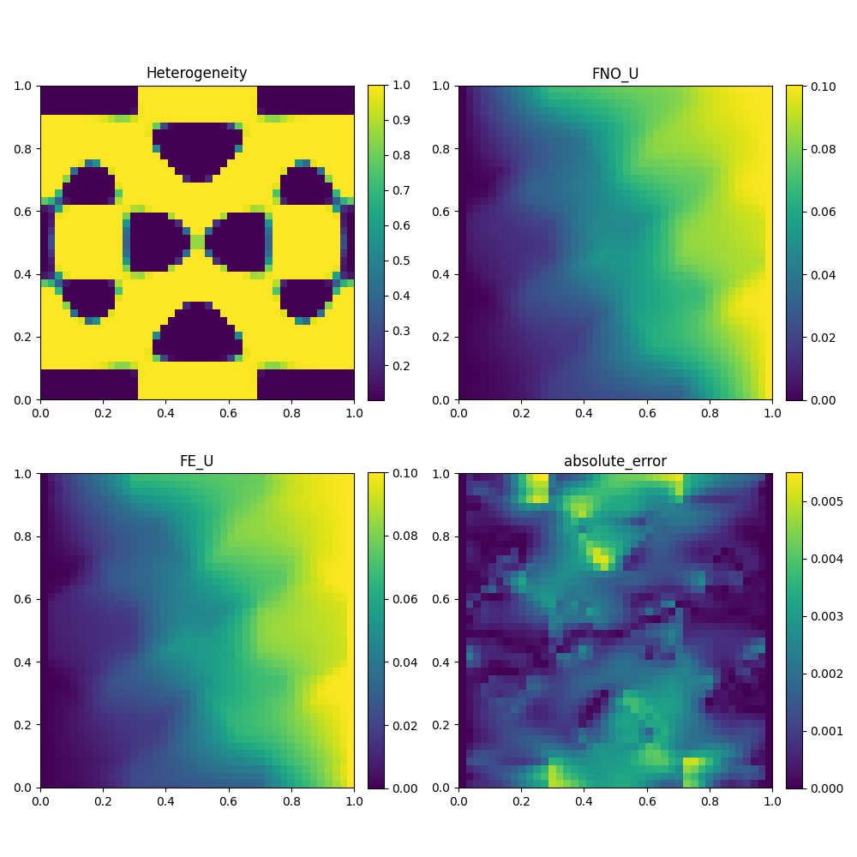

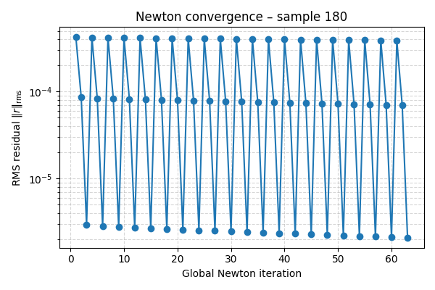

PARAMETRIC TRANSFER LEARN- SLIDE 3.1
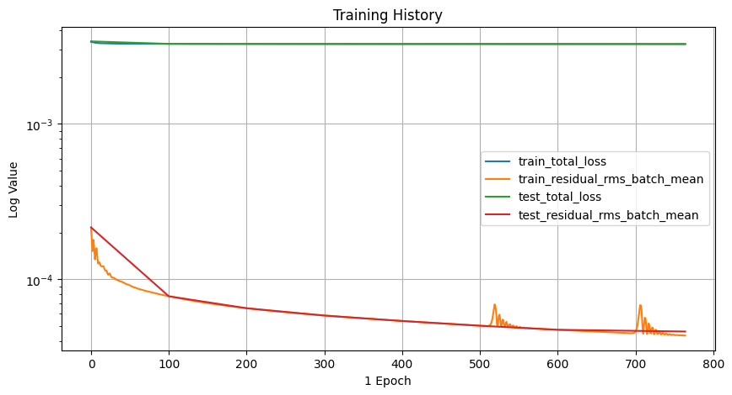
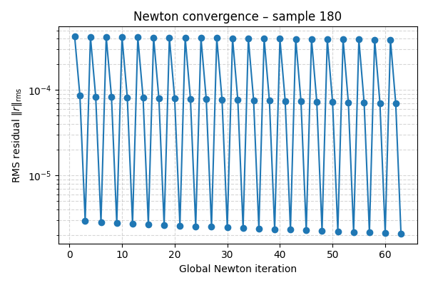
5 mins for training – Auto Stopped between 700-800 epochs
Absolute Error reduction = 0.005 − 0.0005 = 0.0045

Relative improvement = 0.0045 / 0.005 = 0.9 = 90%
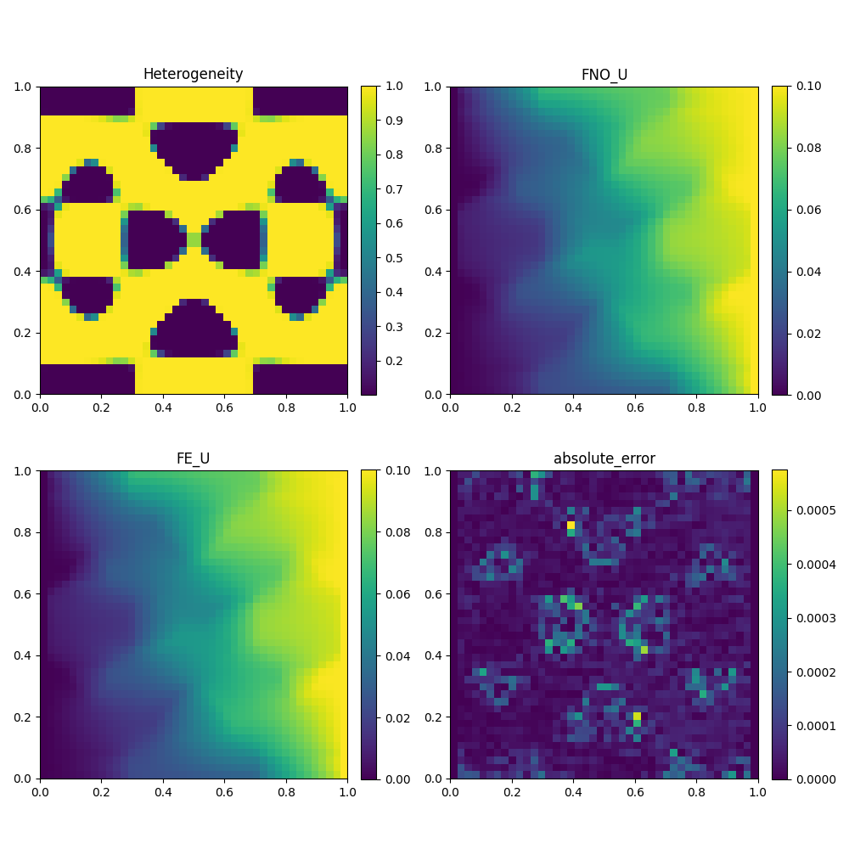

PARAMETRIC - TRANSFER LEARN - SLIDE 3.2
-Dual phase heterogeneous sample
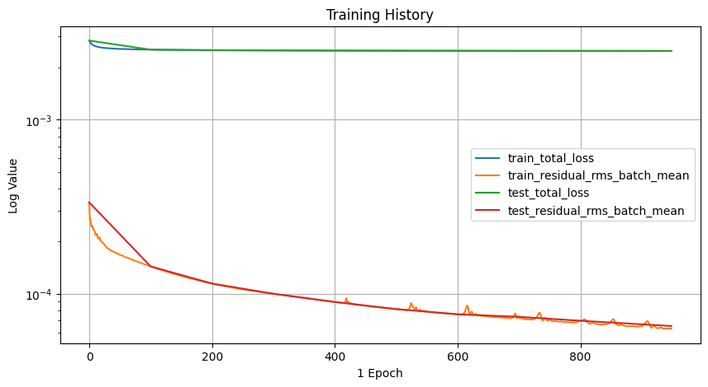
7 mins for training – Auto Stopped between 700-800 epochs

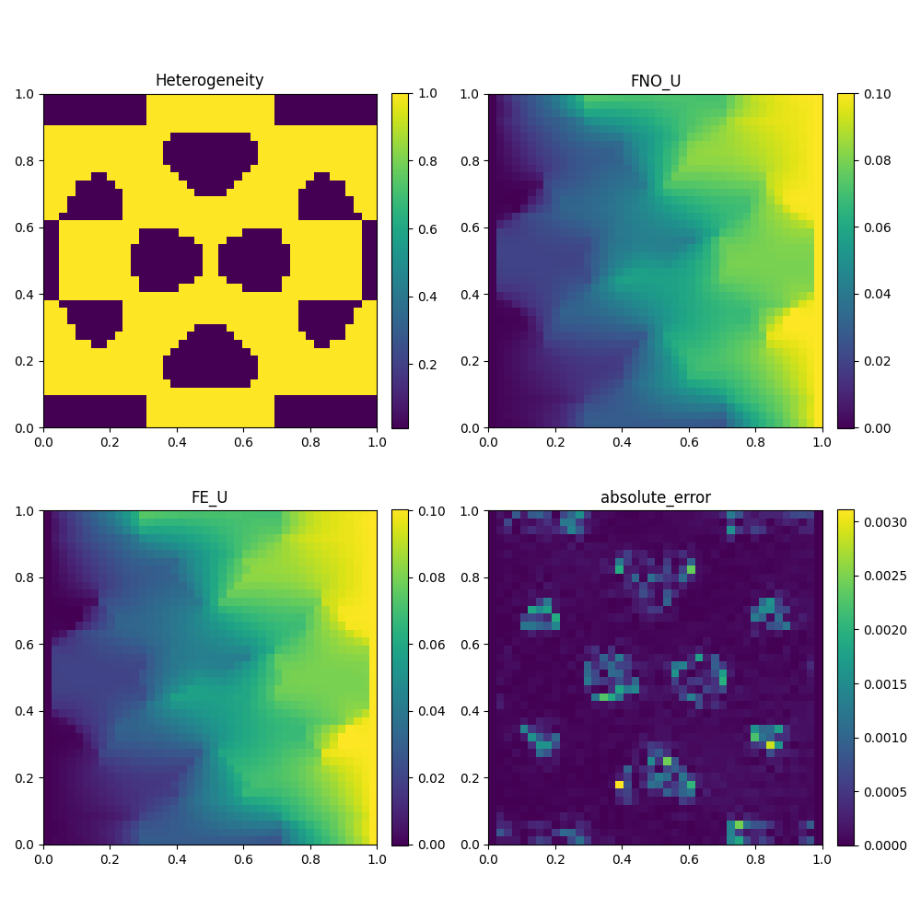

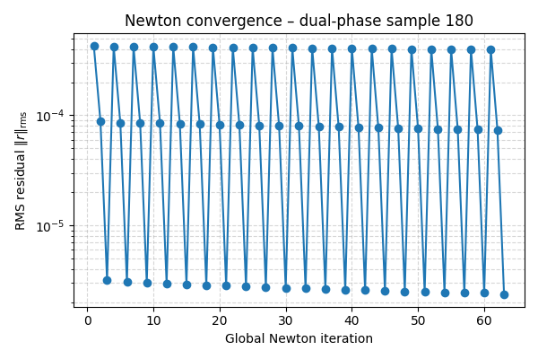

PARAMETRIC TRANSFER LEARN- SLIDE 3.3
-Dual phase heterogeneous sample with Circular inclusion
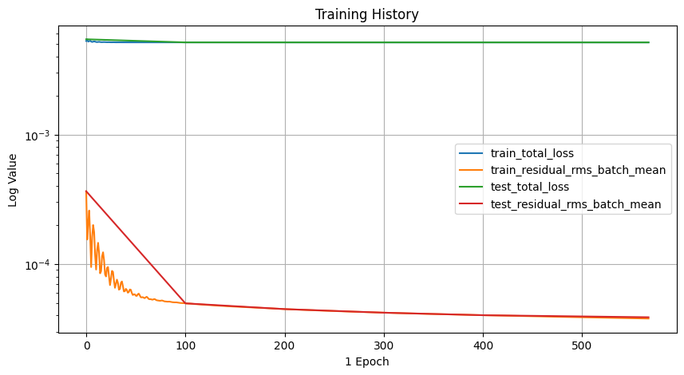
4 mins for training – Auto Stopped between 500-600 epochs
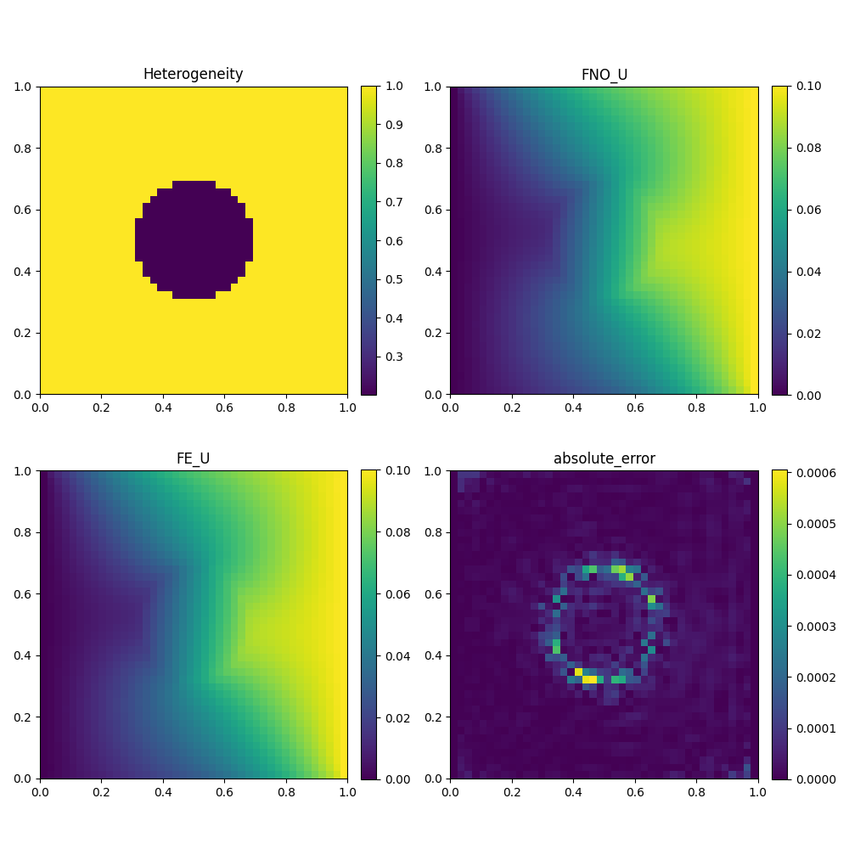

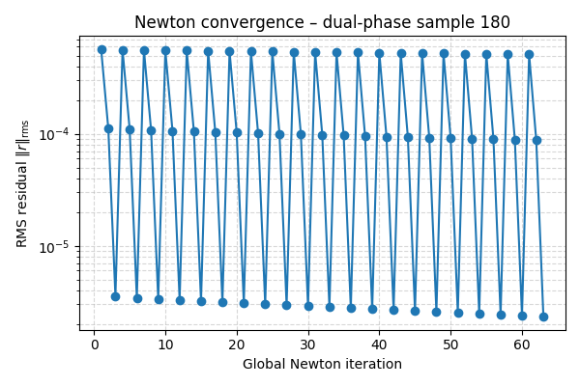

OTF_CIRCLE- SLIDE 4
-Dual phase heterogeneous sample with Circular inclusion
2025-12-10 20:47:35 - Info : pi_fno_pr_learning.Train - train checkpoint settings:{'least_loss_checkpointing': True, 'least_loss': inf, 'frequency'
…..
2025-12-10 20:52:12 - Info : mechanical_loss_2d.ComputeJacobianMatrixAndResidualVector - finished in 0.7253 seconds
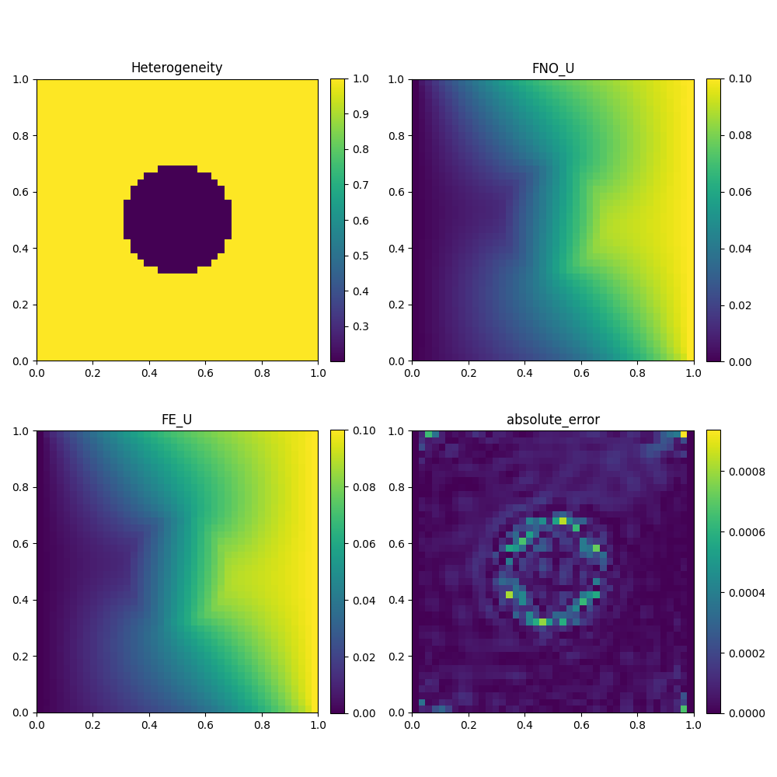
9%| | EPOCHS : AT 1712/20000 [04:34<48:57, 6.23it/s, train_loss=0.00515, test_loss=0.0051 , 2025-12-10 20:52:10 , AUTO-STOPPED
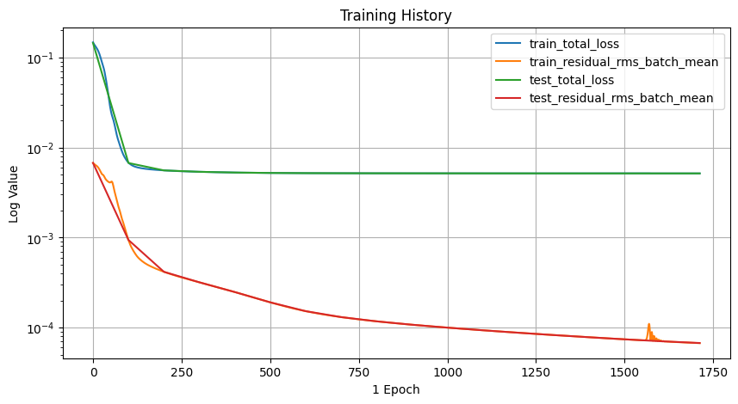

OTF_CIRCLE- SLIDE 4

-Dual phase heterogeneous sample with Circular inclusion
2025-12-10 20:47:35 - Info : pi_fno_pr_learning.Train - train checkpoint settings:{'least_loss_checkpointing': True, 'least_loss': inf, 'frequency'
…..
2025-12-10 20:52:12 - Info : mechanical_loss_2d.ComputeJacobianMatrixAndResidualVector - finished in 0.7253 seconds

