**Research**

**Questions:**

1. What is the real **problem** here?
   1. Currently I’m thinking about this as a solution, so what is the real problem that is trying to be solved?
   2. Is this policy related? Medical?
2. Are there fundamental / definitive differences between people with chronic illness and people with disabilities? Yes- so what are these?
3. Are people who are chronically ill actually searching for work?
4. Would this be a platform that people would be excited to use?
5. Why would employers hire a “sick” person to WFH instead of just a freelancer?
   1. Is this a problem of productivity? Is it more costly for employers to hire chronically ill staff?
6. How could this product be monetized?

**The hypotheses/assumptions I am making are:**

* + (1) The chronically ill population *wants* to work but is *unable* to due to physical restraints.
  + (2) With the current political climate and rising costs of healthcare, people who suffer from chronic illnesses are often *financially tight*, but unable to work a typical 9-5 job, therefore *seeking ways to make an incom*e.
  + (3) Businesses would be able to (and want to) *accommodate employees* working from home with flexible schedules.
  + (4) An application of this sort is *beneficial* for both employers and the chronically ill and is the *best way* to connect the two parties.

**Pain points:**

* Appearing functional at work when feeling anything *but*.
* Commuting: exhausting, stressful, fatigue-inducing, germ-full
* Eating/ finding time to properly nourish your body
* Attention span
* Balancing treatment with being in the office
* Discomfort sitting in a chair all day
* Office/room temperature

**Resources:**

<https://themighty.com/2018/03/social-media-connect-hashtag-chronic-illness/>

<https://www.nytimes.com/2010/03/25/technology/25disable.html>

<https://www.patientslikeme.com/>

<http://www.mychronicconnection.com/>

<https://connect.mayoclinic.org/group/pain/>

<https://themighty.com/>

<https://pdfs.semanticscholar.org/41f8/7f808066a634dcd0dc0d7ea8d648884e9ec2.pdf>

<https://themighty.com/2017/07/remote-jobs-companies-disability/>

<https://www.glassdoor.com/blog/chronic-illness/>

**Interview Conversations**

**Kelly Zucco, MSW**

**Licensed Independent Clinical Social Worker, Southeastern Counseling Associates**

**Faculty Advisor, Boston University School of Social Work**

1. Do you currently work full time? If so, how do you manage working full-time and taking care of yourself? If not, why aren’t you working and what are the barriers you face in terms of finding work/ managing your disease? I work full-time, but because I work for myself, I can be flexible with my schedule. When I was really sick, I dropped my hours significantly... I just couldn't work the long days.
2. In your experience, have you seen a need for people to find jobs that have 'work from home' capabilities or flex schedules? Yes! As a therapist in private practice, I deal with many people with chronic conditions that prevent them from holding full-time jobs outside their homes.
3. Do you think people who are chronically ill are actually searching for work? Some are. Others have given up on the idea and have applied for disability out of necessity.
4. Do you think a website which connects people to these work opportunities would be a solid solution to this problem? I think it's a novel idea! There aren't many resources available for those who have the skills and desire to work without the ability to commit to a regular schedule.
5. Do you see the problem being that employers don’t want to hire sick people because of the productivity/ cost/ etc… or a lack of ways for people to seek out jobs? Or is it that people are just too physically ill to even work? I'd say it's a combination of employers undervaluing the potential contributions of people with chronic conditions and the perception/experience of chronically ill individuals that there aren't many work options for them.

Why I think this is so important:

Ask anyone on the street to tell you about themselves. They usually respond with the roles they play in life. i.e.. I am married and the mother of 2 grown children.... I work as a therapist in private practice, a consultant, and a part-time Faculty Advisor for Boston University's School of Social Work. I direct a children's community-service singing troupe...

The reality is that WORK gives us more than the financial means to support ourselves. It gives us PURPOSE. And it becomes a great part of our IDENTITY. People with chronic illness suffer physically, but when they leave the job market, they also suffer the loss of income, loss of purpose, and a true part of their identity. This only adds to the depression that chronic illness sufferers experience.

Let's face it, many people dread going into work on a Monday morning, but having a regular job gives us a reason to get up in the morning, opportunities to engage with the world (good or bad), and a sense of satisfaction because their days are purposeful, meaningful and productive.

I think you are embarking on a great project here! Let me know if and how I can be of further help!!

**Jennifer Holmes**

**Student at Elon University**

1. Do you currently work full time? If so, how do you manage working full-time and taking care of yourself? If not, why aren’t you working and what are the barriers you face in terms of finding work/ managing your disease? No I currently do not work full time but I am a full time student in college. Although being a student is not technically a job, it certainly feels like it. Being a student with a chronic illness is extremely difficult on its own so I would be unable to also work on the side as I do not think I could handle it. I am concerned for pursuing a career in the future as a chronic illness is unpredictable and difficult.
2. In your experience, have you seen a need for people to find jobs that have WFH capabilities or flex schedules? Do you think people who are chronically ill are actually searching for work? Yes, individuals with chronic illnesses especially need this type of assistance and flex schedules to be able to provide for themselves. It is a difficult spot to be in as you need income for medical bills but also facing bad days that come along with an illness.
3. Do you think a website which connects people to these work opportunities would be a solid solution to this problem? I think having a website that provides these connections would be a great help to those facing a chronic illness. Some workplaces are friendlier and understanding in regards to chronic illness than compared to others. I also think it would provide a little push for those living with a chronic illness that are anxious about pursuing a career.
4. Do you see the problem being that employers don’t want to hire sick people because of the productivity/ cost/ etc… or a lack of ways for people to seek out jobs? Or is it that people are just too physically ill to even work? I think it differs for the individual. But I know many people who are too physically sick to be able to work currently. Then personally I know I get anxious when I look for part time jobs in the summer because I am concerned that something with my health will flare and my employer will become agitated with me. I also think that not many employers are “chronic illness friendly” either and are too concerned with productivity/cost/etc.

**Alexandra Reardon**

1. Do you currently work full time? If so, how do you manage working full-time and taking care of yourself? If not, why aren’t you working and what are the barriers you face in terms of finding work/ managing your disease? I cannot work full time because my days fluctuate so much daily that I would simply not be capable of committing to a full time status. Additionally, due to my chronic pain it’s hard for me to find any job that I could possibly think of doing without it causing an even larger flare than I already do.
2. In your experience, have you seen a need for people to find jobs that have WFH capabilities or flex schedules? Do you think people who are chronically ill are actually searching for work? I think that with some chronic illnesses, there are certainly people who are searching for jobs with flex schedules. On the other hand, there are a large number of people who are too sick, and can’t even imagine having to work given their current health. I do know people who are in all stages with not only Lyme, but other chronic illness as well.
3. Do you think a website which connects people to these work opportunities would be a solid solution to this problem? I think it’s a great idea; however, there are a lot of websites that already exist that have numerous part time jobs listed. Also, if the website is for people with chronic illnesses, then some companies may be less likely to use the site to post jobs due to discrimination (which is illegal)…such companies may question timeliness on scheduled days, responsibility, quality of work if the person is \**sick*\*, etc. On the flip side, so many people with chronic illnesses, also have chronic fatigue. So *Chronically Capable* would be easily accessible and a place where people can look at all jobs at only one location.
4. Do you see the problem being that employers don’t want to hire sick people because of the productivity/ cost/ etc… or a lack of ways for people to seek out jobs? Or is it that people are just too physically ill to even work? I think that it is both. I know for myself, I am just too physically sick to work. However, I know other people (including my Father and Fiancé) who work through it. I also know many people who want / need to work, but need flexibility for infusions / doctors appointments / flares / etc., who employers likely would hire because it then causes more *complication* for the employer.

**Emily Levy**

**Founder of Mighty Well & Friends in the Fight**

Emily Questions:

* Currently, I’m working in a tech startup that has a mission to change the workplace, in a variety of ways. We were allowed to come up with different ideas related to this core mission, so obviously my first thought was: how can I help this huge demographic that I also am a part of?
* So I’m wondering if you’ve seen in your experience a need for people to find jobs that have WFH capabilities or flex schedules? Do you think people who are chronically ill are actually searching for work?
  + She has people every other week asking if theyre hiring
  + Can they work part-time remotely
  + She has hired people who are chronically ill, but the challenge is they can often be unreliable
    - It was frustrating from their standpoint because they wanted to give people jobs but if youre MIA for a week, its really challenging for us
  + She has been telling friends→ learn a skill where you can be an entreprenuer: free lance writer, graphic designer
* As a CEO, how do you manage working full-time and taking care of yourself?
  + Thankfully she’s had less days like the past two days but its a reality for her
* Do you think a platform like this would be something people would use?
  + She sees an initial challenge
  + There might be an initiative to give people with chronic illness jobs
  + Thinks its amazon with people working from home
  + Find the initial right partner who is also looking for the right PR opportunity
* Do you see the problem being that employers don’t want to hire sick people because of the productivity/ cost/ etc… or a lack of ways for people to seek out jobs? Or is it that people are just too physically ill to even work?
* You’ve obviously been working with this group of people for a few years now, do you have any advice for how to speak to this group? What online communities have you found to be the most active that would be receptive to this idea? How to get traction to something like this?
* Start up is a good place to be with health
* Suffering In Silence:Allie → would be happy to make an introduction to me
  + Has chronic lyme but its definitely in remission
* While products are in production, focused on building out a digital community
  + Revamped the blog
  + Hoping to turn it more into a content platform
  + Well & good of the healthcare space
* The mighty is awesome but it can get very negative
* They’re trying to make it a more elevated
* She heard of a similar model that they would work on an idea & then if there was any traction
* Finding partners/ someone to be a pseudo co-founder
* Having a story to go along with the startup, all of their PR has been free
* So many days shes like “why am i doing this? I just wanna focus on my health”
  + It means a lot to hear people like that
* I can post on friends in the fight to get feedback/resarch
* One of her board members lives in DC
* Feel free to txt her or call her with questions- she loves doing
* Skicorp- has a board and then a board of advisors who have less responsibilities
  + Having a board has been extremely helpful
  + Th’eyve been successful on their own and just want to give back
  + It’s a lot of work keeping people updated

**Dan Lennon**

**Lyme Advocate (TX)**

-hackathon with dean center, event style

-people pitched ideas for tech support line

-end of the day, the tools are helpful but it takes a lot to get something off the ground

-at the end of the day, its necessities

→ its really 1) work and 2) care

-the amount of people who are disabled

→ people on disability can still earn a certain amount

-he wishes he could remotely, its not all sunshine and rainbows

-hes working for his friends marketing company, used to work full time but cant do it anymore

-just hustling to make things work

-if u cant work, u cant afford treatment

-woman from TX, didnt work bc she was sick, got a divorce and now shes back to work at a 9-5 and it’s very hard for to do physically

-a lot of it gets lost...being able to give value to the world

-he has a friend whos been very sick for a long time, she works remotely for an IT company

-its very case by case

-hes seen ads for remote year… would be interesting to see what the work is while you’re there

-susan, Nat Cap Lyme

**Global Lyme Alliance Call 10/1/18**

**Sara Tyghter**

**Director, Education and Outreach**

**Holly Wainwright**

**Director of Marketing and Communications**

* content- what you should disclose/ shouldn’t disclose
* knowing their rights —> people currently employed are being challenged by employers
* we just hear from so many people, particularly in college, getting out of college, early 30s, struggling with this”
* —> people have to re-invent themselves to accommodate
* -lots of people are lyme bloggers now
* -theres a lot of potential
* -as we flush it out more, figuring out how we can do things together
* —> putting a blog on their site
* —> this really does address a HUGE need that a lot of people they interact with in their community
* -maybe also giving employers the tools “you don’t want to lose a good candidate or employee because they have a chronic illness”
* -a company wasn’t accommodating this bad ass woman bc she had lyme,
* she’s also overseeing an ambassador program, volunteering in their communities and talking about lyme prevention
* 2 fold
  + glad helping people get back into the work force
  + our company and the services that we provide
* they know that life with lyme sucks, but they always try to show hope and working towards a cure
* our service really provides people hope
* they’ll figure out a target date based on where we all are

**Call with Aunt K**

* -marcus sikowski
* -his friend was this really cool indian guy who works for computer startup out of san fran
* <https://hired.com/>
* -hes pitching this right now
* -he might be reaching out to me
* -hes flying to cape town but hell be back
* -he wants to hire art designers, computer peoples
* -he could take our database and we could take his
* -boomer esiason has Cystic fibrosis
* -gunner
* -BEF is to solve cystic fibrosis
* -how to work with a chronic illness
* -dave roberts is an angel investor —> who to connect me with
* -send aunt K my flyer and they will connect me with Dave Roberts—> he will give me advice, from there we will be introduced to Marcus and Gunner

[**Nels Olson**](https://www.kornferry.com/consultants/nelsolson)

**Vice Chairman and Co-Leader of Korn Ferry’s Board & CEO Services Practice**

* Biggest connection will be Dave Roberts (also present via call in)--> will be sending over his contact info
* Wants to first see something like this:
  + Overview snapshot
* 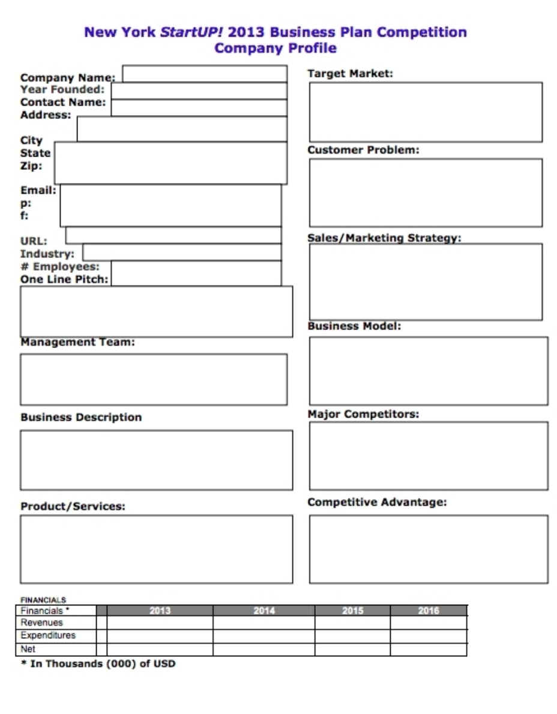
* Thinks we really need to water it down to most simple form
* Then we need to create a board of advisors
  + He’s thinking of cathy merrill from washingtonian for PR / marketing
  + Need someone in health care
  + Financial could potentially be Dave Roberts
  + Strategy= ?
* Board of advisors will help to create business plan
* Thinks we are young and that is not a disadvantage or an advantage
  + But we also need some more seasoned professionals to weigh in because he sees this as turning into a huge company
* **Moral discussion *** (haha)
  + Hannah has to stop juuling
* Event to connect with community
  + Get the big guys on it--- donations$$$$$$

**FB Posts**

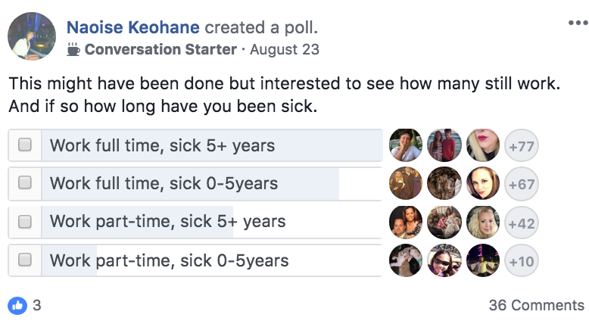

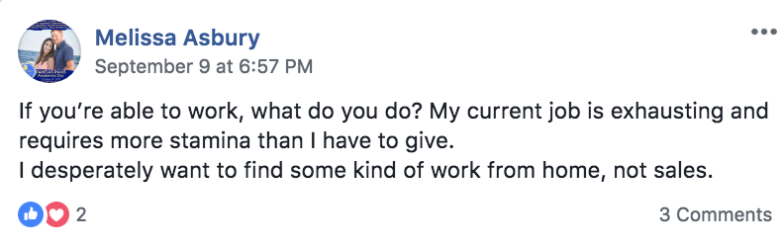

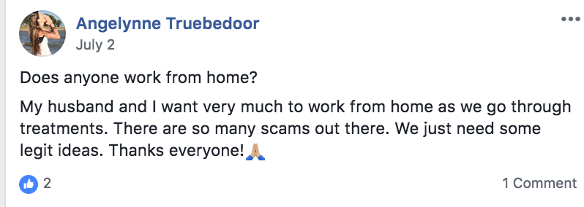

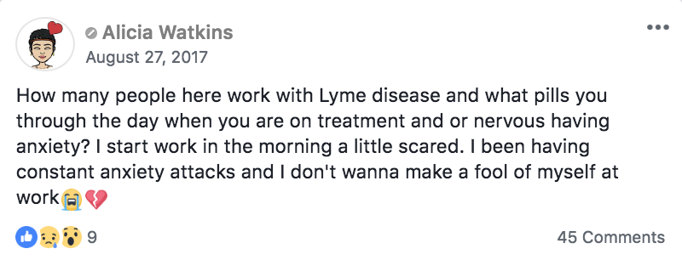

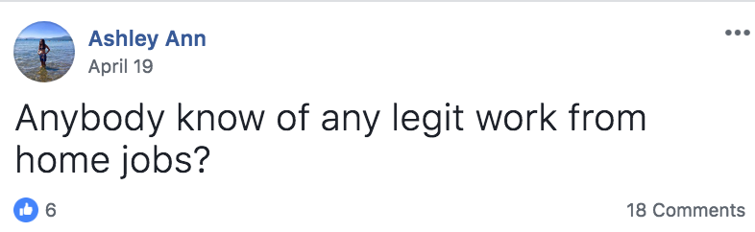

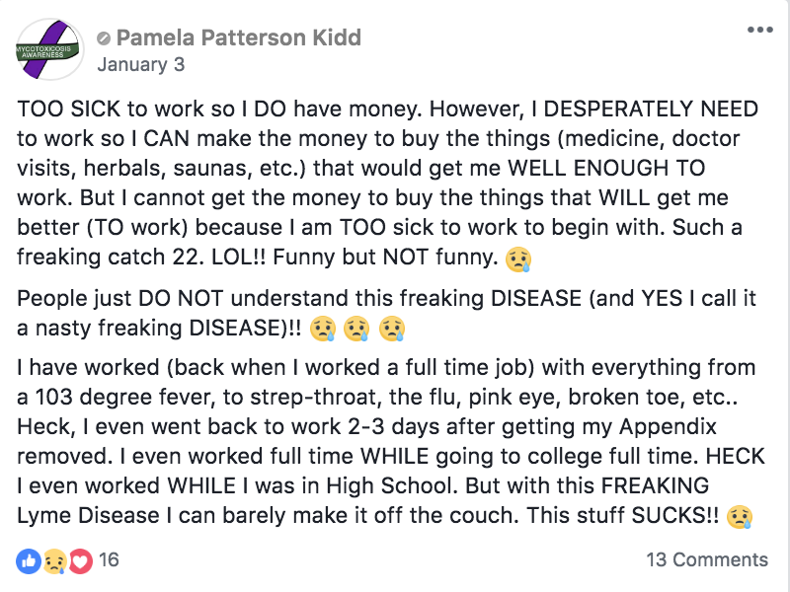

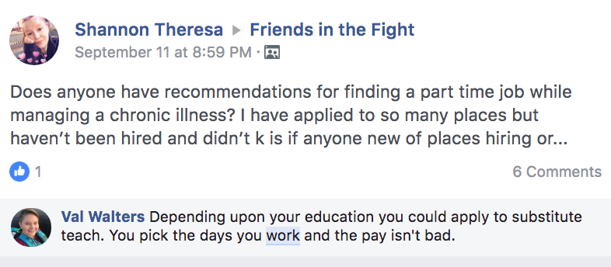

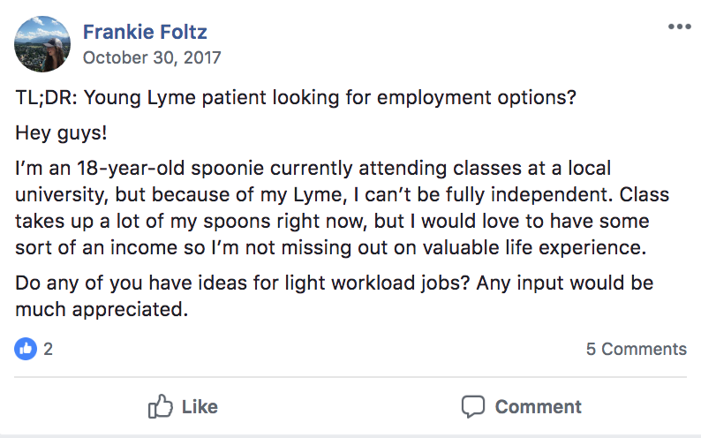

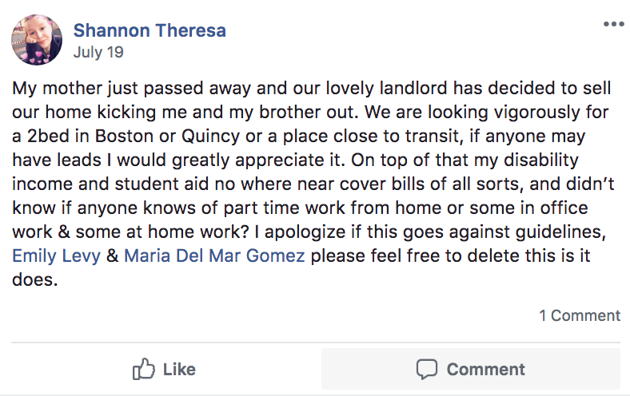

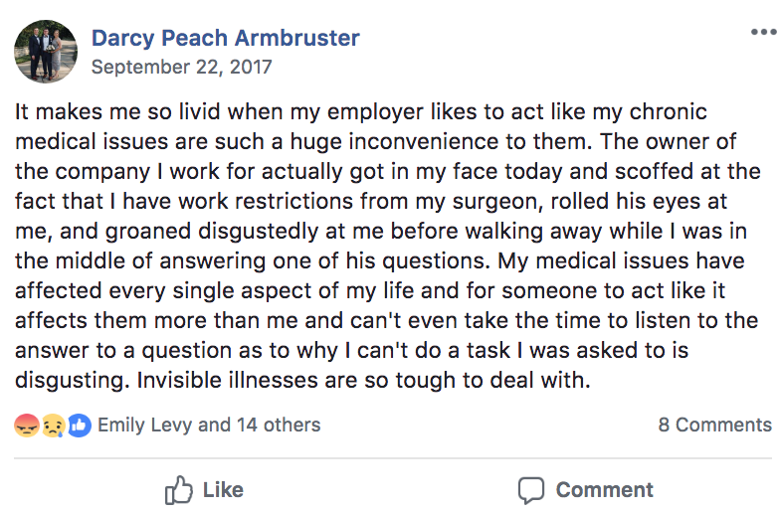

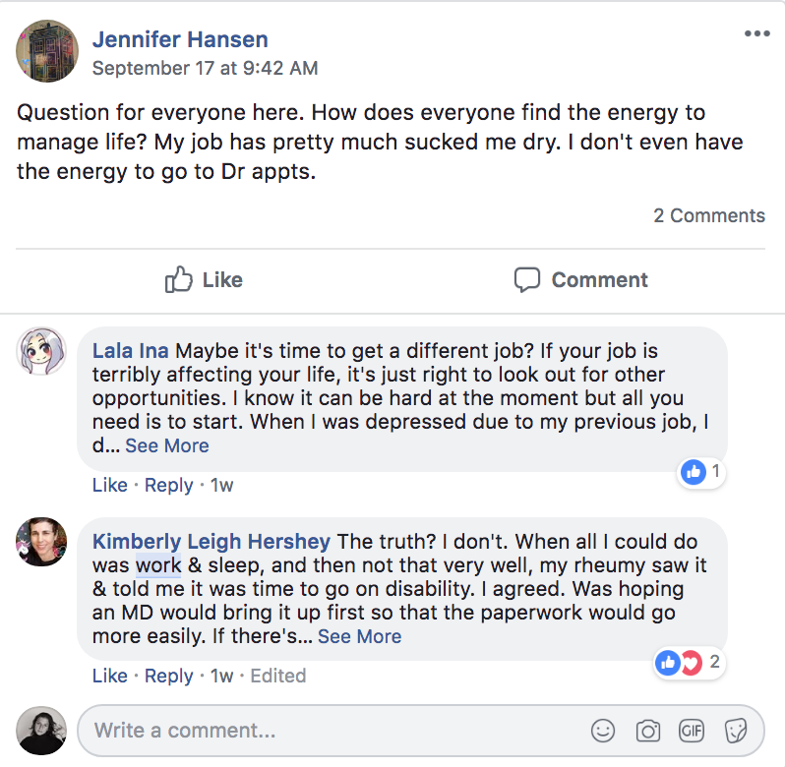

**Technical Jobs**

Quality Assurance Engineer

Web Designer

Web Developer

Software Engineer

Graphic Designer

User Experience Designer

Software Consultant

Product Marketer

Project Manager

IT/Server Administrator

**Online Education Jobs**

SAT/ACT Instructor

Tutor

Online English Instructor

Telecommuting/Online College Professor

Remote Elementary School Teacher

Curriculum Writer

Curriculum Designer

Education Software Technical Trainer

Speech-Language Pathologist/Therapist

Substitute Teacher

**Science/Medical Jobs**

Home-care Provider

Telecommuting Physician

Telecommuting Nurse

Medical Transcriptionist

Research Associate

Therapist

Dietitian

Teleradiologist

Personal Trainer

Telepharmacist

**Business Jobs**

Management Consultant

Marketing Consultant

Actuary

Administrative Assistant

Business Analyst

Business Researcher

Sales Representative

Customer Service Representative

Account Manager/Executive

Virtual Assistant​

**​Media/Communications Jobs**

PR Representative

Marketing Consultant

Copywriter

Copy editor

Brand Strategist

Blogger

Content Writer

Content Marketer

Email Marketing Manager

Translator​

**Miscellaneous​**

Online Survey Taker

Dog Walker or Pet Sitter

Merchandiser

Phone Operator

Film Editor

Teleworking

According to American Community Survey, “3.7 million employees now work from home at least half the time.” There are tons of benefits – for both employers and employees – in working remotely. It is especially a blessing for spoonies like us who have a few challenges in working in a traditional office.

Since there are days that you won’t be feeling well or days that you’re in treatment, you want to choose a job that has a flexible schedule and that is less demanding.

<https://globalworkplaceanalytics.com/telecommuting-statistics>

Work from home opps:

1. Live [Ops-www.liveops.com (url dead)](https://l.facebook.com/l.php?u=http%3A%2F%2FOps-www.liveops.com%2F&h=AT3RXTHvr49qBZSG5I1ParnwBc1nFLioHL8hLd64iEQLIijyW_-QUrEGqlMs-JHYsQ_YxnefLY5ONBRBOevPwqa55dlYSUQtMpX7jwDrLqZj285aaJKnzWIYy39YisIOVO-oCeQ)

2. [TeleTech-TeleTech.localjobster.com](http://teletech-teletech.localjobster.com/) [(url dead)](https://l.facebook.com/l.php?u=http%3A%2F%2FOps-www.liveops.com%2F&h=AT3RXTHvr49qBZSG5I1ParnwBc1nFLioHL8hLd64iEQLIijyW_-QUrEGqlMs-JHYsQ_YxnefLY5ONBRBOevPwqa55dlYSUQtMpX7jwDrLqZj285aaJKnzWIYy39YisIOVO-oCeQ)

3. [Amazon-Amazon.JobsOnline.com](http://amazon-amazon.jobsonline.com/)

4. Sutherland Global Services- <http://www.sutherlandglobal.com/careers.aspx>

5. UnitedHealth Group-[https://careers.unitedhealthgroup.com/.../customer…](https://careers.unitedhealthgroup.com/career-areas/customer-service-and-claims/customer-service-and-call-center) [(404)](https://l.facebook.com/l.php?u=http%3A%2F%2FOps-www.liveops.com%2F&h=AT3RXTHvr49qBZSG5I1ParnwBc1nFLioHL8hLd64iEQLIijyW_-QUrEGqlMs-JHYsQ_YxnefLY5ONBRBOevPwqa55dlYSUQtMpX7jwDrLqZj285aaJKnzWIYy39YisIOVO-oCeQ)

6. Dell-<http://jobs.dell.com/north-America-jobs>

7. [IBM-www.ibm.com/employment](http://ibm-www.ibm.com/employment)

8. U.S Department of Agriculture [www.usda.gov](https://l.facebook.com/l.php?u=http%3A%2F%2Fwww.usda.gov%2F&h=AT3xJELHirEdY35KqZSDoqlQt6iYKsWi62ZHZVroRyWmBUH7ZtCmd-9btm6ksKwh6hfYneRzsVWJ_40ze2BXNlCWRh7N-6uteLPWG4LO_TTL5QHMRvz3YvOE3VEiUBpLdnGdGmI)

9. Working Solutions- [http://workingsolutions.com](https://l.facebook.com/l.php?u=http%3A%2F%2Fworkingsolutions.com%2F&h=AT26uk3IZHBcW4Kx3OOx5qpqJpjfJolyCZxJpDGfCVhFMJOdoSUGMBGnKqzCtRxm1I6L3O1WqSVoeTOXKTPRzt5DwMd8TvzBOgek3UZMHoto3-Bj0CcrXsBHOoagkkHk2d7YnRE)

10. Humana- [www.humana.com](https://l.facebook.com/l.php?u=http%3A%2F%2Fwww.humana.com%2F&h=AT1hzUbolUizvlGsTVrXx4iAj2DcWwXy875fPQhdQDgvxTqdc-YrqA8obmPgFVlGtcuFKuVCfQMKO_-Xf35-9RWv6nD66u9Bq30TzFHjev8C-oNXq56FQCANHQhxVJOBXTaR5mE)

11. Aetna- [https://www.aetna.com/about-us/aetna-careers.html](https://l.facebook.com/l.php?u=https%3A%2F%2Fwww.aetna.com%2Fabout-us%2Faetna-careers.html&h=AT08f6vCPIarNhrgKbRn_At0dFuPAOH2ME-fYIfc7QI6tgwgKbQvjDXkLd0uQNS3KFFP3OyAcTHJK581gQwoVQcu5CP155TYhZQ-tYoghE8d29l_jIbp15z6M_ns6b5dW8YnFGQ)

12. Intuit- [www.Intuit.com](https://l.facebook.com/l.php?u=http%3A%2F%2Fwww.Intuit.com%2F&h=AT242DiguaOUKGPRr1ns8meO1ppkNte3Lfd4UxPBaWE1geW0aHrE470RaJXl31HVZvM_tU2fapdKzdeh8j9uDDQIrvuI4KDvrNWM-qqFNZKkg2GoUhN-6Ai5EMIRLQV_RYUROME)

13. Kaplan- [kaplan.com/work-with-us/our-culture](https://l.facebook.com/l.php?u=http%3A%2F%2Fkaplan.com%2Fwork-with-us%2Four-culture&h=AT0zRctCBhOmwYl-5d3ZHqMnk27EIVLSeQaBzIzVzjO6vDg-cg41UoVF2L0I7DgE84X7xIam1hRLz7e0OGhyKS1sJR5fc4OwQOdrqqV3IF7iJ7nbgiKzgdJmSSiN3NeWmrmWBHI)

14. Kelly Services- [www.kellyservices.us/US/Careers/KellyConnect/Kelly-At-Home](https://l.facebook.com/l.php?u=http%3A%2F%2Fwww.kellyservices.us%2FUS%2FCareers%2FKellyConnect%2FKelly-At-Home&h=AT0AuzEhLOhok3ms35F2K4OYGqKoj6GH6Ucw1COGhKTo5ZG5dhXkJ5kSSeGceyz3qZoWyafBMhe0jErXtPCaHby5oRTvLGBnaTTwXkuv_dQdrPOrxFptjNK5rjwe1HT6o2fKLoI)

15. Cactus Communications- [https://www.flexjobs.com/jobs/telecommuting-jobs-at-cactus](https://l.facebook.com/l.php?u=https%3A%2F%2Fwww.flexjobs.com%2Fjobs%2Ftelecommuting-jobs-at-cactus&h=AT0tYJkVtZEFmJekho9hmiodJF6Hg5Aq02Y3tPtpqQhQv_6m7IA_lJHGLmhooM7dLuOvINAKAhs-fWvYVAcjQKiXsXyRATaPIJlveMtzTokCUsHGAPVZBV18AKdRRAk4F1SCTxI)

16. Westat- [https://www.westat.com](https://www.westat.com/)

17. Salesforce- [www.salesforce.com/company/careers](http://www.salesforce.com/company/careers)

18. PAREXEL- [https://jobs.parexel.com](https://l.facebook.com/l.php?u=https%3A%2F%2Fjobs.parexel.com%2F&h=AT1ObAspEskaoiyj5LBelQRJORjuvjWU-Kdh-UKINSHJqmMgpqDKLHZxv69U_PaR-hlF5akZ_OMGyZIP-pSqx6tAnV_UBOBXsl133kYHq4v8QPKNABUoRqrQNWlWN7rlY0HxFKI)

19. CyberCoders- [https://www.cybercoders.com/.../work-from-home-php-developer](https://www.cybercoders.com/jobs/work-from-home-php-developer)

20. American Express- [https://jobs.americanexpress.com](https://l.facebook.com/l.php?u=https%3A%2F%2Fjobs.americanexpress.com%2F&h=AT0fX6MX1P79QXBOB5ft6kNhss0GLDRf8yzz6RniP3zLElgqxBUqNZ2yU97jZ7pP7ozjyyKcIgEX8G0PbgWzWfH74GP-0Cbs5Tmlv24F-m0gV5wJ-2IMc02gQpHb4re1luCcxic)

21. Vmware- telecommuting-jobs-at-vmware

22. SAP- [www.sap.com/career](https://l.facebook.com/l.php?u=http%3A%2F%2Fwww.sap.com%2Fcareer&h=AT2bc6W7il-Ms1TAqZ-oayx_FehjeHl0bSVPxHESuuAygz4acOT6rCacjiihPBkbaUN1BT2PhwJI6PK7ZJxFZTlmF5-gzdqwGCIOlLhE8OjrF3w5Lxbpa1FIj4YXoGV71qeybwM)

23. Xerox- <https://www.xerox.com/en-us/jobs/work-from-home>

24. First Data- <https://www.firstdata.com/en_us/about-first-data/careers>

25. US-Report- [www.us-reports.com/jobs](https://l.facebook.com/l.php?u=http%3A%2F%2Fwww.us-reports.com%2Fjobs&h=AT1phP1NT5TutV0RZ4qHav04EbntjxlohsZ3ha0ka7N6-oxMiZ1P7x043dwTtgN1o2WF3S5drq7X6NTYU9KOcg5xFjWsWGL_eXSDbgdCZbClZe_CouIWtupC6q4fJXYG-fQbmeI)

26. Oracle- [Oracle-Work.Jobsgalore.com/Jobs](http://oracle-work.jobsgalore.com/Jobs)

27. CACI International- [careers.caci.com/key/work-from-home-jobs.html](http://careers.caci.com/key/work-from-home-jobs.html)

28. A Place for Mom- [www.aplaceformom.com/jobs](http://www.aplaceformom.com/jobs)

29. Anthem,Inc- [careers.antheminc.com](http://careers.antheminc.com/)

30. DellSecureWroks- telecommuting-jobs-at-dell_secureworks

31. World Travel Holdings- [www.worldtravelholdings.com/careers,work-home](https://l.facebook.com/l.php?u=http%3A%2F%2Fwww.worldtravelholdings.com%2Fcareers%2Cwork-home&h=AT0YJ03WHpzjry6MN3YqN73-3OwiT7j4i1xOCcJjwMEXIlOkAKW3QcB4KoTezvHd_w-Yg0UAr_J1PL05-eEd9zVZNhyykis-b0st8W8goqgaSzAt-MSOl7kSP1uY0EfGAx2-QBg)

32. ADP- [www.adp.com/careers.aspx](https://l.facebook.com/l.php?u=http%3A%2F%2Fwww.adp.com%2Fcareers.aspx&h=AT2nZW_qvuDFi8ykOP8gl2P-XxFCgyeFjKz0JQm_RhZflNc3oM47N_Btc_fpj0tvfWFYVhN5hK3m1G0m8x4x4ikGiP6tHoyrmssFKvoZ4TvHYIrda2gn_4GKkQ0FlT6KuJi2Gek)

33. Aon- telecommuting-jobs-at-aon

34. University of Maryland University College- [www.umuc.edu/visitors/careers](https://l.facebook.com/l.php?u=http%3A%2F%2Fwww.umuc.edu%2Fvisitors%2Fcareers&h=AT2WuWSekcnZBjE5qCwhFDy9e23ncy3Nc4uvrF4sHCgiNDILf95AfX0vL6l0Vmv7Fl8Hrr0vZJ7r6KAQ6ya0tI4oZEPhOkYx2tZBDd4A9Zcgisy7AhZjR_fvo26fJA2i6aRwe9E)

35. Allergan Inc.- [www.allergan.com/careers](https://l.facebook.com/l.php?u=http%3A%2F%2Fwww.allergan.com%2Fcareers&h=AT01WNjx-K_Tvlg-AlUW9I1XbmOLlBS-KSTrnYRCB80-BDBC-qD5Cdsvfvkuv9bpcgy8bApEJ0bjaLPtn4r6xMhe3eQ8YPEOkODeyHUr2OcyfSjFvtkowhm4W7I9F27w4W6m5pM)

36. K12- [www.k12.com/careers](https://l.facebook.com/l.php?u=http%3A%2F%2Fwww.k12.com%2Fcareers&h=AT3c8u7dS3HVL-Eaml7rO03g5UHvD8uc5io-e3VII9uL0Wzqn4Q69bWdebFA3RZg9ZOgCLURT9vXMUK_dWRfaVvq5pypNBh3rcy_USaIttwKw9obVleObp5PUlIuZe6NQ8EwOF4)

37. U.S. Department of Transportation- [https://www.transportation.gov/careers](https://l.facebook.com/l.php?u=https%3A%2F%2Fwww.transportation.gov%2Fcareers&h=AT1TrmXDM9gmydjDZbBgG4TjWvrUc6l-3P1xgnXJyJvJnZzvXQHLfMkJImRLchyBkTQxSyPbt7P6y4OPXrBNJqbniHKxDZDPC9cwuyY7KErdPCzTHoLKgKCucLD7eTy_HQCT2Zo)

38. CSI companies- [thecsicompanies.com/candidates](https://l.facebook.com/l.php?u=http%3A%2F%2Fthecsicompanies.com%2Fcandidates&h=AT2YOyPcCwjw4-zqcYYkTx-Vt-KpBJ6LYJHYTG8XXNSqsQj7iuo-8V_EVdF_NP828rAtWFfGVLuG7NA9UdeNaTqcaiQFDQkPLwy-xJ2eDDbjrDLChQyOZ40RI1siyfv5SRznUKo)

39. Robert Half- [www.roberthalf.com](https://l.facebook.com/l.php?u=http%3A%2F%2Fwww.roberthalf.com%2F&h=AT2nn64-H45XmGBfp4-cmc4GFkHDBEDHJ0JYmJZK7norM-1u685qsU3O07BxiZsSpi6h3IhZYqriv5W_Vc3pTzjW0Jb5IOWgW26AqUoge-IMgXFhlhWd3iSz5e2EFAIPsyVMVV4)

40. Nielsen- [sites.nielsen.com/careers](https://l.facebook.com/l.php?u=http%3A%2F%2Fsites.nielsen.com%2Fcareers&h=AT3a7ialg3XLZnLFaUTHDeU3i4tzUBLQdPImldzUjA0MO7zKa20taXFO-4AWRYlvQzJ_0t8KgGpx1sNYWECP0Bkkr4zCosG0AlI2Tmzcudw9rCwvfnCvuzR2fakRpCWGBUG4LyY)

41. Red Hat- [www.redhat.com/en/jobs](https://l.facebook.com/l.php?u=http%3A%2F%2Fwww.redhat.com%2Fen%2Fjobs&h=AT2yiRdFKRQzRQ3vSvtJP_fFfJA-sUxu7UOhxh-pT3JdND_aHfbRH3b-PYYpGbgwjiLWc_7KXLPh3HiMo0xHWb5uhppNDmVZIUQ59fPeKaY1JHluKV2VzhbsIZhRjNbLUU4Bozo)

42. Adobe Systems- [www.adobe.com/careers](https://l.facebook.com/l.php?u=http%3A%2F%2Fwww.adobe.com%2Fcareers&h=AT3dKzJlaitxt5zawdt68npDHqS3h2_DnWUR1yhAijVg5MmtbdkkR0r18lwkZ_ty5omYRPiUOfZxlCb_TYZXAdPoiSHGerojZOg2AlezZsdYM0sgI5eHhDPBVFZqPGjpgSI-_8E)

43. Overland Solutions, Inc.- [overlandsolutionsinc.com](https://l.facebook.com/l.php?u=http%3A%2F%2Foverlandsolutionsinc.com%2F&h=AT0vbt8ZaKp4fDS3uwoxtY9MS6SDIheur4Tbb8m9vrvBuUvJKb2WVJRfsWSbEtqRYYTNvLs-ObZygKTHYT9VksZZx1BC2KcQ2KO6mVLRQCACZYscEksyWdveCxmW0K2ALp2ccco)

44. BCD travel- [www.bcdtravel.com/get-to-know-us/careers](https://l.facebook.com/l.php?u=http%3A%2F%2Fwww.bcdtravel.com%2Fget-to-know-us%2Fcareers&h=AT0OyPq5XEokQuHRhIBhSEmd-pmOOeM-0yGbbSyPRK4PUpHyn6EXgYUH14SnjSFJaX7Llv_PARuXToSn4nlL2zt4fbxYfzVAh4BKtmwwR0i1tko9H7M8C8amR6sdkJPLOILhaq4)

45. Connections Education- [www.connectionsacademy.com/careers](https://l.facebook.com/l.php?u=http%3A%2F%2Fwww.connectionsacademy.com%2Fcareers&h=AT3KFjQHH-bhy7W46J7Vlr0Tsb-CLYK3-Y7n0K0tgwf7Mn-ECaaoUzkwLl0oKDcKBBQwzSbFAy-CPRgDxmebfpIJAoLc7a5v558IbmTA7hEMhfSfdD0mdqOWcMPgkdR9E9-pJqY)

46. Deloitte- [www.deloitte.com/careers](https://l.facebook.com/l.php?u=http%3A%2F%2Fwww.deloitte.com%2Fcareers&h=AT0N8diw4-fZLCNgEZv-z23er1kTSkXZDvuuAor8FU1Lv38Wh6Sa5ClfPEGWB25-w2vX9XEWpKv7hOTE6SgxVw2R-5ejdXiO3VdNdb4TkbdmPFUdu-UstEtKfUBTpG2eE510CTA)

47. Apple- [https://jobs.apple.com](https://l.facebook.com/l.php?u=https%3A%2F%2Fjobs.apple.com%2F&h=AT3YO9DaCqvXitKdZXZVksUlUEHZtbYf_0t5r-23PYbTXr0VougnP21laErO1he8WwQnHdveA-gaJMySBh0LUqCjDw2w9nKMAF3D8KoNIHSp4HUEW0sgrP3q42k4Hox_3MW5aJ4)

48. Mckesson Corporation- [https://careers.mckesson.com](https://l.facebook.com/l.php?u=https%3A%2F%2Fcareers.mckesson.com%2F&h=AT2FEKI0zZDKajIqmesQmPAR0WGd_dvkO9sQxqf5zpgGMzAREW_GwgAYIfFPYrOOMu_CE_9uMx2qPifO-Mtsa2yiAXplXe5ZG6q_dSkaFExLMP3ugQdasG5o7w2uS6-J1p185i0)

49. Thermo Fisher Scientific- [corporate.thermofisher.com/en/home.html](https://l.facebook.com/l.php?u=http%3A%2F%2Fcorporate.thermofisher.com%2Fen%2Fhome.html&h=AT2vXZnzJ28S30atkUPgmN2VTUtZ3IbAB9pQfNZUgUMrpisZM6hIOHaQlR-emabk-kQP-vyDQZ5pzYhdt9YclcA5tVQXz34qTqCrmubgDhFP-QlOSQh98536uNUqNlK2o52PvmM)

50. Precyse- [careers.precyse.com](https://l.facebook.com/l.php?u=http%3A%2F%2Fcareers.precyse.com%2F&h=AT3-TOkkoSqM2sJ9t6wRI3JBqsBBijm43Gv0U1Ad5-oQQlk4dq0H18yr630D5QS9eP8mIYdXN0G2EonQ7dmScLvy58kRrSMkDuFUIuLwS6cPAtfoVuVRYzgc1_ga0JuHUXR9fFA)

51. Haynes & Company- [www.haynesandcompany.com](https://l.facebook.com/l.php?u=http%3A%2F%2Fwww.haynesandcompany.com%2F&h=AT1oe5HBtCS7LaynOEoU7nf6B3nV1MPf35ZKKF1YFTswvNtrV5jfBXOcOOIzYRkC2KQMu6H2QyAaBQz0RZfL9YcXKyHkyMafnhOMAoBQbGws76ZO0yOYGoft6jXVkWWwEpJg6fU)

52. Pharmaceutical Product Development Inc- [www.ppdi.com/careers](https://l.facebook.com/l.php?u=http%3A%2F%2Fwww.ppdi.com%2Fcareers&h=AT1SmF_AlY-5lLn8RyIq6hpcR-j4zAzYZXgw3lYbgy3hYpjQ_jMZFGXNKuTzQWfDujAVoeDZ_DOufwBtGHxwqTje_jqNFsChgNPLAR0w5Mb8zJH104p4fM8q8WEYDuKbli5sQf4)

53. IT Pro Philadelphia- [www.phillymag.com/property/2013/10/22/live-work-homes](https://l.facebook.com/l.php?u=http%3A%2F%2Fwww.phillymag.com%2Fproperty%2F2013%2F10%2F22%2Flive-work-homes&h=AT2SGEkMzU5EpWgGH4GwfHHZB1BwlrbIieMWde4L4R0ZmzcddUcjsRpL11e36wK3pUkSOrDNDco5V9__9jhXaVh_to-YPiG9_c-qFQZpXAby_dmKL41RDJcmXMsrsLGPbLYMHSw)

54. Cingna- [www.cigna.com/career](https://l.facebook.com/l.php?u=http%3A%2F%2Fwww.cigna.com%2Fcareer&h=AT2X60wjqfEiSnHIxHzjv35xiewZfuIkI4GpcpGsmKZ8xTkOb3AeH4Qy1ApNojEwFz6WlT3A5-70Dsp7uFJHwYizu5meqqX5fQ9RZ6Cnj38aJl6UP4bCR5qMA98iIivlPeD_q4A)

55. Houghton Mifflin Harcourt- [careers.hmhco.com](https://l.facebook.com/l.php?u=http%3A%2F%2Fcareers.hmhco.com%2F&h=AT1-zdA_dUsqNVTNH4REBJOEJTrwesWo3eZLRiBSO4RA7yFGgEheHVDNxX8qQEbBSrpfbVuXLyGBlHheskCHTYBsSTNnfqZJSlL0A45zOB4m9FLoo_nIIk-l7s9E9KqI5KUtikE)

56. Sungard Availability Services- [sungardas.com](https://l.facebook.com/l.php?u=http%3A%2F%2Fsungardas.com%2F&h=AT1Zwk7yWQrTisHhSyayb8o7NxXhrcpq4ZLKy-h7_o1h_O_aPSKXJVvTBbbImEHtCrcUtmaZVpUaZ5kM3VR_pvs8LIFzYDitnp_mMvSw_m7Gn3zO0m3PxCxGeiBUoEVWlzg8-pw)

57. Infor- [www.infor.com/company/careers](https://l.facebook.com/l.php?u=http%3A%2F%2Fwww.infor.com%2Fcompany%2Fcareers&h=AT2RZxuZxbxsVtUeoloF9EQLEah8wdAy510KfitmF5cxWvzRjVDhT7HcjlVyDUoGWkNpRzqabxecse_Z7cHhkm5m02GIHKTBRFp2Oy05ymzUOqrjFyBCZ4fBeVgq4gjuSozM344)

58. Sodexo- [www.sodexousa.com/home/careers-usa.html](https://l.facebook.com/l.php?u=http%3A%2F%2Fwww.sodexousa.com%2Fhome%2Fcareers-usa.html&h=AT0DIUx4WsfKlAI6MTYwCZ_CoWpTEVb5q5dXvRHi-4SyiIcDgO8nUYYscmVO2eWqSsqKNZKf6qBN_6PT0V59yZe0vWhX1L-HdGoswyxcaRb8Y9-vHDIPu3LQQbpcspmfKC3zqos)

59. About.com- [About.com/Can](https://l.facebook.com/l.php?u=http%3A%2F%2FAbout.com%2FCan&h=AT1PF3Pd6532vNVwAwRmhGcN4sqL2ANyWpKPvqPBhpxfqUD58oDfer1dssZ0q-UUOO1ybpf9vIerrhX1HTfYIXgC3YP1BE_3RHWOCTqCR5RPAmhnlRAUCV2wId3DxMXds_DRrS4) I Work From Home

60. Altegra Health- [altegrahealth.com/careers](https://l.facebook.com/l.php?u=http%3A%2F%2Faltegrahealth.com%2Fcareers&h=AT0zHcsKyWJ9SbE-GVzq6U_8fOy1JN_nX0CoEnNYumuzl_CRSXIORieab8Gu0OHUmIjAwWjRUkhQj0NOU07_KmAD7iTyEfylCGcIU_eM900BjgXj1HKWJiG5-1ehxd-V5QhZlW8)

61. GE- [jobs.gecareers.com/](https://l.facebook.com/l.php?u=http%3A%2F%2Fjobs.gecareers.com%2F&h=AT2DOWUYwBITx-FoFOXmKmQkAYCTAaCNslgOEb5OVmLTGlFeIDdOBgM86InzXGrCmWs13nRc6Pa2QEUvk0jmJpvLAcSdfV7WlM-Sy4D2IIUne7gqeShl9jlsS72X40wHic6AxOo)

62. Western Governors University- [www.wgu.edu/about_WGU/employment/work_remote](https://l.facebook.com/l.php?u=http%3A%2F%2Fwww.wgu.edu%2Fabout_WGU%2Femployment%2Fwork_remote&h=AT0a9Q-_5jD2VwNPIy67SFryoYhOkDN6Ee9BHnIr0JJlqzRVpMGXyeKKdr33AQzdoe-cbPQHmRKhN0N6MUvZtxuTbQP-dnlFdinp-bUcXweCGMU9mwg0qDR07a9vfvC-1Vs2ATA)

63. Grand Canyon University- [jobs.gcu.edu/admissions-enrollment-jobs](https://l.facebook.com/l.php?u=http%3A%2F%2Fjobs.gcu.edu%2Fadmissions-enrollment-jobs&h=AT0nFUu8Tdku5hYzBvQSuDHZgUPVXc-lrujfLwg8sbiP5UBUqWKP-Pzad_orVHHw4tcHYkkR8YJd_377FvqCWlFSAjtO0xq-2eL7yKNH85G_Vjcc9SnzVbVohqJDXdhmVM3gqHQ)

64. Walden University- [https://www.waldenu.edu](https://l.facebook.com/l.php?u=https%3A%2F%2Fwww.waldenu.edu%2F&h=AT2_oyL3gccYaYQqu52AlrnXIQiFSKjRJxOvYYsqThbhG48IfIl2Z9IaGq_QTCnm7CPMJYFhSa_wUJYBqnlHu0dz0a6zhzbjR_lhTl8wlNDfmQ26d7wAXbYc8_9Kd1rwlh3jveA)

65. Vivint- [www.vivint.com/company/careers](https://l.facebook.com/l.php?u=http%3A%2F%2Fwww.vivint.com%2Fcompany%2Fcareers&h=AT184VYktTy1izO4XVOb5nTbD2Qflwr8Rg_j0SDeO9H8UTsnjquNXsNKDk0XkdLAFDLmj01RdWyM0qpsM0Mn1j7o_Zgr4XPJm0CXPA3Cg86wztIEoGseTTSCg326B3QrOni4KHc)

66. BroadSpire- [https://www.choosebroadspire.com](https://l.facebook.com/l.php?u=https%3A%2F%2Fwww.choosebroadspire.com%2F&h=AT32sSaXPCXWdb9RvANs2j6McoxNw6Ggc0xOkzTrThyxFTihTbQQX7DpgrkZm6H-UDywurZs34Lv65j7ITVtNRegJKdmOV7tvonfeakNDJsmp7_ViPW0QBZu-wEVlC5uA2dHEWQ)

67. Covance- [careers.covance.com](https://l.facebook.com/l.php?u=http%3A%2F%2Fcareers.covance.com%2F&h=AT0KjHCiTV03YVw9V6PtBgiuOEjha18k2Dmc-yftoaYMxorEnZ5uu_4GGijDWjUaN2B1GA0jfCUpnZVPGlnttHggvwVVT2RkOrDTTSRee_-bL-6Y0U44s5pyRvy5Ou4UaaSZw_U)

68. Ellucian- [www.ellucian.com](https://l.facebook.com/l.php?u=http%3A%2F%2Fwww.ellucian.com%2F&h=AT0giIp63-PYtH4Qsg7m_47Bp4k3LrFAarSpGm7-wrYMI6sK6M6clUGZizMK0QIM8sxh8ayjJYFhOy2-AN8gBOhXur07uop6kDckxO1Ylkb4bBzTV-r2Qew936OO3_92eqBlGl4)

69. HD Supply- hdsupply.jobs

70. Perficient Inc.- [www.perficient.com](https://l.facebook.com/l.php?u=http%3A%2F%2Fwww.perficient.com%2F&h=AT2NnRE1kxe9v0XZqopS5_dQM5VFJsSmAT3WH4xPgnHmunDGzhv8hIx_VN2VWWJLuTZy9Uc059TVQoAniKI-tzC2pMCCgzCMWWpWr1xTQ4yEE8MYCVKPodKVxpat1qXMNl97s3Q)

71. Teradata- [https://www.teradata.com](https://l.facebook.com/l.php?u=https%3A%2F%2Fwww.teradata.com%2F&h=AT181ncDrmtUuOWqs8e7CwkCMpcp1zakx6Y8ZOG4Dgo2T3ruJFTBhsCwxubBQxLP-cmtjpCut3bUcB2QG0yFgnZ7wzhMwv4c3pnzGRbf_M4vA7fWSM9cHRX4WIz2DXW_8YB8y_w)

72. Wells Fargo- [https://www.wellsfargo.com/about/careers](https://l.facebook.com/l.php?u=https%3A%2F%2Fwww.wellsfargo.com%2Fabout%2Fcareers&h=AT33gH9Xsq5NMh9UkE5LFPUM_s_SFg-zUvqTJ727bVl3HnsVGQVaUl4gUvGotoflyaXRb191esr5C58FaRSmqjRgmO5f7pGuticRAnLraI9KzH2hS2IUThQQBZuYZ1dauAKR2nU)

73. Symantec Corporation- [www.Symantec.com](http://www.symantec.com/)

74. Real [Staffing-www.realstaffing.com/en](https://l.facebook.com/l.php?u=http%3A%2F%2FStaffing-www.realstaffing.com%2Fen&h=AT1ZDCRdm-MS5_MW3CeY4zcil8keVZZ0CObs_soJIB6DZmy2qxVubm83c_6Q8O9kqhdTnNCxwdxBc4XrPsEG1N8kUZ5d0hxXQDN6oWsll0KkwAlkp3xe3_PTH_vn2U0vmfk1PYY)

75. Science Applications International- [www.saic.com](https://l.facebook.com/l.php?u=http%3A%2F%2Fwww.saic.com%2F&h=AT3jMt3GAC0hhlTj8LkNcv476kfBdvI-TRQeRiGlu9wzd59eKQrVru-3H9y_bPtt-p_7qOk1rqGwGgMnH4PUeg9bScInzeG2AAV4IUY1ZsPIga7mLDTpnUPb_i41TX1sgH0yeVM)

76. AmerisourceBergen Company- [www.amerisourcebergen.com](https://l.facebook.com/l.php?u=http%3A%2F%2Fwww.amerisourcebergen.com%2F&h=AT3BYINSnQ3hu2dV5EN0ec062GlSGkaLo1TvKRTG6-S3QLaaz3e8eW7Vq8FkvuNm_OXq3cxcEdXI1t_gNDrAqwz7SoKDZKtwI1_IGy8zU_LcgNEWE5m1GvVJNkXkHE4X0u7FuXk)

77. Appen- [www.jobs.net/jobs/appen/en-us](https://l.facebook.com/l.php?u=http%3A%2F%2Fwww.jobs.net%2Fjobs%2Fappen%2Fen-us&h=AT2moH1gysEtBuvOppAOx7QXGXqz6Whnbb6ClMTIqxdQAdC81JVy1htTrDMrN0WYhgdbvXm7ojOC0yU5ZFg9HZojVFHKGjiMMJiWEQ49NO6wnkJl89u45cOuizpfpXy1YuEWaIg)

78. Hartford Financial Services Group- [https://www.thehartfordatwork.com](https://l.facebook.com/l.php?u=https%3A%2F%2Fwww.thehartfordatwork.com%2F&h=AT2lEdfPD3PuRxZPlt1GnRNLkZEEgmVv7X7xrtRdkWZdpPEgYcCau406nxFwSGnvS_oq2fSW3Uib8vJnLdJ9ZhewZqu_L3Tf_Vp6n4YhI6oyXIl-AL56mJIA90GvrgpyA7qxaE8)

79. RetailDatat- [retaildatallc.com](https://l.facebook.com/l.php?u=http%3A%2F%2Fretaildatallc.com%2F&h=AT2X8kp5ppK-RqSdQj-L5Ear_rzKuyISxj7qG6qz9hs68IyEGVLJiQHgpOlEDF4jF567e5Lyuaoc5LIUWbQos6IGhgsiIy3G8Z-Yv9AYT0sVVt5O_c6pWcTX1vdelv7VxZFUVlw)

80. SYKES- [www.sykes.com/Careers](https://l.facebook.com/l.php?u=http%3A%2F%2Fwww.sykes.com%2FCareers&h=AT2kS_ZF5zCRjg0dBE3yKPhEtv9ZwDoHNx-OnJO37DzEVpB3hKVOT8xPlIincz2MyQit7IpwhSLMXDwr8i9WxljfZkksQ5assZzfAKZa8KtQin42B4mL7ajGiW8f0UllnCljgwc)

81. CARA- [www.jobbankusa.com](https://l.facebook.com/l.php?u=http%3A%2F%2Fwww.jobbankusa.com%2F&h=AT0wRg7BHkw7RN2D7BsIwVsIhtkvNF6jfzjR5lJ1eRETt5_wK-sXyvVnQ6UxwNY9KqXHQEi7xIyytnxMPLnvUf5HX3g6ERRK0nYMg3InrD0ufGx6SGiB9mPsI1sVgFOI177O0Bc)

82. Citizens Financial Group- [citizensbank.jobs/work-at-home](https://l.facebook.com/l.php?u=http%3A%2F%2Fcitizensbank.jobs%2Fwork-at-home&h=AT2yDAQQ_FOsRQFLWRH7E7s9SkGwNwQvgWYKim5AStF63AaD90ki9YG0kdguIQzpMaafyHo1HnVPiSoTbceoq3duul4GO_763n1_KFTQmRdYzcP1OgfsultEPJERVhnED_CIdrg)

83. CVS Health- [cvshealth.com](https://l.facebook.com/l.php?u=http%3A%2F%2Fcvshealth.com%2F&h=AT3JhSwnuqBAe3XnXsdz8HbzeTZSdgMz8kHaqfPV6g-n4nJNuEbdG4IGA6I0OWOwuvxdco-Cp6NTx3goRvY9kOkLgPnOI-Thh-wJBLBAMH5f0JZeMN5bEX9U0cub3BKC8vGMlXY)

84. Healthfirst- [https://healthfirst.taleo.net/careers.../hf_ext_cs/jobsearch](https://l.facebook.com/l.php?u=https%3A%2F%2Fhealthfirst.taleo.net%2Fcareersection%2Fhf_ext_cs%2Fjobsearch&h=AT1QlBB1VwrtcOIKs5Z86BY9Dp_kAzVsOi5SdPXPEQeG-08wBAWTrA5U6lijYTt6a_RJ7kun3vtRfA0FfnavkQMWXFShidf4Ue6BItP--P_xhZSOp5Jt7970vw0u0yfpotiYC_M)

85. American Heart Association- [careers.heart.org](https://l.facebook.com/l.php?u=http%3A%2F%2Fcareers.heart.org%2F&h=AT281ew5P3SCgm4akhMjj0t0ZajZ_hBeykgGrnRGOFDqNkl38AvEIrcVnUyU6NBqpzNzq2IQfxRjOj4y28UyRs_41aCh2ysOrC9EF5TRD3KmgvgPtRlotsnzp7mX8hb4vnqnG2M)

86. BMC software- [www.bmc.com/careers](https://l.facebook.com/l.php?u=http%3A%2F%2Fwww.bmc.com%2Fcareers&h=AT2woRaUIqSHxTvUyfyoWPB2OWe5bAX7Gx-Qv2mjPm9QGGkY0UEO7DbuJrvd9oseQLW-nxrIoNegrGpAocYNNSw8NylC7Xraw5S6xHy_qJOMf85IUlgQCRA2LVUE-cHbo-eRmcU)

87. Hibu- [https://hibu.com](https://l.facebook.com/l.php?u=https%3A%2F%2Fhibu.com%2F&h=AT2mxKfI02xx5sAZlQXnAaBsGkYIjx5EMlQl4CKI41zY3NSSZGIDx6RRoIe0O7eCjRabOOXNXuu-4PWXzNc7T8AsHjVP5-p0WOO82hS3hJCclqs2tQ4EuvyWwhc38SGGU8HzJq4)

88. inVentive Health- [www.inventivhealth.com/careers](https://l.facebook.com/l.php?u=http%3A%2F%2Fwww.inventivhealth.com%2Fcareers&h=AT1FRt3VisPprVeATQqR9CxVHyZUlNBf6ZrFyR4YV8PyCF_w8FdicSoWhjGQ0EzreYDWjFrAVFd9W1il9niCOI30J_TZNstHI5zgSDnIjGblFsX-e1emHxLriqwRe2-DAAsvMWI)

89. Rosetta Stone- [jobs.jobvite.com/rosettastone](https://l.facebook.com/l.php?u=http%3A%2F%2Fjobs.jobvite.com%2Frosettastone&h=AT15idXoN-7_8TI8aQyHXaNnMdzobGHE5PzmJRKxdbPXZiIHF-HXpqTYK1QcSHK1poTY70RqqmuwKyFJks_2odyHnRxey4xFG4DiDqcQ8Ym0KmMo-ZWaG6PBSTvKeBSSPAU2vMA)

90. Erie Insurance Group- [https://www.erieinsurance.com/careers](https://l.facebook.com/l.php?u=https%3A%2F%2Fwww.erieinsurance.com%2Fcareers&h=AT20uKfWFJa3gYWVfIA9n6tMrwHLR1L9xXxEV2wZFTOhrbNre1JK0wAIbA2KXlIbsLPV3i5V1keS5Vv_pRP7rEgEIjuhel9md4xpZPNGxbk4tOtIu3IF2F_P-wnH86UWM7YDXKg)

91. Deluxe- [https://ww.deluxe.com](https://l.facebook.com/l.php?u=https%3A%2F%2Fww.deluxe.com%2F&h=AT38PnxVAdQfHv13SaMcTBD-aJzgrA1ySAXnEVnYe-Gv9l1Vajm0q4BXu-31NOY5JCx4zFwBekOCqQLRyaijBXxUQkrhXflT2etkrLqs7UUHoz9z2TGaHeVDiiZ2Mr46gjp2Okg)

92. Clevertech- [https://weworkremotely.com/jobs](https://l.facebook.com/l.php?u=https%3A%2F%2Fweworkremotely.com%2Fjobs&h=AT1LE40tuLyHVikP53Io_DfegcUr__gFVK6lEnhy1xuVBN2nMWBogjXtXVWLyW10Mawp3qFKJ8ETLxgtE34ZMngHncK9Oknpc-ZY_1Un6xCz2g36VXhjka3DBCUHDUBlHfIHmuM)

93. Achieve Test Prep- [www.achievetestprep.com](https://l.facebook.com/l.php?u=http%3A%2F%2Fwww.achievetestprep.com%2F&h=AT3SnAus8svTlVJkCirv9ABjGzHSkBx8-sM5Y-sgYG0gXRUVvlhIAkwr4Bh3wahO3vAeUmgnzFFN9dLexHTOCeVolmqyc7Y3n_9Cu0olzeaEiQ0H2mx7N2Rwp6pknmhrg5QzLd0)

94. Worldpay- [www.worldpay.com](https://l.facebook.com/l.php?u=http%3A%2F%2Fwww.worldpay.com%2F&h=AT1ziBgqHZ4pru9IniUwl-Z3o6JK2eN2QV8Zs9KWQUaJRTciD4FqhGH6rx_lFMiARrQwrcbxtOVSky0TaHMPUbSONelcZJ7R3Wz5uIicIDUzYycgOoiQ9CqF19n0X2Sz8xraQxU)

95. DataStax- [https://www.datastax.com/](https://l.facebook.com/l.php?u=https%3A%2F%2Fwww.datastax.com%2F&h=AT1RdAFT4YAasvTHSvxfnP5AJ1uysVY7z6gPwNHK9JIjpuqlqcQ0rTF_5S2TVVAwxOBxwRLJruRherAm1nyYMmpl1PVnkVnMOa1WJGq_HpjFLLftt-rlC0gAg83x4o2dL4qMaCU)

96. CDK Global- [www.cdkglobal.com](https://l.facebook.com/l.php?u=http%3A%2F%2Fwww.cdkglobal.com%2F&h=AT1Uoj1SzHa0Ba-cvHStkHEctMSOoKo4lT8cH0q7J3671jqFmvggiro4opZC7jdLNWIxG_oJTsdXs4NA0P2-zg2vUZlB-cIueuseLy7PrBsJs8CovwVnOqEhaW5Qv1nK-oCTcCk)

97. Teleflex- [www.teleflex.com/en/careers/workingAtTeleflex](https://l.facebook.com/l.php?u=http%3A%2F%2Fwww.teleflex.com%2Fen%2Fcareers%2FworkingAtTeleflex&h=AT0FFU5ki3KSQVhcl3V9-1V3lfm-NDsE_grjcytDVCvsYZDmTyPTURIQhzbolQpSjB8VNWrP-gOjc3A3KdZZ-BzOs37FJ87Red7mjWWAp8dXPH2kb-lkbk36BCXcperYi6oce00)

98. Aquent- [aquent.com/find-work](https://l.facebook.com/l.php?u=http%3A%2F%2Faquent.com%2Ffind-work&h=AT1sx0V8Uhsch1hB5rFcwBjs4DG9AWvdZX3HPkthL4ipOfdFAr18cGvCMcnu0oy83aWDw8uDJMn3uYLWyvSEfC53X3KYmdsE3CTqny8aaIcH96nY5DA0-a919MmF2FlucyFskTQ)

99. Parallon- [www.parallon.com/careers](https://l.facebook.com/l.php?u=http%3A%2F%2Fwww.parallon.com%2Fcareers&h=AT1s7tL_w2QSZyQwqrNzasbERuXGsYZxHYESI70TQ-OPHiHI_6eKMmkOBXhKuywdlq9f_VzixZIheOYXmufU-m6tIBUyzy13bb60Sqvd5p_nPB7hLzl_uyC4j36b-DmwqOs_LKY)

100. U.S Department of the Interior- [https://www.doi.gov/careers](https://l.facebook.com/l.php?u=https%3A%2F%2Fwww.doi.gov%2Fcareers&h=AT1msvXEj0qrK3mHjOLw1BPYnQ2-oyOcAiLgPIb7gqtDG8WXwTYRm3i7lo6FNwaBtPRj0dwW2tiN5H2M-Ec_wyBgh-4Q0nmTVAhWH_EkKlSB7_lIbMfVHnCy3RImU54kEw1UxYc)

https://www.ncbi.nlm.nih.gov/pmc/articles/PMC4969287/

https://medlineplus.gov/ency/patientinstructions/000602.htm

**Alzheimer disease and dementia**

The Alzheimer Association <https://www.alz.org/>

**Arthritis**

Arthritis Foundation <https://www.arthritis.org/>

**Asthma**

Asthma and Allergy Foundation of America <http://www.aafa.org/>

**Cancer**

American Cancer Society <https://www.cancer.org/>

**COPD**

American Lung Association <http://www.lung.org>

**Crohn disease**

Crohn's & Colitis Foundation <http://www.crohnscolitisfoundation.org/>

**Cystic fibrosis**

Cystic Fibrosis Foundation <https://www.cff.org/>

**Diabetes**

American Diabetes Association <http://www.diabetes.org/>

**Epilepsy**

Epilepsy Foundation <https://www.epilepsy.com/>

**Heart Disease**

American Heart Association <https://www.heart.org/en/>

**HIV/AIDS**

AVAC (AIDS Vaccine Advocacy Coalition) <https://www.avac.org/>

**Mood disorders (bipolar, cyclothymic, and depression)**

Anxiety and Depression Association of America <https://adaa.org/>

**Multiple sclerosis**

National Multiple Sclerosis Society <https://www.nationalmssociety.org/>

**Parkinson disease**

Parkinson’s Foundation <https://www.parkinson.org/>

Business models

1. Customer pays to use the service
2. Organizations pay to have their jobs up
3. Nonprofits / Governments pay for customer subscriptions
4. We give certifications to organizations who hire from our service to show how “caring” they are

We should work with NP to come up with criteria that will work for their contingent of people

1. we can ask the users to pay for the product in the form of paying once OR they can pay a subscription fee
   1. not a good model
   2. people won’t want to do that
   3. people are already starved for money
2. for profit companies or entities trying to hire will PAY websites to have their jobs be posted
   1. check out dribble (graphic design website
3. pacify — gov or companies pay for
4. we turn into some type of certification giving entity
   1. if u were to hire 1-5 people from this website, that gets u into silver status gold status as a “caring company”

Quote from NIH article:

*“The National Health Council reports that the United States bears a cumulative annual economic burden of $1.3 trillion from the seven most prevalent chronic conditions – cancer, diabetes, hypertension, stroke, heart disease, pulmonary conditions, and mental illness”*

**Next steps:**

* Hannah to ask GLA to connect her to other nonprofits
* Laila + Kai + Joe to start reaching out to nonprofits
* Kai + Laila to start building ads for FB group
* Becca to finish blog site
* Kai + Laila to design press page
* Kai + Laila + Joe to find reporters
* Hannah to finish blog post for site + ask others to contribute
* Hannah to build Insta
* Hannah to send 500 word post to NoPo News
* Robin to build a resume parser. Once we have around 1k subscribers, we should ask people to fill out their profile (promising we won’t share or sell the data) on our website. We can then get a sense of what types of jobs these people would be capable / interested in doing

**~~Profile form for research + new users / build a profile~~**

1. ~~First + last name~~
2. ~~Email (could this be prepopulated?)~~
3. ~~Optional: if willing to share, chronic illness~~
4. ~~Optional: Multiple choice, type of issues~~
   1. ~~Fatigue~~
   2. ~~Pain / body aches~~
   3. ~~Frequent doctor visits~~
   4. ~~Irritability~~
   5. ~~Sadness~~
   6. ~~Boredom~~
   7. ~~Anxiety~~
   8. ~~Tension~~
   9. ~~Headaches~~
   10. ~~Other~~
5. ~~If you are currently working, are there any issues you facing?~~
6. ~~Check any that applies to you~~
   1. ~~Don’t know where to look for a job~~
   2. ~~Can’t find a job I like~~
   3. ~~Hard to find a job at all~~
   4. ~~Nobody will hire me~~
   5. ~~I don’t want a job~~
7. ~~Type of job they’re looking for~~
8. ~~Optional: if you want weekly job matches BETA! — Upload resume~~

**Profile form for research + new users / build a profile**

1. First + last name
2. Email
3. Optional: if you want weekly job matches BETA! — Upload resume

Updates 10/08

* Robin working on getting as many jobs in our database as possible
  + This will give them more of an incentive
* Becca almost done with the website- should be made live in next 2-3 days
* ***Getting blog posts***
* Will start SEO for website
* Joe to start finding leads on company side- recruiters and HR specialists at Fortune 500s
* Do we think this would be a good idea to
* Joe convo with ADA girl (theresa)- 7% of applicants to come from ADA community
  + We might be able to help companies streamline the process
  + Are companies interested in this type of certification?  
    What specifically will they be looking for?
* Hannah to do: at least 3 testimonials
  + Doctors
  + Non profits
  + Patients
* Next step: endorsements from Nonprofits
* Tomorrow Hannah and Kai will work on deeck