# Event Promotion by Agnes

This coming school year is crucial for Agnes. In order to gain traction, a strong impression must be made as students enter campus. Months of research has led to a completely redesigned product focused on the campus community - going beyond event/group curation.

Agnes aims to foster campus community through:

* A social feed of current events, photos, news, and group updates
* Event curation + recommendations based on the community
* Group communication for both followers and members
* A rewards system where users claim gift cards/food through points earned by daily use

A successful launch of the new version is the immediate goal and focus of the team.

# So… Why are we building something else?

1. By releasing a web tool along with the new version, we can support the launch and help retention. This tool could do this by:
   * Signing up student leaders, a primary source of events, group activity, and more users, onto Agnes
   * Building a relationship with student leaders so they trust Agnes as the place for group/event management
2. A possible path to profitability is building a university-facing side of Agnes, to replace the likes of OrgSync. This web tool could:
   * Prove to universities that the Agnes team is fully capable of building robust, widely-used products
   * Lay the groundwork for a platform that manages organization registration

# What are we building? (And how we decided)

## Initial Plan

We know that student leaders do their work on their desktops. We can build a web version of Agnes where student leaders can:

* Create and share events
* Send emails and reminders about their events
* See analytics on event invites
* Manage their Agnes group

## User Research

How might we build something student leaders want to use? We talked to leaders of 6 different organizations to understand what an Agnes web version for them could be.

**Motivation spectrum**

Student leaders, like their organizations, are diverse. They all have their own approaches ranging from functional tasks to leading a successful group. When leaders are worrying about things they’re motivations lie somewhere in between.

## User Research

How might we build something student leaders want to use? We talked to leaders of 6 different organizations to understand what an Agnes web version for them could be.

Findings revealed that

**What are they motivated by?**

Student leaders, like their organizations, are diverse. They all have their own approaches ranging from functional tasks to leading a successful group. When leaders are worrying about things they’re motivations lie somewhere in between.

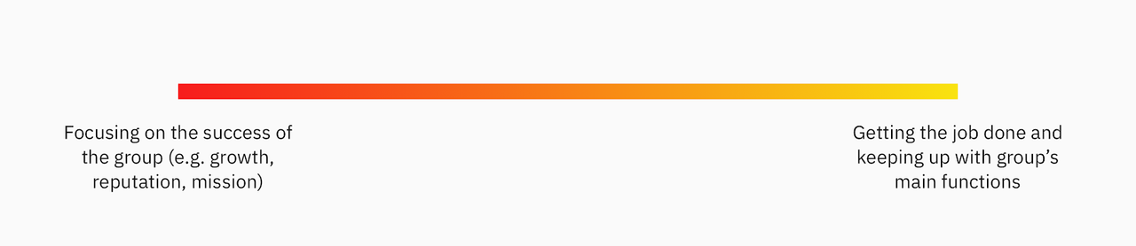

What are the opportunity areas for Agnes?

