# **SIMPLEST PLOT**

# Description

Add the script to a GameObject containing an image.

There are three types of possible plots. All variable are public and accessible directly, except from the resolution of the texture, which is accessed through SetResolution(*Vector2 NewResolution*) and GetResolution() Methods.

Once you have finished editing the parameters and passing the values, call *UpdatePlot()* to draw the plot.

GitHub: https://github.com/NeuralDip/SimplestPlot

## Global Variables

Some parameters are independent of the type of plot:

PlotType MyPlotType : Select the type of the plot.

Bool AxesVisible : Show-hide the Min and Max values of the axes.

int FontSize : The fontsize for the axes and warnings text.

Color TextColor : Set the text color.

Color BackGroundColor : Set the background Color.

bool ShowWarnings : Show warnings in case data are not consistent.

## TimeSeries

float[] SeriesPlotX : Array of the X values. This is optional.

List<SeriesClass> SeriesPlotY : List of the TimeSeries.

float[] SeriesPlotY.YValues : The actual YValues.

Color SeriesPlotY.MyColor : The color for this particular TimeSeries.

## Distribution

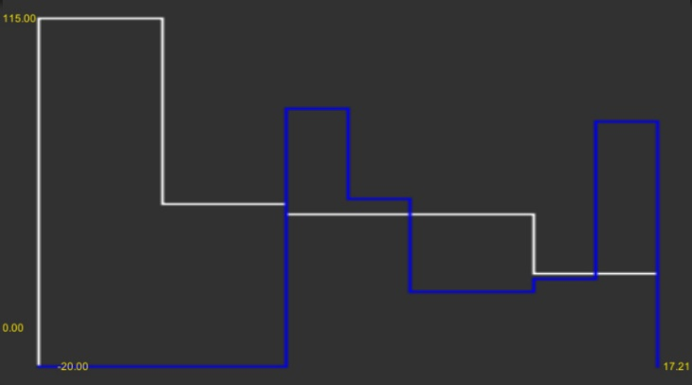

List<DistributionClass> DistributionPlot : List of Distributions

float[] DistributionPlot.Values : Actual values for the distribution.

int DistributionPlot.NumberOfBins : Default = 10.

Color DistributionPlot.MyColor : The color for this particulat Distribution.

## PhaseSpace

List<PhaseSpaceClass> PhaseSpacePlot : List of Phase Space plots.

float[] PhaseSpacePlot.XValues : XValues for the Plot.

float[] PhaseSpacePlot.YValues : YValues for the Plot.

Color PhaseSpacePlot.MyColor : The color for this particular Phase Space plot.