Human Peripheral Nerve Interface Experiment Summary

Neural Engineering Lab

Arizona State University

PI: Bradley Greger, PhD

1. **Introduction**

We would like to use a motion capture system to record the movements of pre-designated points on an intact hand and a residual limb. The purpose of this data collection is to calculate the kinematics of the hand and correlate those data to neural signals. Our volunteers will be seated and will be observing a virtual space and moving their virtual hands according to visual cues. The total volume of the tracking space will be around 8 ft3, directly in front of our seated volunteer.

1. **Marker Locations**

* **Intact Hand**

Total markers: 23 (4 markers per finger, back of hand, wrist joint, dorsal face of forearm)

* **Residual Limb**

Total markers: 3 (To calculate position/orientation.)

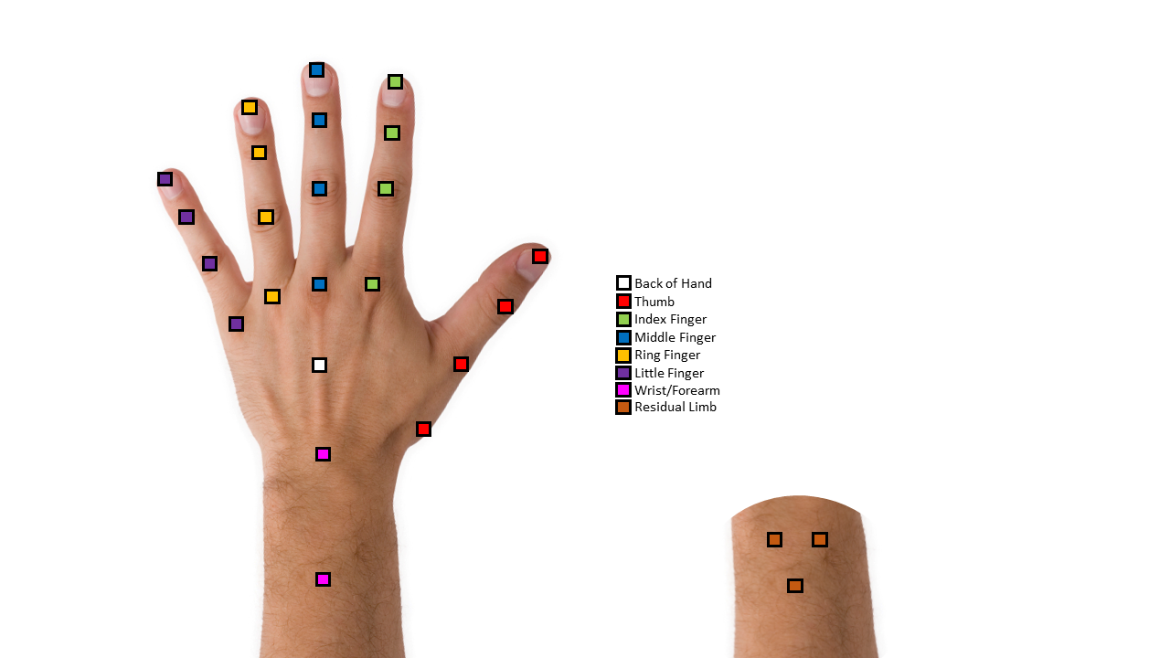

Figure 1. Proposed marker positions for the intact and residual limb.

1. **Experiment Summary**

* **Movements of interest:**

We are interested in several hand movement types. Listed below are the movements we wish to record.

* + Individual finger flexion (Every finger, multiple eccentricities)
  + Multi-finger flexion (Combinations of every finger)
  + Hand postures (Strength and Precision grips)
    - Strength Example: Gripping a railing/drinking glass
    - Precision Example: Holding a pencil
  + Abduction/Adduction of individual fingers

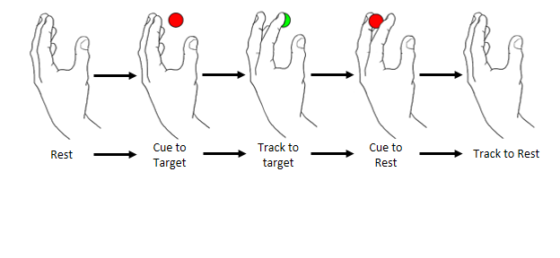

Figure 2: Example of individual finger flexion trial.

* **Hand Orientation:**

The intact hand will need to be able to freely move between prone and supine orientations to completed cued tasks. The following are approximations for the position of the hand during each activity. Figures 2 and 3 show

* + Individual finger flexion (Partial supine, ~45˚ from full supine (palm up))
  + Multi-Finger flexion (Partial supine, ~45˚ from full supine)
  + Hand Postures (Various, between prone (palm down) and ~45˚ from full supine)
  + Abduction/Adduction of individual fingers (Prone hand)
* **Arm/Hand Location:**

We propose that the volunteer uses arm rests to support their arms during the course of an experimental session. This will allow the hands to be held in the air with no table or hard surface beneath them to obscure markers from motion capture cameras. The following images are example positions we will ask volunteers to take to complete assigned tasks.

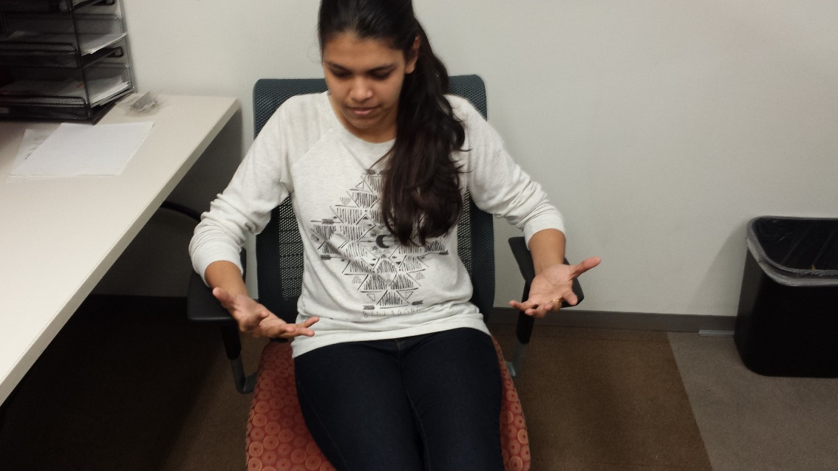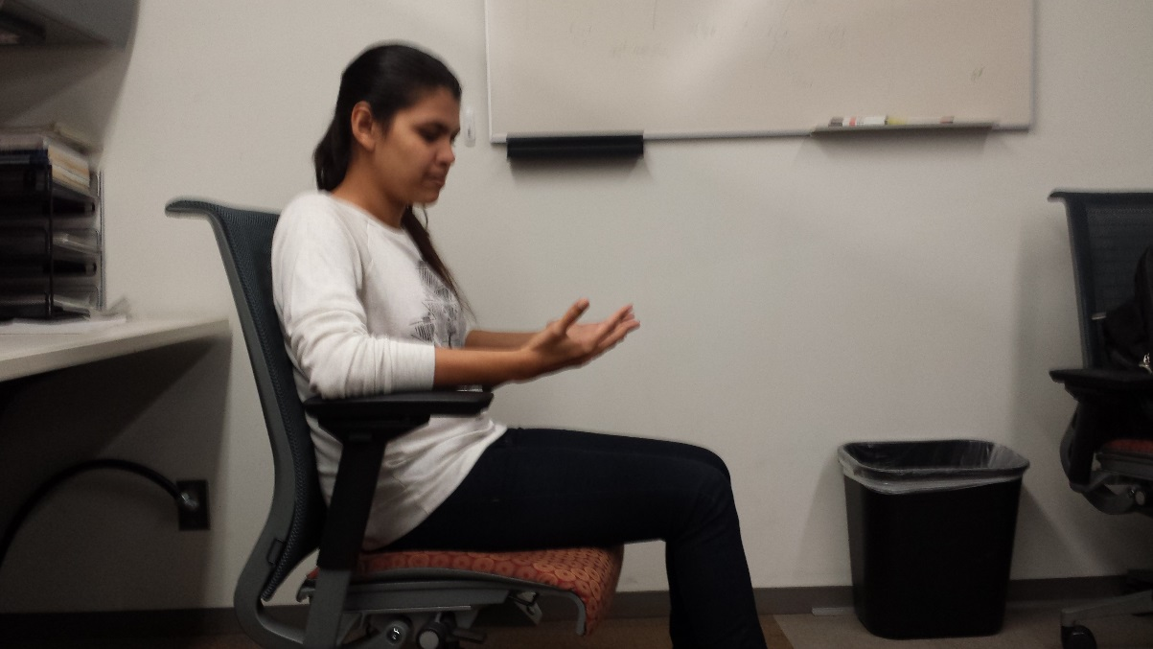

Figure 3. Partially supine hand position. Used to completed individual finger, multi-finger tasks, and some hand posture tasks.

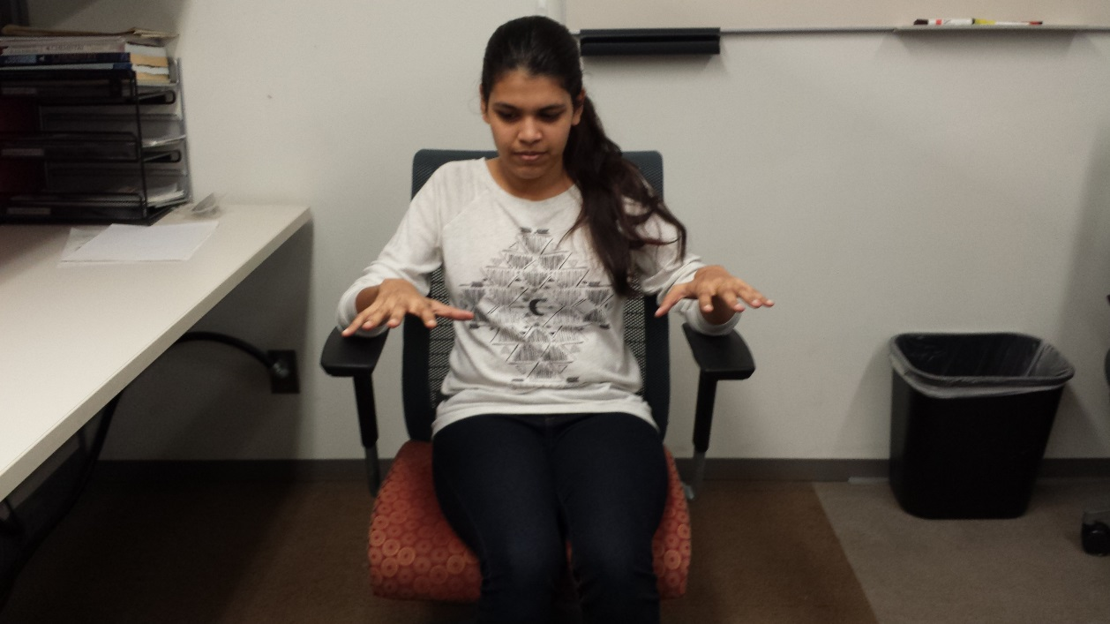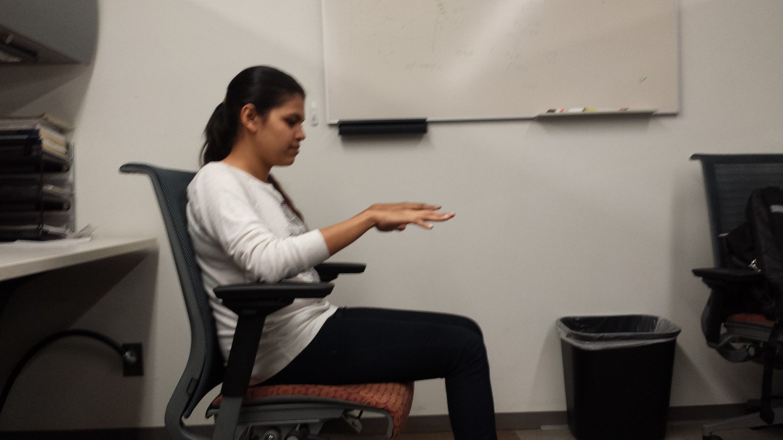

Figure 4. Prone hand position. Used to completed abduction/adduction tasks and some hand posture tasks.