**Inputs and Outputs**

|  |  |  |  |
| --- | --- | --- | --- |
| **LabView** | | | |
| **Inputs** | | **Outputs** | |
| Neural Decode | MATLAB | Decode Method | MATLAB |
| Trained Transfer Matrix/Information | MATLAB | Training Task/Trial Information | MATLAB |
| Residual Limb Movements | Vicon | Task/Trial Information | Unity |
| Hand Movements | Unity | Vicon Control | Vicon |
| Audio | Microphone | Data Streams/Markers | Hard Drive |

|  |  |  |  |
| --- | --- | --- | --- |
| **MATLAB** | | | |
| **Inputs** | | **Outputs** | |
| Training Task/Trial Information | LabView | Trained Transfer Matrix/Information | LabView |
| Decode Method | LabView | Neural Decode | LabView |
| Hand Movements | Unity | Neural Decode | Unity |
| Streaming Neural Data | TDT PO8e Card |

|  |  |  |  |
| --- | --- | --- | --- |
| **Unity** | | | |
| **Inputs** | | **Outputs** | |
| Hand/Finger Movements | Leap Motion | Hand/Finger Movements | MATLAB |
| Residual Limb Movements | Vicon | Hand/Finger Movements | LabView |
| Head Movements | Oculus Rift | Head Movements | Hard Drive |
| Neural Decode | MATLAB | Oculus Rift Video | Hard Drive |
| Task/Trial Information | LabView |

**LabView Experiment Outline**

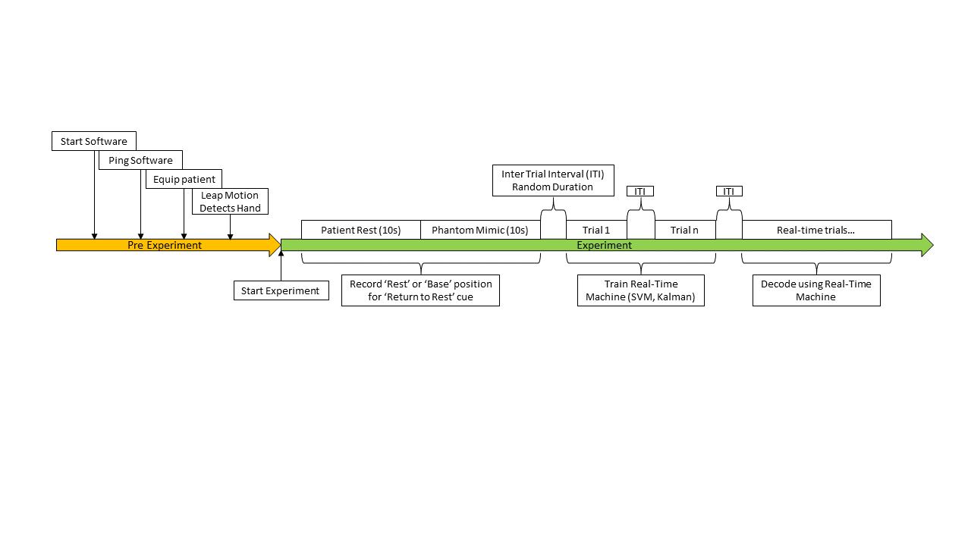

- Initialize and start accessory programs

- Via PowerShell, start MATLAB, Unity, etc...

- Ping software to ensure proper connections.

- Equip the patient with the Oculus Rift, Vicon stickers, and patient cable

- Ask the patient to move their arms until Leap Identifies their intact hand

- Ask patient to move to a rest position for 10 sec (record this base or rest position for 'Return to Rest’ cue)

- Ask patient to mimic phantom perceived positions with intact hand for 10 sec (record this base or rest position for 'Return to Rest’ cue)

- Start Tasks

- Which finger(s) or hand synergies

- Which finger task (spherical or torus)

- Save timestamps

- Update Unity and MATLAB

**Trial Params/Information:**

- Task Duration

- Inter-task interval

**Sphere Task**

- Finger(s) or synergies

- Hold Time

- Success Radius

- Return to Rest cue

**Torus Task**

- Finger

- Success Radius

- Rotation Number

- Target (blue sphere)

- Target Rotation Direction

- Target Speed (Ramp on/Ramp off)

- Cursor Position (Fingertip center)

- Torus Color (Red or green based on the success radius)

- Return to Rest cue

- Save Streams

- TimeStamps

- Markers (success, failure, trial start, trial information/parameters)

- Data Streams (Neural Decode, Finger Movements)

**Task/Trial Summary**

**Patient Rest**

Ask patient to be in a 'relaxed' or base position (Leap must be able to see all 5 fingers)

- 10 seconds hold time

**Mimic Phantom Hand**

Ask patient to mimic the perceived position of their phantom hand with their intact hand

- 10 seconds hold time

**Sphere Task**

Ask patient to move the indicated finger(s) or hand to the cued position

- Red colored spheres will appear for the selected finger(s) and the patient must move their fingers to that position.

- Spheres will become green when the patient's fingertip(s) are within some success radius of the sphere center(s).

- Patients will be cued to return to a rest or base position (positions gathered from the Patient Rest task.

**Torus Task**

Ask patient to follow a blue target sphere around a torus

- A red torus will appear around the selected finger.

- A blue target sphere will appear on the torus.

- Patient will move their finger to the blue target sphere.

- Target sphere will start moving (clockwise or counter-clockwise), and will slowly ramp up speed.

- Torus will change from red to green when the patient's finger is within some success radius of the blue target sphere.

- The blue target sphere will rotate around the torus one or more times, at a set speed (with a ramp up and a ramp down).

- The blue target sphere will appear at the same position each trial. The blue target sphere will also stop at that position.

**Arm Task?**

Ask patient to move arms from resting on the table to held in the air

- Perform the Sphere Task or Torus Task

**Wrist Task?**

Ask patient to move wrist at different angles

- Perform the Sphere Task or Torus Task or Arm Task?

**UDP Connection Scheme**

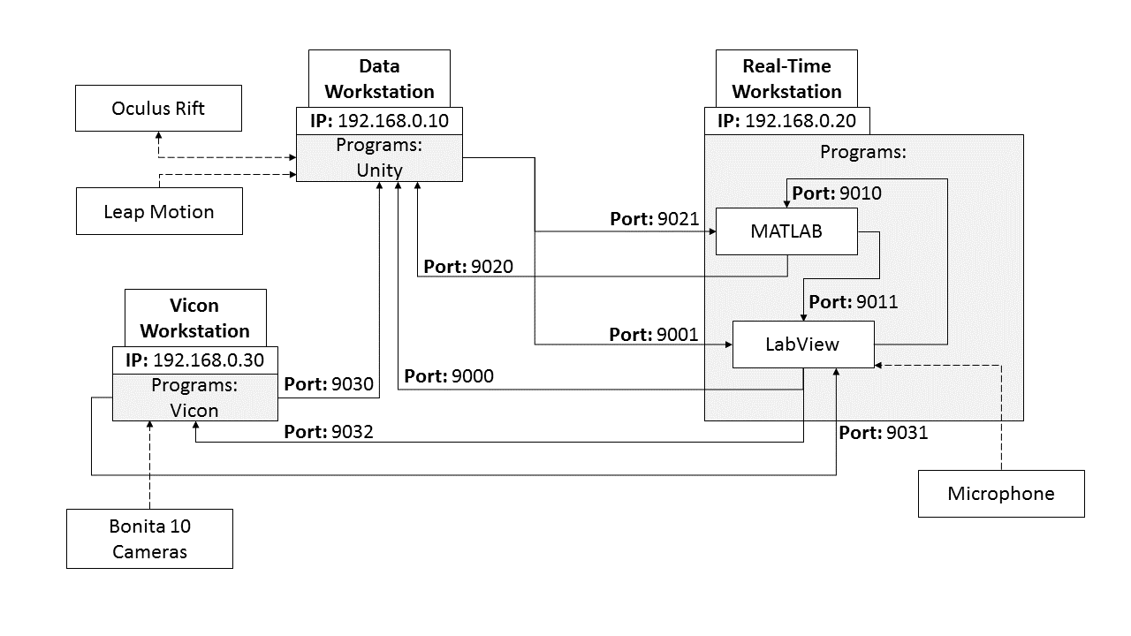

Unity -> LabView

- Data: Hand positions

- IP: 192.198.0.20

- Port: 9001

LabView -> Unity

- Data: Target information

- IP: 192.198.0.10

- Port: 9000

MATLAB -> LabView

- Data: Neural Decode/Trained Matrix/Transfer Matrix/...

- IP: 127.0.0.1

- Port: 9011

LabView -> MATLAB

- Data: Task Information, Success information, (For training)

- IP: 127.0.0.1

- Port: 9010

Unity -> MATLAB

- Data: Hand Positions

- IP: 192.198.0.20

- Port: 9021

MATLAB -> Unity

- Data: Hand Positions

- IP: 192.198.0.10

- Port: 9020

Vicon -> LabView

- Data: Arm Positions

- IP: 192.198.0.20

- Port: 9031

Vicon -> Unity

- Data: Hand Positions

- IP: 192.198.0.20

- Port: 9030

LabView -> Vicon

- Data: ???

- IP: 192.198.0.30

- Port: 9032

**Packet Construction**

**LabView -> Unity**

**Single Finger Trial Example**

Trial Start:

'T:0;D:0;'

- Trial: 0 (Sphere); Display: 0 (off);

Trial Cue:

'F:0;J:[ABD, PIP, IIP, DIP]; C:R;'

- Finger: 0 (Thumb); Joint Angles: [Metacarpal a(b)duction, Proximal Interphalangeal, Intermediate Interphalangeal, Distal Interphalangeal]; Color: Red;

Display Trial:

'F:0;D:1;'

- Display: 1 (on);

Success Visual:

'F:0;C:G;'

- Finger: 0 (Thumb); Color: Green;

Return to Rest Cue:

'F:0;J:[ABD, PIP, IIP, DIP];C:R;'

- Finger: 0 (Thumb); Joint Angles:[ABD, PIP, IIP, DIP]; Color: Red;

Display Trial:

'D:0;'

- Display: 0 (off);

**Multi Finger Trial Example**

Trial Start:

'T:0;D:0;'

- Trial: 0 (Sphere); Display: 0 (off);

Trial Cue

'F:012;Q:[s,i,j,k][s,i,j,k][s,i,j,k][s,i,j,k][s,i,j,k][s,i,j,k][s,i,j,k][s,i,j,k][s,i,j,k];C:RRR;'

- Finger: 0,1,2 (Thumb, Index, Middle); Quaternion: [s,i,j,k][s,i,j,k][s,i,j,k] (First Finger), [s,i,j,k][s,i,j,k][s,i,j,k] (Second Finger), [s,i,j,k][s,i,j,k][s,i,j,k] (Third Finger); Color: Red, Red, Red;

Display Trial:

'D:1;'

- Display: 1 (on);

Partial Success Visual

'F:01;C:GG;'

'F:2;C:G;'

Return to Rest Cue

'F:012;Q:[s,i,j,k][s,i,j,k][s,i,j,k][s,i,j,k][s,i,j,k][s,i,j,k][s,i,j,k][s,i,j,k][s,i,j,k];C:RRR;'

Display Trial:

'D:0;'

- Display: 0 (off);

**Torus Task Example**

Trial Start:

'T:1;D:0;'

- Trial: 1 (Torus); Display: 0 (off);

Trial Cue:

'F:1;Q:[s,i,j,k][s,i,j,k][s,i,j,k];C:R;'

- Finger: 1 (Index); Quaternion: [s,i,j,k][s,i,j,k][s,i,j,k]; Color: Red;

Display Trial:

'D:1;'

- Display: 1 (on);

Success Visual:

'F:0;C:G;'

- Finger: 1 (Index); Color: Green;

Return to Rest Cue:

'F:0;Q:[s,i,j,k][s,i,j,k][s,i,j,k];C:R;'

- Finger: 1 (Index); Quaternion: [s,i,j,k][s,i,j,k][s,i,j,k]; Color: Red;

Display Trial:

'D:0;'

- Display: 0 (off);

**Unity -> LabView/MATLAB**

Hand/Finger Positions

'F:012345;Q:[s,i,j,k][s,i,j,k][s,i,j,k];'