

User’s Manual

Version 1.0

Group #7

Table of Contents

Page #

1. Product Overview………............................................................... 1-1
   1. ConnActiv’s Use……….…..……………………………………………………………. 1-1
   2. Main functions…………………………………………………………………………… 1-1
2. Getting Started……………………………………………………………………..… 2-1
   1. Registering…………………………………………………………………………………. 2-1
   2. Help Mode.……………………….……………………………………………………….. 2-1
   3. Logging In….…………………….…………………………………………………………. 2-2
   4. Sample Run and Example…………………………………………………………… 2-2
      1. The Public Stream……………………………………………………………… 2-2
      2. Other User Profiles…………………………………………………………… 2-3
      3. The Reviews Module ……….……………………………………………… 2-4
      4. Requests – Incoming……………………………………………………..…. 2-5
3. Modes of Operation…………………………………………………………..…... 3-1
   1. Internet Browser……………………………………………………………………….. 3-2
   2. Android Smartphone…………………………………………………………………. 3-2
4. Revision History………………………………………………………………………………….... 4-0

1.0 PRODUCT OVERVIEW

1. PRODUCT OVERVIEW

1.1 ConnActiv’s Use

The product ConnActiv is used to connect physically active users in a community.

1.2 Main Functions

The main functions of ConnActiv are:

* Unique user profiles
* Live streams of activities (ConnActions)
* Ability to find others with similar interests

2.0 GETTING STARTED

1. PRODUCT OVERVIEW

2.1 Registering

It all starts with registering with our site. Upon clicking on register, the user will fill in a small form with similar questions:

* Enter email – this will be your login name
* Verify email – to ensure no typos
* Create unique password
* Verify password – to ensure no typos
* Name
* Age
* Address

2.2 Help Mode

If a user decides he/she wants to look at the site before registering, there will be a button next to the log in button that will automatically fill in the email/password input boxes with credentials for a special “guest” user. When they enter the site as a guest, the user will be presented with a special version of the site. All around the site will be large questions marks that, when pressed, will show a text box that describes the module closest to it. If the user decides to register, they only need to log out and then register.

2.3 Logging In

When a user visits [www.ConnActiv.com](http://www.ConnActiv.com), she will be at the website’s homepage. This page contains useful information about ConnActiv, as well as, username and password textboxes. If the user provides the correct credentials from when she signed up, she will be taken to her unique Home page (see Figure 1).

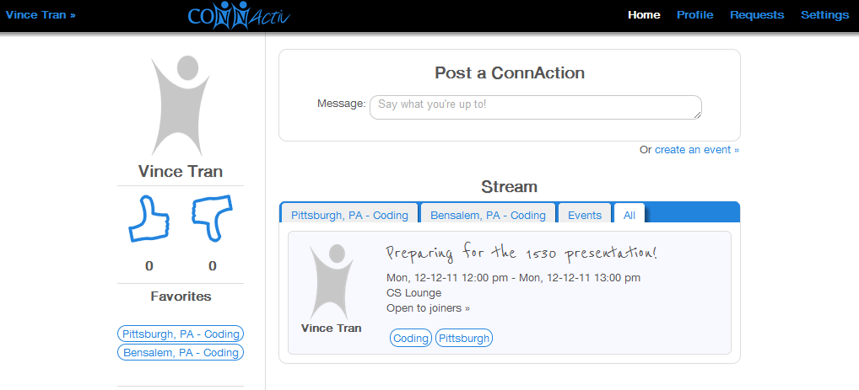

Figure 1

2.4 Sample Run and Example

2.4.1 The Public Stream

Today our loyal user Kim has just woken up. She decides she is going to take her morning run in South Oakland today, but does not want to run alone because that is no fun. She quickly signs into ConnActiv and on her Home page (see Figure 1) she sees another user named Vince T. has posted he will be running at 9:00AM in the Running Stream (see Figure 2). This is exactly what she was looking for!

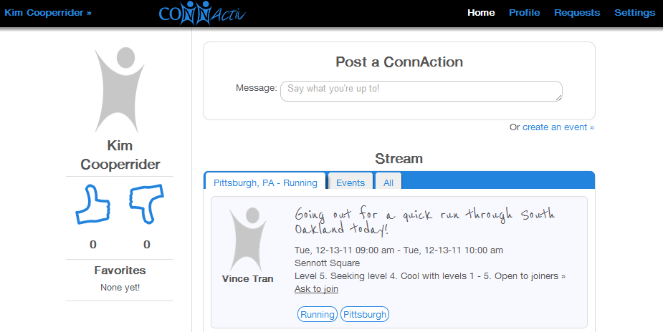

2.4.2 Other User Profiles

She clicks on Vince’s profile name or picture to bring up his profile page (see Figure 3). On Vince’s profile the default view will be his Stream tab. Here anyone can see what he has posted in streams or what other users have said about him.

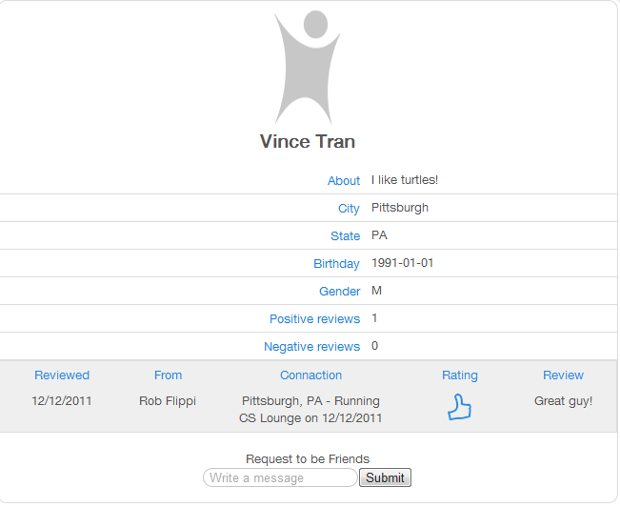

Figure 3

Kim sees that he has a positive amount of thumbs up and enjoyed running with him.

2.4.3 The Reviews Module

On Vince’s profile, she can also read any reviews that were written about Vince (see Figure 3). Users can only review other users if they have attended a ConnAction together.

2.4.5 Requests – Incoming

Vince was logged in and by his computer so he instantly saw the notification pop-up on his Request tab (see Figure 4). Here he sees Kim has asked to join him on his activity he posted. He decides to check out Kim’s profile and make sure she is a good partner for his morning run. He sees that she is and accepts her invite and tell her where to meet up at 9:00AM.

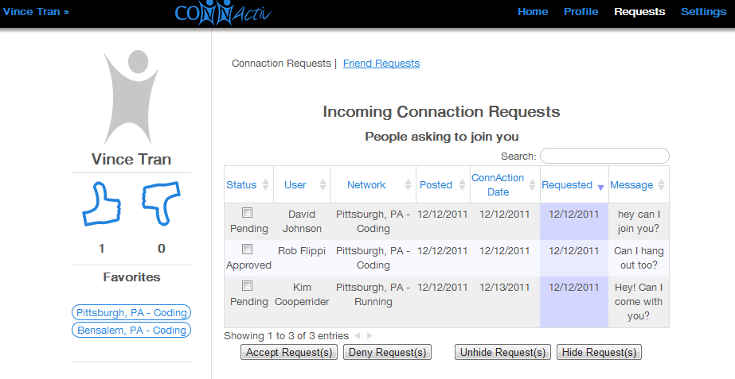

Figure 4

3.0 MODES OF OPERATION

1. MODES OF OPERATION

3.1 Internet Browser

One of the main ways to use ConnActiv is an internet browser like Mozilla Firefox, or Google Chrome. Using an internet browser will allow a user to have full functional use of the site. The user will be able to have access to all of the major functions described in Sections 1.0 and 2.0.

3.2 Android Smartphone

Another way to use ConnActiv is with a smartphone running the Android Operating System. The user simply needs to launch the Market App and download the ConnActiv App. This app contains all of the functions described in Sections 1.0 and 2.0 anywhere you go!

4.0 Revision History

|  |  |  |  |
| --- | --- | --- | --- |
| Person | **Date Modified** | **Section** | **Description** |
| **Rob** | 10/1/11 | Entire Doc | First Draft |
| **Vince** | 12/10/11 | Entire Doc | Added new pictures and removed/edited to reflect the changes to the website |