

User’s Manual

Version 1.0

Group #7

Table of Contents

Page #

1. Product Overview………............................................................... 1-1
   1. ConnActiv’s Use……….…..……………………………………………………………. 1-1
   2. Main functions…………………………………………………………………………… 1-1
2. Getting Started……………………………………………………………………..… 2-1
   1. Registering…………………………………………………………………………………. 2-1
   2. Help Mode.……………………….……………………………………………………….. 2-1
   3. Logging In….…………………….…………………………………………………………. 2-2
   4. Sample Run and Example…………………………………………………………… 2-2
      1. The Public Stream……………………………………………………………… 2-2
      2. Other User Profiles…………………………………………………………… 2-3
      3. The Recommendations Tab……………………………………………… 2-4
      4. The Activates Tab……………………………………………………………… 2-5
      5. Requests – Incoming…………………………………………………………. 2-6
3. Modes of Operation…………………………………………………………..…... 3-1
   1. Internet Browser……………………………………………………………………….. 3-2
   2. Android Smartphone…………………………………………………………………. 3-2

1.0 PRODUCT OVERVIEW

1. PRODUCT OVERVIEW

1.1 ConnActiv’s Use

The product ConnActiv is used to connect physically active users in a community.

1.2 Main Functions

The main functions of ConnActiv are:

* Unique user profiles
* Live streams of activities (ConActions™)
* Ability to find others with similar interests
* Active user reward program – medals that can be displayed on your profile

2.0 GETTING STARTED

1. PRODUCT OVERVIEW

2.1 Registering

It all starts with registering with our site. Upon clicking on register, the user will fill in a small form with similar questions:

* Enter email – this will be your login name
* Verify email – to ensure no typos
* Create unique password
* Verify password – to ensure no typos
* Name
* Age
* Address – used for finding activates (ConActions™) nearby

2.2 Help Mode

Once a user is done registering they will be automatically logged in, but they will be in Help Mode. Help Mode is provided to help guide new users around the site. It will first take users to an Activates page. On this page, a user can select what she is interested in (Running, Tennis, Basketball, etc…) and give herself a level ranking (1-10; 1: Novice, 10: Expert) of how good she is. After she chooses activates, she will be brought to a Streams page. This page displays all of the public local streams in the user’s area; the user can subscribe to as many public streams as she sees fit. The user will now be brought to her Home page (see Figure 1).

2.3 Logging In

When a user visits [www.ConnActiv.com](http://www.ConnActiv.com), she will be at the website’s homepage. This page contains useful information about ConnActiv, as well as, username and password textboxes. If the user provides the correct credentials from when she signed up, she will be taken to her unique Home page (see Figure 1).

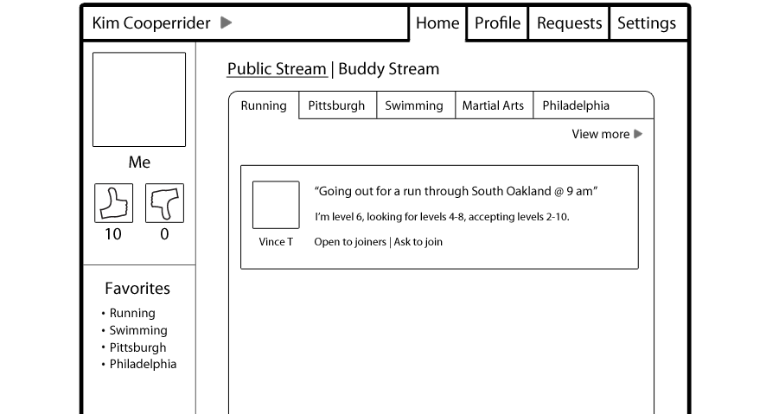

Figure

2.4 Sample Run and Example

2.4.1 The Public Stream

Today our loyal user Kim has just woken up. She decides she is going to take her morning run in South Oakland today, but does not want to run alone because that is no fun. She quickly signs into ConnActiv and on her Home page (see Figure 1) she sees another user named Vince T. has posted he will be running at 9:00AM in the Running Stream. This is exactly what she was looking for!

2.4.2 Other User Profiles

She clicks on Vince’s profile name or picture to bring up his profile page (see Figure 2). On Vince’s profile the default view will be his Stream tab. Here anyone can see what he has posted in streams or what other users have said about him. 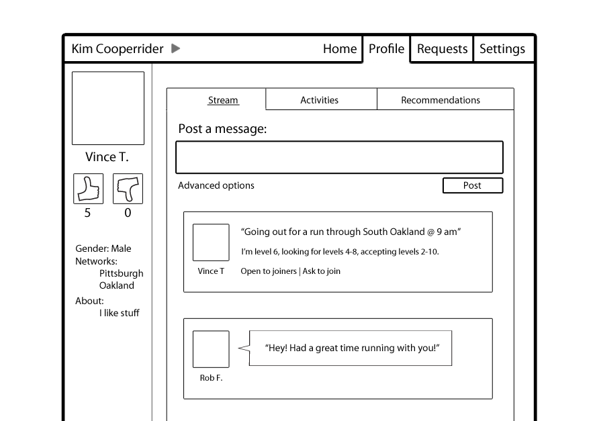

Figure

Kim sees that he has a positive amount of thumbs up, and a comment on his stream that another user, Rob F., enjoyed running with him.

2.4.3 The Recommendations Tab

From here she decides to see if anyone has recommended him for any activates (see Figure 3). She clicks on his Recommendations tab and sees that Rob has recommended him for running and has given him a thumbs up.

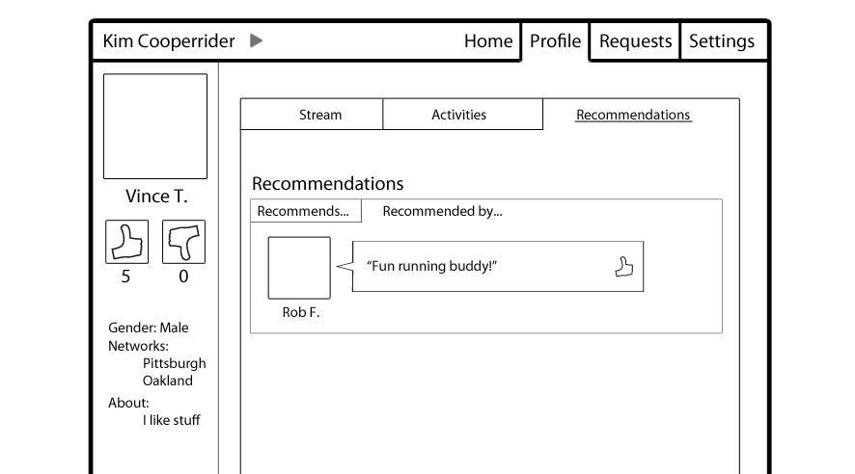

Figure

Kim goes back to his Stream tab (see Figure 2) and clicks Ask to join. A private invite will now go to Vince.

2.4.4 The Activities Tab

While Kim waits for his acceptance, she decides to see what else Vince does by clicking on his Activities tab (see Figure 4).

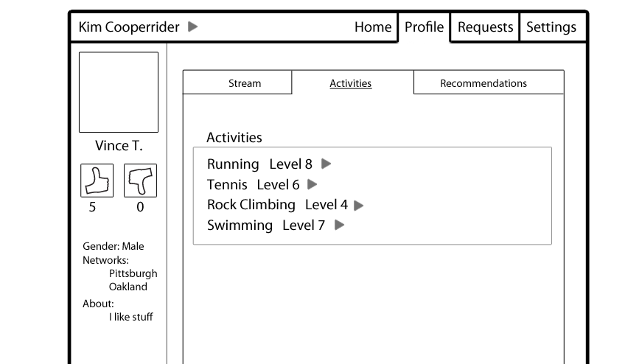

Figure

Here she can clearly see all of the activates he does and what level he ranks himself. By clicking on the arrow, more information about why he ranked himself a specific level will show.

2.4.5 Requests – Incoming

Vince was logged in and by his computer so he instantly saw the notification pop-up on his Request tab (see Figure 5). Here he sees Kim has asked to join him on his activity he posted. He decides to check out Kim’s profile and make sure she is a good partner for his morning run. He sees that she is and accepts her invite and tell her where to meet up at 9:00AM.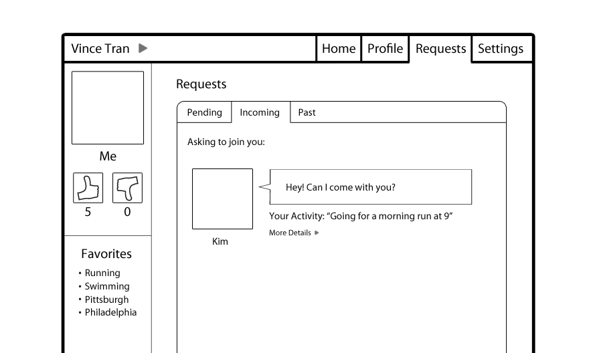

Figure

3.0 MODES OF OPERATION

1. MODES OF OPERATION

3.1 Internet Browser

One of the main ways to use ConnActiv is an internet browser like Mozilla Firefox, or Google Chrome. Using an internet browser will allow a user to have full functional use of the site. The user will be able to have access to all of the major functions described in Sections 1.0 and 2.0.

3.2 Android Smartphone

Another way to use ConnActiv is with a smartphone running the Android Operating System. The user simply needs to launch the Market App and download the ConnActiv App. This app contains all of the functions described in Sections 1.0 and 2.0 anywhere you go!