Contest System Manual

The contest system is web-based. It can be used use through web-browser like Firefox or Microsoft Internet Explorer. The interface is composed of three pages: login page, main page and page for restoring of the files.

Login page

When the user types the URL of the Contest System in the address field of the browser, the system loads the login page, which contains some instructions and two text fields – Login ID and Password. Type the Login ID and Password, given to you by the organizers, to enter the Contest System.

Main page
After typing of Login ID and Password the main page appears. If the page contains the message:
Contest is not running
then the contest has not started yet, was finished or was stopped by the administrator of the System by some reason. If the message Contest is not running was displayed the contestant can not submit and test solutions. It is possible, though, to download back the files that were submitted before.

The Main page contains the following elements:
1 – The title line contains the Login ID of the contestant, the current time of the server (the current time of the server is not necessarily the same as the current time on your machine) and the expected end of the contest session. Attention: current time and expected end are not updated automatically, You need to reload the page manually.
2 – Reloading of the page is necessary also for seeing the progress and the result of the submit. You could reload the main page by pressing the button Reload, or by one of the standard way – by the button F5 or by the icon Reload of the browser.
3 – Table of the accepted files: for each of the tasks the table shows the name of the task, the name of the submitted source file and the time of the submission. Initially the table contains only the names of the tasks. The name of the submitted source file and the time of the submission appear/change after each successful submit. The name of the submitted file is a link through which the contestant can view or download that file. Each successful submit will overwrite the old one and the contestant will not be able to restore the lost file unless it was saved on her/his computer. The successful submission will immediately replace the source file, no mater that the table shows the old one (the change will be shown after the next reload of the page).
4 – In the textbox Announcement the messages of the judges/administrators of the System are displayed. The time of editing of the message is also displayed. You have to reload the main page in order to see the message that was edited after the previous reload.
5 – Section for submission of solutions: Browse the file system with the button Browse. Choose the source file that you would like to submit – the full name of the file will be displayed in the field Submit File – and press the button Submit. During the submission process all section will be replaced by the text Submission Progress… xx%. Reload. The user has to reload the main page in order to receive the status and the result of submit in the field Submit Result.
6 – Section for testing: The contestant could check how her/his source will run on the server with her/his own test input. After a successful compilation the System will run the obtained executable, taking the supplied input file as a standard input. The standard output and the standard error output will be returned to the user. All requirement of the system are checked during the testing.
If you would like the system to check your program with your own test example: Browse the file system with the button Browse. Choose the source file that you would like to test – the full name of the source file will be displayed in the field Test Source File. Browse the file system with the button Browse. Choose the input file that you would like to test the program with – the full name of the input file will be displayed in the field Test Input File. Press the button Test. During the submission process all section will be replaced by the text Test Progress… xx%. Reload. The user has to reload the main page in order to receive the status and the result of the test in the field Test Result.
7 – Backup/restore section: You could save your files on the System server and restore them when necessary. To save your file on the server browse the file system with the button Browse. Choose the source file that you would like to backup – the full name of the file will be displayed in the field Backup File – and press the button Backup. The names of the files have to be created in UNIX style – letters and digits and no spaces. To open the restore dialog press the button Restore.
8 - The name of the contest (it is important when many contests are running in parallel).

Restore page
The page contains the list of files that have been uploaded via backup and there are available for download.

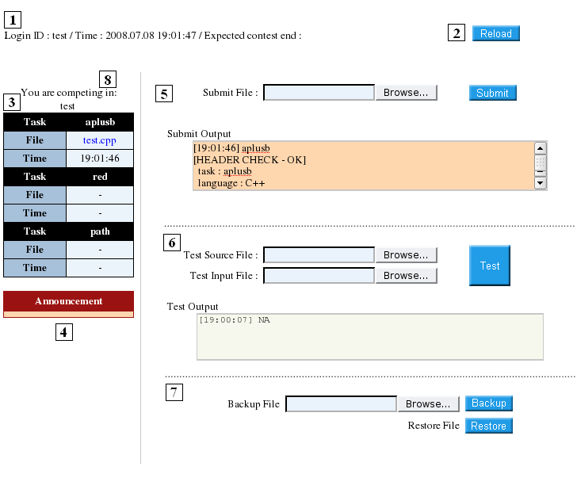

Submission Header
In order for the Contest System to accept a source for grading it needs to know what task does the submit attempt to solve and which language is used. The way to provide this information is by adding a header to the begging of Your source. The format of the header for task “aplusb” is
C | C++ | Pascal
/*  TASK: aplusb  LANG: C  */ | /*  TASK: aplusb  LANG: C++  */ | {  TASK: aplusb  LANG: PASCAL  }
Use the same case, do not leave trailing spaces.

APPENDIX. System messages

Error/Information messages of the web server (displayed in the main page)
Message  Sub-message | Explanation
Submission failed:
Already processing | An attempt for new submit is made before the end of the previous submit.
No file selected | No file name in the field Submit File.
Contest not running | Contest finished. Solutions are no more accepted.
Test failed:
Already processing | An attempt for new test is made before the end of the previous test.
Select two files | No file name in the field Test File and/or Test Input.
Contest not running | Contest will finish in less than 5 min and testing is stopped.
Source code display failed:  Please retry or consult administrator | Please retry or consult an administrator
File upload interrupted:  Please retry | Contestant pressed Cancel or no connection with the server.
Unknown error | Try to reload the page.

Messages of submission and testing
Message | Explanation
! The system failed to process the job. Please consult administrator | Check your program or contact the administrator.
[HEADER CHECK - OK] | The header in the source file is accepted.
[HEADER CHECK - ERROR] | The header in the source file is not accepted.
[COMPILE – OK] | Successful compilation.
[SAMPLE DATA TEST – OK] | Sample test passed successfully.
[SAMPLE DATA TEST – ERROR] | Error during execution of sample tests.
header format error | Wrong format of the header.
task name is invalid | Wrong task name in the header.
execution time limit exceeded! | The program is running longer than limited.
output size limit exceeded! | The output file is too long (more than 200K).
wrong answer | The program produced wrong result.
exit code is non-zero | The program has to quit with exit value 0.  Insert return 0; or exit(0); (for C/C++ and C#) in the end of the program. (Remark. Another possible reason is that the program is reading missing file, unavailable memory or some other mistake in a standard function.)
Execution error (invalid memory reference) | Segmentation fault (probably because memory limit )
...Submission Accepted! | Finally ... submission is accepted!  Notice: Solution might not pass the sample tests. Any way it will overwrite the old one and will be judged.
...Submission Failed! | Submission failed – the file submitted will not be judged. (This can happen for instance if the source doesn't compile)
Invalid task name!  The task you submitted is not part of the contest you are registered in. | Solution rejected because no task with the mentioned name. If you think that this is a mistake of the System – contact the administrator.

