SOP-IT-021: User Access Request
SYNTHETIC SAMPLE for testing the policy compiler. Version 1.0. Owner: IT Service Management.

1 Purpose
1.1 This procedure describes how employees request access to company IT systems.

2 Procedure
2.1 The requester submits the access request form in the IT portal.
2.2 The line manager approves or rejects the request within 2 business days.
2.3 For privileged (administrator) access, the Information Security team reviews the request after manager approval.
2.4 The IT Service Desk provisions access and notifies the requester.
2.5 Access must be reviewed periodically.
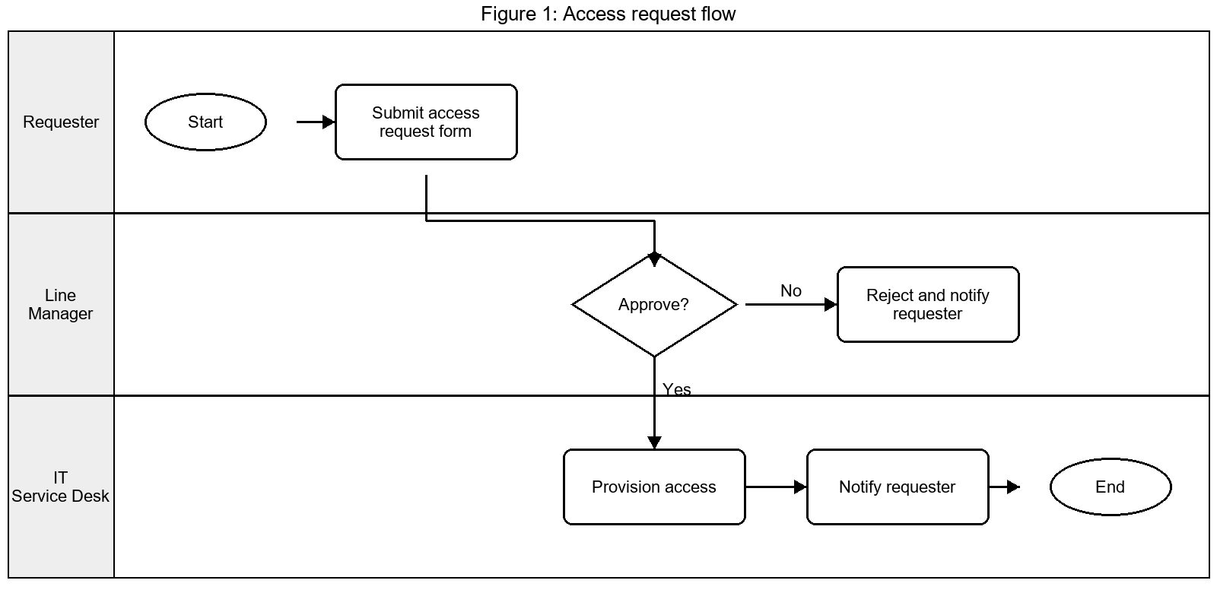
Figure 1: Access request flow

3 Approval matrix
Access type | Approver
Standard | Line manager
Privileged | Line manager and Information Security
Emergency | IT Duty Manager

