raw_to_nwb conversion and spyglass insertion

- Creating a yaml file
Create a yaml file with all the data and path using yaml generator.
Important details to note: (example file)
- Experiment_description - Stepping dynamics during aging (this will be for all the underfloor tracking recordings on 1m/1.25m/2m - its not a unique identity). For W track : W-track continuous alternation
- Animal ID
- Genotype - can be one of these three : 1. Wildtype/
2. PVcre -ve (Wildtype)/
3. PVcre +ve
- Session id - This is animal dependent. Session ID is equivalent to date, so every time the animal goes on any track, it will increase by 1. This is because we want all the sessions for each animal to be in spyglass uniquely.
- Keywords - (keep first letter capital) - Linear track, W track.. etc
- Date of birth (check after generating)
- Cameras
  - Camera Id - (this will be number on the camera)
  - Meters per pixel - calculate from ImageJ and add
  - Manufacturer - Allied Vision
  - Model - AVT Manta G-158C Color CMOS PoE Camera- (add all the details - so if we get a different spec camera, wont be confusing)
  - Lens - Theia (part number)
  - Camera name - camera Id_trackname_date (keep date for the linear track recordings - eg. 4 _linear1.25m-_20250926) - for old (2025 recordings)
2026 recordings - 1_linear1m/ 1_linear1.25m/ 3_linear2m
-
For side camera recordings - no need to add date, because meter to pixel is not changing (eg. 3_sidecam_2m)
For W track - no need to add date, because meter to pixel is not changing (eg. 2_Wtrack)
For sleep box - keep date, because meter to pixel might was not same (eg. 3_sleepbox_20250926)
- Camera id in tasks details
- Path of statescript log
- Video file name - 20250818_na20_07_sleep.1.mp4, even this number (can change if recorded from more than 1 camera) because it will cause errors.
- Default value for times period multiplier : 1.5 ; raw data to volts : 0.000000195 & default_header file path: default header.xml
- Behavioural events it should be at least 5 for linear track :
  - 2 Reward wells (DIn)
  - 2 Reward pumps (Dout)
  - Camera strobe information - ‘Run Camera Ticks’

- Creating nwb files

- Convert raw file to nwb use the following code (“behavioural_only” should be True for data without any neural data)
- Do the conversion in “trode_to_nwb” kernel
- Check the data_path, output_dir and video_directory.
- output_dir and video_directory should be created before conversion
from trodes_to_nwb.convert import create_nwbs
data_path = "/media/NA_2_2025/Supraja/Animal/Koel/na20/raw/20250818"

output_dir = "/media/NA_2_2025/Supraja/Animal/Koel/na20/nwb"

video_directory= "/media/NA_2_2025/Supraja/Animal/Koel/na20/video"

query_expression = f"animal == 'na20' and date == 20250818"
create_nwbs(
path=data_path,
output_dir=output_dir,
video_directory=video_directory,
convert_video=True,
behavior_only=True,
n_workers=1,
query_expression=query_expression,
)

- Check the nwb & video folder and copy the file to media/NA_2_2025/Supraja/spyglass/raw and video respectively
- Compare the overlapping of epoch and video timestamps using “nwb_timestamps_mapping” note (use “trodes_to_nwb” kernel)
  - In the first block add the path of nwb and compare the timestamps
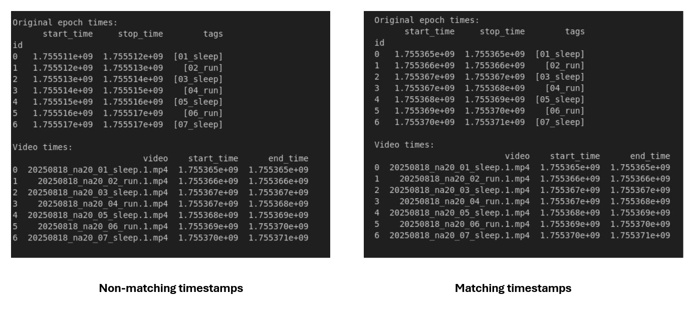
  - If it is not matching, then run the second block and respond ‘y’ to the prompt (example successful conversion output)
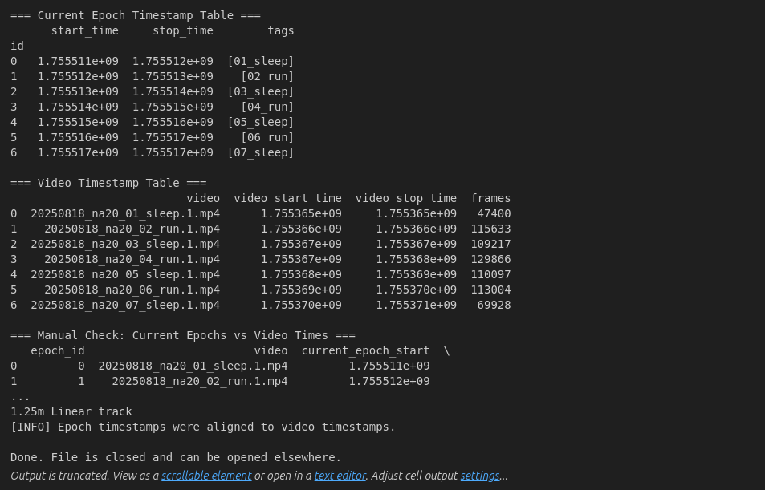

- Inserting nwb file into Spyglass

- Initiate spyglass “setup” notebook (with your username and password and use “spyglass” kernel) and then open “data_load” notebook for insertion
- In the “data_load”, first 3 blocks are defined with default (just check the username in the output of first block)
- In the fourth block, define the nwb_file_name and nwb_file_copy_name
- Then using the fifth block, (sgi.insert_sessions(nwb_file_name, rollback_on_fail=False, raise_err=False)) insert the file.
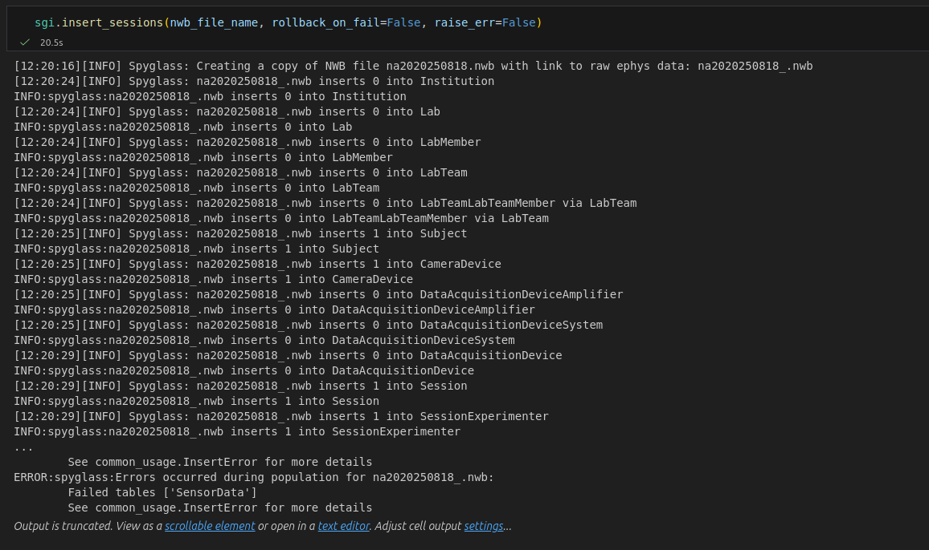
[because the “raise_err” is false there won’t be any error but do check the insertion log whether every file inserted or check separately as:
- Check Nwbfile, session, videofile and dioevents (all these also I have added blocks to check)
[Note: do kernel restart after nwb creation, timestamp mapping]
After checking, you are all done!!

