Probability

Saturday, August 13, 2016

2:32 PM

* + Probability calculus helps understand rules
  + Very complicated though, simplify it via **density** and **mass** functions
  + Random Variables- numerical outcome of experiment
    - Discrete
    - Continuous
  + Probability Mass Function:
    - Discrete
    - Function that associates every outcome with a probability
    - Must always be >= 0
    - Sum of possible vars must always = 1
  + Prevalent example:

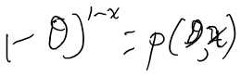

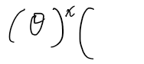

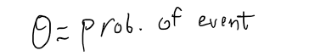

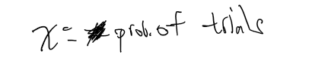

* + Probability Density Function:
    - Continuous
    - Must be larger than 0 everywhere
    - Total area under it must be 1
    - Areas under PDFs correspond to prob for that random var

C:\8993CCC5\36AF9CA1-F8A0-4352-A411-30AB114C7F1E_files\image005.png

C:\8993CCC5\36AF9CA1-F8A0-4352-A411-30AB114C7F1E_files\image006.png

C:\8993CCC5\36AF9CA1-F8A0-4352-A411-30AB114C7F1E_files\image007.png

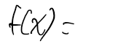

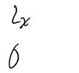

C:\8993CCC5\36AF9CA1-F8A0-4352-A411-30AB114C7F1E_files\image010.png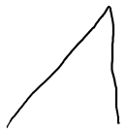C:\8993CCC5\36AF9CA1-F8A0-4352-A411-30AB114C7F1E_files\image012.pngC:\8993CCC5\36AF9CA1-F8A0-4352-A411-30AB114C7F1E_files\image013.pngC:\8993CCC5\36AF9CA1-F8A0-4352-A411-30AB114C7F1E_files\image014.pngC:\8993CCC5\36AF9CA1-F8A0-4352-A411-30AB114C7F1E_files\image015.png

C:\8993CCC5\36AF9CA1-F8A0-4352-A411-30AB114C7F1E_files\image016.png

C:\8993CCC5\36AF9CA1-F8A0-4352-A411-30AB114C7F1E_files\image017.pngC:\8993CCC5\36AF9CA1-F8A0-4352-A411-30AB114C7F1E_files\image018.pngC:\8993CCC5\36AF9CA1-F8A0-4352-A411-30AB114C7F1E_files\image019.pngC:\8993CCC5\36AF9CA1-F8A0-4352-A411-30AB114C7F1E_files\image020.pngC:\8993CCC5\36AF9CA1-F8A0-4352-A411-30AB114C7F1E_files\image021.png

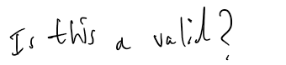

C:\8993CCC5\36AF9CA1-F8A0-4352-A411-30AB114C7F1E_files\image023.png

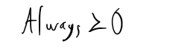

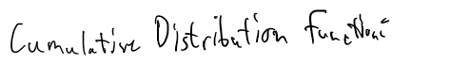

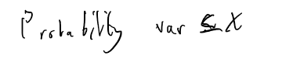

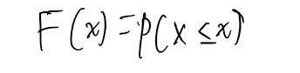

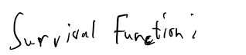

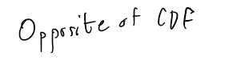

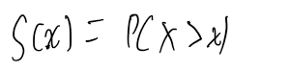

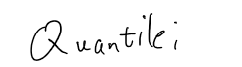

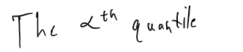

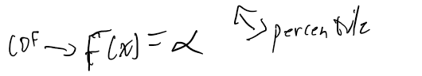

Conditional Probability

Saturday, August 13, 2016

3:15 PM

C:\8993CCC5\36AF9CA1-F8A0-4352-A411-30AB114C7F1E_files\image034.png

C:\8993CCC5\36AF9CA1-F8A0-4352-A411-30AB114C7F1E_files\image035.png

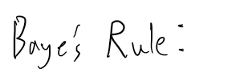

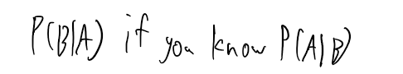

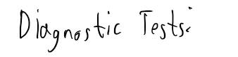

C:\8993CCC5\36AF9CA1-F8A0-4352-A411-30AB114C7F1E_files\image039.png

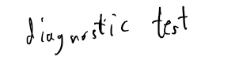

C:\8993CCC5\36AF9CA1-F8A0-4352-A411-30AB114C7F1E_files\image041.png

C:\8993CCC5\36AF9CA1-F8A0-4352-A411-30AB114C7F1E_files\image042.png

C:\8993CCC5\36AF9CA1-F8A0-4352-A411-30AB114C7F1E_files\image043.png

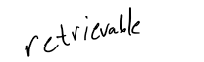

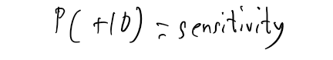

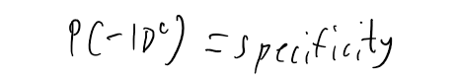

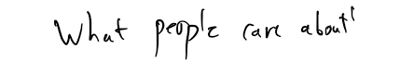

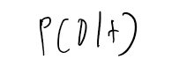

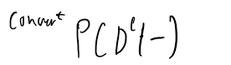

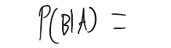

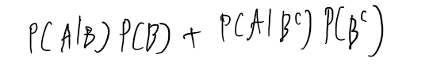

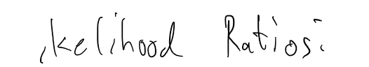

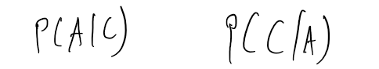

C:\8993CCC5\36AF9CA1-F8A0-4352-A411-30AB114C7F1E_files\image054.png

C:\8993CCC5\36AF9CA1-F8A0-4352-A411-30AB114C7F1E_files\image055.png

C:\8993CCC5\36AF9CA1-F8A0-4352-A411-30AB114C7F1E_files\image056.pngC:\8993CCC5\36AF9CA1-F8A0-4352-A411-30AB114C7F1E_files\image057.pngC:\8993CCC5\36AF9CA1-F8A0-4352-A411-30AB114C7F1E_files\image058.png

C:\8993CCC5\36AF9CA1-F8A0-4352-A411-30AB114C7F1E_files\image059.png

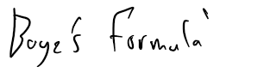

C:\8993CCC5\36AF9CA1-F8A0-4352-A411-30AB114C7F1E_files\image061.png

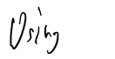

C:\8993CCC5\36AF9CA1-F8A0-4352-A411-30AB114C7F1E_files\image063.pngC:\8993CCC5\36AF9CA1-F8A0-4352-A411-30AB114C7F1E_files\image064.pngC:\8993CCC5\36AF9CA1-F8A0-4352-A411-30AB114C7F1E_files\image065.png

C:\8993CCC5\36AF9CA1-F8A0-4352-A411-30AB114C7F1E_files\image066.pngC:\8993CCC5\36AF9CA1-F8A0-4352-A411-30AB114C7F1E_files\image067.png

C:\8993CCC5\36AF9CA1-F8A0-4352-A411-30AB114C7F1E_files\image068.png

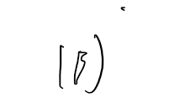

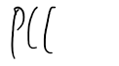

C:\8993CCC5\36AF9CA1-F8A0-4352-A411-30AB114C7F1E_files\image071.pngC:\8993CCC5\36AF9CA1-F8A0-4352-A411-30AB114C7F1E_files\image072.pngC:\8993CCC5\36AF9CA1-F8A0-4352-A411-30AB114C7F1E_files\image073.png

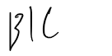

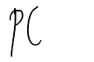

Independence

Saturday, August 13, 2016

3:41 PM

* + A is independent of B if:
    - P(A|B) = P(A) where P(B) > 0
    - P(A^B) = P(A)P(B)
  + Independent
    - Statistically independent of another event
  + Identical Distribution
    - Drawn from the same population distribution

Expected Values

Saturday, August 13, 2016

3:46 PM

* + Making conclusions based on noisy data
  + Sample expected values will predict population expected values
    - Mean
      * C:\8993CCC5\36AF9CA1-F8A0-4352-A411-30AB114C7F1E_files\image076.png
    - Variance
  + Population mean is center of mass of population
  + Sample mean is center of mass of sample population
  + Sample mean is estimate of population mean
  + More data in sample mean, closer to actual mean it is

Variability

Saturday, August 13, 2016

4:04 PM

* + Variance
    - Variance of random var is measure of spread
    - Var(X) = E[(X-u)]^2
    - Square root of variance is std deviation
    - Sample Variance:

Machine generated alternative text:
|0n—l 

Screen clipping taken: 8/13/2016 4:07 PM

* + Sample Variance
    - Distribution of sample variance centered at what's being estimated
    - Gets more concentrated and thus closer to population variance with more samples
    - Variance of sample mean is population variance divided by n

Binomial Distribution

Saturday, August 13, 2016

4:31 PM

* + Bernoulli Distribution
    - Binomial is a series of Bernoullis
  + C:\8993CCC5\36AF9CA1-F8A0-4352-A411-30AB114C7F1E_files\image078.png

Normal Distribution

Saturday, August 13, 2016

4:41 PM

* + Centered on mean
  + Standard deviations have equal number of values
  + 1 std dev away- 68% of data
  + 2 std devs- 95%
  + 3 std devs- 99%

Poisson Distribution

Saturday, August 13, 2016

4:44 PM

* + Used to model counts

Machine generated alternative text:
|0Ι! 

Screen clipping taken: 8/13/2016 4:45 PM

* + Mean and variance are lambda
  + Uses:
    - Count data (especially unbounded)
    - Unknown bounds
    - Contingency tables (qualitative values basically quantified)
    - Approximating binomials if n is too large and p is too small
  + Poisson random vars represent rates
    - C:\8993CCC5\36AF9CA1-F8A0-4352-A411-30AB114C7F1E_files\image080.png
      * C:\8993CCC5\36AF9CA1-F8A0-4352-A411-30AB114C7F1E_files\image081.png
      * t is total monitoring time

Asymptotics and LLN

Sunday, August 14, 2016

12:11 PM

* + Asymptotics
    - Behavior of estimators as sample size approaches infinity
    - Frequency interpretation of probabilities
  + Law of Large Numbers
    - Average limits what its estimating, the population mean
    - As number of samples goes up, converge to true value
  + Estimator is **consistent** if converges to what you want to estimate
  + Good estimators must be consitent, with consistent variance and mean

Central Limit Theorem

Sunday, August 14, 2016

12:19 PM

* + Central Limit Theorem
    - Distribution of averages of iid (Independent Identically Distributed) (properly normalized) approaches standard normal as sample size increases

Confidence Intervals

Sunday, August 14, 2016

12:28 PM

it is = normal w/ me any and

Er

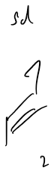

sir-troy.

↳is 95% confidence interval

Fist

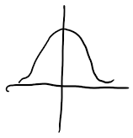

,"

i,

Er

C:\8993CCC5\36AF9CA1-F8A0-4352-A411-30AB114C7F1E_files\image084.png

look at Mike's

for examples,

notes