fmriprep
- fmriprep relies on FreeSurfer, open-source software for structural MRI image processing, to do its anatomical brain reconstructions. This requires a free FreeSurfer license which you can get here. You will need to register using a valid email to which the license will then be sent. After receiving the license file, save it in the same directory where you want all your fmriprep-related output to live. This step is fairly quick, so do not let it discourage you from using fmriprep.
- Use the following command to run fmriprep using Docker.
pip install --user --upgrade fmriprep-docker
- Now we are ready to get our fmriprep hands on the data. All you need is just one command (that takes at least 4-5 hours to execute).

fmriprep-docker /Users/gelanatostaeva/Desktop/sub_1 /Users/gelanatostaeva/Desktop/sub_1/output participant --participant-label 01 --fs-license-file /Users/gelanatostaeva/Desktop/sub_1/license.txt
In this command, we call fmriprep-docker, then provide the path to our single-subject data /Users/gelanatostaeve/Desktop/sub_1, followed by the path to where we want the output to be stored /Users/gelanatostaeve/Desktop/sub_1/output. The keyword participant is there to indicate the level of analysis we want; we also specify which participant we want: --participant-label 01. Finally, we have to point to the FreeSurfer license file by entering its path: --fs-license-file /Users/gelanatostaeve/Desktop/sub_1/license.txt
4. Wait for fmriprep to finish running to see this output. Patience is key here.
Press enter or click to view image in full size
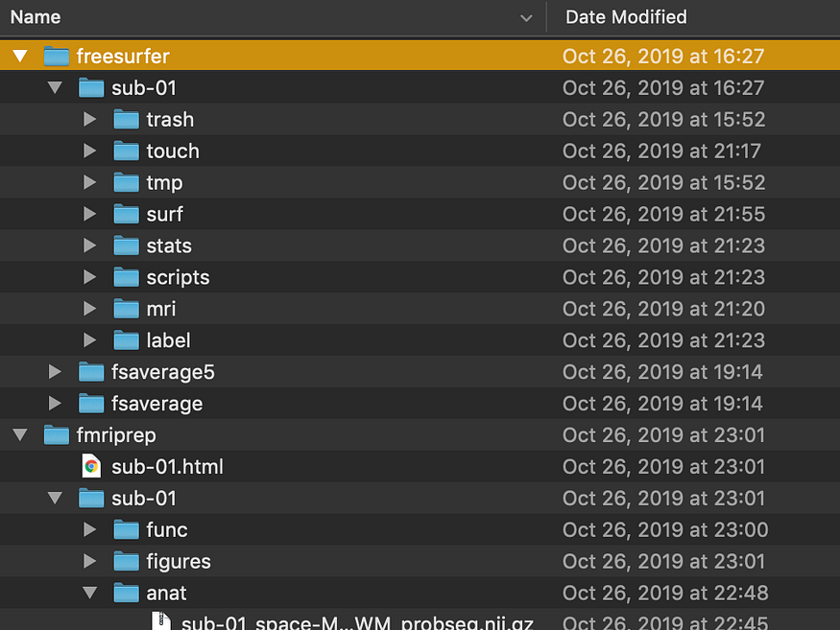
fmriprep-docker output for subject 1.

You faced a couple of hurdles which we summarize below:
- you have Docker, fmriprep, and Python installed and run the pip install command for fmriprep-docker, yet your computer is telling you fmriprep-docker command is not found.
This is probably a PATH problem, not you. First, figure out what the path Docker is in:
which fmriprep-docker
You could also try this other command. Don’t worry: the “yes n” part of this command ensures it will not delete fmriprep-docker:
yes n | pip uninstall fmriprep-docker | grep bin
Now that you know the path it should be in, you should change your PATH to include it. You can do so by running:
export PATH=$PATH: /….echo $PATH
For example, which fmriprep-docker yields /Users/gelanatostaeva/.local/bin//fmriprep-docker. The following command should then fix the problem:
export PATH=$PATH:/Users/gelanatostaeva/.local/bin/
2. fmriprep-docker is running but exits with memory errors

If you are running into memory issues, you might want to consider increasing memory resources available to Docker. Go to the Desktop app -> Preferences -> Advanced, set the maximum limit to 8 GiB and make sure to press Apply & Restart.
Note that this will slow down your computer significantly which might or might not be a good excuse to avoid all other work.
3. fmriprep-docker is running but exits with errors about something named BIDS.
BIDS is a simple way of organizing neuroimaging data designed to maximize adoption. This is what it looks like:
Press enter or click to view image in full size
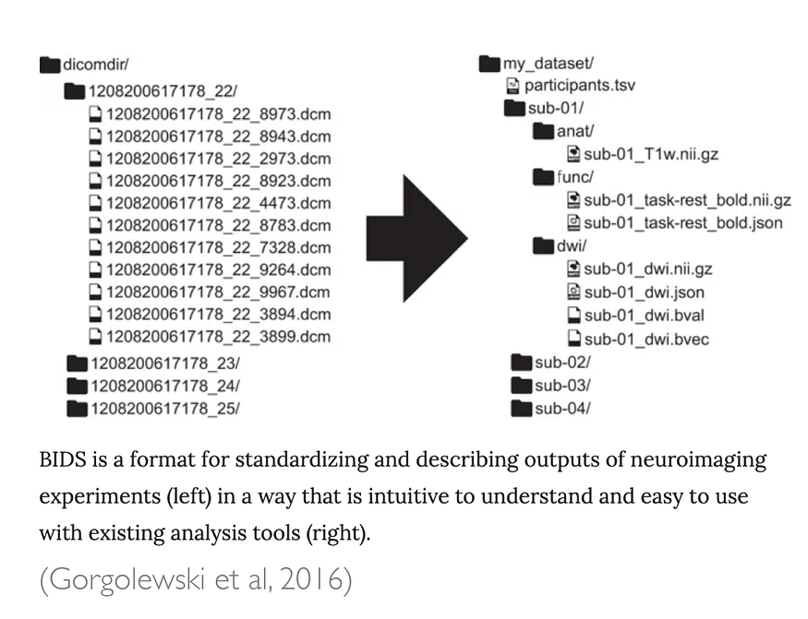
Hopefully, you have fmriprep-docker running now. If you are still experiencing issues not covered here, consider giving Google search a try. For the purposes of this guide, we will now move on to the next big step — making sense of the output and doing some basic analysis.

fMRIPrep Command Structure
The general structure is:
fmriprep <BIDS_dataset> <output_dir> <analysis_level> [options...]
Example:
fmriprep /data/bids /data/derivatives participant --participant-label sub-01 --fs-license-file /opt/freesurfer/license.txt

🧩 1. Positional Arguments
Argument | Description | Example
<BIDS_dataset> | Path to your input dataset in BIDS format | /data/bids
<output_dir> | Path where derivatives (outputs) will be stored | /data/derivatives
<analysis_level> | Either participant (default) or group | participant

🧩 2. Participant Selection
Argument | Description | Example
--participant-label | Run preprocessing for specific subjects only | --participant-label sub-01 sub-02
--session-id | Preprocess a specific session | --session-id ses-1
--task-id | Restrict to specific fMRI tasks | --task-id rest

🧩 3. Output and Working Directory Options
Argument | Description | Example
--output-spaces | Define spatial output spaces | --output-spaces MNI152NLin2009cAsym T1w
--work-dir | Directory for temporary/intermediate files | --work-dir /scratch/fmriprep
--fs-subjects-dir | Custom FreeSurfer subjects directory | --fs-subjects-dir /data/freesurfer
--output-layout | BIDS or legacy output layout | --output-layout bids

🧩 4. FreeSurfer & Anatomical Settings
Argument | Description | Example
--fs-license-file | Path to FreeSurfer license file | --fs-license-file /opt/freesurfer/license.txt
--no-submm-recon | Disable submillimeter recon-all | --no-submm-recon
--no-freesurfer | Skip FreeSurfer surface reconstruction | --no-freesurfer
--anat-only | Only preprocess anatomical data | --anat-only

🧩 5. Functional MRI (fMRI) Processing Options
Argument | Description | Example
--bold2t1w-init | Registration method (header or register) | --bold2t1w-init register
--bold2t1w-dof | Degrees of freedom for BOLD-to-T1w registration | --bold2t1w-dof 9
--dummy-scans | Number of volumes to discard at start | --dummy-scans 5
--use-aroma | Enable ICA-AROMA denoising | --use-aroma
--ignore | Skip specific modalities | --ignore fieldmaps sbref
--cifti-output | Generate CIFTI outputs | --cifti-output 91k

🧩 6. Fieldmap and Susceptibility Distortion Correction
Argument | Description | Example
--use-syn-sdc | Use SyN-based distortion correction (no fieldmaps) | --use-syn-sdc
--force-syn | Force use of SyN even if fieldmaps exist | --force-syn
--ignore fieldmaps | Ignore fieldmap correction entirely | --ignore fieldmaps

🧩 7. Parallelization and Resource Management
Argument | Description | Example
--nthreads | Number of threads per process | --nthreads 8
--omp-nthreads | Threads for OpenMP parallelization | --omp-nthreads 4
--mem-mb | Memory limit in MB | --mem-mb 16000
--low-mem | Use memory-saving mode | --low-mem
--notrack | Disable usage tracking | --notrack

🧩 8. Reporting & Debugging Options
Argument | Description | Example
--reportlets-only | Only generate reports (no processing) | --reportlets-only
--skip-bids-validation | Skip BIDS format validation | --skip-bids-validation
--write-graph | Output workflow graph | --write-graph
--stop-on-first-crash | Stop processing on first error | --stop-on-first-crash
--resource-monitor | Track CPU/memory usage | --resource-monitor
--verbose | Increase verbosity | --verbose

🧩 9. Docker / Singularity Example Usage
When using Docker:
docker run -ti --rm \
-v /data/bids:/data:ro \
-v /data/derivatives:/out \
-v /opt/freesurfer/license.txt:/opt/freesurfer/license.txt:ro \
nipreps/fmriprep:latest \
/data /out participant \
--participant-label 01 \
--fs-license-file /opt/freesurfer/license.txt \
--nthreads 8 --mem-mb 16000 --output-spaces MNI152NLin2009cAsym T1w

🧩 10. Full Example Command
fmriprep /data/bids /data/derivatives participant \
--participant-label sub-01 \
--fs-license-file /opt/freesurfer/license.txt \
--output-spaces T1w fsaverage MNI152NLin6Asym \
--nthreads 8 --omp-nthreads 4 --mem-mb 16000 \
--use-aroma --use-syn-sdc \
--work-dir /scratch/fmriprep \
--write-graph --notrack

