Installation GuideLines

BIDS Specification Guidelines:
In order to convert to BIDS format, we need to follow the BIDS specifications guidelines that clearly document the formatting rules.
- Go to: https://bids-specification.readthedocs.io/en/stable/.
- Click on the embedded link on the page: downloaded as PDF (or go straight to https://zenodo.org/record/6094534#.Yp6OEOzMK3I).
- Download the BIDS Specification Guidelines

BIDS Conversion:
Here's a brief set of instructions to convert to BIDS format.

MRICroGL Installation:
First things first, you need MRICroGL to be able to begin converting your data to BIDS. MRICroGL converts DICOM files to Nifti files and produces an accompanying JSON file.
To download MRICroGL: https://www.nitrc.org/projects/mricrogl/
Reminder: Make sure the version you are downloading is for your specific system.
Note: You may need to create an account to download.

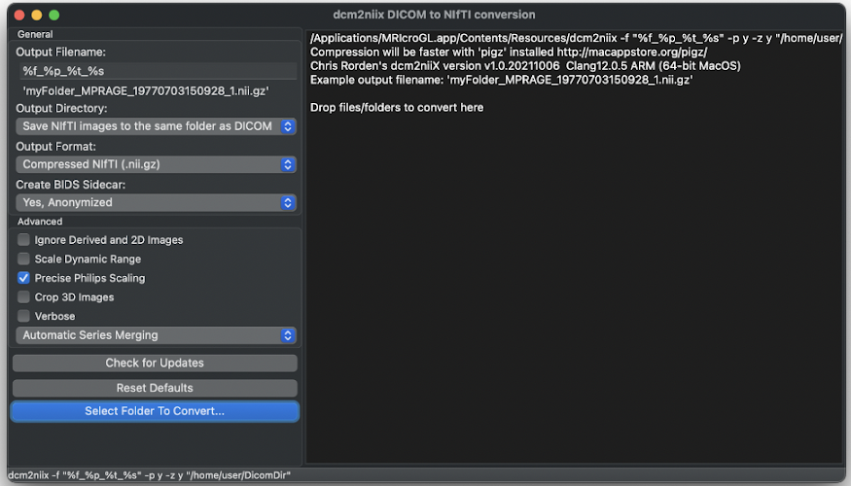

- Under Output Directory: Change the location to where you wish your converted files to go.
- Under Create BIDS Sidecar: Make sure the option is set to ‘Yes, Anonymized’
- Drag and drop files/folders that you wish to convert (should be all of the folders in the data set which have DICOM data).
- Optional: You may delete the DICOM data if you feel you have no need for it.

BIDS Conversion:
- Create a folder for your data (typically with the BIDS label somewhere in the title).
- Create description_dataset.json file using https://jsoneditoronline.org/#right=local.hevino, according to the BIDS Specification guidelines.
- Create a folder hierarchy based on the BIDS Specification guidelines.
- Files should then be renamed according to the BIDS Specification guidelines and the folder hierarchy they are under.
- Utilize the BIDS Validator () to check for errors and fix them accordingly to ensure that the BIDS format is strictly upheld.

Note: this is not a thorough explanation of BIDS conversion, as the guidelines (located here: https://bids-specification.readthedocs.io/en/stable) provide a far more thorough explanation for general formatting and specific cases as well).
- docker run hello-world (should give a message from docker tutorial page itself)
- Close and reopen docker to see hello-world under “images”
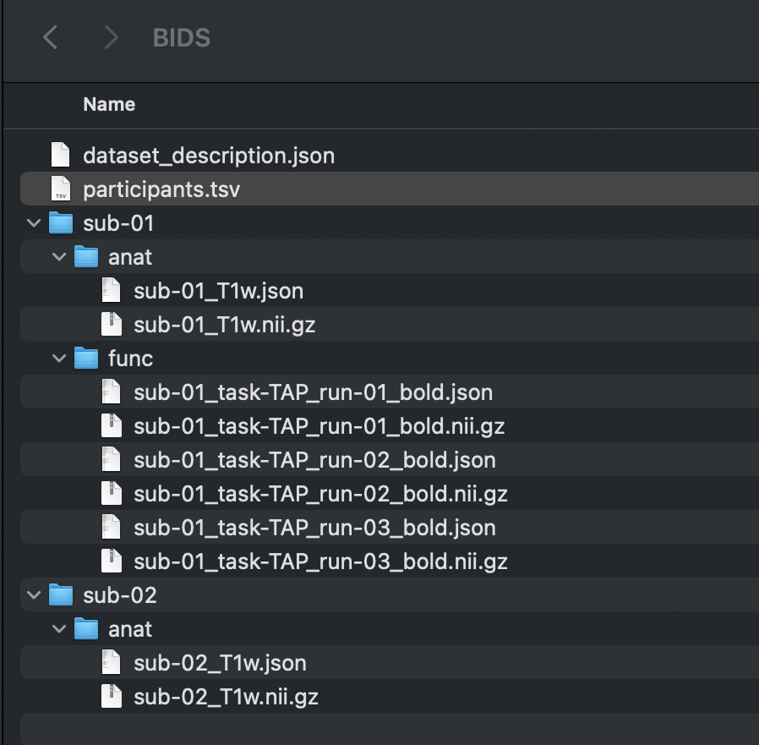

Docker-Interactive Installation
Docker-Interactive Installation
(https://www.youtube.com/watch?v=MU8HUVlJTEY&t=611s):
- Install Docker (enter any passwords asked, etc.) (Choose download for respective processing system: https://docs.docker.com/desktop/mac/install/)
  - The link also has a command line method to install docker if so preferred
- Should see the Docker icon at the top of the screen (upper right)
- Next Validate Install:
  - Click on icon and should see a Docker Desktop is running message
  - In Terminal or Command Prompt:
    - docker (command should give you features of docker)
    - docker run hello-world (should give a message from docker tutorial page itself)
    - Close and reopen docker to see hello-world under “images”

fMRIPrep Installation
fMRIPrep Installation
(https://andysbrainbook.readthedocs.io/en/latest/OpenScience/OS/fMRIPrep.html#fmriprep-installation-option-2-docker)
- which pip
  - If pip not installed: for installation steps, go to https://andysbrainbook.readthedocs.io/en/latest/OpenScience/OS/BIDS_Overview.html
- python3 -m pip install fmriprep-docker
  - When you run it again, it should just list the file path that fmriprep-docker is in
- echo ‘export PATH=$PATH:/path of where fmriprep-docker is located' >> ~/.bash_profile
  - Such as:
echo ‘export PATH=$PATH:/Users/mkayitha/.local/lib/Python3.9/site-packages’ >> ~/.bash_profile
- source ~/.bash_profile

FreeSurfer License:
Get a (free) FreeSurfer License (https://surfer.nmr.mgh.harvard.edu/registration.html) in order to be able to use FreeSurfer tools when running fMRIPrep.
Note: You do not necessarily need to fill in all of the information in order to get the license, but preferably as much as possible.
Note: Save the license and note down the path for later.

fMRIPrep Preprocessing Basic Script:
(https://andysbrainbook.readthedocs.io/en/latest/OpenScience/OS/fMRIPrep.html#frmiprep):

#!/bin/bash
#User inputs:
bids_root_dir=$HOME/BIDS_fMRIPrep/BIDS
subj=01
nthreads=4
mem=20 #gb
container=docker #docker or singularity

#Begin:
#Convert virtual memory from gb to mb
mem=`echo "${mem//[!0-9]/}"` #remove gb at end
mem_mb=`echo $(((mem*1000)-5000))` #reduce some memory for buffer space during pre-processing
export TEMPLATEFLOW_HOME=$HOME/.cache/templateflow
export FS_LICENSE=$HOME/BIDS_fMRIPrep/derivatives/license.txt

#Run fmriprep
if [ $container == singularity ]; then
unset PYTHONPATH; singularity run -B $HOME/.cache/templateflow:/opt/templateflow $HOME/fmriprep.simg \
$bids_root_dir $bids_root_dir/derivatives \
participant \
--participant-label $subj \
--skip-bids-validation \
--md-only-boilerplate \
--fs-license-file $FREESURFER_HOME/license.txt \
--fs-no-reconall \
--output-spaces MNI152NLin2009cAsym:res-2 \
--nthreads $nthreads \
--stop-on-first-crash \
--mem_mb $mem_mb \
-w $HOME
else
fmriprep-docker $bids_root_dir $bids_root_dir/derivatives \
participant \
--participant-label $subj \
--skip-bids-validation \
--md-only-boilerplate \
--fs-license-file $HOME/BIDS_fMRIPrep/BIDS/derivatives/license.txt \
--fs-no-reconall \
--output-spaces MNI152NLin2009cAsym:res-2 \
--nthreads $nthreads \
--stop-on-first-crash \
--mem_mb $mem_mb \
-w $HOME
fi
*Note: This code was obtained from Andy's Brain Book (https://andysbrainbook.readthedocs.io/en/latest/OpenScience/OS/fMRIPrep_Demo_2_RunningAnalysis.html) and only slightly modified based on potential user preferences, as a base script to utilize to start preprocessing. The script will complete standard preprocessing steps including coregistration, normalization, and physiological component extraction.

fMRIPrep Preprocessing Steps:
The method to run the script is relatively simple, with only a few minor tweaks to the script as detailed in the proceeding steps:
Folder Hierarchy:
First, create a folder hierarchy system to organize all data.
- Create the main folder for all the related data and preprocessing data to go into.
- Create a subfolder for the code named ‘code’ (for simplicity).
- Move the BIDS organized data to the folder.
- Create a subfolder titled ‘derivatives’ in the BIDS folder system.
The folder should look similar to this:

FreeSurfer License:
Now, to move the FreeSurfer license to the ‘derivatives’ folder
- First identify the path of your FreeSurfer license (you should have noted it down).
- Next, open your Terminal or Command Prompt.
- Ensure you are in the bash shell (change to bash shell if required).
- Enter the following command prompts to move the license to the created ‘derivative’ folder
mv [path-of-license-file] [path-of-derivatives-folder]
- Note: Where it says [path-of-license-file], input the path of the license file.
Note: Where it says [path-of-derivatives-folder], input the path of the ‘derivatives’ folder where you want the FreeSurfer license file to be located
(such as: mv ~/Downloads/license.txt ~/Desktop/BIDS_fMRIPrep/BIDS/derivatives)
Create and Edit Script File:
- Enter the following command prompts to create and edit the file for the script.
- touch [path-for-code-folder]/fmriprep.sh
Note: Where it says [path-for-code-folder], input the path of the ‘code’ folder where you want the fmriprep.sh script to be located (such as: touch $HOME/Desktop/BIDS_fMRIPrep/code/fmriprep.sh).
- vim [path-for-fmriprep.sh]
Note: Where it says [path-for-fmriprep.sh], input the fmriprep.sh path (such as: vim $HOME/BIDS_fMRIPrep/code/fmriprep.sh).
- You have now opened up the fmriprep.sh file to be edited.
- Press ‘i’.
- Paste the script into the file.
- Where it says bids_root_dir under the block of code commented #User inputs: , set the variable to the path of the folder system for where you want your data to go to (for ex: $HOME/BIDS_fMRIPRep/BIDS)
- Where it says fs-license-file under the Docker if-else block of code, input the FreeSurfer license path (such as: $HOME/BIDS_fMRIPRep/BIDS/derivatives/license.txt)
- Press ‘esc’.
- Type ‘:wq’ to save and exit the file.
- In the command line, type cat [path-for-fmriprep.sh] (such as: cat $HOME/BIDS_fMRIPrep/code/fmriprep.sh)
Note: You now should have the fmriprep.sh file in your derivatives folder. You may edit this file and change the code to add more specific parameters or processing steps or change the container. You may change the subj variable depending on which subject you wish to process.
Run the Script:
Enter bash fmriprep.sh in the command line to run the script.

fMRIPrep Preprocessing Without Script:
Note: This command was derived from Stanford Center for Reproducible Neuroscience at https://reproducibility.stanford.edu/fmriprep-tutorial-running-the-docker-image/.
- Enter fmriprep-docker [path-to-BIDS-data-folder] [path-to-derivatives-folder] participant --participant-label [participant label w/out ‘sub’ prefix] --fs-license-file [path-to-FreeSurfer-license-file]

Such as: fmriprep-docker ~/Desktop/BIDS_fMRIPrep/BIDS ~/Desktop/BIDS_fMRIPrep/BID/derivatives participant --participant-label 01 --fs-license-file ~/Desktop/BIDS_fMRIPrep/BIDS/derivatives/license.txt
You may add additional arguments after the input, output, and analysis levels
(https://fmriprep.org/en/stable/usage.html#command-line-arguments).

EXAMPLE ON WINDOWS POWERSHELL
fmriprep-docker C:\Users\Azam\Desktop\BIDS_Dataset [INPUT PATH]
C:\Users\Azam\Desktop\BIDS_Dataset\output [OUTPUT PATH]
participant --participant-label 01
--fs-license-file C:\Users\Azam\Desktop\freesurfer_license\license.txt [FREESURFER LICENSE FILE PATH]
[NOTE: FREESURFER LICENSE FILE NOT LOCATED IN BIDS_DATASET FOLDER]

Heudiconv is packaged and available from many different sources.

Local
Released versions of HeuDiConv are available on PyPI and conda. If installing through PyPI, eg:
pip install heudiconv[all]
Manual installation of dcm2niix is required. You can also benefit from an installer/downloader helper dcm2niix package on PyPI, so you can simply pip install dcm2niix if you are installing in user space so subsequently it would be able to download and install dcm2niix binary.

Containers
Our container image releases are available on our Docker Hub
If Docker is available on your system, you can pull the latest release:
$ docker pull nipy/heudiconv:latest

Additionally, HeuDiConv is available through the Docker image at repronim/reproin provided by ReproIn heuristic project, which develops the reproin heuristic.

Basic Conversion
Next we will use heudiconv convert DICOMS into the BIDS data structure. The example dataset includes an example heuristic file, heuristic1.py. Typical use of heudiconv will require the creation and editing of your heuristics file, which we will cover in a later tutorial.
Note
Heudiconv requires you to run the command from the parent directory of both the Dicom and Nifti directories, which is MRIS in our case.
Run the following command:
heudiconv --files dicom/219/itbs/*/*.dcm -o Nifti -f Nifti/code/heuristic1.py -s 219 -ss itbs -c dcm2niix -b --minmeta --overwrite
- We specify the dicom files to convert with –files
- The heuristic file is provided with the -f option
- We tell heudiconv to place our output in the Nifti dir with -o
- -b indicates that we want to output in BIDS format
- –minmeta guarantees that meta-information in the dcms does not get inserted into the JSON sidecar. This is good because the information is not needed but can overflow the JSON file causing some BIDS apps to crash.

Output
The Nifti directory will contain a bids-compliant subject directory:
└── sub-219
└── ses-itbs
├── anat
├── dwi
├── fmap
└── func
The following required BIDS text files are also created in the Nifti directory. Details for filling in these skeleton text files can be found under tabular files in the BIDS specification:

IMPORTANT URL LINKS
https://bids-specification.readthedocs.io/en/stable/common-principles.html#tabular-files
https://heudiconv.readthedocs.io/en/latest/reproin.html#output-directory-structure
https://bids.neuroimaging.io/tools/converters.html
https://github.com/bids-standard/bids-examples/tree/bd8a95100a66e0b57498fda905da3f048d76f608
https://bids-website.readthedocs.io/en/latest/datasets/examples.html

