Sample report

Visit review
Every recipe in the Word template, filled with example numbers

1. Summary
This sample shows each part of the Neuromine Word template. The numbers are made up for the example and come from no release.

Counts by site
The table compares two example sites across two visits.
Site | Screening | Month 3 | Change
Site A | 120 | 108 | -10%
Site B | 95 | 91 | -4%
Both sites | 215 | 199 | -7%
Table 1. Example visit counts by site. Source: example numbers, not release data.

What the table shows
- Both sites kept most participants to month 3.
- Site B lost fewer participants than Site A.
To repeat the table for a real release, follow these steps.
- Take the counts from the release index.
- Name the release in the caption.
- Run the checker on the file.
Key point. Every number in a real document comes from a named release.

2. Trend
Visits at both example sites rose through the first half of the year.
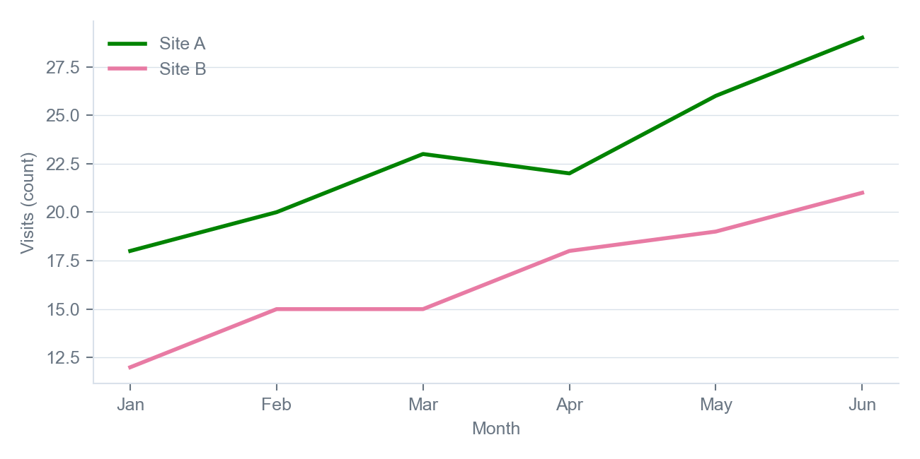
Figure 1. Example visits by month. Source: example numbers, not release data.

