**VIN1** represents the input voltage(1V constant for all the 5000 points)

**Vspike** is the spike generator output

**Vmem** is the output of the hidden state (Voltage across the **CMEM** capacitor)

There are 8 components to be learned and trained:

Because

1. All the transistors length L and W are kept equal and can be varied equally (Due to the reason that the transistor will go out of the operation region and do not generate spikes but a constant voltage).

2. w2 = w3 should be equal and higher than W.(2000u to 3000u)

w2>W

3. All resistors and capacitors are varying.

Here is a sample schematic:

**'CK'**

**'CMEM’**

**'rw1'**

**'Rinv'**

**'RKUP2'**

**'w2'**

**'L'**

**'W'**

Note: The first column in the csv files denote X value(time(s)) second column denotes Y value (Vspike/ Vmem)(V) and so on (alternate columns are X vs Y).

So the X values are repetition in each alternate column

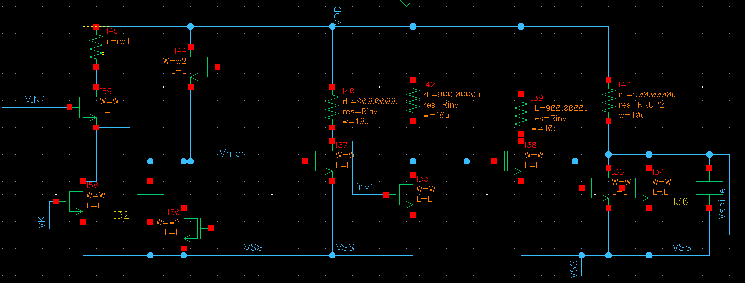

Vspike

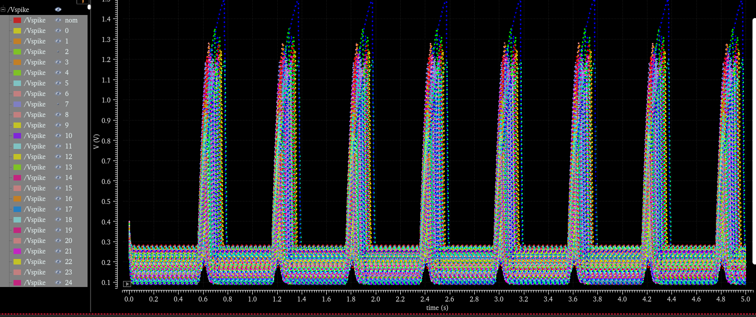

Vmem(Hidden State)

