Exploring the Action Potential

You have just learned how the neuron generates action potentials through ion concentration gradients, ion-selective channels, voltage gating, and inactivation. Now we will use a real neuron simulation on [NeuronBench](https://neuronbench.com) to experiment with these concepts and get deeper intuition about each channel and how its properties impact the ability of a neuron to generate action potentials.

# Section 1. A Simulated Neuron

2

Follow these steps to create your first neuron.

1. Create an account using your gmail login, by going to https://neuronbench.com in a new tab, clicking Create Account, and choosing a unique username. Your username does not need to match your google username. Your NeuronBench username will be used for locating your files.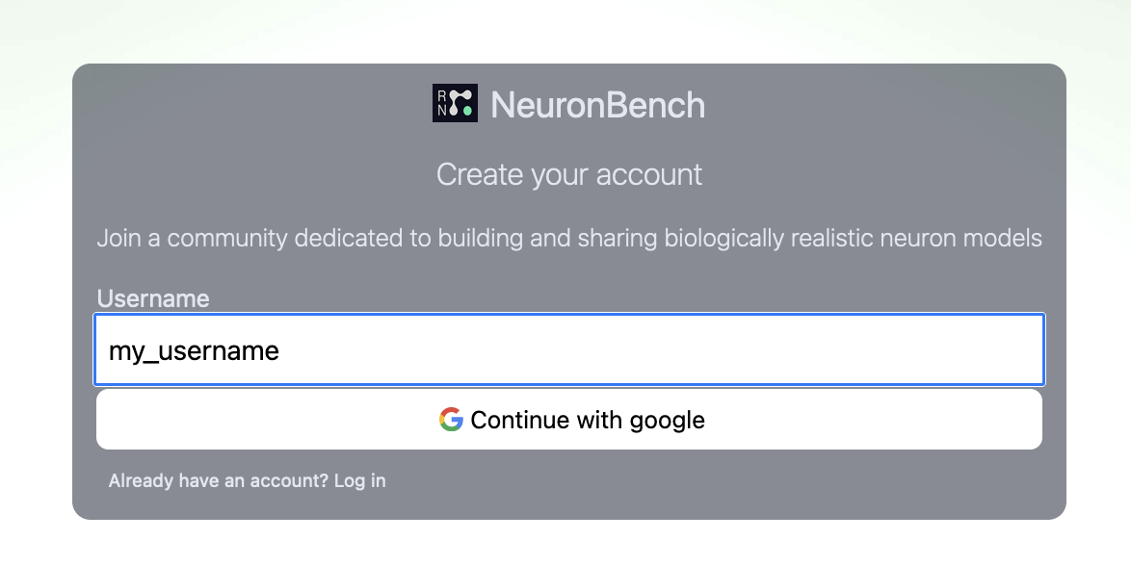

1

3

1. Click "New project", and choose a project name. You will be taken to the project page.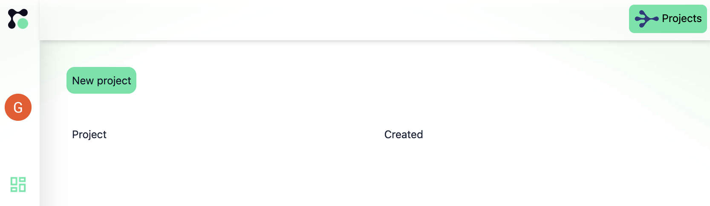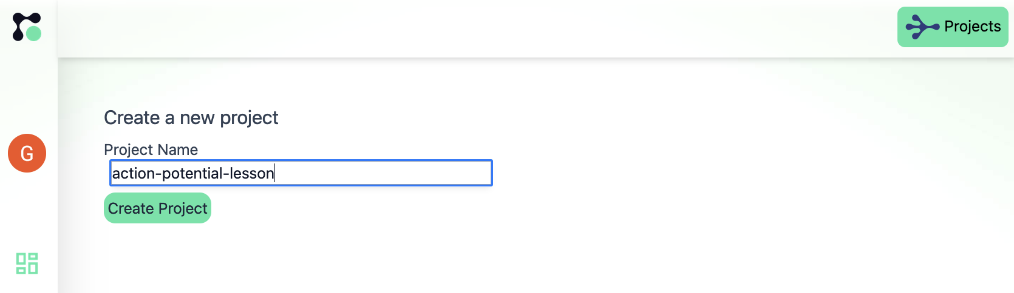

4

5

6

1. Click "New Scene", and name the file scene. The "Prepopulate with example" checkbox can remain blank.  
   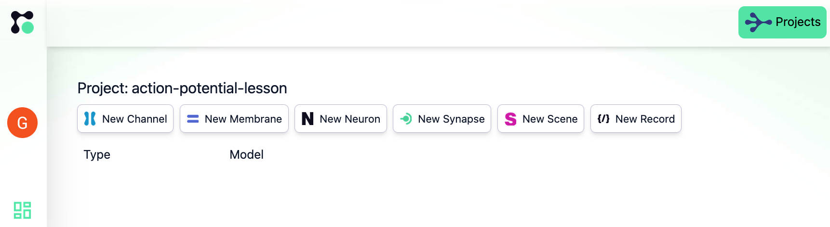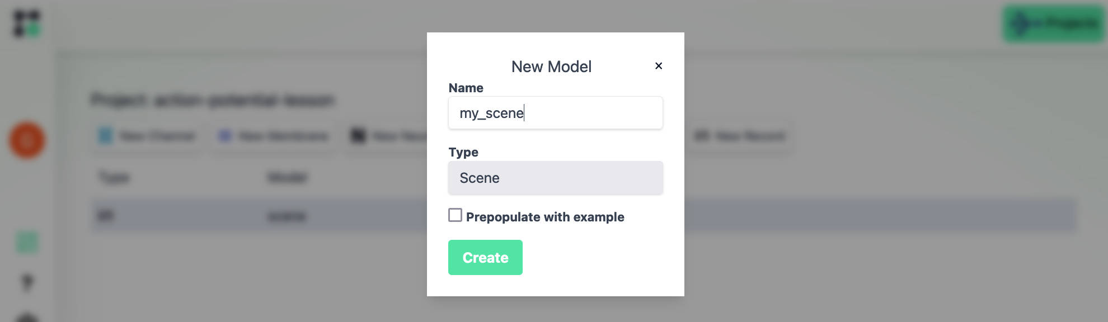
2. You will be taken to the neuron configuration editor. Paste the following code into the editor (if you are working from a printout, you can more easily copy-paste the sources from <https://docs.neuronbench.com/blog/exploring_the_action_potential.pdf> ):

let channels = https://neuronbench.com/imalsogreg/docs-demo/channels.ffg

let buildScene = https://neuronbench.com/imalsogreg/lesson-0000-understanding-the-action-potential/buildScene

7

87

9

10

let membrane = Membrane {

capacitance_farads_per_square_cm: 2.0e-6,

membrane_channels: [

{ channel: channels.giant_squid.na , siemens_per_square_cm: 120.0e-3 },

{ channel: channels.giant_squid.leak , siemens_per_square_cm: 0.3e-3 },

{ channel: channels.giant_squid.k , siemens_per_square_cm: 36.0e-3 }

]

}

in

buildScene membrane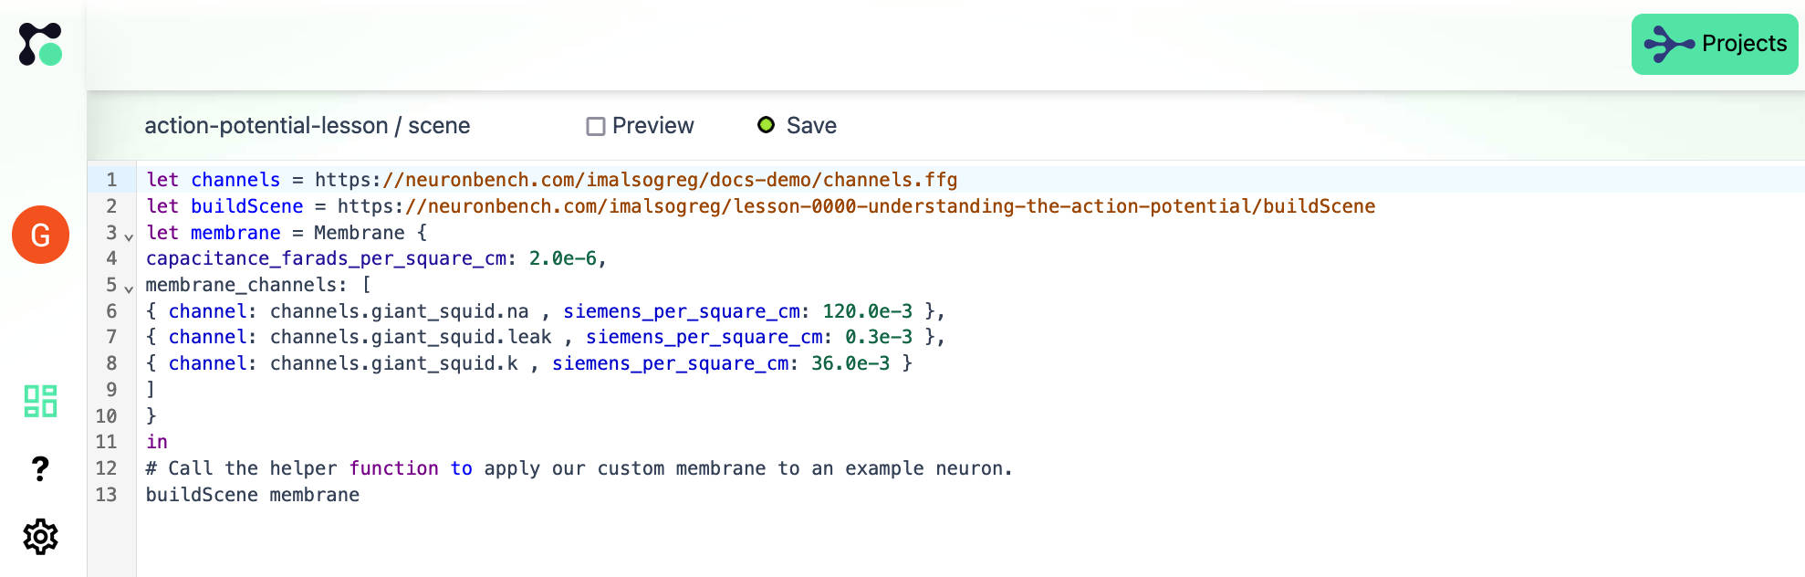

1. Click **Save** and then check **Preview**. Congratulations, you should see your first neuron!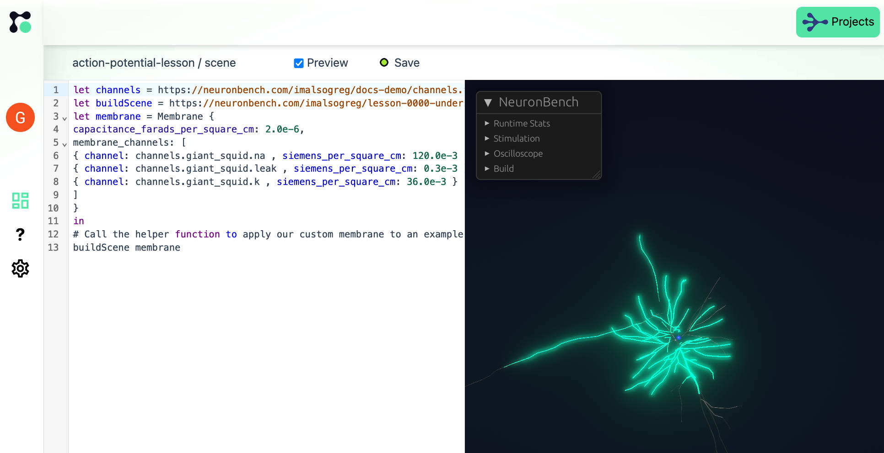  
     
   The small sphere is a stimulator injecting current into the neuron once every few seconds. The segments of the neuron flash green to indicate their increased membrane voltage and return to grey at resting membrane potential.
2. Add an oscilloscope trace - we will need these later in the lesson. Click the **Oscilloscope** dropdown under the NeuronBench menu, and click **1** to activate the first channel. Then click exactly on one of the neuron segments. You may need to zoom in on the neuron (mouse-wheel or two-finger vertical swipe) to make it big enough to easily click.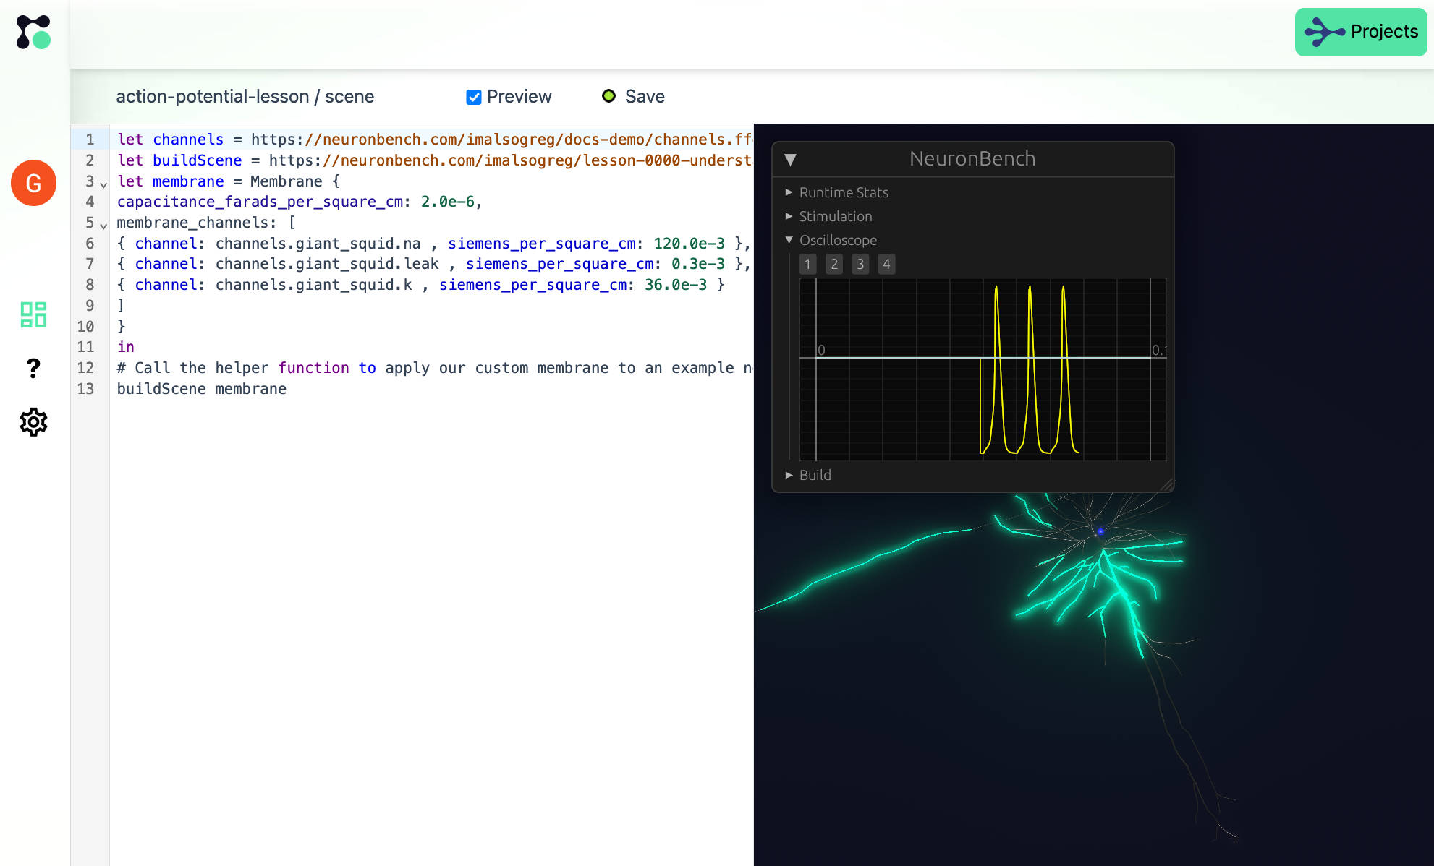

11

12

13

14

### Exercise 1: Channel knockouts

The code snippet gives access to the three ion channels used to define this neuron. Remove one channel at a time by deleting or commenting out the configuration line for that channel. For example, to remove the leak channel, prepend the leak channel line with a # like this:

membrane_channels: [

{ channel: channels.giant_squid.na , siemens_per_square_cm: 120.0e-3 },

# { channel: channels.giant_squid.leak , siemens_per_square_cm: 0.3e-3 },

{ channel: channels.giant_squid.k , siemens_per_square_cm: 36.0e-3 }

]

The # character is used to comment out a line in NeuronBench.

Hitting Save will reload the simulation and restart it.

**Describe the changes to the neuron’s response to current pulses, in the absence of either Na+, K+ or leak channel currents.**

### Exercise 2: The effect of leak currents

The peak conductance of each channel is specified in the siemens_per_square_cm field. siemens is the inverse of Ohms (the physisical unit of electrical resistance), so a higher siemens value means higher peak current.

**Leaving other channels the same, what is the highest leak current that continues to allow the whole neuron to spike?**

**Describe the spatial extent of the action potential, at leak currents just below the threshold where spikes are no longer occurring.**

### Exercise 3: Drawing the action potential waveform

We previously focused on the neuron's color to assess the spatial extent of an action potential. Now we will use a virtual oscilloscope to focus on the voltage dynamics of a single segment.

First, reset the neuron's membrane channels to their original values and hit "Save".

Now in the NeuronBench menu within the Preview, click "Oscilloscope", then click the 1 button, and then immediately click somewhere on the neuron. You should see a yellow trace begin to form on the oscilloscope viewport. If not, try zooming in on the neuron, click 1, and click the neuron again.

**Draw the graph of a single action potential. Label the minimum and maximum membrane potential reached by that segment. Indicate the width at half max (the time difference between when the neuron has gotten half way to its peak voltage and when it has returned half way to its baseline voltage).**

## Section 2: Channel properties

Now we will recap what you learned about the specific properties of these ion channels by experimenting with their low-level properties.

Specifically, we will take a close look at the voltage gating of the activation and inactivation components of the Na+ channel, as well as the time constant of the delayed rectifier K+ channel.

Start by copying this configuration file in to your open configuration file:

let channels = {

k: Channel {

ion_selectivity: { k: 1.0, na: 0.0, cl: 0.0, ca: 0.0 },

activation: {

gates: 4,

magnitude: {v_at_half_max_mv: -53.0, slope: 15.0},

time_constant: Gaussian

{ v_at_max_tau_mv: -79.0,

c_base: 1.1e-3,

c_amp: 4.7e-3,

sigma: 50.0

}

},

inactivation: null,

},

na: Channel {

ion_selectivity: { k: 0.0, na: 1.0, cl: 0.0, ca: 0.0 },

activation: {

gates: 3,

magnitude: {v_at_half_max_mv: -40.0, slope: 15.0},

time_constant: Gaussian

{ v_at_max_tau_mv: -38.0,

c_base: 0.04e-3,

c_amp: 0.46e-3,

sigma: 30.0

}

},

inactivation: {

gates: 1,

magnitude: {v_at_half_max_mv: -62.0, slope: -7.0},

time_constant: Gaussian

{ v_at_max_tau_mv: -67.0,

c_base: 1.2e-3,

c_amp: 7.4e-3,

sigma: 20.0

}

}

},

leak: Channel {

ion_selectivity: { k: 0.0, na: 0.0, cl: 1.0, ca: 0.0 },

activation: null,

inactivation: null,

}

}

let buildScene = https://neuronbench.com/imalsogreg/lesson-0000-understanding-the-action-potential/buildScene

let membrane = Membrane {

capacitance_farads_per_square_cm: 2.0e-6,

membrane_channels: [

{ channel: channels.na , siemens_per_square_cm: 120.0e-3 },

{ channel: channels.leak , siemens_per_square_cm: 0.3e-3 },

{ channel: channels.k , siemens_per_square_cm: 36.0e-3 }

]

}

in

buildScene membrane

This configuration differs from the one we used earlier. It defines its own ion channels, rather than importing standard ones. This way we can play with the ion channel properties and observe the results.

The last channel, leak, is the easiest to understand: is is defined as as channel that is selectively permeable to chloride ions and has no activation or inactivation dynamics.

Depending on the level of detail of your course, the specification of the channels k and na might be more complicated, or at least different, from what you expected. Let's zoom in on k:

k: Channel {

ion_selectivity: { k: 1.0, na: 0.0, cl: 0.0, ca: 0.0 },

activation: {

gates: 4,

magnitude: {v_at_half_max_mv: -53.0, slope: 15.0},

time_constant: Gaussian

{ v_at_max_tau_mv: -79.0,

c_base: 1.1e-3,

c_amp: 4.7e-3,

sigma: 50.0

}

},

inactivation: null,

},

You can find a detailed description of every field in the [Channel](https://docs.neuronbench.com/docs/modeling/core-modeling/%2523the-channel-constructor) documentation. But we can make some simplifying assumptions without sacrificing much accuracy:

* magnitude.v_at_half_max_mv: this is roughly the voltage gating level of this component of the channel.
* time_constant.c_base alone is the time-constant if you set time_constant.c_amp to 0. Otherwise the time constant is always somewhere between c_base and c_base + c_amp.

Using this simplification, we can see our K+ channel activates at -53 mV and the time constant is between 1e-3 and 5e-3.

### Exercise 4: Na+ Activation

Na+ channels in our configuration activate at -40 mv. Let us experiment with this voltage gating to determine how it impacts the sensitivity of the neuron to current pulses.

First we will raise the activation from -40 mV to some higher value.

**Will raising the activation voltage of the Na+ channel make the neuron more likely or less likely to spike? Why?**

**Find the highest voltage at which the neuron fires an action potential in response to the first current pulse (to an accuracy of 1 or 2 mV). Draw the action potential waveform you observe with this activation voltage. Draw the voltage waveform again after raising the activation voltage another 3 mV.**

Now test the opposite direction - change the activation voltage to -60 mV.

**Draw the resulting membrane potential trace. What range of membrane voltages are observed? Should this activity be considered an action potential? Why or why not?**

### Exercise 5: Spike squeezing and stretching

The width of the action potential is determined by how quickly the membrane potential returns to baseline after reaching its peak, which is determined in turn by:

* Activation of the K+ rectifier channels
* Inactivation of the Na+ channels

Set the Na+ channel inactivation time constant c_base and c_amp to 0.6e-3 and 4.0e-3 respectively, about half their normal value. Smaller time constants translate to faster changes in the channel gating.

**How does the action potential shape with reduced inactivation time_constant parameters compare to the original action potential shape, in terms of width and peak amplitude?**

**What happens to the action potential shape if we divide c_base and c_amp by 2 once again, to 0.3e-3 and 2e-3? Why does this happen?**

**Difficult: Changing the inactivation time constant c_base and c_amp to 0.3e-3 and 2.0e-3 had a deleterious effect on the action potential shape. In the previous question you hypothesized a mechanism for this. Based on that hypothesis, find some *other* parameter of either the Na+ channel or another channel you can change, to restore action potential propagation through the neuron. Describe your solution and why it works. Draw the resulting action potential.**