Line follower
The file in the “Student File” folder is distributed to participants.
At the start, ten weight values are set to 0. These values must be adjusted so that the robot can correctly follow the line.
The completed file is then copied into the main folder by replacing the existing file weights_students.c.
Connect the robot to the computer via USB and switch it on.
In a terminal opened in the “3pi-Line” folder, run:
make program
Press Enter to execute.
To upload the reference solution to the robot:
make program SOLUTION=1

Maze solver
The file in the “Student File” folder is distributed to participants.
The function must be completed using an if-else logic so that the robot correctly navigates the maze.
Rules:
- At corners, follow the wall and continue in the direction of the turn
- At junctions, use the markers (small black stripes behind the intersection) to decide the correct path
- At crossings, always continue straight
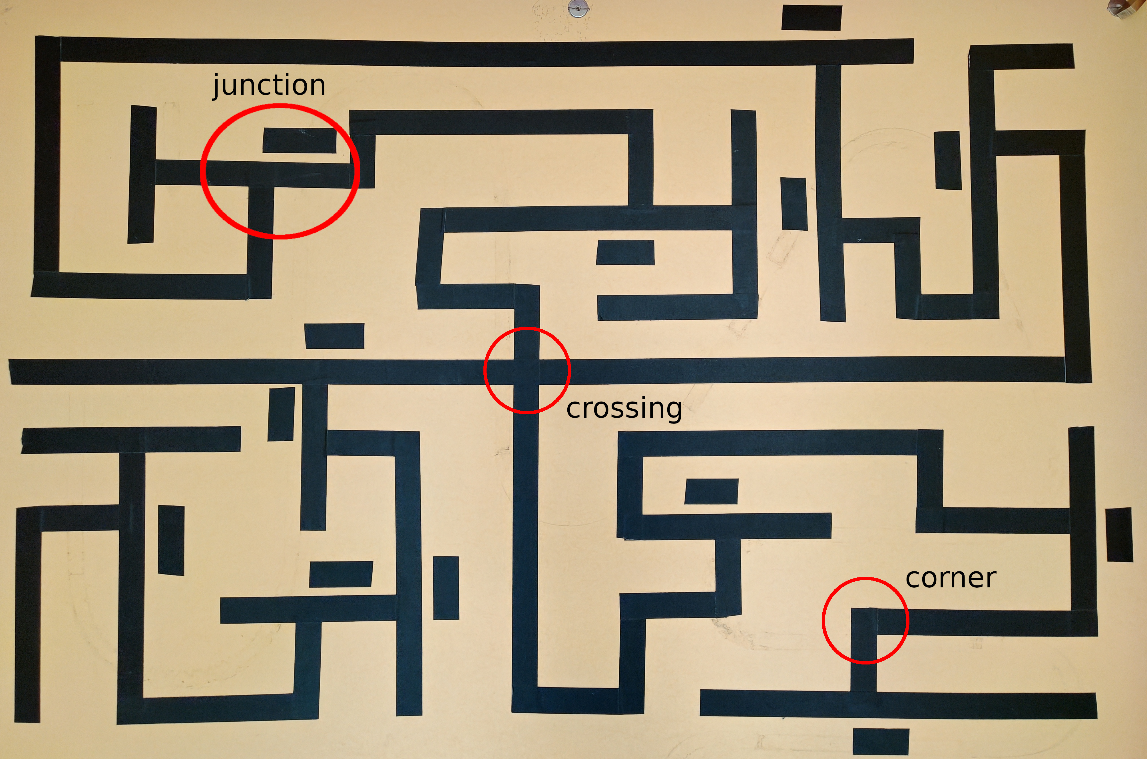
In the example, the robot moves from the bottom left to the bottom right through the maze.
The completed file is copied into the main folder by replacing logic_students.c.
Connect the robot to the computer via USB and switch it on.
In a terminal opened in the “3pi-Maze” folder, run:
make program
Press Enter to execute.
To load the reference solution:
make program SOLUTION=1

