FLEX-DBS: a flexible wireless platform for bilateral constant-current deep brain stimulation in freely moving rodents
Matt Gaidica^{1,*}, Robert D. Graham², Meaghan C. Creed²
¹Department of Neuroscience, Washington University School of Medicine, St. Louis, MO, USA
²Department of Anesthesiology, Washington University School of Medicine, St. Louis, MO, USA
*Corresponding author: Matt Gaidica, gaidica@wustl.edu
Running title: Wireless bilateral DBS for freely moving rodents

Abstract
Background: Preclinical deep brain stimulation (DBS) in rodents is central to understanding how DBS works, but most rodent DBS is delivered through a tether, which constrains behavior, home-cage experiments and uninterrupted stimulation. Existing wireless mouse stimulators achieve long implanted runtimes by setting stimulation parameters before or around implantation and operating from supplies of about 3 V.
New method: FLEX-DBS (Flexible Deep Brain Stimulation) is a head-mounted, battery-powered stimulator that delivers bilateral constant-current stimulation from improved Howland current pumps on ±5 V rails. Amplitude, pulse width and frequency are programmable in continuous and burst modes from an iOS application over Bluetooth Low Energy, and stimulation continues autonomously after the phone disconnects. The device measures 19.5 × 22.5 × 8.72 mm and runs on two size-13 zinc-air cells, which can be exchanged without handling the implant.
Results: Battery current was 1.47–1.89 mA in standby and 3.15–3.42 mA during stimulation at 60–400 µA, giving about three days of continuous stimulation per pair of cells. Implanted platinum electrodes presented 37–80 kΩ over five weeks in two mice, placing the maximum regulated current at roughly 60–120 µA. Analysis of the current-pump network bounds load-dependent current error at 4–8 % for these loads.
Comparison with existing methods: Mouse-scale wireless systems with runtimes of weeks draw roughly 8–22 µA from supplies of about 3 V and are configured before implantation or through a near-field or cable programmer, with a magnet to switch stimulation or presets. FLEX-DBS instead offers real-time phone control, bilateral constant-current output, burst mode and higher compliance, at the cost of runtime measured in days.
Conclusions: FLEX-DBS supports untethered, multiday DBS experiments in which parameters must be set, changed and verified at the cage. Electrode impedance, rather than the programmable range, sets the usable stimulation amplitude in vivo.
Keywords: deep brain stimulation; wireless stimulator; constant current; mouse; Bluetooth Low Energy; electrode impedance

1. Introduction
Deep brain stimulation (DBS) is a surgical therapy in which electrical current is delivered to discrete brain nuclei through implanted electrodes (Lozano et al., 2019). Although it is established primarily as a treatment for movement disorders, DBS is increasingly applied to psychiatric indications, chronic pain, neurodegenerative disorders and developmental disorders (Knotkova et al., 2021; Krauss et al., 2021; Lozano et al., 2019). Despite this growing adoption, the neural mechanisms underlying the therapeutic effects of DBS remain poorly understood, which limits both the rational optimization of stimulation parameters and patient selection (Murphy et al., 2021). Preclinical research in rodents therefore has an important role in determining the behavioral, circuit and synaptic mechanisms through which DBS acts (Creed, 2018; Creed et al., 2015).
Most systems for delivering preclinical DBS require the rodent to be physically tethered to an external pulse generator, which constrains experimental design in several ways. Tethering can be stressful, typically requires habituation before behavior normalizes, and restricts the animal’s movement. These consequences complicate or prevent behavioral assays that depend on unconstrained motor behavior, such as spontaneous pain behaviors, movement-disorder phenotypes and social interaction, and so limit the translational relevance of behavioral observations. Tethering is also difficult to implement in the home cage, so stimulation is usually delivered in dedicated apparatus such as open-field chambers, which can itself alter naturalistic behavior. Together with the cost of conventional stimulators, these constraints limit the throughput and statistical power of preclinical DBS studies.
Tethering also limits the timescales over which DBS can be studied. Clinically, DBS is delivered continuously for months to years, and its efficacy can wane over time for reasons that remain unclear (Fasano and Helmich, 2019). For several emerging indications, therapeutic effects develop over longer periods than the acute motor effects that dominate preclinical work. A wireless, battery-powered system for delivering sustained DBS in rodents would support mechanistic studies of why efficacy is lost with long-term stimulation and of indications in which therapeutic effects emerge slowly.
The few wireless rodent stimulators that exist were largely designed for chronic implantation. Most set the stimulation waveform and parameters before implantation or allow changes only through a near-field or cable programmer, which makes it difficult to change parameters during an experiment or to adjust them as the impedance of the electrode–tissue interface changes over the life of the implant. This is a critical limitation because stimulation parameters that produce a behavioral effect in one paradigm can be inert or even opposite in another, and the most informative preclinical studies have depended on varying frequency, amplitude and target within an experiment (Murphy et al., 2021). Low-frequency stimulation of the nucleus accumbens combined with pharmacology, for example, reversed cocaine-evoked synaptic plasticity where conventional high-frequency stimulation did not (Creed et al., 2015), and the therapeutic and side-effect profiles of subthalamic stimulation depend on parameters that are still being optimized preclinically (Creed, 2018). Existing mouse-scale wireless systems also run from supplies of about 3 V, and several are single-channel (Section 5).
An ideal preclinical DBS device would let the experimenter set and change parameters in a freely moving mouse in its home cage, deliver true constant current into electrodes whose impedance is uncertain and changes after implantation, stimulate bilaterally, and support multiday, uninterrupted experiments with noninvasive battery exchange. Here we describe FLEX-DBS (Flexible Deep Brain Stimulation), a flexible wireless platform for bilateral constant-current deep brain stimulation in freely moving rodents. FLEX-DBS is a battery-powered, head-mounted device with ±5 V compliance rails; programmable amplitude, pulse width and frequency; continuous and burst stimulation modes; and a Bluetooth Low Energy (BLE) interface to an iOS application. We present the design as one point in a general DBS architecture, characterize the electrode load it must drive in vivo, describe its electrical validation, and compare it with tethered and published wireless systems. For this operating regime, generous compliance voltage, a precision current source, live wireless control and a phone-based interface take priority over the minimal quiescent current needed for maintenance-free implantation over weeks or months. Longer protocols remain possible through brief battery exchange, without reintroducing a tether or interrupting the animal overnight. By combining multiday untethered operation with parameter flexibility and verified current delivery, FLEX-DBS enables home-cage, social and extended-duration DBS experiments that are impractical with tethered stimulators or fixed-parameter implants, and supports systematic preclinical testing of stimulation paradigms for new clinical indications.

2. System architecture and implementation

2.1 General DBS architecture
Figure 1 presents the stimulator as a set of functional blocks. Every implanted or head-mounted constant-current stimulator contains the same eight elements, and the design space is defined by how each is implemented:
- Energy source. Primary or rechargeable cells; the cell chemistry sets the rail voltage and the usable capacity.
- Power conditioning and compliance-voltage generation. Either the battery drives the output stage directly (compliance limited to the cell voltage, typically $∼$3 V) or a converter generates higher and/or negative rails.
- Stimulation timing and waveform generation. A microcontroller timer, a dedicated hardware sequencer, or an analog oscillator; the choice sets timing resolution and the processor duty cycle.
- Current regulation. A programmable current source (Howland pump, current-mirror DAC, or a resistor-defined source), or a constant-voltage output with no regulation.
- Polarity and output routing. Switches or an H-bridge that direct the regulated current to one or more electrodes and, for biphasic stimulation, reverse it.
- Charge recovery. Active reversal of current (symmetric or asymmetric), passive electrode shorting, or none.
- Supervisory logic. The microcontroller that stores parameters, sequences the pulse, and monitors the battery.
- Wireless control and telemetry. A radio for real-time control, a near-field or magnetic interface for occasional reprogramming, or none.
The same block diagram exposes the principal trade-offs: battery-direct versus boosted rails, constant-current versus constant-voltage stimulation, single versus split supplies, active versus passive charge recovery, real-time wireless control versus autonomous operation, and experimental flexibility versus power optimization for long-term implantation. Each published rodent stimulator in Section 5 can be placed on this diagram by naming its choice for each block.

2.2 FLEX-DBS implementation
FLEX-DBS implements the general architecture with the choices listed in Table 1. The circuit schematic is provided as Supplementary material S1, and the firmware, application and communication protocol are released as open source (S2–S4); the main text describes function.
Table 1. FLEX-DBS implementation of each architectural block.
Block | FLEX-DBS implementation
Energy source | Two size-13 (PR48) zinc-air cells in series: 2.8 V nominal, $∼$280 mAh
Power conditioning | MAX17220 boost converter to +5 V; MAX1853 charge-pump inverter to −5 V; TPS709 LDO from +5 V to 3.3 V for logic
Timing and waveform | BGM220S microcontroller; pulse edges from a 32.768 kHz low-frequency timer; amplitude from a 16-bit DAC (AD5683) referenced to a 1.25 V precision reference (LT6656)
Current regulation | Two improved Howland current pumps (LT6020-1 dual precision op amp) on ±5 V, one per hemisphere, sharing one DAC command
Polarity and routing | ADG1236 dual SPDT analog switch: each pump output either to its electrode or to ground; polarity reversal by stepping the DAC across the 1.25 V reference
Charge recovery | Active, asymmetric: reverse-polarity phase at one-fifth amplitude for five times the pulse width
Supervisory logic | Same BGM220S; parameters held in non-volatile memory; battery voltage measured by the on-chip ADC
Wireless | BLE 5 with a custom text protocol; iOS application (MouseCap) for configuration; Hall-effect sensor (DRV5032) for magnet wake
Power tree. The two zinc-air cells feed the boost converter, which generates the +5 V rail. The negative rail is derived from +5 V by a charge-pump inverter that is enabled whenever +5 V is present. Logic runs from a 3.3 V linear regulator fed by +5 V. The output stage therefore has a 10 V supply span, and every subsystem, including the microcontroller and radio, sits downstream of the boost converter. This choice prioritizes compliance and precision over the quiescent-current constraints of a fully implanted, long-duration system (Section 7).
Current source. The 1.25 V reference serves as the analog mid-rail and as the external reference of the 16-bit DAC (external-reference variant, gain 2), so the DAC output spans 0–2.5 V centered on 1.25 V. Each Howland pump uses matched 10 kΩ input and feedback resistors on its inverting side and a 12 kΩ reference resistor balanced against a 10 kΩ resistor plus a 2 kΩ sense resistor on its non-inverting side, which satisfies the balance condition of the improved Howland topology (Texas Instruments, 2008). All network resistors are 0.1 % tolerance. At the reference voltage the commanded current is zero; stepping the DAC below the reference produces one polarity and stepping above it produces the other. The ideal transconductance is set by the 2 kΩ sense resistor, 0.5 mA/V, or 6.25 µA per percent of full scale (625 µA at 100 %). The application labels amplitude as a percentage and as the nominal current into a 1 kΩ load, $∼$6 µA per percent (300 µA at 50 % and 600 µA at 100 %). Calibration of the delivered current is described in Section 4.1.
Channels. The device has two output channels, one per hemisphere, each with its own Howland pump, switch and two-stage output filter (two 330 Ω series resistors, each followed by 470 pF to ground; 660 Ω in total per channel). The two channels share the DAC command, so they deliver the same amplitude and, in the current firmware, the same timing: both switches close and open together and both pumps see the same DAC steps. Independent timing per channel is possible with the existing hardware because each switch has its own control line; independent amplitude is not, because the DAC is shared. The four-pin electrode connector carries the two channel outputs and the ground return.
Pulse generation. Each pulse is sequenced by the microcontroller as a fixed chain: the op amp is brought out of shutdown and allowed 150 µs to settle with the DAC at the zero-current reference; the switches then connect both pumps to their electrodes and are allowed 30 µs; the DAC steps to the commanded amplitude I for the programmed pulse width P; the DAC steps to the opposite polarity at I/5 for 5·P; the DAC returns to the reference; the switches disconnect the electrodes; and the op amp is shut down. Switches change state only at zero commanded current, so the load is never connected to a saturated open-circuit current source and never disconnected mid-pulse, and pulse edges are produced by DAC steps into an already-connected load. The reversed phase carries the same charge as the stimulating phase, so each pulse is charge-balanced by construction. Because the op amp is enabled only around each pulse, its on-time is roughly 210 µs + 6·P, about 10 % of the period for a 90 µs setting at 130 Hz and up to about 50 % at 600 µs.
Pulse and inter-pulse timing derive from the 32.768 kHz low-frequency timer, so every duration is quantized to one 30.5 µs tick. Interrupt latency, tick quantization and the DAC write add a fixed $∼$117 µs to each stimulating phase, which the firmware subtracts from the programmed pulse width; settings of 117 µs or less therefore produce a stimulating phase of $∼$117 µs rather than the programmed value. The stimulation period is set by a periodic timer whose period is computed in whole milliseconds, rounded down, so the delivered frequency takes one of seven values between 83.3 and 166.7 Hz (Table 2). The 130 Hz setting used throughout this work delivers 142.9 Hz; 100 and 125 Hz are delivered exactly. In burst mode a second periodic timer starts a train of pulses at the intra-burst frequency every burst period and stops scheduling new pulses at the end of the burst duration. The first pulse of each burst occurs one intra-burst period after burst onset, and a pulse already in progress when the burst ends completes its full charge-balanced chain rather than being truncated.
Parameters. Table 2 lists the parameters exposed by the application and what the hardware and firmware v0.5 deliver for each. Parameters are stored in the microcontroller’s non-volatile memory and survive power cycling, so a device configured in the laboratory delivers the same protocol after its cells are replaced in the behavior room or home cage.
Table 2. Programmable stimulation parameters: application settings and delivered values (firmware v0.5).
Parameter | App setting | Delivered | Notes
Amplitude | 0–100 % in 1 % steps; labeled 0–600 µA into 1 kΩ | 16-bit DAC; ideal transconductance 6.25 µA per percent (0–625 µA), limited by compliance at high load (Section 3.3) | Shared by both channels
Pulse width P | 90–600 µs in 30 µs steps | $∼$120–600 µs, quantized to 30.5 µs; settings of 117 µs or less deliver $∼$117 µs | Recovery phase is 5·P at I/5
Frequency (continuous mode) | 80–160 Hz in 5 Hz steps | Period in whole milliseconds, rounded down: 83.3, 90.9, 100, 111.1, 125, 142.9 or 166.7 Hz | 130 Hz setting delivers 142.9 Hz
Burst period | 1 ms – 60 min | As set | Burst mode only
Intra-burst frequency | 80–160 Hz in 5 Hz steps | Same seven values as continuous mode | Burst mode only
Burst duration | 1 ms – 120 s | Capped at the burst period; about duration ÷ intra-burst period pulses per burst | Burst mode only; in-flight pulse completes
Device ID | 00–99 | — | Displayed in the app for multi-animal cohorts
Wireless control and user interface. The device advertises as a BLE peripheral at a 2 s interval and exposes one service with a write characteristic (app to device) and a notify characteristic (device to app). Commands and responses are short ASCII strings of comma-separated key–value pairs; for example, _M0,A50,F130,P90,G0,N0 sets continuous mode, 50 % amplitude, a 130 Hz frequency setting, a 90 µs pulse-width setting, activation off and device number 0. The device replies with its full configuration, battery voltage and firmware version. The negotiated ATT MTU (up to 247 bytes) allows a complete configuration in a single packet. The iOS application (Figure 3) presents amplitude, pulse width and frequency as sliders with the derived current shown alongside, a segmented control for continuous versus burst mode, and a toggle that starts the stimulation protocol. A red outline on the Sync button indicates that on-screen values differ from those confirmed by the device.
The intended workflow is configure-then-run: the experimenter connects, sets parameters, arms activation and disconnects; the device begins stimulating and stops advertising. Stimulation continues autonomously with no radio link. Passing a magnet over the device’s Hall-effect sensor re-enables advertising so the phone can reconnect to inspect battery voltage, change parameters or stop stimulation without handling the animal. A status LED indicates device state.
Battery telemetry. The microcontroller samples the battery voltage on request and reports it in millivolts; the application maps 1.4–2.8 V to a 0–100 % indicator.
Physical design. The circuit is built on a 1 mm thick printed circuit board measuring 19.5 mm × 22.5 mm, excluding the programming tab, and the assembled device is 8.72 mm thick (Figure 2). Firmware is loaded through a Tag-Connect TC2050 footprint on a break-away programming tab (Figure 2A, P), which can be cut off once firmware is loaded. Silicon Labs over-the-air device firmware update (DFU) is not currently enabled but could be added to allow firmware updates without the tab. A custom snap-on shroud covers the device (Figure 2B). The shroud was designed in Fusion 360 (Autodesk; design available at https://a360.co/3TqHAxf) and printed in PLA on a Bambu Lab X1 Carbon printer.

2.3 Design considerations
The architecture follows from a set of coupled experimental requirements rather than from a single optimum.
Stimulation envelope. Parameter ranges were chosen to reproduce protocols with established behavioral effects in our prior rodent DBS work rather than from theoretical models of neural activation. Stimulation at 100 µA, 90 µs and 130 Hz (Creed et al., 2012) is the reference protocol around which the application’s defaults are written. The frequency range covers the 130 Hz clinical standard and the 80–160 Hz window in which most rodent high-frequency protocols fall; it does not extend to the 30 and 60 Hz conditions used in earlier comparative work (Creed et al., 2011), a limitation taken up in Section 7. Amplitude is programmable in $∼$6 µA steps to 600 µA nominal, which covers the 100 µA protocols above and the several-hundred-microampere range used in behavioral studies (Aleksandrova et al., 2013; Creed et al., 2013). Firmware v0.5 does not yet deliver the reference protocol exactly: the 90 µs setting produces a $∼$117 µs stimulating phase and the 130 Hz setting produces 142.9 Hz (Table 2). Both are firmware limitations with straightforward fixes (Section 7).
Compliance and electrode impedance. A constant-current source needs an output voltage of $I⋅|Z|$ plus headroom for the sense resistor, the output filter and the amplifier’s swing limit. With ±5 V rails, a 2 kΩ sense resistor and 660 Ω of series filter resistance per channel, the voltage available at the electrode is approximately ±4.6 V at 100 µA and ±3.9 V at 400 µA (derived from the schematic). Section 3 shows that the implanted electrodes used here present 37–80 kΩ in vivo, so compliance rather than the programmable range sets the largest current that can be delivered. A battery-direct design with $∼$3 V of compliance would support substantially less current into the same electrodes; this is the principal reason that the present flexible, multiday platform and a power-optimized fully implanted derivative require different architectures.
Waveform and charge balance. Reversing the current through the electrode after each stimulating phase prevents net charge accumulation at the electrode–tissue interface and limits the generation of harmful electrochemical reaction products (Merrill et al., 2005). FLEX-DBS does this actively but asymmetrically: the recovery phase is one-fifth the amplitude for five times the duration. Compared with a symmetric biphasic pulse, the low-amplitude recovery phase is less likely to be excitatory itself and avoids a sharp reversal transient; compared with passive electrode shorting, it recovers charge in a defined time regardless of the electrode’s RC time constant. The ratio is fixed in firmware.
Bilateral operation. Bilateral stimulation is standard in our behavioral protocols (Aleksandrova et al., 2013) and is required to reproduce them. The shared-DAC design halves the analog cost of a second channel and guarantees identical amplitude in both hemispheres. It cannot deliver different amplitudes to the two sides; that would require a second DAC or time-multiplexing of the existing one.
Wireless interaction. Real-time control from a phone removes the tether without removing the experimenter’s ability to intervene. In the configure-then-run model the radio is not part of the stimulation path, so a dropped connection does not interrupt stimulation. The advertising interval, connection behavior and text protocol were chosen for reliability and ease of debugging rather than power.
Operating duration versus long-term implant power budget. The measured platform current (Section 4.3) is dominated by the boost converter chain, the negative rail and the awake microcontroller rather than by stimulation itself. The design accepts this overhead to provide compliance, precision and reconfigurability. A fully implanted, long-duration derivative would instead treat quiescent current, rail generation, charge-recovery method and radio duty cycle as the primary constraints, and would point toward a battery-direct, hardware-timed design with an average current roughly two orders of magnitude lower (Section 7).

3. Electrode impedance and stimulation robustness
Electrode characterization is part of the methods contribution because a constant-current stimulator cannot be evaluated independently of the load it drives.

3.1 Electrode construction
[Pending; see Working notes.]

3.2 In-vivo impedance measurement
Platinum electrodes were implanted bilaterally in two mice (mouse 1 and mouse 2), and impedance was measured weekly from 1 to 5 weeks after implantation. At each session a StimJim stimulator (Cermak et al., 2019) delivered 10 µA, 450 µs pulses at 130 Hz for 10 s through each electrode against the common return, and the pulse voltage and delivered current reported by the StimJim were recorded five times. Impedance was computed as voltage divided by delivered current and averaged over the five readings. This two-electrode configuration is the one the stimulator itself drives, and two- and three-electrode impedance measurements are highly correlated (Koo and Weiland, 2018). This pulse-based estimate matches the quantity that matters for a constant-current stimulator, the voltage required per unit of delivered current, rather than a small-signal impedance at a single frequency.
We report one electrode per animal (output 1). The other electrode of mouse 1 read near 0 V at every session, consistent with a short to the return, so output 0 was not analyzed.
Two properties of the measurement bound its interpretation. First, in a bench check against resistive loads, the voltage reported by the StimJim fell 6–73 % below the oscilloscope-measured voltage for loads of 2–68 kΩ, with the largest errors above 10 kΩ; the in-vivo values may therefore underestimate the true load. Second, the 450 µs measurement pulse is longer than typical DBS pulses, so the polarization it includes overstates the voltage needed for shorter pulses. The values below are best treated as an estimate of the load range rather than a calibrated impedance.

3.3 In-vivo impedance and the compliance envelope
Measured impedances ranged from 37 to 80 kΩ over the five weeks (Figure 4A). The electrode in mouse 1 was stable at 37–49 kΩ (mean 43.9 ± 4.7 kΩ, mean ± SD across weeks), and the electrode in mouse 2 ranged from 54 to 80 kΩ (66.0 ± 11.0 kΩ), peaking at 3 weeks and falling to 60 kΩ by 5 weeks. Impedance therefore differed by about 1.5-fold between animals and varied by up to 1.5-fold within one animal over time.
These loads place FLEX-DBS in its compliance-limited regime. With an amplifier swing of about 4.9 V and 2.66 kΩ of sense and filter resistance in series with the electrode, the largest regulated current is approximately $I_{max}=4.9 V/(|Z|+2.66 kΩ)$ (Figure 4B). For the measured electrodes this corresponds to 95–123 µA in mouse 1 and 59–86 µA in mouse 2, compared with the 600 µA nominal range of the application. The 100 µA reference protocol was therefore within compliance for mouse 1 in three of five weeks and was not for mouse 2 at any time point. A battery-direct design with $∼$3 V of compliance would reach only $∼$38–81 µA into the same loads. The usable amplitude is set by electrode impedance and compliance together, not by the programmable range, and it changes as the electrode–tissue interface matures.

4. Electrical validation of the wireless stimulator

4.1 Current accuracy and pulse fidelity
[Pending; see Working notes.]

4.2 Load tolerance and compliance
[Pending; see Working notes.]

4.3 Battery and operating duration
Battery current was measured at the cell terminals in each operating state with the LED heartbeat active (Table 3). The device draws 1.47 mA when idle and not advertising, 1.62 mA while advertising, 1.89 mA while connected to the application, and 3.15–3.42 mA while stimulating with 60 and 400 µA commanded, respectively, at the 130 Hz frequency setting (142.9 Hz delivered; Table 2).
Table 3. Measured battery current and projected runtime on two size-13 zinc-air cells in series ($∼$280 mAh; 90 % of nameplate capacity assumed usable). Stimulation rows use the 130 Hz setting, which delivers 142.9 Hz.
Operating state | Battery current | Projected runtime
Idle, not advertising | 1.47 mA | $∼$7.1 d
Advertising | 1.62 mA | $∼$6.5 d
Connected to app | 1.89 mA | $∼$5.6 d
Stimulating, 60 µA | 3.15 mA | $∼$3.3 d
Stimulating, 400 µA | 3.42 mA | $∼$3.1 d
Two features of these numbers define the usable experimental window. First, raising the commanded current from 60 to 400 µA adds only 0.27 mA at the battery: stimulation itself is a minor term, and the platform current (boost converter chain, negative rail, DAC and reference, and a microcontroller that remains awake to sequence pulses) sets the runtime. Second, even at the highest measured current a fresh pair of cells supports about three days of continuous stimulation, and more than five days of standby with the phone connected. Hours-long, overnight and multiday experiments can therefore run without disturbing the animal, and longer studies remain feasible through a brief, noninvasive battery exchange that avoids the restraint and handling a tether requires. Zinc-air cells are inexpensive and widely available, which suits a device whose cells are replaced frequently.
Runtime should therefore be interpreted against the experimental protocol rather than as a binary acute-versus-chronic designation. The device can be used for chronic studies with scheduled battery exchange; it is not intended as a fully implanted, maintenance-free system operating for weeks or months. Section 7 describes why that use case requires a different architecture rather than a firmware change.

5. Comparison with existing methods
Table 4 places FLEX-DBS alongside conventional tethered stimulation and published wireless rodent stimulators that are small enough for mice or are architecturally instructive. The columns are the properties that determine whether a system can run a given experiment: species and mass, channels, output type, supply or compliance, parameter range, how parameters are set, power and operating duration, and whether the hardware and software are released.
Table 4. FLEX-DBS in the context of tethered stimulation and published wireless rodent stimulators. Values for published systems are as reported by the authors; blank cells are not reported in the source. CC, constant current; CV, constant voltage.
System | Species tested | Mass with battery | Channels | Output | Supply / compliance | Amplitude, pulse width, frequency; waveform | Parameter control | Current draw; operating duration | Open release
Tethered stimulator (reference method) | Any | n/a (tether) | Instrument-dependent | CC or CV | Instrument-dependent | Instrument-dependent | Wired, real time | Mains powered; limited by the tether | n/a
FLEX-DBS (this work) | Mouse |  | 2; shared amplitude and timing | CC | ±5 V rails; $∼$4.9 V swing | 0–625 µA ideal (compliance-limited in vivo); $∼$117–600 µs; 83.3–166.7 Hz delivered; charge-balanced biphasic, 1:5 recovery; continuous or burst | Real-time BLE from an iOS app; autonomous after disconnect | 3.15–3.42 mA stimulating; $∼$3 d per cell pair | Schematic, firmware, app, protocol (S1–S4)
t-IPG, Paulat et al. (2026) | Mouse (s-IPG also in rats and mice) | 0.9 g (s-IPG 1.6 g) | 2, time-delayed | CC | 3 V lithium cell, direct | 1–100 µA, 50–700 µs, 2–257 Hz; cathodic phase with long low-amplitude anodic phase; theta- and beta-burst modes | Predefined paradigms via near-field transponder | 21.3 µA maximum; 49 d voltage-compliant | Partial (GitHub)
STELLA, Plocksties et al. (2021) | Rat (proposed for mice $>$20 g) | 4.0 g encapsulated (CR1225); 2.6 g (CR1216) | 2, synchronized | CC | Boost 3.1–3.7 V; 2.2–2.8 V at electrode | 42–100 µA, 1 µs–100 % duty, 10–5000 Hz; monophasic, passive charge balance | Firmware set before implantation; Hall sensor steps through presets | 7.6–8.3 µA; $≥$12 wk in vitro, 42 d in vivo | Yes, open license (GitHub)
Grotemeyer et al. (2024) | Mouse | 2 g | 1 | CC | 3 V (two 1.5 V cells) | 10–500 µA, 60–500 µs, 10–200 Hz; monophasic, passive discharge | Cable programmer, reprogrammable after implantation; reed switch on/off | $∼$20 µA; 52 d in vitro | Analysis code only; commercialized
Fleischer et al. (2020) | Mouse | 2.8 g | 1 | CC | 3 V (two V364 cells) | 0–500 µA (text: up to 300 µA), 60–500 µs, 10–200 Hz (text: 10–500 Hz); monophasic, passive discharge | Programmed before mounting; switch on/off | $∼$20 µA; $∼$30 d in vitro
Haas et al. (2012) | Mouse |  | 2 (bilateral) |  |  | Biphasic
Alpaugh et al. (2019) | Mouse | 4.7 g | 1 | CC | 3 V (two 393 cells); 2.1 V output headroom | Fixed 149 µA, $∼$103 µs, $∼$130 Hz; balanced biphasic | Preprogrammed via external circuit; no radio | $∼$2 wk per cell set, $≥$30 d with weekly exchange | Component list only
Kouzani et al. (2013) | Rat (designed for mice) | 3.27 g (head-mount) | 1 | CC | 3.1 V (two silver-oxide cells) | Fixed 200 µA, 90 µs, 130 Hz; monophasic, capacitor-coupled | Preprogrammed; changes require reflashing or a resistor change | $∼$870 µA; 12.3 d on bench, 7 d in vivo | Schematic and pseudocode
Pinnell et al. (2018) | Rat | 2.8 g with battery and head cap | 2 | CC | 12.29 V regulated | 20 µA–2 mA, 10 µs–100 % duty, 0.1–5000 Hz; monophasic or biphasic; dual-frequency burst | Wired programmer; amplitude by potentiometer; magnet on/off | 35 µA in low-power state; $∼$30 h stimulating | Yes (Figshare)
Burton et al. (2021) | Rat | 0.046 g, battery-free | 1 bipolar electrode | CV | 1.5–5.5 V (regulated) | 1.5–5.5 V, $≥$20 µs pulses; biphasic | Real time via modulation of RF power | 9.35 mW while stimulating; $>$36 d in vivo with RF power
Shen et al. (2026) | Rat | 12.5 g (7.5 g battery) |  | CV | 3.7 V Li-ion | 2.3–3 V, 40–340 µs, 80–150 Hz; biphasic | Real-time BLE (MATLAB interface) | $≥$300 h on 400 mAh
Three patterns emerge. First, the mouse-scale systems with runtimes of weeks (Fleischer et al., 2020; Grotemeyer et al., 2024; Paulat et al., 2026; Plocksties et al., 2021) run from supplies of about 3 V, either directly from the cells or through a small boost that leaves 2.2–2.8 V at the electrode, and draw roughly 8–22 µA. Their parameters are set before implantation or through a near-field or cable programmer, and a magnet or reed switch turns stimulation on and off or steps through presets. Their average currents are two orders of magnitude below the 3.15–3.42 mA of FLEX-DBS, and that gap reflects the cost of compliance rails, precision analog circuitry and a live radio rather than of stimulation. The low supply also bounds the load these systems can drive: Alpaugh et al. (2019) note that their 2.1 V of output headroom delivers the full 149 µA only into loads below about 20 kΩ, well below the 37–80 kΩ measured in vivo in Section 3. Second, the systems that offer real-time wireless control are rat-scale or externally powered and regulate voltage rather than current: Burton et al. (2021) harvest power from a radio-frequency field in the arena, and Shen et al. (2026) use BLE with a 7.5 g battery. Pinnell et al. (2018) combine constant current, two channels and 12.29 V compliance in a 2.8 g package, but set parameters through a wired programmer and potentiometers and run for about 30 h. Third, no system in Table 4 combines bilateral constant-current output, compliance rails of ±5 V, continuously programmable amplitude, pulse width and frequency, burst mode, and real-time phone control. That combination is what FLEX-DBS contributes, and it is bought with runtime measured in days rather than weeks.
The comparison is not a claim of universal superiority. For a fully implanted study with fixed parameters and no routine access to the animal, an architecture such as that of Paulat et al. (2026) or Plocksties et al. (2021) is suitable. FLEX-DBS is designed for experiments in which the investigator must set, change and verify parameters at the cage, deliver known current into an uncertain load, and stimulate continuously from hours through multiple days. Section 6 tests whether it behaves like the tethered reference method it replaces.

6. In-vivo functional validation

6.1 Experimental paradigm
[Pending; see Working notes.]

6.2 Video-based behavioral analysis
[Pending; see Working notes.]

6.3 Functional equivalence
[Pending; see Working notes.]

7. Discussion
FLEX-DBS provides flexible, bilateral, constant-current DBS with live wireless control for experiments in freely moving rodents. A single pair of cells supports approximately three days of continuous stimulation, including undisturbed overnight and multiday protocols, and longer studies are possible with a brief battery exchange. The design prioritizes stimulation flexibility, electrical headroom, bilateral operation and a phone interface over maintenance-free operation for weeks or months, and the measurements reported here quantify what that priority costs and what it enables. Removing the tether while retaining the ability to set, change and verify parameters at the cage allows paradigms our laboratory has used with tethered hardware (Aleksandrova et al., 2013; Creed et al., 2011; Creed et al., 2013, 2012) to move into home-cage, social and extended-duration assays in which a tether is a significant confound.
The in-vivo impedance measurements reinforce that DBS delivery is a systems problem. Electrode impedance and stimulator compliance jointly determine whether the commanded constant current is actually delivered, and impedance differs between electrodes and changes after implantation (Section 3). A stimulator specified only by its programmable current range has not been fully specified. For the implanted platinum electrodes used here, 37–80 kΩ in vivo, the ±5 V rails of FLEX-DBS support roughly 60–120 µA, well below the 600 µA programmable range and on the order of the 100 µA protocols used in prior work. We therefore recommend reporting the compliance limit alongside the measured impedance distribution (Figure 4B) for any rodent stimulator. Two practical consequences follow. First, electrode impedance is the most direct lever on usable amplitude, and future protocols will establish a method for fabricating lower-impedance electrodes. Second, in our work stimulation parameters were guided by the behavioral effects they produced in prior studies rather than by theory alone; a configurable stimulator lets the experimenter confirm that a chosen amplitude is both deliverable into the implanted load and behaviorally effective, and adjust it if either condition fails.
Flexible multiday systems and fully implanted long-duration systems occupy different optimization spaces, and the current budget in Section 4.3 shows why. Only 0.27 mA of the 3.42 mA drawn during 400 µA stimulation is attributable to stimulation itself; the remainder is the platform. Each source of overhead enables a capability of FLEX-DBS: a boost converter and inverter provide ±5 V compliance; a continuously powered precision DAC and reference set the current accurately; an awake microcontroller sequences each pulse; and the radio stack permits configuration and verification at the cage. Power was reduced within these constraints, most visibly by shutting the output amplifier down between pulses, but maintenance-free operation for weeks or months was not the primary objective. A fully implanted derivative would invert the priorities: battery-direct operation at $∼$3 V if electrode impedance allows it, a shared current source with hardware-timed polarity switching, asymmetric or passive charge recovery, a radio used only to configure, and a microcontroller whose hardware peripherals can sequence a pulse without waking the core. Published mouse-scale systems show that this combination reaches average currents of roughly 8–22 µA (Fleischer et al., 2020; Grotemeyer et al., 2024; Paulat et al., 2026; Plocksties et al., 2021).
Limitations. The device’s size and mass suit a head-mounted, accessible system but exclude fully implanted use, and runtime beyond about three days of continuous stimulation requires a battery exchange. The two channels share amplitude and, in the current firmware, timing, so protocols that require different bilateral amplitudes or deliberately offset pulses are not supported without hardware or firmware changes. Firmware v0.5 quantizes the stimulation period to whole milliseconds and cannot deliver stimulating phases shorter than $∼$117 µs, so the common 130 Hz, 90 µs protocol is delivered as 142.9 Hz with a $∼$117 µs phase (Table 2). The 80 Hz frequency floor is also set in software and excludes the low-frequency protocols of comparative and therapeutic interest (Creed et al., 2015, 2011). The recovery-phase ratio is fixed at 1:5. The Howland pumps are not perfectly load-independent: with 0.1 % resistors, the worst-case resistor mismatch gives an output impedance of about 0.9 MΩ, so delivered current can fall by up to 4–8 % into the 37–80 kΩ loads measured here relative to a low-impedance load. Amplitude should therefore be interpreted against the measured load and the calibration in Section 4.1 rather than as an absolute. Finally, the impedance data come from two animals and a stimulator whose voltage read-back underestimates high loads (Section 3.2).
Future development. The schematic, firmware, application and protocol are released so that others can reproduce or adapt the platform (Supplementary material). Several extensions are firmware-level within the present hardware: computing the stimulation period in timer ticks rather than whole milliseconds, which would deliver 130 Hz and other frequencies exactly; raising the minimum pulse-width setting to match what is delivered, or restructuring pulse timing to reach shorter phases; independent per-channel timing; a wider frequency range; a selectable recovery ratio; and over-the-air firmware update. Lower-power, fully implanted derivatives would extend the platform’s reach without changing the role of FLEX-DBS as a configurable system for hours-long through multiday experiments.

8. Conclusions
FLEX-DBS is a head-mounted, bilateral, constant-current stimulator with real-time smartphone control that supports about three days of continuous stimulation per pair of cells. Its ±5 V compliance rails deliver roughly 60–120 µA into implanted platinum electrodes of 37–80 kΩ, which shows that electrode impedance, not the programmable range, sets usable amplitude in vivo. The platform trades runtime for flexibility and is intended for experiments in which parameters must be set, changed and verified at the cage.

Figures
Figure 1. FLEX-DBS architecture. Functional blocks common to constant-current rodent stimulators, as implemented in FLEX-DBS. Zinc-air cells feed a boost converter that generates the +5 V rail; an inverter derives −5 V, and a regulator derives 3.3 V for the BLE microcontroller. The microcontroller sets pulse timing, commands amplitude through a reference and DAC, and controls the output switches. The DAC drives two Howland current pumps on ±5 V, one per hemisphere, whose outputs pass through the switches and output filters to bilateral electrodes with a common return. A Hall-effect sensor wakes the device when a magnet is passed over it, and parameters are set from an iOS application over BLE. Components are listed in Table 1.
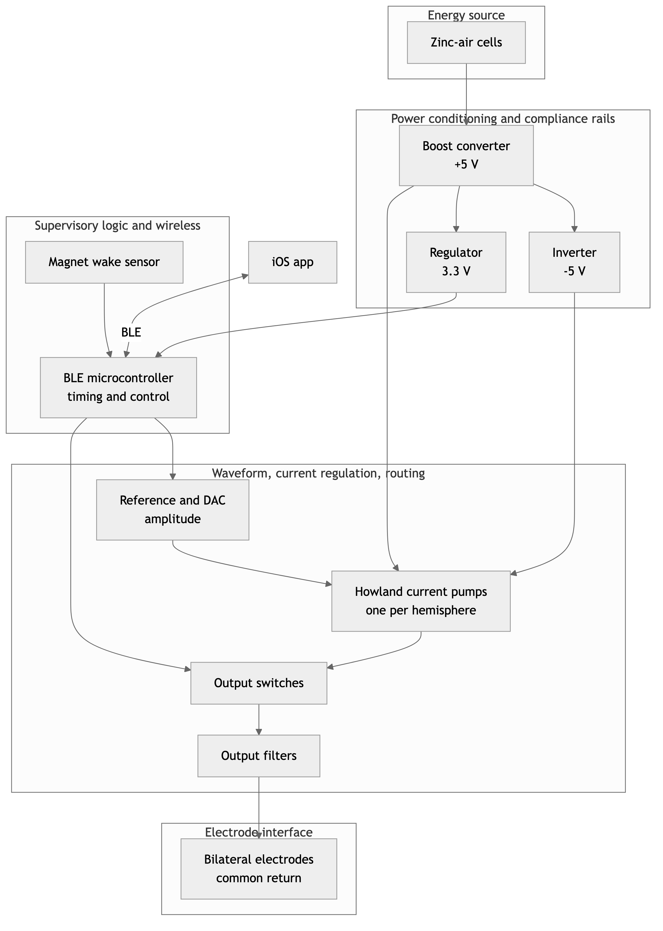
Figure 2. FLEX-DBS hardware. (A) Assembled device viewed from above; scale bar, 10 mm. P, break-away programming tab carrying the Tag-Connect TC2050 footprint, which can be cut off after firmware is loaded. (B) Rendering of the device from below with the snap-on shroud, showing the two zinc-air cell holders and the electrode connector. The board measures 19.5 mm × 22.5 mm excluding the programming tab, and the assembled device is 8.72 mm thick.
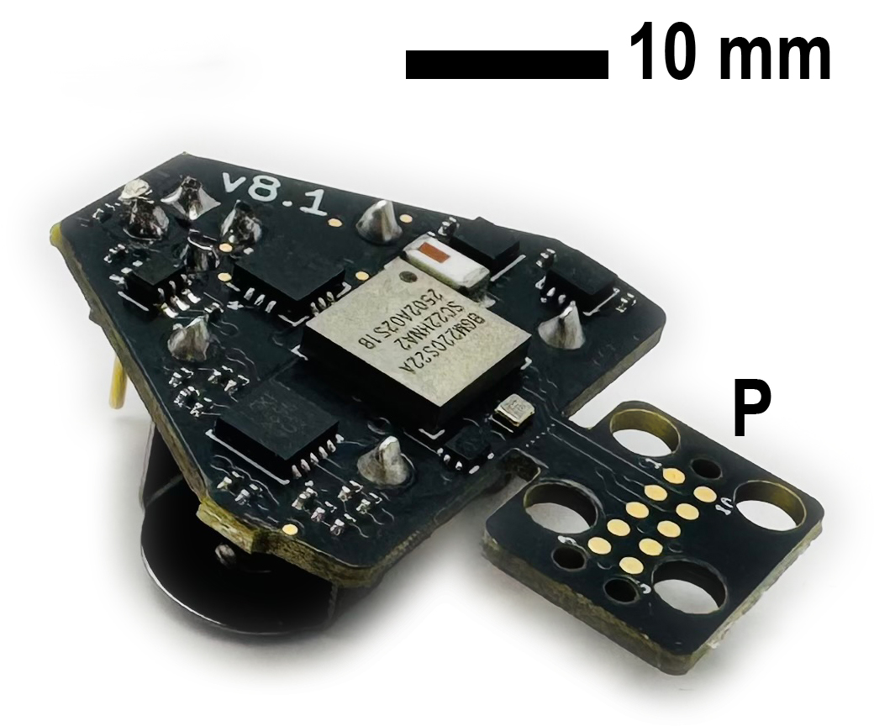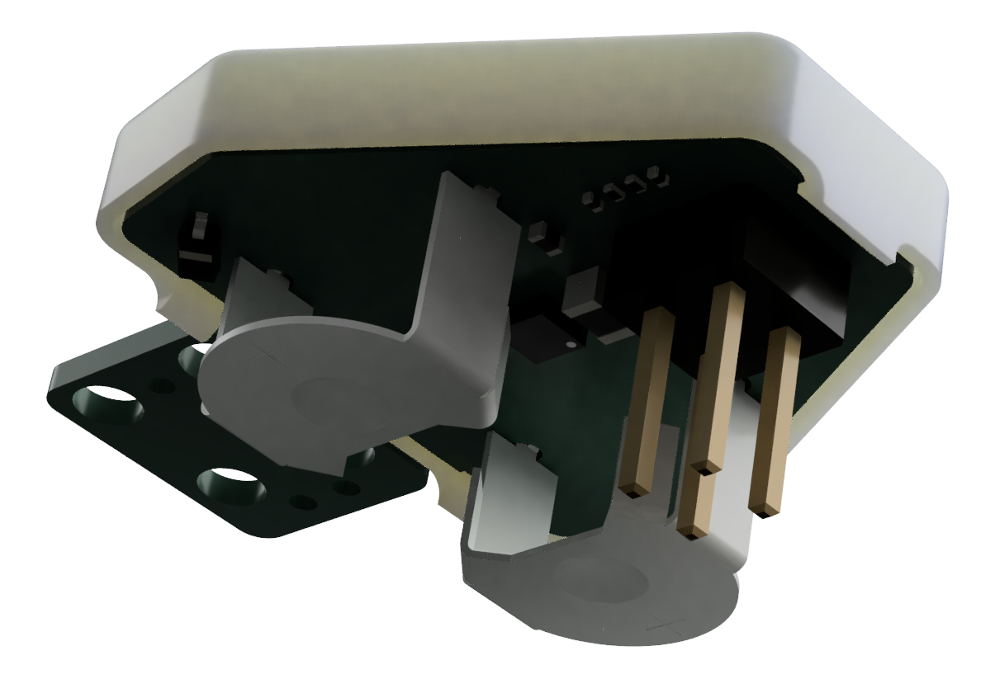
Figure 3. MouseCap iOS application. (Left) Continuous mode: amplitude (percent of full scale and nominal current into 1 kΩ), pulse duration and frequency sliders; device ID, firmware version and battery indicator; activation toggle, Sync, LED and Read controls. (Right) Burst mode: burst period, intra-burst frequency and burst duration with unit selection. Representative settings are shown (50 %, 90 µs, 130 Hz; 30 s burst period, 10 s burst duration). With firmware v0.5, the 90 µs and 130 Hz settings deliver a $∼$117 µs stimulating phase at 142.9 Hz (Table 2).
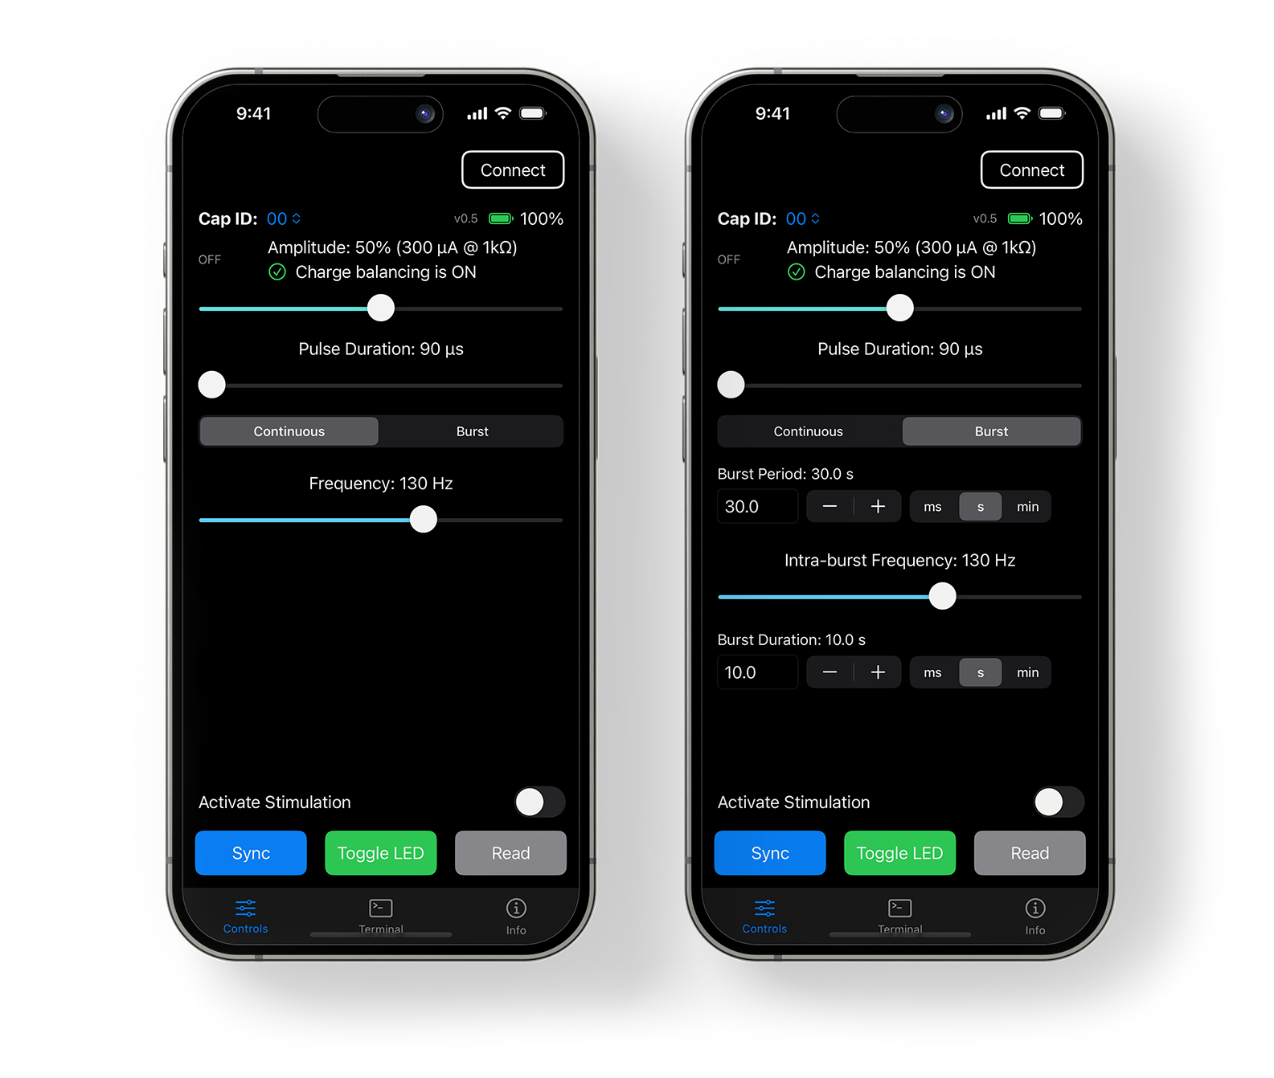
Figure 4. In-vivo electrode impedance and the compliance envelope. (A) Impedance of one implanted platinum electrode per mouse from 1 to 5 weeks after implantation, measured with 10 µA, 450 µs pulses (mean of five readings per session; Section 3.2). (B) Largest regulated current as a function of load impedance for FLEX-DBS, $I_{max}=4.9 V/(|Z|+2.66 kΩ)$ (solid), and for an illustrative battery-direct stimulator with $∼$3 V of compliance (dashed). Points mark the measured impedances from (A) on the FLEX-DBS curve; the dotted line marks the 100 µA reference protocol.
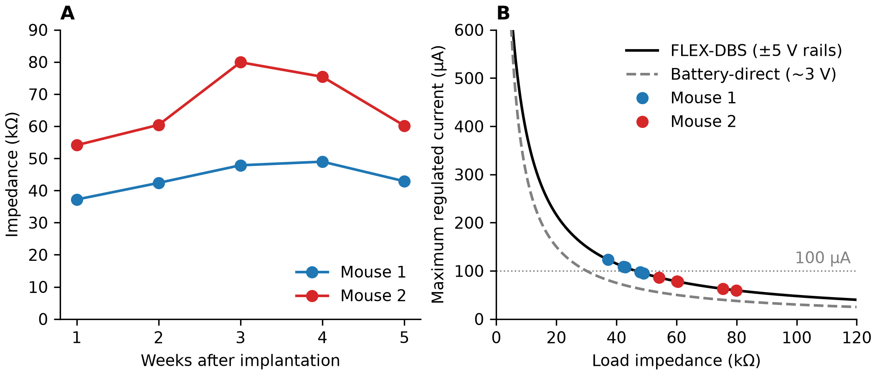

Supplementary material
- S1. Circuit schematic of the FLEX-DBS board (PDF).
- S2. Firmware for the BGM220S (Silicon Labs Simplicity Studio project), v0.5. Repository: https://github.com/Neurotech-Hub/Creed-DBS-SiLabs
- S3. MouseCap iOS application source. Repository: https://github.com/Neurotech-Hub/MouseCap-iOS
- S4. BLE protocol specification (MCU_BLE_PROTOCOL.md in S3): service and characteristic UUIDs, command grammar, parameter keys and ranges, and response format.
- S5. Shroud design (Fusion 360): https://a360.co/3TqHAxf

Author contributions
[Pending; see Working notes.]

Competing interests
[Pending; see Working notes.]

Funding
[Pending; see Working notes.]

Data and code availability
The circuit schematic is provided as Supplementary material S1. Firmware, iOS application source and the BLE protocol specification are available in the repositories listed as S2–S4, and the shroud design is available at https://a360.co/3TqHAxf. The impedance data underlying Figure 4 are available from the corresponding author on request.

Acknowledgments
[Pending; see Working notes.]

Working notes
Open items for the authors. Remove this section before posting.

Data still needed
- Device mass. Table 4 leaves the FLEX-DBS mass blank. R. Graham (comment, 2026-09-18): “If i remember right, we were around 4.4 grams the last time i weighed a device w/ batteries.” Weigh the device with cells, with and without the shroud and with the programming tab removed, and add the value to Section 2.2 and Table 4.
- Electrode construction (Section 3.1). Materials, wire diameter, insulation, exposed length or tip geometry, bilateral spacing, return electrode, connector and fabrication steps. Planned figure: electrode photograph and schematic.
- Surgery and animals. Strain, sex, age, housing, stereotaxic target and coordinates, anesthesia, IACUC protocol number, and the implantation date that anchors “weeks after implantation” in Section 3.
- Bench electrical characterization (Sections 4.1, 4.2). Commanded versus measured current into 1 kΩ (resolves the 6.25 µA/% ideal transconductance versus the application’s 6 µA/% label); programmed versus measured stimulating- and recovery-phase widths (confirms the $∼$117 µs floor and the 1:5 recovery ratio); delivered current versus load at 100 and 400 µA to measure the compliance limit (confirms the $∼$4.9 V swing used in Section 3.3 and Figure 4B) and the Howland load dependence bounded analytically in Section 7; a representative pulse at the reference protocol; op-amp on-time per pulse (210 µs + 6·P, currently from firmware constants). Planned Figure 5 legend: (A) commanded versus measured current into 1 kΩ; (B) programmed versus measured stimulating- and recovery-phase widths; (C) representative pulse at the reference protocol showing the asymmetric recovery phase; (D) delivered current versus load at 100 and 400 µA with the compliance limit marked.
- Battery measurements (Section 4.3, Table 3). Record the conditions of the current measurements (pulse width, load, LED state, instrument) from the bench notes, and replace the runtime projections with a measured discharge to cutoff.
- In-vivo validation (Sections 6.1–6.3). Setup, wireless-versus-tethered comparison and behavioral outcome. Planned Figure 6 legend: (A) head-mounted device on the animal and arena; (B) example tracking; (C) behavioral metric for baseline, tethered DBS and FLEX-DBS wireless DBS, per animal and group.
- Abstract and Conclusions. Update the Results and Conclusions once bench and in-vivo data exist; both currently describe design, impedance and battery results only.
- Timing diagram. The per-pulse sequence in Section 2.2 (amplifier enable and 150 µs settle; switches close and 30 µs settle; DAC step to I for P; step to −I/5 for 5·P; return to reference; switches open; amplifier shutdown) could become a Figure 1 inset or a panel of Figure 5, preferably from a scope capture.

Impedance measurement
- Only the platinum cohort 1 sheet, output 1, is reported. Output 0 of mouse 1 read near 0 V throughout and was excluded; output 0 of mouse 2 (47–53 kΩ) is not reported, to keep one electrode per animal. Confirm this choice.
- The StimJim bench check (2/10/20/68 kΩ) showed its voltage read-back 6–73 % below the oscilloscope, so the in-vivo values may be underestimates. Consider remeasuring with an impedance meter (for example, a NanoZ at 1 kHz) or with an oscilloscope on the StimJim output, and report both.
- The 450 µs measurement pulse is longer than the DBS pulses; a measurement at the stimulation pulse width would better match the compliance calculation.
- The two-electrode configuration is justified with Koo and Weiland (2018); confirm that this is the framing the authors want.
- The other workbook sheets (gold-plated platinum, in vivo two months post, in vivo, bench testing) are not used.

Citations to add or verify
- Introduction: the claims that tethers constrain behavior or add stress, and that some therapeutic effects of DBS develop over days to weeks, have no citation and were softened. Add references or keep the softened wording.
- Introduction: Creed (2018) reviews neuromodulation for addiction; confirm that it supports the sentence on subthalamic stimulation parameters, or substitute a subthalamic reference.
- Section 2.3: confirm that Aleksandrova et al. (2013) and Creed et al. (2013) used amplitudes in the several-hundred-microampere range, and that Creed et al. (2012) is the right citation for the 100 µA, 90 µs, 130 Hz reference protocol.
- The Howland balance and load-dependence analysis cites the TI application note (Texas Instruments, 2008); a peer-reviewed source could be added.
- Paulat et al. (2026) is a Research Square preprint; update if it is published.

Table 4
- Haas et al. (2012) is paywalled and only its abstract was checked, so most of its row is blank. Secondary sources (Kouzani et al., 2013) describe it as a 2.1 g, 8 × 30 mm cylinder with a 4.65 V battery, magnet on/off, parameters set with a programming fixture and fixed resistors, and a 10 h runtime; the parameter cell in that source is garbled (probably 20–100 µA, 60 µs, 131 Hz). Verify against the original and fill in.
- Supplementary files were not read for Burton et al. (2021) or Shen et al. (2026), and Paulat et al. (2026)’s programmable ranges and battery models come from its supplement. The Pinnell firmware release was not checked in the Figshare repository.
- Inconsistencies within sources: Fleischer et al. (2020) gives amplitude and frequency ranges that differ between text and table (both shown), and a 9 × 9 mm versus 10 × 10 mm board; Pinnell et al. (2018) gives 2.8 g in its table and 2.7 g in its introduction; Shen et al. (2026) gives $≥$300 h in its table but more than 30 days in its discussion, and demonstrates settings outside its stated ranges; Burton et al. (2021) gives a 50 kHz and a 25 kHz maximum frequency; the t-IPG thickness is 5.3 mm in the text of Paulat et al. (2026) and 2.6 mm in its supplementary table.
- Kouzani et al. (2013) was designed for mice but tested in rats; Alpaugh et al. (2019)’s “wireless” means untethered, with no radio; its pulse width is read from its Figure 1d.
- Consider adding dimensions as a column once the FLEX-DBS mass is known.

Firmware and design
- Firmware v0.5 delivers 130 Hz as 142.9 Hz and settings of 117 µs or less as $∼$117 µs (Table 2). If the fixes listed in Section 7 are made before posting, update Table 2, Figure 3’s legend and the Limitations.
- The photograph in Figure 2A shows the “v8.1” board silkscreen; decide whether to mention the hardware revision in the text.
- Supplementary S1: consider adding the BOM (v8.1/BOM.csv) alongside the schematic.

End matter
- Confirm author order, middle initials and affiliations.
- Author contributions, competing interests, funding and acknowledgments are pending.
- Data availability: decide whether to deposit the impedance data and figure scripts in a public repository instead of “available on request”.
- Before journal submission (not needed for bioRxiv): Highlights, graphical abstract, CRediT statement, generative-AI declaration, line numbers and double spacing per the Journal of Neuroscience Methods guide.
Aleksandrova, L.R., Creed, M.C., Fletcher, P.J., Lobo, D.S.S., Hamani, C., Nobrega, J.N., 2013. Deep brain stimulation of the subthalamic nucleus increases premature responding in a rat gambling task. Behavioural Brain Research 245, 76–82. https://doi.org/10.1016/j.bbr.2013.02.011
Alpaugh, M., Saint-Pierre, M., Dubois, M., Aubé, B., Arsenault, D., Kriz, J., Cicchetti, A., Cicchetti, F., 2019. A novel wireless brain stimulation device for long-term use in freely moving mice. Scientific Reports 9, 6444. https://doi.org/10.1038/s41598-019-42910-7
Burton, A., Won, S.M., Sohrabi, A.K., Stuart, T., Amirhossein, A., Kim, J.U., Park, Y., Gabros, A., Rogers, J.A., Vitale, F., Richardson, A.G., Gutruf, P., 2021. Wireless, battery-free, and fully implantable electrical neurostimulation in freely moving rodents. Microsystems & Nanoengineering 7, 62. https://doi.org/10.1038/s41378-021-00294-7
Cermak, N., Wilson, M.A., Schiller, J., Newman, J.P., 2019. Stimjim: Open source hardware for precise electrical stimulation. https://doi.org/10.1101/757716
Creed, M., 2018. Current and emerging neuromodulation therapies for addiction: Insight from pre-clinical studies. Current Opinion in Neurobiology 49, 168–174. https://doi.org/10.1016/j.conb.2018.02.015
Creed, M.C., Hamani, C., Nobrega, J.N., 2013. Effects of repeated deep brain stimulation on depressive- and anxiety-like behavior in rats: Comparing entopeduncular and subthalamic nuclei. Brain Stimulation 6, 506–514. https://doi.org/10.1016/j.brs.2012.09.012
Creed, M.C., Hamani, C., Nobrega, J.N., 2012. Early gene mapping after deep brain stimulation in a rat model of tardive dyskinesia: Comparison with transient local inactivation. European Neuropsychopharmacology 22, 506–517. https://doi.org/10.1016/j.euroneuro.2011.11.004
Creed, M., Hamani, C., Nobrega, J.N., 2011. Deep brain stimulation of the subthalamic or entopeduncular nucleus attenuates vacuous chewing movements in a rodent model of tardive dyskinesia. European Neuropsychopharmacology 21, 393–400. https://doi.org/10.1016/j.euroneuro.2010.06.012
Creed, M., Pascoli, V.J., Lüscher, C., 2015. Refining deep brain stimulation to emulate optogenetic treatment of synaptic pathology. Science 347, 659–664. https://doi.org/10.1126/science.1260776
Fasano, A., Helmich, R.C., 2019. Tremor habituation to deep brain stimulation: Underlying mechanisms and solutions. Movement Disorders 34, 1761–1773. https://doi.org/10.1002/mds.27821
Fleischer, M., Endres, H., Sendtner, M., Volkmann, J., 2020. Development of a fully implantable stimulator for deep brain stimulation in mice. Frontiers in Neuroscience 14, 726. https://doi.org/10.3389/fnins.2020.00726
Grotemeyer, A., Petschner, T., Peach, R., Hoehl, D., Knauer, T., Thomas, U., Endres, H., Blum, R., Sendtner, M., Volkmann, J., Ip, C.W., 2024. Standardized wireless deep brain stimulation system for mice. npj Parkinson’s Disease 10, 153. https://doi.org/10.1038/s41531-024-00767-2
Haas, R. de, Struikmans, R., Plasse, G. van der, Kerkhof, L. van, Brakkee, J.H., Kas, M.J.H., Westenberg, H.G.M., 2012. Wireless implantable micro-stimulation device for high frequency bilateral deep brain stimulation in freely moving mice. Journal of Neuroscience Methods 209, 113–119. https://doi.org/10.1016/j.jneumeth.2012.05.028
Knotkova, H., Hamani, C., Sivanesan, E., Le Beuffe, M.F.E., Moon, J.Y., Cohen, S.P., Huntoon, M.A., 2021. Neuromodulation for chronic pain. The Lancet 397, 2111–2124. https://doi.org/10.1016/S0140-6736(21)00794-7
Koo, B., Weiland, J., 2018. Experimental factors effecting stability of electrochemical impedance spectroscopy measurements, in: 2018 40th Annual International Conference of the IEEE Engineering in Medicine and Biology Society (EMBC). pp. 2949–2952. https://doi.org/10.1109/EMBC.2018.8512973
Kouzani, A.Z., Abulseoud, O.A., Tye, S.J., Hosain, M.K., Berk, M., 2013. A low power micro deep brain stimulation device for murine preclinical research. IEEE Journal of Translational Engineering in Health and Medicine 1, 1500109. https://doi.org/10.1109/JTEHM.2013.2264093
Krauss, J.K., Lipsman, N., Aziz, T., Boutet, A., Brown, P., Chang, J.W., Davidson, B., Grill, W.M., Hariz, M.I., Horn, A., Schulder, M., Mammis, A., Tass, P.A., Volkmann, J., Lozano, A.M., 2021. Technology of deep brain stimulation: Current status and future directions. Nature Reviews Neurology 17, 75–87. https://doi.org/10.1038/s41582-020-00426-z
Lozano, A.M., Lipsman, N., Bergman, H., Brown, P., Chabardes, S., Chang, J.W., Matthews, K., McIntyre, C.C., Schlaepfer, T.E., Schulder, M., Temel, Y., Volkmann, J., Krauss, J.K., 2019. Deep brain stimulation: Current challenges and future directions. Nature Reviews Neurology 15, 148–160. https://doi.org/10.1038/s41582-018-0128-2
Merrill, D.R., Bikson, M., Jefferys, J.G.R., 2005. Electrical stimulation of excitable tissue: Design of efficacious and safe protocols. Journal of Neuroscience Methods 141, 171–198. https://doi.org/10.1016/j.jneumeth.2004.10.020
Murphy, C., Matikainen-Ankney, B., Chang, Y.-H., Copits, B., Creed, M.C., 2021. Optogenetically-inspired neuromodulation: Translating basic discoveries into therapeutic strategies, in: International Review of Neurobiology. Academic Press, pp. 187–219. https://doi.org/10.1016/bs.irn.2021.06.002
Paulat, R., Koschützke, L., Haumesser, J., Maurer, L., Altschüler, J., Tang, H., Hounchonou, H., Daugardt, A., Harnack, D., Just, V., Schulz, G., Harms, C., Kühn, A.A., Wenger, N., Riesen, C. van, 2026. Wireless lightweight implantable pulse generators enable chronic dual-target deep brain stimulation in rodent disease models. https://doi.org/10.21203/rs.3.rs-9019884/v1
Pinnell, R.C., Pereira de Vasconcelos, A., Cassel, J.C., Hofmann, U.G., 2018. A miniaturized, programmable deep-brain stimulator for group-housing and water maze use. Frontiers in Neuroscience 12, 231. https://doi.org/10.3389/fnins.2018.00231
Plocksties, F., Kober, M., Niemann, C., Heller, J., Fauser, M., Nüssel, M., Uster, F., Franz, D., Zwar, M., Lüttig, A., Kröger, J., Harloff, J., Schulz, A., Richter, A., Köhling, R., Timmermann, D., Storch, A., 2021. The software defined implantable modular platform (STELLA) for preclinical deep brain stimulation research in rodents. Journal of Neural Engineering 18, 056032. https://doi.org/10.1088/1741-2552/ac23e1
Shen, Y., Zhao, D., Lv, Y., Liu, Y., Chen, Y., Zhang, Y., Chen, S., 2026. A wearable deep brain stimulation system for behavioral studies in rodents. Frontiers in Neuroscience 19, 1707636. https://doi.org/10.3389/fnins.2025.1707636
Texas Instruments, 2008. AN-1515 a comprehensive study of the Howland current pump (Application Report No. SNOA474A). Texas Instruments.

