Shotclock design choices / notes / tasks REV 3

A product that displays a countdown timer on seven segment displays once a button has been pressed. The countdown will show a maximum of 99 seconds (2 digits), and each of these 2 digits should be present on 4 sides of the product (so a total of 8 seven segment displays).
A buzzer is added to audibily hear when the timer has ran out.
The product is designed to have a ‘main pcb’, which houses most electrical components. On each 90 degree edge of the main PCB, there will be a connector that connects to a set of 2 seven segment display digits.
See requirements below for more info.
The REV2 boards & encasing:
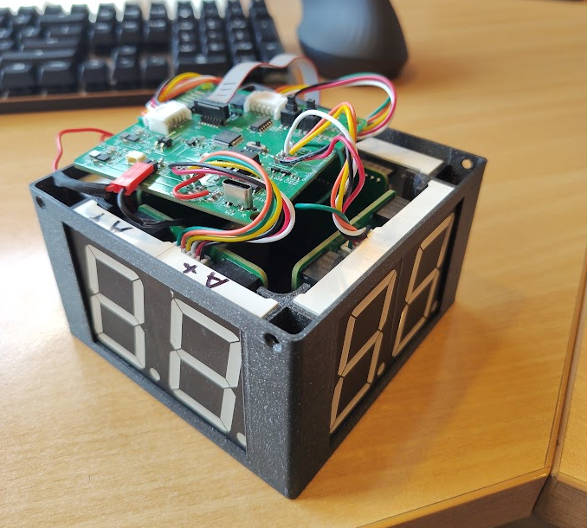
Table of Contents
Updated requirements REV2 -> REV3 3
Thoughts and questions 4
Main PCB 4

This document only contains updates, tasks etc for REV3! The information for REV2 is in the other .odt file.

Updated requirements REV2 -> REV3
1. Battery powered, rechargable
1.1 USB type C, product must keep functioning while charging!
2. New buttons with new seperate connectors instead of buttons on PCB
3. More relaxed fitment in the encasing to reduce stress on the PCBs and the segment displays

Research notes

Notes for charging while using product
BQ25895 as charging IC is a good option
TPS61288RQQR as a high current buck converter

