Shotclock design choices / notes
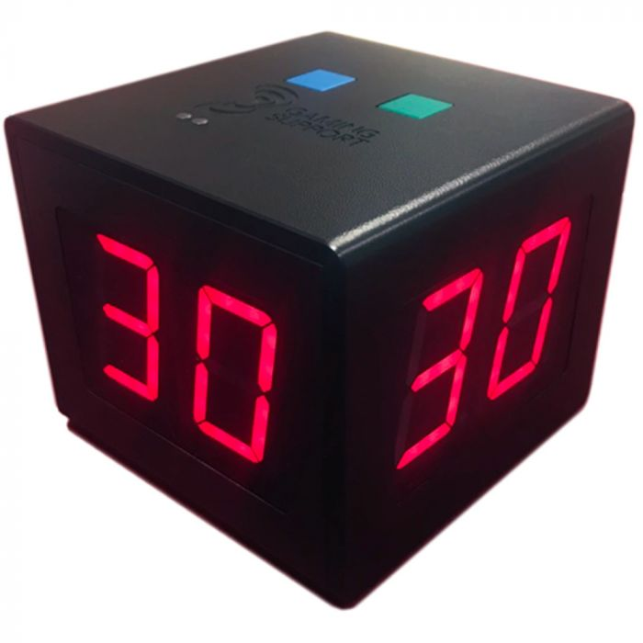
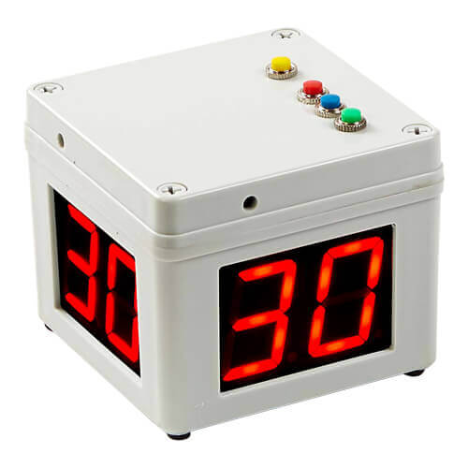
Product reference photos

A product that displays a countdown timer on seven segment displays once a button has been pressed. The countdown will show a maximum of 99 seconds (2 digits), and each of these 2 digits should be present on 4 sides of the product (so a total of 8 seven segment displays).
A buzzer is added to audibily hear when the timer has ran out.
The product is designed to have a ‘main pcb’, which houses most electrical components. On each 90 degree edge of the main PCB, there will be a connector that connects to a set of 2 seven segment display digits.
See requirements below for more info.
First encasing prototype is shown below:
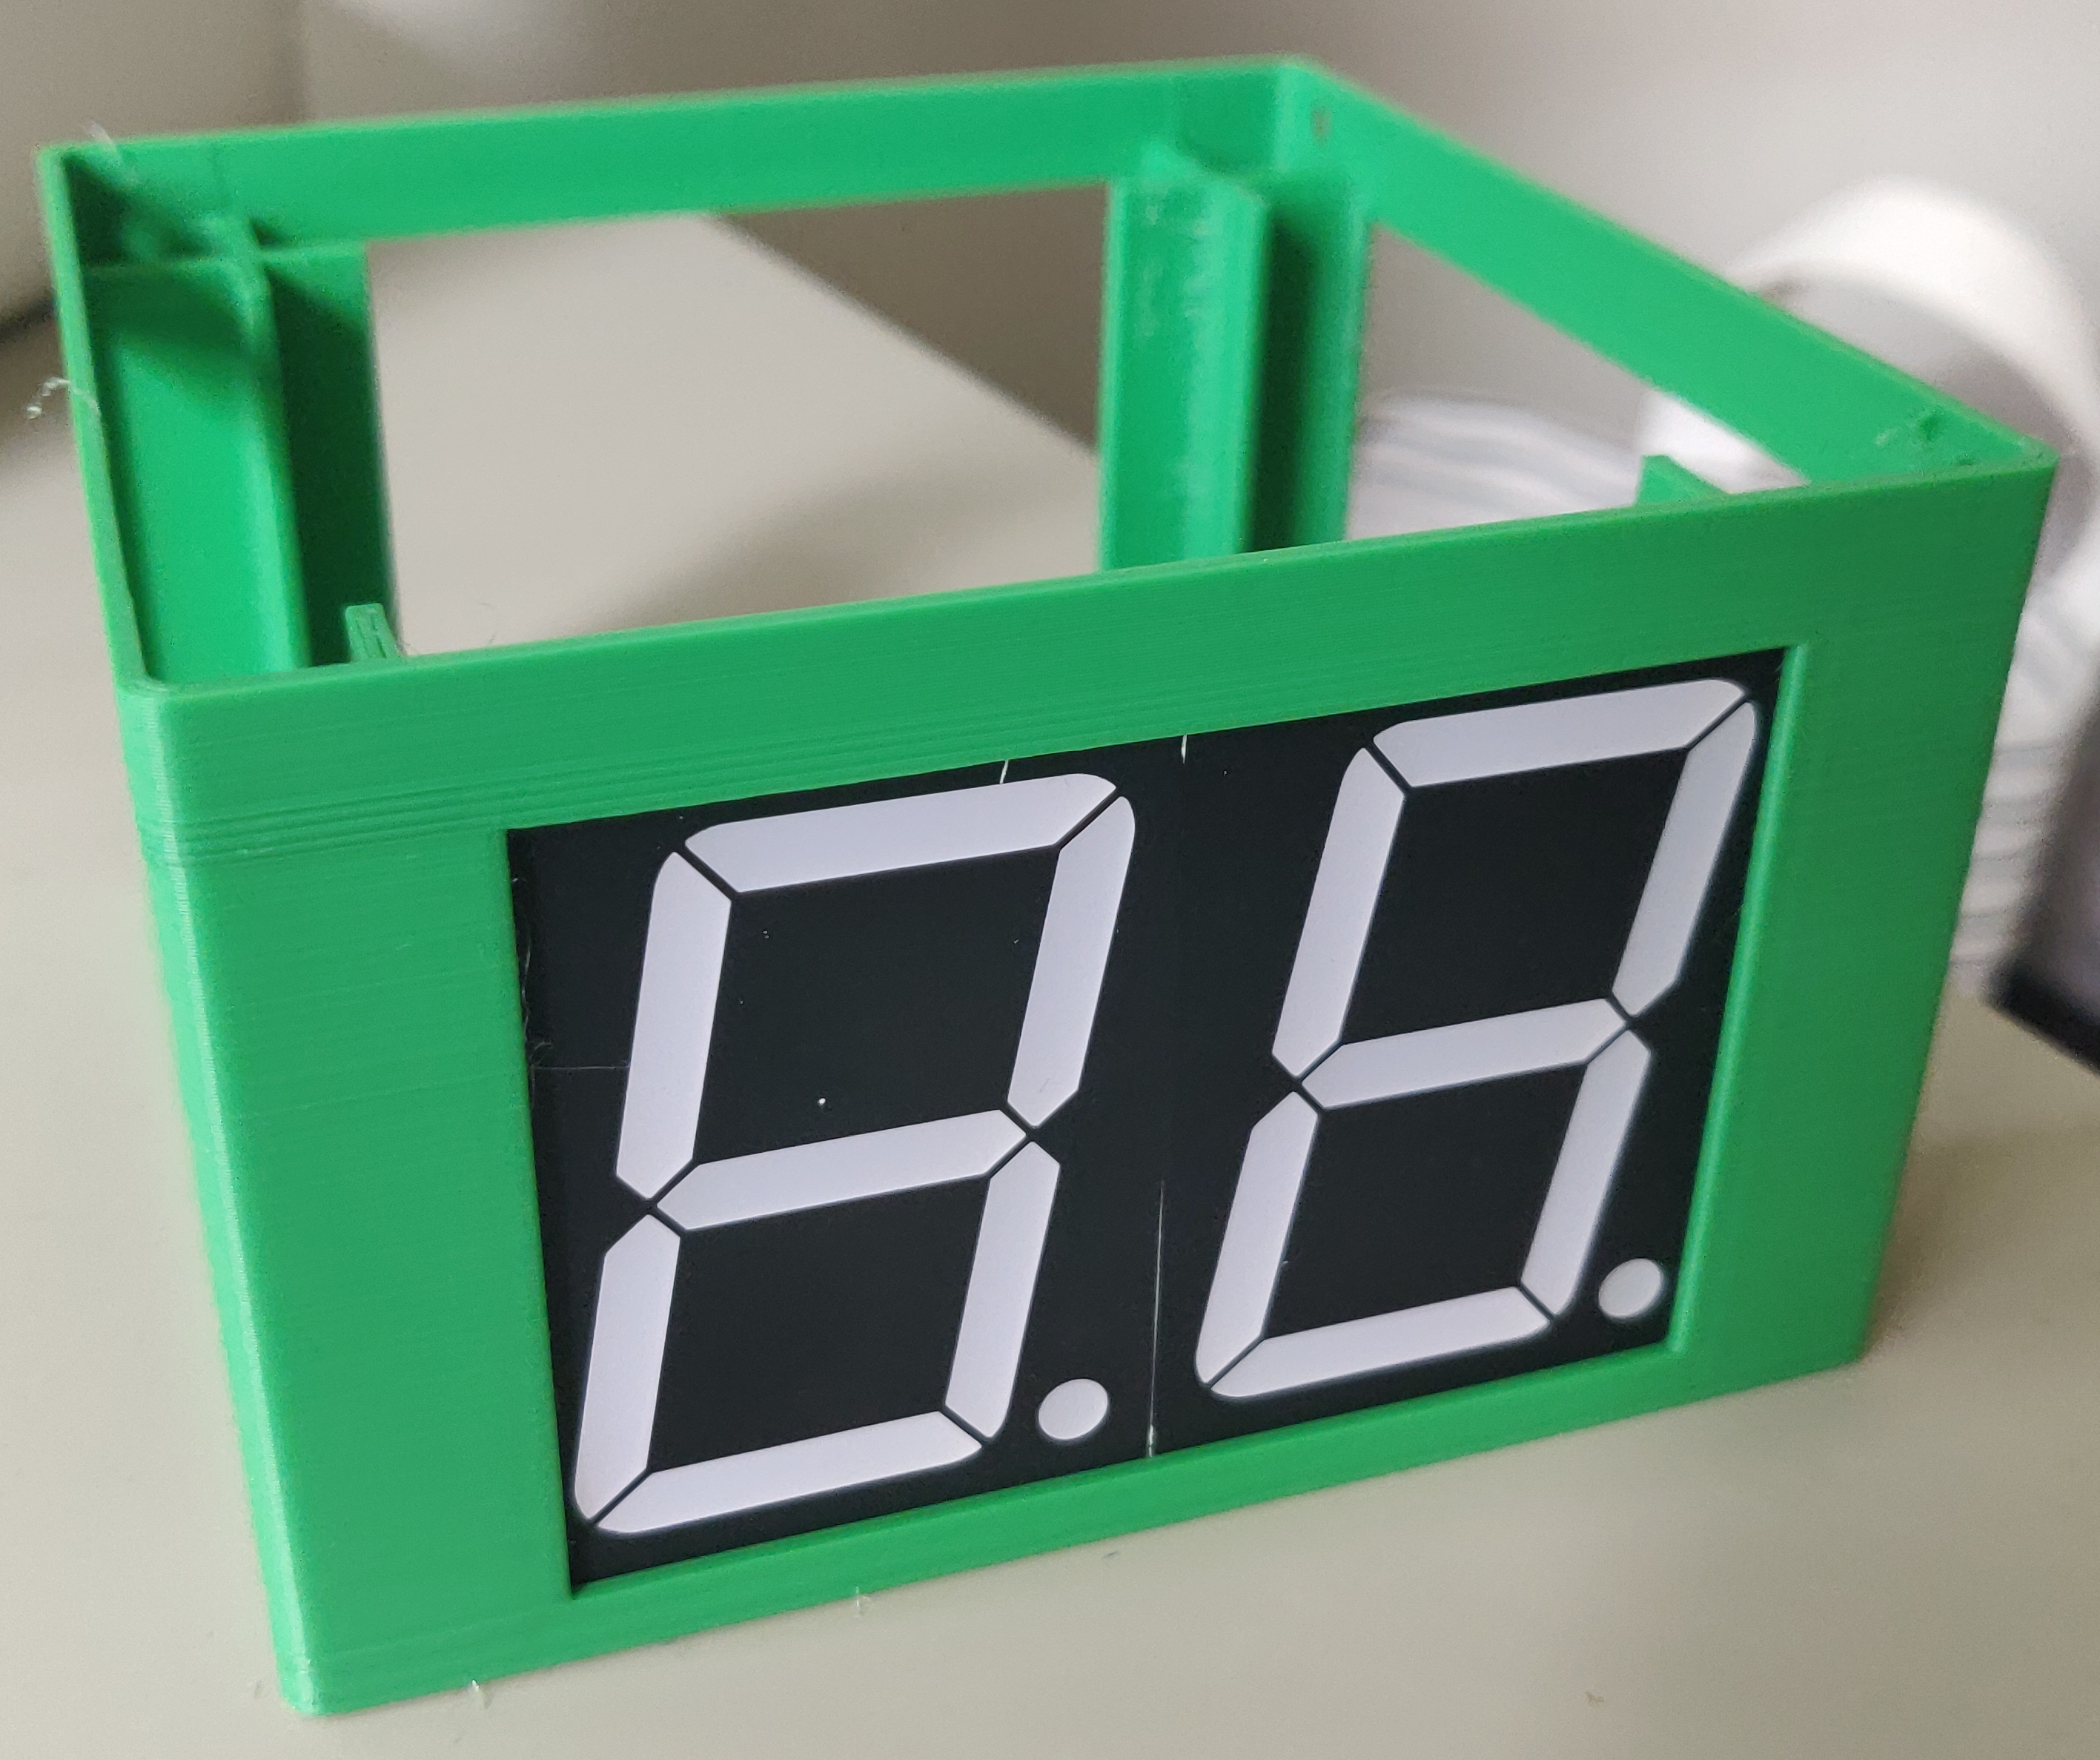
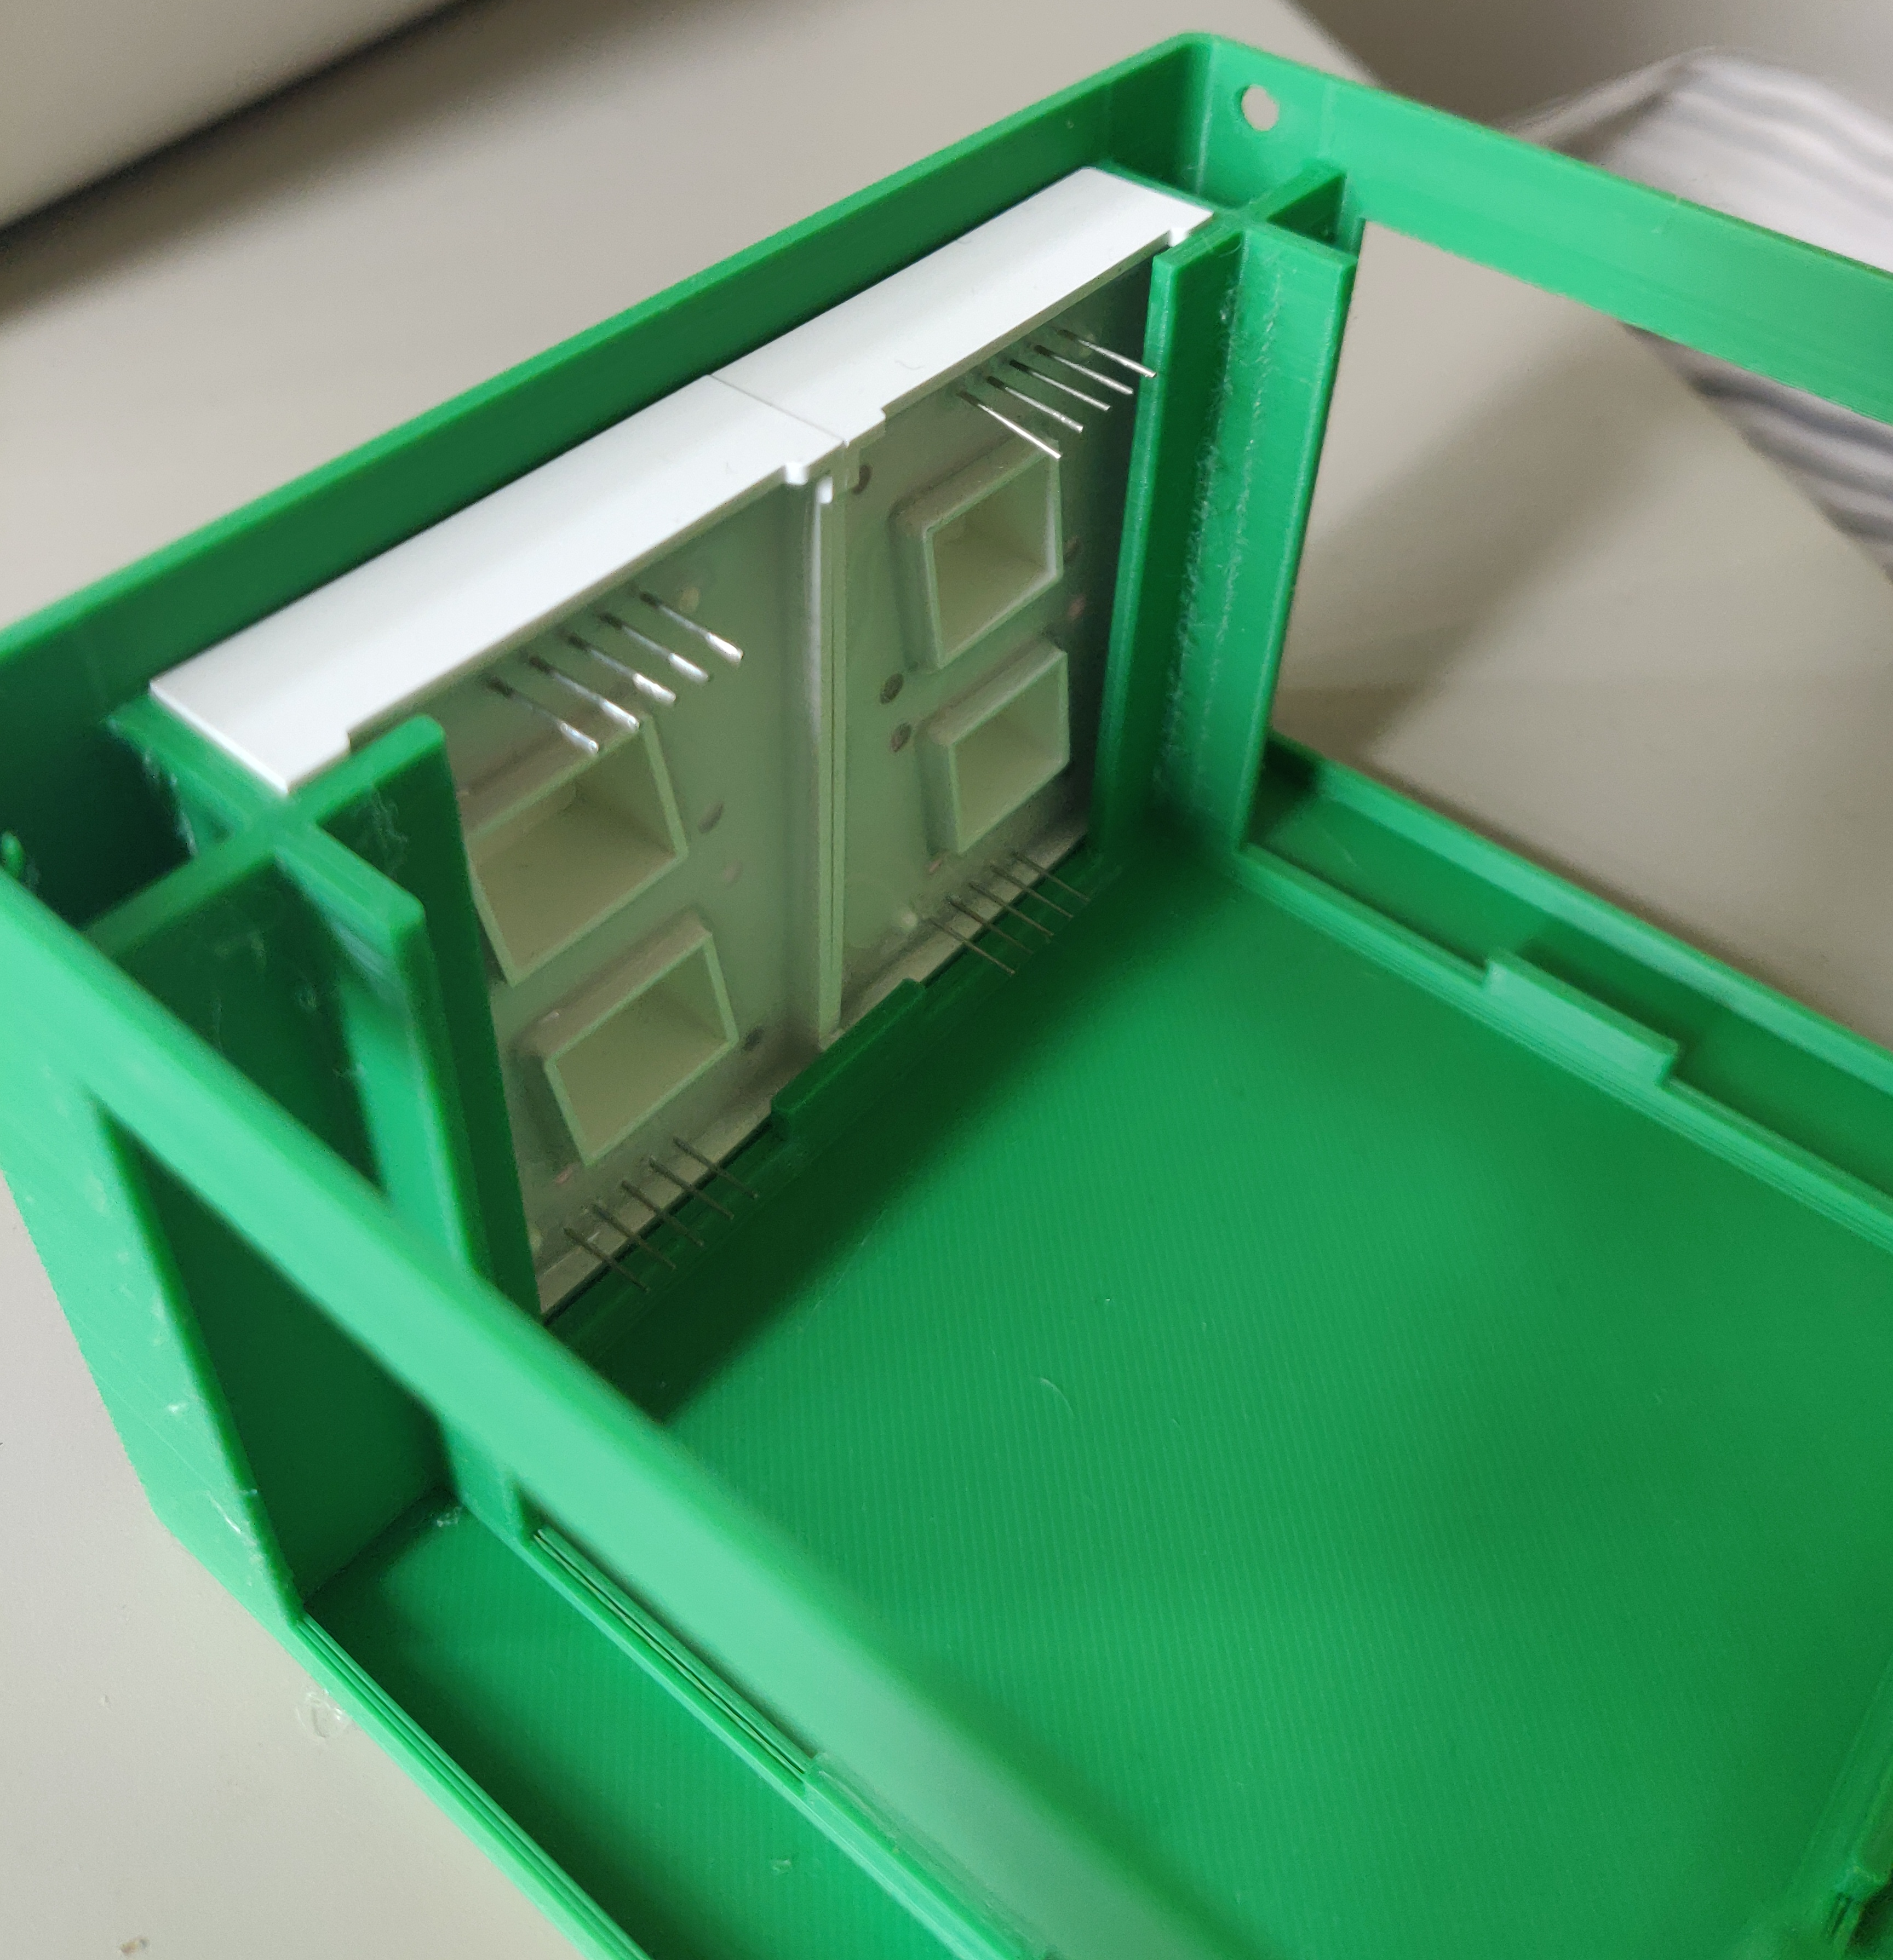
First product encasing prototype

Table of Contents
Requirements 3
Battery charger & ADC charge status 4
General info pages used 4
TEMP Pin NTC: R1, R2 calculation 4
Battery charge reading & battery lvl status LED 5
Voltage regulator (3v3) 6
R2 calculation 7
Cff calculation 7
Vbat pin on MCU 8
Momentary buttons and hardware debouncing 9
Buzzer 9
Connectors to seven (eight) segment displays 10
Footprint / part choices 11
Main PCB 11
Thoughts and questions 13
Main PCB 13

Requirements
1. Battery powered, rechargable
1.1 Li-Po would be nice, since large capacity and shitload of form factors
1.2 USB type C connector as charge plug (charging may stop usage of product if using li-po)
1.3 USB type C connector as USB D+/D- to MCU
2. Can drive 2x4 seven (actually, eight segment. They have a dot.) segment displays, with brightness control
3. LED to display battery < 20%
4. LED to display charging status (‘is charging’ and ‘is done charging’)
5. Switch (latching) to turn product on and off, while still being able to charge product (preferably in both the on and off state. But only off state is also fine for version 1).
6. Three functional buttons (momentary) with hardware debouncing
7. STM32 MCU, with SWD connector
8. UART header
9. Bootloader button to STM
10. Buzzer to indicate that the timer has ran out.
11. EEPROM to store user settings (atleast countdown time and buzzer on/off). So RTC registers of STM should be good enough.

Battery charger & ADC charge status

General info pages used
TP4056 as charging IC (https://dlnmh9ip6v2uc.cloudfront.net/datasheets/Prototyping/TP4056.pdf)
Page used on deciding charge current:
https://www.xtar.cc/news/What-Is-The-Best-Charging-Current-And-How-To-Calculate-The-Charging-Time-Of-Lithium-Battery-154.html
Disable system while charging battery:
https://www.microtype.io/lithium-ion-battery-charger-circuit-load-sharing/
Choosing battery of 1500 or 2000 mAh, since it is good middle-way between size, weight, price and capacity (should last the product more than long enough to be able to only charge it when systemload is off).
I got these in house: https://nl.aliexpress.com/i/1005005148897780.html?gatewayAdapt=glo2nld
With a thermistor in them. Calculations for this temp pin are in TEMP Pin NTC: R1, R2 calculation.
There will a 3 pin JST connector.
I’ve also added an extra 2 pin connector, since a load of cells don’t have a thermistor in them. A jumper is also present to pull the TEMP pin to ground, if no thermistor is to be used.

TEMP Pin NTC: R1, R2 calculation
The batteries I have, have a 10k NTC at room temp. I don’t know the specifics, because it is a chinese battery, without good datasheet. Internet says “10K NTC usually has 3977K Thermistor Beta Value” (https://www.eevblog.com/forum/projects/ntc-thermistor-resistance-(li-ion-charging)/).
The datasheet of the TP4056 mentions: “If TEMP pin’s voltage is below 45% or above 80% of supply voltage VIN for more than 0.15S, this means temp is to low or high”.
So if assuming that the following is true:
For 45°C the thermistor resistance is about 4k2.
For 5°C the thermistor resistance is about 26k.
(at ambient room temp of +/- 20°C, the resistance was about 7k8, measured myself, so this assumption sounds about right)

I’ve converted the resistance calculator from above post: https://www.best-microcontroller-projects.com/tp4056-page2.html into Python code (inserted as OLE object, also found on my GitHub):

Then using the following input values for the Python script:
vratio1 = 0.45
vratio2 = 0.80
ratio_tol1 = 0.01
ratio_tol2 = 0.05
Rntc_min = 4200
Rntc_max = 26000

Gives the following closest E48 resistors (just as in the article. Atleast I know how to calculate this now hahaha):
r1 4780 r2 86600 Rntc1 4.2e3 Rntc2 26e3
I am also adding a jumper, to switch off the whole functionality as well. Both to support 2 pinned batteries, and to disable the temp sensing, if these assumption and/or calculations are wrong.

Battery charge reading & battery lvl status LED
To read the amount of charge in the battery, I want to use the ADC of the STM32.
This article was used as example: https://vivonomicon.com/2019/10/15/reading-battery-voltage-with-the-stm32s-adc/
It mentions that: “if you use smaller resistor values for the voltage divider, you use more current, but the sampling can be faster”. A commentor on that post replied: “You can use larger resistors (i.e. 1M) in the divider and still use short sampling times if you add a small capacitor (1n-100n). [between the Analog pin and ground, to buffer so the ADC peripheral gets current more quickly. Instead of via the high resistance path of the voltage divider]”.
So that is what is implemented. A 1:1 voltage division (a single Lithium cell get to a max of 4.2V, so divided by 2 will give a max of 2.1V, which the analog pins easily accept), with large resistance values (1M) and a 100n capacitor between the analog ADC peripheral and GND.
Max current leakage would be:
4.2 = I * 2000000
I = 0.0000021 amps (or 2.1 microamps).

Should be reasonable for a 1500mAh battery (or is it smart to increase the resistance values & capacitor value even more, to reduce the current leakage even more?).
And for the battery level status led:
Assuming a forward voltage drop of 2.0 volts and a forward current of 10 mA, we can calculate the resistor value using Ohm's Law (V = IR).

Rearranging the formula, we get R = V / I.
R = (Vsupply - Vf) / I
R = (3.3V - 2.0V) / 0.01A
R = +/- 130 Ω (130 is closest E48 std. value.)

Voltage regulator (3v3)
TPS63000, variable output DC/DC buck boost.
Variable output calculation
From datasheet:
8.2.2 Detailed Design Procedure
8.2.2.1 Programming the Output Voltage
“Within the TPS6300x family, there are fixed and adjustable output voltage versions available. To properly configure the fixed output voltage devices, the FB pin is used to sense the output voltage. This means that it must be connected directly to VOUT. At the adjustable output voltage versions, an external resistor divider is used to adjust the output voltage. The resistor divider must be connected between VOUT, FB and GND. When the output voltage is regulated properly, the typical value of the voltage at the FB pin is 500 mV. The maximum recommended value for the output voltage is 5.5 V. The current through the resistive divider should be about 100 times greater than the current into the FB pin. The typical current into the FB pin is 0.01 μA, and the voltage across the resistor between FB and GND, R2 , is typically 500 mV. Based on those two values, the recommended value for R2 should be lower than 500 kΩ, in order to set the divider current at 1 μA or higher. TI recommends to keep the value for this resistor in the range of 200 kΩ. From that, the value of the resistor connected between VOUT and FB, R1 , depending on the needed output voltage (VOUT), can be calculated using Equation 1. (1) If as an example, an output voltage of 3.3 V is needed, a 1-MΩ resistor should be chosen for R1 . To improve control performance using a feedforward capacitor in parallel to R1 is recommended. The value for the feedforward capacitor can be calculated using Equation 2.”

This data from the datasheet has been used to calculate R2 and Cff, see R2 calculation and Cff calculation.

R2 calculation
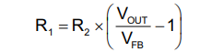
Wanted Vout is 3v3.
R1 = 1M (according to datasheet 8.2.2.1)
R2 = ?
Vout = 3.3V
Vfb = 0.5V (typical value from datasheet 8.2.2.1)

Solving for R2:
R2 = (Vfb * R1) / (Vout - Vfb )
R2 = (0.5 * 1000000) / (3.3 – 0.5) = 178571,4285714286 ohms.

Solved for Vout (to make sure I did not make a solving mistake):
Vout = (Vfb * (R1 + R2) ) / R2
Vout = (0.5 * (1000000 + 178000)) / 178000 = 3,308988764044944 = 3.3v.

So chosen R2 = 178k.

Cff calculation
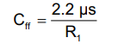
2.2us = 0.0000022 s
R1 = 1000000 ohm
Cff = 2.2us / R1 = 0.0000022 / 1000000 = 0.0000000000022 F
0.0000000000022 F = 2.2 pF
So Cff should be 2.2pF

Crystal resonator CL calc
Crystal is: YSX321SL
Datasheet info says
Shunt capacitance is: 7 pF Max
Load capacitance should be 10pF.

So to calculate the load capacitors, the following formula has been used, to get 10pF.

CL = ((CX1 x CX2) / (CX1 + CX2)) + Cstray

((6 x 6) / (6 + 6)) + 7
(36 / 12) + 7 = 10pF

So the capacitors used on both ends of the crystal are: 6pF

Vbat pin on MCU
I’d like to connect the Vbat pin on the MCU, to the Li-Ion battery. This way I don’t have to put an extra coin-cell in, and I can still use the RTC functionality on the MCU.
The datasheet mentions the following important information on the RTC and backup registers (2.3.16, but I’ve marked important keywords here):
“+/- 2.2 uA power usage at 3v3 (see figure 16 of datasheet)
VBAT Backup operating voltage min: 1.8V and max 3.6V.
The RTC and the backup registers are supplied through a switch that takes power either on VDD supply when present or through the VBAT pin. The backup registers are forty-two 16-bit registers used to store 84 bytes of user application data when VDD power is not present. They are not reset by a system or power reset, and they are not reset when the device wakes up from the Standby mode. The real-time clock provides a set of continuously running counters which can be used with suitable software to provide a clock calendar function, and provides an alarm interrupt and a periodic interrupt. It is clocked by a 32.768 kHz external crystal, resonator or oscillator, the internal low-power RC oscillator or the high-speed external clock divided by 128. The internal low-speed RC has a typical frequency of 40 kHz. The RTC can be calibrated using an external 512 Hz output to compensate for any natural quartz deviation. The RTC features a 32-bit programmable counter for long term measurement using the Compare register to generate an alarm. A 20-bit prescaler is used for the time base clock and is by default configured to generate a time base of 1 second from a clock at 32.768 kHz.”
So:
1. No higher than 3.6V (Li-Po can get up to 4.2V, so we need a lower voltage).
2. Low power consumption, which is nice. LDO would be good option
3. 84 bytes of user data is more than enough. This means no extra EEPROM chip is needed.
4. Can be clocked by internal clock, or High-Speed External. Since I see no use for a really precise, non-drifting clock, this means that I can omit the 32.768kHz crystal from the design.

Only problem, is the voltage.
A voltage division would probably not work here, since the voltage would keep changing when the battery drains. This would probably give weird clock issues (I don’t need a really stable RTC clock, but a sort-off stable RTC would be nice).
So next best option would probably to use a small LDO. The RTC pin does not use to much current, so the inefficiency does not matter to much.
LD39015M33R is chosen, since this has input range of 1.8 to 5.5v and a stable output of 3v3. Very low quiescent current (18 µA typ. at no load, 38 µA typ. at 150 mA load, 1 µA max. in OFF mode) and also 150mA output current, which should be way more than enough.

Momentary buttons and hardware debouncing
I want 3 digital input momentary buttons, with hardware debouncing integrated into the PCB.
Schmitt Trigger IC chosen for debouncing: STM m74hc14yrm13tr.
Because the internet said this IC is great for button removing hysterisis at 3v3 levels since it is a really fast schmitt trigger IC. The IC doesn’t need additional configuration. Also the IC is ok in terms of availability.
https://www.st.com/resource/en/datasheet/m74hc14.pdf
I’ve used ‘snapeda.com’ to create a schematic symbol (footprint was already available). Quite useful stuff: https://www.snapeda.com/parts/M74HC14YRM13TR/STMicroelectronics/view-part/

Buzzer
To make sure the buzzer does not pull to much current from the MCU, an NPN transistor is used:
Also a flyback diode is placed between buzzer pins, to act as a bypass if the magnetic field collapses, to not damage the transistor.
A current limiting resistor of 1k ohm is used for the base pin of the transistor.
Then 3v3 is connected to GND, via the transistor.
Since the chosen buzzer (see Footprint / part choices) only uses +/- mA, almost all transistors should be fine.

Connectors to seven (eight) segment displays
The used segment displays are common cathode: https://t.ly/1rQHq (short URL, because AliExpress creates huge URLs).
There are 8 segments (7 for the digit, 1 for a dot), and two ground pins per display:
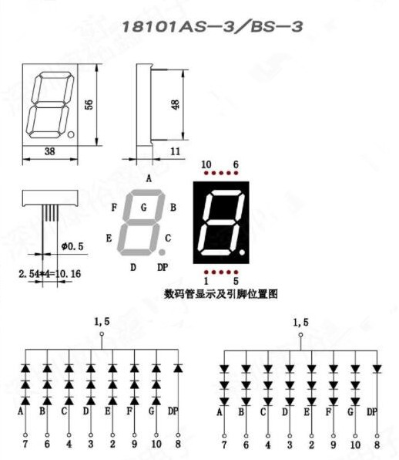
PIN 1 = GROUND
PIN 5 = GROUND
PIN 2 = E
PIN 3 = D
PIN 4 = C
PIN 6 = B
PIN 7 = A
PIN 8 = DP
PIN 9 = F
PIN 10 = G

The displays will be mounted on seperate PCB’s for easy product assembly (the displays have pins, so the PCB’s will have header sockets). Then, each segment PCB will be connected to the main shotclock PCB, also using header pins/sockets.

To minimize noise, low impedance paths and reduces the chances of ground bounce or voltage fluctuations, I’ll try to add as much ground pins between the two PCB’s as possible.

Each segment PCB will mount two segment displays (each display should be able to show a different digit). Each shotclock will have 4 segment PCB’s mounted in 90° offset rotation from main PCB center. These all show the same 2 sets of digits (hense, 16 signals needed in total). The transistors will be mounted on the segment display PCB, not on the main PCB. Main PCB will only provide power, GND & PWM signals.

A good connector I could find, is the male and female 2x10 p=2.54mm header pins/sockets.
Since there are 16 (PWM) signal lines needed between the boards, 1 3v3 line, this leaves 3 GND pins.

Since I2C PWM IO expanders are used, only 6 pins are needed to each display PCB.
GND
5V
3V3
SDA
SCL
nRESET

The same pin headers as used for the UART debug can be used.

Segment displays and driving them

Current usage at 5V
The displays need to be powered with 5V. With 3v3, the voltage drop it too high to light all the 3 LEDs per segement.

220 ohms
Using 5V, and a 220 ohm resistor (which gives a maximum brightness which I would consider to be atleast what we want), the measured current usage of a segment is:
5.1 mA for segments, and 6.7 mA for dot point.
So total for 1 display is: (5.1 * 7) + 6.7 = 42,4 mA
This means that all 8 segment displays, when fully on, use:
42,4 * 8 = 339,2 mA

100 ohms
Using 5V, and a 100 ohm resistor (which gives a maximum brightness which seems bright enough), the measured current usage of a segment is:
10 mA for segments, and 10.2 mA for dot point.
So total for 1 display is: (10 * 7) + 10.2 = 80,2 mA
This means that all 8 segment displays, when fully on, use:
80,2 * 8 = 641,6 mA

47 ohms
Using 5V, and a 47 ohm resistor (which gives a maximum brightness which is quite blinding), the measured current usage of a segment is:
18.2 mA for segments, and 13.8 mA for dot point.
So total for 1 display is: (18.2 * 7) + 13.8 = 141,2 mA
This means that all 8 segment displays, when fully on, use:
141,2 * 8 = 1129,6 mA
There will be capability to change brightness programatically. But if we use 100 ohms, then the TPS63000 can also be used to create 5V, since it’s maximum Iout is 800mA when the LiPo cell is at its lowest charge (+/- 3V)
So this means that when 100 ohms is chosen, the maximum brightness should still be able to be reached when the battery is almost empty.

Voltage regulator (5V)
TPS63000, variable output DC/DC buck boost. Same as for 3v3. But with a different R2 calculation result.

R2 calculation
Wanted Vout is 3v3.
R1 = 1M (according to datasheet 8.2.2.1)
R2 = ?
Vout = 5V
Vfb = 0.5V (typical value from datasheet 8.2.2.1)

Solving for R2:
R2 = (Vfb * R1) / (Vout - Vfb )
R2 = (0.5 * 1000000) / (5 – 0.5) = 111111,1111111111 ohms.
(closest E48 resistor is 110K)

Solved for Vout (to make sure I did not make a solving mistake):
Vout = (Vfb * (R1 + R2) ) / R2
Vout = (0.5 * (1000000 + 110000)) / 110000 = 5,045454545454545 = 5,05v.

So chosen R2 = 110k.

Cff calculation
2.2us = 0.0000022 s
R1 = 1000000 ohm
Cff = 2.2us / R1 = 0.0000022 / 1000000 = 0.0000000000022 F
0.0000000000022 F = 2.2 pF
So Cff should be 2.2pF

Transistor base current limiting resistor

Calculations are for: https://jlcpcb.com/partdetail/Mdd-SS8050/C431710

Determine Desired Base Current (Ib)
If 100 ohm resistor is used, the transistor needs a maximum of 10mA of collector current to flow through for 1 segment. To calculate the current limiting resistor, we calculate base current:
Ib = Ic / hFE, where hFE is the DC current gain.
Since the datasheet provides two hFE values, let's use the more conservative one, which is hFE(2) = 40.
Ib = 10mA / 40 = 0.25mA (0.00025 A)

Calculate Voltage Across Resistor (Vresistor)
The voltage across the current limiting resistor (Vresistor) can be calculated by subtracting the base-emitter voltage (VBE) from the signal voltage (3.3V):
Vresistor = 3.3V - 1.2V (using VBE(sat) from the datasheet) = 2.1V

Calculate Resistor Value (R)
Now, use Ohm's law (V = IR) to calculate the value of the current limiting resistor (R):
R = Vresistor / Ib
R = 2.1V / 0.00025 A = 8400 ohms (or 8.4 kΩ)

So closest E24 resistor is 10k ohm.

I2C Bus
Since a TLC59116 I2C PWM IO expander is used, per display print, we need the calculate the I2C bus pull up resistor values.
This document by TI is used: https://www.ti.com/lit/an/slva689/slva689.pdf?ts=1695456181866&ref_url=https%253A%252F%252Fwww.google.com%252F
First need to know the total bus capacitance: Cb. Which is:
C_B = C_I1 + C_I2 + C_I3 + C_I4 + ... + Additional capacitance
There will be 4 expanders, which have a input capacitance of 5pF.
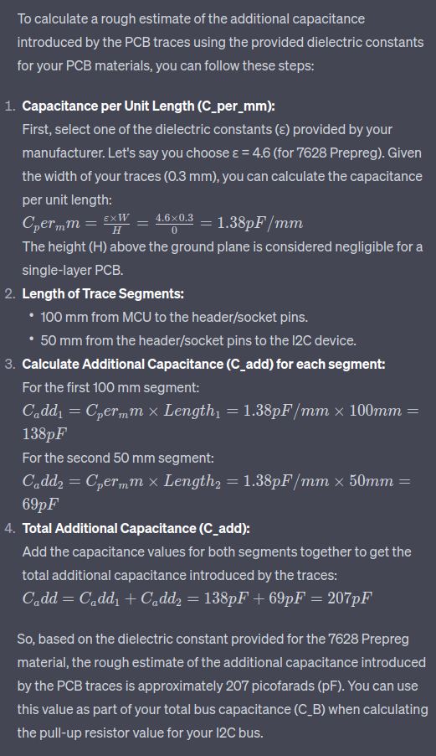
Since I’d like to have I2C fast mode, the specs for the I2C device state that the rise time of the SDA and SCL signals need to be 300ns.
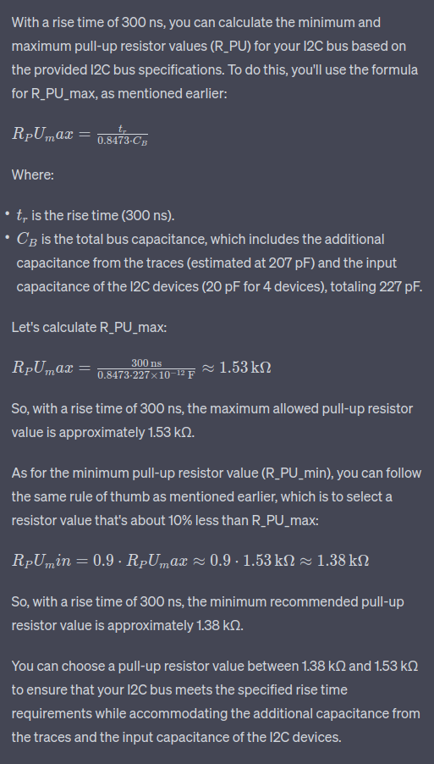
So this gives:
Pull-ups between 1.38k and 1.53k ohms.
A 1.5k 0402 will be used:
https://jlcpcb.com/partdetail/26610-0402WGF1501TCE/C25867

These will be placed near the MCU, since all 4 I2C devices should equally spread (same trace length) from the MCU pins.

Footprint / part choices

REV1

Main PCB
USB c female: https://jlcpcb.com/partdetail/Molex-1054500101/C134092 OR https://jlcpcb.com/partdetail/ShouHan-TYPE_C_16P_LTH68/C5187468
Buzzer (9x9mm SMD): https://jlcpcb.com/partdetail/1056281-Cy_SMD_90193040/C968734
Capacitors: 0603 (actually not really backed by reason, see Thoughts and questions).
Resistors: 0603 (actually not really backed by reason, see Thoughts and questions).
LEDs: 0603
- Green: https://jlcpcb.com/partdetail/EverlightElec-19_217_GHC_YR1S23T/C72043
- Orange: https://jlcpcb.com/partdetail/EverlightElec-19_21SOCTR8/C264451
- Red: https://jlcpcb.com/partdetail/EverlightElec-19_213_R6C_AN1P23T/C128250
Diode (for buzzer bypass): SOD-323, because it is readily available: https://jlcpcb.com/partdetail/2485-1N4148WS/C2128
Ferrite Bead (0603): https://jlcpcb.com/partdetail/taitech-HCB1608KF121T20/C127301
TP4056 (SOP8): https://jlcpcb.com/partdetail/772193-TP4056/C725790
Inductor for voltage regulator (3012S): https://jlcpcb.com/partdetail/Tdk-VLS3012HBX2R2M/C404494
STM32F103RCT6 (LQFP-64, 10x10): https://jlcpcb.com/partdetail/Stmicroelectronics-STM32F103RCT6/C8323
Voltage regulator TPS63000 (SON-10-EP, 3.1x3.1): https://jlcpcb.com/partdetail/TexasInstruments-TPS63000DRCR/C24966
Smitt trigger M74HC14YRM13TR(SO-14): https://jlcpcb.com/partdetail/Stmicroelectronics-M74HC14YRM13TR/C157450
LDO 3v3 for battery to Vbat pin, LD39015M33R (SOT-23-5): https://jlcpcb.com/partdetail/Stmicroelectronics-LD39015M33R/C2798212
16Mhz 10pf Crystal (3225-4p): https://jlcpcb.com/partdetail/YangxingTech-X322516MMB4SI/C112972
Boot switch (latching, slide, 2 choices with same footprint):
https://jlcpcb.com/partdetail/gswitch-MK_12C02G025/C778186 OR https://jlcpcb.com/partdetail/XkbConnectivity-SS_3292S_L2B/C500057
Main power switch (SMD, push latching):
https://jlcpcb.com/partdetail/gswitch-PS_5824SVB6PL/C5155575
OR
https://jlcpcb.com/partdetail/Yuandi-TK_6580S1/C528774

Fucntional momentary buttons(B3U-1000):
https://jlcpcb.com/partdetail/OmronElectronics-B3U1000P/C231329
OR
https://jlcpcb.com/partdetail/Yuandi-TK_6580S2/C528775
Transistor for buzzer (SOT-23): https://jlcpcb.com/partdetail/Shikues-MMBT3904/C111113
MOSFET for load disabling while charging: https://jlcpcb.com/partdetail/Pjsemi-PJM2301PSA/C411715
https://jlcpcb.com/partdetail/InfineonTechnologies-IRF9540NSTRLPBF/C33903

Pin header display PCBs female:
https://jlcpcb.com/partdetail/ConnflyElec-DS1023_212SF11/C92265
or
https://jlcpcb.com/partdetail/Dealon-DW254W_22_2085/C2936006

or
https://jlcpcb.com/partdetail/Jushuo-AFC01_S24FCA00/C262669

Pin header 2x7 stdc14 debugger connector:
https://jlcpcb.com/partdetail/Hctl-PZ127_2_07S/C3975190

Pin header 1x6 angled p2.54mm for UART:
https://jlcpcb.com/partdetail/boomele_boom_Precision_elec-C56816/C56816

Pin header 1x3 angled p2.54 for battery TEMP on/off:
https://jlcpcb.com/partdetail/boomele_boom_Precision_elec-C92159/C92159

Pin header 1x3 p1.00m for battery (JST plug):
https://jlcpcb.com/partdetail/171769-BM03B_SRSS_TB_LF_SN/C160389
or
https://jlcpcb.com/partdetail/171783-SM03B_SRSS_TB_LF_SN/C160403

pin header 1x2 p2.54 for battery:
https://jlcpcb.com/partdetail/cjt_changjiang_connectors-A2005WR2P/C225269

USB ESD protection
https://jlcpcb.com/partdetail/Stmicroelectronics-USBLC62SC6/C7519

Segment disp PCB
1x5 P 2.54 for segment display:
https://jlcpcb.com/partdetail/125689-B_2200S05PA120/C124414

Transistors to toggle LEDs on/off, and for PWM MOSFET base switching:
https://jlcpcb.com/partdetail/Mdd-SS8050/C431710

MOSFET for 5V → PWM → LEDs:
https://jlcpcb.com/partdetail/324136-AO3401A/C347476

JST PH connector print to print 2mm 6 pins side
https://jlcpcb.com/partdetail/Jst_SalesAmerica-S6B_PH_K_S_LF_SN/C157920

REV2
For REV2, it is decided to use a I2C PWM IO expander on each display board. Also the chosen STM32F103RCT6 MCU is out of stock, so this is also replaced.
I2C PWM IO expander
https://jlcpcb.com/partdetail/TexasInstruments-TLC59116IRHBR/C575579

STM32G070CBT6 MCU
https://jlcpcb.com/partdetail/Stmicroelectronics-STM32G070CBT6/C529338

I2C pull ups 1.5k +/- 1% 0402
https://jlcpcb.com/partdetail/26610-0402WGF1501TCE/C25867

Display connectors on mainboard pin socket female 1x6 shrouded p2.54mm
https://jlcpcb.com/partdetail/Dealon-DW254W_11_0685/C2935996
Display connectors on displayPCB pin socket male 1x6 straight p2.54mm
https://jlcpcb.com/partdetail/boomele_boom_Precision_elec-C37208/C37208

Thoughts and questions

Main PCB
1. Does the LDO for the Vbat pin and batt+ connection make sense? Or should I just use voltage division or a switching regulator for this? (high clock accuracy is not needed, just a clock, and a way to power backup registers when 3v3 is off)
2. Is it smart to add reverse polarity protections, or ESD protections? If so, where?
3. Any handy places to put a test point, that I have forgotten? (Testpoints for a pin-bed is a bit out of scope for V1, might add this in later though).
4. For the ADC voltage divider, what stops me from increasing resistance and buffer capacitor even more, to get less current leakage?
5. Is it a good idea to create a hard shut-off for the li-ion when it is for example < 3.0V? If so, what is a good way to do so? (the charge IC TP4056 does not have such functionality built-in).
6. Should my jumper system, to shut off the TEMP sensing of the TP4056 work? By just pulling the ‘IC_TEMP’ label to GND, the whole ‘BATT_NTC’ label, and that voltage divider will effectivly be ‘disabled’ right? Or am I also pulling the ‘Vbus’ to GND in that case?
7. When do I use larger/smaller packages for passive components? The current package sizes are just ‘randomly’ selected.
8. Do I connect USB c shield to ground? I guess so?
9. What is important to look for in an inductor? VLF4012-2R2 is recommended by datasheet for L1. VLS3012HBX-2R2M seems to roughly have the same characteristics, and is available.
10. On Page 5 (Schmitt trigger), I have a pull-up to 3v3 (47k) and a smaller 10k to create path of least resistance. Is this assumption correct? Or is the 10k not needed?
11. On Page 5 (Schmitt trigger), I there is a voltage division on pin 1 of the switches. Does it matter? I would’nt think so, since 3v3 will flow to the pin of the Schmitt trigger when the button is not pressed, else to ground.
12. Current limiting for the Schmitt trigger shouldn’t matter to much, right?
13. Is 1 3v3 pin, and 3 GND pins enough for the display PCB?
14. Any comments on the component PCB placements? I tried to put decoupling capacitors as close to their respective pins. Same for crystal oscillator. USB D+ and D- are also placed as close to the MCU pin as possible.

