**2013**

Mike Dean

NSCC Middleton

12/10/2013

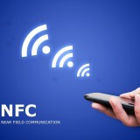

Near Field Communication:

A Trendy Idea

December 7, 2013

Greg French, Joy Brown

NSCC Instructors  
50 Elliott Road  
Lawrence town, Nova Scotia B0S 1M0

Dear Mr. French and Mrs. Brown

In this report, you will find my findings on the near field communication trend that is slowly gaining momentum.

Some sections, I believe you will find of interest are the benefits of using near field communication for both consumers and businesses, NFC technologies used outside information technology, and the future of near field communication as it stands right now.

Some limitations of my research were that near field communication is fairly new and there are mostly only digital articles and websites about the topic.

Upon further investigation, some specifics of the technology could be found if it becomes better known as it develops.

My personal opinion about near field communication is that it is only starting and with the premise that I have seen during my research, it will only get better and it has gotten me to think about whether or not to get an nfc-enabled phone.

Upon reading this document, I urge you to learn more about near field communication as it stands right now. There are many websites that will give you an accurate understanding of near field communication and future development of the technology.

I would like to thank Desiree Rice for aiding me in editing my report to the best of her ability.

Sincerely yours,   
  
Mike Dean, NSCC - Student   
  
190 Oakdene Avenue, Apt 214.

Kentville, Nova Scotia B4N 2C1

# Executive Summary

The objective is to present information to readers about what near field communication is how it works and specific benefits to both consumers and businesses.

In this report the main findings were

* Near field communication is a form of communication using radio waves to transmit (move) data from one device to another.
* It is a subset of Radio Frequency Identification (using radio waves to identify devices)
* Applications of Near Field Communication (NFC) around the world –
* In Germany - NFC Ticketing for travel
* In Pakistan –Medical uses of NFC
* Benefits for consumers and businesses
* Less time spent in lines.
* Providing and giving information quickly and easily.
* Possible downfalls of using NFC technology.
* Public Knowledge – What most people know about NFC.
* High costs.
* Future of NFC - possible ideas it could be used for
* Parking meters
* Programmable tags.

In conclusion, near field communication is definitely a trend on the rise as more and more companies and individuals see the benefits of this wireless technology to improve efficiency in many aspects of our digital lives.

Table of Contents

[Executive Summary iii](#_Toc374461083)

[Table of Figures v](#_Toc374461084)

[Introduction 1](#_Toc374461085)

[What it is 1](#_Toc374461086)

[History of NFC 1](#_Toc374461087)

[Properties of Near Field Communication 2](#_Toc374461088)

[Mechanics 2](#_Toc374461089)

[Applications of NFC in the world 3](#_Toc374461090)

[Germany 3](#_Toc374461091)

[Pakistan 3](#_Toc374461092)

[Consumer Benefits 3](#_Toc374461093)

[Contactless Payments 3](#_Toc374461094)

[Information Sharing 3](#_Toc374461095)

[Medical 4](#_Toc374461096)

[Benefits for Businesses 4](#_Toc374461097)

[Staff Communication 4](#_Toc374461098)

[Possible downfalls 4](#_Toc374461099)

[Public Knowledge 4](#_Toc374461100)

[High costs for retailers and businesses. 5](#_Toc374461101)

[What is the Future of NFC? 5](#_Toc374461102)

[Parking Meters 5](#_Toc374461103)

[Programmable tags 5](#_Toc374461104)

[Conclusion 5](#_Toc374461105)

[References 6](#_Toc374461106)

# Table of Figures

Figure 1 - RFID Tag 4

Figure 2 - NFC Tag 5

Figure 3 - Smart Poster 5

Figure 4 - NFC Interaction with tag 5

Figure 5 - NFC Card Reader 6

Figure 6 - Smart Poster Interaction 6

Figure 7 - InViu NFC Tracker 7

Figure 8 - Table of Programmable tag examples 8

Near Field Communication:

A Trendy Idea

# Introduction

As technology advances each year, the world finds itself “reinventing" ways to do things more efficiently. One of these things that can help us do this is near field communication. This report summarizes what NFC or near field communication is and how it is slowly becoming a new trend to watch for in the future.

## What it is

Near field communication is a form of contactless communication between two devices using an RF field or radio frequency field. This field is comprised of electromagnetic fields which alter in frequency as data is being transmitted between devices. Because these are essentially radio waves, the range in which the data exchange occurs is minimal and t for data to be transferred, a device must be close in proximity (distance). This is what makes NFC more secure for payments and transfers of important data between devices.

## Microchip_rfid_rice.jpgHistory of NFC

Figure - RFID Tag

NFC traces its roots back to [**radio-frequency identification**](http://en.wikipedia.org/wiki/Radio-frequency_identification), or RFID. It allows a reader (device) to send radio waves to a passive electronic tag for identification, authentication and tracking. It was first patented in 1983 by Charles Walton. One of the devices that uses this technology is called an RFID tag.. An example of these tags can be seen to the right in Figure 1. (School of Engineering, 2005)

It was not until much later that the technology seen in use today was created.

In 2002, Sony and its partner NXP Semiconductors created the new NFC technology. It was inspired by its RFID predecessor and was designed to act upon the same principles. A few years later in 2004, the **NFC forum** was created by Sony, Nokia, and Philips (NXP) to set strict standards that manufacturers must meet when designing NFC compatible devices.

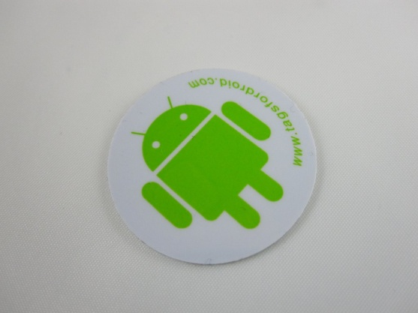Though the NFC Forum formed in 2004, it wasn’t until 2006 that the first set of specifications for NFC tags were created. NFC tags are small objects that contain information that a NFC compatible device, such as a smartphone, can read when passed. The information on the tag is usually read-only, but certain tags do allow the device reading it to write new information to it or alter old information on the tag as well. An example of one of these tags can be seen in Figure 2.

Figure - NFC Tag

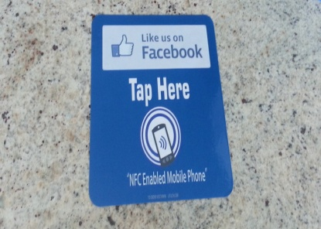

Figure - Smart Poster

In the same year, specifications for smart posters were also created. **Smart posters** hold information that an NFC compatible device can read when passed over it. It can provide different kinds of information, such as information about an artwork hanging in a museum or a short biography of a famous person on a poster. For example in figure 3, the tag contains a link to like a certain group or page on facebook.

In 2009, peer-to-peer applications also known as P2P were applied to the specifications of NFC technology which allowed users to send pictures, music, and movies to other enabled phones using Bluetooth or other NFC compatible communications(e.g wireless).

# header_16.pngProperties of Near Field Communication

Figure - NFC Interaction with tag

## ****Mechanics****

Your smartphone or other NFC compatible device sends out radio frequency signals, which interact with NFC tags found in compatible card readers and smart posters.

The signal creates a current that flows through the NFC tag and allows the device and tag to communicate with one another. Typically one device (the tag) is passive and only sends out information while the other device (the smartphone) reads that information and information is hence sent back and forth.

An example of these interactions is in Figure 4.

# Applications of NFC in the world

## ****Germany****

“In 2008, German rail operator Deutsche Bahn launched an NFC-ticketing pilot program in which 200 travelers touched their phones to an NFC tag when they boarded the train and then to another when they got off. The fare was calculated and added to their monthly bill. In January 2010, the successful program was expanded to an additional 3,000 travelers.”

## ****Pakistan****

A program was developed that helps track patients in low resource areas and was used in a pneumonia study of young children in Pakistan. Each child was given a bracelet with an RFID tag in it. Each time the child was brought in, the tag was scanned and all relevant data was sent off to labs for analysis.

# nfcpayment.jpgConsumer Benefits

## ****Contactless Payments****

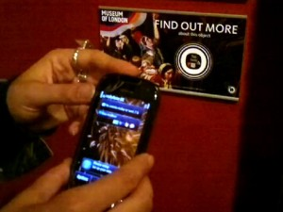One of the most well known benefits to consumers is contactless payments. By swiping their smartphone over a card reader to make a purchase, their credit or debit card is debited the amount of the transaction. By removing the need to carry cards, it simplifies the process and makes it quick and efficient. (Bodhani, 2013)

Figure - NFC Card Reader

## ****Information Sharing****

Another benefit is the ease of sharing information from one person to another. Because NFC tags do not rely on a battery and are powered by the radio waves sent out by other NFC devices, they are extremely portable which means they can virtually go everywhere. This is a definite benefit for consumers as it makes it simple for anyone to get information from smart tags in posters, displays and other phones. An example is shown in Figure 6.

Figure - Smart Poster Interaction

## ****Medical****

With NFC technology, hospitals could track patient information and doctors’ notes easily in real-time. Each time a nurse or doctor visits the patient, they can make note of any changes in symptoms and record what medicine was given at a certain time. This helps to prevent the wrong medications being given to the wrong patients and creates a system focused on the best patient care.

# ecdbc3c0ff.pngBenefits for Businesses

Figure - InViu NFC Tracker

Staff Communication  
  
NFC tags can allow employees to check in and record time spent working and time spent on breaks. Knowing where employees are at any given time is important factor for a manager to keep his business running smoothly. This could result in a manager knowing exactly if an employee is taking too much time for his breaks or working more or less hours than specified. An example of this is an application for an Android phone to track time with NFC tags.

(Enaikoon)

See Figure 7   
Improved Customer Service  
  
Cutting down on wait times is something every customer appreciates; NFC would allow customers to pre-load coupons into their smartphone or collect store reward points automatically. Having everything in one place means a customer never misses an opportunity for savings because they forgot coupons or cards at home. Also, cashiers would no longer have to scan separate coupons or type in complex discounts, thus saving customers even more time per transaction. (Bodhani, 2013)

# Possible downfalls

## ****Public Knowledge****

One of the most general reasons for NFC to fail is the lack of public knowledge of how secure and safe it is. As well, most people do not like having credit card information amongst other things stored on their mobile device as they can easily be stolen. As well consumers and businesses are unable to see the big picture of what NFC technology can do for them. (Osbourne, 2013)

## ****High costs for retailers and businesses.****

As costs rise for equipment, many businesses are unable to afford new and updated systems that incorporate NFC into their payment, information systems. Because of the high costs, many businesses do not weigh the benefits more than the costs and therefore it puts the technology at a disadvantage.

(Osbourne, 2013)

# What is the Future of NFC?

## ****Parking Meters****

A prime example of where NFC could possibly go in the future would be: enabling customers to pay for their parking with NFC. It would greatly improve the system already implemented for parking meters. By paying with your phone, you could get a notification of when the meter is about to expire and you could opt to pay for more time with the touch of your device. (Hill, 2012)

## ****Programmable tags****

A great way to promote the use of NFC technology is to allow consumers to make use of the technology relevant to them. For example programmable tags allow the possibility of creating different tags for different locations, times and events. For examples see figure 8. (Hill, 2012)

|  |  |  |
| --- | --- | --- |
| Place: | Setting 1 | Setting 2 |
| Home | Turn Wi-fi On | Turn Data Network off |
| Work | Turn off Ringer | Turn on Wi-fi |
| Traveling | Data Network on | Open apps etc. |

Figure 8 - Table of Programmable tag examples

# Conclusion

Near field communication is a form of contactless communication that uses radio waves to transfer data between two compatible devices. One of the more prevalent ideals that come from using NFC technology is the idea of convenience and efficiency.

There are many applications of NFC that are being used today and there are plans for where it can go, such as making parking meters able to accept nfc payments or the customization of your own nfc tags. Even though there are some downfalls that could hinder the adoption of NFC technology, near field communication has proven itself to be a worthy concept and because of this, it is slowly becoming a trend that will adapt and grow.

# References

Bodhani, A. (2013, August 1). *New Ways to Pay.* Retrieved December 2013, from http://web.ebscohost.com.ezproxy.nscc.ca:2048/ehost/detail?sid=bb174def-ddbf-45a6-bf0a-3749765fd603%40sessionmgr4003&vid=1&hid=4201&bdata=JnNpdGU9ZWhvc3QtbGl2ZQ%3d%3d

Communication, N. F. (nd). *Near Field Communication*. Retrieved 11 20, 2013, from Nearfieldcommunication.org: http://www.nearfieldcommunication.org

Enaikoon. (n.d.). *Inviu NFC tracker*. Retrieved December 2013, from Enaikoon: http://www.nfc-tracker.com/

Hill, S. (2012, August 21). *Digital Trends*. Retrieved December 2012, from A dozen ways NFC could change your life: http://www.digitaltrends.com/mobile/ways-nfc-could-change-your-life/

Kessler, S. (2010, May 6). *NFC Technology: 6 ways it could change our daily lives*. Retrieved December 2013, from Mashable: http://mashable.com/2010/05/06/near-field-communication/

Osbourne, R. (2013, October 17). *Downfalls of Near field communication.* Retrieved December 2013, from prezi: http://prezi.com/8rkdzlptcts\_/possible-downfall-of-near-field-communication/

School of Engineering, M. (2005, May). *Inventor of the week*. Retrieved December 2013, from Lemelson - MIT: http://web.mit.edu/invent/iow/waltonc.html