# Student Name: Mike Dean

# Network Tools Assignment

In each step you will be asked to provide a screen cap and/or provide an answer to a question. Once complete, save this document, and upload to moodle.

## Instructions

For each task below, carry out the steps, then answer the question.

## Step 1: Configuration

Use the appropriate command to determine the following:

Your computer’s IP address. 10.25.228.12

Your computer’s default gateway. 10.25.231.254

Your computer’s DHCP server. 10.25.1.5

Your computer’s MAC address. F6-B7-E2-44-E7-C0

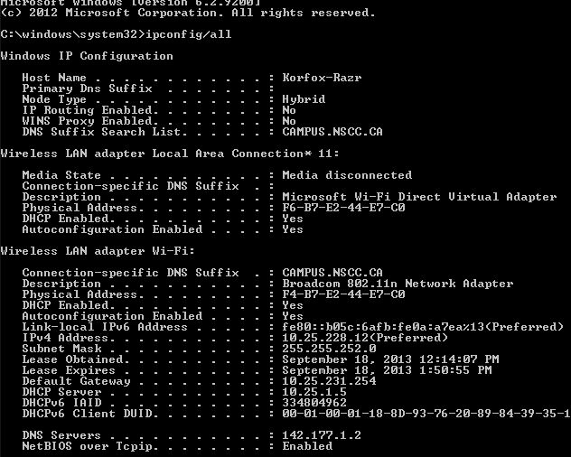

## Step 2: Ping

Use the ping command to ping two different servers – google.ca, and pravda.ru. Paste a screen capture showing the two results. Answer the following: Other than the obvious difference in IP addresses, how do the results of the two pings differ, and why?

The pings differ in that it took longer for the ping to reach Pravda.ru than it took to get to google.ca because the server containing pravda.ru is located farther away then the server containing google.ca in relation to our computer which sent the ping.

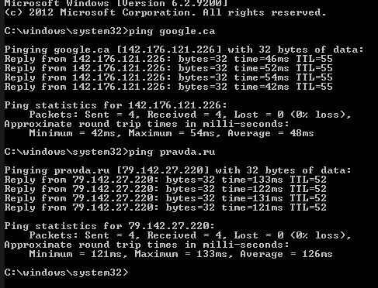

## Step 3: Route to destination

Use the appropriate command to examine the route to google.ca. Paste screen cap here

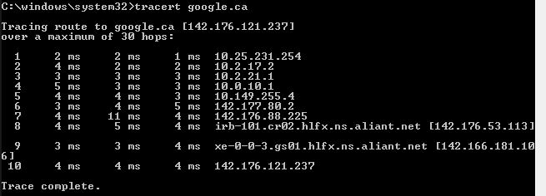

## Step 4: DNS

Use the appropriate command to find the name of the server with the IP address 175.111.69.153. Paste screen cap here.

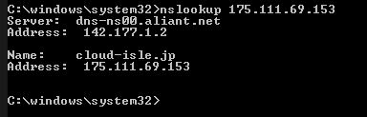

## Step 6: Troubleshooting

**a)** What is the most appropriate command line tool to use to quickly determine Connectivity to a specific host?

The most appropriate command line tool to efficiently determine connectivity to a specific host is the ping tool.

**b)** You receive complaints that people at your organization are unable to reach any websites. A little checking shows access to network printers and shared folders, but no websites. You try to use ping, but receive the message “Ping request could not find host google.com”. However, you are able to ping using Google’s IP address.

What might the problem be? Explain. The problem might be that their dns servers are down and that is why they are unable to get to websites by their website address but are still able to reach them via ip address.

What command-line tool or tools might be used to investigate?

The tools that might be used to investigate would be the ping tool and the nslookup tool. And you may also use ipconfig /displaydns as well to see the information displayed there for dns servers.

**c)** What would be the result of a DHCP server becoming unavailable? What command line tools could you use to diagnose this problem? What configuration changes to your PC might be required?

The result of a DHCP server becoming unavailable would be that anything that requests, renews or obtains an ip address or dns server address from that server would be unable to do so during that downtime which result in a loss of connectivity to the internet or unable to view websites by entering their website address.

The command line tools you could use to diagnose this problem are ipconfig/all and ipconfig /displaydns to see whether or not there are dns servers reachable.

The configuration changes to a PC that may be required are to release its current ip address and/or renew the ip address that is currently being used. Also you could flush the dns cache so that it flushes and resets what the cache contains forcing it to retrieve new content from the dhcp server.