|  |
| --- |
| NSCC Middleton |
| Emulation vs. Simulation |
|  |
| **Technical Foundations** |
| **Mike Dean** |
| **10/6/2013** |

|  |
| --- |
|  |

Emulation vs. Simulation

# Introduction:

There are many different views on the internet about what emulation and simulation mean. These terms are often misused because many are unable to determine exactly what each term means and use them in the proper context. In this report, I will summarize what emulation and simulation are, show examples of each, and explain the certain similarities/differences between them.

# What is Emulation?

Making software behave exactly as it would on its own hardware and making it abide or listen to the rules that govern how it should run or executed. It is an exact complete copy of the original system but it is made to operate in a completely different environment than what it was originally executed in.

## Example of Emulation

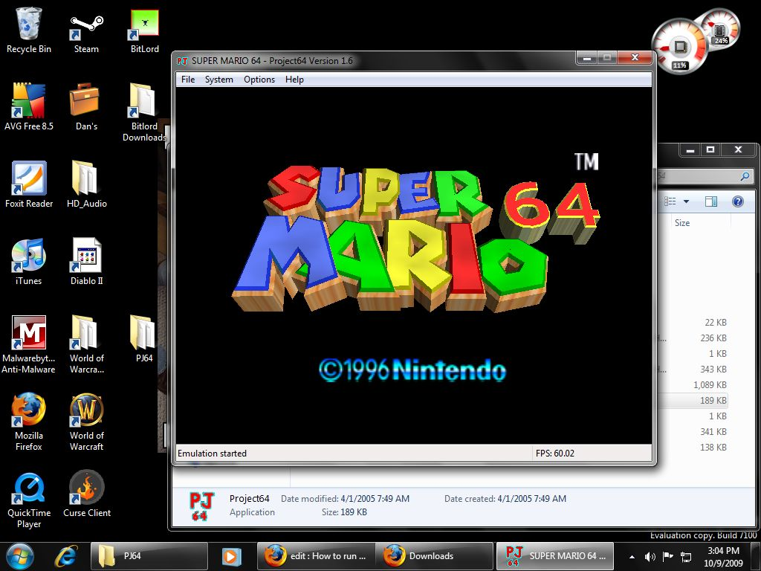

An example of emulation would be an emulator application on your computer or Smartphone. For example Project 64 loads the ROM for Super Mario 64 into an environment where it believes its being run on a Nintendo 64 and behaves exactly the same as it would have in the original gaming console itself as if you had the console in front of you.

# What is Simulation?

A simulation is the computer’s reproduction of a particular scenario or system that is designed to act like the real system or scenario. The reproduction simulates the basic behavior of the system or scenario but doesn’t have to listen to the rules of that system/scenario. It is an effective way of seeing how something works or how a scenario will play out.

## the-sims-3.jpgExample of Simulation

An example of simulation would be a simulation game like “The Sims”. You simulate everyday life but are not bound to the laws of the real world. Basically you are allowed to change different aspects of the world the Sims live in by changing their appearance, where they live and dictate when or where they go to do an everyday task.

# Similarities and Differences

## Similarity:

The similarity between emulation and simulation is that they both work on the premise of copying or imitating a system and making it run in a totally different system.

## Differences:

The differences between emulation and simulation are:

* Emulation is limited as it is mainly used to emulate computer hardware systems so in essence it is a computer system simulator but can also emulate anything that can be reduced down to a software program.
* Simulation is not limited to just simulating systems and software, it can also be used to simulate scenarios and other important situations.
* A key difference between emulating and simulating is that in emulation, you are bound to the rules of the native system being emulated, and any errors that may occur if something goes wrong. But in simulation, you are not necessarily bound to those rules and you may bend or break them to the need of the one using the simulation.

# Conclusion

In conclusion, we can say that emulation is an imitation or copy of a system that is bound to the rules of the original system being emulated. It is limited to computer systems but you are able to emulate hardware that may not exist anymore or hard to acquire. Also we can say that a simulation is the computer reproduction of a scenario or system that is not bound to the rules of the original but is a way to see how system works or how a scenario will play out without actually having to be in that scenario or use the actual system.

# Sources

* Michael Signal. (n.d). Emulation vs. Simulation. In e-how. Retrieved October 6 2013, from http://www.ehow.com/about_7216799_emulation-vs_-simulation.html.
* James McIlhargey. (n.d). Difference between Simulator and Emulator. In e-how. Retrieved October 6 2013, from http://www.ehow.com/info_8582388_difference-between-simulator-emulator.html.
* Frank Boosman. (Nov 9 2012). Simulation versus Emulation. In z-shift. Retrieved October 6 2013, from http://www.zshiftgroup.com/blog/simulation-versus-emulation-1284/.
* S.Robins. (Feb 13 2012). What's the difference between simulation and emulation. In Programmer's Stack Exchange. Retrieved October 6 2013, from http://programmers.stackexchange.com/questions/134746/whats-the-difference-between-simulation-and-emulation.