**Assignment1**

**KONG, Kangyi**

**20413394**

System: Linux neutrino-VirtualBox 5.4.0-51-generic #56-Ubuntu SMP Mon Oct 5 14:28:49 UTC 2020 x86_64 x86_64 x86_64 GNU/Linux

**QUESTION 1**

1. **Run the command ”top”**

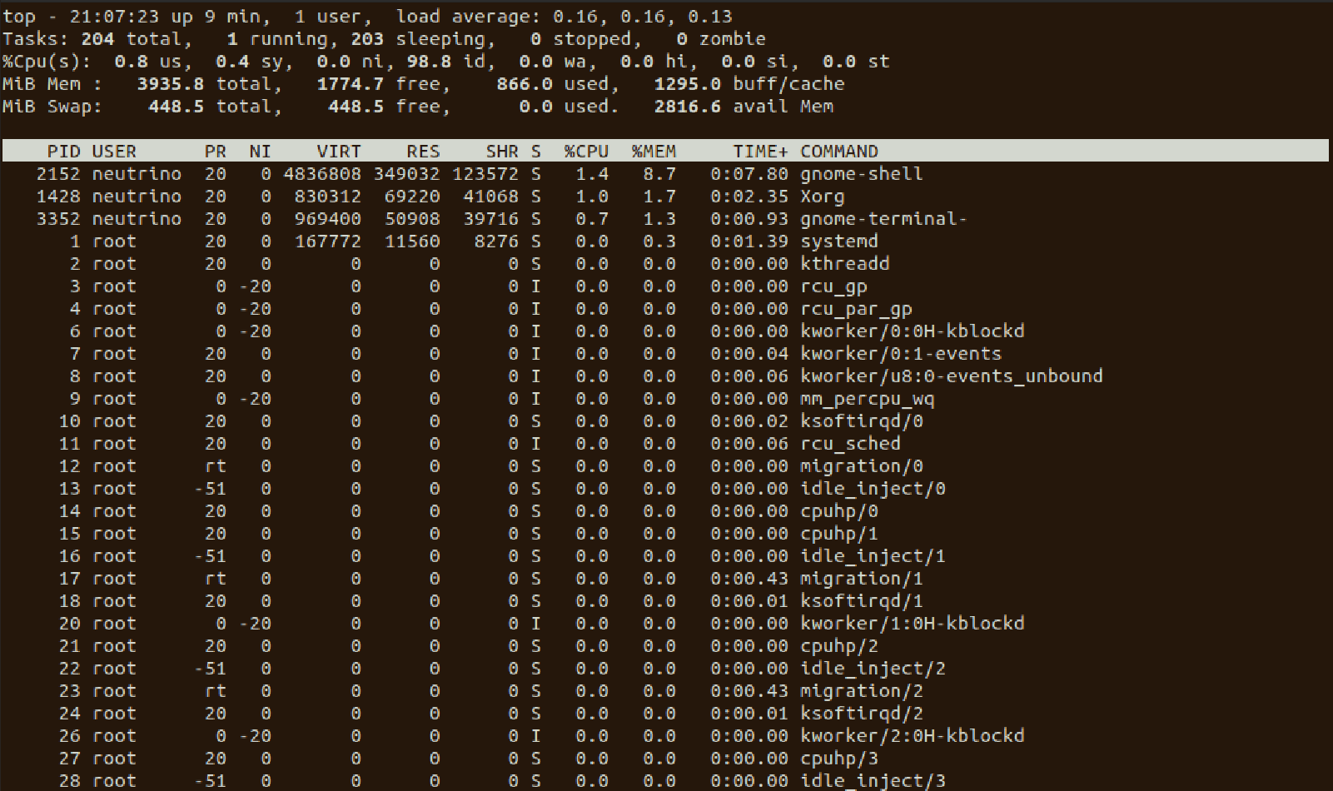

1. **Memory hierarchy diagram**

$getconf -a | grep CACHE_SIZE>result.txt

#(get the configuration)|(Search for key word “CACHE_SIZE”)

# >(overwrite the result into result.txt)

LEVEL1_ICACHE_SIZE 32768

LEVEL1_DCACHE_SIZE 32768

LEVEL2_CACHE_SIZE 262144

LEVEL3_CACHE_SIZE 16777216

LEVEL4_CACHE_SIZE 0

1. **Run ” cd /; tree | head -n 15”**

#(change directory to root);(plot the tree diagram of the directories)|(displaying from the beginning while limiting to 15 lines)

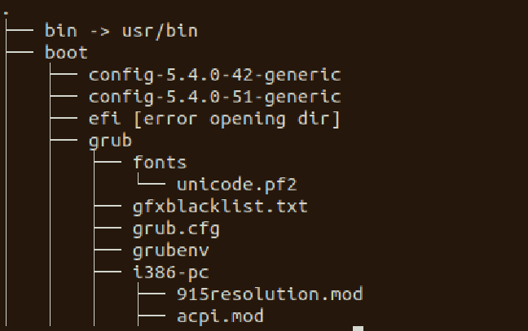

**QUESTION 2**

#see hw1_q2.sh

#the output will be put into “dir100”

**QUESTION 3**

#see hw1_q3_1.sh, hw1_q3_2.sh