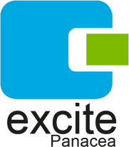

Office Address: 2 Pade Odanye Street, Harmony Enclave. Allen Avenue. Ikeja, Lagos.
Email: info@excitepanacea.com
Tel: 234(0)90 69444460

January 30th 2023.
The State Coordinator,
National Youth Service Corps,
Lagos State,
Nigeria.
Dear Sir/Madam,

CLEARANCE LETTER
This is to certify that ADENIYI PETER OLUWATOSIN, a corps member with NYSC code NYSC/BCU/2023/290470 and state code LA/23C/10151, has diligently served in our organization, Excite Panacea Limited. He has consistently demonstrated punctuality and regularity in his work.

Yours sincerely,
FOR: EXCITE PANACEA LIMITED

Evelyn Obekpa
HR Manager
(eobekpa@excitepanacea.com)

Excite Panacea Limited© 2023- All Rights Reserved.
Website: www.excitepanacea.com
Tel: 234(0)9069444460
Email:info@excitepanacea.com

