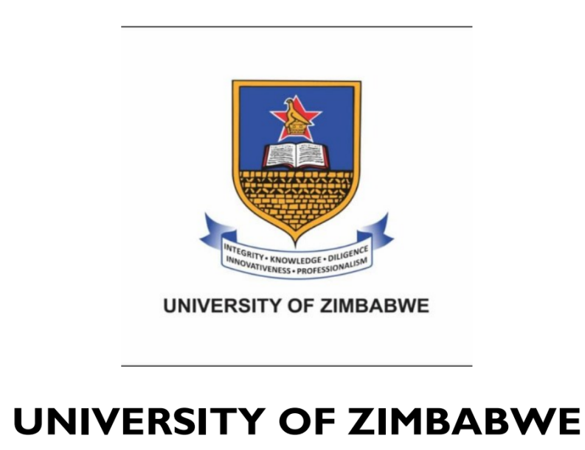

Faculty: Computer Engineering Informatics and Communications

Department: Computer Science

HCS201/HCC201/HAI201: Object Oriented Programming
Member | Reg Number | Course
Victor Motsi | R2528731 | HCS
Lizbertin Mpofu | R2528662 | HCC
Akatendeka Mashaya | R2528684 | HCC
Kelly T Nyakujara | R2528728 | HCS
Faith Zvokuomba | R2528656 | HCC

DPDMS System Documentation
Rushinga Provincial Disaster Monitoring and Management System

1. Overview
DPDMS captures hazard incidents at ward level, routes each one through a hazard-specific approval, publishes approved incidents to a dashboard and map, produces reports, and sends email and WhatsApp alerts.
It covers five hazards around Rushinga Province: floods, droughts, fires, zoonotic diseases and mining accidents. Each hazard is its own Spring Boot microservice with its own MySQL database, so any one can be built, run and deployed alone.
- Code: github.com/Nevada257/DPDMS, branch main

Team
Each member built one hazard end to end; the group then built the shared services and integrated the system together.

2. Architecture
The React front end talks only to the API Gateway. The gateway finds every service through Eureka, so services can move port or run several copies without any configuration change.
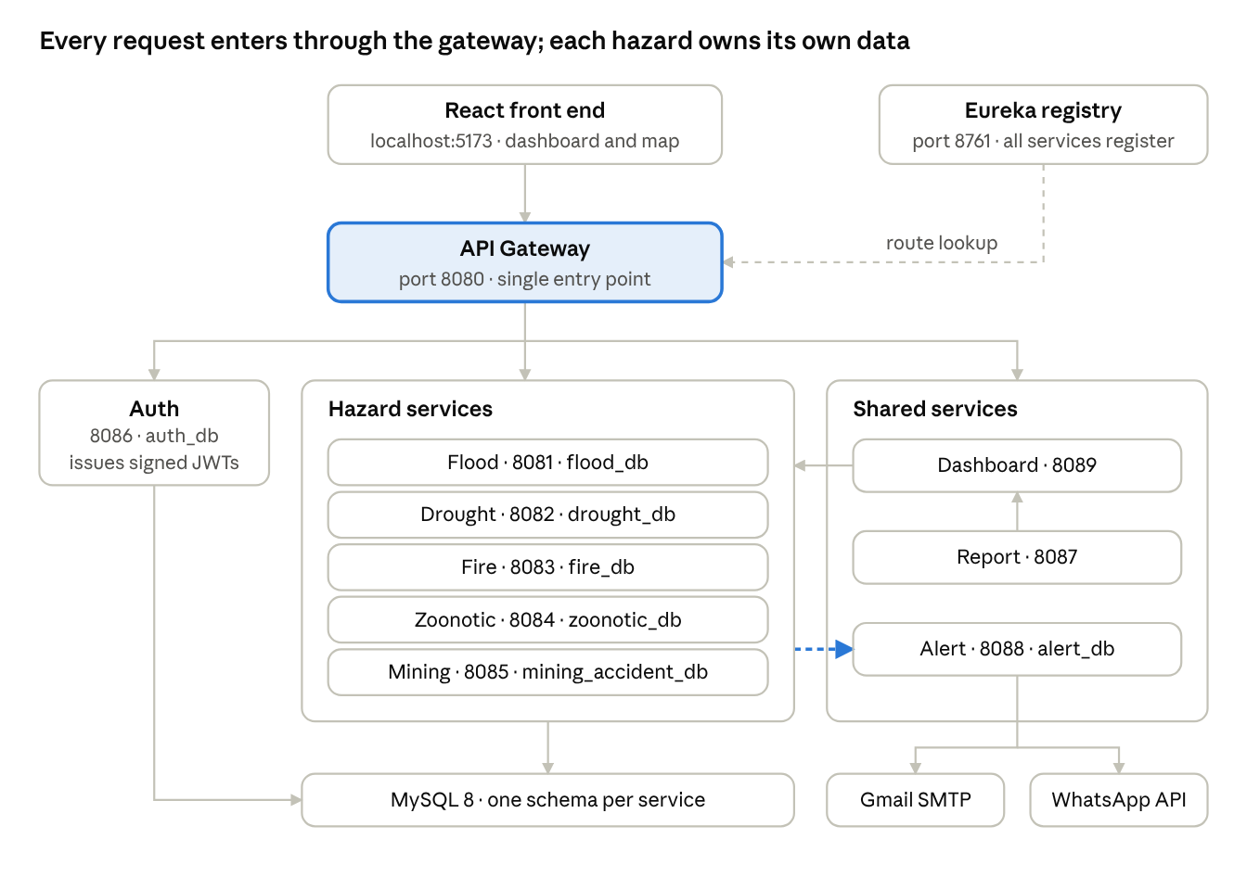
DPDMS architecture · 11 services
The dashed accent arrow is the alert: after a capture, a hazard service posts to alert-service without waiting for the reply. Dashboard and report calls forward the caller's own JWT, so each hazard service applies its own access rules again.

Services and ports
Service | Folder | Port | Database | Purpose
API Gateway | dpdms-api-gateway | 8080 | none | Single entry point, routing, CORS
Flood | flood | 8081 | flood_db | Flood incidents and workflow
Drought | drought | 8082 | drought_db | Drought incidents and workflow
Fire | fire | 8083 | fire_db | Fire incidents and workflow
Zoonotic disease | zoonotic-disease-service | 8084 | zoonotic_db | Zoonotic incidents and workflow
Mining accident | mining-accident-service | 8085 | mining_accident_db | Mining accidents and workflow
Auth | auth-service | 8086 | auth_db | Login, BCrypt passwords, signed JWTs
Report | report-service | 8087 | none | PDF, DOCX, XLSX and CSV files
Alert | alert-service | 8088 | alert_db | Alert rules, email, WhatsApp, delivery log
Dashboard | dashboard-service | 8089 | none | Approved incidents: counts, trends, map
Eureka | discovery-service | 8761 | none | Service registry
Front end | flood-frontend | 5173 | none | React app with every hazard, dashboard and map

Gateway routes
Path | Goes to
/api/auth/** | auth-service (the /api prefix is stripped)
/api/floods/** | flood
/api/drought/** | drought
/api/fire-incidents/**, /api/audit/** | fire
/api/zoonotic-incidents/**, /api/audit-trails/** | zoonotic
/api/mining-accidents/** | mining
/api/reports/** | report-service
/api/alerts/** | alert-service
/api/dashboard/** | dashboard-service

Technology
- Back end: Java 21, Spring Boot (Web MVC, Data JPA, Security, Validation, Actuator), Spring Cloud Eureka and Gateway, JJWT, springdoc-openapi.
- Database: MySQL 8, one schema per service. No service reads another's database.
- Front end: React 19 with Vite and react-leaflet (OpenStreetMap).
- Why REST, not a message broker: it keeps the deployment small, with no broker to run, while alerts are still sent asynchronously.
- Why React, not Thymeleaf: the dashboard is very interactive (filters, live counts, a map with pop-ups), and a front end that uses only the REST API keeps every service stateless.

3. What every hazard service shares
All five hazard services follow the same pattern, so sections 4 to 8 only describe what is specific to each disaster.
- Own service, own database: each can be built, run and deployed alone.
- REST CRUD: list (GET), get one (GET /{id}), create (POST), update (PUT /{id}), delete (DELETE /{id}).
- Approval workflow and audit trail: see section 10.
- Scoping filter: refuses tokens for another hazard with 403 (see section 9).
- Alert call: after a capture or edit, posts to alert-service without waiting.
- Swagger UI at http://localhost:<port>/swagger-ui.html and health at /actuator/health.
Every record carries the same metadata:
- ward, district and province
- date and time of occurrence
- reporter (always taken from the login token)
- severity: LOW, MEDIUM, HIGH or CRITICAL
- approval status
- GPS latitude and longitude, captured on entry
The endpoint paths and status names differ a little because each member built their own service. The dashboard hides these differences.

4. Flood
The flood service records river and flash floods, and alerts when water reaches the danger level.
Built by | @Nevada257
Folder | flood
Port | 8081
Database | flood_db
Base path | /api/floods
Demo users | flood_recorder (Ward 1), flood_recorder_w2 (Ward 2), flood_supervisor
Key indicators
- Peak water level (m)
- River basin
- Households displaced
- Area flooded (ha)
- Duration of inundation (days)
Workflow endpoints
Action | Endpoint
Approved records | GET /api/floods/approved
Approve | POST /api/floods/{id}/approve
Reject | POST /api/floods/{id}/reject
Request corrections | POST /api/floods/{id}/corrections
Audit trail | GET /api/floods/{id}/audit
Status sent back for corrections: CORRECTIONS_REQUESTED
Alert when: peak water level is 3.0 m or more (FLOOD_DANGER_LEVEL_M), or severity is HIGH or CRITICAL.
Tests: HazardScopingFilterTest, FloodIncidentControllerScopingTest (ward scoping and visibility), FloodApprovalWorkflowTest, FloodApiIntegrationTest.

5. Drought
The drought service tracks dry spells and their effect on crops, water and livestock.
Built by | @Trixxie-art
Folder | drought
Port | 8082
Database | drought_db
Base path | /api/drought/incidents
Demo users | drought_recorder (Ward 1), drought_supervisor
Key indicators
- Rainfall deficit (mm)
- Consecutive dry days
- Crop failure (%)
- People facing water shortages
- Livestock deaths
Workflow endpoints
Action | Endpoint
Approved records | GET /api/drought/incidents/approved
Approve | PATCH /api/drought/incidents/{id}/approve
Reject | PATCH /api/drought/incidents/{id}/reject
Request corrections | PATCH /api/drought/incidents/{id}/request-correction
Audit trail | GET /api/drought/incidents/{id}/audit
Status sent back for corrections: CORRECTION_REQUESTED
Alert when: crop failure is 50% or more (DROUGHT_CROP_FAILURE_PCT), or severity is HIGH or CRITICAL.
Tests: HazardScopingFilterTest, DroughtIncidentServiceTest, DroughtIncidentControllerTest, DroughtApiIntegrationTest.

6. Fire
The fire service records veld and structure fires and whether each one is still burning.
Built by | @aka-hub-hub
Folder | fire
Port | 8083
Database | fire_db
Base path | /api/fire-incidents
Demo users | fire_recorder (Ward 1), fire_supervisor
Key indicators
- Area burned (ha)
- Suspected cause: NATURAL, ACCIDENTAL or DELIBERATE
- Injuries or fatalities
- Structures destroyed
- Active or contained
Workflow endpoints
Action | Endpoint
Approved records | GET /api/fire-incidents/approved
Approve | PUT /api/fire-incidents/{id}/approve
Reject | PUT /api/fire-incidents/{id}/reject
Request corrections | PUT /api/fire-incidents/{id}/correction
Audit trail | GET /api/audit/{incidentId}
Status sent back for corrections: NEEDS_CORRECTION
Alert when: the fire is still active (not contained).
Tests: HazardScopingFilterTest, FireIncidentServiceTest, FireApiIntegrationTest.

7. Zoonotic disease
The zoonotic service records animal diseases that can pass to people, such as anthrax and rabies.
Built by | @mpofutinah-dev
Folder | zoonotic-disease-service
Port | 8084
Database | zoonotic_db
Base path | /api/zoonotic-incidents
Demo users | zoonotic_recorder (Ward 1), zoonotic_supervisor
Key indicators
- Disease (for example anthrax, rabies, brucellosis)
- Animal species
- Confirmed human cases
- Confirmed animal cases
- Classification: CLUSTER or OUTBREAK
Workflow endpoints
Action | Endpoint
Records (filtered by role; national sees approved only) | GET /api/zoonotic-incidents
Approve | POST /api/zoonotic-incidents/{id}/approve
Reject | POST /api/zoonotic-incidents/{id}/reject
Request corrections | POST /api/zoonotic-incidents/{id}/request-correction
Audit trail | GET /api/audit-trails/{incidentId}
Status sent back for corrections: CORRECTION_REQUIRED
Alert when: classified as a cluster or outbreak, or there is any confirmed human case.
Tests: ZoonoticIncidentServiceTest.
Note: this service keeps its own users table, so its role column must be text (VARCHAR). database/05_zoonotic_db.sql makes that change.

8. Mining accidents
The mining service records accidents at formal and artisanal mines, with rescue status.
Built by | @faye904
Folder | mining-accident-service
Port | 8085
Database | mining_accident_db
Base path | /api/mining-accidents
Demo users | mining_recorder (Ward 1), mining_supervisor
Key indicators
- Mine name and type: FORMAL or ARTISANAL
- Accident type: COLLAPSE, GAS_EXPLOSION, FLOODING or FALL_OF_GROUND
- Trapped or injured miners
- Fatalities
- Rescue ongoing
Workflow endpoints
Action | Endpoint
Approved records | GET /api/mining-accidents/approved
Records by status | GET /api/mining-accidents/status/{status}
Approve | POST /api/mining-accidents/{id}/approve
Reject | POST /api/mining-accidents/{id}/reject
Request corrections | POST /api/mining-accidents/{id}/request-correction
Audit trail | GET /api/mining-accidents/{id}/audit
Status sent back for corrections: CORRECTION_REQUESTED
Alert when: there are any fatalities, or trapped or injured miners.
Tests: HazardScopingFilterTest, MiningApprovalWorkflowTest, MiningApiIntegrationTest.

9. Security and roles
Every service checks the user's role, hazard and ward itself. The front end only hides buttons; the back end is what enforces the rules.

Demo accounts
Every demo account uses the password password123. auth-service creates them on start-up if they are missing.
Username | Role | Hazard | Ward | What they can do
flood_recorder | RECORDER | FLOOD | Ward 1 | Capture and edit their own flood records in Ward 1
flood_recorder_w2 | RECORDER | FLOOD | Ward 2 | The same in Ward 2 (shows ward scoping)
drought_recorder | RECORDER | DROUGHT | Ward 1 | Capture drought records
fire_recorder | RECORDER | FIRE | Ward 1 | Capture fire records
zoonotic_recorder | RECORDER | ZOONOTIC | Ward 1 | Capture zoonotic records
mining_recorder | RECORDER | MINING | Ward 1 | Capture mining records
flood_supervisor | SUPERVISOR | FLOOD | any | Approve, reject or return flood records
drought_supervisor | SUPERVISOR | DROUGHT | any | The same for drought
fire_supervisor | SUPERVISOR | FIRE | any | The same for fire
zoonotic_supervisor | SUPERVISOR | ZOONOTIC | any | The same for zoonotic
mining_supervisor | SUPERVISOR | MINING | any | The same for mining
provincial_admin | ADMIN | ALL | any | Read-only; sees pending records; manages users, subscribers and test alerts
national_user | NATIONAL | ALL | any | Read-only; approved records, dashboard and reports only
Only an ADMIN can create new users (POST /api/auth/register), so nobody can give themselves a role.

How scoping works
- The token carries the scope. On login, auth-service signs a JWT with the shared JWT_SECRET. It holds the user's role, hazardScope and ward. Recorders and supervisors get exactly one hazard; only ADMIN and NATIONAL get ALL.
- Each hazard service checks the hazard first. A filter runs before any controller and returns 403 Forbidden unless the token's hazard is the service's own, or the hazard is ALL and the role is NATIONAL or ADMIN. A flood supervisor calling the drought service is refused by the drought service itself.
- Roles decide the operation (see the table below).
- Ward is checked on the record. A recorder cannot capture for another ward, and can only edit or delete their own records that are not yet approved.
- Shared services apply the same scope. The dashboard only asks for hazards in the caller's scope and forwards the caller's token. The alert service refuses alerts for another hazard. Reports come from the dashboard feed, so they inherit the same rules.
Operation | RECORDER | SUPERVISOR | ADMIN | NATIONAL
Create, update, delete | Yes (own ward, own records) | No | No | No
Approve, reject, request corrections | No | Yes (own hazard) | No | No
Read approved records | Yes | Yes | Yes | Yes
Read pending records | Own only | Yes | Yes | No

Other protections
- Ward box is locked on purpose: in the capture form, a recorder's Ward is filled in with their own ward and cannot be changed. This is ward-level scoping, not a bug; the back end also rejects any other ward with 403.
- Passwords are hashed with BCrypt.
- Input is validated (for example latitude between −90 and 90, no negative counts).
- All database access uses JPA parameter binding, which prevents SQL injection.
- React escapes everything it displays, which prevents XSS.
- No password, key or token is in the code. They all come from dpdms.env, which git ignores.

10. Approval workflow and audit trail
Every new record starts as PENDING, and only the supervisor of that hazard can move it on.
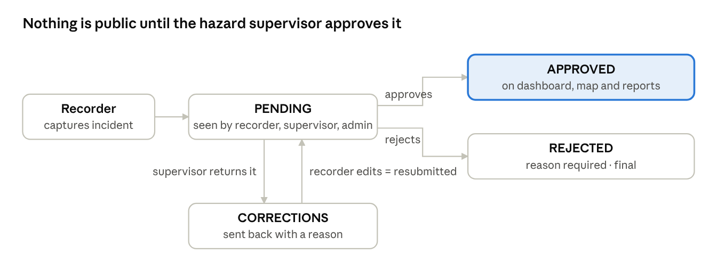
approval workflow · 4 states

Rules
- A new record is always saved as PENDING, whatever status the client sends. Editing never changes the approval status directly.
- Only PENDING records can be approved, rejected or sent back. Approving twice, or approving a rejected record, returns 400.
- Rejecting and requesting corrections both need a reason, which is stored on the record.
- When the recorder edits a record that was sent back, it returns to PENDING automatically.
- A recorder cannot edit or delete an approved record.
- A pending record is visible only to the recorder who captured it, that hazard's supervisor and the provincial admin. It never appears for national users, on the dashboard, on the map or in reports.

Audit trail
Every change is written to the service's audit table: capture, edit, resubmission, approval, rejection, correction request and deletion. Each entry records:
- who acted, taken from the signed token (never from a request field);
- when it happened;
- what changed: the old and new status, and the reason.
Example: GET /api/floods/{id}/audit.
Status names differ slightly between services, for example CORRECTIONS_REQUESTED in flood and NEEDS_CORRECTION in fire. The dashboard normalises them.

11. Alert service
alert-service (port 8088) decides whether an incident is serious enough to alert on, then sends email and WhatsApp messages in the background and logs every attempt.

How an alert is raised
- A recorder captures or edits an incident.
- The hazard service posts a summary (metadata, GPS and the five indicators) to POST /api/alerts/incidents. It forwards the user's token and does not wait for a reply.
- alert-service checks the rules below. If they match, it replies 202 Accepted at once.
- A background thread pool sends the alert to every active subscriber of that hazard, by email and by WhatsApp.
- Each attempt is saved in the alert log.
If alert-service is down, capture still succeeds; the hazard service only logs a warning.

When an alert is sent
Hazard | Alert when | Setting
Flood | peak water level ≥ 3.0 m, or severity HIGH or CRITICAL | FLOOD_DANGER_LEVEL_M
Drought | crop failure ≥ 50%, or severity HIGH or CRITICAL | DROUGHT_CROP_FAILURE_PCT
Fire | the fire is still active (not contained) | none
Zoonotic | classified as a cluster or outbreak, or any confirmed human case | none
Mining | any fatalities, or trapped or injured miners | none
The message includes the location, severity, the reason for the alert and a Google Maps link to the GPS point.

Reliability
- WhatsApp provider: alerts go through Green API when the three GREENAPI_ settings are filled in (no 24-hour window, no expiring token). Otherwise they go through the Meta WhatsApp Cloud API.
- A failed send is retried up to 3 times, 2 seconds and then 4 seconds apart.
- With the Meta Cloud API, WhatsApp only delivers free text to a number that messaged the business number in the last 24 hours. Outside that window, the service automatically sends the approved template message instead (hello_world by default, set by WHATSAPP_TEMPLATE) and notes this in the log.
- The provincial admin can press Send test alert on the dashboard (POST /api/alerts/test) to check both channels before a demo.

Delivery log
Every attempt is stored in alert_log with hazard, incident, channel, recipient, time, number of tries and status:
- SENT: the provider accepted it;
- FAILED: the provider returned an error, stored in brackets on the dashboard;
- SIMULATED: no email or WhatsApp settings were configured.
Supervisors see the log for their own hazard; admin and national users see everything (GET /api/alerts/logs). The dashboard shows it under Recent alerts sent.

Subscribers
The provincial admin manages recipients at /api/alerts/subscribers. Each subscriber follows some hazards or ALL. The Provincial Duty Officer subscriber is updated from ALERT_DEMO_EMAIL and ALERT_DEMO_PHONE every time alert-service starts.

12. Dashboard and report services
Both shared services work only with approved incidents, and only for the hazards the caller is allowed to see.

dashboard-service (port 8089)
- Calls the hazard services in parallel, forwarding the caller's token, so each hazard service applies its own rules.
- Converts the five hazards' records into one shape (IncidentView), so they can be counted and mapped together.
- Drops anything not approved.
- Returns counts by hazard, severity and status; the 10 most recent incidents; a monthly trend per hazard over 12 months; and every incident with GPS for the map.
- Filters: hazard, ward, district, severity and date range.
- If a hazard service is down, the dashboard still loads and lists that hazard as temporarily unavailable.
Endpoint | Returns
GET /api/dashboard/overview | Counts, recent incidents, trend and map points
GET /api/dashboard/incidents | The filtered list of approved incidents

report-service (port 8087)
Generates PDF, Word (DOCX), Excel (XLSX) and CSV files. It is the only place report code lives.
Endpoint | Purpose
GET /api/reports/incidents?format=PDF&hazard=&ward=&district=&severity=&from=&to= | Incident report from live data, downloaded directly
POST /api/reports/generate with {title, format, columns, rows} | Generic generator that other services can use
- Data comes from dashboard-service with the caller's own token, so a report contains approved records only and never covers another hazard.
- Dates use yyyy-MM-dd and are inclusive.
- If the data source is down, it returns 503 with a clear message.
- PDF: landscape A4 table, header repeated on each page, with title, time generated and record count. XLSX: bold header row. CSV: correctly quoted.
Example, as a flood supervisor:
curl -H "Authorization: Bearer $TOKEN" -o floods.pdf "http://localhost:8080/api/reports/incidents?format=PDF&hazard=FLOOD&from=2026-01-01"

13. Front end
One React app at localhost:5173 serves every user. After login it shows the screen that matches the user's role and hazard.
Who logs in | What they see first
Recorder | Their hazard's panel: capture form, their records, edit and resubmit
Supervisor | Their hazard's panel: pending records with Approve, Reject and Request corrections
provincial_admin, national_user | The national dashboard for all five hazards
All users can open the dashboard from the Dashboard, map & reports button. Recorders and supervisors see only their own hazard there.

Hazard panels
- Flood is built into App.jsx; the others are DroughtPanel.jsx, FirePanel.jsx, ZoonoticPanel.jsx and MiningPanel.jsx.
- Each panel has the capture form with GPS fields and the five indicators, a list of records with their status, and the audit trail.

National dashboard (NationalDashboard.jsx)
- Filters: hazard, ward, district, severity and date range.
- Cards: one per hazard with its count; clicking a card opens that hazard's panel.
- Map: OpenStreetMap with Leaflet. Markers are coloured by hazard and sized by severity; clicking one shows its location, date, severity, status and five indicators.
- Charts: counts by severity and status, and a 12-month trend.
- Recent approved incidents table.
- Recent alerts sent: channel, recipient, status, number of tries and any error in brackets. The admin also sees the Send test alert button.
- Report buttons: PDF, DOCX, XLSX and CSV, using the current filters.

14. Setup and running (Windows)
After the first setup, starting the system is one double-click on start-dpdms.bat.

What you need installed
- JDK 21
- MySQL 8, running, with user root
- Node.js 20 or newer
- Git
- Windows Terminal (optional; it puts every service in one window with tabs)

First-time setup
- Get the code:
git clone https://github.com/Nevada257/DPDMS.git
cd DPDMS
- Make your settings file:
copy dpdms.env.example dpdms.env
notepad dpdms.env
- Fill in at least these two lines, then save:
  - DB_PASSWORD= your MySQL root password
  - JWT_SECRET= any random text of 32 or more characters (the same on every laptop that shares tokens)
- Load the demo data (about 60 incidents):
powershell -ExecutionPolicy Bypass -File scripts\load-seed-data.ps1
Email and WhatsApp settings are optional. Without them, alerts are still checked and logged as SIMULATED. Section 15 explains how to set them up.

Start and stop
To | Do this
Start everything | Double-click start-dpdms.bat, then wait about 3 minutes
Stop everything | Double-click stop-dpdms.bat
Open the app | http://localhost:5173
Check all services are UP | http://localhost:8761 (Eureka)
Get the latest code | git pull in the project folder, then stop and start again

Run one hazard on its own
Each hazard service can run without the others. Eureka, auth, the gateway and the front end always start with it.
powershell -ExecutionPolicy Bypass -File scripts\start-all.ps1 -Only flood
powershell -ExecutionPolicy Bypass -File scripts\start-all.ps1 -Only flood,fire -WithExtras
-WithExtras also starts the alert, report and dashboard services. Hazards that are not running are shown on the dashboard as unavailable.

Settings file (dpdms.env)
Setting | Required | Meaning
DB_PASSWORD | Yes | MySQL root password
JWT_SECRET | Yes | Token signing key, 32+ characters
MAIL_HOST, MAIL_PORT, MAIL_USERNAME, MAIL_PASSWORD, MAIL_FROM | For email | SMTP server and login
GREENAPI_API_URL, GREENAPI_ID_INSTANCE, GREENAPI_API_TOKEN | For WhatsApp (Green API) | From the Green API console: apiUrl, idInstance, apiTokenInstance. Used instead of Meta when set
WHATSAPP_TOKEN, WHATSAPP_PHONE_NUMBER_ID | For WhatsApp | From the Meta developer app (backup, used only when Green API is empty)
WHATSAPP_TEMPLATE | No | Template used outside the 24-hour window (default hello_world)
ALERT_DEMO_EMAIL, ALERT_DEMO_PHONE | For alerts | Who receives the demo alerts; phone with country code
FLOOD_DANGER_LEVEL_M, DROUGHT_CROP_FAILURE_PCT | No | Alert thresholds (defaults 3.0 and 50)
dpdms.env is ignored by git. Never commit it or share it, because it holds passwords.

Database export
A full export of all seven databases (structure and every record: users, incidents, approvals, audit trail and alert logs) is saved in the project folder at database\export\dpdms_database_dump.sql. It is created by double-clicking package-submission.bat, which also zips the project for submission without dpdms.env.
To restore it on another computer with MySQL 8:
mysql -u root -p < database\export\dpdms_database_dump.sql
The files database\01_auth_db.sql to 07_alert_db.sql are the setup scripts with the table structure and the demo data.

15. Email and WhatsApp setup
Email uses a Gmail App Password. WhatsApp uses Green API, with Meta's WhatsApp Cloud API test number as a backup. All are set in dpdms.env, and a restart applies them.

Email (Gmail)
- Open myaccount.google.com, then Security, and turn on 2-Step Verification.
- Search the account settings for App passwords. Create one named DPDMS and copy the 16-letter code.
- In dpdms.env set:
MAIL_HOST=smtp.gmail.com
MAIL_PORT=587
MAIL_USERNAME=your.address@gmail.com
MAIL_PASSWORD=the 16-letter code, no spaces
MAIL_FROM=your.address@gmail.com
ALERT_DEMO_EMAIL=the address that should receive alerts
- Keep only one line for each setting. If a setting appears twice, the lower line wins.
- Stop and start the system, log in as provincial_admin, and press Send test alert. The EMAIL row should show SENT. Check the Spam folder the first time.

WhatsApp (Green API, recommended)
- Go to console.green-api.com and log in. Click Create an instance and choose the free Developer plan.
- Open the instance. On the phone that will send the alerts, open WhatsApp, then Settings, Linked devices, Link a device, and scan the QR code. Wait until the console shows Authorized.
- Copy apiUrl, idInstance and apiTokenInstance into dpdms.env:
GREENAPI_API_URL=the apiUrl, e.g. https://7107.api.greenapi.com
GREENAPI_ID_INSTANCE=the idInstance
GREENAPI_API_TOKEN=the apiTokenInstance
ALERT_DEMO_PHONE=+263XXXXXXXXX
- Use a different WhatsApp number for ALERT_DEMO_PHONE than the one that scanned the QR code; otherwise the alert lands in "Message yourself".
- Stop and start the system, then run powershell -ExecutionPolicy Bypass -File scripts\test-alert.ps1. The WHATSAPP line should show SENT. There is no 24-hour window and the token does not expire. The free plan only allows messages to a few different numbers.

WhatsApp backup: Meta Cloud API test number
- Go to developers.facebook.com and log in with Facebook. Register as a developer if asked.
- Open developers.facebook.com/apps and click Create app. Choose the business or WhatsApp use case and name it DPDMS Alerts.
- On the app page, add WhatsApp and open API Setup. Meta gives you a free test "From" number.
- Under To, add your own WhatsApp number and confirm it with the code Meta sends.
- Copy two values into dpdms.env:
WHATSAPP_TOKEN=the temporary access token
WHATSAPP_PHONE_NUMBER_ID=the Phone number ID (not the phone number itself)
ALERT_DEMO_PHONE=+263XXXXXXXXX
- From your phone, send "hi" to the Meta test number. This opens the 24-hour window for free-text alerts.
- Stop and start the system, then press Send test alert again. The WHATSAPP row should show SENT.
The temporary token expires after 24 hours. If you use Meta instead of Green API: on demo day, copy a fresh token from API Setup into dpdms.env and restart. If the WhatsApp row shows FAILED, the reason is in brackets; an expired token is the most common cause.

16. Testing and CI
All 11 Maven projects and the front end build and pass their tests on GitHub Actions on every push.
Run one service's tests with:
cd flood
mvnw.cmd test
Area | Tests | What they prove
Hazard scoping | HazardScopingFilterTest (flood, drought, fire, mining) | Other-hazard, scope-less and recorder-with-ALL tokens get 403; own hazard and national are allowed
Ward scoping and visibility | FloodIncidentControllerScopingTest | No capture in another ward; reporter comes from the token; national sees approved only; recorder sees own pending only; approval is credited to the real supervisor
Approval workflow | FloodApprovalWorkflowTest, MiningApprovalWorkflowTest, FireIncidentServiceTest, DroughtIncidentServiceTest, ZoonoticIncidentServiceTest | Always PENDING on create; only PENDING can move; reasons required; resubmission works; actor in audit trail
API over HTTP | FloodApiIntegrationTest, DroughtApiIntegrationTest, FireApiIntegrationTest, MiningApiIntegrationTest | Real service and database: capture, 403s for the wrong user, supervisor-only approval, approved records locked
Alert rules | AlertRulesTest | Every hazard's threshold, both sides
Alert security | AlertControllerSecurityTest | Cross-hazard and national alerts refused; log scoping; admin-only subscribers
Alert reliability | AlertDispatcherReliabilityTest | Retries, WhatsApp template fallback, attempts logged
Dashboard | DashboardServiceTest | Scoping, pending dropped, normalisation, date filters, trend, a service down
Reports | ReportGenerationTest | PDF, DOCX, XLSX and CSV files are produced correctly
The workflow file is .github/workflows/build.yml. Results are on the repository's Actions tab.

17. Demo script and troubleshooting
Start the system 10 minutes before presenting and keep two browser windows open: one for the recorder or supervisor, one for national_user.

Demo in seven steps
- Eureka: open localhost:8761 and show all ten services UP.
- Capture: log in as flood_recorder and capture a 3.5 m flood in Ward 1. It is saved as PENDING, and because 3.5 m is above the danger level, the alert email and WhatsApp are sent.
- Hidden: in the other window, national_user does not see it yet.
- Scoping: log in as fire_supervisor and try to open floods. The service refuses with 403.
- Approve: log in as flood_supervisor and approve it. It moves to APPROVED.
- Published: national_user now sees it on the map, in the trend and in Recent alerts sent.
- Reports and resilience: download a flood PDF report, then stop one hazard service and show the dashboard still loads.

Troubleshooting
Problem | Fix
A tab shows WeakKeyException | JWT_SECRET is too short. Use 32 or more characters.
A service says access denied for MySQL | DB_PASSWORD in dpdms.env is wrong.
Zoonotic fails to start with a role error | Run database/05_zoonotic_db.sql again; it changes the role column to text.
No Send test alert button | Log in as provincial_admin, and make sure you ran git pull and restarted.
Email goes to duty.officer@example.org | dpdms.env still has the example ALERT_DEMO_EMAIL line. Keep one line with the real address and restart.
Email row shows FAILED | Check MAIL_USERNAME and the App Password; the reason is shown in brackets.
WhatsApp row shows FAILED | Green API: check the instance shows Authorized and the three GREENAPI_ values. Meta: the token has expired (after 24 hours) or your number is not added under To.
Alerts show SIMULATED | No email or WhatsApp settings are in dpdms.env.
Dashboard lists a hazard as unavailable | That service is not running. Check its tab or Eureka.
Browser shows a blank page | Wait until the frontend tab says ready, then refresh localhost:5173.
git pull says not a git repository | Run cd into the project folder first.

