Employee Management App
Comprehensive Technical Documentation & UI Showcase
Developed with Visual Excellence in Mind
Powered by Angular 17+ & Glassmorphism

1. Executive Overview
The Employee Management App (Enterprise CMS) is a high-performance Angular application designed for modern enterprise environments. It serves as a centralized hub for managing workforce data, offering real-time analytics, secure authentication, and advanced data manipulation capabilities. The application is built with a focus on visual excellence and technical robustness.

2. Technology Infrastructure
The application leverages a cutting-edge frontend stack to ensure scalability and performance.
Category | Technology Detail
Framework | Angular 17+ (Standalone Components)
State Management | RxJS BehaviorSubject Pattern
UI Library | Angular Material (Premium Theming)
Data Access | HttpClient with JSON persistence
Utilities | Custom Pipes & Smart Directives

3. User Interface & Experience Gallery
The application design utilizes a "Glassmorphism" system, providing a premium aesthetic with translucent backgrounds and smooth animations.

3.1 Secure Login Portal
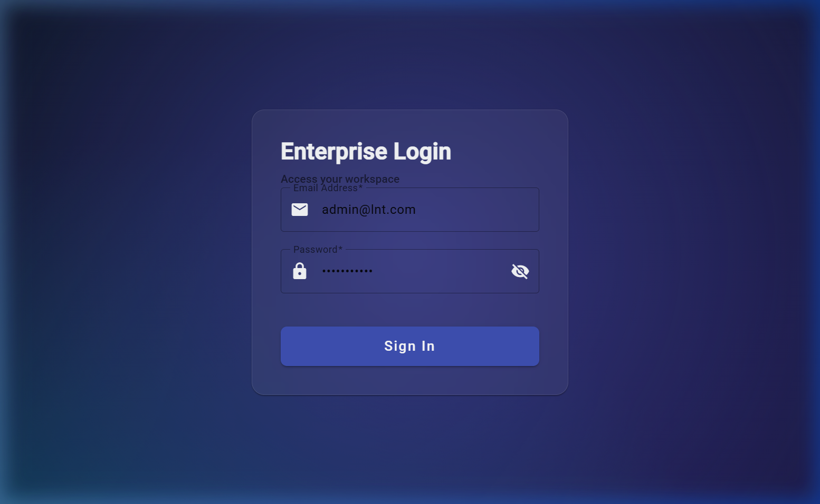
Centered authentication card with field-level validation and enterprise branding.

3.2 Real-time Analytics Dashboard
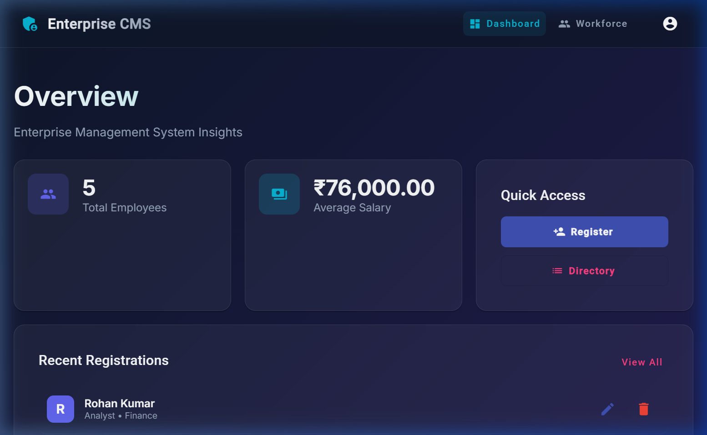
Bento-style grid providing immediate insights into workforce metrics.

3.3 Advanced Workforce Directory
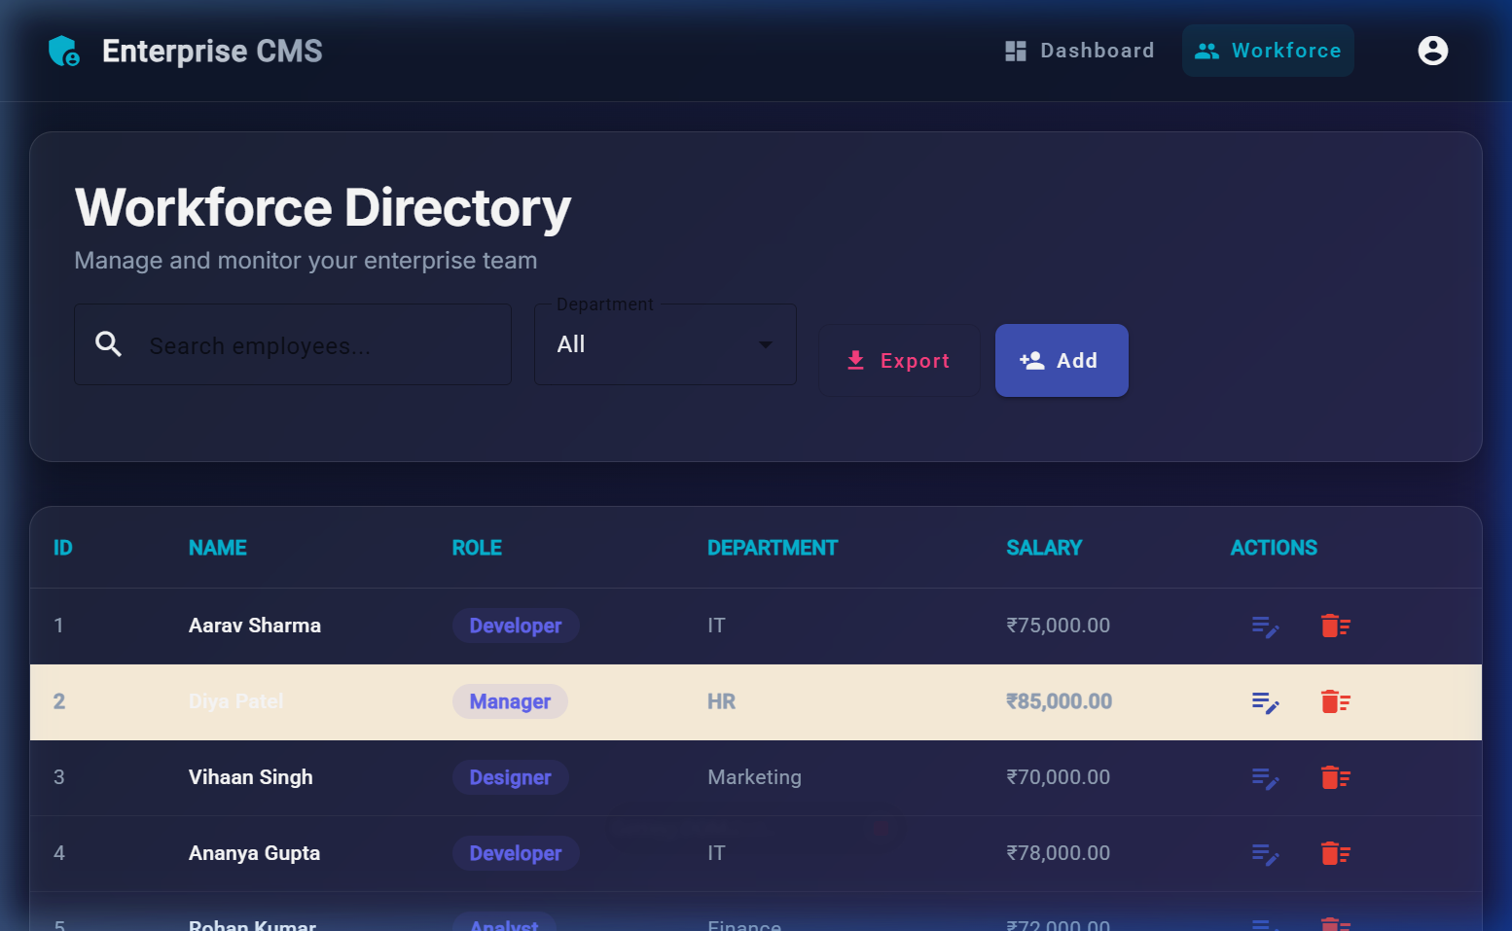
High-density Material table with integrated search, filtering, and data export.

4. Core Architectural Patterns

4.1 Reactive Data Layer
The application utilizes the "Observable Data Service" pattern. By using RxJS BehaviorSubjects, state is propagated instantly across the component tree without the overhead of Redux or NgRx. This ensures a responsive and efficient user experience.

4.2 Responsive Table Logic
The Workforce table implementation leverages MatTableDataSource with custom filterPredicate overrides. This allows for multi-faceted filtering (text + department) directly on the client side, ensuring near-instantaneous search results.

5. Conclusion
In summary, the Employee Management App is a polished, enterprise-ready demonstration of Angular development best practices. Every aspect, from the glassmorphic UI to the reactive service layer, has been optimized for both developer productivity and user satisfaction.

