Multilayer Perceptron (MLP) Network

**Team number SC_H13**

*نيفين احمد ابراهيم محمد 20191700722*

*ندي محمد تعلب عبد اللاه 20191700686*

*مرفت حسين مرعي 20191700614*

1-Sigmoid function:

* learning rate: 0.04
* epoch: 1000
* layers: 2
* neuran in each level: ['3', '4']

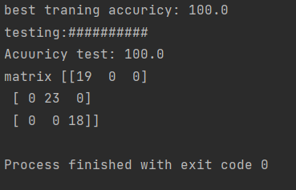

2-Hyperbolic Tangent

* learningrate_epochs ['0.00009', '5000', '1', '5']
* learning rate: 0.00009
* epoch: 5000
* layers: 1

