EUROP ASSISTANCE CZECH SITE

Applications for generating reports about attendant profiles and agent skills

©2016. decembar, SAGA d.o.o Beograd – New Frontier Group

Contents

Primary CIC server 3

10.132.68.11 – pvw1hdcicbecz 3

Backup CIC server 7

10.133.68.11 – pvw2hdciculcz 7

profiles.xml file 12

skills.xml 13

skills.csv 15

# Primary CIC server

## 10.132.68.11 – pvw1hdcicbecz

Applications for generating xml files about:

1. Attendant profile
2. Agent skills

are in D:\I3\IC\Apps folder (10.132.68.11).

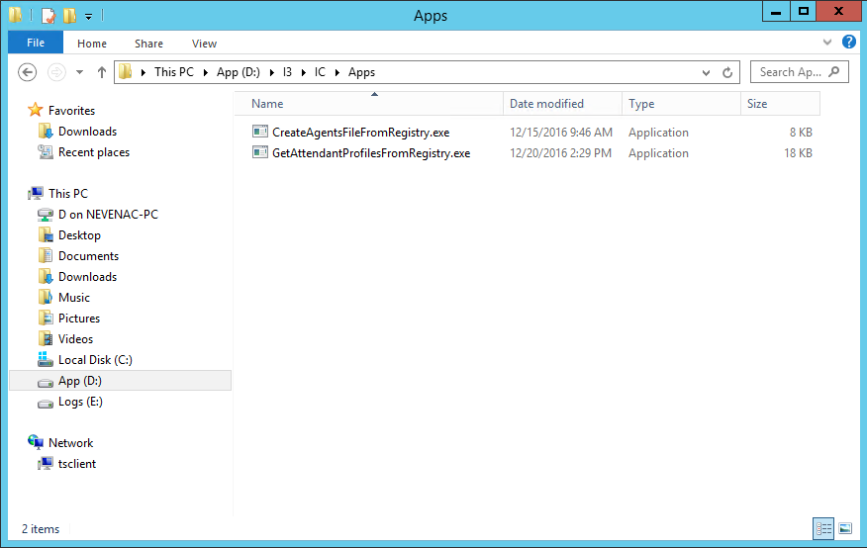

Picture : Path to applications for generating reports

The first one, GetAttendantProfilesFromRegistry.exe runs every day at 8pm and it generates report called profiles.xml[1] in D:\I3\IC\Server\Reports\Custom\ProfileReport folder.

It runs because in Windows scheduler there is a task called Create attendant profile report.



Picture 2: Tasks in Windows task scheduler

The second application called CreateAgentsFileFromRegistry.exe runs every 10 minutes because of task named Create agent skill report and it generates two files – skills.xml and skills.csv. These files are in D:\I3\IC\Server\Reports\Custom\AgentSkillWorkgroup folder.

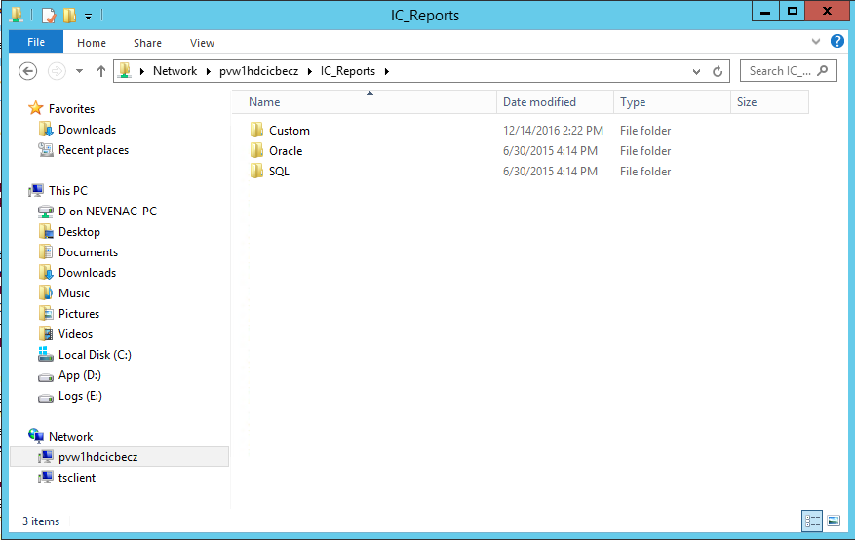

Picture 3: Path to report files 1

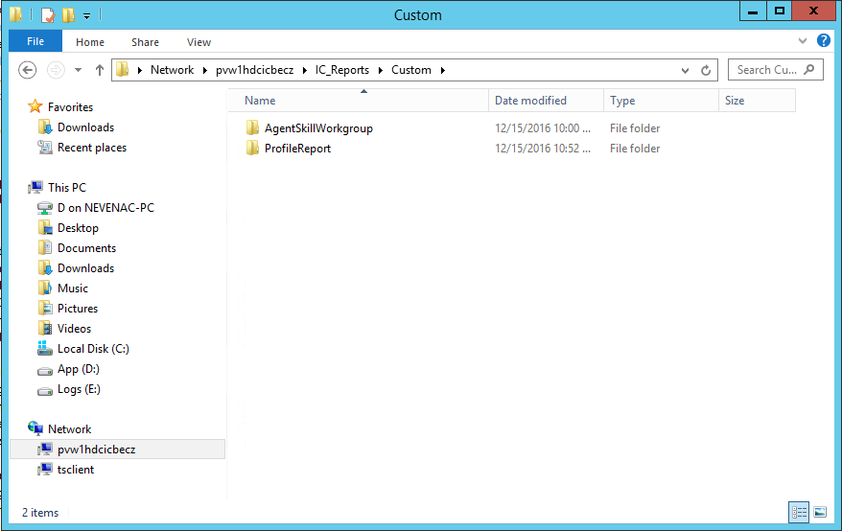

Picture 4: Path to report files 2

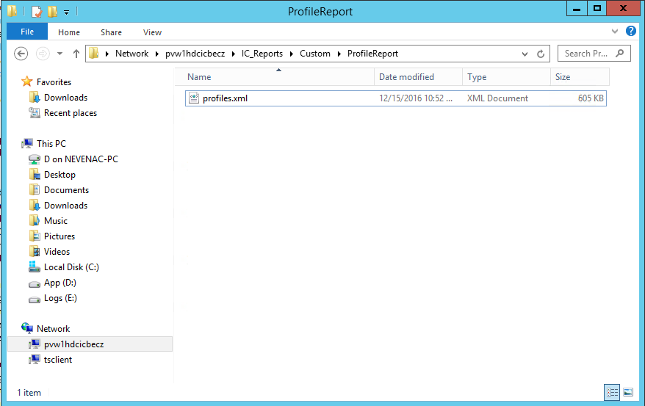

Picture 5: Path to profiles.xml file

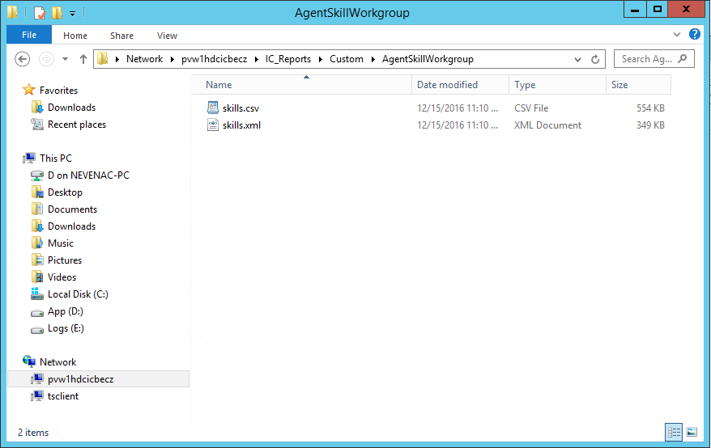

Picture 6: Path to files about agent skills

# Backup CIC server

## 10.133.68.11 – pvw2hdciculcz

Applications for generating xml files about:

1. Attendant profile
2. Agent skills

are in D:\I3\IC\Server\Apps folder (10.132.68.11).

For now, they are disabled because primary CIC is generating reports already, but if switchover happens, it is easy to enable these two tasks.

The first one, GetAttendantProfilesFromRegistry.exe will run every day at 8pm and it generates report called profiles.xml[2] in D:\I3\IC\Server\Reports\Custom\ProfileReport folder.

It will run because in Windows scheduler there is a task called Create attendant profile report.



Picture 7: Tasks in Windows task scheduler

The second application called CreateAgentsFileFromRegistry.exe will run every 10 minutes because of task named Create agent skill report and it generates two files – skills.xml and skills.csv. These files are in D:\I3\IC\Server\Reports\Custom\AgentSkillWorkgroup folder.

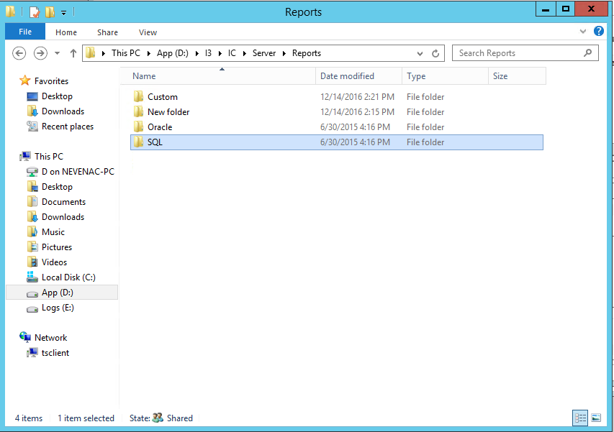

Picture 8: Path to report files at backup server

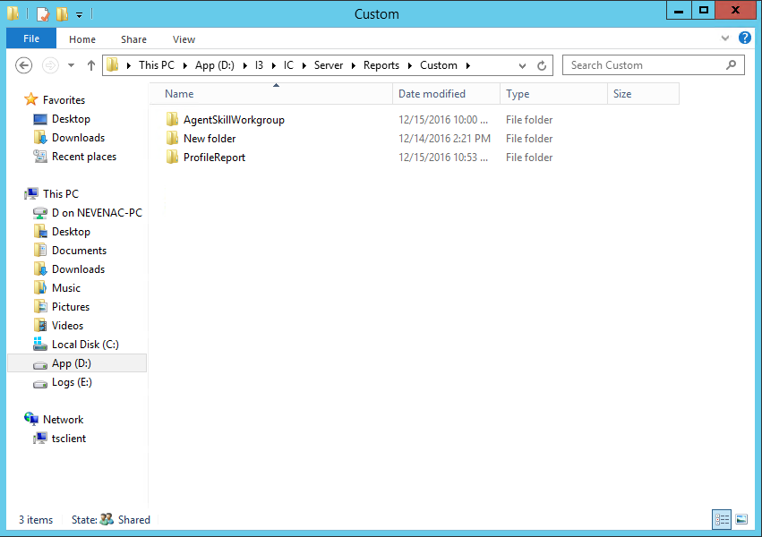

Picture 9: Path to report files at backup server 2

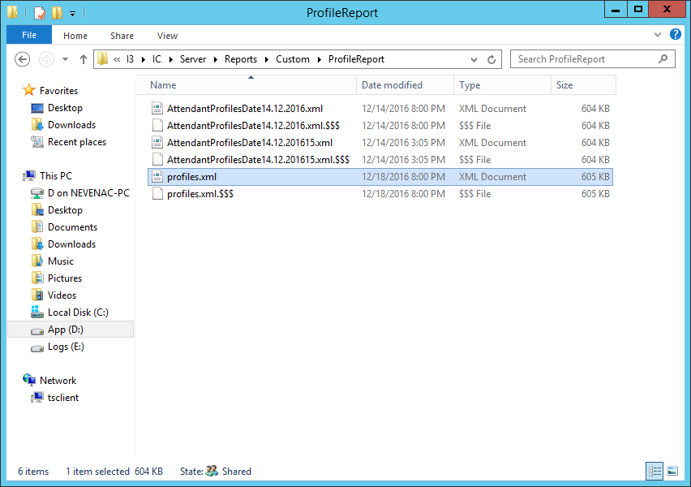

Picture 10: Path to profiles.xml file at backup server

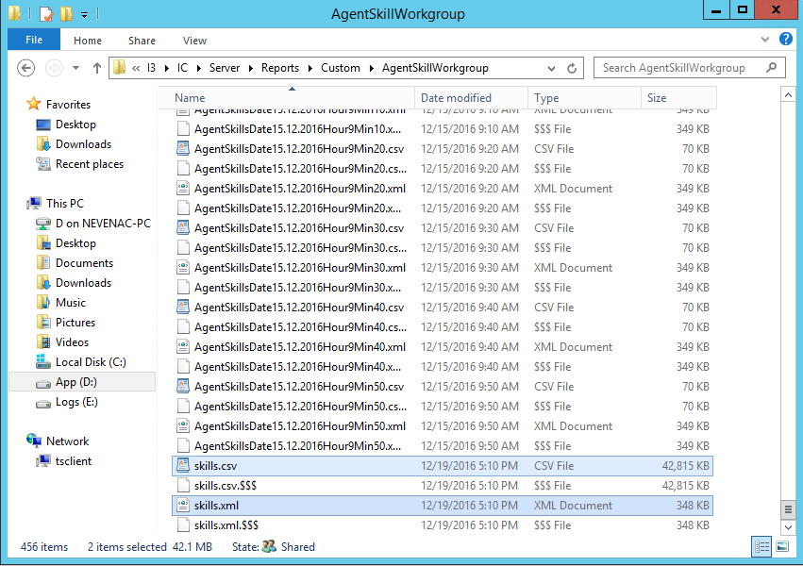

Picture 10: Path to files about agent skills at backup server

# profiles.xml file

In profiles.xml file you can find all data about attendant profiles and workgroups. Following diagram shows the structure of the document:

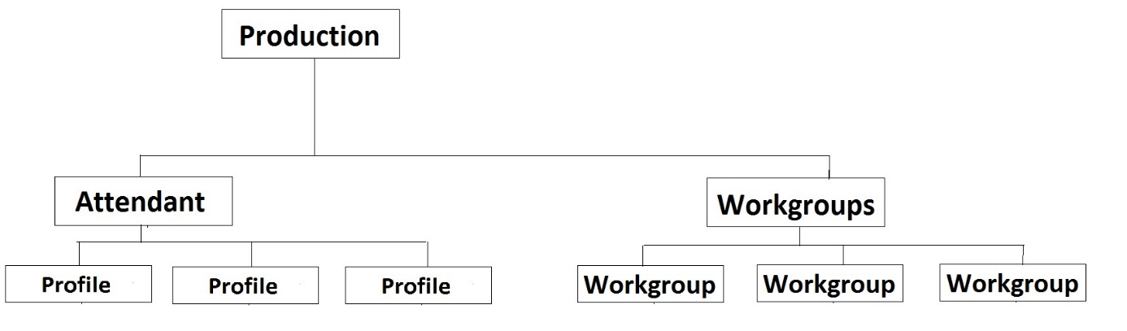

Picture : profiles.xml structure

Other nodes depend from defined profiles and workgroups.

Example for one profile:

<Profile>

<ProfileNumber>000001O</ProfileNumber>

<Name>EAIB Default Profile</Name>

<ReportingGroup>No</ReportingGroup>

<ANI>No</ANI>

<DNIS>

<UseDNIS>No</UseDNIS>

<DNISString>35318973230</DNISString>

</DNIS>

<Schedule>

<Name>Default Schedule</Name>

<Operation>

<Name>Agent Transfer1</Name>

<Type>Agent Transfer</Type>

<Digit>-</Digit>

</Operation>

<Operation>

<Name>Disconnect1</Name>

<Type>Disconnect</Type>

<Digit>-</Digit>

</Operation>

</Schedule>

</Profile>

This xml shows profile name and number, reporting group, DNIS for incoming calls, and schedules in this profile.

Example for one workgroup:

<Workgroup>

<Name>+420 221 586 677</Name>

<QueueManagementStyle>ACD</QueueManagementStyle>

<Utilization>Call|100|1Chat|100|0EMail|100|0Generic|100|0IWebCallback|100|0</Utilization>

<Users>

<User>cz_ehrenbergerova</User>

<User>cz_kaderabkova</User>

<User>cz_lacek2</User>

<User>cz_nykodem</User>

<User>cz_prochazka</User>

</Users>

</Workgroup>

This xml gives name of a workgroup, it’s queue management style and utilisation and all users who are members of it.

# skills.xml

In skills.xml you can find data about all agents and their skills. Following diagram shows the structure of the xml document:

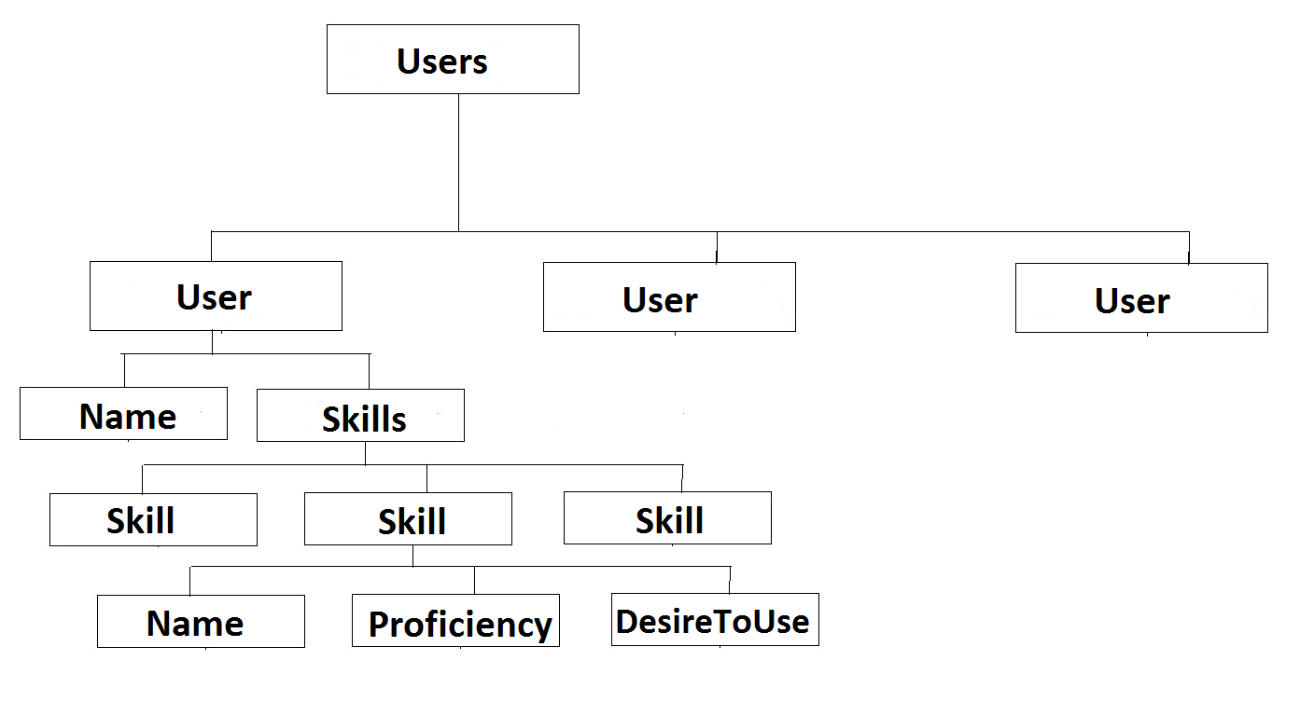

Picture : skills.xml structure

Example for one agent (user):

<User>

<Name>cz_arazim</Name>

<Skills>

<Skill>

<Name>CZ_Linka_Pomoci_Ridicum</Name>

<Proficiency>50</Proficiency>

<DesireToUse>50</DesireToUse>

</Skill>

<Skill>

<Name>CZ_Czech</Name>

<Proficiency>3</Proficiency>

<DesireToUse>1</DesireToUse>

</Skill>

<Skill>

<Name>CZ_Slovak</Name>

<Proficiency>1</Proficiency>

<DesireToUse>1</DesireToUse>

</Skill>

<Skill>

<Name>CZ_T1</Name>

<Proficiency>1</Proficiency>

<DesireToUse>1</DesireToUse>

</Skill>

<Skill>

<Name>CZ_T2</Name>

<Proficiency>1</Proficiency>

<DesireToUse>1</DesireToUse>

</Skill>

<Skill>

<Name>CZ_Generali_Info</Name>

<Proficiency>50</Proficiency>

<DesireToUse>50</DesireToUse>

</Skill>

<Skill>

<Name>CZ_M1</Name>

<Proficiency>50</Proficiency>

<DesireToUse>50</DesireToUse>

</Skill>

<Skill>

<Name>CZ_Europ_Assist</Name>

<Proficiency>1</Proficiency>

<DesireToUse>1</DesireToUse>

</Skill>

<Skill>

<Name>CZ_T3</Name>

<Proficiency>1</Proficiency>

<DesireToUse>1</DesireToUse>

</Skill>

<Skill>

<Name>CZ_Tech2</Name>

<Proficiency>1</Proficiency>

<DesireToUse>1</DesireToUse>

</Skill>

<Skill>

<Name>CZ_Home</Name>

<Proficiency>1</Proficiency>

<DesireToUse>1</DesireToUse>

</Skill>

<Skill>

<Name>CZ_Home_SK</Name>

<Proficiency>1</Proficiency>

<DesireToUse>1</DesireToUse>

</Skill>

<Skill>

<Name>CZ_Medipartner</Name>

<Proficiency>50</Proficiency>

<DesireToUse>50</DesireToUse>

</Skill>

</Skills>

</User>

This example shows all data about one agent skills.

# skills.csv

This document gives a list of all agents and all of their skills. For example:

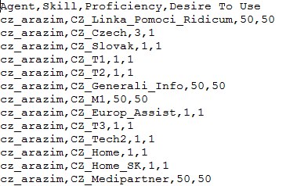

Picture : skills.csv for one agent and his skills

# Links for applications:

[http://www.filedropper.com/getattendantprofilesfromregistry](http://www.filedropper.com/getattendantprofilesfromregistry%20-%20for%20profiles.xml) for profiles.xml

<http://www.filedropper.com/createagentsfilefromregistry>   - for skills.xml and skills.csv

1. We agreed to generate xml except csv file about profiles in an email.
2. We agreed to generate xml except csv file about profiles in an email.