Applications for generating xml files about:

1. Attendant profile
2. Agent skills

are in D:\I3\IC\Apps folder (10.132.68.11).

The first one, CitanjeIzRegistra.exe runs every day at 8pm and it generates report called profiles.xml[1] in D:\I3\IC\Server\Reports\Custom\ProfileReport folder.

It runs because in Windows scheduler there is a task called Create attendant profile report.



Picture 1: Tasks in Windows task scheduler

The second application called CreateAgentsFileFromRegistry.exe runs every 10 minutes because of task named Create agent skill report and it generates two files – skills.xml and skills.csv. These files are in D:\I3\IC\Server\Reports\Custom\AgentSkillWorkgroup folder.

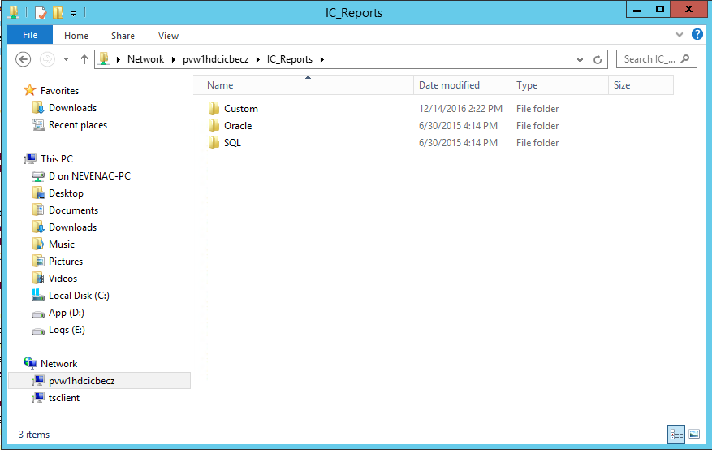

Picture 2: Path to report files 1

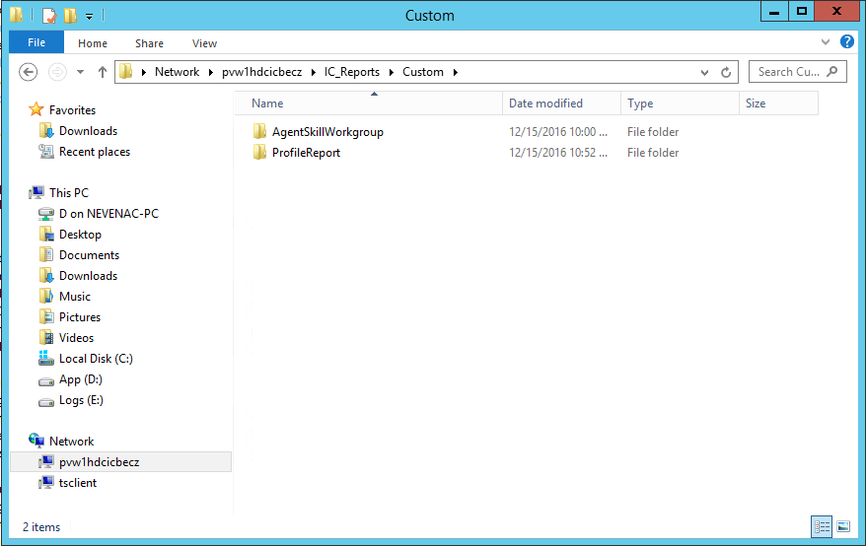

Picture 3: Path to report files 2

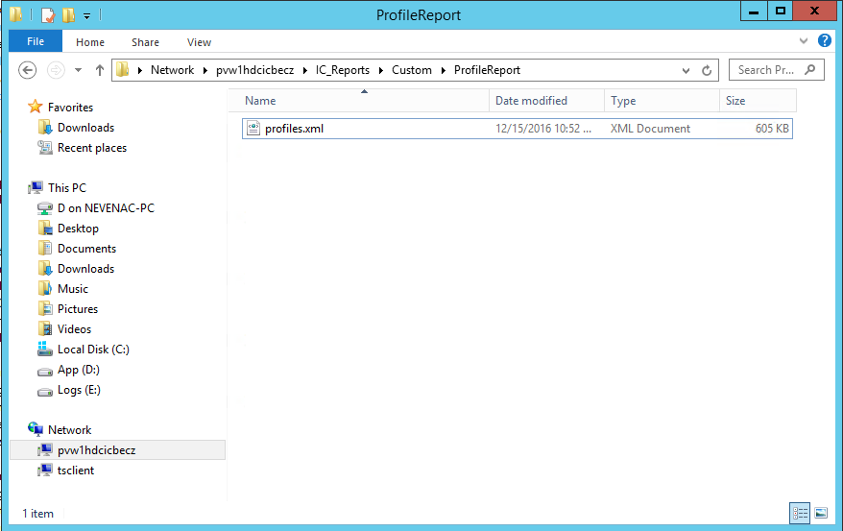

Picture 4: Path to profiles.xml file

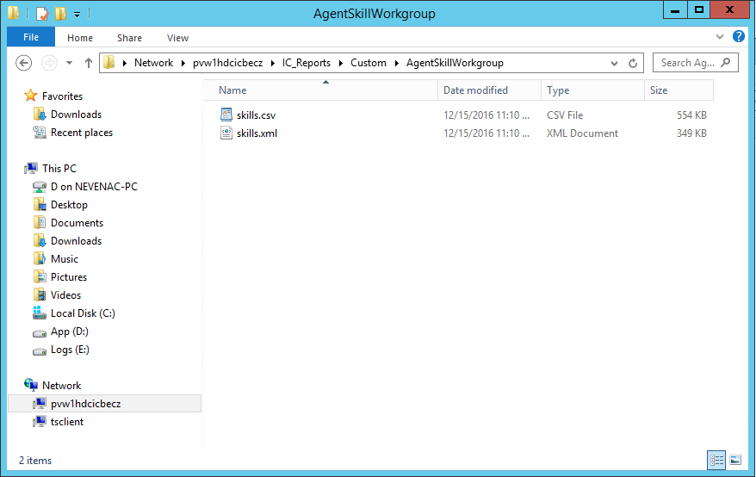

Picture 5: Path to files about agent skills

1. We agreed to generate xml except csv file about profiles in an email.