Reading VeChain Transactions: A Node.js/JavaScript Developer's Guide

VeChain is an enterprise-grade blockchain that offers predictable fees and is an excellent tool for developers building real-time data management applications.
In this tutorial, we'll explore how to use your Node.js and JavaScript knowledge to connect your backend to VeChain and read transactions in just a few steps.

Adding Project Dependencies

The first step is to install the dependencies required to interact with VeChain. As shown in the code below, you only need two packages to get started.
npm install @vechain/sdk-network @vechain/sdk-core

Connecting to the VeChain Blockchain

Next, you need to connect to the VeChain network. You can choose between two endpoints depending on your use case: MainNet for production applications, or TestNet for development and testing. For this tutorial, we'll use the TestNet.
The code below demonstrates the simple process of initializing the Thor client via the VeChain SDK to establish your connection to the blockchain.
const { SimpleHttpClient, ThorClient } = require("@vechain/sdk-network");

// Choose the network by changing the URL
const TESTNET = "https://testnet.vechain.org";
const MAINNET = "https://mainnet.vechain.org";

(async () => {
// Connect
const thor = new ThorClient(new SimpleHttpClient(TESTNET));

To confirm your connection is active and correctly initialized, you can perform a simple health check by fetching the network's current state. The easiest way is to request the latest block information.
// Test connection
await thor.blocks.getBestBlockCompressed();
console.log("✅ Connected to VeChain testnet!");
})();

Fetching transactions

To fetch and analyze any transaction, the first step is always knowing its Transaction ID (TxID). It can be obtained directly from a block explorer (website) or automatically retrieved by parsing the transaction list of a block.

Option A: Transaction ID from a block explorer (Website)

Open a new tab and navigate to the official VeChain block explorer: https://explore.vechain.org/. The Recent Transactions list is located in the right section of the page and provides confirmed TxIDs you can use for testing.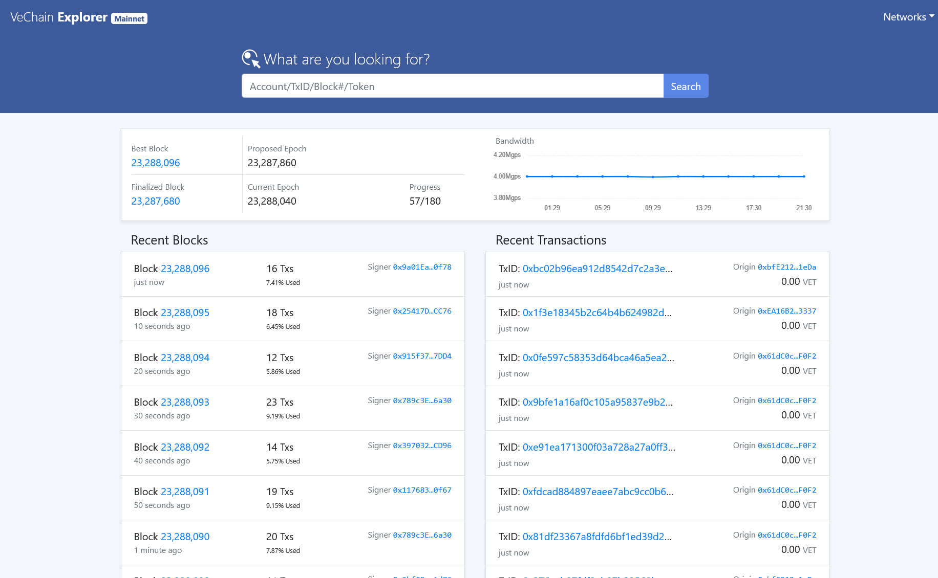

Copy the Transaction ID (TxID) from the explorer and assign it to the TX_ID variable within your asynchronous function block.
// The ID for this transaction could have expired, so change it with the one you copied
const txId = “0xcb31fe3934fcd97b9fe7c3cf5ef3aa966b3d7fa5dc783951c5f15971bb93bd6f”;

Option B: Transaction ID from a fetched block (Using Code)

Transaction IDs can also be obtained programmatically by reading them directly from a fetched block. However, note that blocks could be empty and might not contain any transactions.
// Get latest block (expanded)
const latestBlock = await thor.blocks.getBestBlockCompressed();
const blockNumber = latestBlock.number;
console.log(`\nLatest ${network} block number: ${blockNumber}`);

const expanded = await thor.blocks.getBlockExpanded(blockNumber);

// Extract transaction IDs safely
const txs = expanded.transactions || [];
if (txs.length === 0) {
console.log(“No transactions available in this block.”);
return;
}

console.log(`Block ${blockNumber} has ${txs.length} transactions.`);

// Fetch full transaction + receipt
for (let i = 0; i < txs.length; i++) {
const txId = txs[i].id;
console.log(`\nTransaction #${i + 1} ID: ${txId}`);

Fetching the Transaction Data

The remaining code is identical regardless of how you acquired the TxID. The next step is to use that ID to read the transaction data and its corresponding receipt from the network.
// Get the transaction details
const tx = await thor.transactions.getTransaction(txId);
console.log("Transaction:", tx);

// Get the receipt for that transaction (if confirmed)
const receipt = await thor.transactions.getTransactionReceipt(txId);
console.log("Transaction Receipt:", receipt);

// (Optional) Wait for the receipt if it's pending
//const receipt2 = await thor.transactions.waitForTransactionReceipt(txId);
// console.log("Receipt after confirmation:", receipt2);

Reading and Analyzing Transactions

You have now successfully fetched both the Transaction and the Transaction Receipt objects. These two structures are important to distinguish. The Transaction Body conveys the intended action, including the instructions and parameters planned for execution. On the other hand, a Transaction Receipt describes the final result of the execution and explains what actually happened.
The most crucial fields for developers to track are those describing the identification, origin, recipient, and costs of the transaction.
Key fields in the Transaction:
- id: identifies the transaction and helps us fetch it
- origin: sender’s address
- clauses: transaction details, including to (recipient address) and value (amount of VET to transfer)
- meta: metadata about the block containing the transaction
Key fields in the Transaction Receipt:
- reverted: indicates if the transaction failed; true means it did
- gasUsed: gas consumed by the transaction (in VTHO)
- outputs: result of the transaction, such as created contract addresses, emitted events, or token/VET transfers
To correctly interpret the transaction data, understanding the difference between VET and VTHO is essential. VET indicates the amount a transaction plans to send and may be zero if no tokens are being transferred. VTHO, in contrast, reflects the cost of executing the transaction and applies even when no tokens are being moved or the transaction fails.

Practical use cases

Having established how to read transactions, let’s focus on the purpose they can serve in your application.
Supply Chain Tracking is one of the most common applications. Companies use transactions to monitor product movements, as ownership is transferred by executing a transaction. This allows them to monitor the product's entire journey, from the manufacturer to the end consumer. This capability is especially valuable for tracking high-value items.
Another valuable application lies in building Business Intelligence (BI) dashboards. By processing transaction data, developers can create sophisticated analytics platforms that monitor transaction volumes, identify top trading partners, track value movements, and analyze gas costs. These dashboards provide businesses with the critical insights needed to make data-driven decisions and understand their overall blockchain activity at a glance.
For compliance and regulatory purposes, reading transactions enables automated monitoring systems. Financial institutions and regulated businesses can track activity involving specific addresses, detect large transfers that may require reporting, and ensure adherence to anti-money laundering regulations. The immutable nature of the blockchain, combined with real-time transaction monitoring, provides a reliable and transparent audit trail.
Reading transactions is equally vital for a range of other innovative applications. These include advancing sustainability through carbon credit tracking, establishing trust via digital identity verification, and creating new markets through asset tokenization. Ultimately, it provides the immutable data integrity and audit trails that are crucial for modern industry compliance.

Conclusion

This tutorial has equipped you with the knowledge to connect to the VeChain network, fetch transactions, and interpret their data using Node.js and JavaScript. With these skills, you can examine transaction details, understand execution outcomes, and begin incorporating VeChain data into your own applications.These foundational techniques provide a clear and practical starting point for building applications that leverage blockchain technology effectively.

