Part 1
VHDL
-- Sean Thomas
-- Section 1361

library ieee;
use ieee.std_logic_1164.all;
use ieee.numeric_std.all;

entity adder8numeric is
port
(
input1, input2 : in std_logic_vector(7 downto 0);
carry_in : in std_logic;
sum : out std_logic_vector(7 downto 0);
carry_out : out std_logic
);
end adder8numeric;

architecture behavior of adder8numeric is

signal temp : unsigned(8 downto 0);

begin

temp <= resize(unsigned(input1), 9) + resize(unsigned(input2), 9) + resize(unsigned'("" & carry_in), 9);
sum <= std_logic_vector(temp(7 downto 0));
carry_out <= temp(8);
end behavior;

TB
-- Sean Thomas
-- Section 1361

library ieee;
use ieee.std_logic_1164.all;
use ieee.numeric_std.all;

entity adder8_tb is
end adder8_tb;

architecture TB of adder8_tb is

signal input1, input2, sum : std_logic_vector(7 downto 0);
signal carry_in, carry_out : std_logic;

begin -- TB

UUT : entity work.adder8numeric
port map (
input1 => input1,
input2 => input2,
carry_in => carry_in,
sum => sum,
carry_out => carry_out);

process

function sum_test (
constant in1 : integer;
constant in2 : integer;
constant carry_in : integer)
return std_logic_vector is
begin
return std_logic_vector(to_unsigned((in1+in2+carry_in) mod 256, 8));
end sum_test;

function carry_test (
constant in1 : integer;
constant in2 : integer;
constant carry_in : integer)
return std_logic is
begin
if (in1+in2+carry_in > 255) then
return '1';
else
return '0';
end if;
end carry_test;

begin
-- test all input combinations
for i in 0 to 255 loop
for j in 0 to 255 loop
for k in 0 to 1 loop

input1 <= std_logic_vector(to_unsigned(i, 8));
input2 <= std_logic_vector(to_unsigned(j, 8));
carry_in <= std_logic(to_unsigned(k, 1)(0));
wait for 40 ns;
assert(sum = sum_test(i,j,k)) report "Sum incorrect";
assert(carry_out = carry_test(i,j,k)) report "Carry incorrect";

end loop; -- k
end loop; -- j
end loop; -- i

report "SIMULATION FINISHED!";

wait;

end process;

end TB;

Simulation
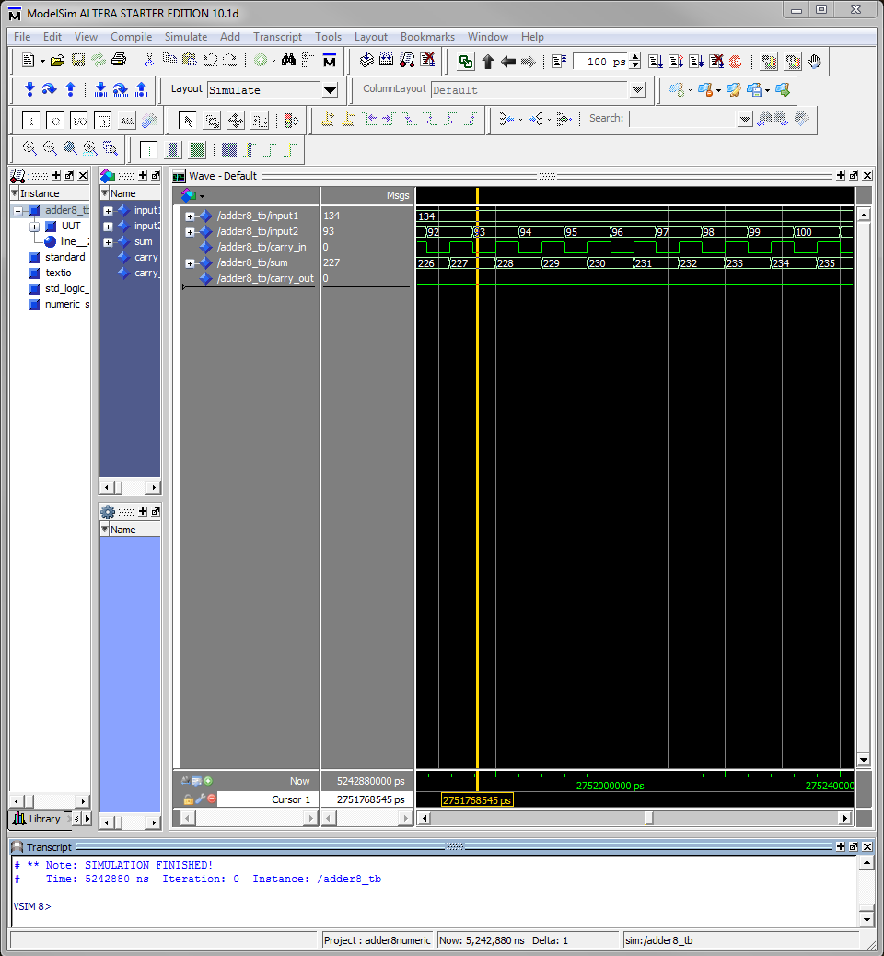

Part 2
VHDL
-- Sean Thomas
-- Section: 1361
library ieee;
use ieee.std_logic_1164.all;
use ieee.numeric_std.all;

entity alu_ns is
generic
(
WIDTH : positive := 16
);
port
(
input1 : in std_logic_vector(WIDTH-1 downto 0);
input2 : in std_logic_vector(WIDTH-1 downto 0);
sel : in std_logic_vector(3 downto 0);
output : out std_logic_vector(WIDTH-1 downto 0);
overflow : out std_logic
);
end alu_ns;

architecture behavior of alu_ns is
Signal Sub : unsigned(WIDTH downto 0);
Signal Add : unsigned(WIDTH downto 0);
Signal Mul : unsigned((WIDTH * 2 - 1) downto 0);
Signal Test : std_logic;
Signal Rev : std_logic_vector(0 TO WIDTH-1);

begin -- behavior
Sub <= resize(unsigned(input1), WIDTH+1) + resize(unsigned(not input2), WIDTH+1) + resize(unsigned'("01"), WIDTH+1);
Add <= resize(unsigned(input1), WIDTH+1) + resize(unsigned( input2), WIDTH+1);
Mul <= unsigned(input1) * unsigned(input2);
Test<= '1' WHEN (Mul > unsigned'(resize(not resize(("00"),WIDTH),WIDTH * 2))) ELSE '0';
Rev <= input1;
With sel SELECT
output <= not input1 when "0000",
input1 nor input2 when "0001",
input1 xor input2 when "0010",
input1 or input2 when "0011",
input1 and input2 when "0100",
std_logic_vector( Add(WIDTH-1 Downto 0) ) when "0101",
std_logic_vector( Sub(WIDTH-1 Downto 0) ) when "0110",
std_logic_vector( Mul(WIDTH-1 Downto 0) ) when "0111",
std_logic_vector(unsigned'(resize("0",WIDTH))) when "1000",
std_logic_vector(unsigned'(resize("0",WIDTH))) when "1001",
(input1(WIDTH-2 Downto 0) & "0") when "1010",
("0" & input1(WIDTH-1 Downto 1)) when "1011",
Rev when "1100",
(input1((WIDTH/2 - 1) Downto 0) & input1((WIDTH - 1) Downto WIDTH/2)) when "1101",
std_logic_vector(unsigned'(resize("0",WIDTH))) when "1110",
std_logic_vector(unsigned'(resize("0",WIDTH))) when others;
WITH sel SELECT
overflow <='0' when "0000",
'0' when "0001",
'0' when "0010",
'0' when "0011",
'0' when "0100",
Add(WIDTH) when "0101",
'0' when "0110",
Test when "0111",
'0' when "1000",
'0' when "1001",
input1(WIDTH-1) when "1010",
input1(0) when "1011",
'0' when "1100",
'0' when "1101",
'0' when "1110",
'0' when others;
end Behavior;
TB
library ieee;
use ieee.std_logic_1164.all;
use ieee.std_logic_arith.all;
use ieee.std_logic_unsigned.all;

entity alu_ns_tb is
end alu_ns_tb;

architecture TB of alu_ns_tb is

component alu_ns

generic (
WIDTH : positive := 16
);
port (
input1 : in std_logic_vector(WIDTH-1 downto 0);
input2 : in std_logic_vector(WIDTH-1 downto 0);
sel : in std_logic_vector(3 downto 0);
output : out std_logic_vector(WIDTH-1 downto 0);
overflow : out std_logic
);

end component;

constant WIDTH : positive := 8;
signal input1 : std_logic_vector(WIDTH-1 downto 0) := (others => '0');
signal input2 : std_logic_vector(WIDTH-1 downto 0) := (others => '0');
signal sel : std_logic_vector(3 downto 0) := (others => '0');
signal output : std_logic_vector(WIDTH-1 downto 0);
signal overflow : std_logic;

begin -- TB

UUT : alu_ns
generic map (WIDTH => WIDTH)
port map (
input1 => input1,
input2 => input2,
sel => sel,
output => output,
overflow => overflow);

process

function sum_test (
constant input1 : integer;
constant input2 : integer)
return std_logic_vector is
begin
return conv_std_logic_vector((input1+input2), WIDTH);
end sum_test;

function carry_test (
constant input1 : integer;
constant input2 : integer)
return std_logic is
begin
if (input1+input2 >= 2**WIDTH) then
return '1';
else
return '0';
end if;
end carry_test;

function sub_test (
constant input1 : integer;
constant input2 : integer)
return std_logic_vector is
begin
return conv_std_logic_vector((input1-input2), WIDTH);
end sub_test;

function mul_test (
constant input1 : integer;
constant input2 : integer)
return std_logic_vector is
begin
return conv_std_logic_vector((input1*input2), WIDTH);
end mul_test;

function MULOFL_test (
constant input1 : integer;
constant input2 : integer)
return std_logic is
begin
if (input1*input2 > ((2**WIDTH)-1)) then
return '1';
else
return '0';
end if;
end MULOFL_test;

begin
sel <= "0101";
for i in 0 to 255 loop
for j in 0 to 255 loop

input1 <= conv_std_logic_vector(i, WIDTH);
input2 <= conv_std_logic_vector(j, WIDTH);
wait for 40 ns;
assert(output = sum_test(i,j)) report "Sum incorrect";
assert(overflow = carry_test(i,j)) report "OFL incorrect";

end loop; -- j
end loop; -- i

sel <= "0110";
for i in 0 to 255 loop
for j in 0 to 255 loop

input1 <= conv_std_logic_vector(i, WIDTH);
input2 <= conv_std_logic_vector(j, WIDTH);
wait for 40 ns;
assert(output = sub_test(i,j)) report "Sub incorrect";
assert(overflow = '0') report "Overflow incorrect";

end loop; -- j
end loop; -- i

sel <= "0111";
for i in 0 to 255 loop
for j in 0 to 255 loop

input1 <= conv_std_logic_vector(i, WIDTH);
input2 <= conv_std_logic_vector(j, WIDTH);
wait for 40 ns;
assert(output = mul_test(i,j)) report "MUL incorrect";
assert(overflow = mulOFL_test(i,j)) report "MULOverflow incorrect";

end loop; -- j
end loop; -- i
-- test 2+6 (no overflow)

wait;

end process;

end TB;

Simulation
