Readme
- Start up
For command line compiling, you can try to enter
javac --module-path "ABSOLUTE_PATH" --add-modules=javafx.controls,javafx.media,javafx.fxml -cp ../dependencies/*;. gymSystem/controller/afterLogin/*.java -encoding UTF-8
at path Software/src, where ABSOLUTE_PATH is the absolute path of file Software/dependencies/lib
You need to compile all java file under gymSystem, we have already compiled it once.

For command line running, you can try to enter
java --module-path "ABSOLUTE_PATH" --add-modules=javafx.controls,javafx.media,javafx.fxml -cp ../dependencies/*;. gymSystem.Main

at path Software/src, where ABSOLUTE_PATH is the absolute path of file Software/dependencies/lib

Due to some characteristics of JavaFx and path format, our program may met some problems when complied and ran in command line. When the command line doesn’t work, please try to run it in IDEA.
Our program runs with Window OS, IDEA 2020, the java SDK version is 16.0.1.
To begin with, please create a new Java project with JDK version 16.0.1
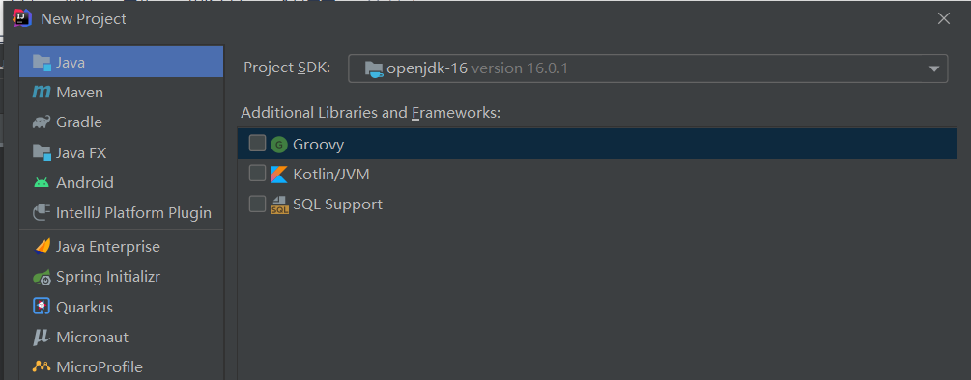

Locate the src folder of the created project, drag and drop the gymSystem folder to the src folder
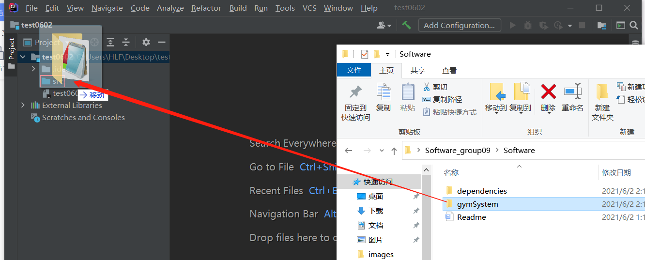

Select Refactor
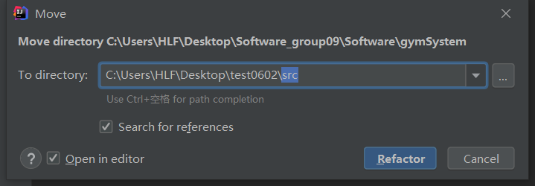
Go to File--Project Structure--Libraries--New Project Library--Java
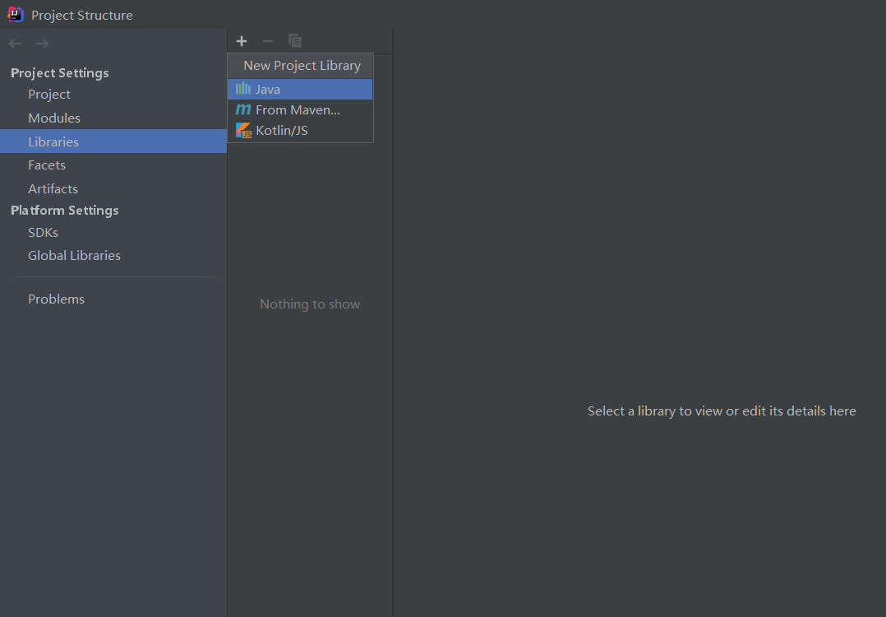

Add the components in dependencies folder one by one to the module, then Apply--OK.
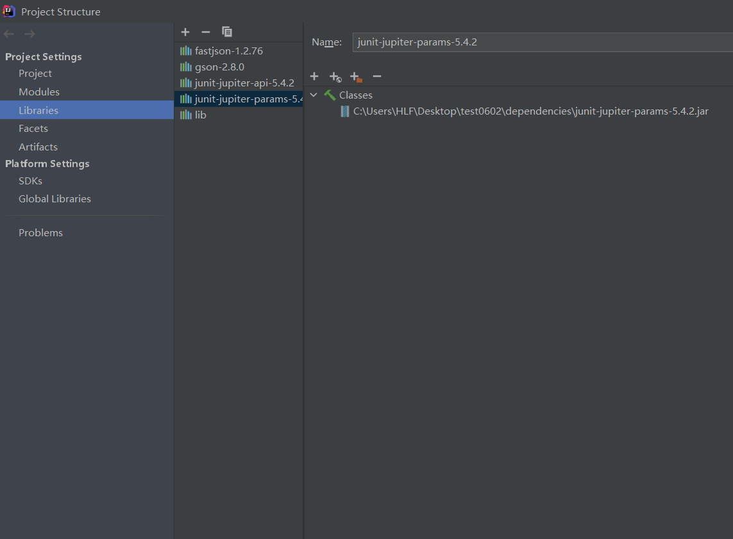
Find the Main function, right click on it and select Run
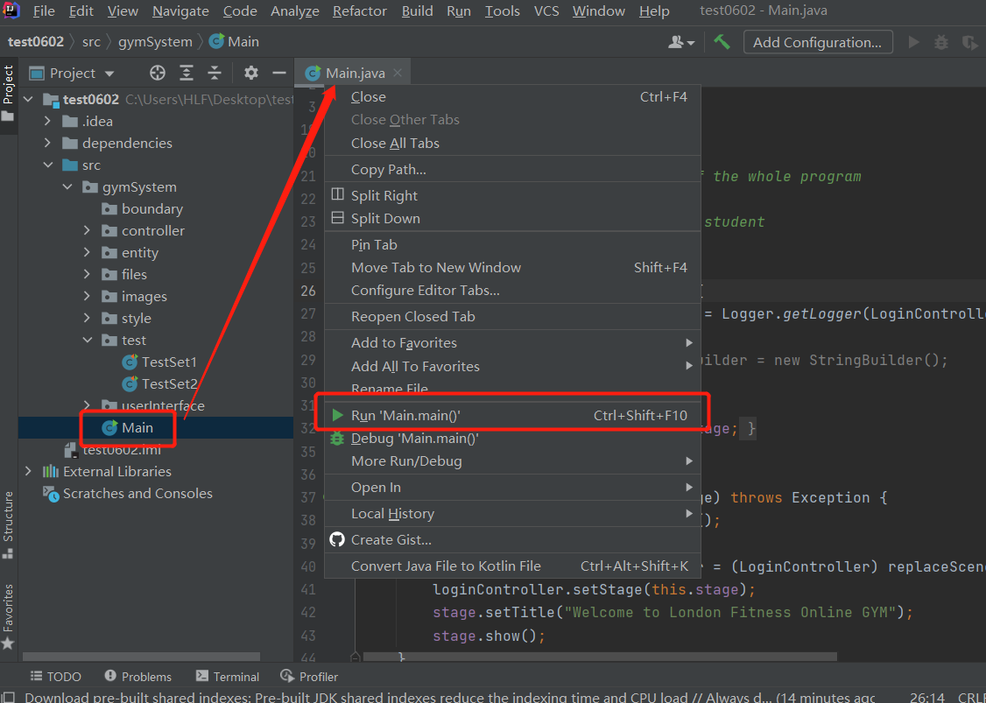

Then you will get an error stating that JavaFx is missing, go to Run--Edit Configurations
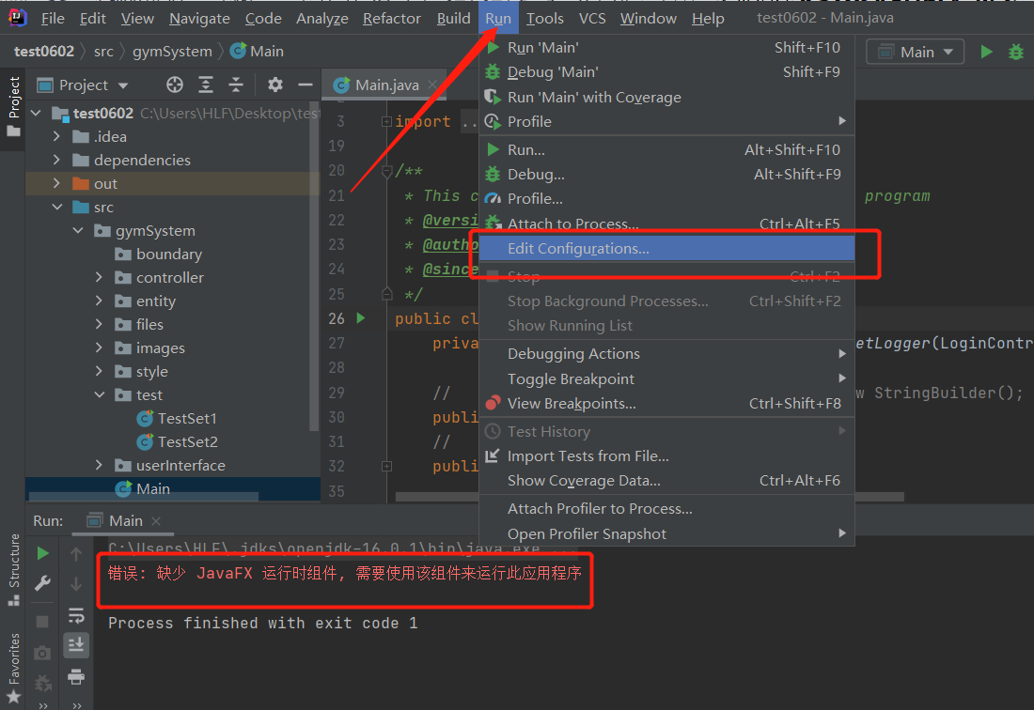

Go to File--Settings--Appearance & Behaviour--Path Variables--Add
Variable Name: PATH_TO_FX
Value: folder Software_group09\Software\dependencies\lib
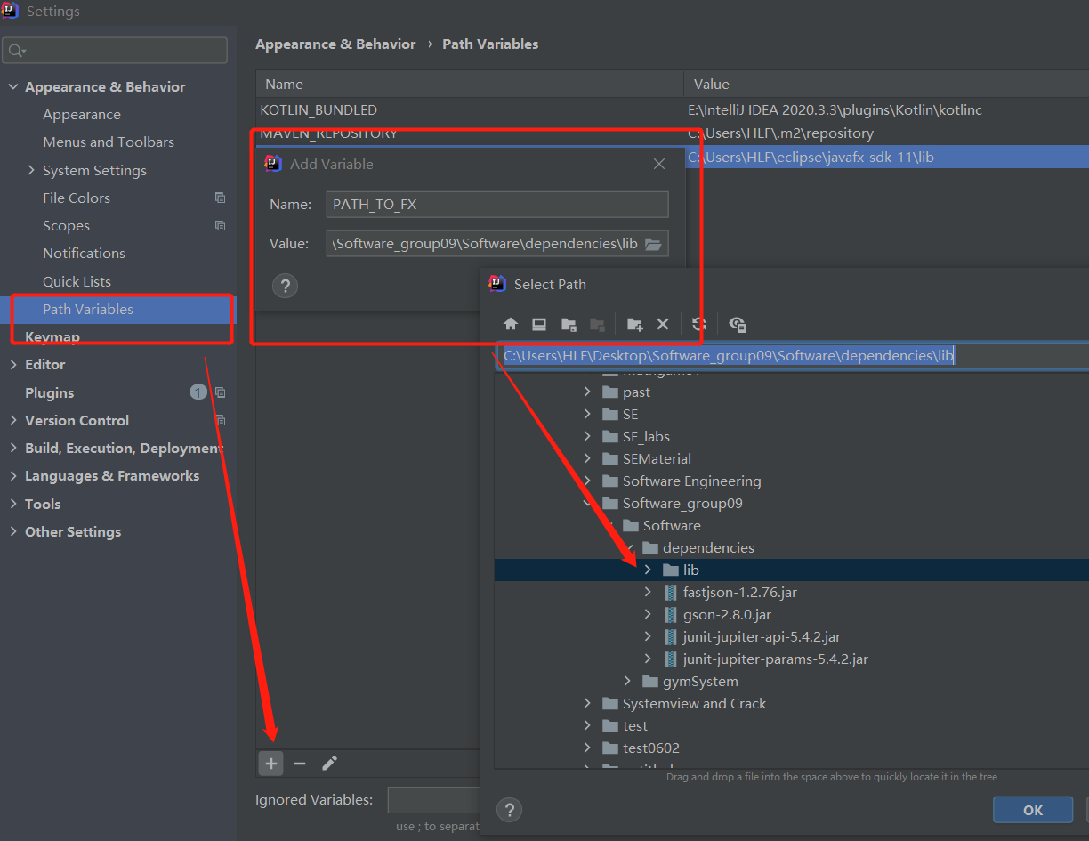

Select Modify options--Add VM options, then paste the following text to this text area. Then Apply--OK
--module-path ${PATH_TO_FX} --add-modules javafx.controls,javafx.fxml,javafx.media
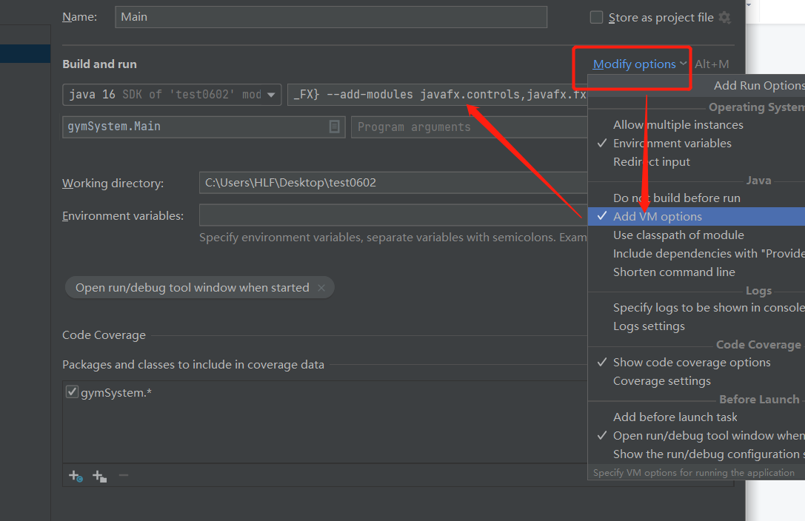

Run ‘Main’ now, and you can successfully start the program
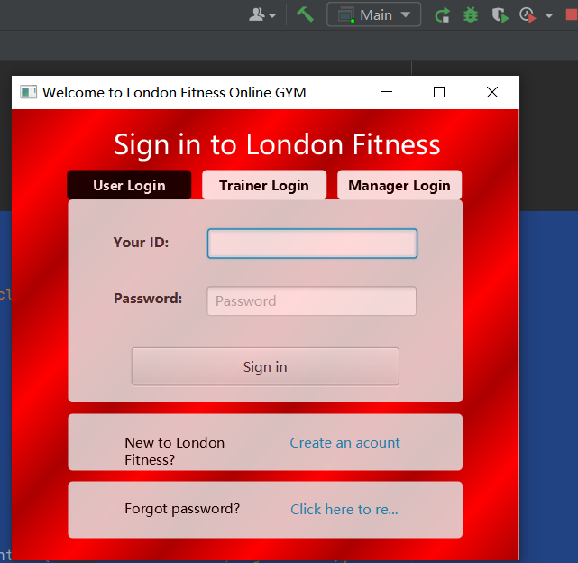
- Default Identities (already set)
User:
ID：43 Password：222222 User Type：Ordinary
For user, you can also choose to sign up and create and account as you like, you can also try to reset your password. If you want to use Live Training section, please upgrade to be premier user first, detailed operations could be found in User Manual.

Trainer:
Name | ID | Password
Qwl We | 22 | 222222
Gsad Qfg | 33 | 222222
Ere We | 47 | 222222
When you log in as different trainers, you can receive different reservation details in Live Training part for each trainer, detailed information can be found in user manual.

Manager:
ID: 100 Password:123123
When you log in as Manager, you can have access to Management section, detailed information can be found in user manual.

- Contact
If you want to run our project, but encounter an unsolvable error reporting problem, or if situation appears that the project is not running as expected, please contact us by:
- mail: huanglinfei2018@bupt.edu.cn
WeChat: huanglinfei746530 or cyt20001107
We will try our best to solve the problem, or we will screenshot a short video to show the operation process.

