nmon资源使用报告
时间范围：文件全部时间 ~ 文件全部时间

整体汇总
文件名 | IP地址 | CPU使用率 | 内存使用率 | SWAP使用率 | 磁盘读速率(KB/s) | 磁盘写速率(KB/s) | 网络读速率(KB/s) | 网络写速率(KB/s) | 系统类型 | 读取范围
110.221534.nmon | - | 61.10% | 35.44% | 0.00% | 2.40 | 24,888.50 | 141,042.60 | 81,032.20 | Linux | 1943-44242
110.224253.nmon | - | 63.50% | 34.96% | 0.00% | 2.30 | 24,903.10 | 141,060.70 | 57,548.70 | Linux | 1943-44242
110.276836.nmon | - | 90.00% | 45.36% | 0.00% | 239.40 | 26,057.70 | 199,274.90 | 100,819.30 | Linux | 1949-44248
111.224998.nmon | - | 61.70% | 35.22% | 0.00% | 2.30 | 24,837.40 | 141,054.70 | 57,563.00 | Linux | 1943-44242
111.225223.nmon | - | 62.40% | 35.23% | 0.00% | 2.30 | 24,887.20 | 141,050.30 | 57,561.50 | Linux | 1943-44242
112.223179.nmon | - | 61.70% | 35.24% | 0.00% | 2.30 | 24,685.30 | 141,054.90 | 57,572.50 | Linux | 1943-44242

CPU使用情况
instance-er5vfe0o - cpu_usage.png
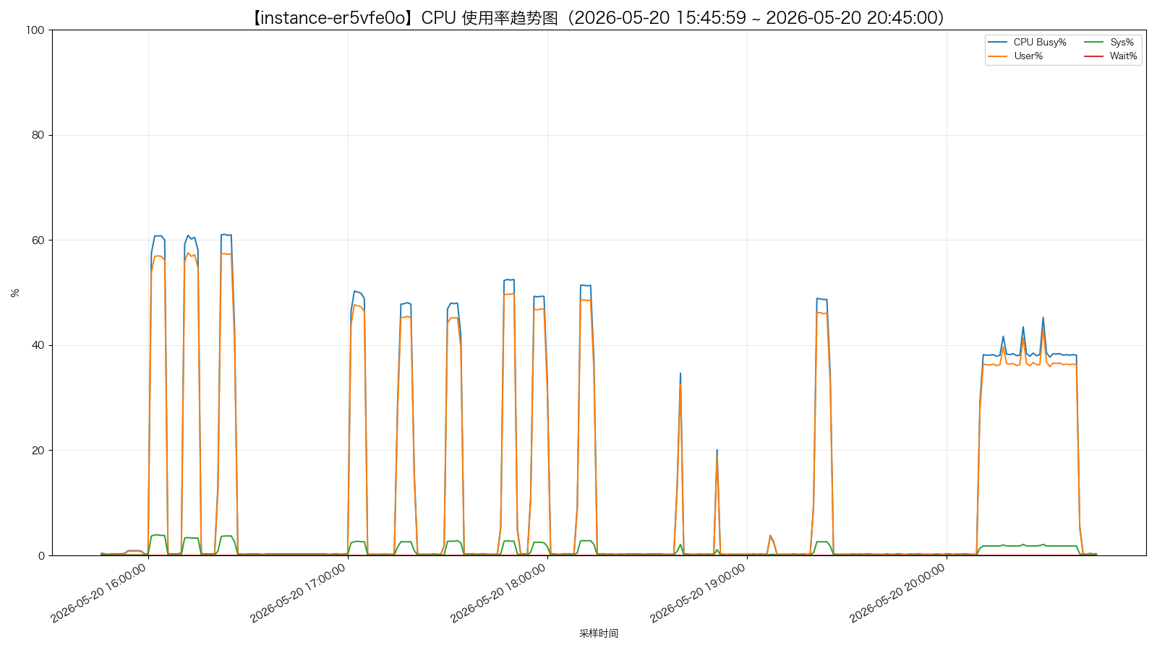
instance-psds6c8p - cpu_usage.png
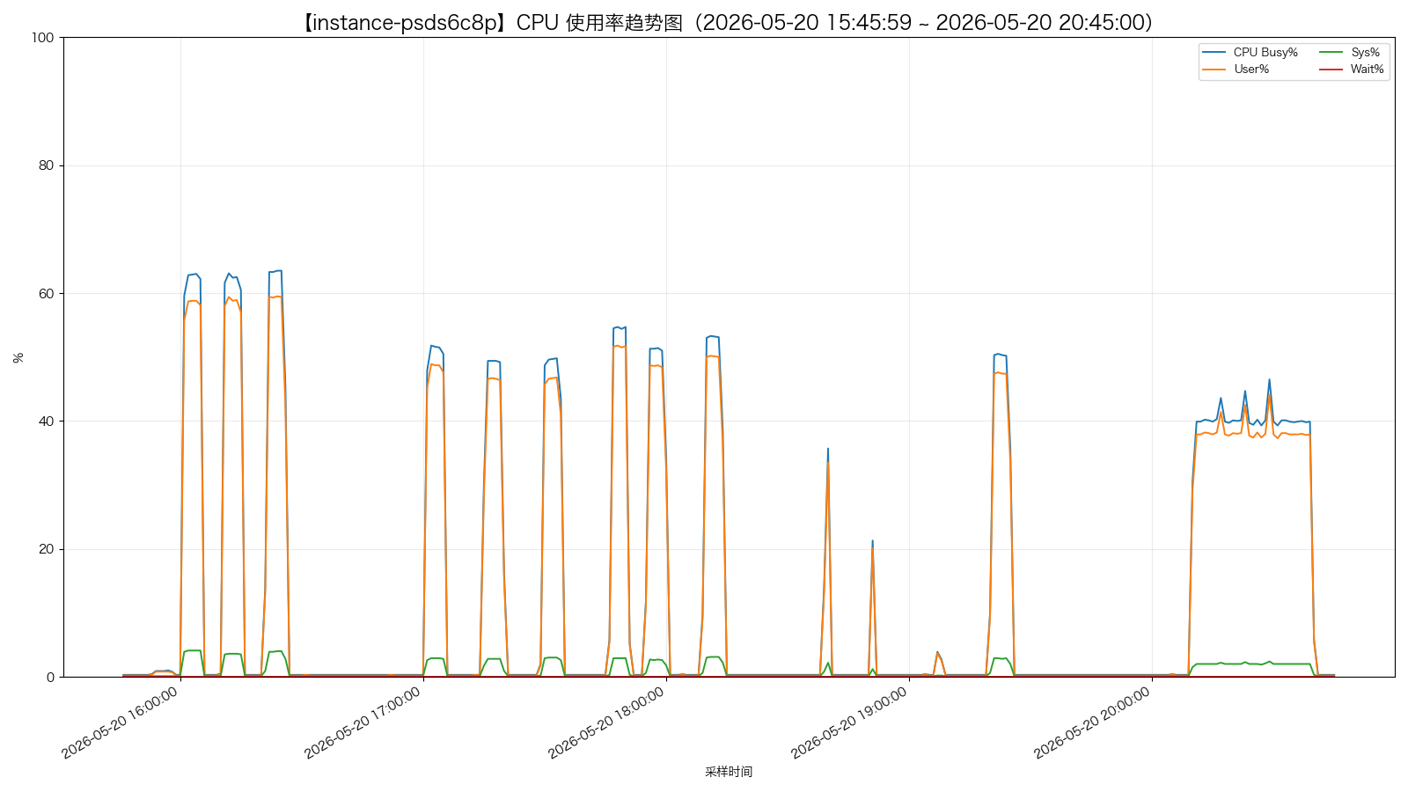
instance-cp18i9mr - cpu_usage.png
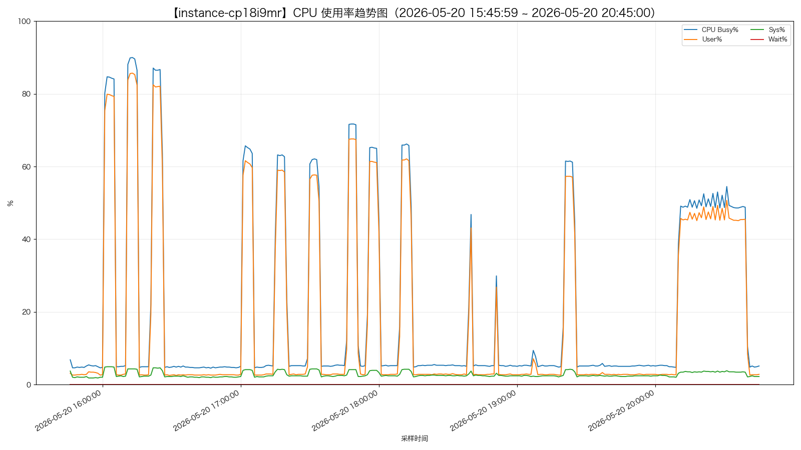
instance-tpexaqbu - cpu_usage.png
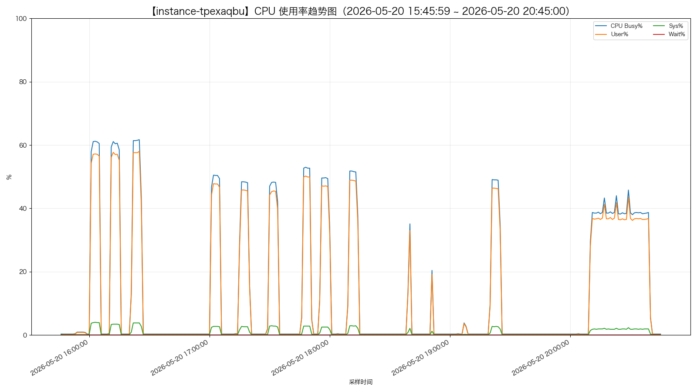
instance-p08t7hw7 - cpu_usage.png
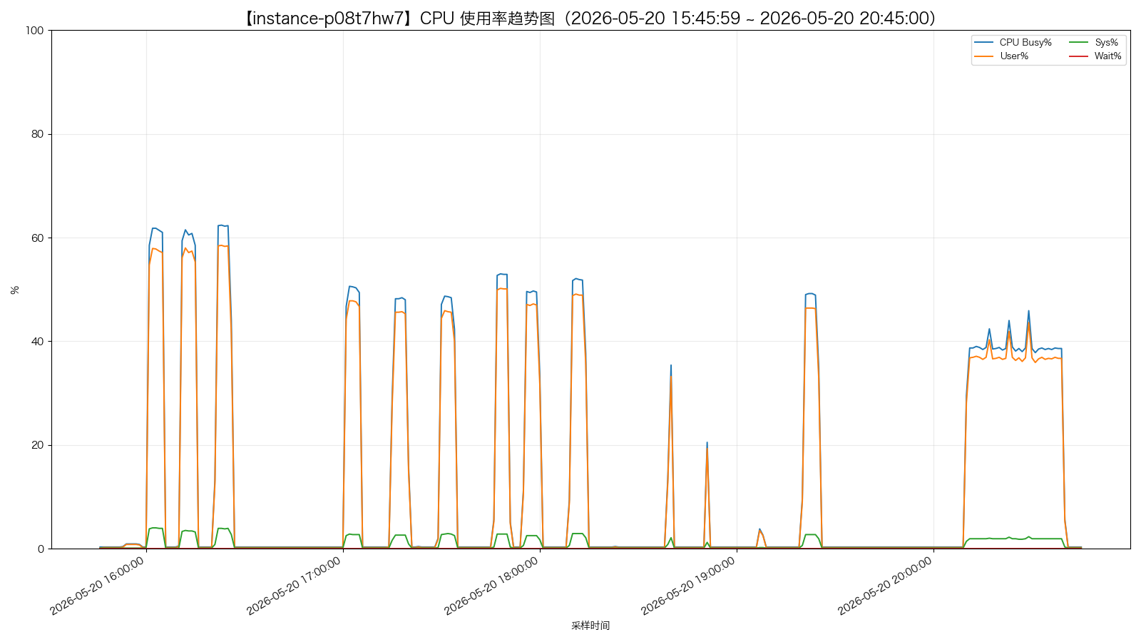
instance-yc02wghu - cpu_usage.png
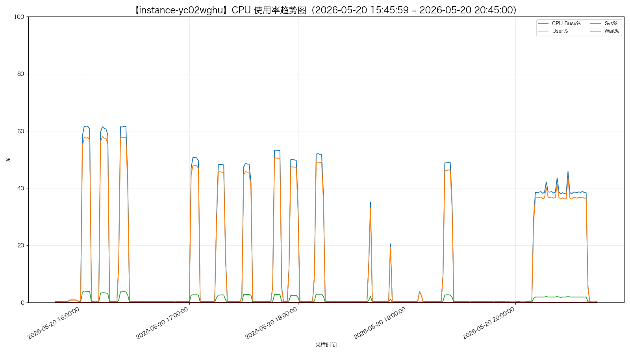

内存使用情况
instance-er5vfe0o - memory_usage_percent.png
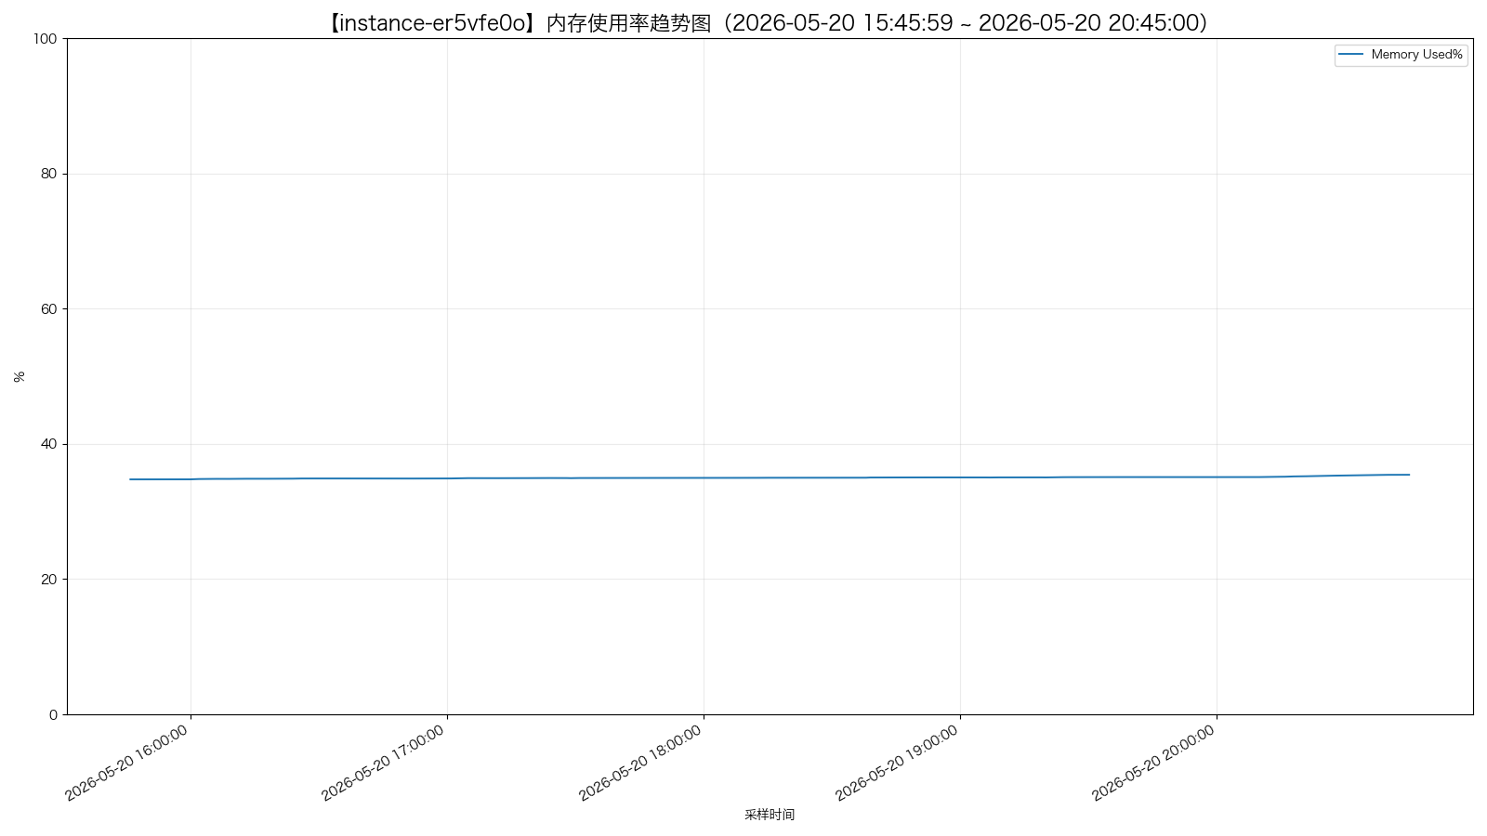
instance-er5vfe0o - memory_detail.png
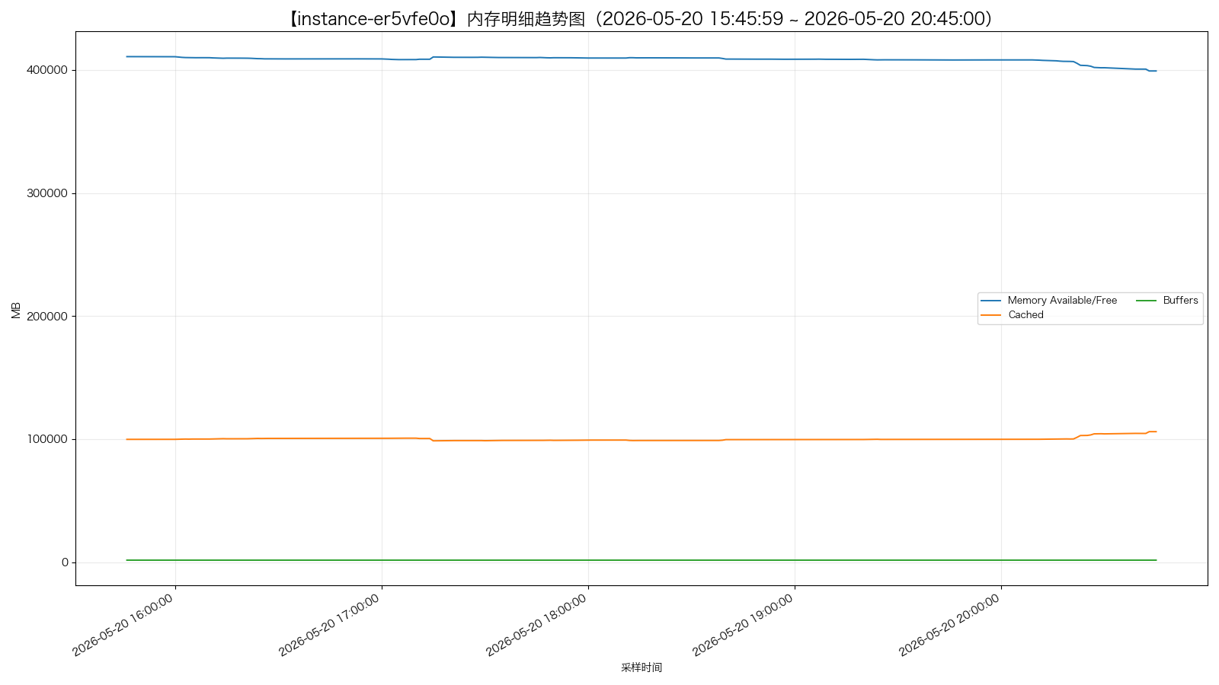
instance-er5vfe0o - swap_usage.png
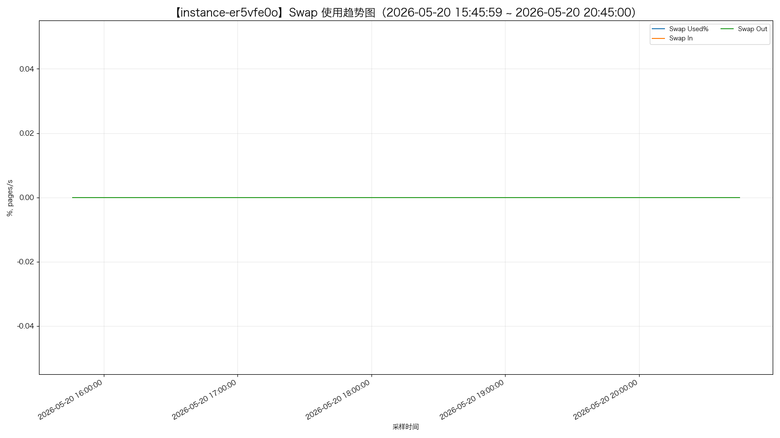
instance-psds6c8p - memory_usage_percent.png
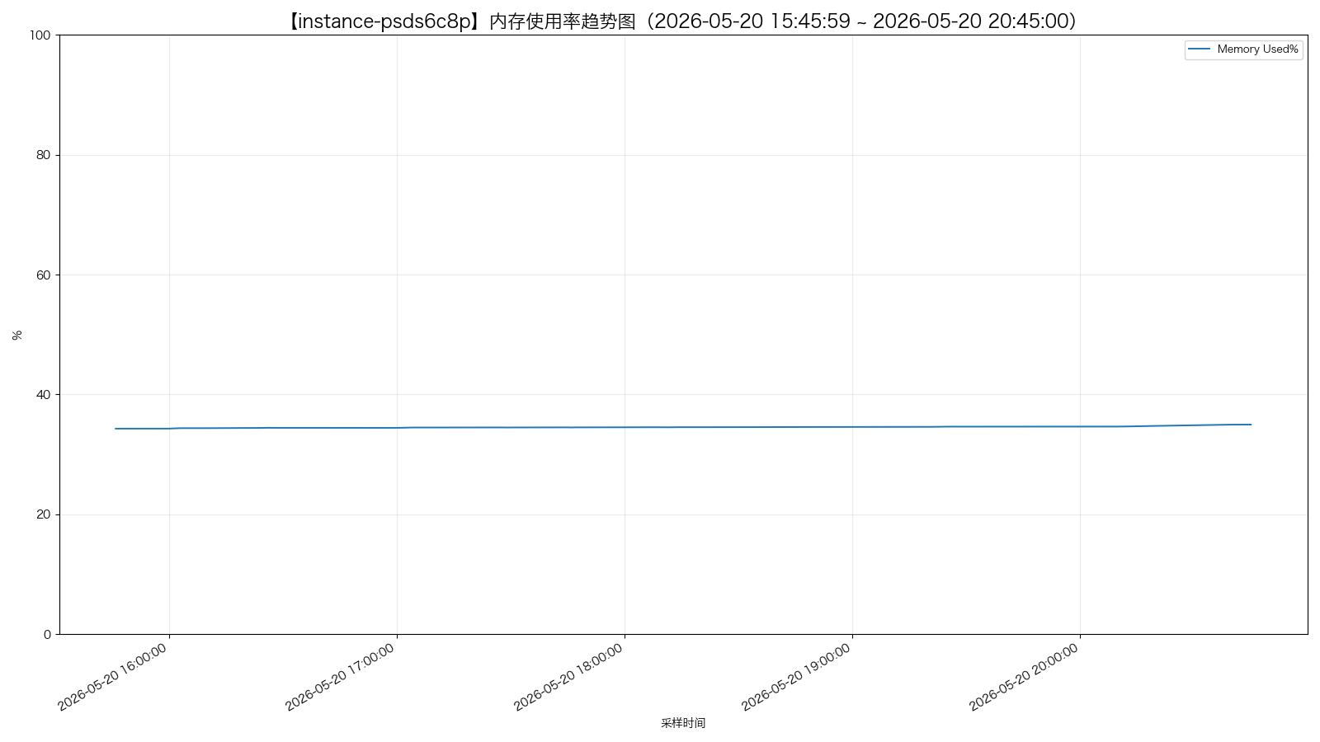
instance-psds6c8p - memory_detail.png
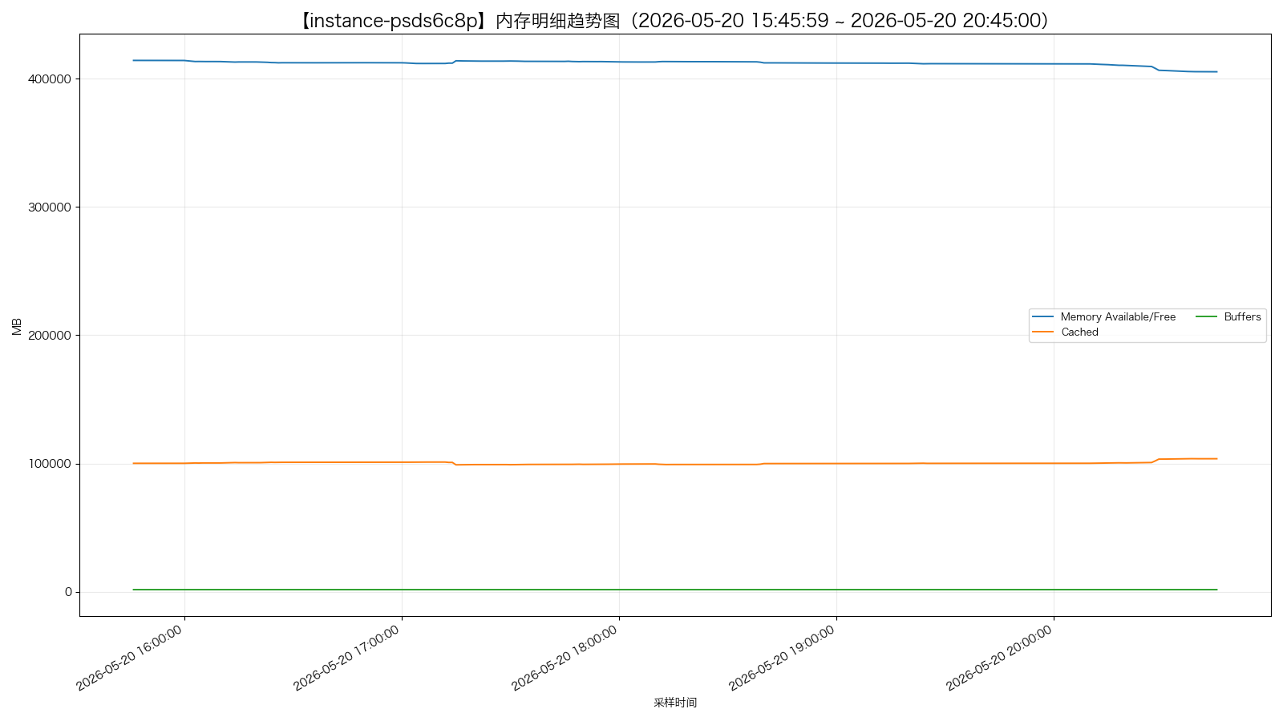
instance-psds6c8p - swap_usage.png
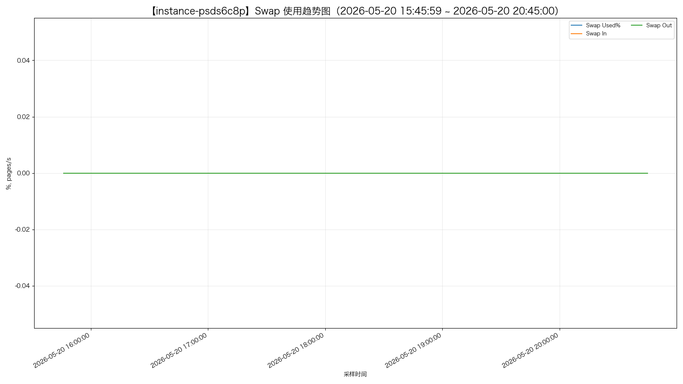
instance-cp18i9mr - memory_usage_percent.png
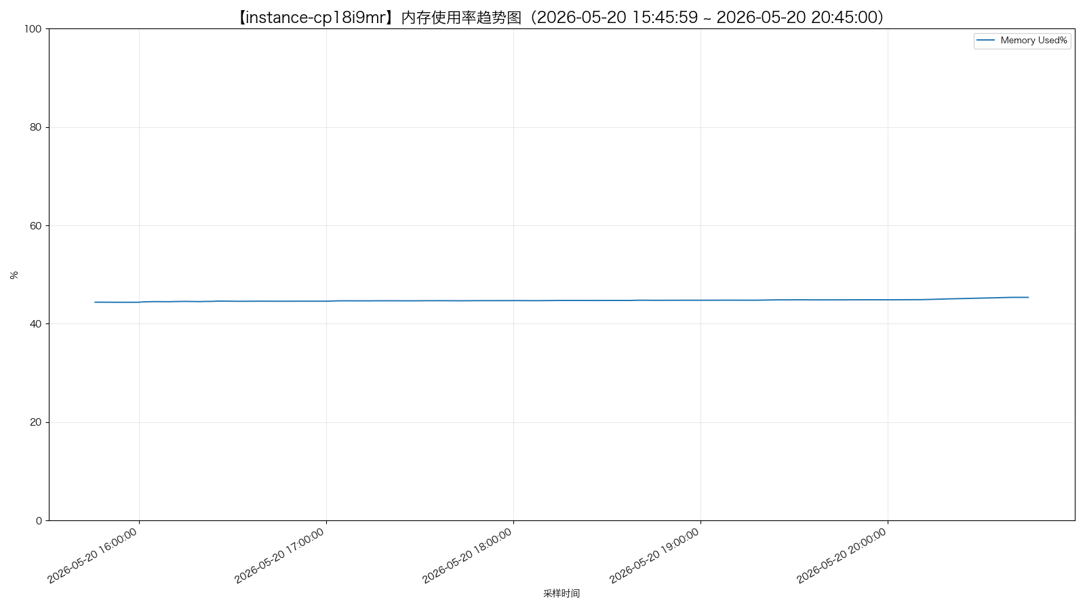
instance-cp18i9mr - memory_detail.png
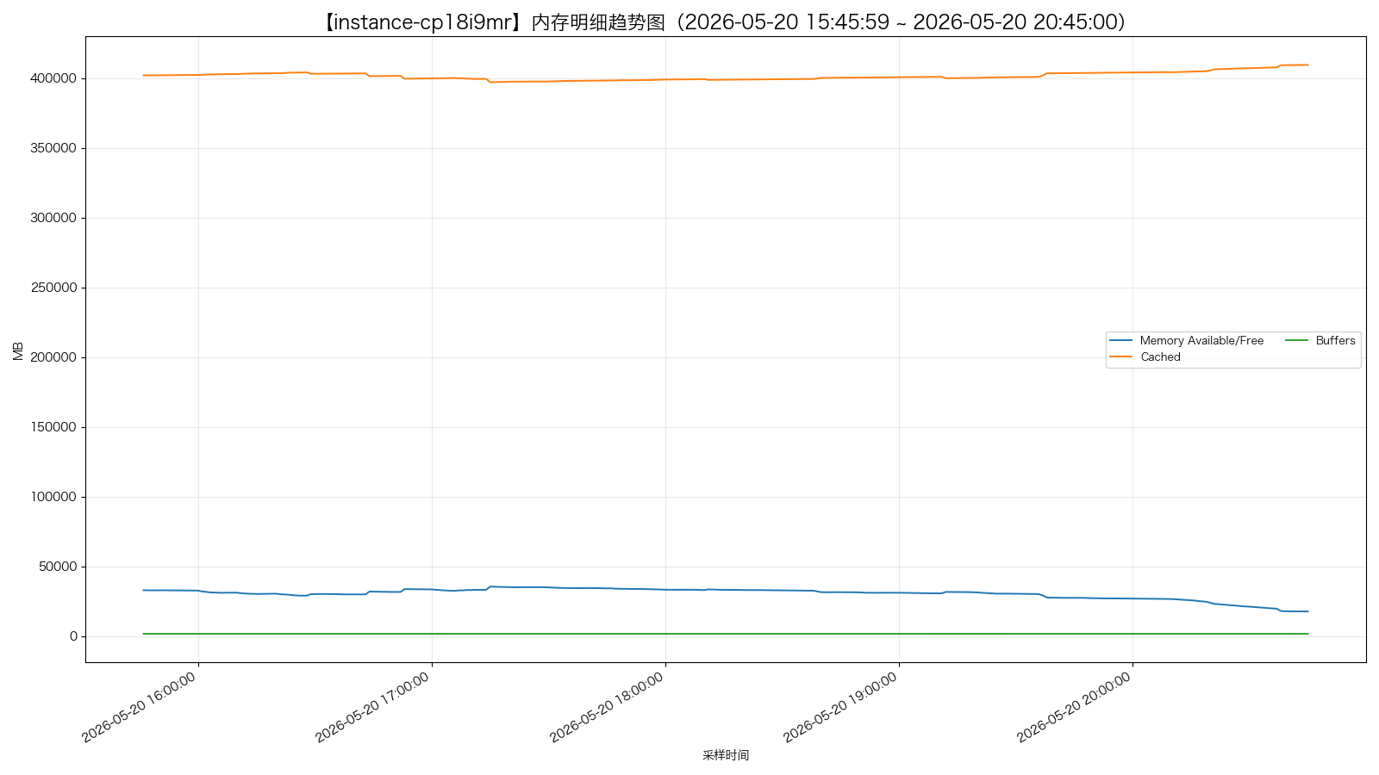
instance-cp18i9mr - swap_usage.png
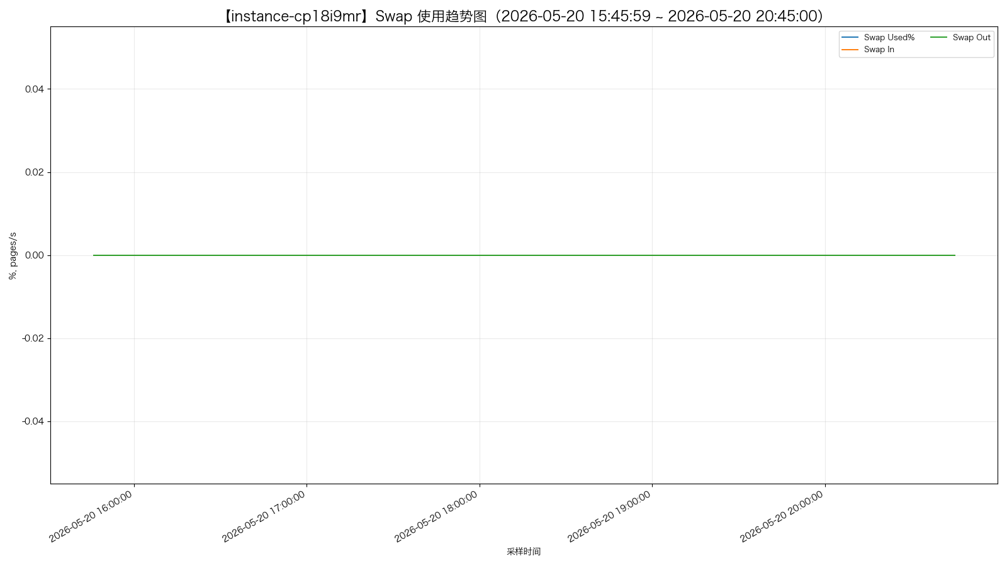
instance-tpexaqbu - memory_usage_percent.png
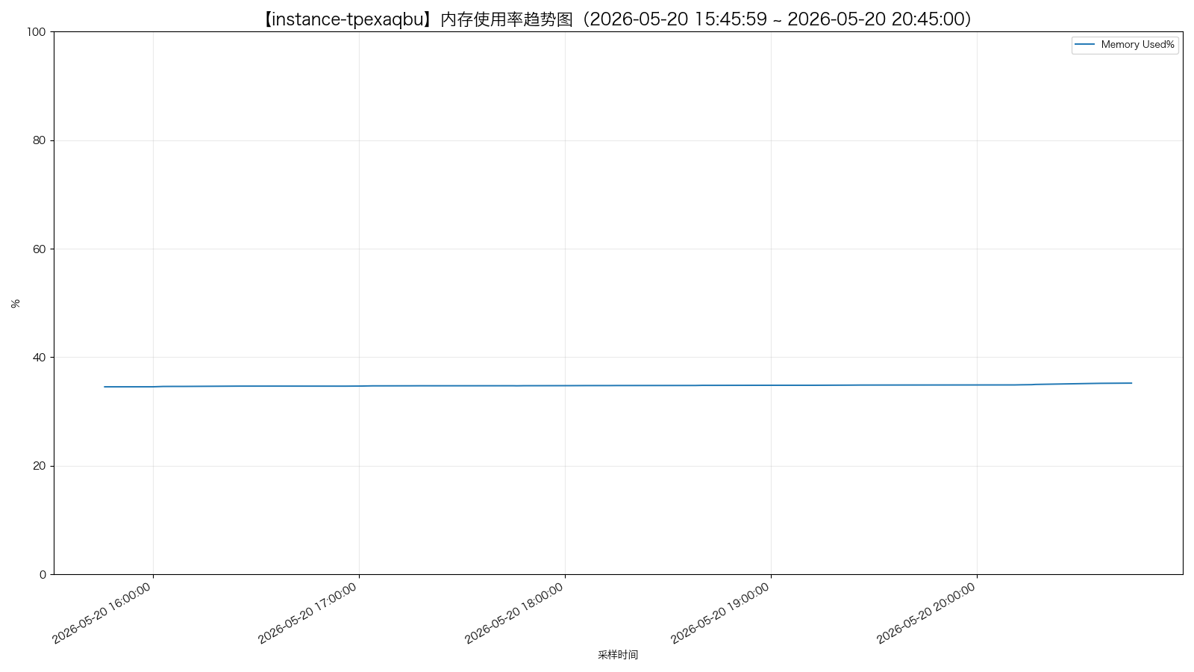
instance-tpexaqbu - memory_detail.png
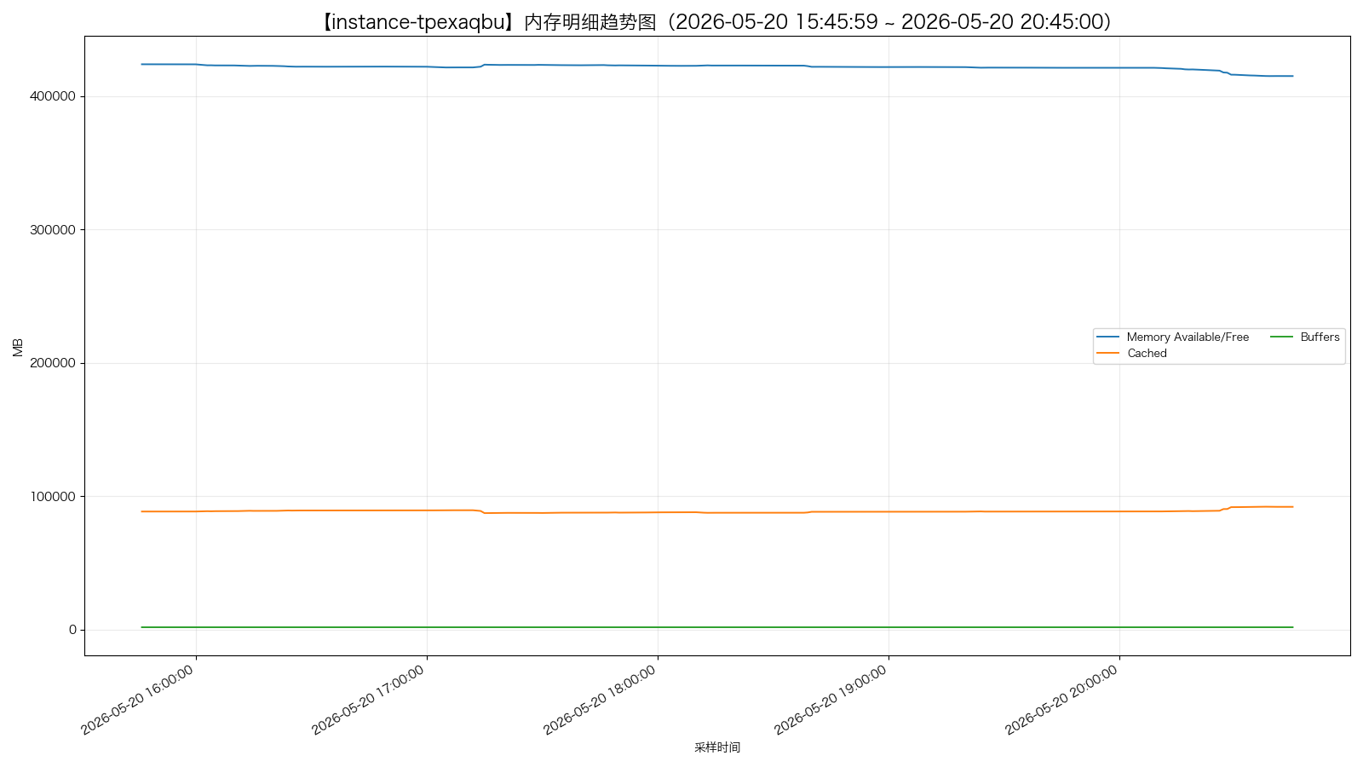
instance-tpexaqbu - swap_usage.png
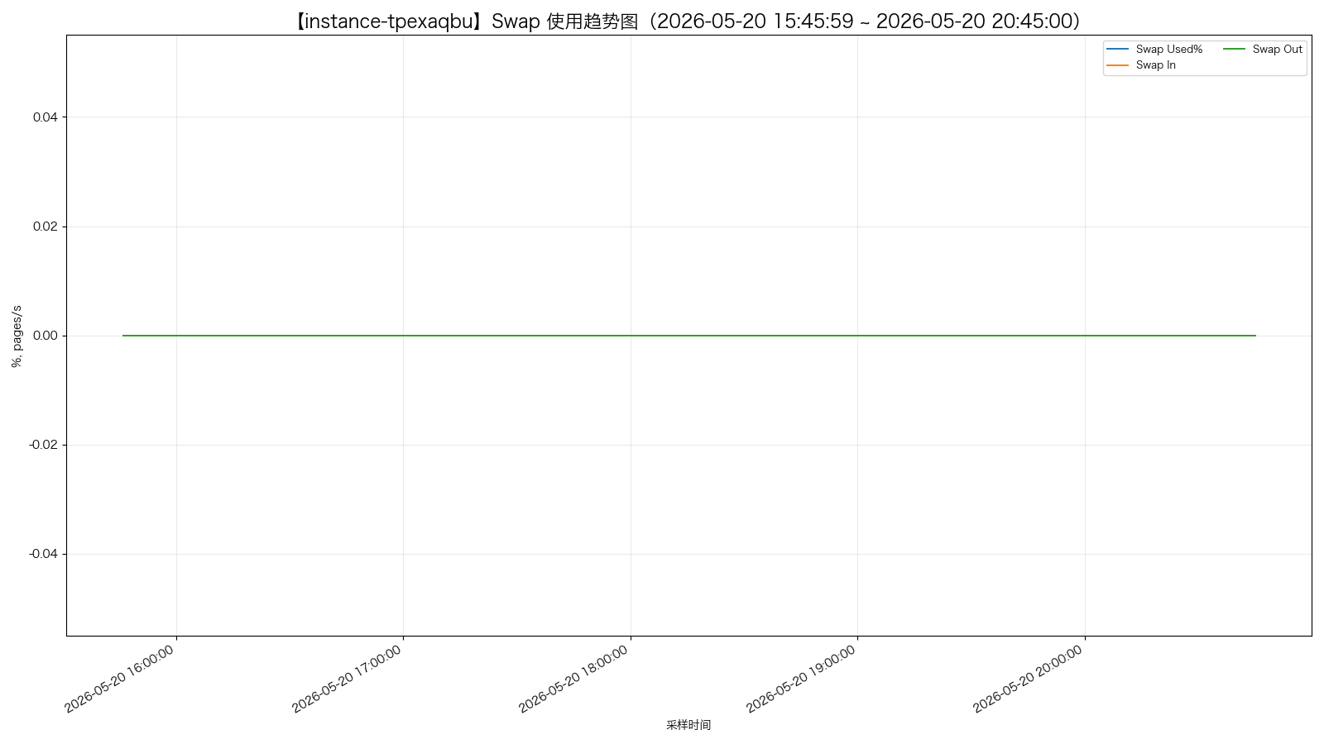
instance-p08t7hw7 - memory_usage_percent.png
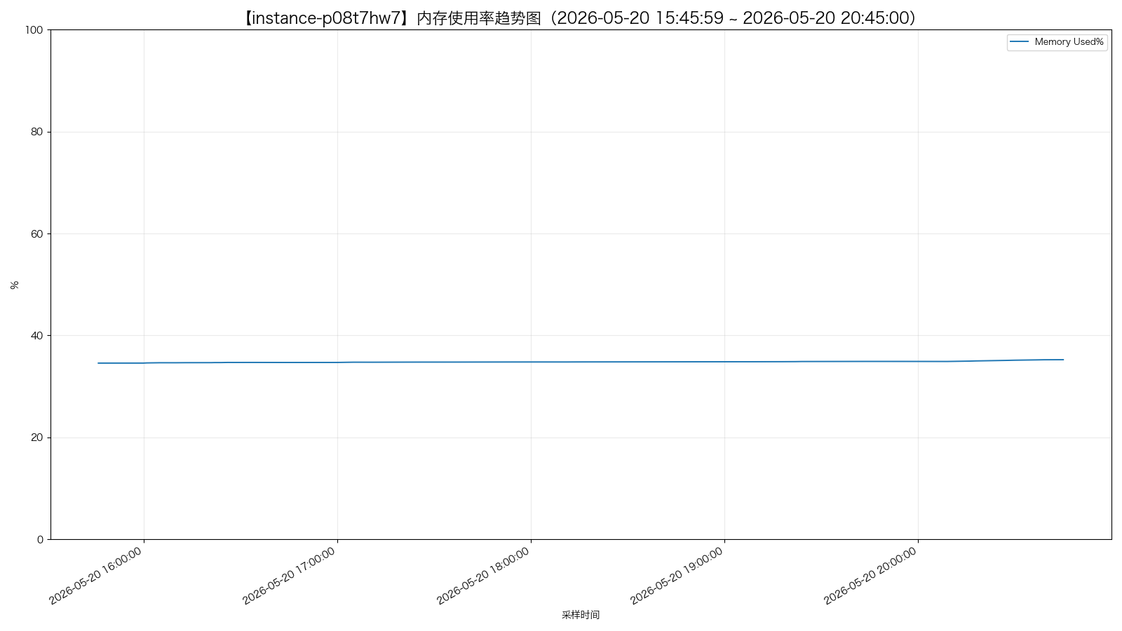
instance-p08t7hw7 - memory_detail.png
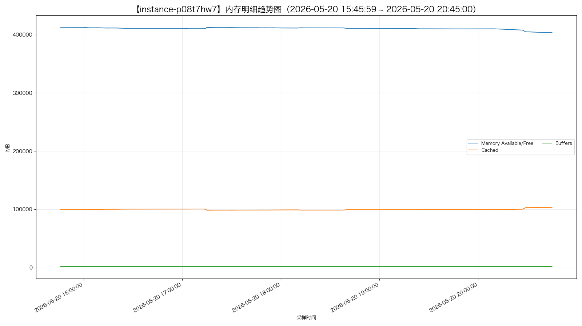
instance-p08t7hw7 - swap_usage.png
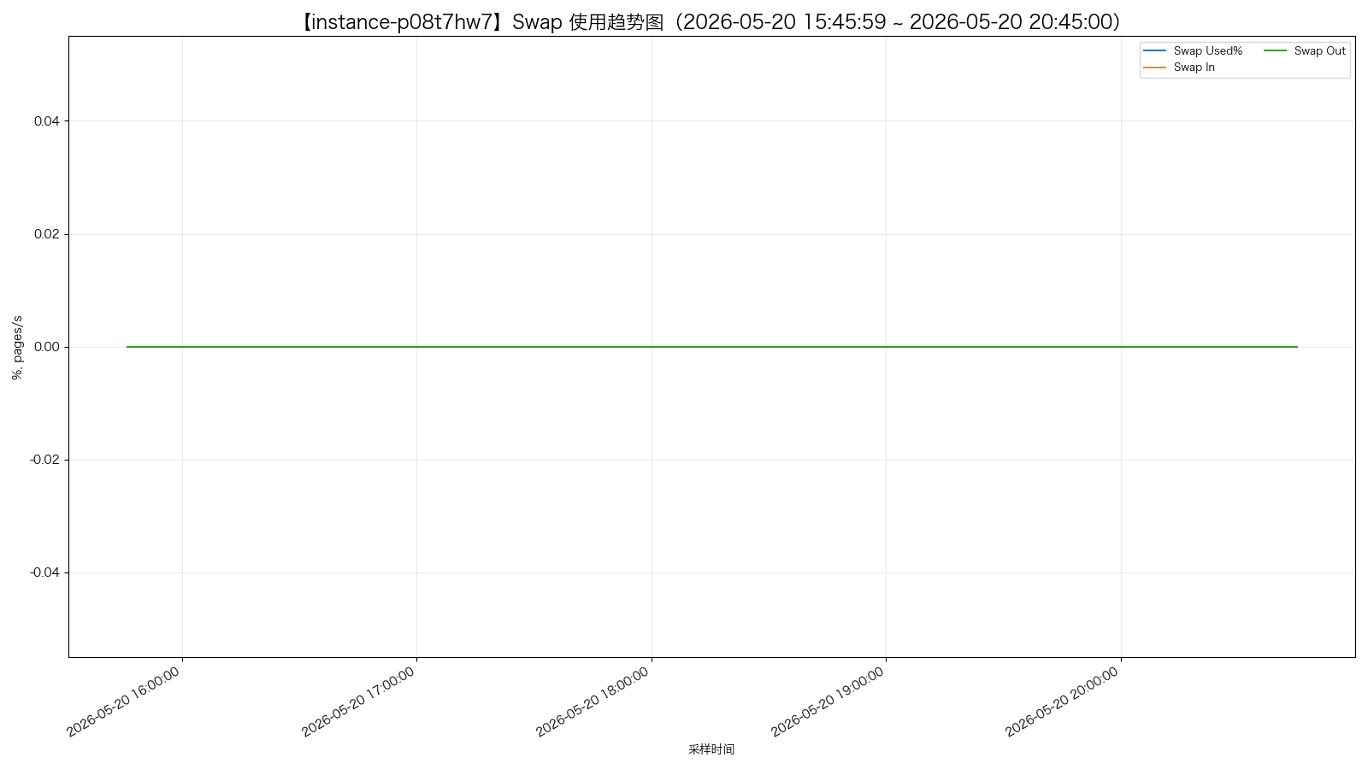
instance-yc02wghu - memory_usage_percent.png
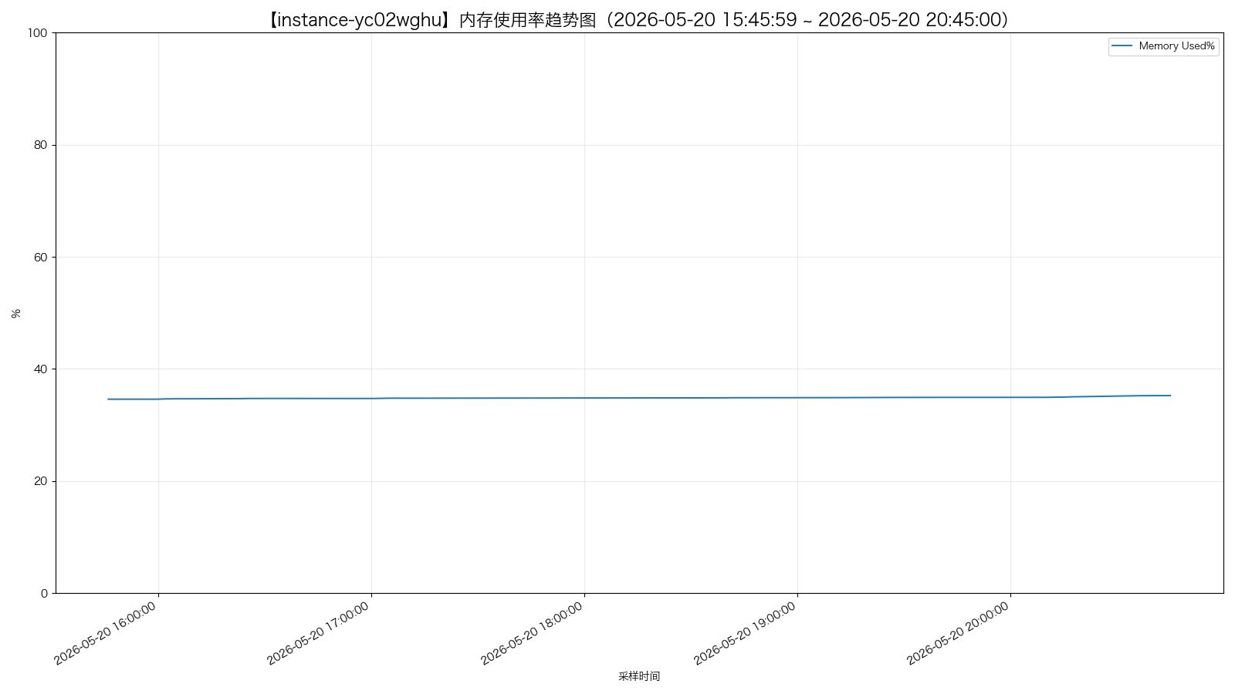
instance-yc02wghu - memory_detail.png
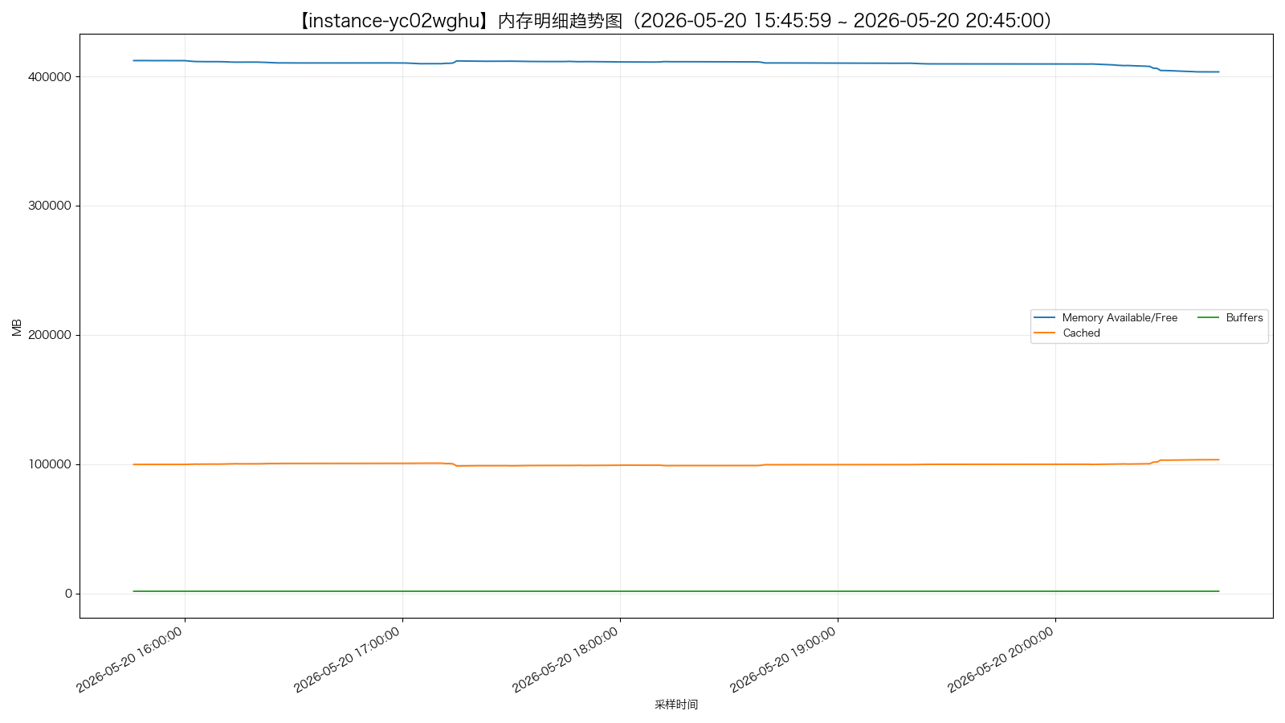
instance-yc02wghu - swap_usage.png
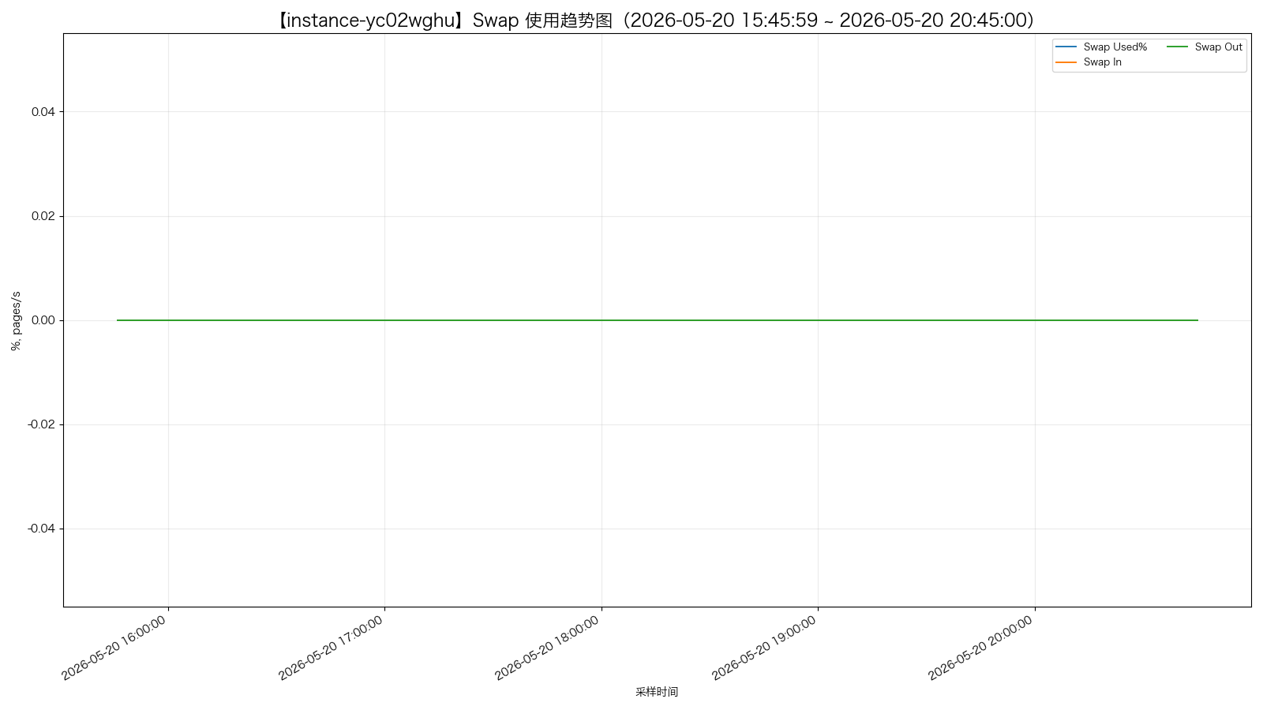

磁盘使用情况
instance-er5vfe0o - disk_busy_top5.png
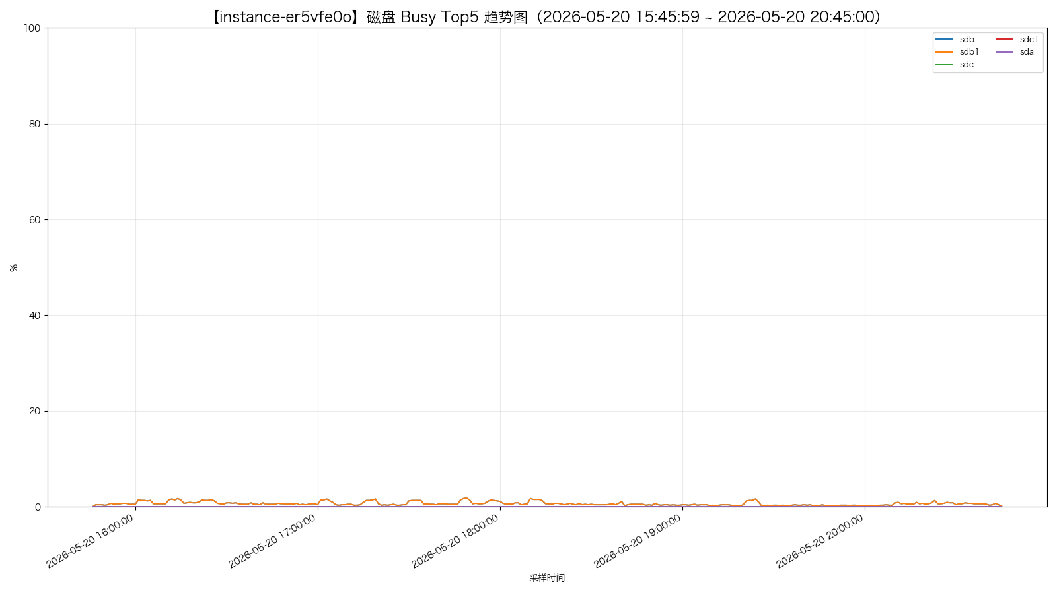
instance-er5vfe0o - disk_io_top5.png
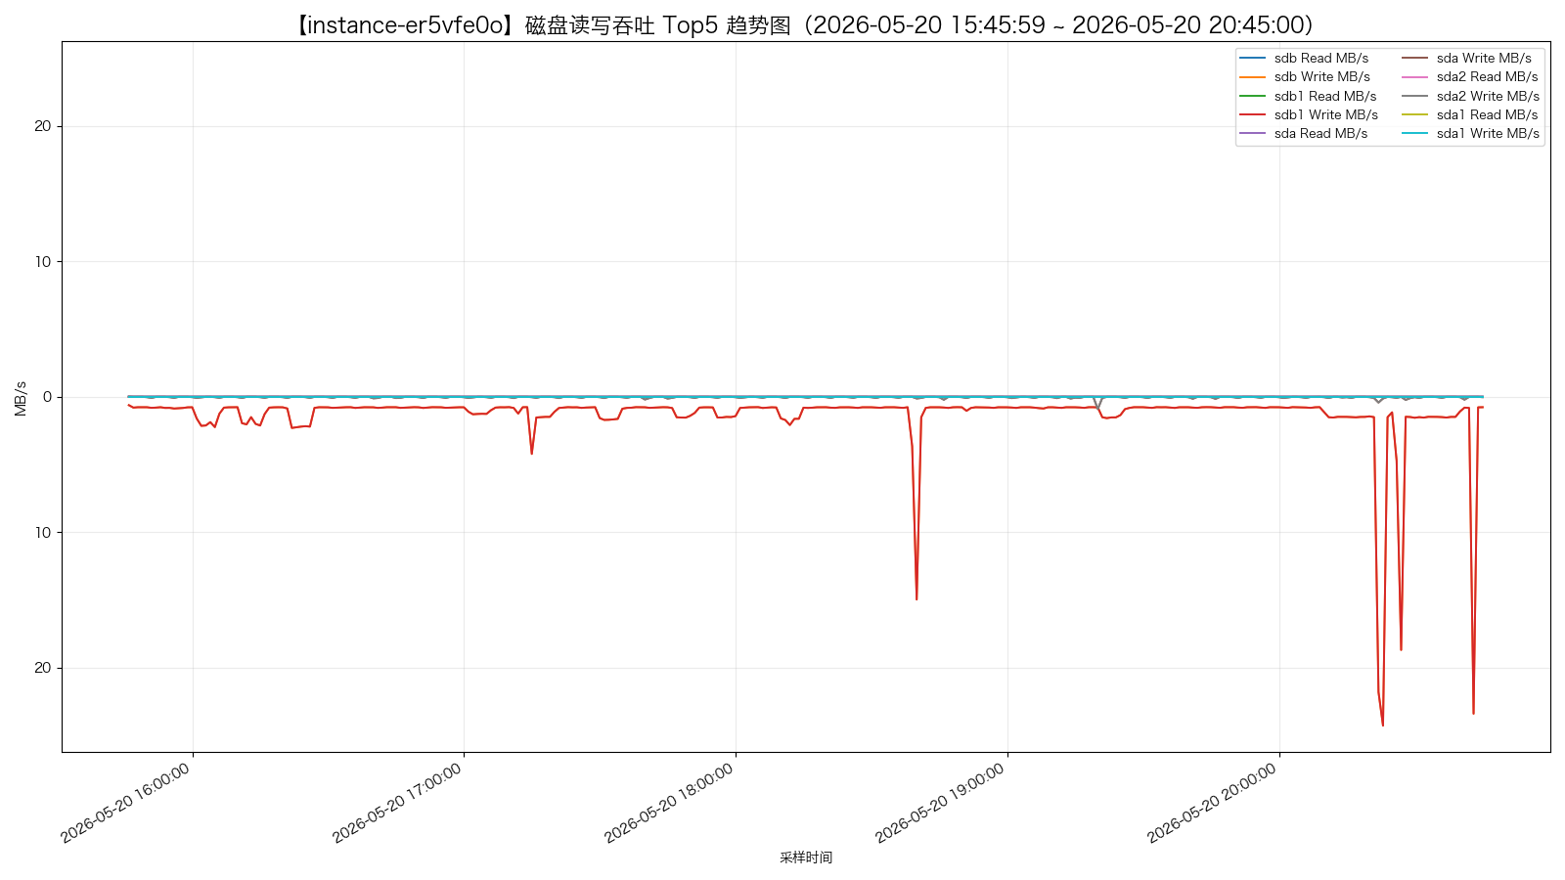
instance-er5vfe0o - disk_iops_top5.png
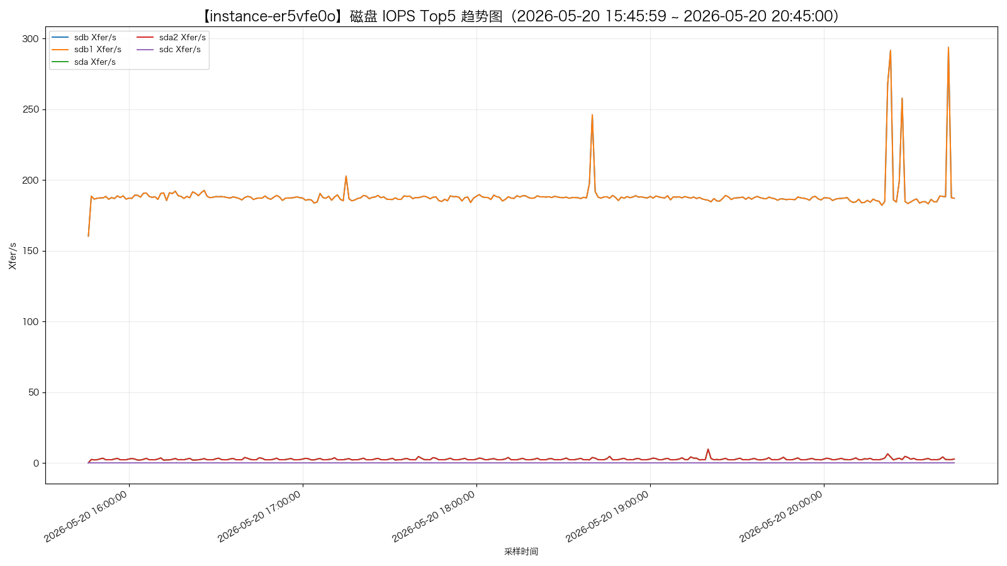
instance-psds6c8p - disk_busy_top5.png
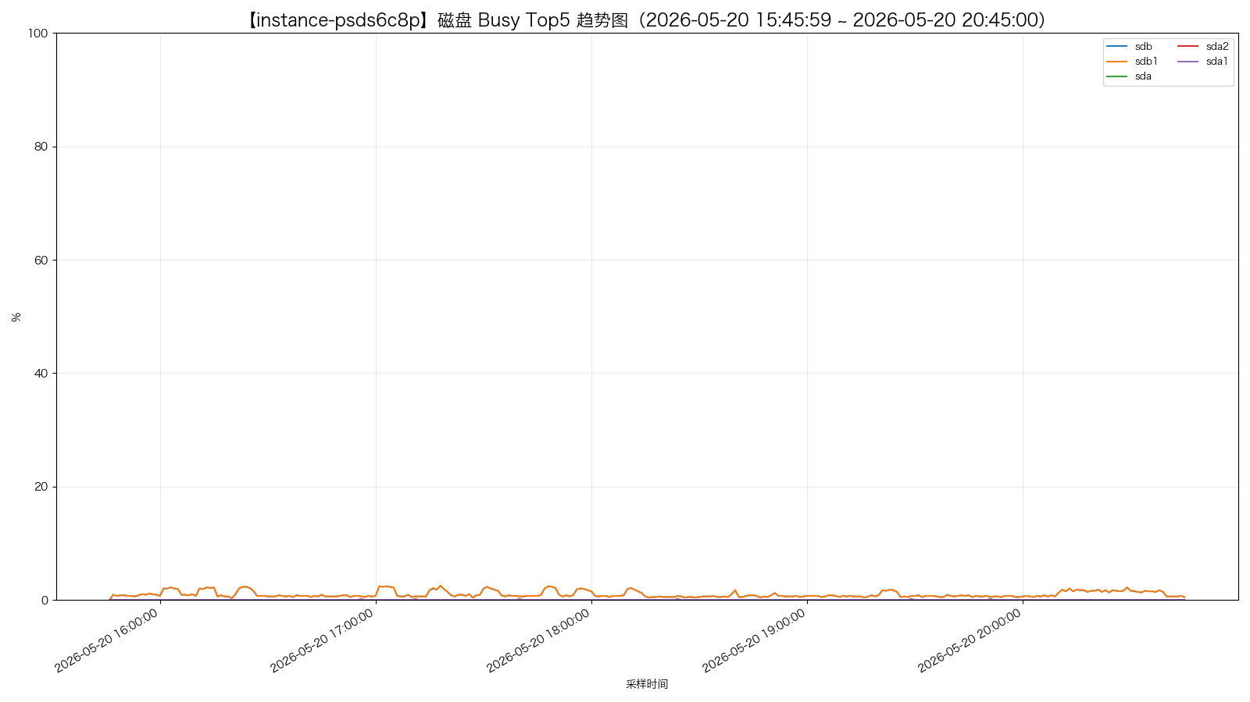
instance-psds6c8p - disk_io_top5.png
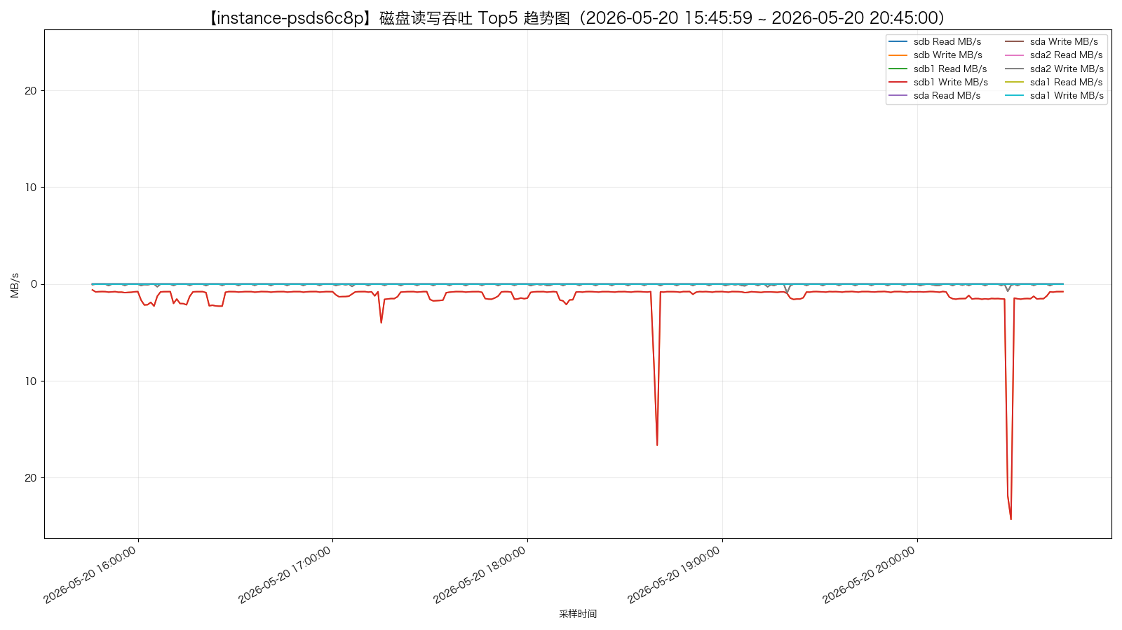
instance-psds6c8p - disk_iops_top5.png
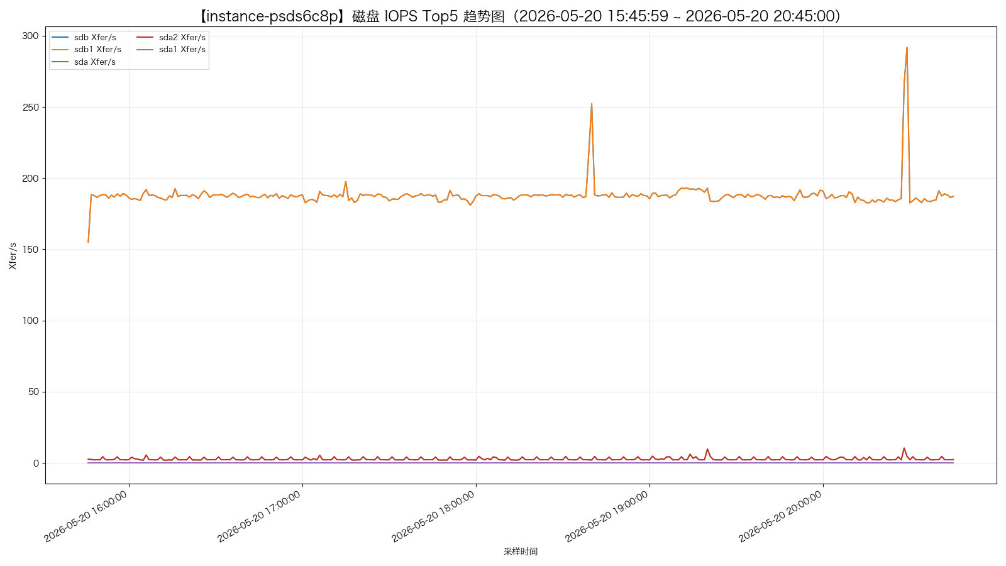
instance-cp18i9mr - disk_busy_top5.png
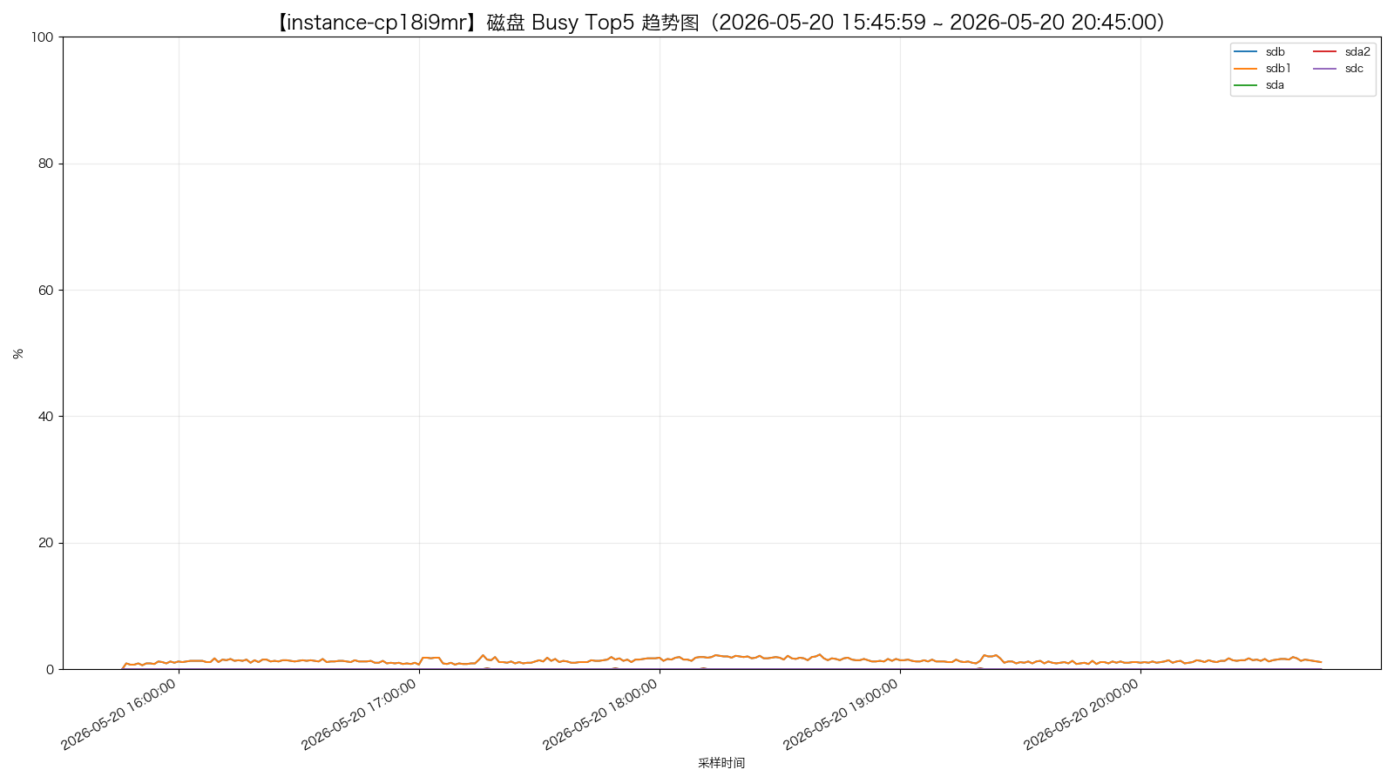
instance-cp18i9mr - disk_io_top5.png
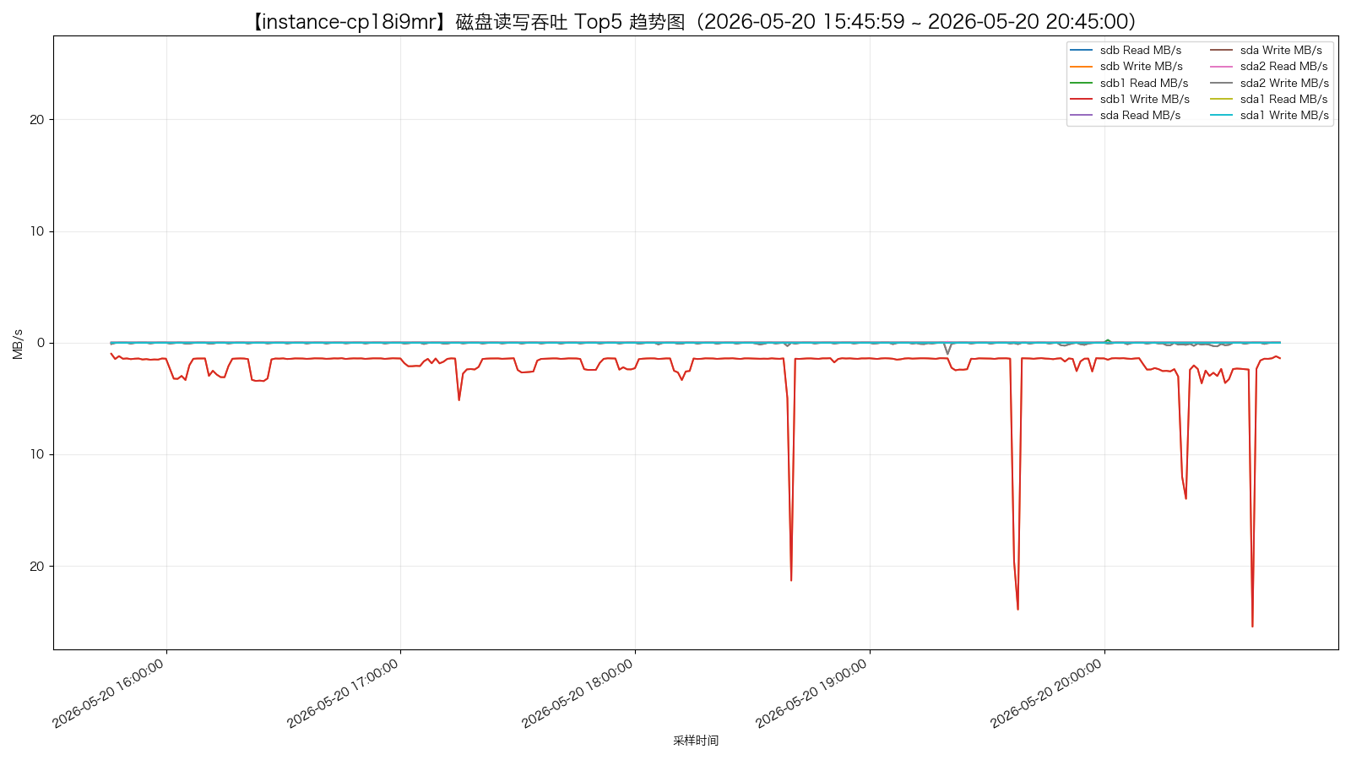
instance-cp18i9mr - disk_iops_top5.png
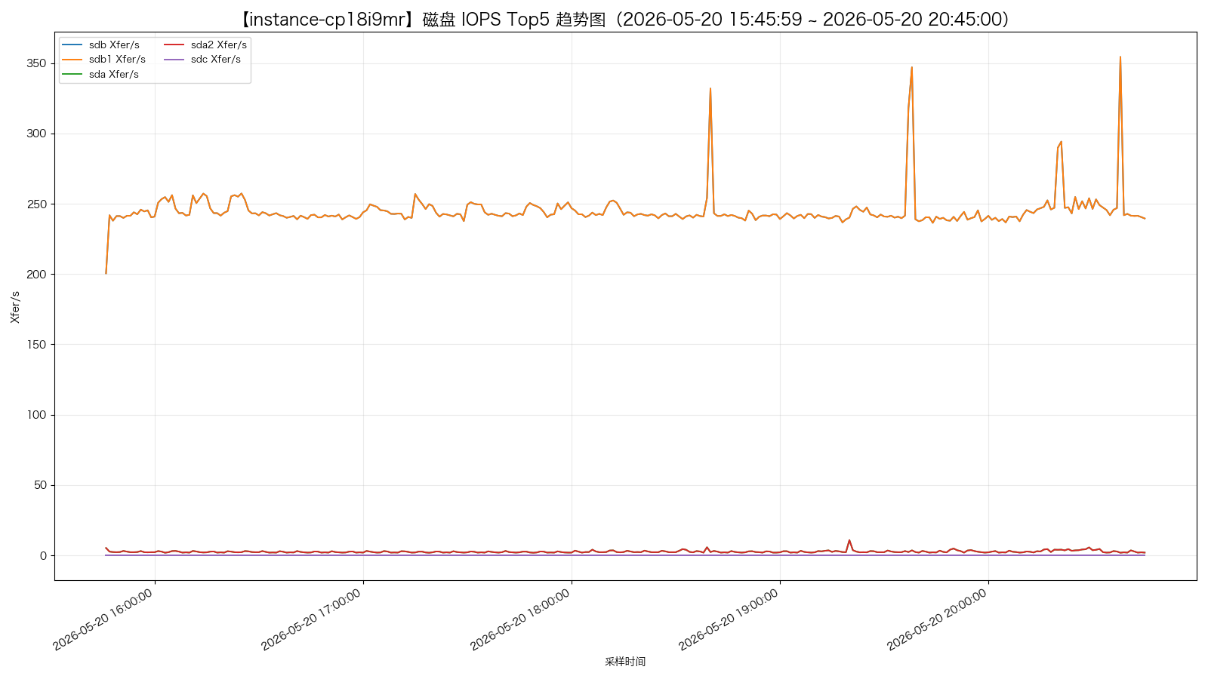
instance-tpexaqbu - disk_busy_top5.png
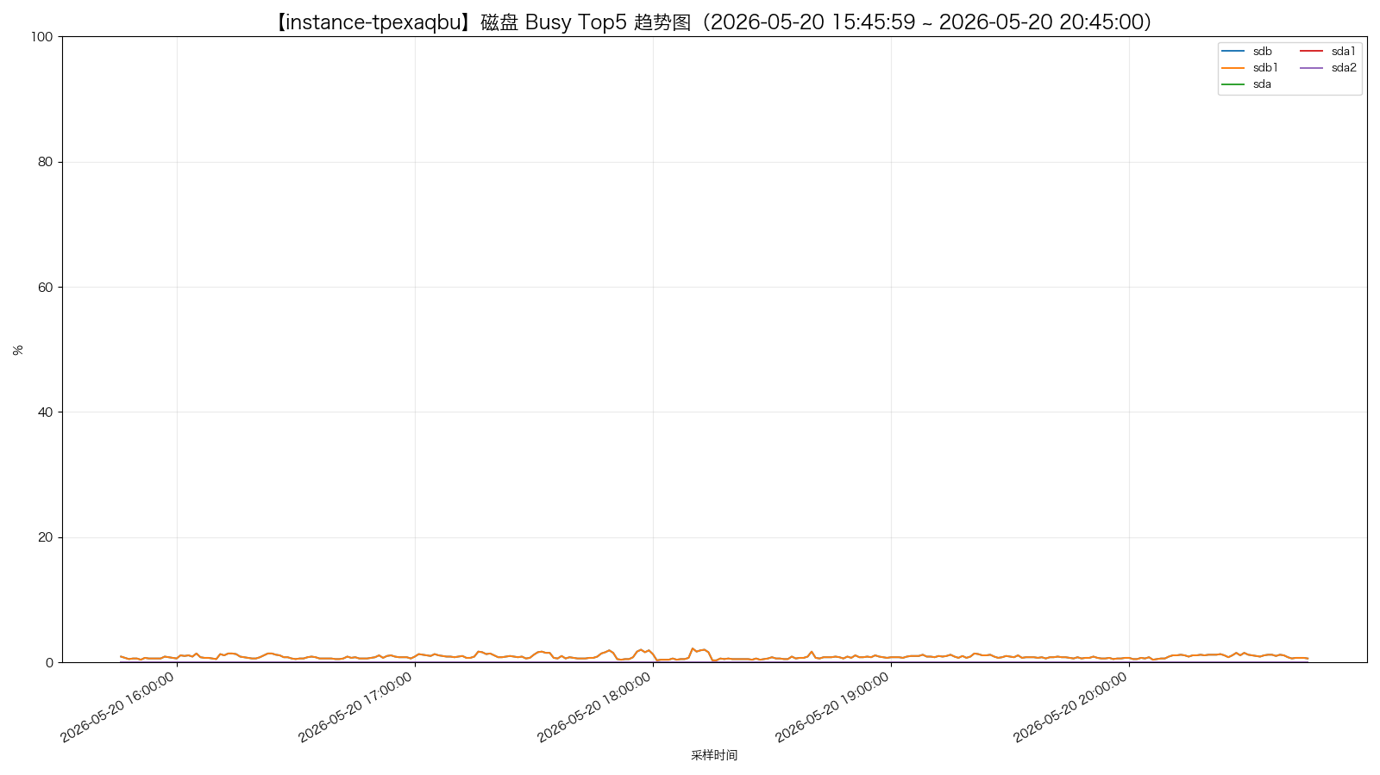
instance-tpexaqbu - disk_io_top5.png
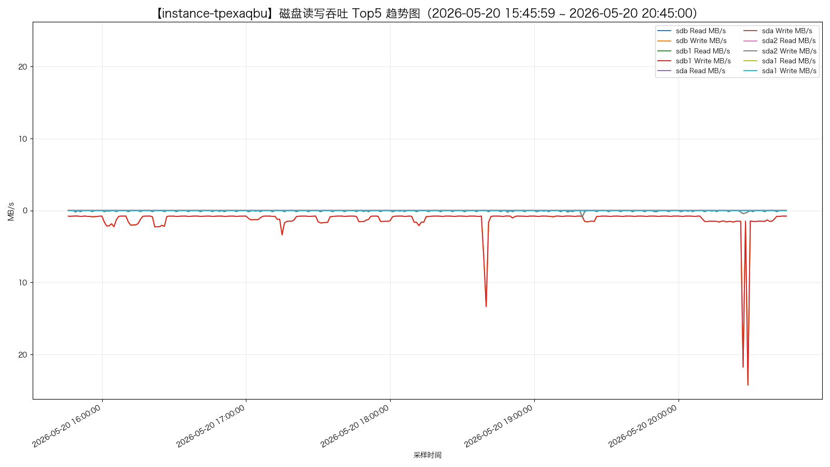
instance-tpexaqbu - disk_iops_top5.png
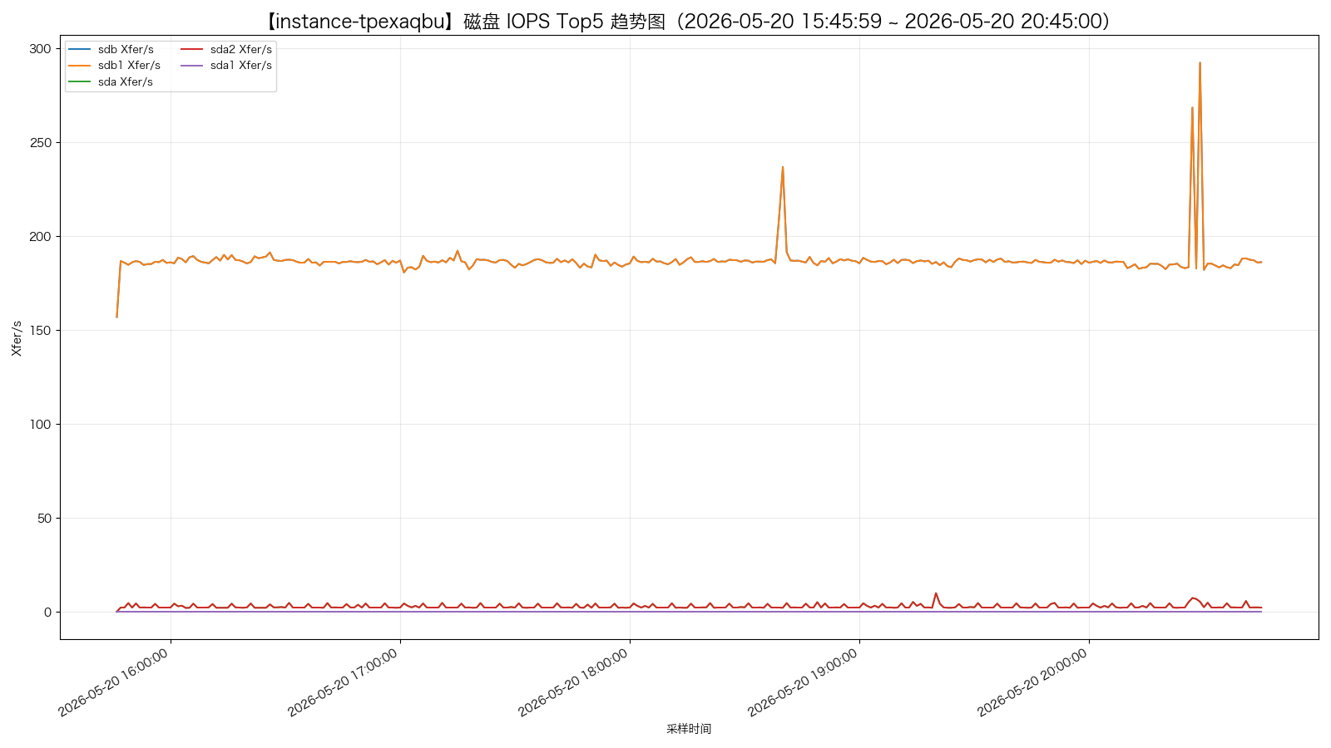
instance-p08t7hw7 - disk_busy_top5.png
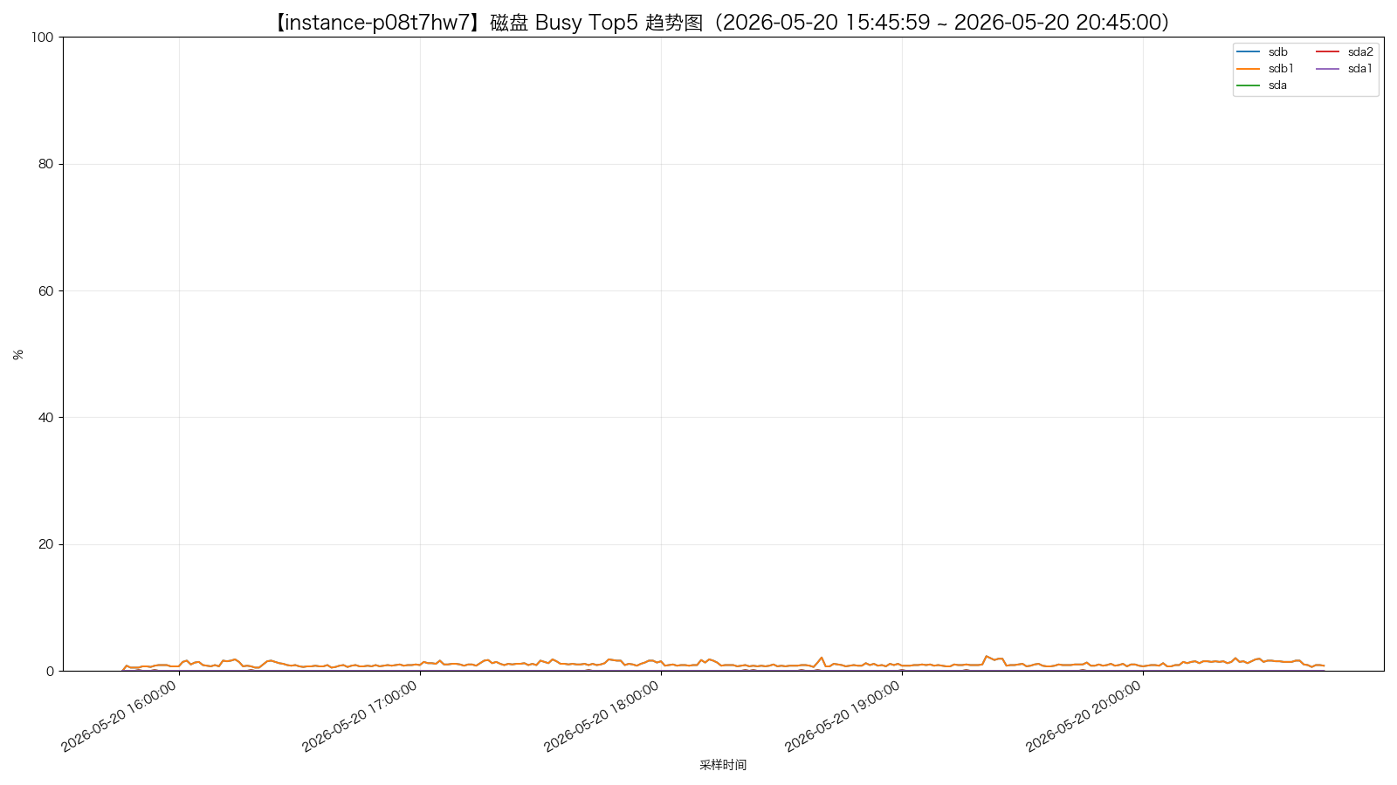
instance-p08t7hw7 - disk_io_top5.png
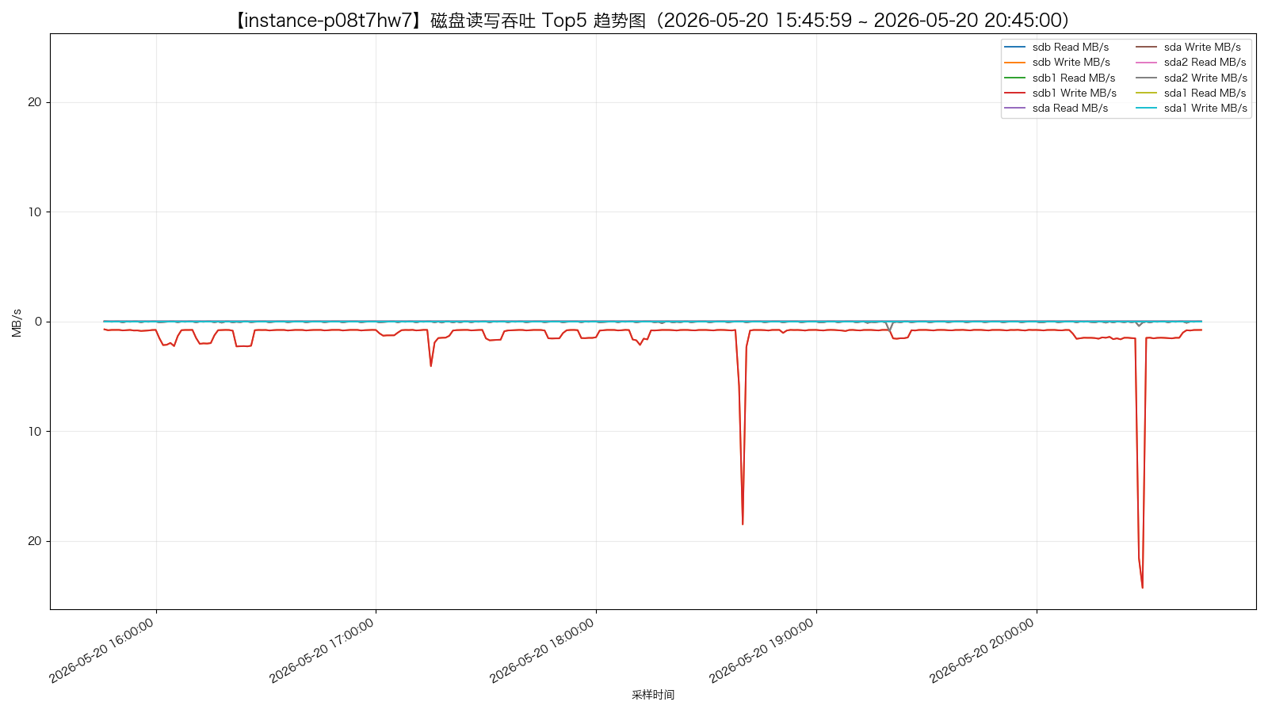
instance-p08t7hw7 - disk_iops_top5.png
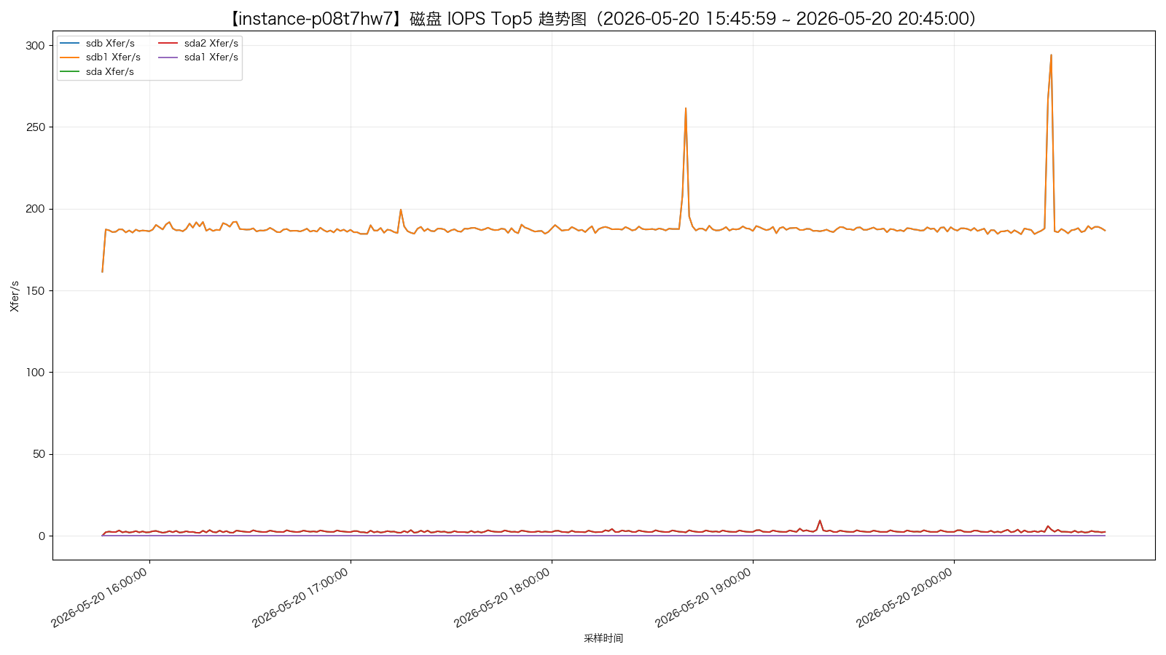
instance-yc02wghu - disk_busy_top5.png
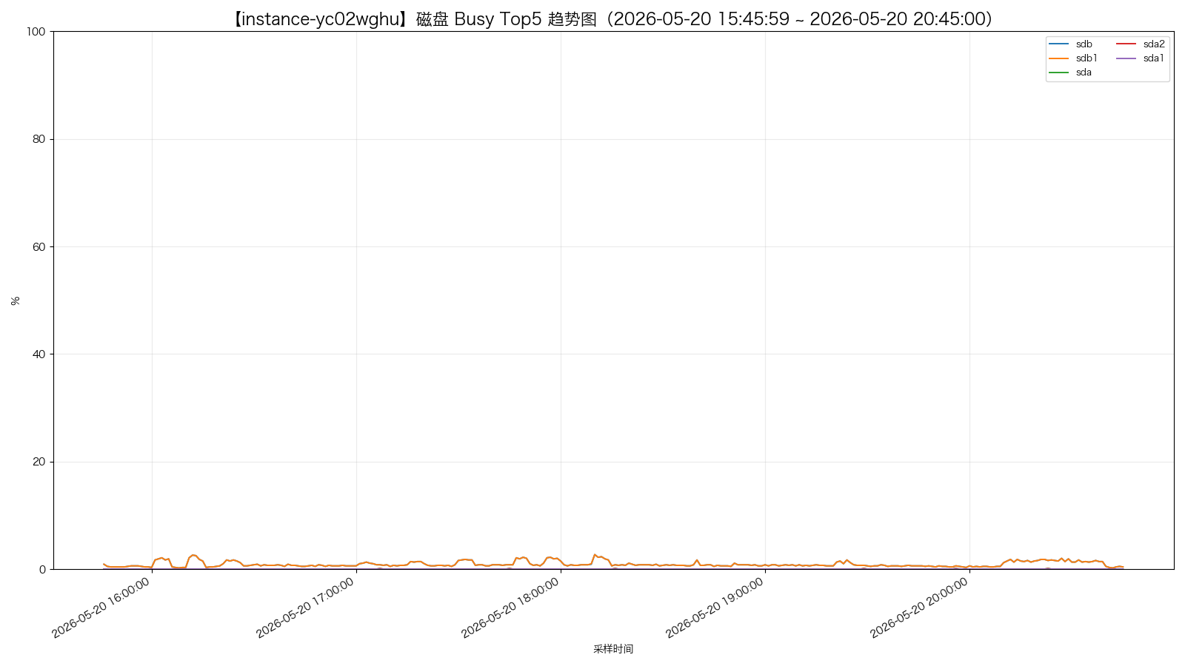
instance-yc02wghu - disk_io_top5.png
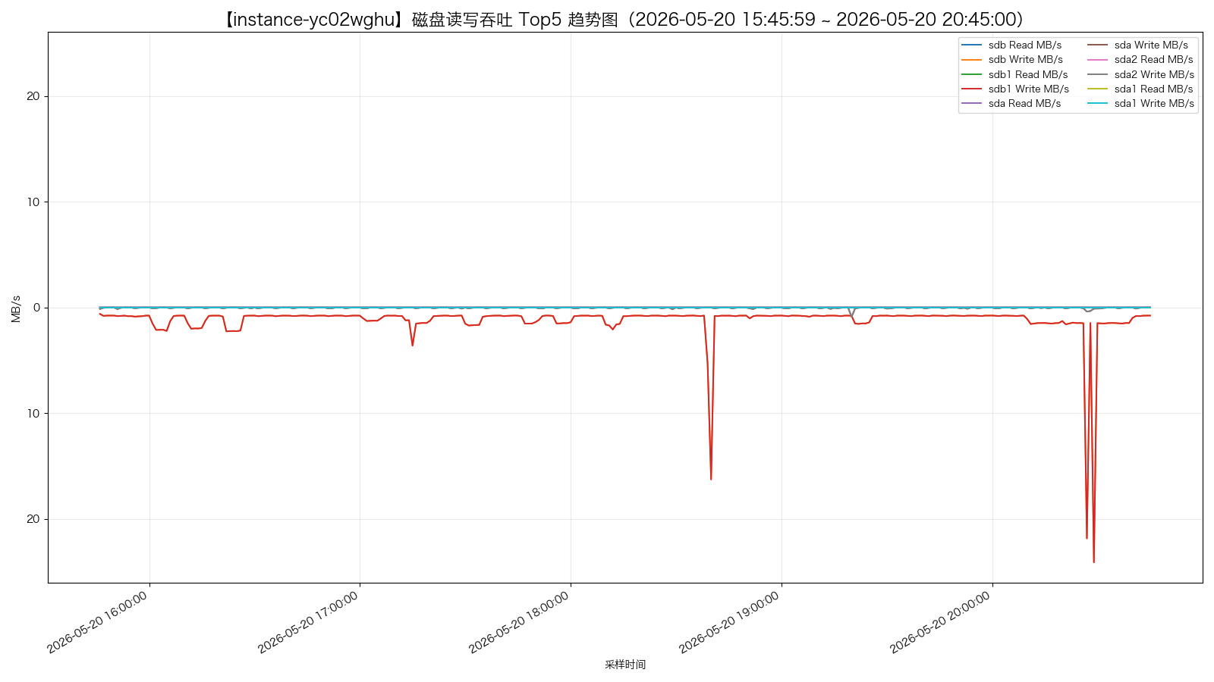
instance-yc02wghu - disk_iops_top5.png
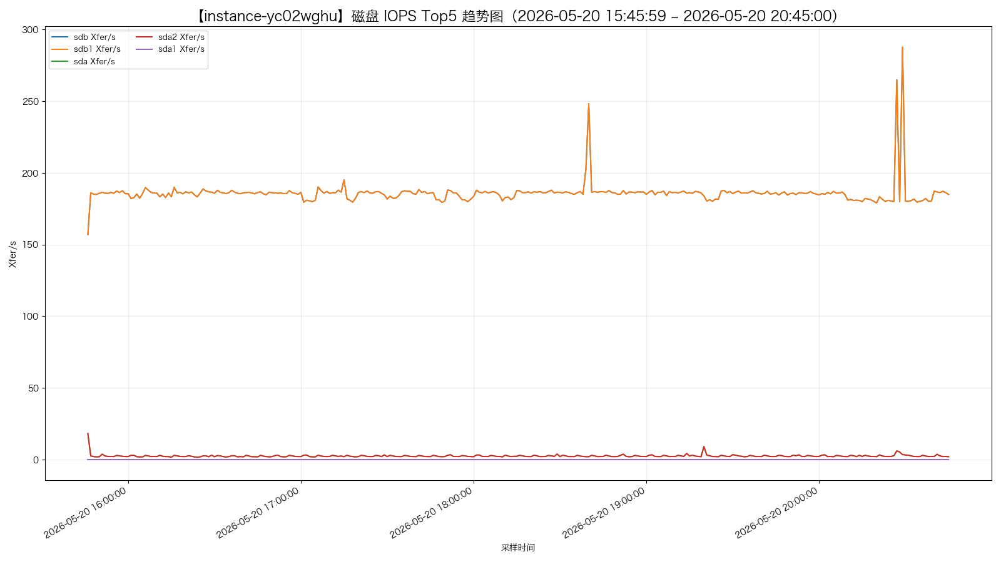

网络使用情况
instance-er5vfe0o - network_top5.png
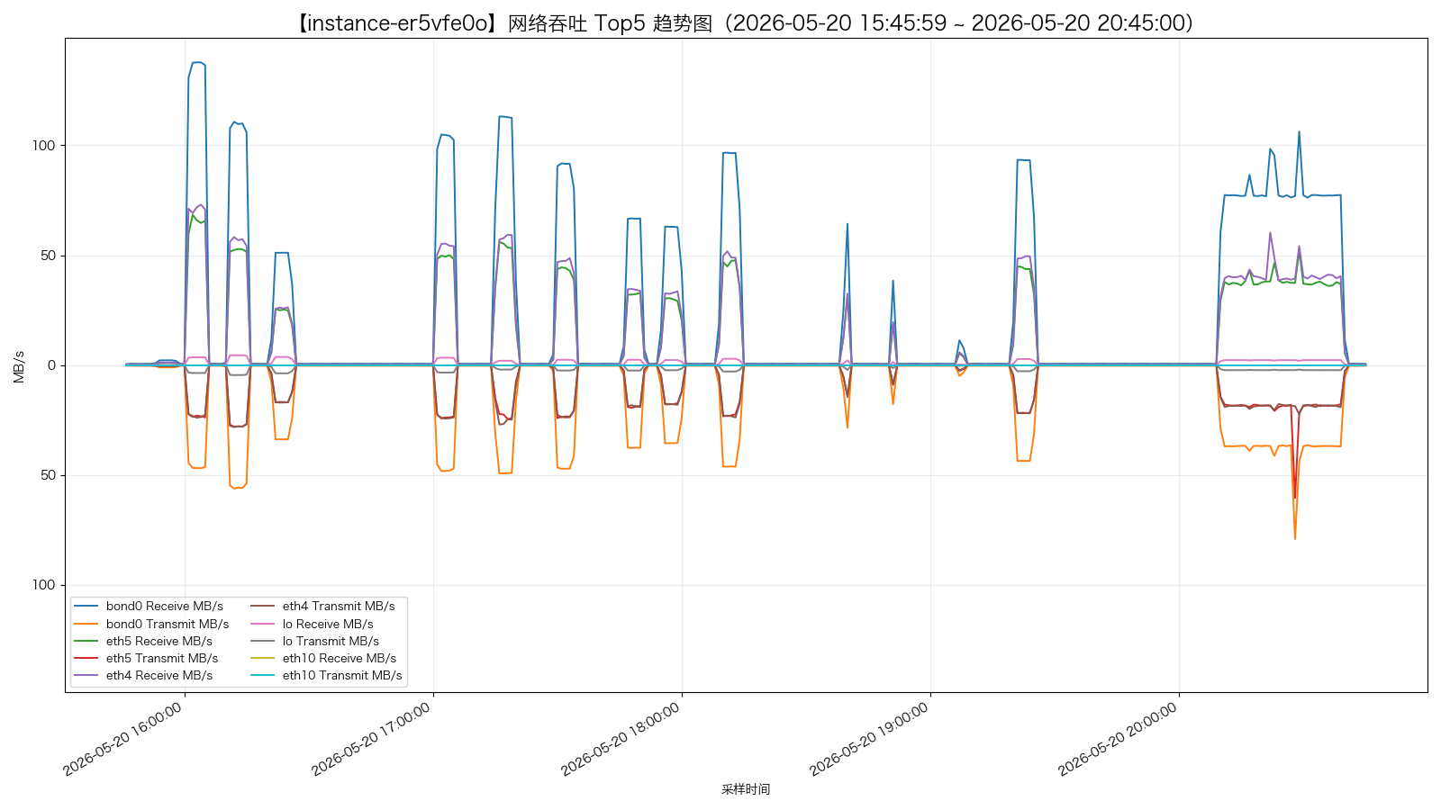
instance-psds6c8p - network_top5.png
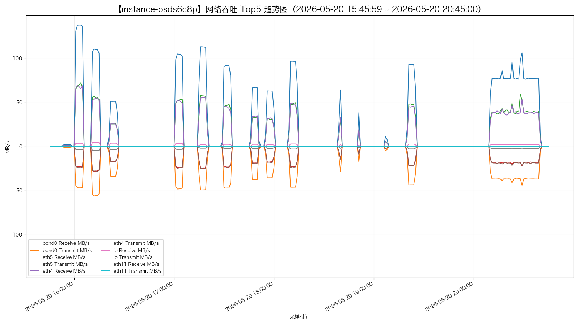
instance-cp18i9mr - network_top5.png
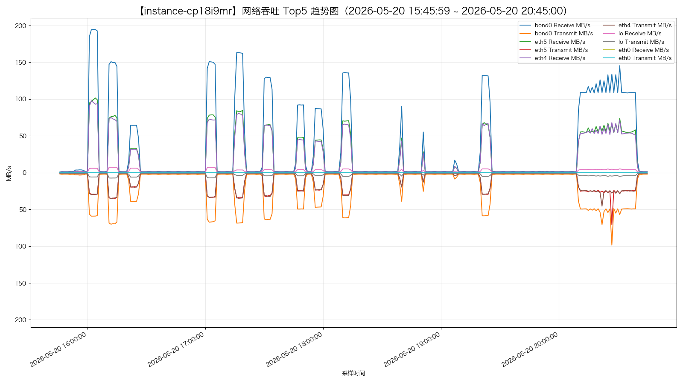
instance-tpexaqbu - network_top5.png
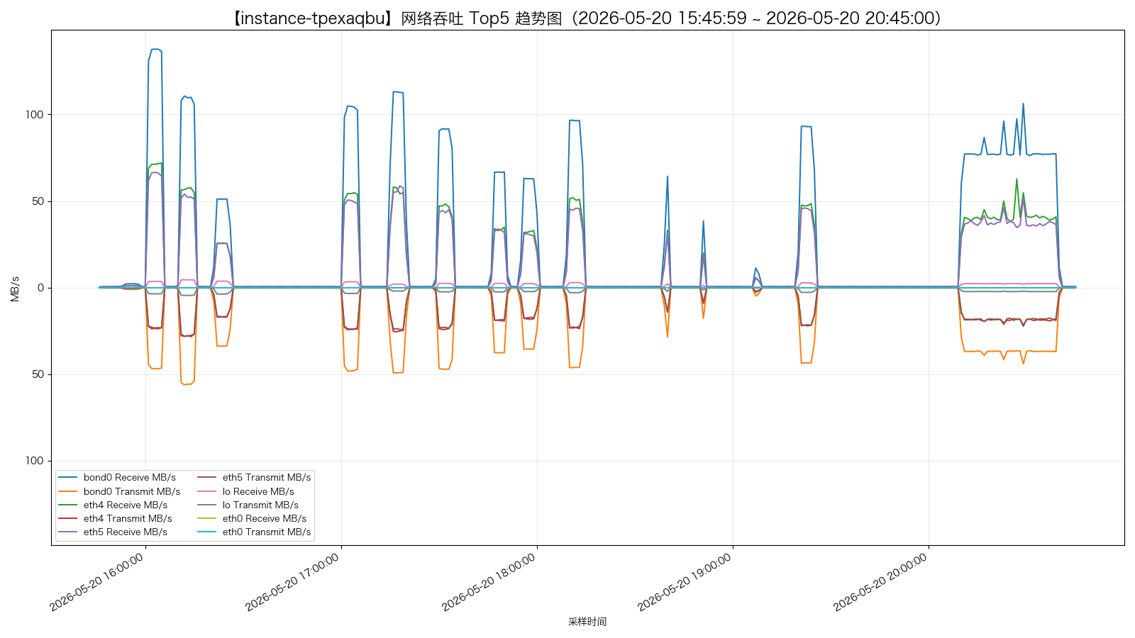
instance-p08t7hw7 - network_top5.png
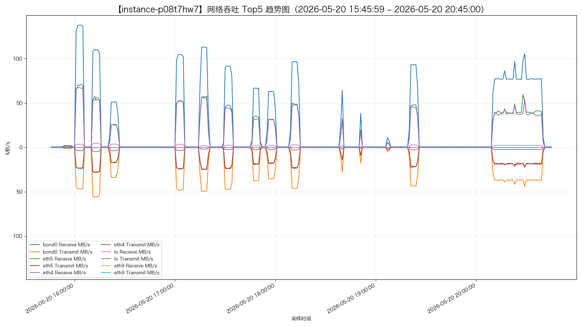
instance-yc02wghu - network_top5.png
