SoftwareMethods and Tools

Assigmnet 3

Manohar Reddy Dyapa

Student ID: 16199984

**Sequence Diagram:**

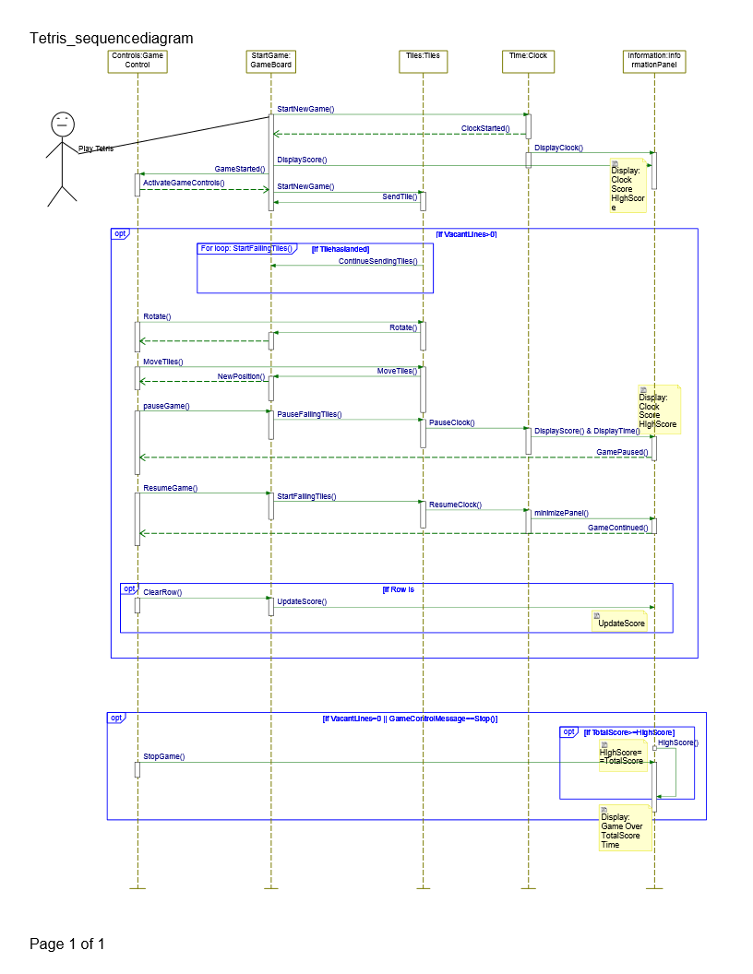

The above Diagram Depicts the Sequence diagram of Tetris game.

In the Above sequence diagram, once user starts the game, the game board will sends messages to game Control, Clock, tiles and information panel and receives the reply messages from all. After the game is started it will check, if the game board has vacant place for the new tiles or not. If the board has enough place then the game will continue. The falling tiles operation checks that the last sent tile is landed or not in the game board, before sending a new tile. The game controller will be able to change the position of the tiles and able to rotate the tiles. Once the line is completed, it will check whether a row is completely filled or not and will clear the row upon the completion. Once the row is cleared it will update the score in the information panel. Game controller will have pause functionality, to pause the game in between. Once the game is paused, falling tiles and the timer will be paused and information panel will be covering the game board, and will display Total score, Time, high score with resume and stop options. Once we hit resume, Score, clock and falling tiles gets resume.

In case there is not enough space for the coming tiles, or user chooses to stop the game, controller will send stop command and information panel compares the high score with total score, and update the high score with the greater value and displays Game Over message to the user.

**State Chart:**

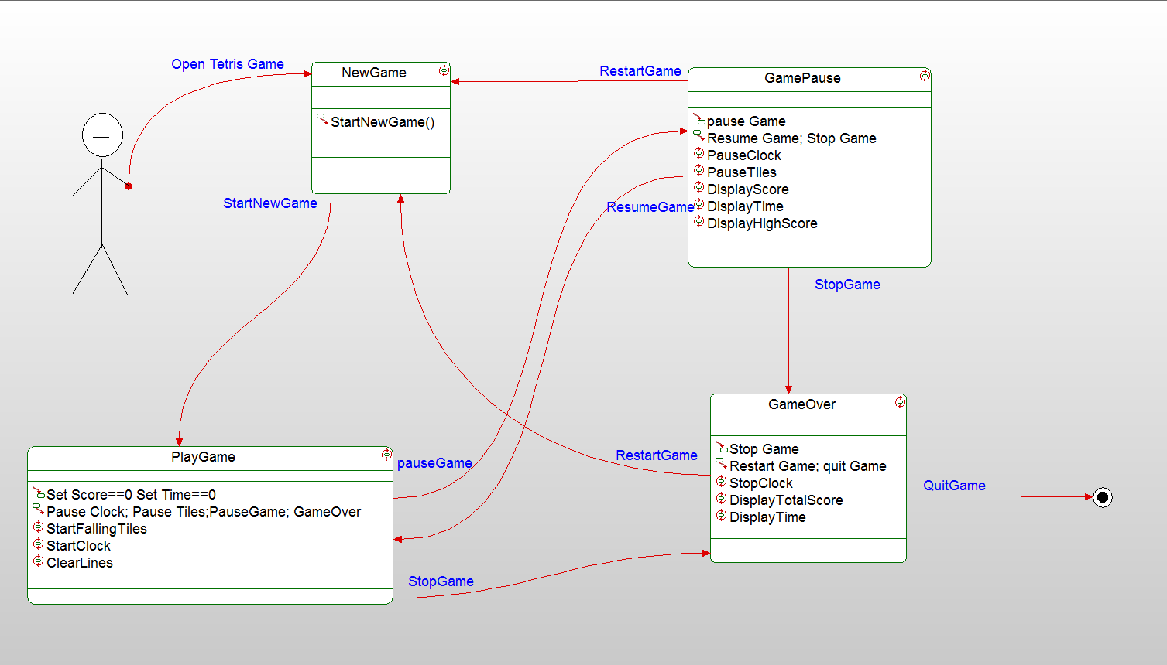

The above diagram represents the state chart diagram for the game Control Class. It has 4 states. NewGame, PlayGame, GamePause, GameOver.

When player starts a new game it will come to NewGame state, where a new Tetris game will start, and it sends control to PlayGame. PlayGame sets the clock and score to zero, and once the game is started it starts clock, and FallingTiles. This state has two options, pause and stop. Once the game is paused the clock and falling tiles also gets paused and the control goes to PauseGame state. This state holds the Clock, Score and Falling Tiles in pause state, and will display the current score, time and high score to the user. This state has 3 options Resume, Restart, Stop. Resume takes the Control to Playgame state, Restart takes it to NewGame state, and Stop from PlayGame/GamePause will take you to GameOver state. In this one it stops clock, and displays Time, TotalScore and compares the score with highscore and replaces with higher one.