**Software Methods and Tools**

**Fall 2015 Assignment 7 – JUnit Testing**

Sri Harsha Chennavajjala

[sc9v9@mail.umkc.edu](mailto:sc9v9@mail.umkc.edu)

# What problems did you find in the code? For each problem, further explain how you found it (e.g. using which test case).

When I test the application, I found that the score is increasing abnormally. I’ve found this by testing the *updateGame()* method of *Tetris* class and *checkLines()* method of *BoardPanel* class.

***TetrisTest.java***

This JUnit test file has the logic to test the *updateGame()* method of *Tetris* class.

***BoardPanelTest.java***

This JUnit test file has the logic to test *isValidAndEmpty()*, *addPiece()* and *checkLines()* methods of *BoardPanel* class.

# Specifically explain the test case that you have created for the updateGame method of Class Tetris. What is your input, and what is your expected output? What is your logic of testing this method?

This method doesn’t have any return type. So, in order to test this method, I’ve temporarily changed the return type of this method. Based on the return value of this method, I am validating its correctness.

Once we successfully cleared the row, then score should be updated. Score assignment is as below…

1 row cleared – 100 points

2 rows cleared – 200 points

3 rows cleared – 400 points

4 rows cleared – 800 points

At any point of time, we can clear a maximum of 4 rows in a single go. This is because the maximum length of all types of tiles is 4 (for I shaped tile).

This information will come from the method *checkLine()* method of *BoardPanel* class. As I did the unit testing on updateGame() method, the number of rows cleared each time is 22. This is the reason for the abnormal scores.

**The general equation for score is:**

score **+=** 50 **<<** cleared

score **=** score **+** 50**\***2**[**0**-**4**]**

Here the range of *cleared* variable should be:

0 **<=** cleared **<=** 4

But, here as we are always getting 22 cleared rows (which we should not get), the score is becoming abnormal.

**New equation for score is:**

score **=** score **+** 50**\***222

To identify this bug, I’ve created a test case for *updateGame()* method which check the validity of number of cleared rows. Here, once the tile reached the bottom of the board, even if the row is not full, we get 22 (which is total height of board) as the cleared rows. My test case will check for count and returns fail status. Below is the output of the test case.

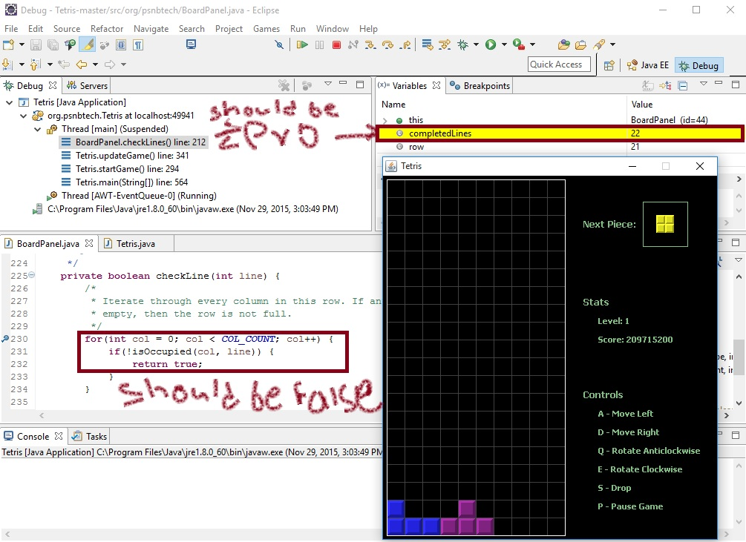

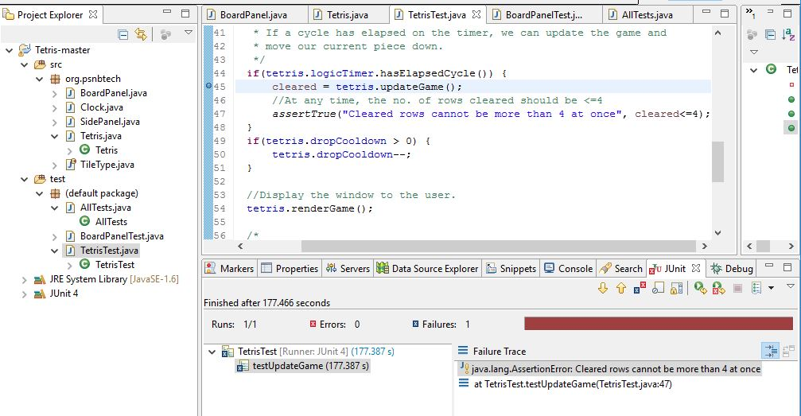

Here, the test case is failed (which is success scenario for us) because the method *updateGame()* received invalid number of cleared rows.

# Testing *BoardPanel* methods:

The methods *isValidAndEmpty* and *addPiece* don’t have any bugs in them. But the method *checkLines()* is receiving invalid input from *checkLine()* method. checkLine() method should return *false* if the position on the board is occupied. But it is returning *true*. So, *checkLines()* method yielding invalid results. Here, *addPiece()* method doesn’t have a return type. So, I’ve temporarily modified its code such that it returns a value based on its side effect on the application.

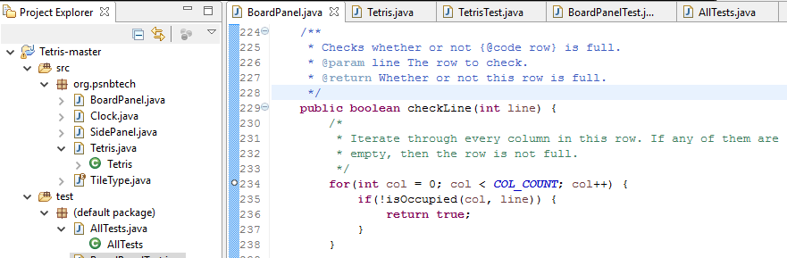

# Include a screenshot of the result of running your test suite

I’ve created a test suite which includes all the test cases that I’ve created. The results of the test cases are as below…

## 4.1 Test Case result of *updateGame()* method:

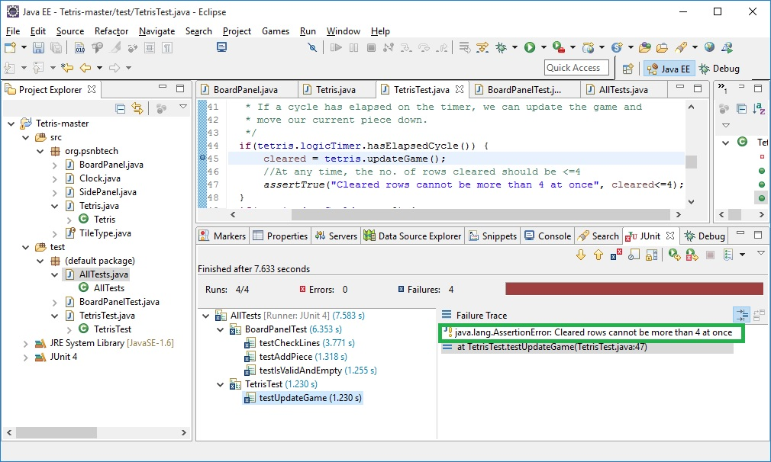

## 4.2 Test case result of *isValidAndEmpty()* method:

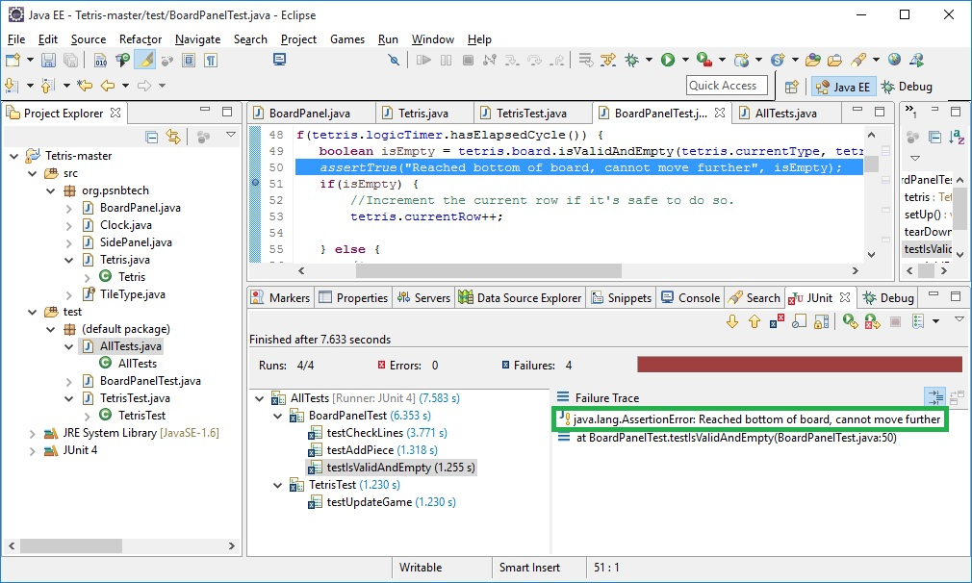

## 4.3 Test case result of *addPiece()* method:

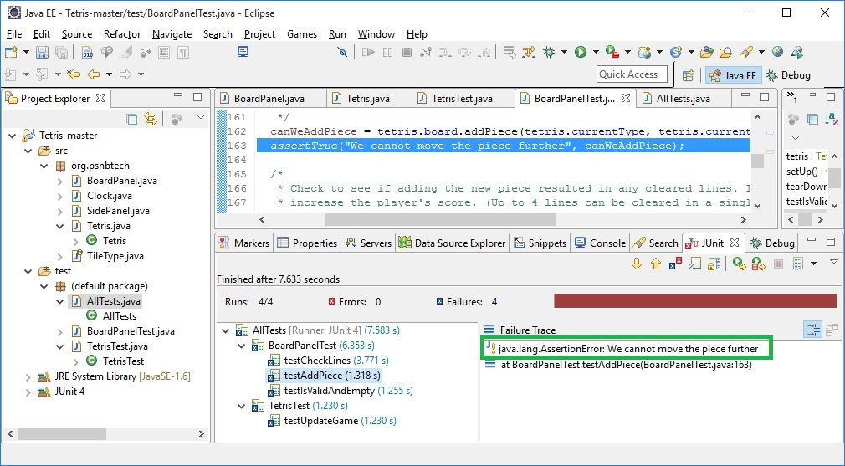

## 4.4 Test case result of *checkLines()* method:

